Ex. No.: 7

Date:

**SubQuery& Correlated Query**

1. Which of the student’s score is greater than the highest score?

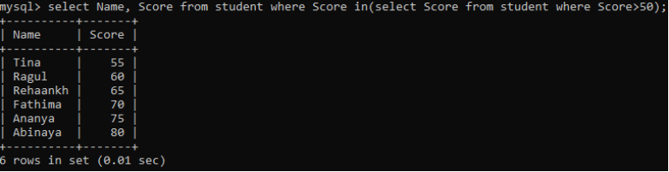

1. Which of the students’ have written more than one assessment test?

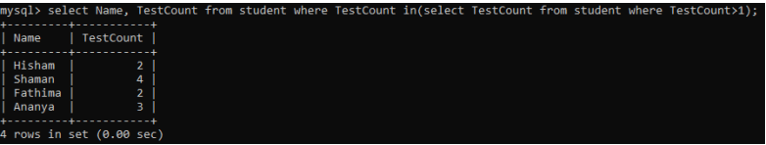

1. Which faculty has joined recently and when?

