RETAILPULSE
Metadata-Driven Retail Supply Chain Analytics Pipeline
Technical Project Documentation
Built on the Medallion (Bronze–Silver–Gold) Architecture
Prepared by: Teja sree
Data Engineering Intern | CEI Program 2026, Celebal Technologies
July 2026

Abstract
Retail organizations generate substantial volumes of operational data across orders, inventory, products, stores, and suppliers. In many organizations, this data remains fragmented across disconnected CSV files, leading to duplicate records, missing values, and inconsistent schemas that make reliable analysis difficult. RetailPulse addresses this problem by implementing a metadata-driven ETL pipeline built on the Medallion Architecture, which processes raw retail data through Bronze, Silver, and Gold layers to produce clean, validated, and analytics-ready datasets.
The pipeline ingests raw CSV files, applies schema validation, duplicate removal, and null handling, and enriches the data with derived business attributes such as Total Value and Low Stock Flag. Processed datasets are aggregated into business KPIs, including Daily Sales, Top Products, Store Performance, Category Revenue, and Low Stock Alerts, and are persisted in a SQLite database to support SQL-based analytics. All schemas, validation rules, and business logic are externalized in a YAML configuration file, allowing the pipeline's behavior to be modified without changes to the underlying Python code. An interactive Streamlit dashboard sits on top of this pipeline, enabling users to trigger pipeline execution, explore data at each layer, review KPIs and charts, run ad-hoc SQL queries, and monitor execution logs.
This document presents the complete design, architecture, and implementation of RetailPulse, along with the challenges encountered during development, the business insights the system enables, and the enhancements identified for future iterations. It is intended to serve as a comprehensive technical reference suitable for academic evaluation, internship submission, GitHub portfolio presentation, and technical interview discussion.

Table of Contents
Abstract 1
Table of Contents 1
Chapter 1 — Introduction 1
1.1 Problem Statement 1
1.2 Objectives 1
1.3 Scope 1
Chapter 2 — Existing System 1
2.1 Limitations of the Existing System 1
Chapter 3 — Proposed System 1
3.1 System Flow 1
3.2 Layer Description 1
Bronze Layer 1
Silver Layer 1
Gold Layer 1
SQLite Database 1
Streamlit Dashboard 1
Chapter 4 — System Architecture 1
4.1 Architecture Flow 1
4.2 Component Description 1
Chapter 5 — Project Structure 1
5.1 Folder Description 1
Chapter 6 — Technologies Used 1
Chapter 7 — Dataset Description 1
Chapter 8 — Pipeline Implementation 1
8.1 Bronze Layer 1
8.2 Silver Layer 1
8.3 Gold Layer 1
8.4 Pipeline Orchestration 1
8.5 Metadata-Driven Configuration 1
8.6 SQLite Loading 1
8.7 Chart Generation 1
8.8 Dashboard 1
Chapter 9 — Metadata-Driven Pipeline 1
9.1 Schema Definitions 1
9.2 Primary Keys 1
9.3 Validation Rules 1
9.4 Engine Selection 1
Chapter 10 — Dashboard Implementation 1
10.1 Pipeline Overview 1
10.2 Medallion Data Viewer 1
10.3 KPIs & Analytics 1
10.4 SQL Workbench 1
10.5 Pipeline Logs 1
10.6 Configuration Viewer 1
Chapter 11 — SQL Analytics 1
11.1 Daily Sales 1
11.2 Store Performance 1
11.3 Top Products 1
11.4 Category Revenue 1
11.5 Low Stock Alerts 1
Chapter 12 — Results 1
Chapter 13 — Business Insights 1
13.1 Highest Revenue Store 1
13.2 Top Selling Products 1
13.3 Revenue Trend 1
13.4 Category Performance 1
13.5 Low Stock Products 1
13.6 Inventory Analysis 1
13.7 Business Recommendations 1
Chapter 14 — Challenges Faced 1
14.1 PySpark Configuration 1
14.2 SQLite Synchronization 1
14.3 Metadata Validation 1
14.4 Path Handling 1
14.5 Dashboard Integration 1
14.6 Spark Data Type Issues 1
Chapter 15 — Advantages 1
15.1 Metadata-Driven Pipeline 1
15.2 Modular Design 1
15.3 Reusable Components 1
15.4 Easy Maintenance 1
15.5 Interactive Dashboard 1
15.6 SQL Support 1
15.7 Scalable Architecture 1
Chapter 16 — Limitations 1
Chapter 17 — Future Enhancements 1
Chapter 18 — Learning Outcomes 1
Chapter 19 — Conclusion 1
References 1
Appendix 1
A.1 Project Directory Reference 1
A.2 Gold-Layer SQL Reference 1
A.3 Primary Key Reference 1

Note: Right-click the table above and select "Update Field" (or press Ctrl+A, then F9) after opening this document in Word to populate page numbers.

Chapter 1 — Introduction

1.1 Problem Statement
Retail organizations generate large volumes of data spanning orders, inventory, products, suppliers, and stores. In the absence of a structured processing pipeline, this data is typically maintained as a collection of independent CSV files, each with its own inconsistencies — duplicate records, missing values, and schemas that vary from one dataset to another. Cleaning this data manually and compiling business reports from it is slow, repetitive, and prone to human error, which in turn delays decision-making and reduces confidence in the resulting insights.
RetailPulse was built to remove this manual overhead. It implements a metadata-driven ETL pipeline based on the Medallion Architecture that automates ingestion, validation, cleansing, transformation, and business analytics generation for retail supply chain data — turning a folder of raw CSV files into a queryable, analytics-ready data warehouse with a single pipeline run.

1.2 Objectives
The RetailPulse project was designed around the following objectives:
- Develop an end-to-end ETL pipeline using the Medallion (Bronze–Silver–Gold) Architecture.
- Automate the ingestion of multiple retail datasets from raw CSV sources.
- Improve data quality through schema validation, duplicate removal, and null handling.
- Enrich datasets with derived business attributes such as Total Value and Low Stock Flag.
- Generate core business KPIs — Daily Sales, Top Products, Store Performance, Category Revenue, and Low Stock Alerts.
- Persist processed data in SQLite to enable SQL-based analytics.
- Build an interactive Streamlit dashboard for pipeline monitoring, data exploration, and reporting.
- Implement a metadata-driven configuration layer using YAML for flexibility and maintainability.

1.3 Scope
RetailPulse covers the processing of retail datasets through the Bronze, Silver, and Gold layers of the Medallion Architecture — including ingestion, cleansing, enrichment, KPI generation, SQLite integration, chart generation, and dashboard visualization.
The current implementation is scoped to batch processing of static CSV files using a local SQLite database. It does not cover real-time data streaming, cloud deployment, workflow scheduling, user authentication, or machine learning-based forecasting; these are identified as candidate directions for future enhancement in Chapter 17.

Chapter 2 — Existing System
Traditional retail businesses commonly manage operational data using spreadsheets and standalone CSV exports from point-of-sale, inventory, and supplier systems. While straightforward to produce, this approach has several structural limitations that directly affect data quality and the speed of business decision-making.

2.1 Limitations of the Existing System
- Data is stored in separate CSV or Excel files, making cross-dataset integration difficult.
- Manual data cleaning is time-consuming and prone to human error.
- Duplicate and missing records reduce the accuracy of downstream reporting.
- The absence of standardized schemas creates inconsistencies across datasets.
- Business reports are compiled manually, slowing down decision-making.
- There is no centralized database for storing and querying processed data.
- Limited visualization and analytical tooling make ongoing business monitoring difficult.
These limitations collectively point to the need for an automated, structured data engineering pipeline — one that can ingest raw data consistently, enforce data quality rules, and make business-ready datasets available for analysis without manual intervention. This need is what RetailPulse was designed to address.

Chapter 3 — Proposed System
RetailPulse is a metadata-driven retail supply chain analytics pipeline built on the Medallion Architecture. It automates the complete ETL workflow, taking raw retail data through progressive stages of refinement until it is clean, validated, and ready for analytics.

3.1 System Flow
Raw CSV Files
|
v
Bronze Layer
|
v
Silver Layer
|
v
Gold Layer
|
v
SQLite Database
|
v
Streamlit Dashboard
Figure 3.1: High-level RetailPulse pipeline flow, from raw CSV ingestion to dashboard visualization.

3.2 Layer Description

Bronze Layer
Copies raw CSV files into the pipeline without modification, preserving the original data for auditing and traceability.

Silver Layer
Performs data cleaning, schema validation, duplicate removal, and null handling, and enriches the data with new business fields such as Total Value and Low Stock Flag.

Gold Layer
Aggregates the cleansed Silver datasets into business KPIs, including Daily Sales, Top Products, Store Performance, Category Revenue, and Low Stock Alerts.

SQLite Database
Stores the processed Silver and Gold datasets, enabling SQL-based analytics and serving as the data source for the dashboard.

Streamlit Dashboard
Provides an interactive interface to execute the pipeline, explore datasets, view KPIs, run SQL queries, and visualize charts.

Chapter 4 — System Architecture
RetailPulse follows the Medallion Architecture pattern, in which data passes through successive, well-defined processing stages before it becomes analytics-ready. Each stage has a single, clearly scoped responsibility, which keeps the pipeline easy to reason about, test, and extend.

4.1 Architecture Flow
Raw CSV Files
|
v
Bronze Layer
|
v
Silver Layer
|
v
Gold Layer
|
v
SQLite Database
|
v
Streamlit Dashboard
Figure 4.1: RetailPulse system architecture across the Bronze, Silver, and Gold layers.

4.2 Component Description
Component | Responsibility
Raw CSV Files | Source datasets, including Orders, Inventory, Products, Stores, and Suppliers.
Bronze Layer | Ingests raw data and stores an unchanged copy for auditing and data lineage.
Silver Layer | Improves data quality through validation, cleansing, and business enrichment.
Gold Layer | Produces business-ready datasets and KPIs through aggregation and joins.
SQLite Database | Acts as a lightweight analytical data warehouse for processed datasets.
Streamlit Dashboard | Displays KPIs, metadata, SQL query results, visualizations, and execution details through an interactive web interface.
Table 4.1: RetailPulse architecture components and their responsibilities.

Chapter 5 — Project Structure
RetailPulse follows a modular project structure in which each folder has a single, well-defined responsibility, keeping the codebase easy to navigate and extend.
RetailPulse/
├── dashboard/
├── data/
├── images/
├── logs/
├── outputs/
├── scripts/
├── sql/
├── pipeline_config.yaml
├── run_pipeline.py
├── requirements.txt
└── README.md
Figure 5.1: RetailPulse top-level project directory structure.

5.1 Folder Description
Folder / File | Description
dashboard/ | Contains the Streamlit dashboard application.
data/ | Stores raw, Bronze, Silver, and Gold datasets, the SQLite database, and pipeline reports.
scripts/ | Contains all ETL scripts for Bronze, Silver, and Gold processing, along with utilities and chart generation.
outputs/ | Stores generated visualization charts.
images/ | Contains the project logo, architecture diagram, and dashboard screenshots.
logs/ | Stores pipeline execution logs.
sql/ | Contains SQL queries used for analysis and testing.
pipeline_config.yaml | Metadata-driven configuration file containing schemas, validation rules, and KPI definitions.
run_pipeline.py | Main orchestration script that executes the complete ETL pipeline.
requirements.txt | Lists all required Python dependencies.
README.md | Contains complete project documentation for GitHub.
Table 5.1: Description of RetailPulse's top-level folders and files.

Chapter 6 — Technologies Used
RetailPulse is built using a focused set of Data Engineering technologies that together support ETL processing, data storage, analytics, and dashboard development.
Technology | Purpose
Python | Core programming language used to develop the ETL pipeline and dashboard.
Pandas | Performs data ingestion, cleaning, transformation, joins, and aggregation.
SQLite | Stores processed Silver and Gold datasets for SQL-based analytics.
SQL | Executes analytical queries against the processed data.
Streamlit | Builds the interactive dashboard for monitoring and visualization.
YAML | Stores metadata, schemas, validation rules, and pipeline configuration.
Matplotlib | Generates static business charts and reports.
Seaborn | Enhances chart styling and visualization quality.
Logging | Records pipeline execution details and errors for monitoring.
PySpark | Provides optional support for distributed data processing on larger datasets.
Table 6.1: Core technologies used in RetailPulse and their purpose within the pipeline.

Chapter 7 — Dataset Description
RetailPulse operates on five interrelated retail datasets — Orders, Inventory, Products, Stores, and Suppliers — supplied as raw CSV files. These datasets together represent a typical retail supply chain: what was sold and where (Orders), what is available and in what quantity (Inventory), what is being sold (Products), where sales take place (Stores), and who supplies the goods (Suppliers).
Dataset | Represents
Orders | Transactional sales records processed through the pipeline to compute revenue and demand KPIs.
Inventory | Stock-on-hand information used to derive the Low Stock Flag and Low Stock Alerts.
Products | Product catalog details, including category, used for category-level revenue analysis.
Stores | Store master data used to compute store-wise performance KPIs.
Suppliers | Supplier reference data associated with the products and inventory datasets.
Table 7.1: Source datasets processed by the RetailPulse pipeline.
Each dataset carries a primary key used for validation and duplicate detection — for example, order_id for Orders, product_id for Products, and store_id for Stores (see Chapter 9 for the complete list). The exact column-level schema, data types, and validation rules for every dataset are declared centrally in pipeline_config.yaml rather than hard-coded in the pipeline scripts, which is what allows RetailPulse to remain metadata-driven (Chapter 9).

Chapter 8 — Pipeline Implementation
RetailPulse implements a modular ETL pipeline based on the Medallion Architecture. Each layer has a specific, single responsibility, which keeps the pipeline both easy to reason about and straightforward to extend.

8.1 Bronze Layer
The Bronze layer ingests raw CSV files and stores an unchanged copy in the data/bronze folder. It preserves the original data, maintains data lineage, and generates ingestion metadata for each run.
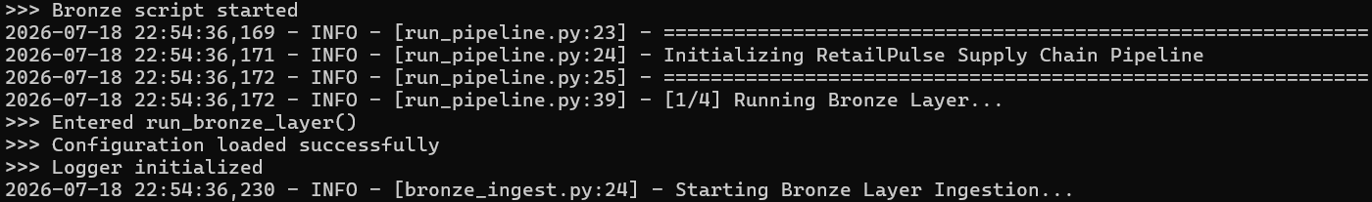Figure 8.1: Bronze layer ingestion output.

8.2 Silver Layer
The Silver layer cleans and validates the Bronze data by removing duplicates, handling missing values, and enforcing schemas defined in the pipeline configuration. It also enriches the datasets with derived business fields, including Total Value and Low Stock Flag.
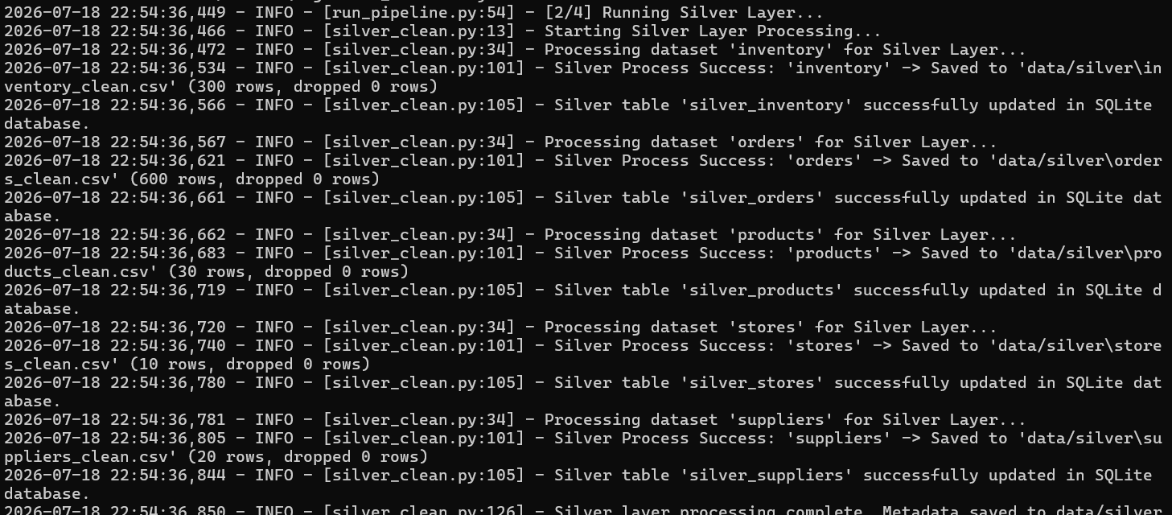Figure 8.2: Silver layer cleaning and enrichment output.

8.3 Gold Layer
The Gold layer performs joins and aggregations across the Silver datasets to generate business KPIs, including Daily Sales, Top Products, Store Performance, Category Revenue, and Low Stock Alerts.
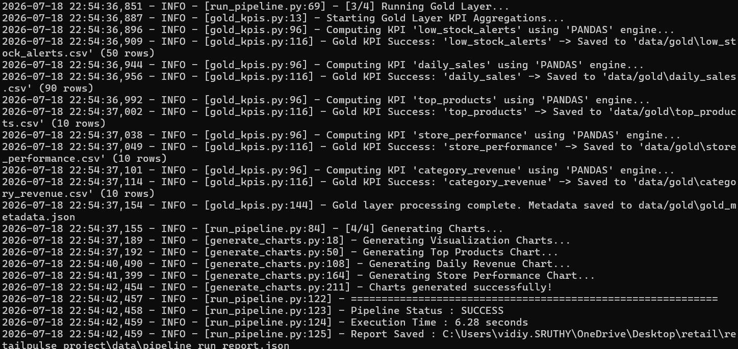Figure 8.3: Gold layer KPI generation output.

8.4 Pipeline Orchestration
The run_pipeline.py script orchestrates the complete pipeline execution. It sequentially runs the Bronze, Silver, Gold, and chart-generation modules, recording execution logs and generating a pipeline execution report at the end of each run.

8.5 Metadata-Driven Configuration
All dataset schemas, validation rules, enrichment logic, and KPI definitions are stored in pipeline_config.yaml. This lets business rules be modified without touching the underlying Python code — the design is explored in full in Chapter 9.

8.6 SQLite Loading
After processing, the Silver and Gold datasets are loaded into a SQLite database (retailpulse.db), which becomes the single source of truth for SQL-based analytics and dashboard integration.

8.7 Chart Generation
After KPI generation, the pipeline automatically produces business visualization charts using Matplotlib and Seaborn, including Daily Revenue Trend, Top Products by Revenue, and Store Performance.
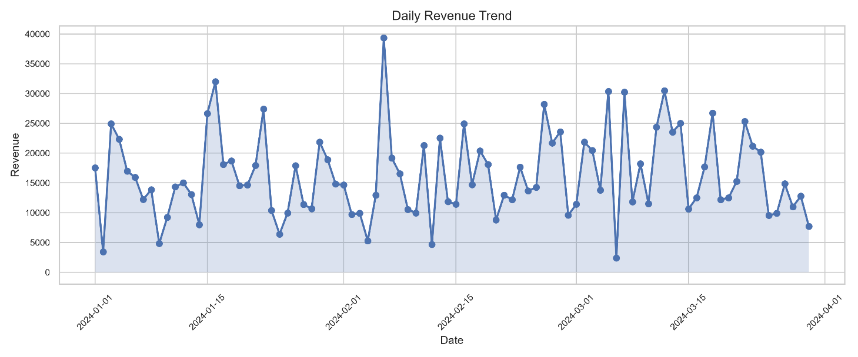
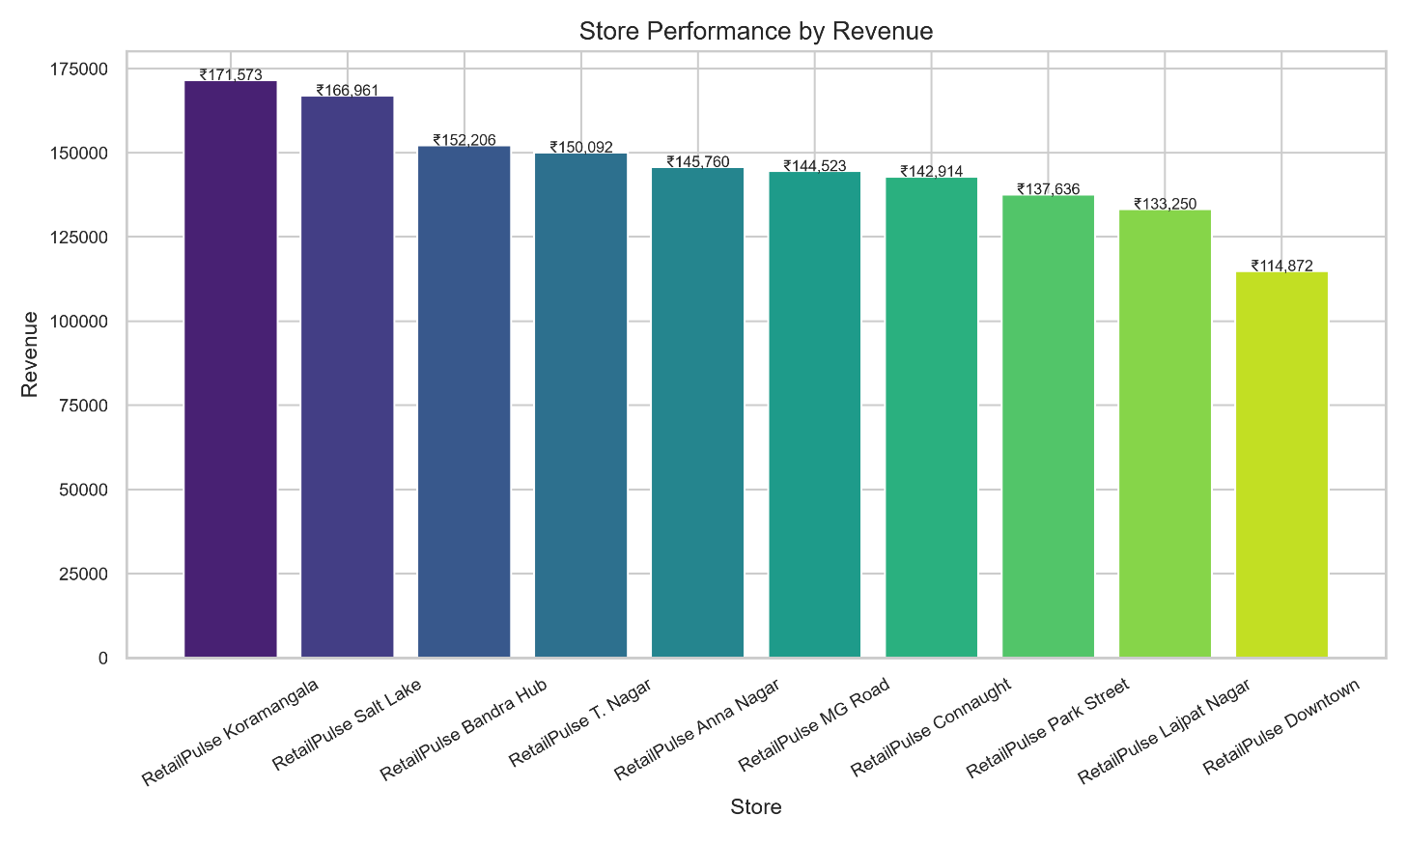
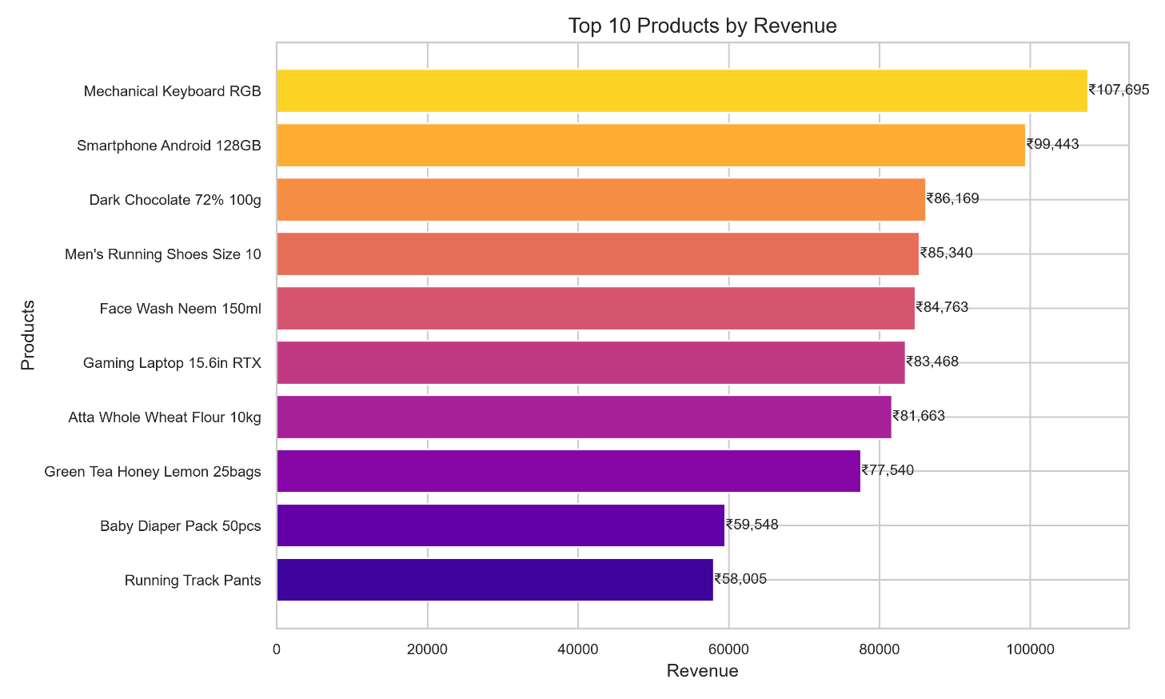Figure 8.5: Auto-generated business charts (Daily Revenue Trend, Top Products, Store Performance).

8.8 Dashboard
The processed data is surfaced through a Streamlit dashboard that lets users execute the pipeline, monitor KPIs, explore datasets, run SQL queries, and view execution logs — covered in detail in Chapter 10.
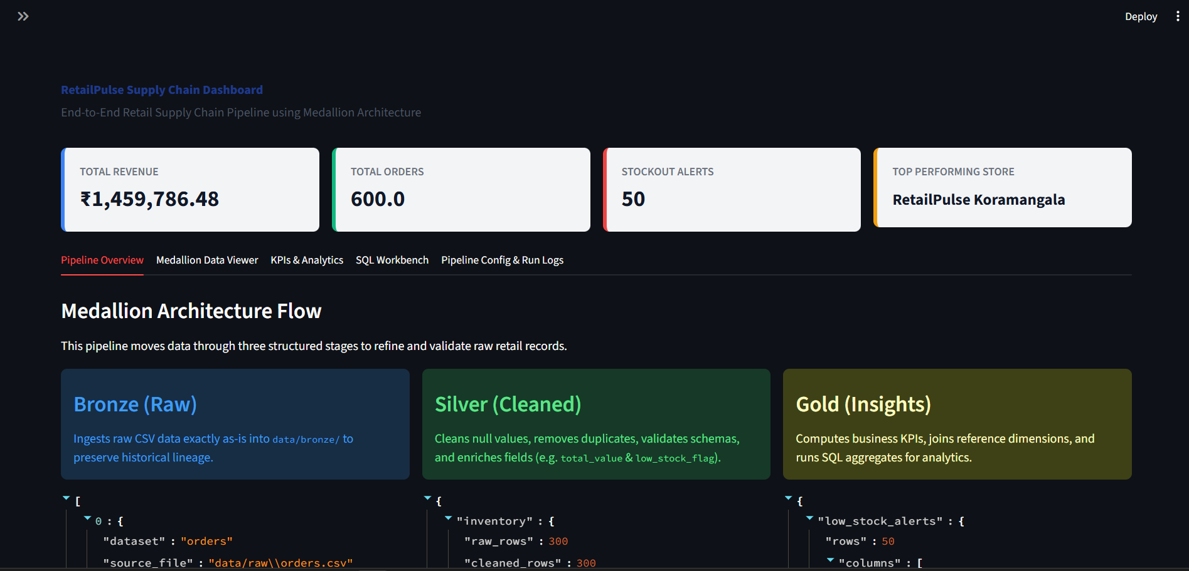Figure 8.6: RetailPulse Streamlit dashboard home view.

Chapter 9 — Metadata-Driven Pipeline
RetailPulse follows a metadata-driven design in which all processing rules are declared in pipeline_config.yaml rather than embedded in code. This separation of configuration from application logic is what gives the pipeline its flexibility, maintainability, and scalability.

9.1 Schema Definitions
The configuration file defines the expected columns and data types for each dataset, ensuring consistent structure is enforced at every pipeline run.

9.2 Primary Keys
Primary keys are declared per dataset and used for duplicate detection and validation during the Silver layer:
Dataset | Primary Key
Orders | order_id
Products | product_id
Stores | store_id
Table 9.1: Primary keys used for duplicate detection across core datasets.

9.3 Validation Rules
The configuration file defines the rules applied uniformly across datasets:
- Data type validation
- Null value removal
- Duplicate removal
- Business enrichments
- Aggregation rules

9.4 Engine Selection
The execution engine — Pandas or PySpark — is configurable through the YAML file, allowing the same pipeline logic to run either locally on Pandas or, when needed, on a distributed PySpark engine for larger datasets.

Chapter 10 — Dashboard Implementation
The RetailPulse dashboard is built with Streamlit and provides a single interactive interface for monitoring and interacting with the complete ETL pipeline.

10.1 Pipeline Overview
Displays the complete Medallion Architecture along with the metadata generated by the Bronze, Silver, and Gold layers.

10.2 Medallion Data Viewer
Lets users preview datasets from the Bronze and Silver layers and inspect their schemas directly within the dashboard.

10.3 KPIs & Analytics
Displays Gold layer outputs — Top Products, Store Performance, Category Revenue, and Low Stock Alerts — alongside the generated charts.

10.4 SQL Workbench
Provides an interface to execute custom SQL queries against the SQLite warehouse and view the results directly in the dashboard.

10.5 Pipeline Logs
Displays the latest execution logs generated during pipeline runs, supporting monitoring and debugging.

10.6 Configuration Viewer
Displays the contents of pipeline_config.yaml along with the latest pipeline execution report.

Chapter 11 — SQL Analytics
RetailPulse uses SQLite to run SQL-based analytics directly on the processed Gold-layer datasets.

11.1 Daily Sales
SELECT * FROM gold_daily_sales;
Output: date-wise total orders, revenue, and average order value.

11.2 Store Performance
SELECT * FROM gold_store_performance ORDER BY total_revenue DESC;
Output: store-wise revenue, identifying the top-performing stores.

11.3 Top Products
SELECT * FROM gold_top_products;
Output: the top 10 revenue-generating products.

11.4 Category Revenue
SELECT * FROM gold_category_revenue;
Output: revenue and units sold per product category.

11.5 Low Stock Alerts
SELECT * FROM gold_low_stock_alerts;
Output: products with stock levels below the reorder threshold, along with the units required for replenishment.

Chapter 12 — Results
Executing the RetailPulse pipeline end to end successfully produces a complete set of analytics-ready outputs:
- Bronze Layer datasets
- Silver Layer cleaned datasets
- Gold Layer KPI reports
- SQLite analytical database
- Streamlit dashboard
- Business visualization charts
- Pipeline execution logs
- Pipeline execution report

Chapter 13 — Business Insights
The KPIs generated by the Gold layer translate directly into insights that support retail management decisions.

13.1 Highest Revenue Store
The Store Performance KPI identifies the store generating the highest sales revenue.

13.2 Top Selling Products
The Top Products KPI highlights the products with the highest revenue and sales volume.

13.3 Revenue Trend
The Daily Sales KPI shows day-to-day revenue fluctuations, useful for identifying sales patterns and peak business periods.

13.4 Category Performance
The Category Revenue KPI compares revenue generated across different product categories.

13.5 Low Stock Products
The Low Stock Alerts KPI identifies products that require immediate inventory replenishment.

13.6 Inventory Analysis
Inventory-derived fields, such as the Low Stock Flag, support ongoing stock-level monitoring and replenishment decisions.

13.7 Business Recommendations
- Replenish products flagged with low stock levels.
- Increase inventory allocation for high-demand products.
- Promote top-performing product categories.
- Review underperforming stores for operational improvements.
- Use daily sales trends to support demand forecasting and inventory planning.

Chapter 14 — Challenges Faced
Building RetailPulse surfaced several practical engineering challenges, each of which shaped a specific design decision in the final pipeline.

14.1 PySpark Configuration
Setting up PySpark required a Java installation and environment variable configuration. To keep the pipeline resilient, it was designed to fall back to the Pandas engine automatically when PySpark was unavailable.

14.2 SQLite Synchronization
Keeping processed datasets synchronized with SQLite required careful table replacement and connection handling to maintain consistency between the CSV outputs and the corresponding database tables.

14.3 Metadata Validation
Implementing a metadata-driven pipeline required dynamically reading schemas, validation rules, and business logic from the YAML configuration file while still guaranteeing correctness at runtime.

14.4 Path Handling
Managing file paths consistently across the project's folders — and ensuring compatibility between the Python ETL scripts and the Streamlit dashboard — required dynamic path resolution using the os module.

14.5 Dashboard Integration
Keeping the dashboard synchronized with the latest pipeline outputs required automatically refreshing metadata, charts, SQLite tables, and execution reports after every successful pipeline run.

14.6 Spark Data Type Issues
While experimenting with the PySpark engine, data type mismatches were encountered during development. These were resolved by applying consistent schema definitions and validation rules through the metadata configuration, ensuring uniform processing across the pipeline.

Chapter 15 — Advantages
RetailPulse's metadata-driven design delivers several practical advantages over a hand-coded pipeline.

15.1 Metadata-Driven Pipeline
Business rules, schemas, validations, and KPI definitions live in the YAML configuration file, allowing them to be modified without changing the application code.

15.2 Modular Design
The project is organized into independent modules — Bronze, Silver, Gold, dashboard, and utility scripts — improving code organization and readability.

15.3 Reusable Components
Common functionality such as logging, configuration loading, database connections, and SQL execution is implemented as reusable utility functions rather than duplicated across modules.

15.4 Easy Maintenance
The combination of metadata-driven configuration and modular architecture makes the pipeline straightforward to update, debug, and extend.

15.5 Interactive Dashboard
The Streamlit dashboard allows users to execute the pipeline, monitor KPIs, view datasets, run SQL queries, and review business insights through a single intuitive interface.

15.6 SQL Support
Because processed datasets are stored in SQLite, users can perform SQL-based analytics and generate customized business reports directly against the warehouse.

15.7 Scalable Architecture
The Medallion Architecture's separation of raw, cleaned, and analytical data makes the pipeline scalable and well-positioned for future enhancements such as cloud deployment and distributed processing.

Chapter 16 — Limitations
While RetailPulse demonstrates a complete ETL workflow, the current implementation has several known limitations:
- The pipeline processes only static CSV files and does not support real-time streaming data.
- SQLite is well suited to small and medium-sized projects but is not designed for large-scale enterprise data warehouses.
- The dashboard does not include user authentication or role-based access control.
- The project does not support automated workflow scheduling.
- Cloud storage and cloud-based data processing platforms are not integrated.
- Advanced predictive analytics and machine learning models are not included in the current implementation.

Chapter 17 — Future Enhancements
RetailPulse's modular, metadata-driven foundation makes it a natural base for enterprise-grade extensions. Candidate enhancements identified for future iterations include:
- Apache Airflow — automate and schedule ETL workflows.
- Apache Kafka — support real-time streaming data ingestion.
- Azure Data Factory — build cloud-based ETL pipelines.
- Azure Data Lake — store large-scale structured and unstructured data.
- Snowflake — replace SQLite with a cloud data warehouse.
- Delta Lake — provide ACID transactions and data versioning.
- Power BI — develop advanced interactive business dashboards.
- Machine Learning — implement demand forecasting and inventory prediction models.
- CI/CD Pipelines — automate testing and deployment using GitHub Actions or Azure DevOps.
- Docker — containerize the application for consistent, portable deployment.
- Kubernetes — deploy and manage the pipeline in a scalable cloud environment.

Chapter 18 — Learning Outcomes
Building RetailPulse provided hands-on experience across the core competencies of modern Data Engineering:
- Understanding the complete ETL (Extract, Transform, Load) process.
- Developing modular Python applications for data processing.
- Performing data manipulation using Pandas.
- Understanding the fundamentals of PySpark for distributed processing.
- Working with relational databases using SQLite.
- Writing and executing SQL queries for business analytics.
- Designing metadata-driven pipelines using YAML configuration files.
- Implementing the Medallion Architecture (Bronze, Silver, Gold).
- Building interactive dashboards using Streamlit.
- Generating business visualizations using Matplotlib and Seaborn.
- Managing centralized logging and execution monitoring.
- Developing business KPIs for retail analytics.
- Understanding data warehousing concepts and analytical reporting.

Chapter 19 — Conclusion
RetailPulse successfully demonstrates the design and implementation of an end-to-end retail supply chain analytics pipeline built on the Medallion Architecture. The project automates the complete ETL workflow — ingesting raw retail datasets, improving data quality through validation and enrichment, generating business KPIs, and storing processed data in a centralized SQLite database.
Its metadata-driven approach improves flexibility and maintainability by separating business rules from application logic, while the interactive Streamlit dashboard allows users to monitor pipeline execution, explore processed datasets, execute SQL queries, and visualize business insights through charts and KPI reports.
Overall, RetailPulse brings together ETL development, metadata-driven processing, SQL integration, dashboard development, and business analytics into a single, production-inspired solution for retail supply chain data management.

References
The following official documentation and resources were referred to during the development of RetailPulse:
- Python Documentation — https://docs.python.org/3/
- Pandas Documentation — https://pandas.pydata.org/docs/
- Streamlit Documentation — https://docs.streamlit.io/
- SQLite Documentation — https://www.sqlite.org/docs.html
- Apache Spark Documentation — https://spark.apache.org/docs/latest/
- Matplotlib Documentation — https://matplotlib.org/stable/
- Seaborn Documentation — https://seaborn.pydata.org/
- PyYAML Documentation — https://pyyaml.org/wiki/PyYAMLDocumentation

Appendix

A.1 Project Directory Reference
RetailPulse/
├── dashboard/
├── data/
├── images/
├── logs/
├── outputs/
├── scripts/
├── sql/
├── pipeline_config.yaml
├── run_pipeline.py
├── requirements.txt
└── README.md

A.2 Gold-Layer SQL Reference
SELECT * FROM gold_daily_sales;
SELECT * FROM gold_store_performance ORDER BY total_revenue DESC;
SELECT * FROM gold_top_products;
SELECT * FROM gold_category_revenue;
SELECT * FROM gold_low_stock_alerts;

A.3 Primary Key Reference
Dataset | Primary Key
Orders | order_id
Products | product_id
Stores | store_id
Table A.3: Primary keys used for duplicate detection (repeated from Chapter 9 for quick reference).

