OUTPUTS

1. Data Import into Databricks

Steps Followed
- Logged into Databricks Workspace.
- Opened Catalog and selected the default schema.
- Used Create or Modify Table option.
- Uploaded the Superstore CSV file.
- Created the table named superstore.
- Verified the data using SQL querie

2. Verify Dataset

Query
SHOW TABLES;

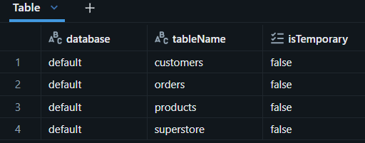

Insight: The dataset was successfully loaded into Databricks and is available for analysis

Query
SELECT COUNT(*)
FROM superstore;

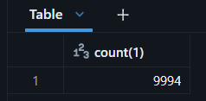

Insight: The dataset contains 9,994 records which will be used for customer sales analysis

Query
SELECT *
FROM superstore
LIMIT 10;
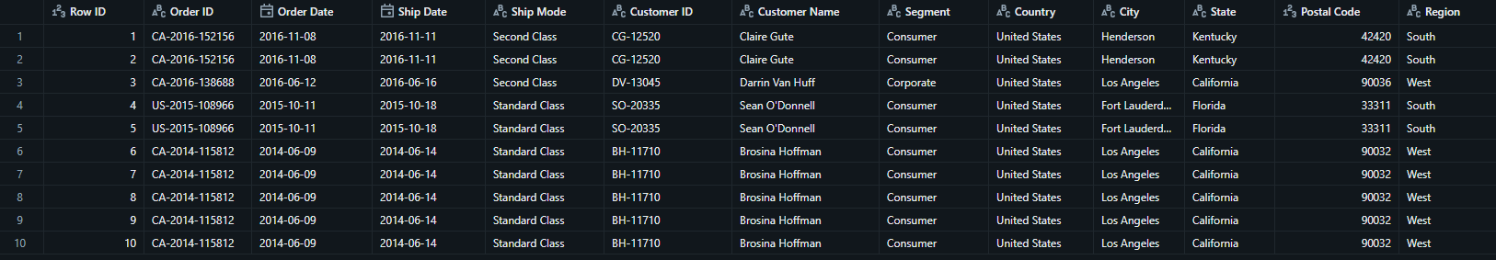
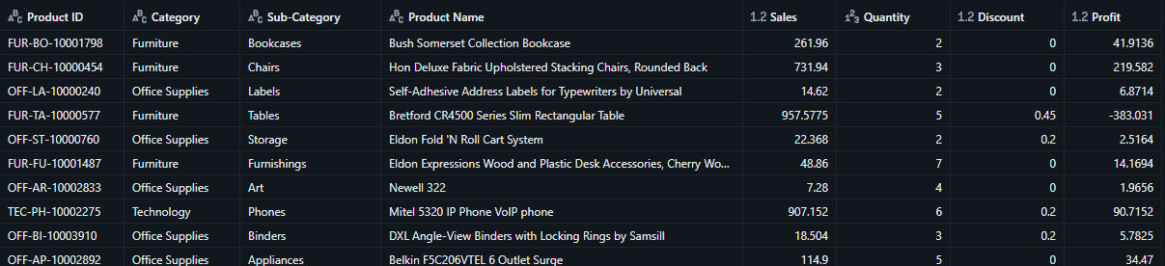
Insigh: The query displays sample records and confirms that the data has been loaded correctly.

Customers Table
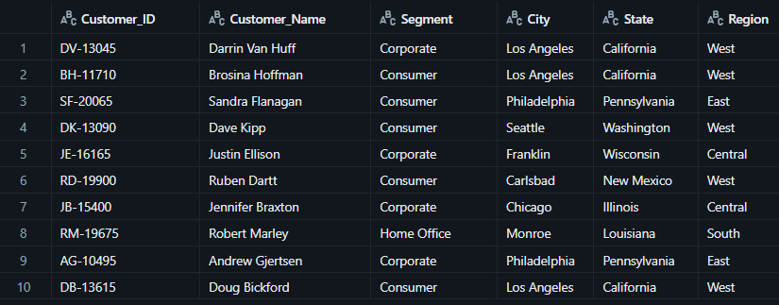
Insight: A separate customers table was created using DISTINCT values to remove duplicate customer records and improve data organization.

Products Table
Insight: Product information was extracted into a dedicated table containing unique product records.

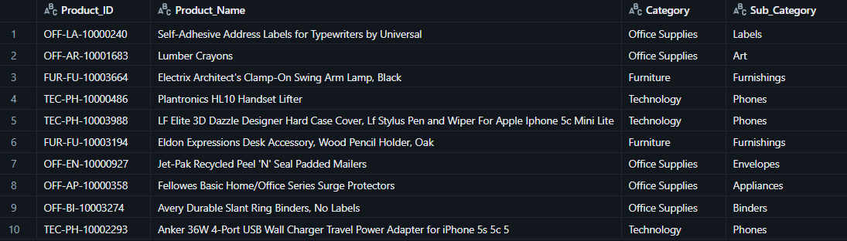

Orders Table

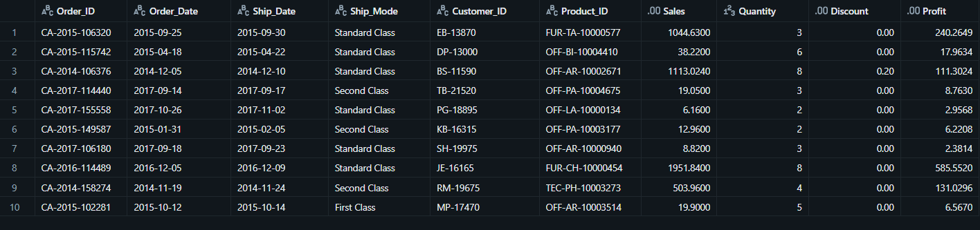
Insigh: Order transaction details were stored separately to support efficient sales analysis.

Step 2: Perform Required Queries

Query 1: Orders with Sales Greater Than Average Sales
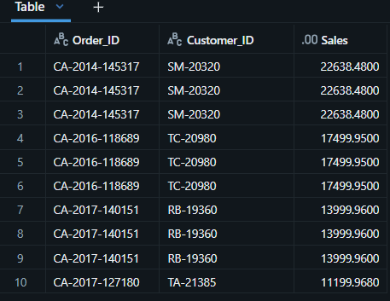
Insight:This query shows the orders whose sales are higher than the average sales value. It helps identify high-value orders in the dataset

Query 2: Highest Sales Order for Each Customer
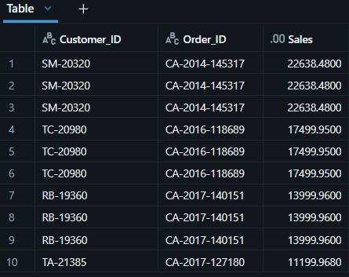
Insight:This query finds the highest sales order placed by each customer. It helps understand the maximum purchase made by every customer.

Query 3: Total Sales per Customer
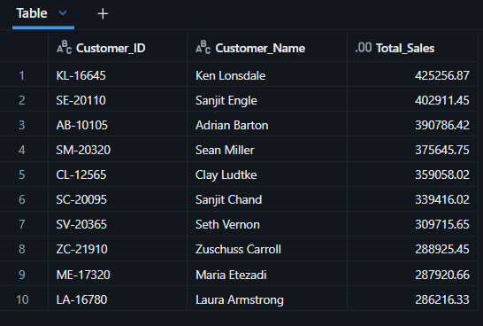
Insight:This query calculates the total sales generated by each customer. It helps identify customers who contribute more to overall sales.

Query 4: Customers with Above-Average Sales
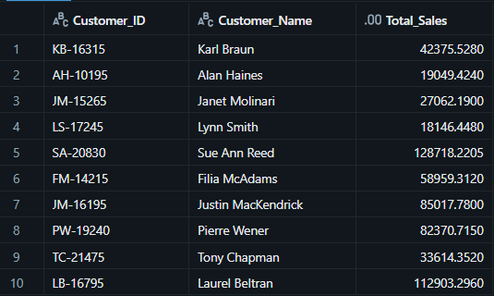
Insight:This query displays customers whose total sales are greater than the average customer sales. These customers can be considered important customers for the business.

Query 5: RANK() and DENSE_RANK()
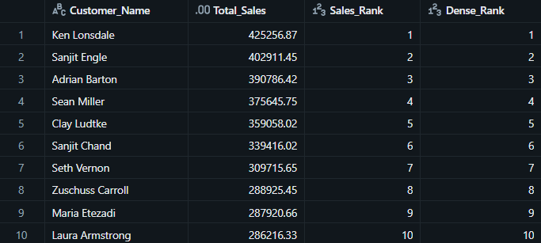
Insight:This query ranks customers based on their total sales. It helps compare customer performance and identify top customers.

Query 6: ROW_NUMBER()
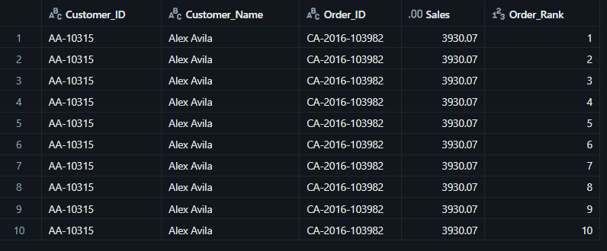
Insight:This query assigns a row number to each order within a customer group based on sales value. It helps organize customer orders from highest to lowest sales.

Query 7: Top 3 Customers
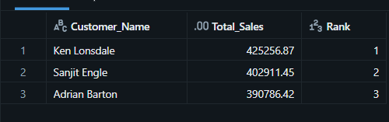
Insight:This query shows the top 3 customers with the highest sales. These customers contributed the most revenue in the dataset.

Query 8: Final Combined Query
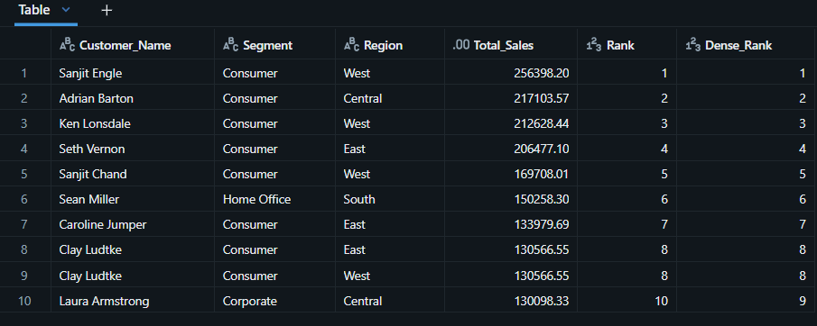
Insight:This query combines customer details, total sales, and rankings into a single result. It provides a complete view of customer performance.

Mini Project: Customer Sales Insights

Top 5 Customers
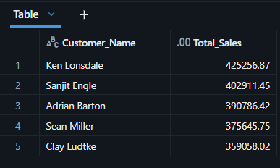
Insight: This query shows the top 5 customers based on total sales. These customers contributed the highest sales in the dataset.

Bottom 5 Customers
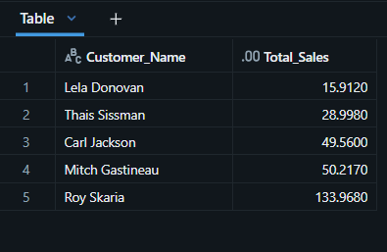
Insigh: This query shows the bottom 5 customers based on total sales. These customers contributed the least sales compared to other customers.

Customers with Only One Order
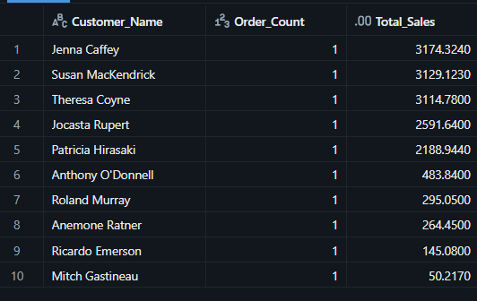
Insight: This query identifies customers who placed only one order. It helps understand customers with very limited purchase activity.

Customers with Above-Average Sales
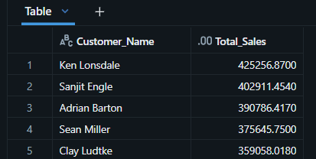
Insight: This query displays customers whose total sales are greater than the average customer sales. These customers performed better than the overall average.

Highest Order Value per Customer
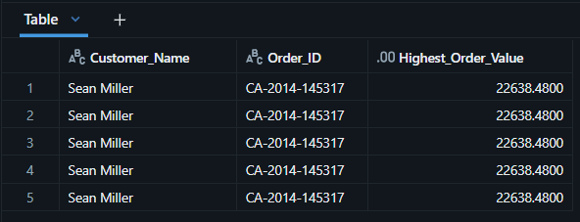
Insigh: This query finds the highest-value order placed by each customer. It helps identify the maximum purchase made by every customer.

.

