Objective: Analyze sales data using SQL with filtering, aggregation, and business queries.
- Load dataset into a SQL database.
CREATE TABLE sample - superstore (
row_id INT,
order_id VARCHAR(20),
order_date DATE,
ship_date DATE,
ship_mode VARCHAR(50),
customer_id VARCHAR(20),
customer_name VARCHAR(100),
segment VARCHAR(50),
country VARCHAR(50),
city VARCHAR(50),
state VARCHAR(50),
postal_code VARCHAR(20),
region VARCHAR(50),
product_id VARCHAR(30),
category VARCHAR(50),
sub_category VARCHAR(50),
product_name VARCHAR(255),
sales DECIMAL(10,2),
quantity INT,
discount DECIMAL(5,2),
profit DECIMAL(10,2));
DESC superstore;

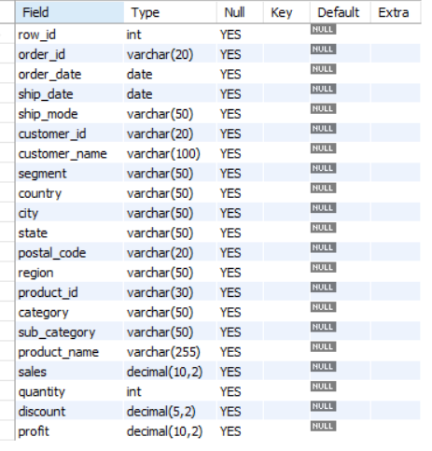

Data Import Process into MySQL Workbench:

Download Dataset

Downloaded the Superstore dataset from Kaggle in Excel format (.xlsx).

Converted Excel File to CSV
- Create Database
- CREATE DATABASE shopease_db;
USE shopease_db;

Create Table:Created the superstore table with appropriate columns and data types.

5) Import CSV File
- Opened MySQL Workbench.
- Connected to the local MySQL server.
- Selected the target schema (shopease_db).
- Launched the Table Data Import Wizard.
- Selected the superstore.csv file.
- Chose Use Existing Table ----> superstore.
- Verified column mappings.
- Clicked Next and completed the import process.

SELECT * FROM `sample - superstore` LIMIT 10;
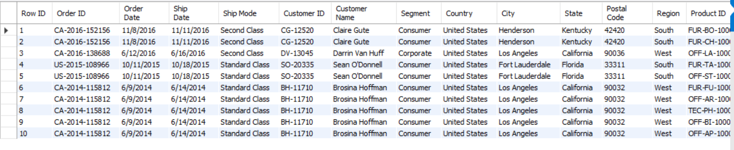

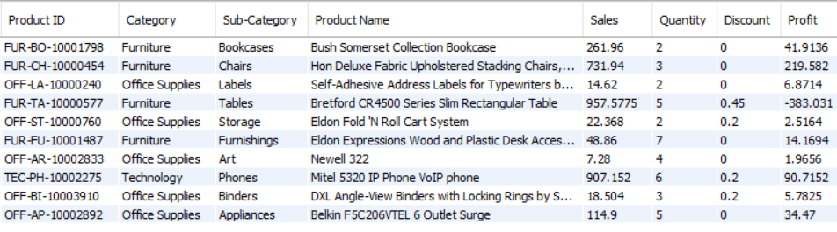

Insight
- Successfully imported the Superstore dataset into MySQL Workbench.
- Verified that all columns were mapped correctly during the import process.
- The dataset contains information related to customers, products, sales, discounts, and profits

2.Explore table (schema, sample data).
- View Table Schema

DESC `sample - superstore`;
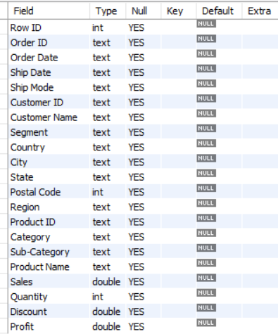

- View Sample Data

SELECT * FROM ‘sample - superstore’ LIMIT 10;



- Count Total Rows

SELECT COUNT(*) AS total_rows
FROM ‘sample - superstore’;
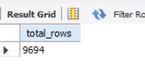

- View unique regions

SELECT DISTINCT region FROM ‘sample - superstore’;
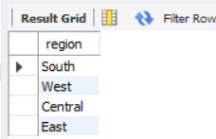

- View unique categories

SELECT DISTINCT category FROM ‘sample - superstore’;
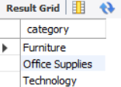

- View unique segments

SELECT DISTINCT segment FROM `sample - superstore`;
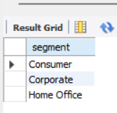

- Sample 5 rows to see the data

SELECT `Order ID`, `Order Date`, Region, Category, Sales, Quantity, Profit
FROM `sample - superstore`
LIMIT 5;
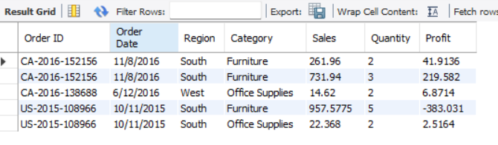

- Date range of the dataset

SELECT MIN(`Order Date`) AS Earliest_Order,
MAX(`Order Date`) AS Latest_Order
FROM `sample - superstore`;
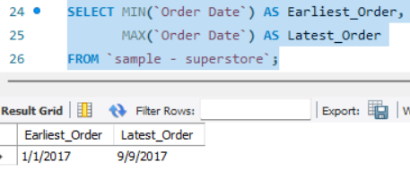

- Count of unique customers, products, and orders

SELECT COUNT(DISTINCT `Customer ID`) AS Unique_Customers,
COUNT(DISTINCT `Product ID`) AS Unique_Products,
COUNT(DISTINCT `Order ID`) AS Unique_Orders
FROM `sample - superstore`;

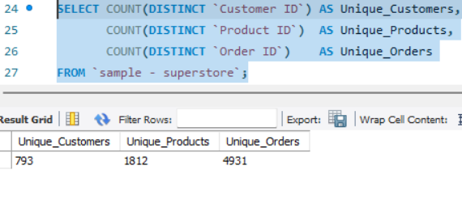
INSIGHTS
Q1 — Table Schema (DESC)
The table contains 21 columns related to orders, customers, products, sales, and profits. Checking the schema helped me understand the structure of the dataset and the data types available for analysis.
Q2 — Sample Data (SELECT * LIMIT 10)
Viewing the first few records helped me verify that the data was imported correctly. I also noticed that the same Order ID appears multiple times because a single order can contain multiple products.
Q3 — Total Number of Rows
The dataset contains 9,994 records. This gives an idea of the overall size of the dataset and confirms that the import process was completed successfully.
Q4 — Unique Regions
The data is divided into four regions: East, West, Central, and South. This will help in comparing sales and profit performance across different locations.
Q5 — Unique Categories
There are three main product categories: Technology, Furniture, and Office Supplies. These categories will be useful for analyzing sales and profit trends.
Q6 — Unique Customer Segments
The dataset contains three customer segments: Consumer, Corporate, and Home Office. This allows us to study purchasing behavior among different customer groups.
Q7 — Sample Records with Key Columns
Looking at selected columns such as Order Date, Region, Sales, Quantity, and Profit provided a quick overview of the business data. It was interesting to observe that some orders generated sales but still resulted in low or negative profit.
Q8 — Date Range of Dataset
The data covers a period from 2014 to 2017. Having multiple years of data makes it possible to analyze trends, seasonality, and year-over-year performance.
Q9 — Unique Customers, Products, and Orders
The dataset contains hundreds of customers, products, and orders. Comparing these numbers shows that many orders contain more than one product, which is common in retail transactions.

- Apply WHERE filters (region, category, date, sales).

- All orders from West region

SELECT `Order ID`, `Customer Name`, Region, Sales, Profit
FROM `sample - superstore`
WHERE Region = 'West'
LIMIT 5;

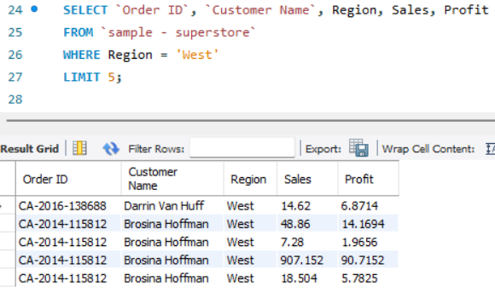

- Orders NOT from South region

SELECT `Order ID`, `Customer Name`, Region, Sales
FROM `sample - superstore`
WHERE Region != 'South'
LIMIT 5;
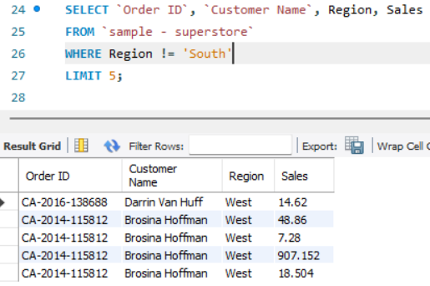

- Orders from East OR Central region

SELECT `Order ID`, `Customer Name`, Region, Sales
FROM `sample - superstore`
WHERE Region IN ('East', 'Central')
LIMIT 5;
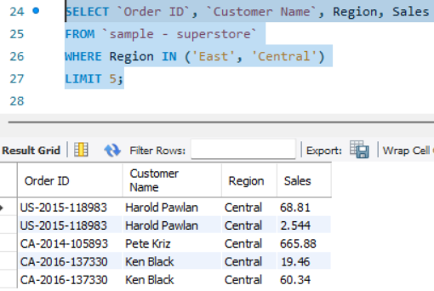

- Total sales per region filtered to only show regions with sales > 600000

SELECT Region, ROUND(SUM(Sales), 2) AS Total_Sales
FROM `sample - superstore`
GROUP BY Region
HAVING SUM(Sales) > 600000

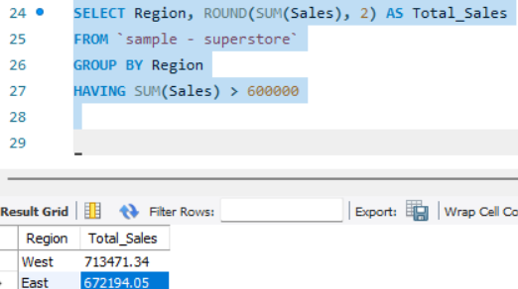

-- CATEGORY FILTERS

- All Technology orders

SELECT `Order ID`, `Customer Name`, Category, `Sub-Category`, Sales
FROM `sample - superstore`
WHERE Category = 'Technology'
LIMIT 10;
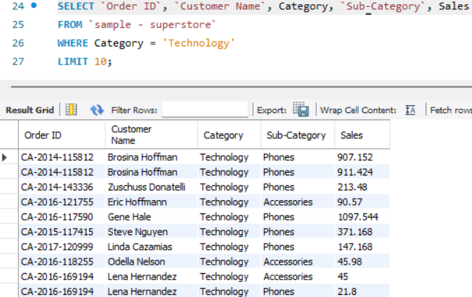

- Orders that are NOT Furniture

SELECT `Order ID`, Category, `Sub-Category`, Sales
FROM `sample - superstore`
WHERE Category != 'Furniture'
LIMIT 10;
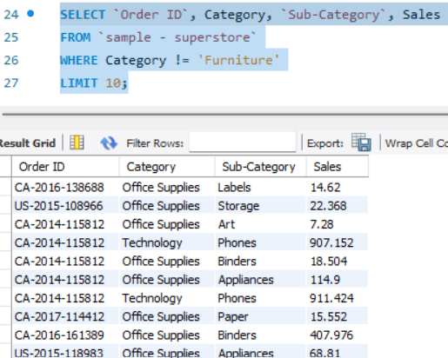

- Orders from specific Sub-Categories

SELECT `Order ID`, Category, `Sub-Category`, Sales, Profit
FROM `sample - superstore`
WHERE `Sub-Category` IN ('Phones', 'Chairs', 'Copiers')
LIMIT 10;

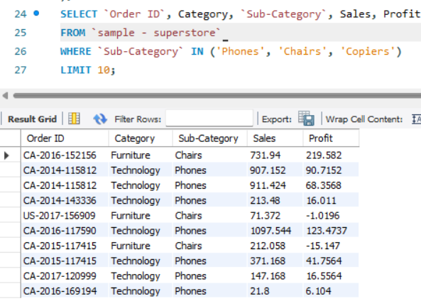

- 'High-value Technology orders (Sales > 1000)

SELECT `Order ID`, `Customer Name`, Category, `Sub-Category`, Sales
FROM `sample - superstore`
WHERE Category = 'Technology' AND Sales > 1000
LIMIT 5;

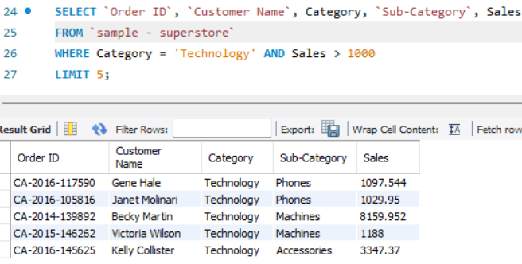

DATE FILTERS

- Orders after 2016 (recent data only)

SELECT `Order ID`, `Order Date`, Region, Category, Sales
FROM `sample - superstore`
WHERE `Order Date` > '2016-12-31'
LIMIT 5;

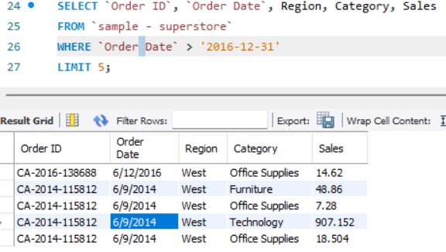

- Year-wise order count and total sales

SELECT YEAR(`Order Date`) AS Year,
COUNT(DISTINCT `Order ID`) AS Total_Orders,
ROUND(SUM(Sales), 2) AS Annual_Sales
FROM `sample - superstore`
GROUP BY YEAR(`Order Date`)
ORDER BY Year;

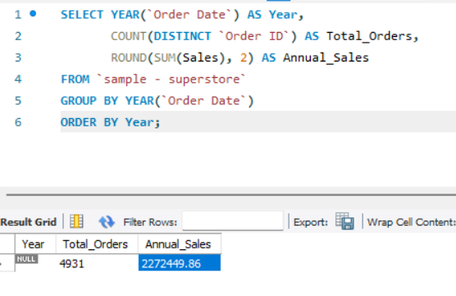
- Retrieve all orders placed during the year 2017.
SELECT `Order ID`, `Order Date`, `Customer Name`, Sales
FROM `sample - superstore`
WHERE YEAR(STR_TO_DATE(`Order Date`, '%m/%d/%Y')) = 2017
LIMIT 5;
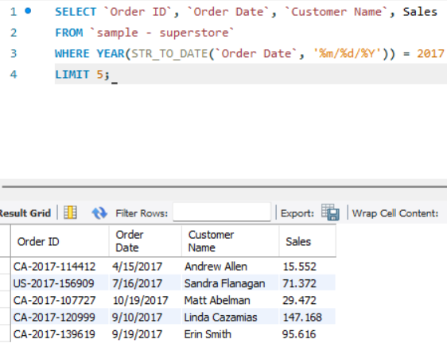

- Orders Placed in November Across All Years
SELECT `Order ID`, `Order Date`, `Customer Name`, Sales
FROM `sample - superstore`
WHERE MONTH(STR_TO_DATE(`Order Date`, '%m/%d/%Y')) = 11
LIMIT 5;

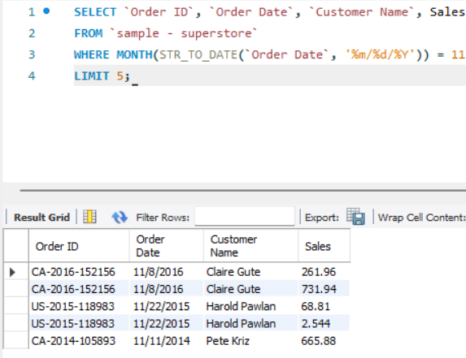
SALES

- High value orders (Sales > 500)

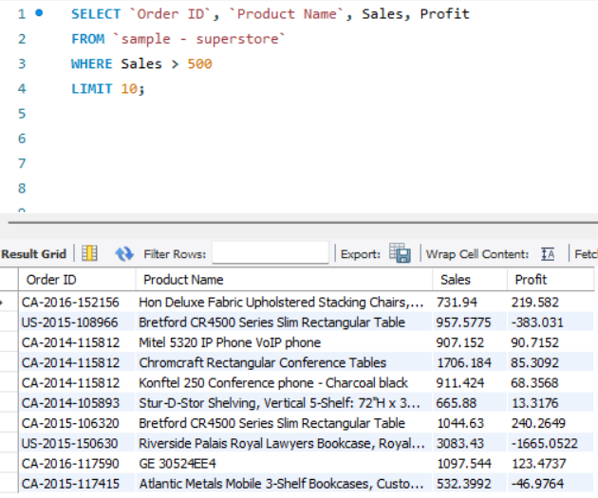

- Low value orders (Sales < 50)

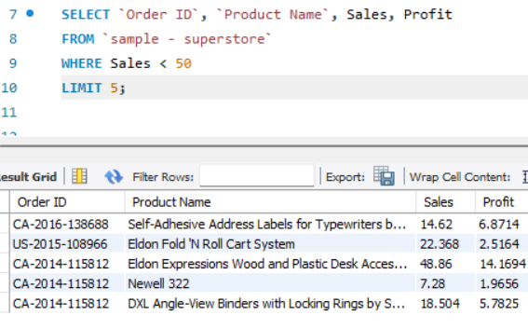

- Orders where Sales is between 200 and 1000
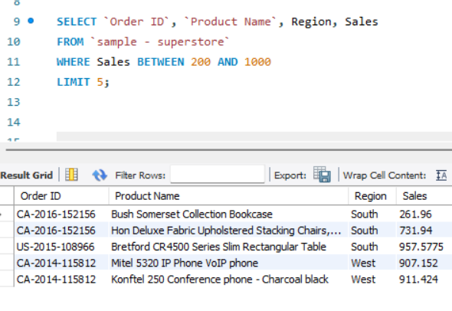

- Orders with Sales > 500 but still made a loss

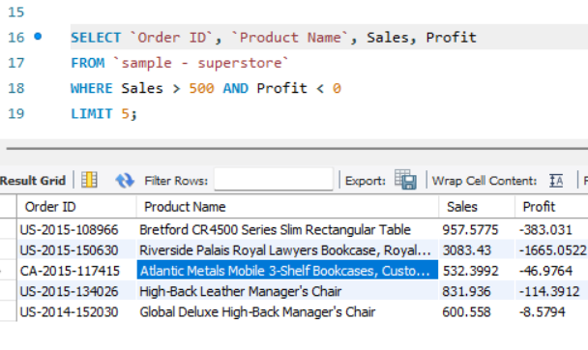

COMBINED FILTERS (Region + Category + Date + Sales)

1.West region + Technology + Sales > 500

SELECT `Order ID`, `Customer Name`, Region, Category, Sales, Profit
FROM `sample - superstore`
WHERE Region = 'West'
AND Category = 'Technology'
AND Sales > 500
LIMIT 5;
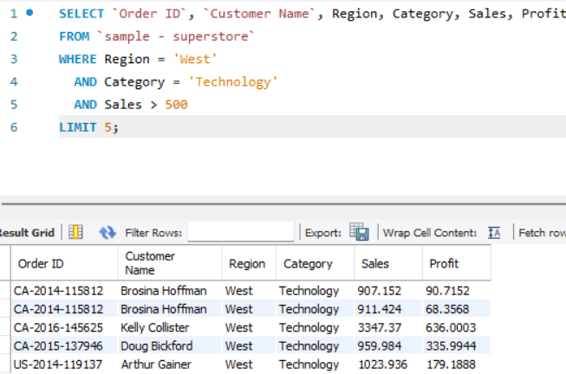

2.East region + Furniture + Year 2017

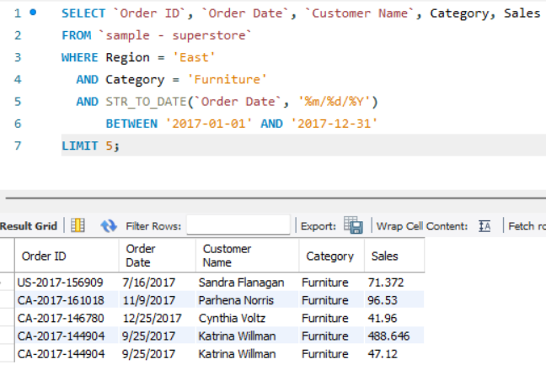

Insights
Region Filters
Q1 — West Region Orders
The West region contains a large number of orders and contributes significantly to overall sales. It appears to be one of the strongest performing regions in the dataset.
Q2 — Orders Not from South Region
This filter helps analyze orders from all regions except the South region. It provides a broader view of business performance in the remaining regions.
Q3 — Orders from East or Central Region
The East and Central regions together account for a considerable portion of sales. Combining these regions helps compare their performance with other regions.
Q4 — Regions with Sales Greater than 600000
Only a few regions meet this sales threshold, indicating that revenue is concentrated in specific geographic areas.
Category Filters
Q1 — Technology Orders
Technology products generate strong sales and are among the most valuable products in the dataset.
Q2 — Orders Not in Furniture Category
Excluding Furniture allows us to focus on Technology and Office Supplies, which show different sales and profit patterns.
Q3 — Phones, Chairs, and Copiers
These sub-categories are popular products and contribute significantly to overall sales.
Q4 — Technology Orders with Sales Greater than 1000
These represent high-value transactions and highlight premium technology purchases made by customers.
Date Filters
Q1 — Orders After 2016
The data shows continued business activity in recent years and can be used to analyze recent trends.
Q2 — Year-wise Orders and Sales
Comparing yearly sales helps understand business growth and changes in customer demand over time.
Q3 — Orders in 2017
The year 2017 contains a large number of transactions and provides useful insights into recent business performance.
Q4 — Orders in November
November appears to be an active sales month and can be useful for studying seasonal trends.
Sales Filters
Q1 — Sales Greater than 500
These are high-value orders that contribute significantly to total revenue.
Q2 — Sales Less than 50
These are low-value transactions that occur frequently but contribute less to overall revenue.
Q3 — Sales Between 200 and 1000
This range represents medium-value orders and forms an important part of daily business transactions.
Q4 — Sales Greater than 500 but Negative Profit
These orders generated good sales but resulted in losses, indicating possible pricing or discount-related issues.
Combined Filters
Q1 — West Region + Technology + Sales Greater than 500
This filter identifies high-value technology sales in the West region and highlights premium customer purchases.
Q2 — East Region + Furniture + 2017
This query helps analyze Furniture sales in the East region during 2017 and understand category performance in a specific location and time period.

4.Use GROUP BY for aggregations (sales, quantity, averages).

- Total Sales by Region

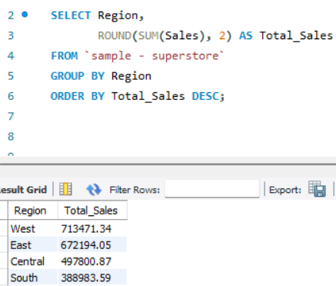

- Total Quantity sold by Category

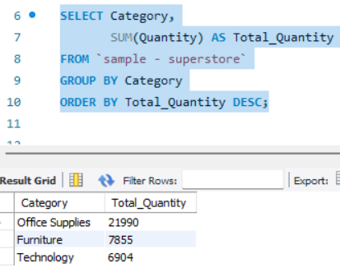

- Average Sales by Category

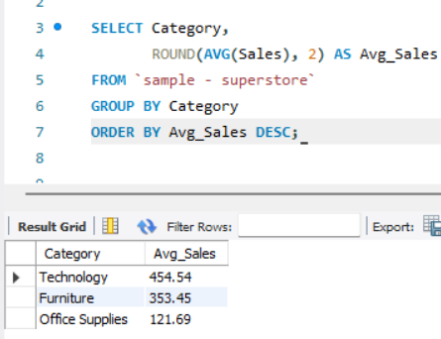

- Total Sales, Total Quantity, Average Sales by Category (combined)

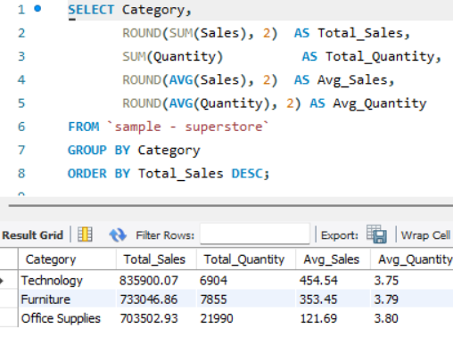

- Total Sales and Profit by Sub-Category
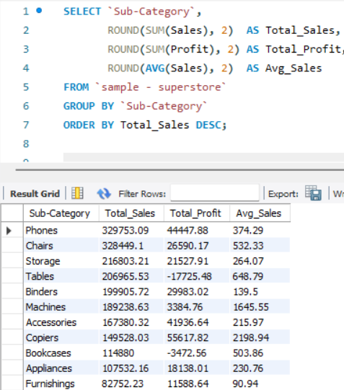

- Total Sales by Region and Category combined
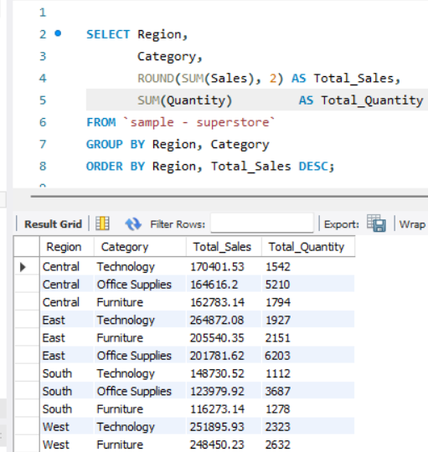
- Total Orders by State

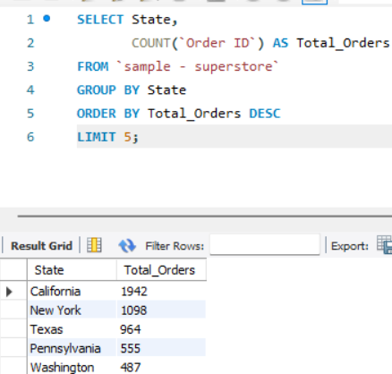

- Top Categories by Quantity Sold

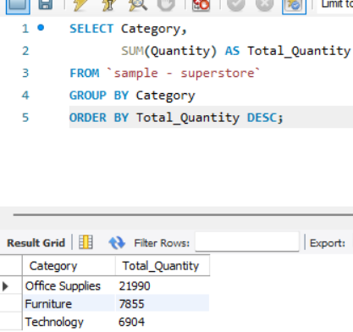
INSIGHTS
Q1 — Total Sales by Region
The sales performance varies across different regions. Some regions contribute more revenue than others, showing where the business has a stronger customer base and market presence.
Q2 — Total Quantity Sold by Category
Different product categories have different demand levels. Some categories sell more units, indicating higher customer demand and frequent purchases.
Q3 — Average Sales by Category
The average sales value differs across categories. This helps identify which categories generate higher revenue per transaction.
Q4 — Sales, Quantity, and Average Sales by Category
Looking at sales, quantity, and average sales together provides a complete view of category performance. Each category contributes differently in terms of revenue and customer demand.
Q5 — Sales and Profit by Sub-Category
Some sub-categories generate strong profits, while others contribute less despite having good sales. This analysis helps identify the most and least profitable product groups.
Q6 — Sales by Region and Category
This analysis shows how product categories perform in different regions. It helps understand regional preferences and supports better business planning.
Q7 — Total Orders by State
Order volume varies from state to state. A few states contribute a larger share of orders, making them important markets for the business.
Q8 — Top Categories by Quantity Sold
Certain categories are purchased more frequently than others. High quantity sold indicates strong customer demand and product popularity.

- Sort and limit results (top products, top categories).
- Top 10 Products by Total Sales
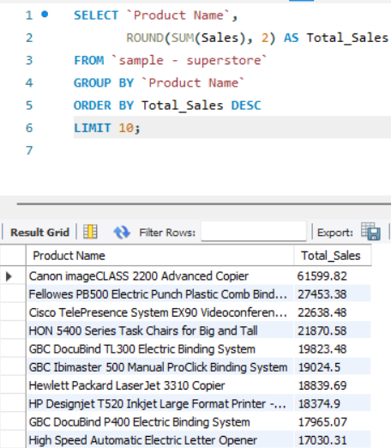

- Bottom 10 Products by Total Sales (least selling)
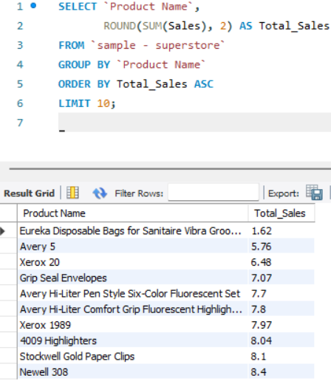
- Top 5 Categories by Total Sales
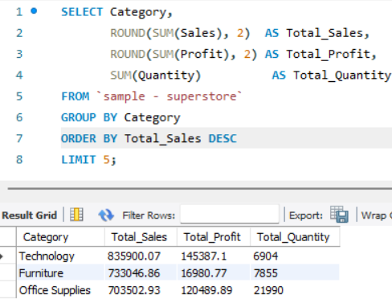

- Top 5 Sub-Categories by Total Profit
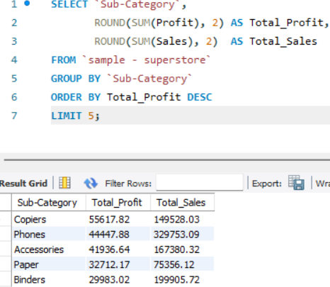

- Top 5 Loss Making Sub-Categories

SELECT `Sub-Category`,
ROUND(SUM(Profit), 2) AS Total_Profit,
ROUND(SUM(Sales), 2) AS Total_Sales
FROM `sample - superstore`
GROUP BY `Sub-Category`
ORDER BY Total_Profit ASC
LIMIT 5;
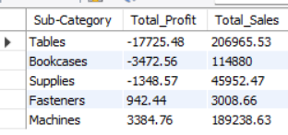

- Top 5 States by Total Sales

SELECT State,
Region,
ROUND(SUM(Sales), 2) AS Total_Sales,
ROUND(SUM(Profit), 2) AS Total_Profit
FROM `sample - superstore`
GROUP BY State, Region
ORDER BY Total_Sales DESC
LIMIT 5;
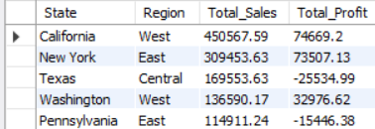

- Top 5 Most Ordered Products by Quantity

SELECT `Product Name`,
Category,
`Sub-Category`,
SUM(Quantity) AS Total_Quantity,
ROUND(SUM(Sales), 2) AS Total_Sales
FROM `sample - superstore`
GROUP BY `Product Name`, Category, `Sub-Category`
ORDER BY Total_Quantity DESC
LIMIT 10;

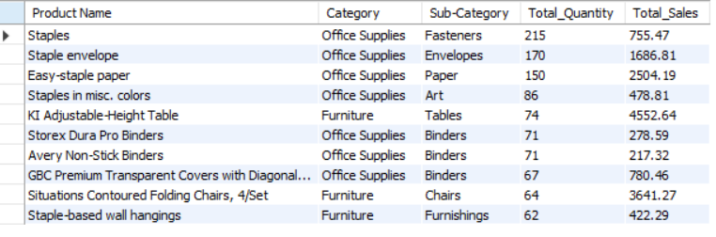

INSIGHTS

Q1 — Top 10 Products by Sales
The top-selling products contribute a significant portion of the overall revenue. These products are popular among customers and play an important role in business performance.
Q2 — Bottom 10 Products by Sales
These products have the lowest sales contribution. Although they generate less revenue, they may still be useful for completing customer purchases or serving niche requirements.
Q3 — Top 5 Categories by Sales
Some categories generate much higher sales than others. This helps identify which product categories are most important for revenue generation.
Q4 — Top 5 Sub-Categories by Profit
These sub-categories contribute the highest profits to the business. They are strong performers and can be considered key areas for growth.
Q5 — Top 5 Loss-Making Sub-Categories
Certain sub-categories show negative profits despite generating sales. This indicates potential issues related to pricing, discounts, or operational costs.
Q6 — Top 5 States by Sales
A few states contribute a large share of total sales. These locations represent important markets and have a strong customer base.
Q7 — Top Products by Quantity Sold
These products are purchased most frequently by customers. High demand for these items suggests they are essential products and play a major role in order volume.

- Solve use cases (monthly trends, top customers, duplicates)

- Analyze monthly sales performance over time
SELECT YEAR(`Order Date`) AS Year,
MONTH(`Order Date`) AS Month,
ROUND(SUM(Sales),2) AS Monthly_Sales,
ROUND(AVG(Sales),2) AS Avg_Sale,
COUNT(DISTINCT `Order ID`) AS Total_Orders
FROM `sample - superstore`
GROUP BY YEAR(`Order Date`), MONTH(`Order Date`)
ORDER BY Year, Month;
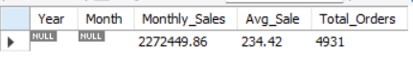

- View monthly sales in YYYY-MM format

SELECT DATE_FORMAT(`Order Date`, '%Y-%m') AS Month,
ROUND(SUM(Sales),2) AS Monthly_Sales,
COUNT(DISTINCT `Order ID`) AS Total_Orders
FROM `sample - superstore`
GROUP BY DATE_FORMAT(`Order Date`, '%Y-%m')
ORDER BY Month;

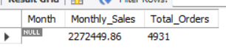

- Find the highest sales month in each year

SELECT Year, Month, Monthly_Sales
FROM (
SELECT YEAR(`Order Date`) AS Year,
MONTH(`Order Date`) AS Month,
ROUND(SUM(Sales),2) AS Monthly_Sales,
RANK() OVER (
PARTITION BY YEAR(`Order Date`)
ORDER BY SUM(Sales) DESC
) AS rank
FROM `sample - superstore`
GROUP BY YEAR(`Order Date`), MONTH(`Order Date`)
) ranked
WHERE rank = 1
ORDER BY Year;

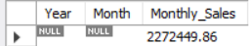

- Duplicate Order IDs

SELECT `Order ID`,
COUNT(*) AS Count_Of_Records
FROM `sample - superstore`
GROUP BY `Order ID`
HAVING COUNT(*) > 1
LIMIT 5;
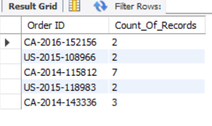

- Duplicate Customer Orders

SELECT `Customer Name`,
`Order ID`,
COUNT(*) AS Duplicate_Count
FROM `sample - superstore`
GROUP BY `Customer Name`, `Order ID`
HAVING COUNT(*) > 1
LIMIT 5;
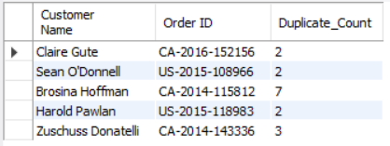

Customer with Maximum Orders
SELECT `Customer Name`,
COUNT(DISTINCT `Order ID`) AS Total_Orders
FROM `sample - superstore`
GROUP BY `Customer Name`
ORDER BY Total_Orders DESC
LIMIT 10;

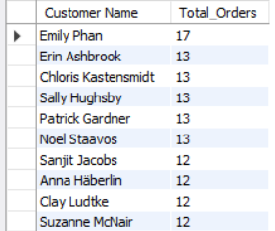

- Customers who ordered more than 10 times (loyal customers)

SELECT `Customer Name`,
`Customer ID`,
Segment,
COUNT(DISTINCT `Order ID`) AS Total_Orders,
ROUND(SUM(Sales), 2) AS Total_Sales
FROM `sample - superstore`
GROUP BY `Customer Name`, `Customer ID`, Segment
HAVING COUNT(DISTINCT `Order ID`) > 10
ORDER BY Total_Orders DESC
LIMIT 10;

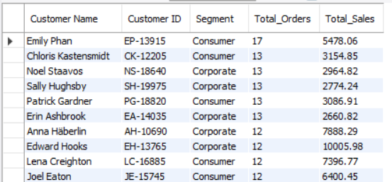

- Quarterly Sales Trend across all years

SELECT YEAR(`Order Date`) AS Year,
QUARTER(`Order Date`) AS Quarter,
ROUND(SUM(Sales), 2) AS Quarterly_Sales,
SUM(Quantity) AS Total_Quantity,
COUNT(DISTINCT `Order ID`) AS Total_Orders
FROM `sample - superstore`
GROUP BY YEAR(`Order Date`), QUARTER(`Order Date`)
ORDER BY Year, Quarter;

- Month with highest number of unique customers (peak engagement)

SELECT DATE_FORMAT(`Order Date`, '%Y-%m') AS Month,
COUNT(DISTINCT `Customer ID`) AS Unique_Customers,
COUNT(DISTINCT `Order ID`) AS Unique_Orders,
ROUND(SUM(Sales), 2) AS Total_Sales
FROM `sample - superstore`
GROUP BY DATE_FORMAT(`Order Date`, '%Y-%m')
ORDER BY Unique_Customers DESC
LIMIT 10;

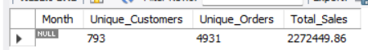

INSIGHTS
Q1 — Monthly Sales Trend
The monthly sales trend shows that sales vary throughout the year. Some months perform better than others, indicating seasonal patterns in customer purchasing behavior.
Q2 — Monthly Sales in YYYY-MM Format
Viewing sales month-wise provides a clearer picture of how revenue changes over time. It helps identify periods of high and low business activity.
Q3 — Best Month of Each Year
Every year has certain months that perform better than others in terms of sales. Identifying these months can help in planning future promotions and marketing campaigns.
Q4 — Duplicate Order IDs
Some Order IDs appear multiple times because a single order may contain multiple products. This is expected in transactional datasets and does not indicate duplicate records.
Q5 — Duplicate Customer Orders
Customers can place orders containing multiple items, which results in multiple rows for the same order. This reflects the structure of the data rather than a data quality issue.
Q6 — Customers with Maximum Orders
A small group of customers places orders more frequently than others. These customers contribute significantly to business activity and are important for customer retention.
Q7 — Loyal Customers (More Than 10 Orders)
Customers who place repeat orders show strong engagement with the business. Maintaining good relationships with these customers can help drive consistent sales.
Q8 — Quarterly Sales Trend
Sales performance differs across quarters. Quarterly analysis provides a broader view of business trends and helps identify stronger and weaker periods during the year.
Q9 — Month with Highest Customer Activity
Some months attract more customers and orders than others. These periods are important for understanding customer demand and planning business strategies accordingly.

7: Validate Results (Row Counts & Data Quality)

- Total Row Count

SELECT COUNT(*) AS Total_Rows
FROM `sample - superstore`;
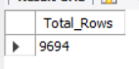

- Check for Negative or Zero Sales (invalid transactions)

SELECT COUNT(*) AS Invalid_Sales_Rows
FROM `sample - superstore`
WHERE Sales <= 0;

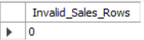

- Check for Negative Quantity (impossible value)

SELECT COUNT(*) AS Negative_Quantity_Rows
FROM `sample - superstore`
WHERE Quantity <= 0;

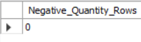

- Loss-Making Orders (Profit < 0)

SELECT COUNT(*) AS Loss_Orders,
ROUND(SUM(Profit), 2) AS Total_Loss,
ROUND(AVG(Profit), 2) AS Avg_Loss_Per_Order
FROM `sample - superstore`
WHERE Profit < 0;

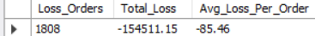

- Basic Stats Validation on Numeric Columns

SELECT
ROUND(MIN(Sales), 2) AS Min_Sales,
ROUND(MAX(Sales), 2) AS Max_Sales,
ROUND(AVG(Sales), 2) AS Avg_Sales,
ROUND(MIN(Profit), 2) AS Min_Profit,
ROUND(MAX(Profit), 2) AS Max_Profit,
ROUND(AVG(Profit), 2) AS Avg_Profit,
MIN(Quantity) AS Min_Quantity,
MAX(Quantity) AS Max_Quantity,
ROUND(MIN(Discount), 2) AS Min_Discount,
ROUND(MAX(Discount), 2) AS Max_Discount
FROM `sample - superstore`;

- Category and Region Coverage Check (are all combos present?)

SELECT Region,
Category,
COUNT(*) AS Row_Count,
ROUND(SUM(Sales), 2) AS Total_Sales
FROM `sample - superstore`
GROUP BY Region, Category
ORDER BY Region, Category
LIMIT 10;

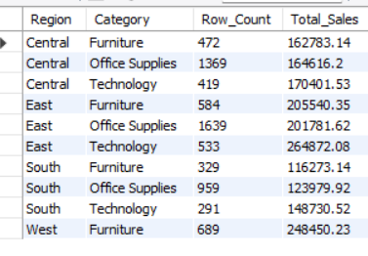

INSIGHTS
Q1 — Total Row Count
The row count confirms that the dataset was imported successfully. It also serves as a reference point for validating future queries and filters.
Q2 — Check for Negative or Zero Sales
No invalid sales values were found. This indicates that all transactions have meaningful sales amounts and can be used for analysis.
Q3 — Check for Negative Quantity
The quantity values are valid and represent actual product purchases. No impossible quantity values were detected.
Q4 — Loss-Making Orders
Some orders generated negative profit despite recording sales. This suggests that discounts, shipping costs, or pricing decisions may have affected profitability.
Q5 — Basic Statistics Validation
Reviewing the minimum, maximum, and average values helped verify that sales, profit, quantity, and discount values fall within reasonable ranges. This confirms that the dataset is suitable for analysis.
Q6 — Category and Region Coverage Check
All major regions and product categories are represented in the dataset. This ensures that the analysis covers the complete business and provides a balanced view of performance across different areas.

