1. **Summary of the project**: This section describes the project and its major objectives;

We worked hard together to finish this project, so we did our best to include all the requirements of this project. Firstly, if you open our website, you will face a login form with the colours blue and purple. In addition, you have to authenticate with a username and password, so you need to entre “**user1**” as user and “**passAdmin01#**” as password and press “Log in” in order to go to the questionnaire otherwise it will show an error. In the questionnaire, you have to fill your name and answer all the questions, because if you do not fill all fields, you will see the message “Please Fill All Required Field”. After filling the questionnaire form, you have to press submit in order to see you results. The results will be as pages with your color.

1. **Team and Tasks Breakdown**: This section presents the team members and the tasks achieved by each of them; Our team members are Tejvir, Roger and Mohamad Nour AL Shaar.

**Tejvir:** Created the login page and validated it. Linking all the pages together.

**Roger:** Validated the form. Created two result pages. CSS components.

**Mohamad Nour:** Validated the form. Created two other result pages. CSS components.

We cannot say that one or the other did more because we helped each other in all aspects in all the parts. Every time we worked on project, we created a room and worked together. Hence, everyone contributed equally in gathering information and applying it.

1. **Environment and Technical specifications**: This section gives details on the programming languages and all the tools used.

We used HTML and CSS to do the design and the interface. Firstly, in the login form and questionnaire form we used HTML and CSS to describe the appearance of web page such as the username and password and the colours, size, margin and adding background image.

We used JavaScript for Validation of the fields and the results.

1. **Major components**: this section lists the major components you created (files and web components) for developing the project and indicates their purpose and any particular specifications about them.

We created a form for the login page. And same for the questionnaire. In addition to it, we used CSS, javascript and several images to make our project more attractive.

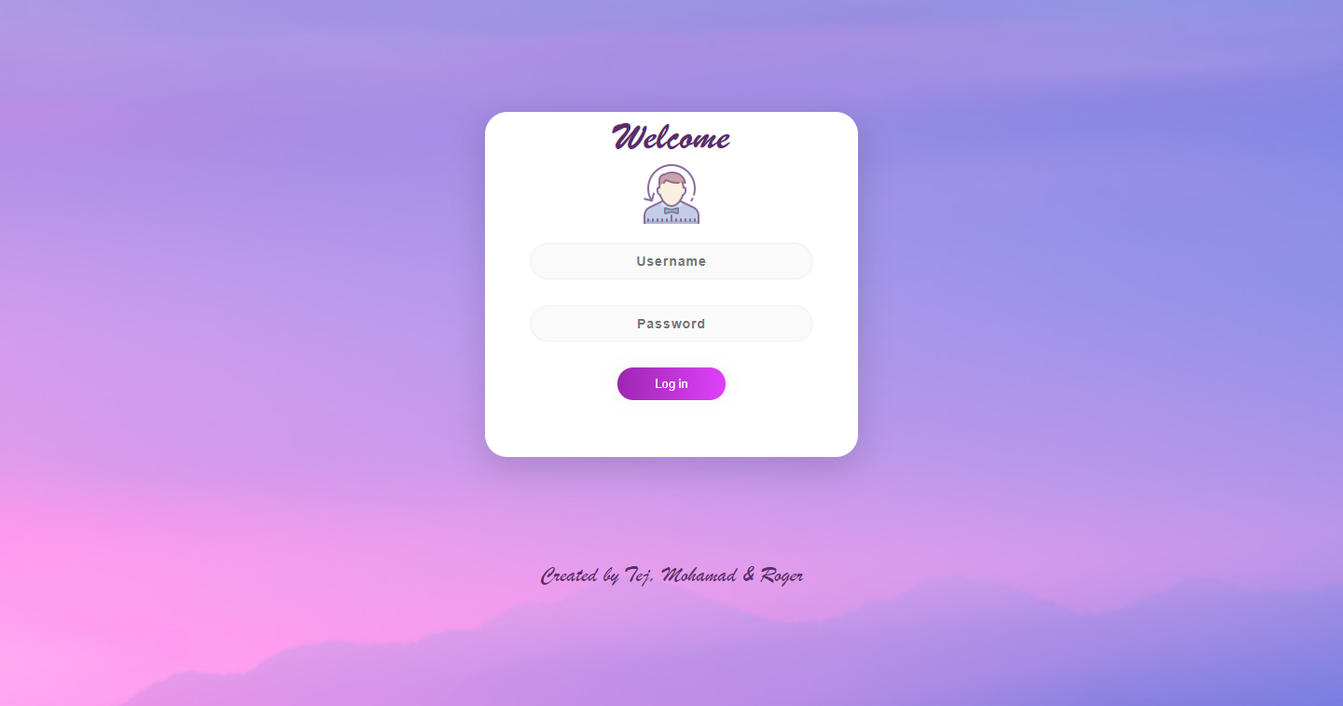

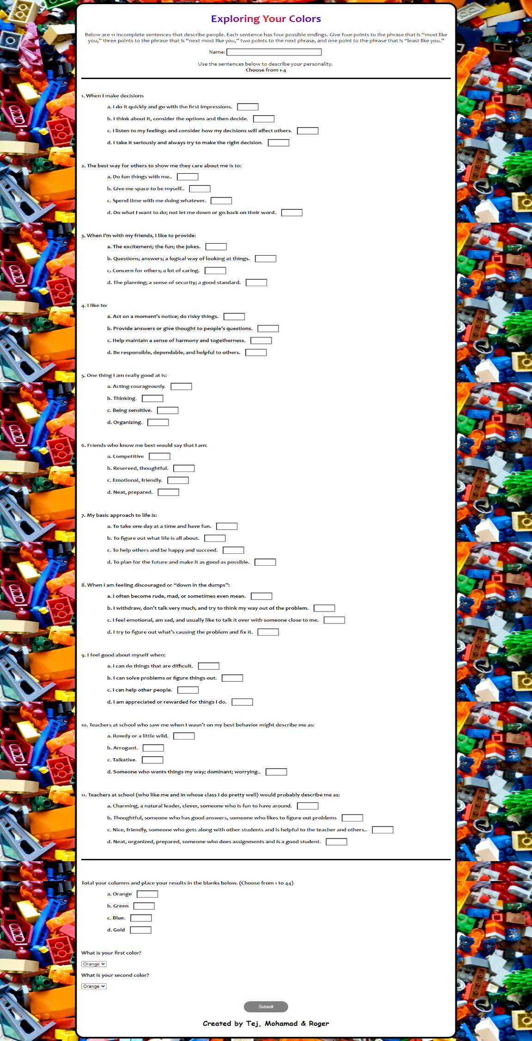

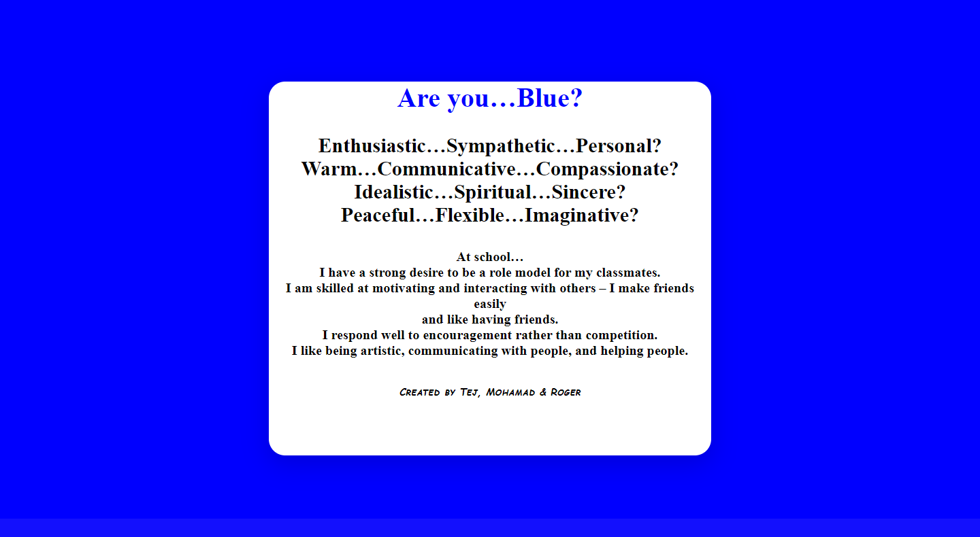

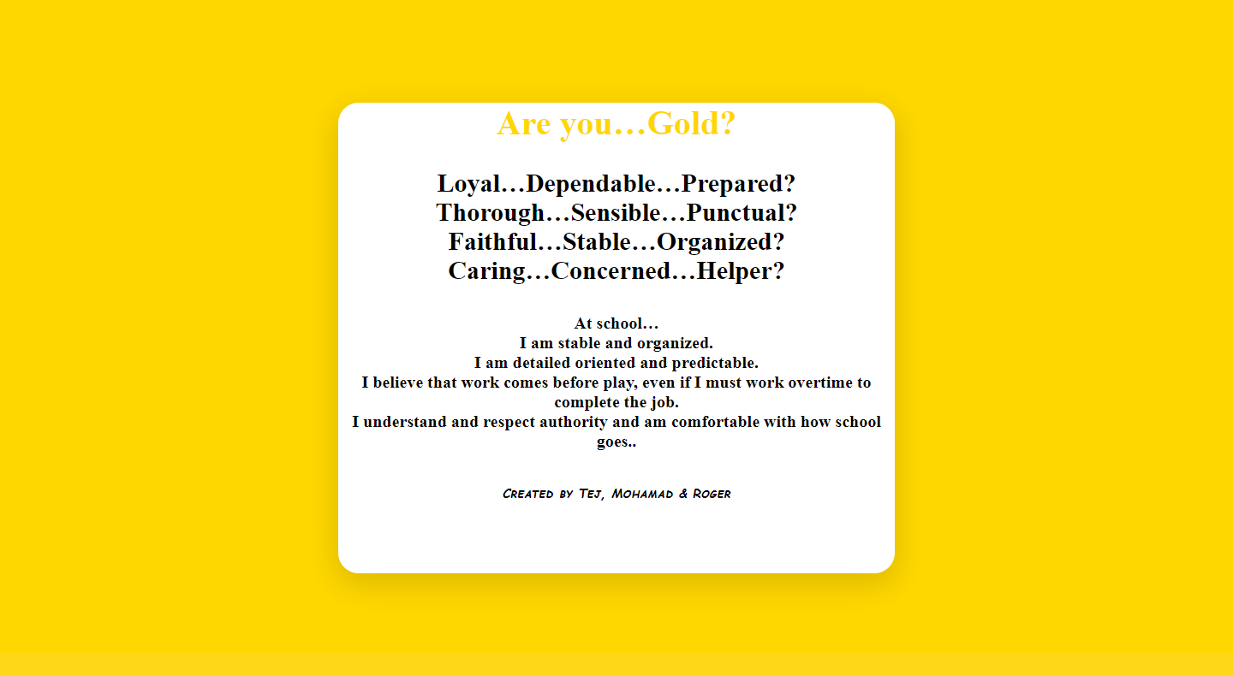

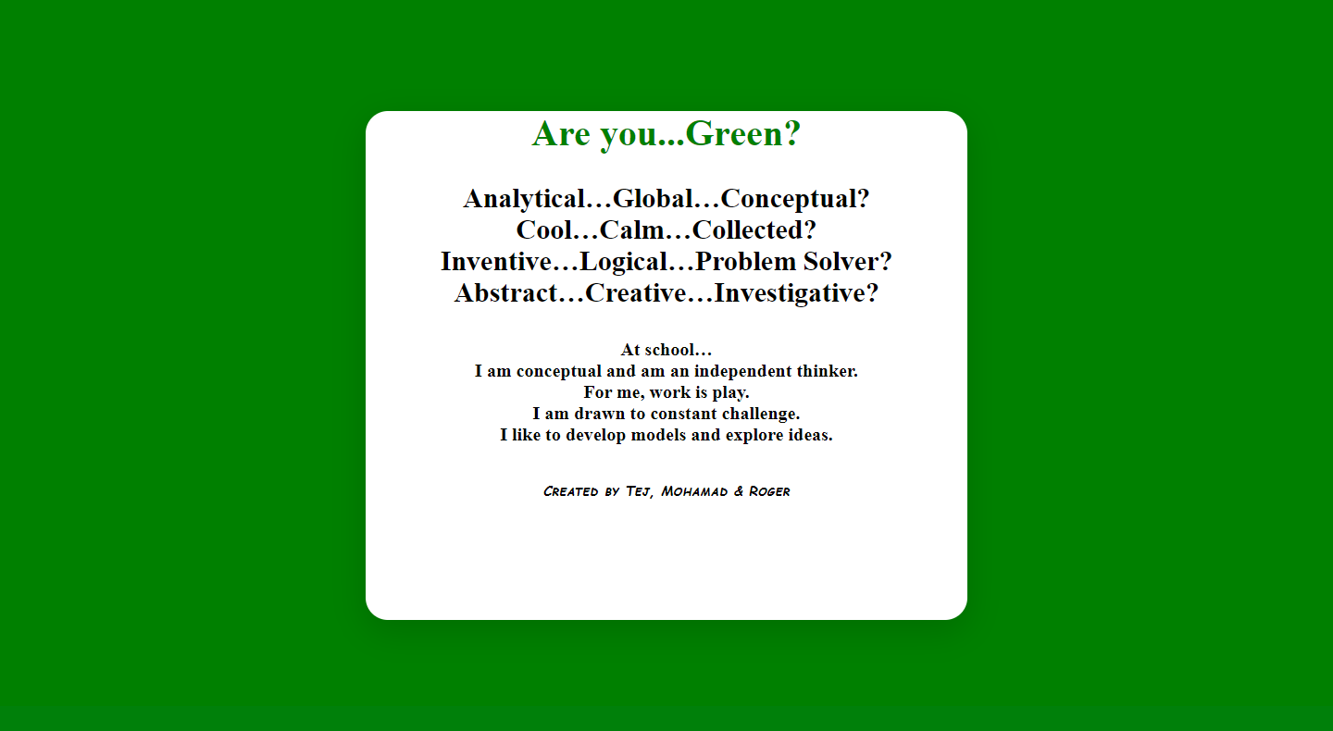

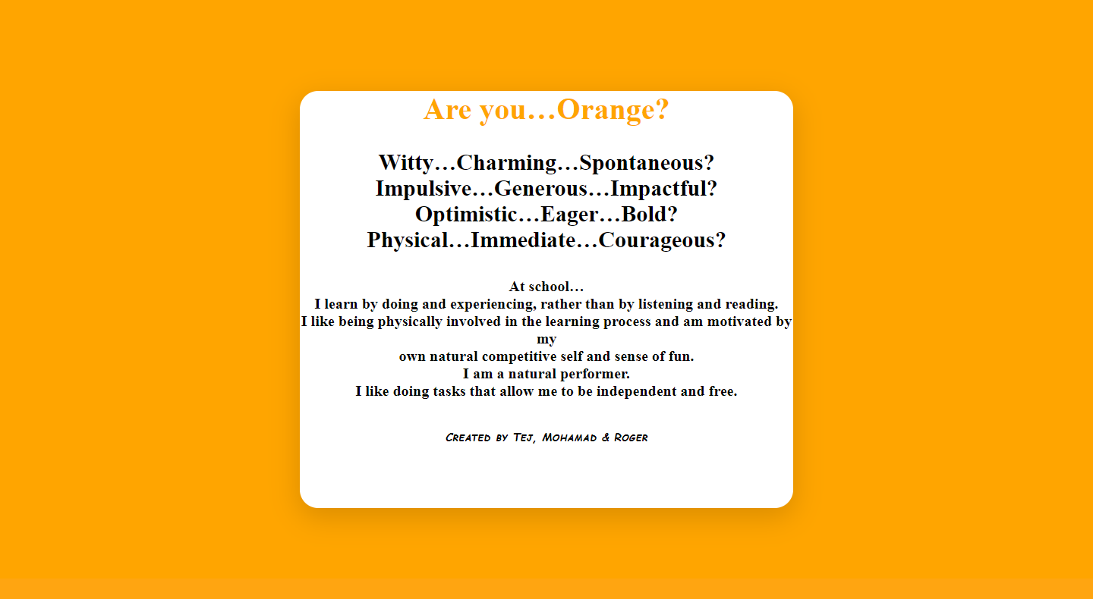

1. **Functional test:** this section summarizes the functional tests achieved to make sure the application is working as expected;

We planed our website before we created it, so that our website works as we expected.

Everything works perfectly well. Login page displays errors depending on if u leave the fields empty or if you input wrong user information until the selected username and password are entered.

Questionnaire works perfectly and returns error if any of the fields are not filled. Result is displayed depending upon the total points.

1. **Feedback:** this section indicates what you learn more via the development of this project that was not covered in the class.

We learned how to use the HTML, CSS and JavaScript together.

We learned to use JQuery.

We learned how to validate several forms with JavaScript.

We learned how display the results of the form by using JavaScript.

Along with it, we learned about various more components of javascript.

1. **References:** this section indicates all references – books, articles or webpages – you read to create your project document and achieved the development tasks, when applicable.

We used the book that was provided by the teacher.

[www.unsplash.com](http://www.unsplash.com) to take some pictures.

[www.w3schools.com](http://www.w3schools.com) for learning more about JavaScript and JQuery.