ASSESSING THE FEASIBILITY OF LOCAL TARPS AS ADDITIONAL POST-CALIBRATION TARGETS FOR FIELD NDVI TIMESERIES

A Project Report
Presented to the Faculty of the Graduate School
of Cornell University
in Partial Fulfillment of the Requirements for the Degree of
Master of Professional Studies in Integrative Plant Science (Geospatial Applications)

by
Omkar Dnyaneshwar Tekawade
August 2025

© 2025 Omkar Dnyaneshwar Tekawade

ACKNOWLEDGMENTS

I sincerely thank Dr. Louis Longchamps for his guidance and supervision throughout this project. I am grateful to Alexander Yore, Extension Associate, as well as PhD students Phillip Lanza and Katie Rorhbough, and Postdoctoral Researcher Abdelkrim Lachgar, for their valuable technical support, insightful discussions, and assistance with data analysis. I also wish to acknowledge the contributions of seasonal interns Noah Bauser, Charles Boyd, and Brenden Shek for their dedication in field data collection and maintenance of experimental plots.

ABSTRACT
The Normalized Difference Vegetation Index (NDVI) is a widely used indicator of vegetation vigor, yet its reliability in agricultural time series is limited by atmospheric and radiometric inconsistencies. This study evaluates two local correction methods using pseudo-invariant reference tarps to reduce noise in Planet Scope NDVI measurements for maize fields in Ithaca, New York during the 2023 growing season. The first approach, the Satellite Tarp Residual Method, applied residuals from linear regressions of satellite-derived tarp NDVI to adjust field NDVI. The second approach, the Spectral–Satellite Tarp Correction, predicted spectral tarp NDVI for satellite acquisition dates via linear models, computed correction terms, and applied them to field NDVI. Validation against spectral ground-truth NDVI from Elementary Measurement Areas (EMAs) employed Dynamic Time Warping (DTW) to assess temporal profile similarity. Results indicate that the Satellite Tarp Residual Method provided the smallest DTW distance (0.6064) compared to the uncorrected NDVI (0.6091), with the best performance achieved by subtracting red tarp residuals. The Spectral–Satellite Tarp Correction yielded minimal improvement and, in some cases, degraded temporal agreement due to interpolation errors. Findings suggest that temporally coincident satellite-based reference measurements offer more effective short-term corrections than predicted spectral values when spectral data are temporally sparse. Future work should integrate satellite temporal coverage with spectral spectral precision through hybrid or non-linear correction frameworks to improve NDVI time series reliability for precision agriculture.
Keywords: NDVI, radiometric correction, pseudo-invariant targets, reference tarps, Planet Scope, spectral, Dynamic Time Warping (DTW), precision agriculture, time series alignment,

INTRODUCTION
The Normalized Difference Vegetation Index (NDVI) is a widely used vegetation index derived from the red (620–750 nm) and near-infrared (NIR) (750–900 nm) spectral bands. NDVI has become the most common vegetation index worldwide because it provides a reliable, quantitative measure of vegetation vigor and density. With increasing global demand for food and the growing impacts of climate variability, tools like NDVI play a critical role in enabling sustainable agriculture by supporting efficient resource management, yield prediction, and early stress detection at scale.
NDVI is a key indicator of crop health and growth. On large farms, it is impractical to take manual measurements or rely solely on visual inspection to detect nutrient deficiencies, pest damage, or other stress factors. By providing frequent, spatially comprehensive insights into vegetation vigor, remote sensing offers scalable opportunities to better understand the spatial and temporal variability of crops, enabling more informed and timely management decisions. Remote sensing satellites, such as those operated by Planet Labs PBC, can achieve temporal resolutions of up to one image per day, enabling the creation of dynamic NDVI time series. These time series provide valuable insights into plant growth patterns and help identify early signs of stress, allowing for timely interventions. However, while NDVI is effective, it is also susceptible to limitations such as sensitivity to soil background reflectance, saturation in dense vegetation canopies, and variability across sensors.
NDVI measurements are further affected by atmospheric and radiometric conditions, which can lead to misleading signals about crop health (Huang et al., 2021). Even though atmospheric correction algorithms are applied to satellite data, these corrections are typically global and may not fully capture local atmospheric conditions at the time of image acquisition (Fan & Liu, 2016). As a result, NDVI fluctuations may sometimes be due to environmental noise rather than true changes in vegetation (Hird, 2008).
This project addresses the gap in local radiometric correction of NDVI time series for agriculture. The approach involves placing inexpensive tarps—assumed to be pseudo-invariant surfaces—within the field. The NDVI of these tarps is expected to remain constant; therefore, any variation detected in satellite imagery is interpreted as error introduced by atmospheric or radiometric inconsistencies. Unlike purely algorithmic corrections, this pseudo-invariant surface method provides a low-cost, in-situ calibration reference that reflects local atmospheric and illumination conditions, enabling higher precision in time series analysis. This study hypothesizes that local radiometric correction of NDVI using pseudo-invariant tarp references will significantly reduce noise in satellite-derived NDVI time series and improve agreement with spectral ground-truth measurements. If successful, this method could enhance the accuracy of crop monitoring systems, inform precision agriculture decisions, and be scaled to diverse agricultural contexts worldwide.

MATERIALS AND METHODS

2.1 Study Site
The experiment was conducted during the 2023 growing season in Ithaca, New York. Two artificial tarps—one red and one white—were deployed adjacent to the field to serve as pseudo-invariant reference surfaces for radiometric correction.

2.2 Experimental Design
The experimental field weas located in Ithaca, NY, and encompassed approximately 0.8 ha. Field was moldboard plowed to a depth of 20 cm and cultivated several days prior to planting. Maize (Pioneer 9492AM) was planted at a density of 74,000 plants ha⁻¹. The experimental field was subdivided into 3 × 3 m Elementary Measurement Areas (EMAs), grid-registered to match the geospatial pixel raster of the Planet satellite network. EMAs were evenly distributed across the field, with 9 in each half, totaling 18 EMAs per year. Corner locations of each EMA were marked with flags using a real-time kinematic (RTK) GPS for repeated measurements throughout the season. Weeds were controlled using glyphosate applied 2–3 weeks after planting.

2.3 Crop Spectral Measurement and Vegetation Index Calculation
Throughout the growing season, spectral reflectance was measured above the canopy of each EMA. In Ithaca, this was performed manually using an ASD Hand Held 2 spectroradiometer (Malvern Panalytical, Malvern, UK). The spectroradiometer was mounted to a custom boom with a trigger to hold the device’s aperture nadir and centered above the EMA at a height of approximately 4.5 m, ensuring clearance above the canopy throughout the season. For each EMA and for each tarp on every measurement date, 10 consecutive readings were taken and averaged. The full averaged spectrum (325–1075 nm, 1 nm resolution) was then divided into spectral bands corresponding to the Planet PSB.SD instrument (Table 1). Each band’s reflectance was calculated by averaging all wavelengths within its full-width half-maximum (FWHM) range.
The Normalized Difference Vegetation Index (NDVI) was calculated as:
$$NDVI =\frac{ NIR - Red}{NIR + Red}$$
Table 1. Planet PSB.SD spectral bands
Band | Coastal Blue | Blue | Green I | Green | Yellow | Red | Red Edge | NIR
Wavelength (nm) | 443 | 490 | 531 | 565 | 610 | 665 | 705 | 865
FWHM (nm) | 20 | 50 | 36 | 36 | 20 | 31 | 15 | 40

2.4 Satellite Remote Sensing Data
PlanetScope PSB.SD satellite imagery was downloaded from Planet Labs for each measurement date. For every dataset, reflectance values and NDVI were extracted for both the EMAs and the tarp locations using the same band definitions and NDVI calculation as for the ground-based measurements.

2.5 Spectral Ground Truth
The spectral measurements collected using the ASD HandHeld 2 served as the ground truth for validating and calibrating the satellite-derived NDVI time series. Both EMA and tarp NDVI values were obtained from these spectral measurements, allowing for direct comparison to PlanetScope-derived values. The tarp NDVI was used to estimate local atmospheric and radiometric effects, which were then applied as corrections to the EMA NDVI time series.

2.6 Data Processing and Correction Workflow
The data processing and correction procedure was conducted in five major stages:
1. Data Acquisition
Spectral ground-truth measurements were collected using an ASD HandHeld 2 spectroradiometer for all experimental measurement areas (EMAs) and both reference tarps (red and white) on each measurement date during the 2023 growing season. PlanetScope PSB.SD satellite imagery was acquired for the corresponding dates, and spectral reflectance values were extracted for both EMAs and tarps from atmospherically corrected surface reflectance products.
2. Spectral Band Conversion
The spectral measurements, covering the range of 325–1075 nm, were resampled to match the spectral band definitions of the Planet PSB.SD sensor. For each Planet band, reflectance was computed as the mean value of all wavelengths within its full-width half-maximum (FWHM) range to ensure comparability between spectral and satellite datasets.
3. Local Radiometric Correction Using Satellite Tarp Residuals
The NDVI time series of the red and white tarps, derived from satellite imagery only, was modelled as a function of days after planting (DAP) using Ordinary Least Squares (OLS) regression:
NDVI ₍_{satellite, tarp}₎ (t) = β₀ + β₁ × DAP(t) + ε(t)
Figure 1. shows the OLS regression for the red and white tarps.
Residuals from these models were calculated as:
$$Residual_{\left(satellite,tarp\right)}\left(t\right)=NDVI_{\left(satellite,tarp\right)}\left(t\right)-\hat{NDVI_{\left(satellite,tarp\right)}}\left(t\right)$$
Figure 2. shows the regression residuals for the for the Red, NIR bands and NDVI of red and white tarps
These residuals represent short-term atmospheric or radiometric deviations from the expected tarp NDVI trend. The residuals were then added to and subtracted from the satellite-derived NDVI for pixel 6 (field location) to produce two corrected NDVI series for each tarp.

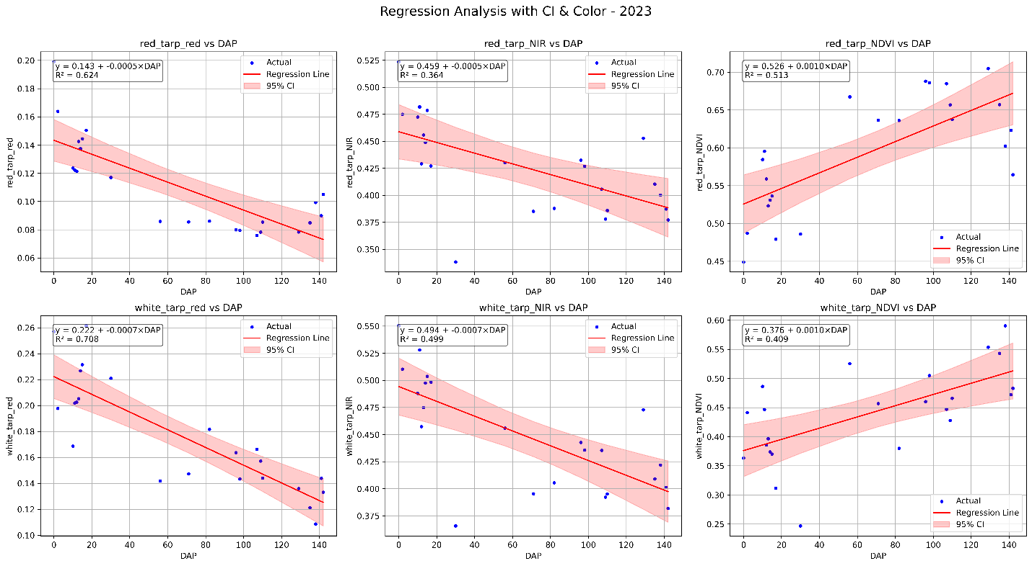
Figure.1. OLS regression for the Red, NIR bands and NDVI of red and white tarps
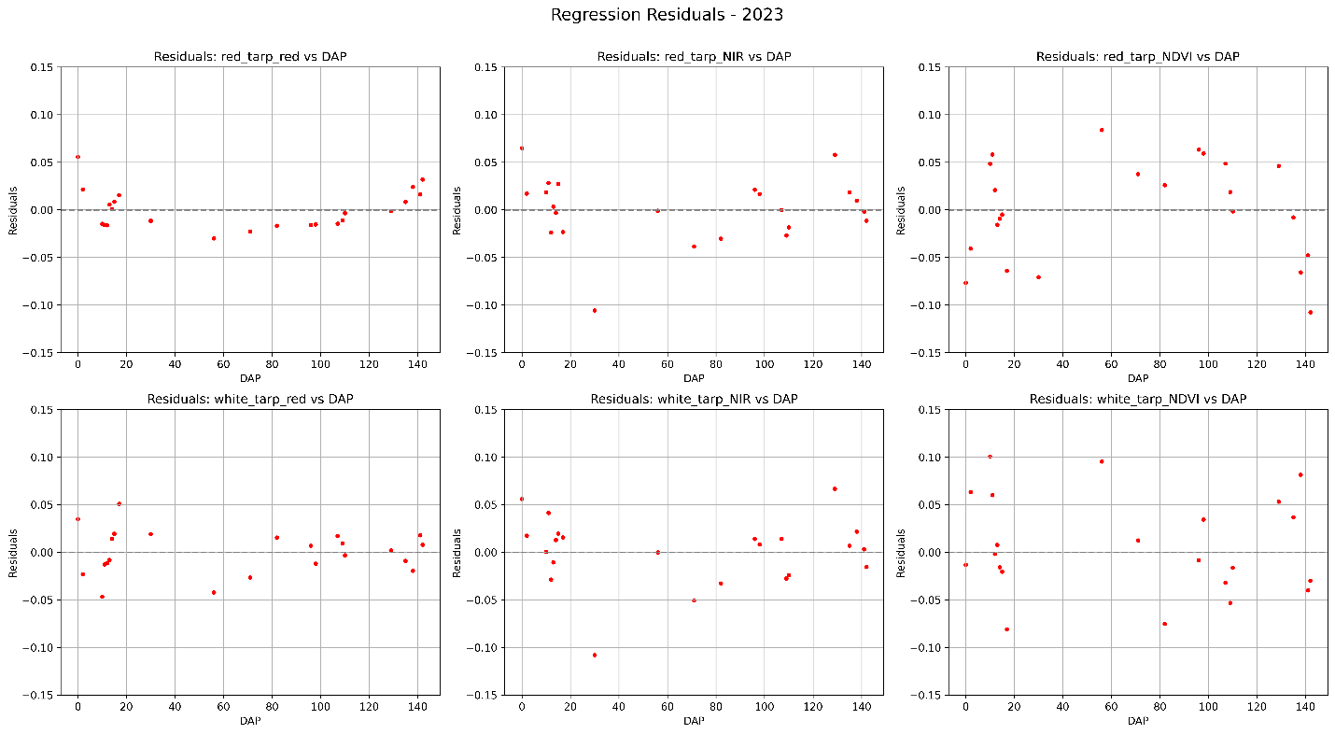Figure 2. OLS regression residuals for the Red, NIR bands and NDVI of red and white tarps

4. Spectral–Satellite Tarp Correction Approach
Because spectral and satellite imagery were collected on different dates, a linear regression model was fitted between spectral tarp NDVI and DAP:
NDVI ₍_{spectral, tarp}₎ (t) = α₀ + α₁ × DAP(t) + η(t)
This model was used to predict spectral tarp NDVI for the exact dates of satellite imagery. Figure 3 shows the OLS regression of the red and white tarp NDVI for the spectral data. It also verifies the assumption that the NDVI for the tarps should be constant.
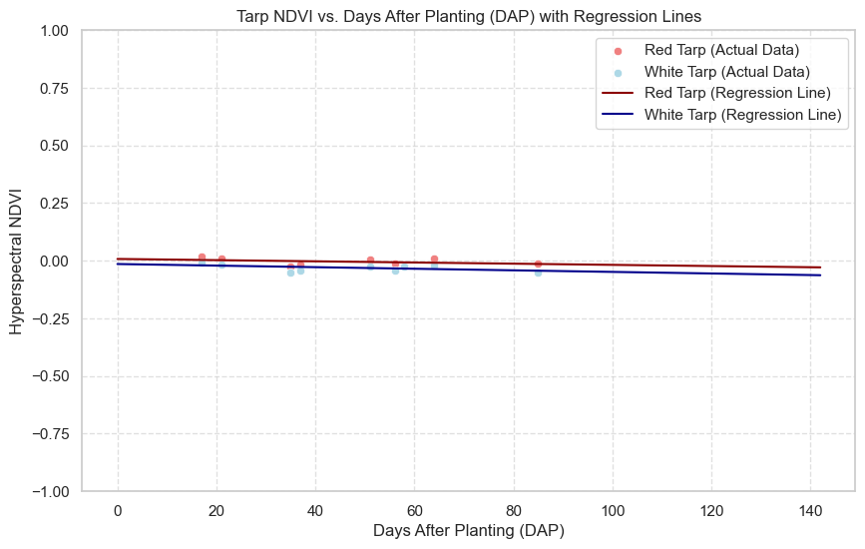
Figure 3. OLS regression of the red and white tarp NDVI for the spectral data
The NDVI correction term for each date was calculated as:
$$NDVI_{\left(Correction\right)}\left(t\right)=NDVI_{\left(satellite,tarp\right)}\left(t\right)-\hat{NDVI_{\left(spectral,tarp\right)}}\left(t\right)$$
These NDVI correction terms were then added to and subtracted from the satellite-derived pixel 6 NDVI values to generate additional corrected NDVI series.
5. NDVI Validation and Temporal Alignment
Corrected NDVI time series from both methods (satellite tarp residual correction and spectral–satellite tarp correction) were compared to spectral EMA NDVI.
Performance was evaluated using root mean square error (RMSE), bias, and coefficient of determination (R²).
Due to differences in acquisition dates between satellite and spectral datasets, Dynamic Time Warping (DTW) was applied to assess the similarity between NDVI temporal profiles. DTW is a time series alignment algorithm that allows non-linear matching between two sequences, enabling direct comparison of vegetation dynamics even when measurements are taken on different dates.
DTW distances were calculated for original and corrected NDVI series, with lower values indicating improved temporal agreement with spectral data.

3. Results

3.1 Regression Analysis of EMA and Tarp NDVI
Ordinary Least Squares (OLS) regression models were fitted for the 2023 growing season to quantify the temporal dynamics of NDVI relative to days after planting (DAP). The regression model took the form:
NDVI = β₀ + β₁ × DAP + ε
where β₀ represents the intercept, β₁ represents the rate of NDVI change per day after planting, and ε is the model residual.
Separate regressions were conducted for:
- Pixel 6 NDVI (field pixel)
- Red tarp NDVI (satellite)
- White tarp NDVI (satellite)
Analysis of the satellite-derived red and NIR reflectance showed that both tarps exhibited similar overall temporal patterns across the growing season. However, the strength of the linear relationship (R²) varied between tarps and spectral bands, suggesting differences in the magnitude and consistency of seasonal change. NDVI calculated from the tarp reflectances showed a gradual increasing trend over time, which may indicate biological or surface changes such as algae accumulation on the tarp surfaces.

3.2 Residual-Based NDVI Adjustment (Satellite Tarp Residuals)
Regression residuals from the tarp NDVI models were used to generate adjusted NDVI series for Pixel 6. These residuals represent short-term variability in tarp reflectance that is not captured by a simple linear model. Figure 4, shows the correction applied to the field NDVI using the red and white tarp NDVI regression residuals.
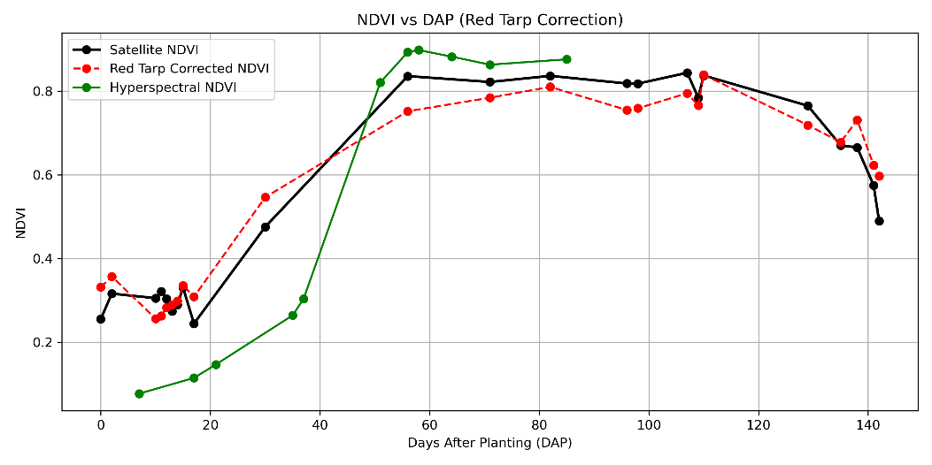

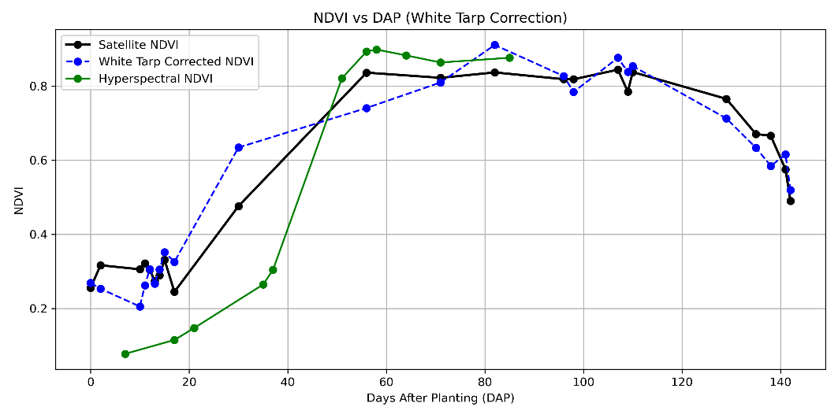
Figure 4. Red and White tarp correction (top to bottom) applied to the Field NDVI using the residuals

Table 2. DTW Results – Satellite Tarp Residual Method
NDVI Series | DTW Distance | Warping Path Length
Pixel 6 NDVI | 0.6091 | 26
Pixel 6 NDVI + Red Tarp Residual | 0.6967 | 25
Pixel 6 NDVI – Red Tarp Residual | 0.6064 | 24
Pixel 6 NDVI + White Tarp Residual | 0.6861 | 26
Pixel 6 NDVI – White Tarp Residual | 0.6320 | 24
The smallest DTW distance (0.6064) was obtained for Pixel 6 NDVI – Red Tarp Residual, indicating a marginal improvement in temporal alignment with spectral data compared to the unadjusted NDVI (0.6091).

3.3 Spectral–Satellite Tarp Correction
Because spectral and satellite measurements were collected on different dates, linear regression models were fitted to the spectral tarp NDVI time series as a function of DAP. These models were then used to predict spectral tarp NDVI for the exact acquisition dates of satellite imagery.
The NDVI correction term was calculated as:
$NDVI_{\left(Correction\right)}\left(t\right)=NDVI_{\left(satellite,tarp\right)}\left(t\right)-\hat{NDVI_{\left(spectral,tarp\right)}}\left(t\right)$
The resulting correction values were added to and subtracted from the satellite-derived Pixel 6 NDVI to produce alternative corrected time series.
Among the spectral–satellite tarp correction outputs, Pixel 6 NDVI – White Tarp Residual yielded the smallest DTW distance (0.6320). However, the improvement over the uncorrected NDVI (0.6091) was minimal, and in some cases, corrections based on predicted spectral residuals increased the DTW distance substantially, indicating reduced temporal agreement with the spectral reference.
Table 3. DTW Results – Spectral–Satellite Tarp Correction
NDVI Series | DTW Distance | Warping Path Length
Pixel 6 NDVI | 0.6091 | 26
Pixel 6 NDVI – Red Tarp Residual | 0.6064 | 24
Pixel 6 NDVI – White Tarp Residual | 0.6320 | 24
Pixel 6 NDVI + Red Tarp Residual | 0.6967 | 25
Pixel 6 NDVI + White Tarp Residual | 0.6861 | 26
Pixel 6 NDVI – Predicted Red Tarp Residual | 2.2977 | 26
Pixel 6 NDVI – Predicted White Tarp Residual | 1.9855 | 23
Pixel 6 NDVI + Predicted Red Tarp Residual | 2.2982 | 27
Pixel 6 NDVI + Predicted White Tarp Residual | 1.8689 | 27

4. Discussion
The comparison of NDVI correction strategies highlights the relative effectiveness of using satellite-derived tarp residuals versus spectral–satellite-based corrections for improving temporal agreement between PlanetScope imagery and spectral ground-truth measurements.
The regression analysis of the reference tarps indicated consistent seasonal patterns in both red and NIR reflectance, with NDVI showing a gradual increase over time. This trend may reflect subtle surface changes such as algae accumulation, a factor that, while minor in magnitude, can introduce systematic bias into the reference signal. The R² variability across tarps and spectral bands suggests that spectral stability is not uniform and that certain wavelengths are more susceptible to environmental or surface changes over the course of the season.
The residual-based adjustment using satellite tarp NDVI provided the most consistent improvement in DTW alignment, with the Pixel 6 NDVI – Red Tarp Residual producing the smallest DTW distance relative to spectral measurements. This suggests that short-term variability in the reference tarp NDVI, which may be driven by transient atmospheric conditions, localized illumination effects, or minor BRDF influences, can meaningfully influence the accuracy of canopy NDVI estimates. By directly accounting for these short-term deviations, this method appears to reduce local radiometric inconsistencies more effectively than corrections derived from predicted spectral values.
In contrast, the spectral–satellite tarp correction approach produced minimal improvement in temporal alignment, with the best-performing variant (Pixel 6 NDVI – White Tarp Residual) only marginally reducing DTW distance compared to the uncorrected series. Moreover, correction terms derived from predicted spectral residuals substantially increased DTW distances, suggesting that model extrapolation errors outweighed potential benefits. This limitation likely reflects the sensitivity of the linear model to sparse spectral sampling and the challenge of accurately predicting high-frequency variation between acquisition dates.
Overall, these findings underscore the importance of correction methods that operate on temporally co-incident reference data. While spectral measurements provide an accurate spectral baseline, their lower temporal resolution constrains their utility for capturing rapid atmospheric or illumination changes. Satellite tarp residuals, although more susceptible to noise, appear better suited for operational local correction due to their temporal synchrony with field imagery. Future work should explore hybrid correction strategies that combine the temporal coverage of satellite residuals with the spectral precision of spectral references, potentially through data assimilation or bias-adjusted fusion techniques.

5. Limitations
Several limitations of this study should be considered when interpreting the results:
- Temporal mismatch in spectral and satellite acquisitions – While linear interpolation of spectral tarp NDVI provided estimates for satellite acquisition dates, this method cannot capture short-term atmospheric variability or rapid surface changes, limiting correction accuracy.
- Potential instability of reference tarps – The gradual seasonal increase in tarp NDVI suggests surface changes such as algae growth, dust deposition, or material degradation, introducing bias into the correction process
- Linear model constraints – The use of linear regression assumes a constant rate of change over time and may fail to capture non-linear reflectance patterns in both tarps and vegetation.
- Residual attribution uncertainty – The residuals derived from regression models cannot be confirmed as purely atmospheric effects; they may also contain noise from sensor artifacts, local illumination changes, or surface changes in the tarps.
- Surface anisotropy effects – The tarps are non-Lambertian surfaces, meaning their apparent reflectance depends on the relative geometry of the sun, satellite, and target. This bidirectional reflectance behavior introduces angular dependence into the measurements that is not corrected in the current workflow.
- Simplified residual transfer – The NDVI correction approach assumes a direct, proportional transfer of tarp residuals to crop pixels. This simplification may overlook differences in atmospheric path effects or surface scattering characteristics between the reference and target pixels.

6. Conclusion
This study evaluated two approaches for local radiometric correction of PlanetScope NDVI in maize fields using reference tarp data:
- Satellite Tarp Residual Method – Adjusting field NDVI using residuals from satellite-derived tarp NDVI regressions.
- Hyperspectral–Satellite Tarp Correction – Estimating spectral tarp NDVI for satellite acquisition dates via linear models, calculating correction terms, and applying them to field NDVI.
Results showed that the Satellite Tarp Residual Method provided the smallest Dynamic Time Warping (DTW) distance between corrected field NDVI and spectral ground truth, with the best performance achieved by subtracting red tarp residuals from the field NDVI. In contrast, the Hyperspectral–Satellite Tarp Correction approach yielded minimal improvement and, in some cases, degraded alignment with spectral measurements, likely due to interpolation limitations and prediction error.
The findings suggest that temporally co-incident reference measurements from satellite imagery offer more effective short-term radiometric correction than predicted spectral values when spectral data is temporally sparse. However, both methods are subject to physical limitations, including tarp surface changes, angular reflectance effects, and the assumption that tarp-derived corrections can be directly transferred to crop canopy pixels.
Future work should explore hybrid correction strategies that combine the temporal resolution of satellite residuals with the spectral precision of spectral measurements, potentially incorporating non-linear models or angular normalization to address surface anisotropy.

References
Huang, S., Tang, L., Hupy, J.P., Wang, Y., & Shao, G. (2021). A commentary review on the use of normalized difference vegetation index (NDVI) in the era of popular remote sensing. Journal of Forestry Research, 32, 1–19. https://doi.org/10.1007/s11676-020-01155-1
Fan, X., & Liu, Y. (2016). A global study of NDVI difference among moderate-resolution satellite sensors. ISPRS Journal of Photogrammetry and Remote Sensing, 121, 177–190. https://doi.org/10.1016/j.isprsjprs.2016.09.008
Hird, J.N. (2008). Noise Reduction for Time Series of the Normalized Difference Vegetation Index (NDVI): An Empirical Comparison of Selected Techniques. University of Calgary. Retrieved from https://ucalgary.scholaris.ca/bitstreams/3579548c-42cf-4f0b-82d2-c4ec261667e0/download

