Class: PLSCS 5200 – Geographic Information Systems (GIS): Concepts and Applications
Title: Exploratory Spatial Analysis of Urban Agriculture and Air Quality in NYC (2019–2024)
By: Omkar Tekawade
Abstract
This study examines the spatial relationship between urban agriculture (UA) sites and air quality in New York City using GIS-based analysis. Annual average concentrations of PM2.5, NO, and NO2 from 2008 to 2022 were analyzed at UA locations and randomly generated reference points. Results indicate that air quality at UA sites is consistently lower than at random sites, though the difference has decreased over time. Findings suggest potential biases in UA site placement and highlight the need for further analysis considering additional factors influencing air quality.
- Introduction:
The study was conducted on the effect of Urban Agriculture (UA) on air quality. Literature mentions that air quality is improved due to urban agriculture, but a detailed analysis has not been conducted on a city-wide scale to prove that it does. So that is where this study comes in.
UA can be defined as “as an industry that produces, process & markets food & fuel , largely in response to the daily demand of consumers within a town , city or metropolis, on land & water dispersed throughout the urban & peri-urban area, applying intensive production methods, using & reusing natural resources & urban wastes, to yield a diversity of crops and livestock.”(Smit et.al 1996)
There is projected to be 50% rise in world population by 2050 and agriculture will struggle to meet the food requirements of the world. It is also projected that 2050, 70% of the world’s population will live in urban areas.(UNPF, 2018) So urban agriculture is being looked as a potential and sustainable alternative to feed people rather than relying on the transportation of food from rural areas/ traditional areas. Urban agriculture has recently received recognition as a food source in cities, due to the production and logistics disruption of food during the COVID-19 pandemic.
Beyond food production, UA has increasing benefits in improving the socioeconomic-environmental dimension of cities. It provides economic benefits through cash sales and jobs while directly linking to other entrepreneurial activities. Social benefits include improved nutritional outcomes, individual and community wellbeing, recreation activities, educational opportunities, land reclamation, poverty mitigation and improved social integration. The environmental benefits include improved carbon and storm water capture, ground water recharge, food and organic waste composting, improved local biodiversity, contamination mitigation, improved air quality, urban cooling, energy savings. (Orsini et. al. 2020)
But from another perspective, the increased levels of pollution in cities can diminish the quality of urban-grown products, generating health risks for consumers. (Tuijl et. al 2018). The use of certain pesticides, herbicides and fertilizers in the process of farming can generate additional risks for the residents and damage local biodiversity. While these additional risks are minimal for small scale UA, the practice of commercial UA using soil base farming will bring the same risks as agro-industrial farms do on their surrounding environments.
It emerges that, within urban environments, contamination hazards generally varies according to the location where horticulture takes place being higher in proximity of pollution sources (e.g. main roads, or, within formal industrial districts)(Hursthouse & Leitao, 2016) or as a consequence of the background geology of the site (Jean-Soro, et al. 2014)
Traditionally, the effect of traditional agriculture is said to be a net negative on air quality but Urban Agriculture is said to be improving air quality. A GIS-based spatial analysis is necessary for this study as it explores the geographic relationship between urban agriculture sites and air quality patterns. Given the spatial nature of the data—urban agriculture represented as point features and air quality as raster layers—GIS provides the appropriate framework for data management and analysis. Analytical tools such as buffering, extraction, and zonal statistics are integral to quantifying these spatial interactions. Moreover, GIS-based mapping supports the visualization of spatial distributions and the identification of potential geographic associations within this exploratory research.
This study incorporates two primary spatial data types: point features representing Urban Agriculture (UA) sites across New York City and raster layers depicting annual average concentrations of key air pollutants, namely PM2.5, NO2, and NO. To assess spatial relationships between these datasets, standard GIS techniques are utilized, including raster extraction to assign pollutant values to UA locations and proximity-based methods such as buffer creation and zonal statistics to compute mean air quality within defined distances of each site. These spatial data types and analytical approaches are well-aligned with the objectives of examining geographic patterns and associations central to this GIS-based research.

- Methodology
2.1 Study Area:
The study is set in New York City, a highly urbanized and densely populated metropolitan area composed of five boroughs: Manhattan, Brooklyn, Queens, The Bronx, and Staten Island. As one of the most spatially and demographically diverse cities in the United States, NYC presents a complex urban environment with varied land use, green infrastructure, and environmental conditions. In recent years, urban agriculture (UA) has been expanding rapidly across the city, driven by growing interest in local food systems, environmental sustainability, and community resilience. This increasing presence of UA makes NYC an ideal setting for examining the spatial relationships between urban agriculture sites and air quality across different neighborhoods.
2.2 Data Source:
- NYC Urban Agriculture Sites:
This dataset is a point vector layer representing the locations of urban agriculture sites throughout New York City. It contains up to 2000 features and is compiled by the NYC Mayor’s Office of Urban Agriculture (MOUA), publicly available on ArcGIS Online. The dataset includes various attributes describing each site, such as Name, Address, Neighborhood, Borough, ZIPCode, and UrbanAgricultureSiteType. The site types include Community Gardens, Controlled Environment Agriculture, Food Forest, School & Learning Garden, and Urban Farm. The dataset also includes information on Growing Methods Resources (e.g., Soil-based, Vertical Farming, Hydroponics). The dataset was last updated on December 10, 2024. Note that the specific start date or year for individual urban agriculture sites was not available in this data.
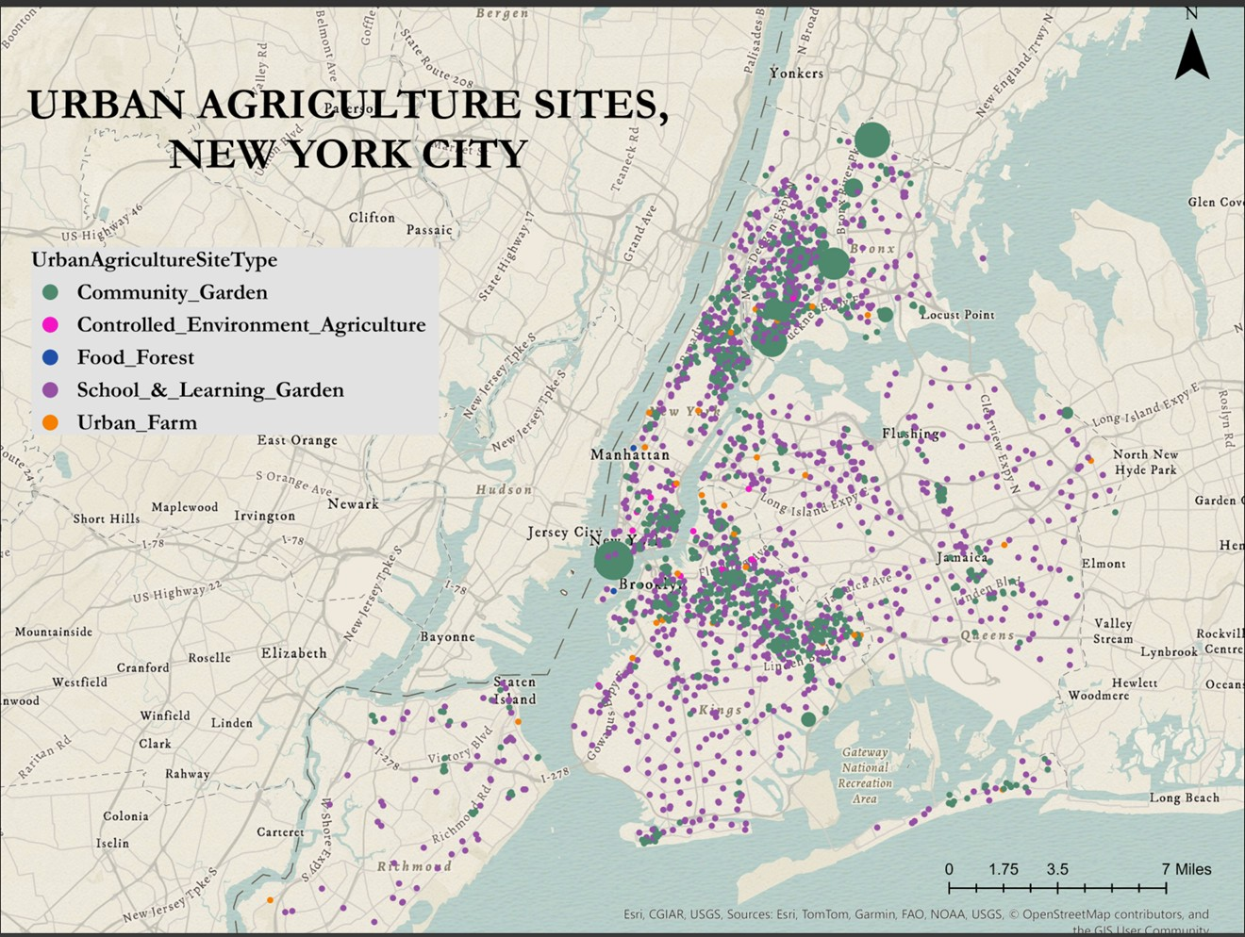
Fig1. The Urban Agricultural Sites in New York City

- New York City Community Air Survey (NYCCAS) air pollution raster:
This dataset consists of citywide ESRI grid raster files providing the annual average predicted surface concentrations for key air pollutants. While the full dataset includes Black Carbon (BC), summer average Ozone (O3), and winter average Sulfur Dioxide (SO2), this study primarily utilizes the annual average predicted surface concentrations for Nitrogen Dioxide (NO2), Fine Particulate Matter (PM2.5), and Nitric Oxide (NO). These predicted surfaces were generated from Land Use Regression modeling of NYCCAS monitoring data covering the period December 2008 through December 2022 (years 1-14). The data has a spatial resolution of 300m and is provided annually by the NYC Department of Health and Mental Hygiene (DOHMH), available on the NYC Open Data Portal. The rasters use the NAD83 New York Long Island State Plane FIPS, feet projection.
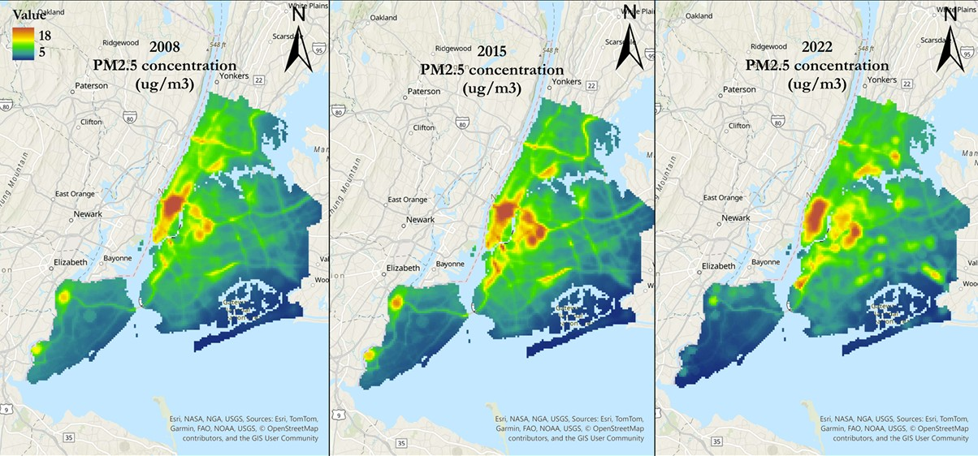
Fig 2. PM_{2.5} concentration in NYC for years 2008,2015 and 2022
2.3 Data Conversion:
To ensure spatial compatibility and accurate distance-based analysis, particularly for buffer operations, all data layers were reprojected to the NAD83 / New York Long Island (ftUS) coordinate system (EPSG: 29618). This reprojection was performed using QGIS software.
  - Analytical Steps:
- Method 1: Extract Values to Points:
Objective: The primary objective of this method was to determine the estimated air quality concentration directly at the precise geographic location of each urban agriculture site. This provides a snapshot of the ambient air quality conditions within the 300m raster cell that contains each UA site.
Process: This was achieved by loading the urban agriculture site point layer and the annual NYCCAS air pollution raster layers (for PM2.5, NO2, and NO for each year from 2008-2022) into a GIS environment (QGIS). Prior to extraction, it was ensured that both the point layer and the raster layers were in compatible coordinate systems. The "Sample Raster Values" geoprocessing tool was then applied. This tool iterates through each point feature in the input point layer and samples the value from the corresponding cell in the input raster layer at that exact location.
- Method 2: Buffer & Zonal Statistics:
Objective: The objective of this method was to understand the average air quality conditions in the vicinity of each urban agriculture site, rather than just at the exact point location. This approach acknowledges the 300m spatial resolution of the air quality raster data and provides a potentially more representative measure of the air quality surrounding each site.
Process: This method involved two main steps performed in QGIS. First, buffer polygons were created around each urban agriculture site point. A buffer radius of 300 meters was chosen to align with the spatial resolution of the NYCCAS raster data, representing the immediate area covered by the raster cell containing or adjacent to the point. Second, the "Zonal Statistics" geoprocessing tool was applied. This tool calculates summary statistics for the cells of a raster layer that fall within the boundaries of features in another layer (the zones). In this case, the buffer polygons served as the zones, and the annual NYCCAS air pollution rasters were the input raster layers. The tool was configured to calculate the Mean raster value within each buffer polygon for each pollutant (PM2.5, NO2, NO) for each year (2008-2022).
- Comparison with Random Sites:
Process: To provide a reference for comparison, a set of random points was generated. This was done by first creating buffer polygons of 600 meters and 900 meters around the original urban agriculture sites. The "Difference" geoprocessing tool was then used to remove the 600m buffer polygon area from the 900m buffer polygon area, resulting in a series of ring-shaped polygons located between 600m and 900m from the original UA sites. Within these resulting polygons, 2618 random points were generated using the "Random points in polygon" tool. This specific process was chosen to ensure that the 300m buffers subsequently created around these random points would not intersect with the 300m buffers around the original UA sites, thus minimizing spatial overlap and providing a comparison group that is relatively close but distinct from the immediate vicinity of the UA sites. This spatial separation serves as a proxy for potentially similar external conditions affecting air quality without direct influence from the UA sites' immediate surroundings.
Analysis: Method 1 (Extract Values to Points) and Method 2 (Buffer & Zonal Statistics) were then applied to these randomly generated points to obtain their corresponding air quality values or average air quality within a 300m buffer, respectively, for each year from 2008 to 2022.
Comparison Approach: The final step involved comparing the air quality values ( direct point values and average buffer values) over time between the original urban agriculture sites and the randomly generated reference sites.
- Results
- The data shows that the overall air quality of NYC has improved from 2008 to 2022.
- The average values for all the UA sites and the random points show the same trend.
- For both the analysis conducted (Extract values at points and Buffer & Zonal statistics), show that the air pollutant concentration at UA sites is higher than the concentration at the randomly generated points for all the three pollutants analyzed i.e. PM_{2.5}, NO and NO₂. This holds true throughout the time period of 2008 – 2022.
- The difference between the air pollution concentration at the UA sites and randomly generated points is decreasing with time.
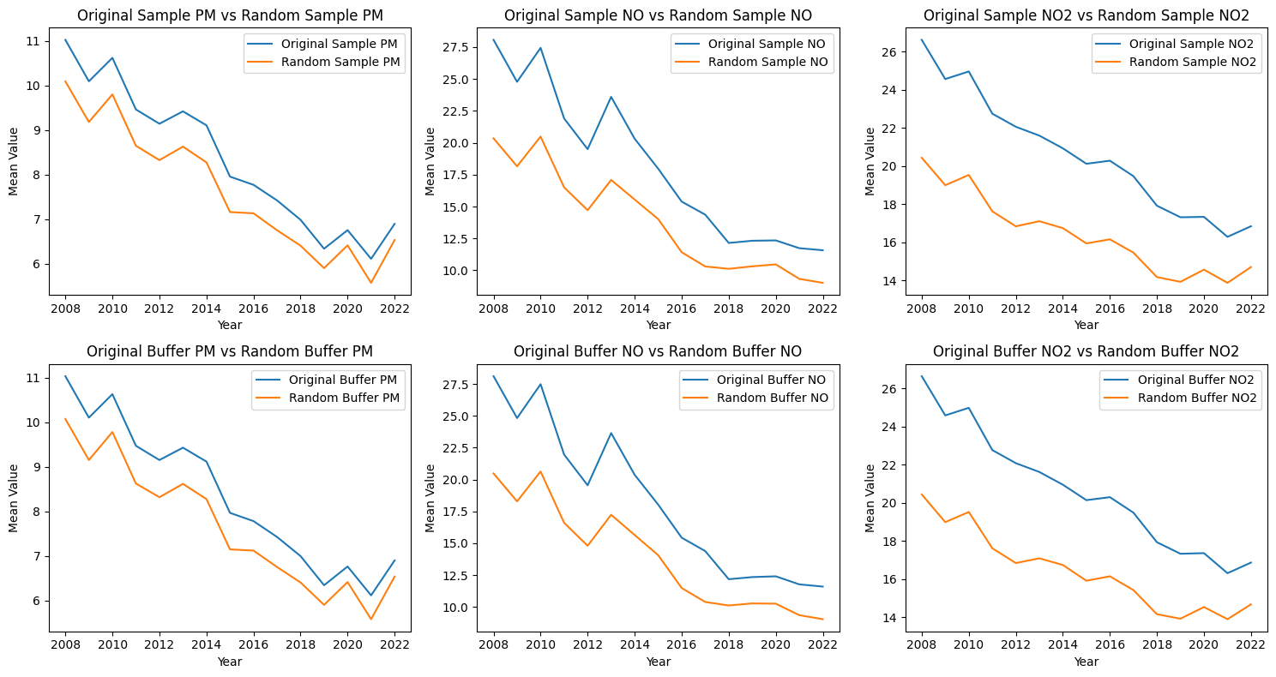
Fig 3. Line graphs for comparison of UA sites and randomly generated sites for Method 1 (top) and Method 2 (bottom) for 3 air pollutants, PM_{2.5}, NO and NO₂. (left to right)
- Discussion
The air quality at the Urban Agriculture sites is lower than the randomly generated sites for the whole period. This holds true for all the 3 pollutants (PM_{2.5}, NO and NO₂) analyzed. The study also points out that there might be initial bias in the UA sites placement as they are mostly located in higher-pollution neighborhoods—perhaps due to land costs, zoning of vacant lots. The difference in the air quality of UA sites and the randomly generated sites is reducing. This could be a indicator of UA working to reduce the air pollutant concentration. This needs to be further analyzed.
This study used direct comparison between the air pollutant concentration at the UA sites and the randomly generated points. The analysis is conducted annually, so the analysis cannot capture the changes throughout the year. The analysis does not take into account the other factors that affect air quality such as wind speed, wind direction, residential buildings, industrial buildings, traffic pollution and many more. So the analysis needs to be conducted further while taking the other factors into consideration, to comment of the effect of urban agriculture on air quality in NYC.
- Limitations
- The starting date/year for the urban agricultural sites was not available in the data.
- The air pollution rasters are annual average of the pollution and so they cannot represent fully represent air quality.
- The spatial resolution of the data is 300m which might not fully represent the effects of UA on air quality.
- Due to the quantity of the UA sites, the randomly generated reference data seems to mostly cover the border regions and cannot cover most of the city ground.
- The analysis was conducted directly on the UA site location and the air quality, but we need to keep in mind that air pollution is a complex system and has many different factors affecting it.
- References
- Yuan, G. N., Marquez, G. P. B., Deng, H., Iu, A., Fabella, M., Salonga, R. B., ... & Cartagena, J. A. (2022). A review on urban agriculture: technology, socio-economy, and policy. Heliyon, 8(11).
- Smit, J., Ratta, A., & Nasr, J. (1996). Urban agriculture: food, jobs and sustainable cities (Vol. 2, pp. 35-37). New York: United Nations Development Programme.
- United Nations Population Fund, 2007, 2018 UN Population Division, World Urbanization Prospects: 2018 Revision, key facts. Available from https://population.un.org/wup/Publications/Files/WUP2018-KeyFacts.pdf
- Van Tuijl, E., Hospers, G. J., & Van Den Berg, L. (2018). Opportunities and challenges of urban agriculture for sustainable city development. European Spatial Research and Policy, 25(2), 5-22.
- Hursthouse, A. S., Leitão, T. E., Voigt, A., Heller, A., Bechet, B., & da Luz, P. B. (2016). Environmental pressures on and the status of urban allotments. In Urban allotment gardens in Europe (pp. 142-164). Routledge.
- Jean-Soro, L., Le Guern, C., Bechet, B., Lebeau, T., & Ringeard, M. F. (2015). Origin of trace elements in an urban garden in Nantes, France. Journal of Soils and Sediments, 15, 1802-1812.

