Interactive Tree Database & Yield Calculator
User Manual
Version 1.0 - October 2026
Course BSCS Final Project - Human-Computer Interaction
Prepared by [Group Name / Members]
Submitted to [Instructor]
Software Visual Basic .NET Windows Forms (.NET Framework 4.5.2) + Microsoft Access database (.mdb), Visual Studio 2015 solution

Contents
1. Introduction
1.1 What the program does
1.2 Who should read which part
1.3 About the figures
1.4 Conventions used in this manual
2. System requirements
3. Installing and starting the program
3.1 The project folder
3.2 Start the program from Visual Studio
3.3 Start the program without Visual Studio
3.4 The first start
4. The main window
5. Calculating yield and sales
6. Browsing and inspecting species records
6.1 Search
6.2 Sort and select
6.3 Inspect a record
7. Multi-year projection
8. Saving and loading scenarios
8.1 Save a scenario
8.2 Load or delete a scenario
9. Exporting and printing
9.1 Export to CSV (Excel)
9.2 Print a report
10. Administrator guide
10.1 Sign in
10.2 First sign-in: change the default password
10.3 The Manage Species Records window
10.4 Add a species
10.5 Edit a species
10.6 Delete a species
10.7 Audit log
10.8 Change password, reset sample data, sign out
11. Keyboard shortcuts
12. How the calculations work
12.1 Yearly yield and gross sales
12.2 Projection for annual species
12.3 Projection for rotation (timber) species
12.4 What the program does not include
13. The database file (Microsoft Access)
13.1 Open it in Microsoft Access
13.2 Rules kept by the database
13.3 Back up, restore and start fresh
14. Troubleshooting and frequently asked questions
15. Glossary
Appendix A. Sample species
Appendix B. Test cases

1. Introduction

1.1 What the program does
The Interactive Tree Database & Yield Calculator is a desktop program for farmers, agriculture students, extension workers and planners. It keeps a database of tree species and, for any species and number of trees, calculates the expected yearly harvest and the estimated gross sales in Philippine pesos.
With the program you can:
- filter the species by type: All Species, Fruit-Bearing or Non-Fruit-Bearing;
- choose a species and a tree count and see the annual yield and gross sales immediately;
- search, sort and inspect every species record;
- see a year-by-year projection (1 to 30 years) with a chart and a table;
- save calculations as scenarios and load them again later;
- export a calculation to a CSV file for Excel, or print a one-page report;
- as an administrator, add, edit and delete species records and review an audit log.

1.2 Who should read which part
Reader | Sections
Every user | 2 to 9, 11 and 14
Administrator (keeps the records up to date) | 10 and 13, plus the sections above
Anyone who wants to check the numbers | 12. How the calculations work

1.3 About the figures
Note: The 22 sample species and their yields and prices are planning estimates prepared for this school project. Real yields depend on variety, tree age, spacing, soil, weather and care, and farm-gate prices change with the season and the market. Check current figures with the Department of Agriculture (DA), the Philippine Statistics Authority (PSA) or local buyers. An administrator can update any record (Section 10).

1.4 Conventions used in this manual
- Names of buttons, labels and windows are written in bold, for example Save Scenario.
- Keys and shortcuts look like Ctrl+S; file and folder names look like TreeYieldDb.mdb.
- Amounts are shown in the program with the peso sign; this manual writes them as PHP.

2. System requirements
Item | Requirement
Operating system | Windows 7 SP1, 8.1, 10 or 11 (tested on Windows 11)
.NET Framework | 4.5.2 or later (already included in Windows 10 and 11)
Database | Nothing to install. The data is kept in a Microsoft Access file (TreeYieldDb.mdb) inside the project and is read with the Microsoft Jet 4.0 OLE DB provider, which is part of Windows.
Microsoft Access (optional) | Any version from Access 2000 on, to open and browse the database file (Section 13)
Screen | 1024 x 768 or larger; 1280 x 800 or larger recommended
Printer (optional) | Any printer, or the built-in "Microsoft Print to PDF"
To open or change the code | Visual Studio 2015 (any edition) or newer

3. Installing and starting the program

3.1 The project folder
Copy the whole project folder to the PC (for example to the Desktop or Documents). The parts you need are:
File or folder | What it is
Interactive Tree Database\Interactive Tree Database.sln | The Visual Studio solution. Open this file.
Interactive Tree Database\Interactive Tree Database\Database\TreeYieldDb.mdb | The Microsoft Access database with all records.
docs\ | This manual, the test cases and the source-code soft copy.

3.2 Start the program from Visual Studio
- Open the file Interactive Tree Database\Interactive Tree Database.sln in Visual Studio 2015.
- Press F5 (or click Start). The project Interactive Tree Database starts.

3.3 Start the program without Visual Studio
Double-click Interactive Tree Database.exe in the folder Interactive Tree Database\Interactive Tree Database\bin\Debug (or bin\Release). Keep the files TreeYield.Core.dll and Interactive Tree Database.exe.config in the same folder. The program finds the database in the project folder automatically.
To use the program on another PC without the project, copy the bin\Debug folder and put a folder named Database with TreeYieldDb.mdb inside it, next to the .exe. (If no database is found, the program creates a new one.)

3.4 The first start
When the program starts, the status bar at the bottom shows "Opening the database..." and then "Ready". If the file Database\TreeYieldDb.mdb does not exist yet, the program creates it by itself with all tables, relationships and 22 sample species. This takes only a few seconds. The status bar shows the name of the database file; point at it to see the full path.
If the database cannot be opened, the window Database Not Available explains how to fix it (see Section 14).

4. The main window
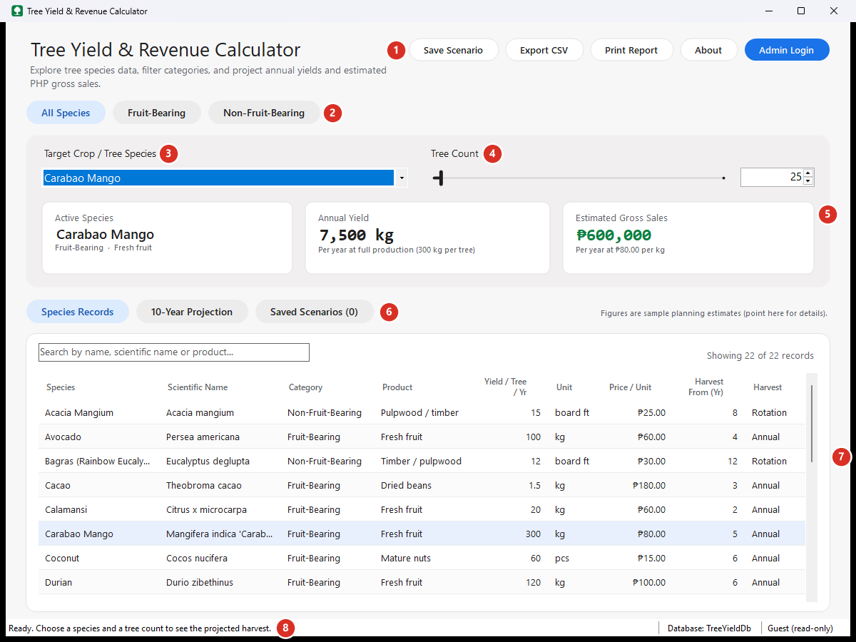
Figure 1. The main window with Carabao Mango and 25 trees selected (numbers explained below)
# | Part | What it is for
1 | Action buttons (top right) | Save Scenario, Export CSV, Print Report, About and Admin Login.
2 | Category chips | All Species, Fruit-Bearing, Non-Fruit-Bearing. The blue chip is the active filter.
3 | Target Crop / Tree Species | Drop-down list of the species in the active category.
4 | Tree Count | Slider (1 to 1,000) and number box (1 to 100,000).
5 | Result cards | Active Species, Annual Yield and Estimated Gross Sales (green).
6 | Section chips | Species Records, 10-Year Projection and Saved Scenarios.
7 | Content area | Shows the section chosen with the section chips.
8 | Status bar | Messages, the database in use and who is signed in ("Guest (read-only)" or the administrator).

Point the mouse at a button to see a short explanation and its keyboard shortcut. The window can be resized or maximized; on small screens it opens maximized.

5. Calculating yield and sales
- (Optional) Click a category chip to narrow the list, for example Fruit-Bearing.
- Choose the species in Target Crop / Tree Species.
- Set the number of trees: drag the slider, click a point on it, or use the arrow keys; or type a number from 1 to 100,000 in the box and press Enter.
- Read the three result cards. They change immediately whenever you change the species or the tree count.

Card | Meaning
Active Species | The species being calculated, with its category and product.
Annual Yield | Tree count x yield per tree per year, at full production (mature trees).
Estimated Gross Sales | Annual yield x farm-gate price per unit, in pesos, before any costs.

Worked example
25 Carabao Mango trees x 300 kg per tree = 7,500 kg per year
7,500 kg x PHP 80 per kg = PHP 600,000 per year
Note: Timber trees (harvest type "Rotation", for example Mahogany or Gmelina) are cut only once, at rotation age. For them the cards show annualized figures - the average per year - and the caption tells you the one-time harvest value and the harvest year. Use the projection (Section 7) to see when the money actually comes in.
Numbers outside the allowed range are corrected automatically: 0 becomes 1 and anything above 100,000 becomes 100,000. Letters cannot be typed in the number box.

6. Browsing and inspecting species records
Click Species Records to see the table of all species in the active category.
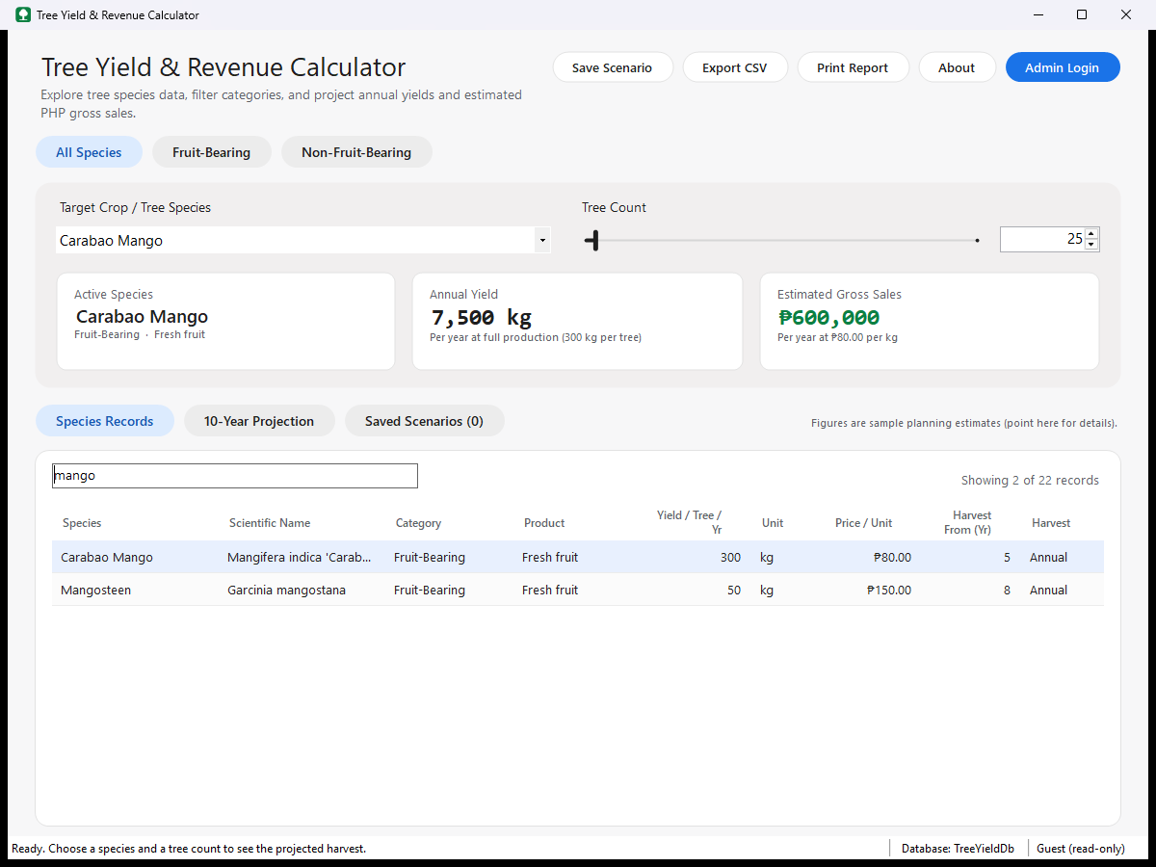
Figure 2. Searching for "mango" finds Carabao Mango and Mangosteen

6.1 Search
- Type part of a common name, scientific name or product in the search box (Ctrl+F jumps there).
- The list updates after a short pause. Upper or lower case does not matter.
- The line on the right shows how many records match, for example "Showing 2 of 22 records".
- Press Esc in the search box to clear it.
- Any characters can be typed safely; they are always treated as plain text.

6.2 Sort and select
Click a column header to sort by that column; click again to reverse the order. Click a row (or move with the arrow keys) to load that species into the calculator.

6.3 Inspect a record
Double-click a row, or select it and press Enter, to open the Species Details window with every field of the record and the result for the current tree count. Click Use in Calculator or Close.
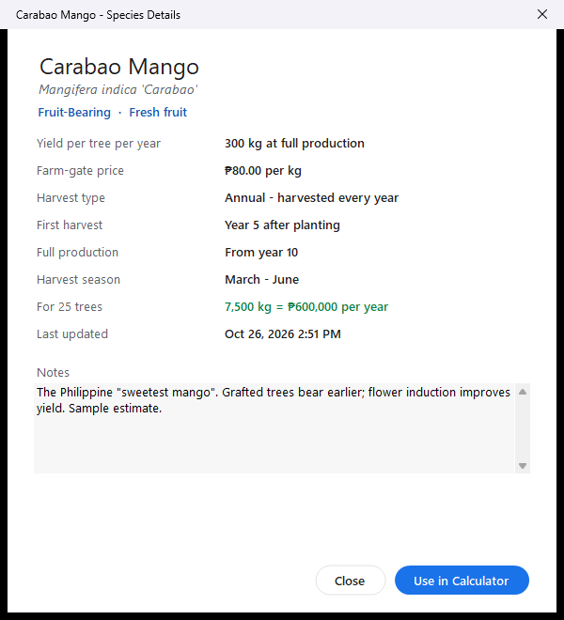
Figure 3. The Species Details window
Column | Meaning
Species / Scientific Name | Common (local) name and botanical name.
Category / Product | Fruit-Bearing or Non-Fruit-Bearing; what is sold (fresh fruit, timber, latex...).
Yield / Tree / Yr, Unit | Harvest of one mature tree per year (timber: average growth per year).
Price / Unit | Estimated farm-gate price in pesos for one unit.
Harvest From (Yr) | Annual species: first harvest year. Rotation species: rotation age.
Harvest | "Annual" (harvested every year) or "Rotation" (cut once).

7. Multi-year projection
Click 10-Year Projection to see what the trees produce in each year after planting.
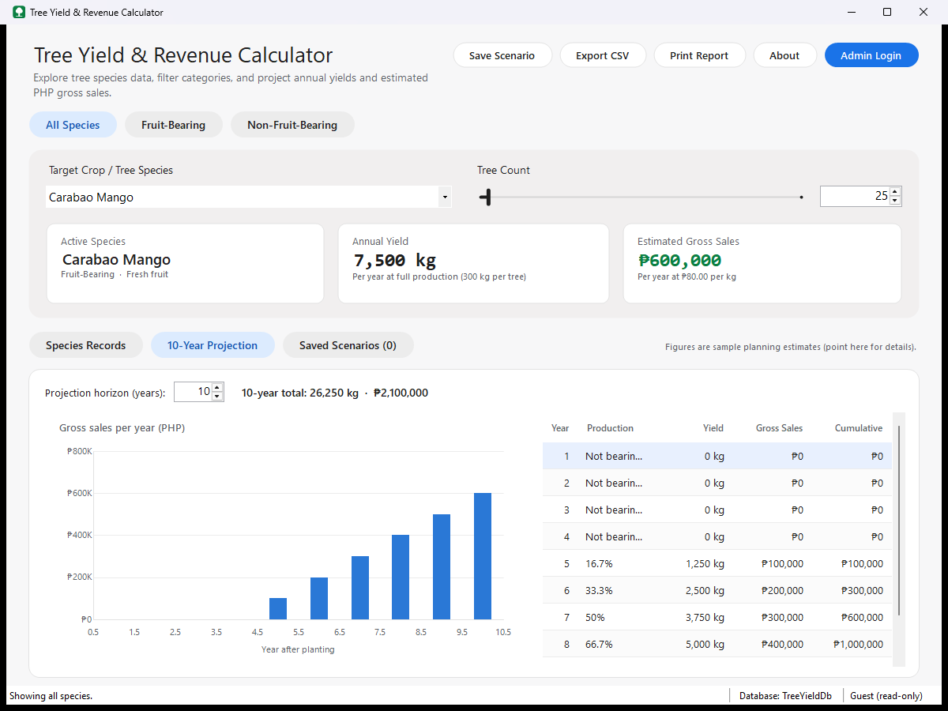
Figure 4. 10-year projection for 25 Carabao Mango trees
- Projection horizon (years): choose 1 to 30 years (default 10). The section name changes, for example "20-Year Projection".
- Summary line: total yield and total gross sales over the horizon.
- Chart: gross sales per year. Point at a column to see the exact amount.
- Table: Year, Production, Yield, Gross Sales and Cumulative (running total) sales.

"Production" shows | Meaning
Not bearing yet | The trees are still too young to harvest.
16.7%, 50%, 100%... | Share of full production reached that year (yield rises evenly until full production).
Growing | Timber species before rotation age: no income yet.
Harvest | Timber species at rotation age: the trees are cut and sold.

If the first harvest comes after the last projected year (for example Mahogany, cut at year 25), the summary says so and shows the expected harvest value.

8. Saving and loading scenarios
A scenario is a saved calculation: species, tree count and projection horizon, with a name and notes.

8.1 Save a scenario
- Choose the species and tree count.
- Click Save Scenario (or press Ctrl+S).
- Keep or change the suggested name, add notes if you like, and click Save Scenario.

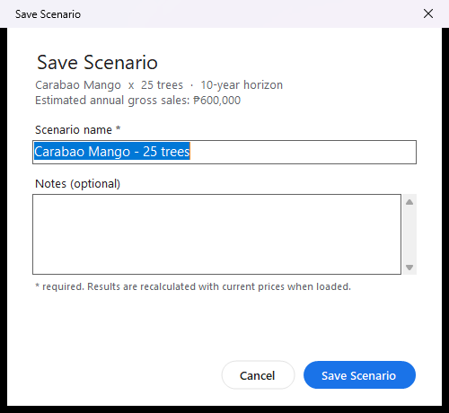
Figure 5. Saving a scenario

8.2 Load or delete a scenario
- Click Saved Scenarios. The number in the chip shows how many are saved.
- To load: double-click the scenario, or select it and click Load Selected (or press Enter). The calculator and the projection show the saved values.
- To delete: select it and click Delete Selected (or press Delete), then confirm.

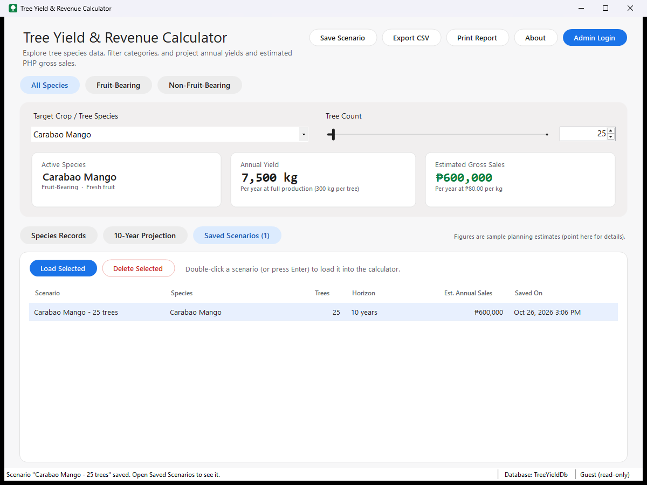
Figure 6. The Saved Scenarios section
Note: Only the inputs are saved. The results are recalculated with the current species data, so if an administrator updates a price, the scenario shows the new amount.

9. Exporting and printing

9.1 Export to CSV (Excel)
- Click Export CSV (or press Ctrl+E).
- Choose a folder and file name (a name such as TreeYield_Carabao_Mango_25trees_20261026.csv is suggested) and click Save.
- Open the file in Excel. It contains the species details, the inputs, the results and one row per projected year.

9.2 Print a report
- Click Print Report (or press Ctrl+P). A print preview opens.
- Click the printer icon to print. To make a PDF, choose the printer "Microsoft Print to PDF".
- Click Close to return to the program.

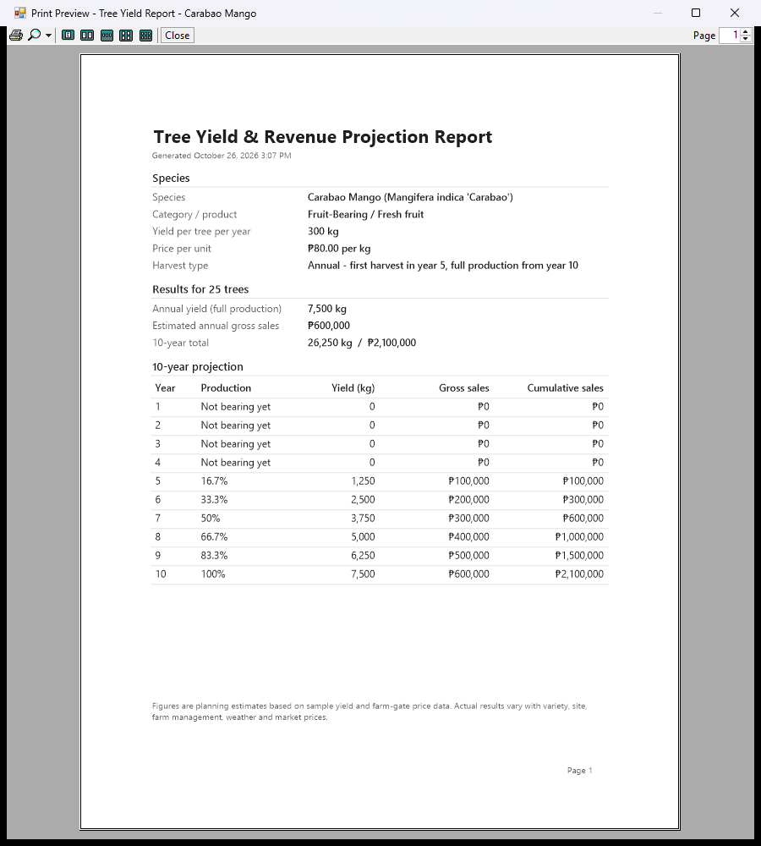
Figure 7. Print preview of the projection report

10. Administrator guide
Everybody can view and calculate. Only a signed-in administrator can add, edit or delete species records.

10.1 Sign in
- Click Admin Login.
- Type the username and password and click Sign In (or press Enter).

Default account | Value
Username | admin
Password | Admin@123 (works only until it is changed at the first sign-in)

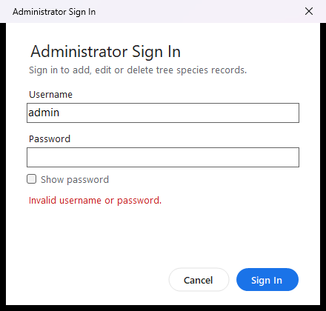
Figure 8. Sign-in window after a wrong password
- A wrong username or password shows "Invalid username or password." For security the program does not say which of the two is wrong.
- A warning appears when Caps Lock is on, because passwords are case-sensitive.
- After 5 wrong passwords the account is locked for 5 minutes, even for the right password.

10.2 First sign-in: change the default password
The first time you sign in with the default password, the Change Password window appears. Type the current password (Admin@123) and a new password twice. Clicking Sign Out cancels and signs you out.
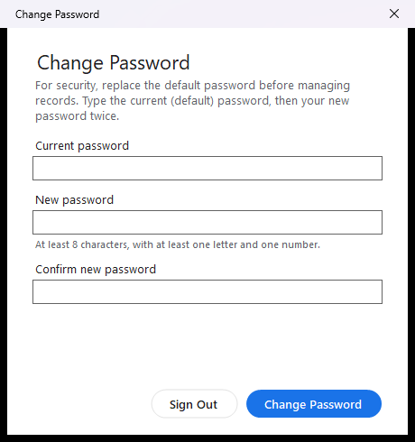
Figure 9. The password must be changed at the first sign-in
Password rules: at least 8 characters, with at least one letter and one number; not the same as the username; not the default password. Write the new password down in a safe place.

10.3 The Manage Species Records window
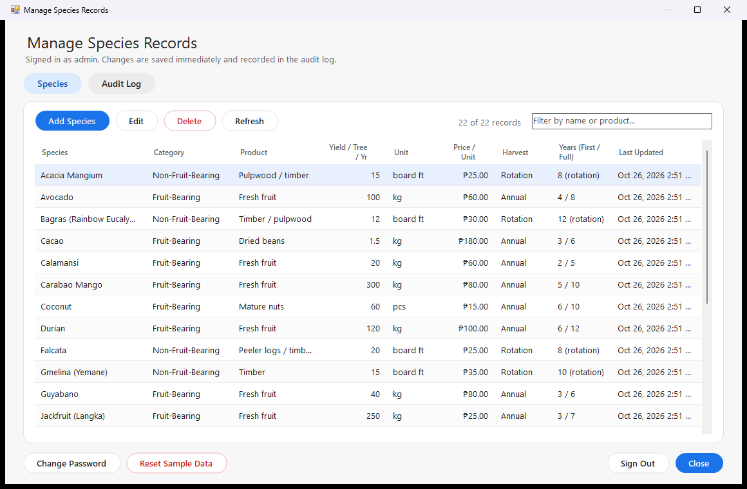
Figure 10. Manage Species Records
- Add Species (Ctrl+N), Edit, Delete, Refresh (F5).
- The filter box at the right narrows the list by name or product.
- Audit Log shows the history of sign-ins and changes.
- At the bottom: Change Password, Reset Sample Data, Sign Out and Close.
- Changes are saved immediately. When you close the window, the main window reloads the records.

10.4 Add a species
- Click Add Species.
- Fill in the fields (see the table below). The green Preview line shows what one tree is worth.
- Click Save Species.

If something is missing or not allowed, a message lists every problem and a red icon appears next to each field; point at the icon to read the problem again. Nothing is saved until all problems are fixed.
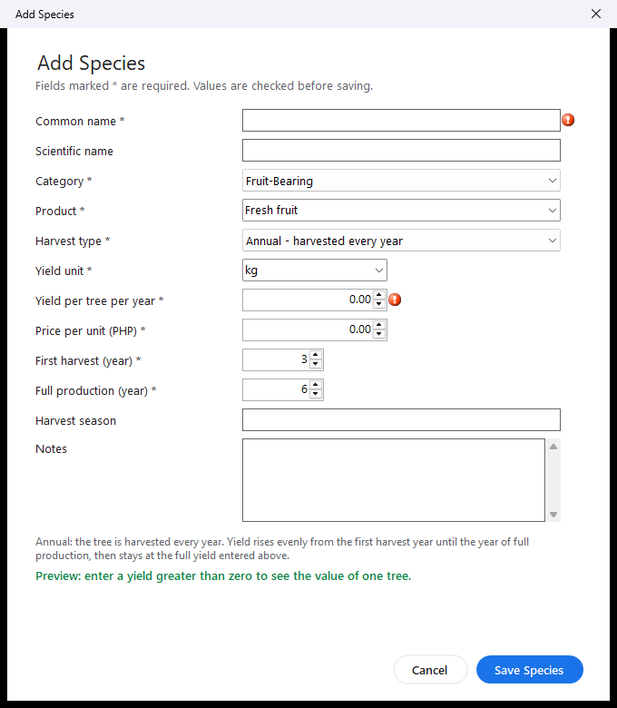
Figure 11. Required fields are marked when Save is clicked on an empty form
Field | Rules and tips
Common name * | Required, up to 100 characters, must be unique (two species cannot have the same name).
Scientific name | Optional, up to 150 characters.
Category * | Fruit-Bearing or Non-Fruit-Bearing.
Product * | What is sold. Pick from the list or type your own (up to 60 characters).
Harvest type * | Annual = harvested every year. Rotation = the tree is cut once at rotation age (timber).
Yield unit * | For example kg, pcs or board ft (up to 20 characters).
Yield per tree per year * | More than 0, at most 100,000, up to 2 decimals. For timber: the average growth per tree per year.
Price per unit (PHP) * | 0 to 1,000,000, up to 2 decimals.
First harvest (year) / Rotation age * | 0 to 60. For rotation species it is the year the tree is cut (at least 1).
Full production (year) * | 0 to 60, not earlier than the first harvest. Not used for rotation species.
Harvest season, Notes | Optional, up to 100 and 1,000 characters.

10.5 Edit a species
Double-click the species (or select it and click Edit or press Enter), change the fields and click Save Species. If you click Cancel after changing something, the program asks before throwing your changes away.

10.6 Delete a species
Select the species and click Delete (or press Delete). The confirmation tells you how many saved scenarios use the species; they are deleted together with it. The safe answer No is selected by default. Deleting cannot be undone.

10.7 Audit log
Click Audit Log to see the 200 most recent actions, newest first: sign-ins, failed sign-ins, lockouts, password changes and every added, edited or deleted record, with time and details.
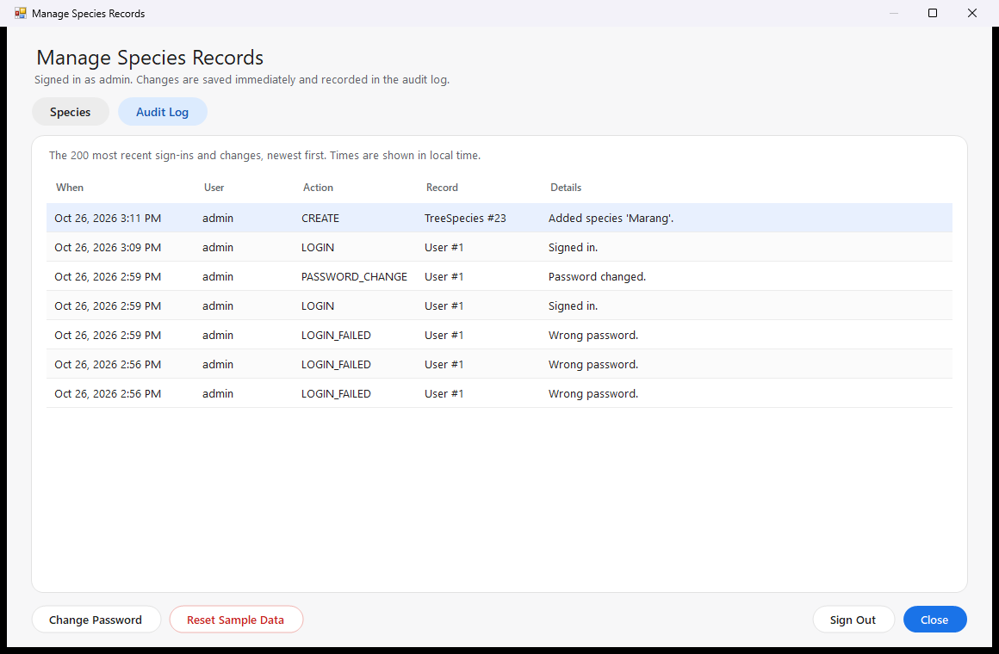
Figure 12. The audit log

10.8 Change password, reset sample data, sign out
- Change Password: type the current password and the new one twice.
- Reset Sample Data: deletes all species (including your own) and all saved scenarios, then restores the 22 sample species. User accounts and the audit log are kept. You are asked to confirm first.
- Sign Out: ends the administrator session. The program also signs you out automatically after 15 minutes without administrator activity.

11. Keyboard shortcuts
Keys | Action
Ctrl+S | Save scenario
Ctrl+E | Export CSV
Ctrl+P | Print report
Ctrl+F | Go to the search box
Ctrl+1 / Ctrl+2 / Ctrl+3 | Species Records / Projection / Saved Scenarios
F1 | About window
Arrow keys, Page Up/Down, Home/End | Move the tree-count slider (when it has focus)
Enter (in a table) | Open details / load scenario / edit species
Delete (in a table) | Delete the selected scenario or species (with confirmation)
Esc | Clear the search box; close a dialog
Ctrl+N / F5 (admin window) | Add species / refresh
Tab / Shift+Tab, Space | Move between controls; press the focused button

12. How the calculations work

12.1 Yearly yield and gross sales
Formulas
Annual yield = number of trees x yield per tree per year
Estimated gross sales = annual yield x price per unit
All amounts are calculated with exact decimal numbers, so there are no rounding errors. Pesos are rounded to the nearest whole peso only when they are displayed.

12.2 Projection for annual species
Young trees produce nothing until the first harvest year. From then on, yield rises in equal steps until the year of full production, and stays at full production afterwards:
Production factor in year y
before the first harvest year: 0%
from the first harvest to full production: (y - first + 1) / (full - first + 1)
from the full-production year on: 100%
Example - Carabao Mango (first harvest year 5, full production year 10), 25 trees: years 1-4 give nothing; year 5 gives 1/6 = 16.7% of 7,500 kg = 1,250 kg = PHP 100,000; year 10 gives the full 7,500 kg = PHP 600,000. The 10-year total is 26,250 kg = PHP 2,100,000.

12.3 Projection for rotation (timber) species
Timber grows every year but is sold only when it is cut at rotation age. The yearly yield entered for these species is the mean annual increment (average growth per tree per year).
Timber harvest
Harvest at rotation age = trees x yearly growth x rotation age
Example - 25 Gmelina trees, 15 board ft per year, cut at year 10:
25 x 15 x 10 = 3,750 board ft x PHP 35 = PHP 131,250 in year 10
The projection assumes the land is replanted right after a harvest, so the harvest repeats every rotation (for Gmelina in years 10, 20 and 30).

12.4 What the program does not include
Gross sales are before costs (seedlings, fertilizer, labor, transport) and taxes. Losses from typhoons, pests or tree deaths are not included. Use the results for planning and comparison, not as a guarantee.

13. The database file (Microsoft Access)
All records are stored in one Microsoft Access file:
Location
Interactive Tree Database\Interactive Tree Database\Database\TreeYieldDb.mdb

13.1 Open it in Microsoft Access
- Close the program first, so you do not change the same record in two places at once.
- Double-click TreeYieldDb.mdb, or start Access and choose File > Open > Browse.
- If Access shows a yellow security bar, you can ignore it; it is only needed for macros, and this file has none.
- Double-click a table in the navigation pane on the left to see its records.
- Choose Database Tools > Relationships to see how the tables are connected.

Table | What it holds
Categories | The two categories: Fruit-Bearing and Non-Fruit-Bearing.
TreeSpecies | One row per species: names, category, product, yield, price, harvest type and years.
Scenarios | Saved calculations (species, tree count, horizon, name, notes).
Users | Administrator accounts. Passwords are stored only as a salted PBKDF2 hash, never as text.
AuditLog | History of sign-ins and changes.
SchemaVersion | The version of the table layout (used by the program).

13.2 Rules kept by the database
- Primary keys (AutoNumber ID columns) identify every row.
- Relationships with referential integrity: a species must belong to an existing category; a scenario must belong to an existing species. Deleting a species also deletes its scenarios (*Cascade Delete Related Records*).
- Validation rules: for example the yield must be greater than 0, prices cannot be negative and full production cannot come before the first harvest. They apply even when a record is typed directly into Access.
- Unique indexes: two species cannot have the same common name; two users cannot have the same username.

Note: Do not change the PasswordHash, PasswordSalt or Iterations columns by hand; the account would no longer be able to sign in. Do not open the file with Open Exclusive while the program is running.

13.3 Back up, restore and start fresh
- Back up: close the program and copy TreeYieldDb.mdb to a safe place.
- Restore: close the program and copy the backup back over TreeYieldDb.mdb.
- Start fresh: close the program and delete (or rename) TreeYieldDb.mdb. The next start creates a new file with the 22 sample species and the default admin account.
- Keep it small: after many changes, use Database Tools > Compact and Repair Database in Access.

14. Troubleshooting and frequently asked questions
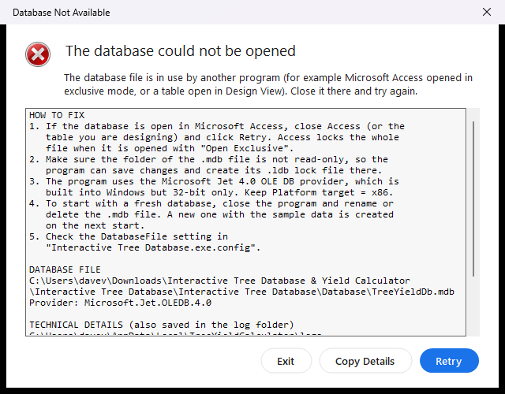
Figure 13. Shown when the database cannot be opened
Problem | What to do
"Database Not Available" when the program starts | Usually the file is open in Microsoft Access with Open Exclusive, or a table is open in Design View. Close Access and click Retry. Also check that the folder is not read-only (the program creates a small TreeYieldDb.ldb lock file next to the database). Copy Details copies the technical information for your instructor or IT staff.
"The Microsoft.Jet.OLEDB.4.0 provider is not registered" | The program was built as 64-bit. In Visual Studio open Project > Properties > Compile > Advanced Compile Options and set Target CPU to x86, then rebuild. (Jet is 32-bit only.)
The database file cannot be found | Check the DatabaseFile setting in Interactive Tree Database.exe.config (next to the .exe), or copy TreeYieldDb.mdb into a Database folder next to the .exe.
"This account is locked..." | Too many wrong passwords. Wait 5 minutes, then sign in with the correct password.
Forgot the administrator password | Close the program and open TreeYieldDb.mdb in Access. Choose Create > Query Design, close the table list, click SQL View and run UPDATE AuditLog SET UserId = Null (Run). Replace the text with DELETE FROM Users and run it too. Close Access and start the program: the default account admin / Admin@123 is created again.
Signed out automatically | The administrator session ends after 15 minutes without administrator activity. Sign in again.
"No printer is installed" | Add a printer, or turn on "Microsoft Print to PDF" in Windows Settings > Printers & scanners.
The peso sign looks wrong in the CSV file | Open the file in Excel (the file is UTF-8). The money columns use "PHP" in the headings.
Text is cut off or the window is too big | Maximize the window. The minimum size is 960 x 640.
A figure looks outdated or wrong | Ask the administrator to edit the species (Section 10.5). The sample figures are estimates.
Where are the error logs? | In the folder %LOCALAPPDATA%\TreeYieldCalculator\logs (one file per day).
Start again with fresh sample data | Administrator: Reset Sample Data. Or close the program and delete TreeYieldDb.mdb; it is re-created at the next start (Section 13.3).

15. Glossary
Term | Meaning
Annual species | A tree harvested every year once it bears (fruit, nuts, beans, latex).
Rotation species | A tree cut once when it reaches rotation age (timber, pulpwood).
Rotation age | The age, in years, at which a timber tree is harvested.
Mean annual increment | Average growth of a timber tree per year; harvest = increment x rotation age.
Board foot (board ft) | Unit of lumber volume: 1 ft x 1 ft x 1 inch.
Farm-gate price | Price the farmer receives at the farm, before transport and trader margins.
Full production | The year from which a tree gives its full yearly harvest.
Gross sales | Yield x price, before costs.
Projection horizon | Number of years shown in the projection (1-30).
Scenario | A saved calculation (species, tree count, horizon) with a name.
Audit log | A record of administrator sign-ins and changes.
Microsoft Access database (.mdb) | A single file that holds tables, relationships and rules; it can be opened in Microsoft Access.
Jet OLE DB provider | The part of Windows the program uses to read and write the .mdb file.

Appendix A. Sample species
Records created on the first start (planning estimates; yield per mature tree per year; price per unit).
Species | Product | Yield / tree / yr | Price | Harvest | Years
Carabao Mango | Fresh fruit | 300 kg | 80 | Annual | 5 / 10
Coconut | Mature nuts | 60 pcs | 15 | Annual | 6 / 10
Calamansi | Fresh fruit | 20 kg | 60 | Annual | 2 / 5
Rambutan | Fresh fruit | 80 kg | 70 | Annual | 5 / 9
Lanzones | Fresh fruit | 60 kg | 90 | Annual | 8 / 15
Durian | Fresh fruit | 120 kg | 100 | Annual | 6 / 12
Jackfruit (Langka) | Fresh fruit | 250 kg | 25 | Annual | 3 / 7
Avocado | Fresh fruit | 100 kg | 60 | Annual | 4 / 8
Cacao | Dried beans | 1.5 kg | 180 | Annual | 3 / 6
Robusta Coffee | Green coffee beans | 1 kg | 120 | Annual | 3 / 5
Guyabano | Fresh fruit | 40 kg | 80 | Annual | 3 / 6
Pomelo (Suha) | Fresh fruit | 100 kg | 50 | Annual | 5 / 8
Santol | Fresh fruit | 100 kg | 30 | Annual | 5 / 10
Pili | Nuts in shell | 30 kg | 50 | Annual | 6 / 12
Mangosteen | Fresh fruit | 50 kg | 150 | Annual | 8 / 15
Rubber | Cup lump (latex) | 4 kg | 35 | Annual | 6 / 9
Mahogany | Timber | 8 board ft | 70 | Rotation | 25
Gmelina (Yemane) | Timber | 15 board ft | 35 | Rotation | 10
Falcata | Peeler logs / timber | 20 board ft | 25 | Rotation | 8
Teak | Timber | 6 board ft | 120 | Rotation | 20
Acacia Mangium | Pulpwood / timber | 15 board ft | 25 | Rotation | 8
Bagras (Rainbow Eucalyptus) | Timber / pulpwood | 12 board ft | 30 | Rotation | 12

Years: first harvest / full production for annual species; rotation age for rotation species. The first 15 rows are Fruit-Bearing; Rubber and the six timber species are Non-Fruit-Bearing. Prices are in pesos per unit.

Appendix B. Test cases
The file docs\TEST_CASES.txt contains 40 test cases with steps, expected results and a PASS / FAIL column for the live demonstration. They cover start-up and calculation (TC-01 to TC-09), searching and inspecting records (TC-10 to TC-14), the projection (TC-15 to TC-18), scenarios, export and printing (TC-19 to TC-23), the administrator functions and security (TC-24 to TC-36), robustness and usability (TC-37 to TC-39), and the data stored in the Access file (TC-40).
In addition, the project TreeYield.Tests runs 94 automated tests, 22 of them on a throw-away Access database (expected result: "94 passed, 0 failed").

