Journal of Applied Engineering Mathematics

Volume 8, December 2021

title

NAME

Mechanical Engineering Department
Brigham Young University
Provo, Utah 84602
email

Abstract

A short abstract (100 words maximum) should open the paper or brief. The purposes of the abstract are:
- To give a clear indication of the objective, scope, and results so that readers may determine whether the full text will be of particular interest to them.
- To provide key words and phrases for indexing, abstracting, and retrieval purposes.

The abstract text should be organized to include the following categories in the order noted:
- Background
- Method of Approach
- Results
- Conclusions

Nomenclature

Put nomenclature here.

introduction

Put introduction here

Put body of the paper here:

The text should be organized into logical parts or sections. The purpose of the paper, or the author's aim, should be stated at the beginning so that the reader will have a clear concept of the paper's objective. This should be followed by a description of the problem, the means of solution, and any other information necessary to properly qualify the results presented and the conclusions. Finally, the results should be presented in an orderly form, followed by the author's conclusions.

CONCLUSIONS

Put conclusions here
Acknowledgments

Put acknowledgments here.
References

[1] Ning, X., and Lovell, M. R., 2002, “On the Sliding Friction Characteristics of Unidirectional Continuous FRP Composites,” ASME J. Tribol., 124(1), pp. 5-13.
[2] Barnes, M., 2001, “Stresses in Solenoids,” J. Appl. Phys., 48(5), pp. 2000–2008.
[3] Jones, J., 2000, Contact Mechanics, Cambridge University Press, Cambridge, UK, Chap. 6.

APPENDIX

Put appendix here.

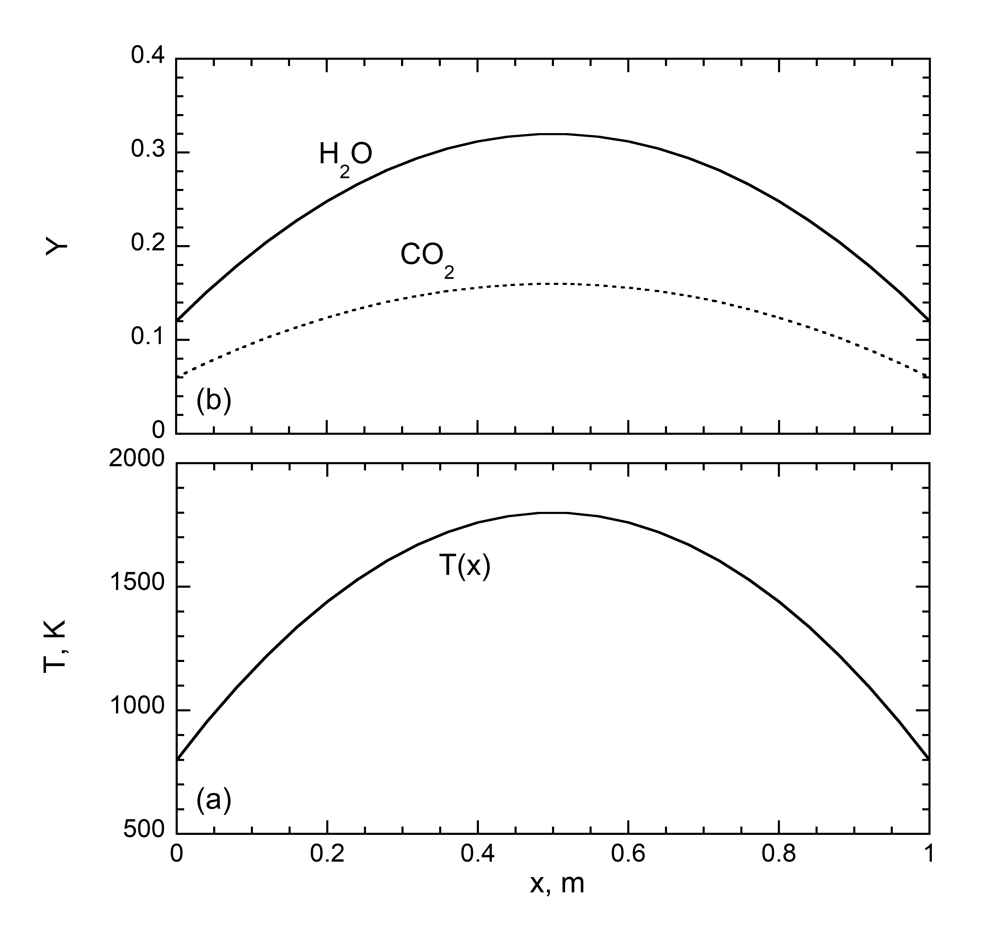

Figure 1. Profiles of temperature and gas mole fraction.

