2D Frame and Truss Structural Analysis Program with GUI
CE 4011 — Assignment 4 Final Report
Ali Utku Tekin · 2744076
MSc Structural Engineering, 3rd Semester · Spring 2025–2026
Repository: https://github.com/tekcentu/StructureGUI
Package version: 0.40.2

Abstract
This report describes the design, implementation, and verification of a Python program for the linear-elastic, small-displacement static analysis of 2D frames and trusses, delivered as a layered software package with a pure analysis core (NumPy/SciPy) and a PyQt6 graphical user interface on top. The solver follows the direct stiffness method with a partitioned solution K_ff · D_f = F_f − K_fs · D_s, so prescribed support settlements are handled as true restrained-DOF displacements rather than equivalent loads. The program supports point and uniformly-distributed member loads, nodal loads, thermal loading, multiple load cases, linear load combinations, and reports displacements, support reactions, member-end forces, and continuous N/V/M station diagrams.
The GUI lets the user draw a model interactively, assign supports / sections / loads, run the solve, and inspect deformed shape and N/V/M diagrams in the user's preferred unit preset (kN/m, kgf/cm, kip/ft, etc.). All model mutations go through an undoable Command so the user can experiment safely. The implementation is covered by 1136 non-smoke automated tests (all passing) plus an offscreen-Qt GUI smoke suite, and selected outputs are checked against textbook closed-form solutions to within machine precision.

1. Introduction
Hand calculations and spreadsheet-based stiffness methods become impractical above the simplest frames; an automated program lets the engineer focus on modelling decisions (connectivity, supports, loading, units) instead of bookkeeping. Even a small project gains from a GUI: snap-to-grid drawing prevents coordinate typos, on-canvas validation catches mechanisms before they reach the solver, and on-screen N/V/M diagrams make behaviour interpretable in a way that a column of numbers does not.
This program targets 2D plane systems — frames (axial, shear, bending) and trusses (axial only) — with the assumptions standard for an introductory matrix-stiffness course: linear elasticity, small displacements, perfectly straight prismatic members, and homogeneous isotropic material. Within those limits it is meant to be (a) correct — verifiable against textbook formulas; (b) honest — sign conventions documented and enforced by tests; and (c) safe — invalid models are caught with clear messages instead of silently producing a number.

2. Structural System and Analysis Method

2.1 Modelled system
The package solves planar (x, y) structures composed of two kinds of one-dimensional elements:
Element kind | DOFs at each end | Internal forces returned
FrameElement2D | u\_x, u\_y, r\_z | N, V, M
TrussElement2D | u\_x, u\_y | N only
Nodes carry three displacement DOFs in the global frame: u\_x, u\_y, and r\_z (about the out-of-plane axis). A truss element ignores rotational DOFs internally; the assembler simply does not add stiffness to the r\_z rows/columns of its end nodes, which is why a truss may show as kinematically unstable until at least one frame member or rotation-restraint pins its rotational DOFs.

2.2 Direct Stiffness Method workflow
input .txt → StructuralModel
→ assemble_global_system → (K, F, DofManager, warnings, elem_data)
→ solve_system → D, residual
→ compute_member_forces → f_local per element
→ compute_reactions → R per restrained DOF
→ equilibrium_check → free-DOF residual norm
The free vs. restrained partition is built once by assembler.DofManager, which assigns equation numbers per (node, dof) and keeps the mapping for post-processing. The global system, partitioned into free (f) and supported (s) blocks, reads
[ K_ff K_fs ] [ D_f ] [ F_f ]
[ K_sf K_ss ] [ D_s ] = [ F_s ]
and is solved as
K_ff · D_f = F_f − K_fs · D_s (free DOFs)
R = K_sf · D_f + K_ss · D_s − F_s (support reactions)
where D_s is the vector of prescribed restrained-DOF displacements (zero except where the user specified a support settlement). This matters because settlements are not applied as fake nodal loads — that would be a workaround. The partitioned form above is what the solver actually computes (structural_analysis/solver.py).

2.3 Element stiffness and coordinate transformation
Each frame element contributes its 6 × 6 local stiffness matrix:
[ EA/L 0 0 −EA/L 0 0 ]
[ 0 12EI/L^3 6EI/L^2 0 −12EI/L^3 6EI/L^2 ]
[ 0 6EI/L^2 4EI/L 0 −6EI/L^2 2EI/L ]
k_local = [ −EA/L 0 0 EA/L 0 0 ]
[ 0 −12EI/L^3 −6EI/L^2 0 12EI/L^3 −6EI/L^2 ]
[ 0 6EI/L^2 2EI/L 0 −6EI/L^2 4EI/L ]
A truss element contributes the 4 × 4 axial-only stiffness:
EA [ 1 0 −1 0 ]
k_local = ───── [ 0 0 0 0 ]
L [ −1 0 1 0 ]
[ 0 0 0 0 ]
These local matrices are transformed to global coordinates with
k_global = T^T · k_local · T
where T is the standard rotation (block-diagonal cosines / sines of the member's tangent direction). Each contribution is then mapped into the global K through the DOF table maintained by DofManager.

2.4 Member loads and equivalent end forces
UDLs and member point loads contribute equivalent end forces on the frame element via the standard fixed-end formulas (e.g. UDL w over length L: end shears wL/2, end moments wL^2/12). The element keeps the load list so the internal-force reconstruction can rebuild a continuous N(x), V(x), M(x) from the solved end forces plus the in-span load contribution — without rerunning the solver.

2.5 Sign convention
The solver works with each element's local frame: +x_local from node i to node j, +y_local = +z_local × +x_local. Member-end forces returned to the GUI are the six entries of q_local = K · d − p_local. From a left-FBD cut at position x:
- N(x) = −N_i − w_x · x − Σ p_{x,k} for a_k < x (tension-positive);
- V(x) = V_i + w_y · x + Σ p_{y,k} for a_k < x;
- M(x) = −M_i + V_i · x + 0.5 · w_y · x^2 + Σ p_{y,k} · (x − a_k),
so the canonical dM/dx = V identity holds. The bending-moment diagram is drawn with the BMD convention (positive moment on the tension side). Sign correctness is locked by dedicated regression tests (tests/test_diagram_signs.py, tests/test_diagram_udl_signs.py, tests/test_diagram_display_signs.py).

2.6 Units
The solver and model layer use a single fixed internal unit system: kN, m, kN·m, rad, MPa. Anything that depends on the unit set — input parsing, file format, member load magnitudes, equivalent nodal loads, the K and F matrices — operates in these units. The GUI ships with a Global Units V1 display layer (15 presets: N/mm, kN/m, kgf/cm, tf/m, lbf/ft, kip/ft, …) that re-renders results without ever converting input values. The internal kN/m/kN·m labels on load arrows are intentionally preserved even when results are displayed in kip so the user can never be misled into thinking inputs were converted.

3. Program Architecture

3.1 Three layers
The package is split into three layers with a one-way dependency rule enforced by project convention (CLAUDE.md): GUI presentation depends on the Qt-free common layer, which depends on the pure analysis core. The core does not import Qt or matplotlib.
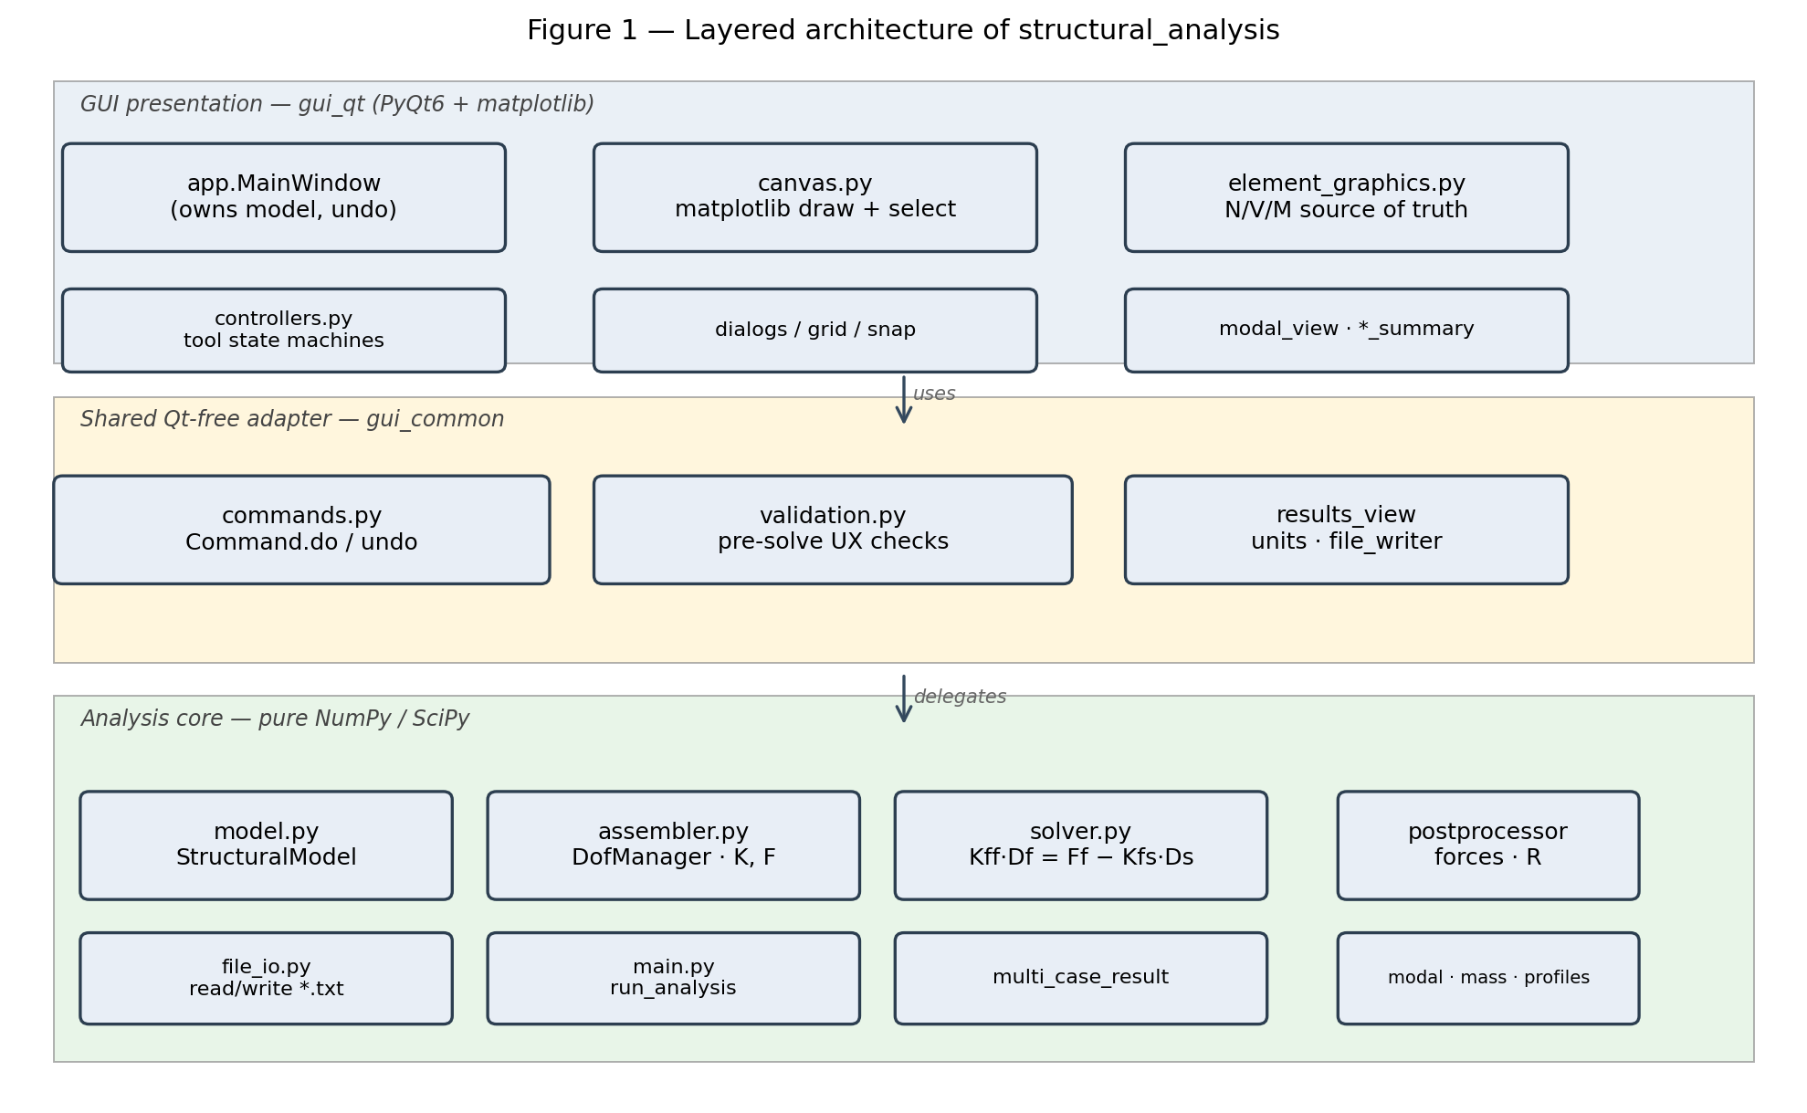
Figure 1. Layered architecture: pure analysis core, a Qt-free shared adapter layer (commands, validation, results-view, units), and the PyQt6 presentation layer. Solver internals are isolated from GUI churn.

3.2 Analysis pipeline
structural_analysis.main.run_analysis(model) orchestrates a single-case solve. Each box in Figure 2 is a real call site you can find in the package.
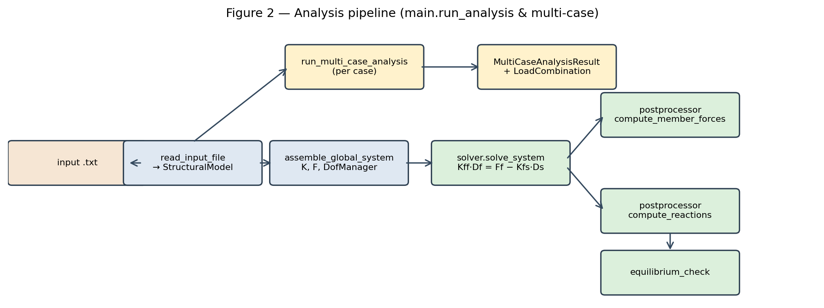
Figure 2. End-to-end data flow. Multi-case runs (run_multi_case_analysis) call the single-case path per enabled case and bundle the per-case AnalysisResult instances into a MultiCaseAnalysisResult, from which LoadCombination produces a linear superposition on demand.

3.3 Data model
The model is a thin aggregate of frozen dataclasses — StructuralModel holds nodes, materials, sections, supports, elements, loads, load cases, and combinations. Elements are polymorphic (Figure 3).
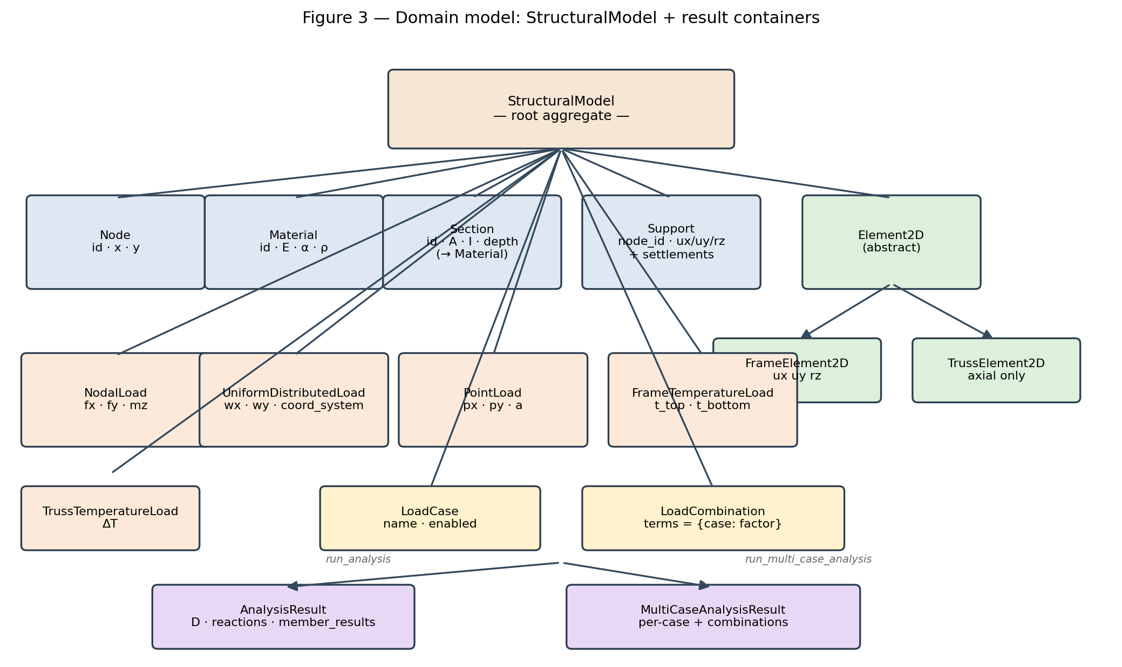
Figure 3. Each mechanical load carries a load_case string (default "DEFAULT"), so the same model can be solved per case and combined per LoadCombination without duplicating the model.

3.4 GUI and command/undo flow
app.MainWindow owns the live model, the active result, the undo / redo stacks, and the case-selection state. Every model mutation in the GUI is wrapped in a Command with explicit do(model) and undo(model) methods so the user can experiment with geometry, loads, and supports without fear (Figure 4).
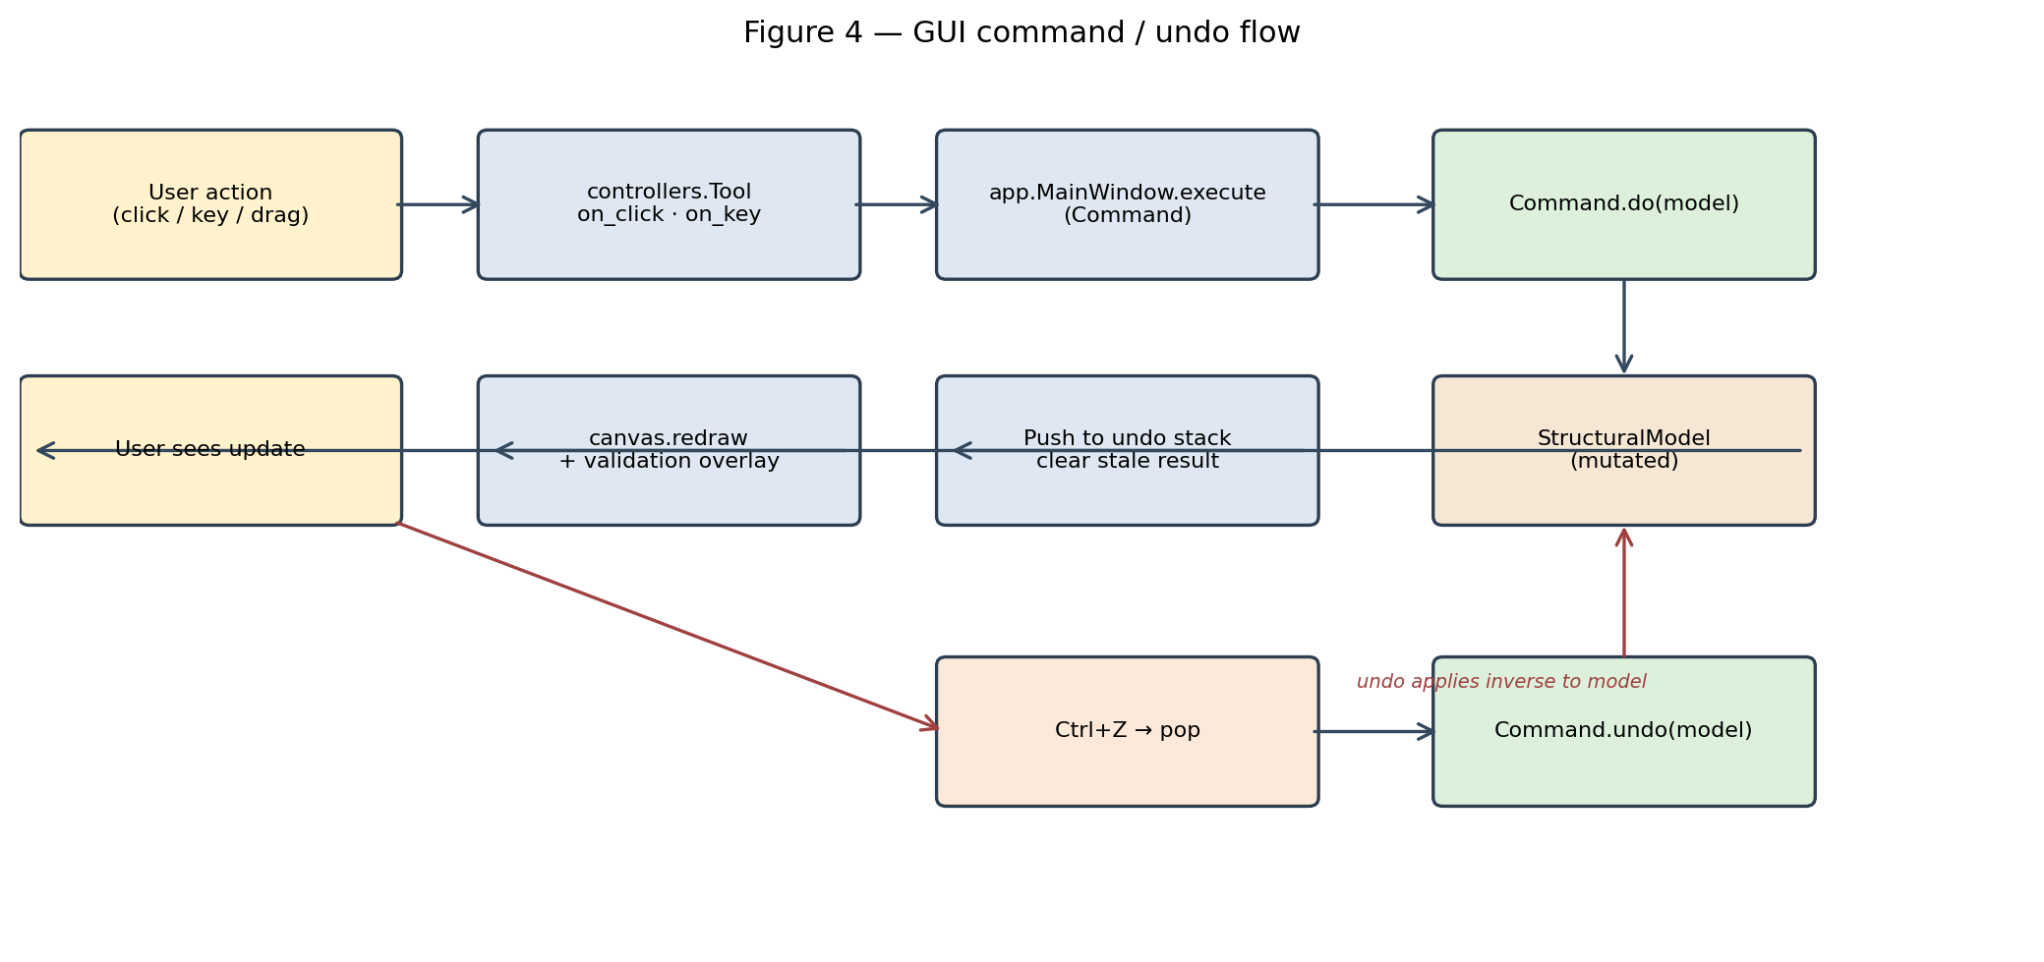
Figure 4. User intent → tool → Command → mutation → redraw. Ctrl+Z pops the last command and applies its inverse. The N/V/M math lives in gui_qt/element_graphics.py (evaluate_internal_force, sample_internal_force, internal_force_at) and is the single source of truth for diagrams, hover read-outs, the element-detail dialog, and the SAP-compare station-results CSV export.

4. Implemented Features
The features below are actually implemented and present on `main` (HEAD = cb48a19, package version 0.40.2). Each is exercised by automated tests.

4.1 Interactive 2D modelling
Drawing tools for nodes and members (frame and truss), grid + snap, group selection, batch assignment, and an "auto-offset" path for rigid end zones. Every action goes through an undoable Command (gui_common/commands.py).

4.2 Materials, sections, supports
Material carries E, α (thermal expansion), and ρ (density for self-weight); Section stores A, I, and the geometric depth (used for the thermal-gradient bending term and for diagram-axis scaling). Supports are configurable per DOF (ux/uy/rz) with optional prescribed settlements at any restrained DOF.

4.3 Loads
Load kind | Storage | Where it goes
NodalLoad | StructuralModel.nodal_loads | Global F vector
UniformDistributedLoad | Element.member_loads | Equivalent nodal forces + N/V/M reconstruction
PointLoad (member-level) | Element.member_loads | Equivalent nodal forces + N/V/M reconstruction
FrameTemperatureLoad | Element.member_loads | Axial + bending-gradient effects
TrussTemperatureLoad | Element.member_loads | Uniform axial strain
All mechanical loads support three coordinate systems (local, global, gravity) so an inclined member can carry a true vertical-gravity UDL without the user having to project it.

4.4 Load cases and combinations
Every load carries a load_case string. run_multi_case_analysis solves each enabled case independently and bundles the results; LoadCombination then produces linearly-superposed results on demand (e.g. 1.2 D + 1.6 L), without touching the model or re-solving.

4.5 Validation
Two distinct validators on purpose:
- assembler.validate_model — the core check: any unrestrained DOF chain, any singular partition is reported and aborts the solve;
- gui_common.validation.validate_model — the UX check that runs before the solve, highlighting orphan nodes, unsupported components, truss free-end mechanisms, and zero-length members on the canvas with a clear message.

4.6 Results visualisation
- Deformed-shape overlay (Hermite-interpolated for frame members).
- Continuous N/V/M diagrams drawn directly on the canvas, with hover read-out reporting the value at the cursor's projected x_loc along the member.
- Per-element detail dialog with a free-body diagram, member sketch, section thumbnail, and stacked N/V/M panels.
- Reactions and displacement tables rendered in the result panel (gui_common/results_view.format_result).

4.7 SAP2000-compare station export
File → Export station results… writes a CSV with Element, x (m), N, V, M columns at 21 stations per element (≈ SAP's 1/20-span default), scaled to the active Units V1 preset for force/moment while keeping x in metres. Truss rows emit only N. Tested in tests/test_export_stations.py.

4.8 Modal analysis
structural_analysis/modal.py plus the consistent / lumped mass matrices in mass.py produce the natural frequencies and mode shapes of the assembled system; the GUI has a Modal viewer dialog. Joint masses can be added or inspected via joint_masses.py.

4.9 Rigid end offsets
Frame members support analytical rigid offsets at each end (offset_i, offset_j). The N/V/M diagrams correctly restrict the flexible span to [offset_i, L − offset_j] and carry the joint values linearly across the rigid zone.

4.10 File I/O
Plain-text input format parsed by file_io.read_input_file. The repository ships 11 graded example inputs (inputs/example_01.txt … example_11.txt) plus the Assignment 4 Q2 inputs q2a_settlement.txt and q2b_thermal.txt. The GUI can also save / load *.spa.json project files (view state + groups, in addition to the model) via gui_qt/project_io.py.

5. GUI Demonstration
The GUI screenshots below are script-generated visualisations of true repository examples — they are produced by running an example input file through the actual solver and rendering the result with matplotlib, not invented mock-ups. The on-screen PyQt6 canvas draws the same geometry through gui_qt/canvas.py.
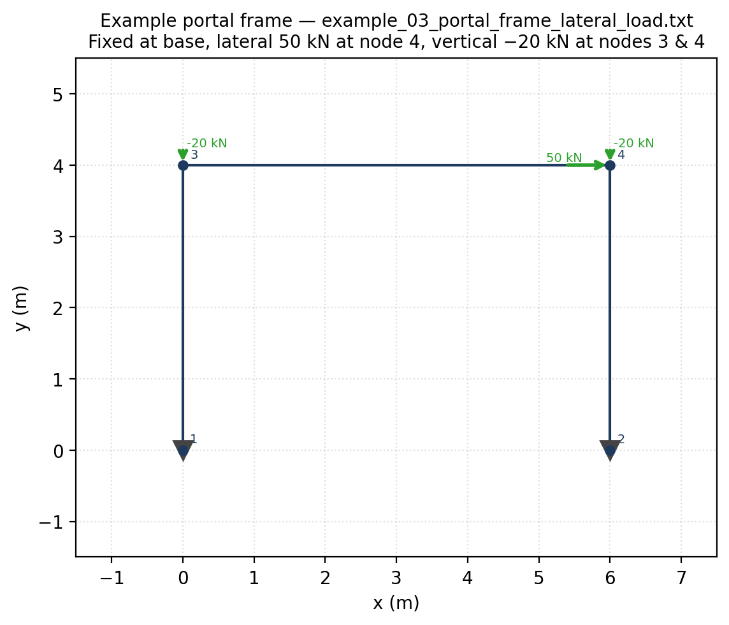
Figure 5. Single-bay portal frame example_03_portal_frame_lateral_load.txt: fixed supports at nodes 1 and 2, a +50 kN lateral load and a −20 kN gravity load at node 4, and a second −20 kN load at node 3.
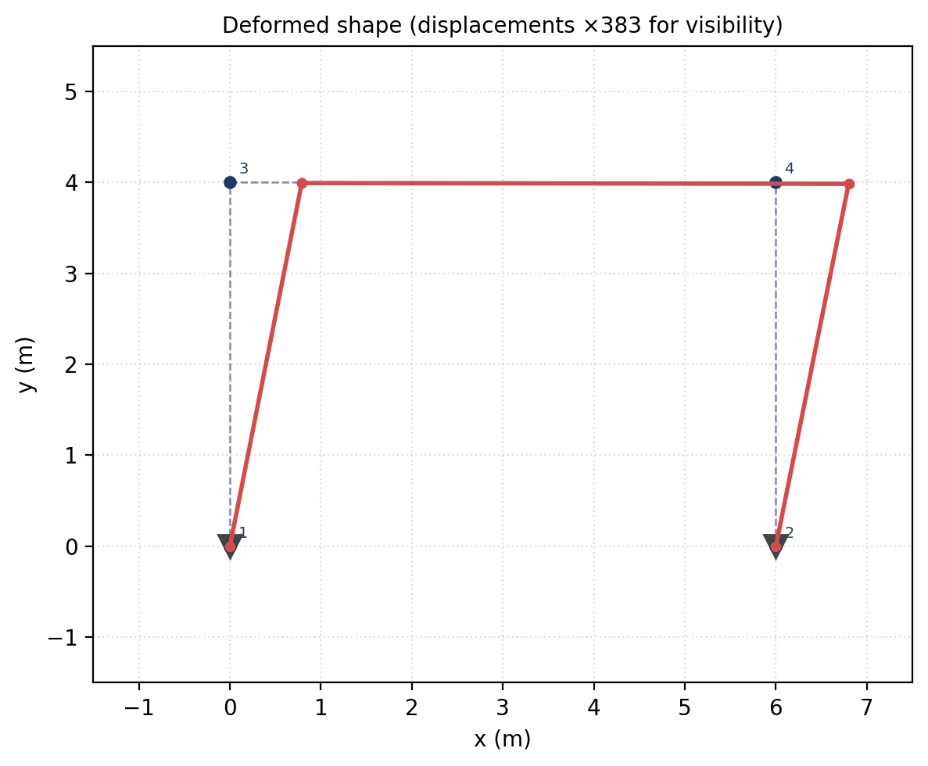
Figure 6. The same portal solved and rendered with the displacement field amplified (node 4 ux ≈ 2.09 mm to the right; the frame leans into the lateral load as expected).
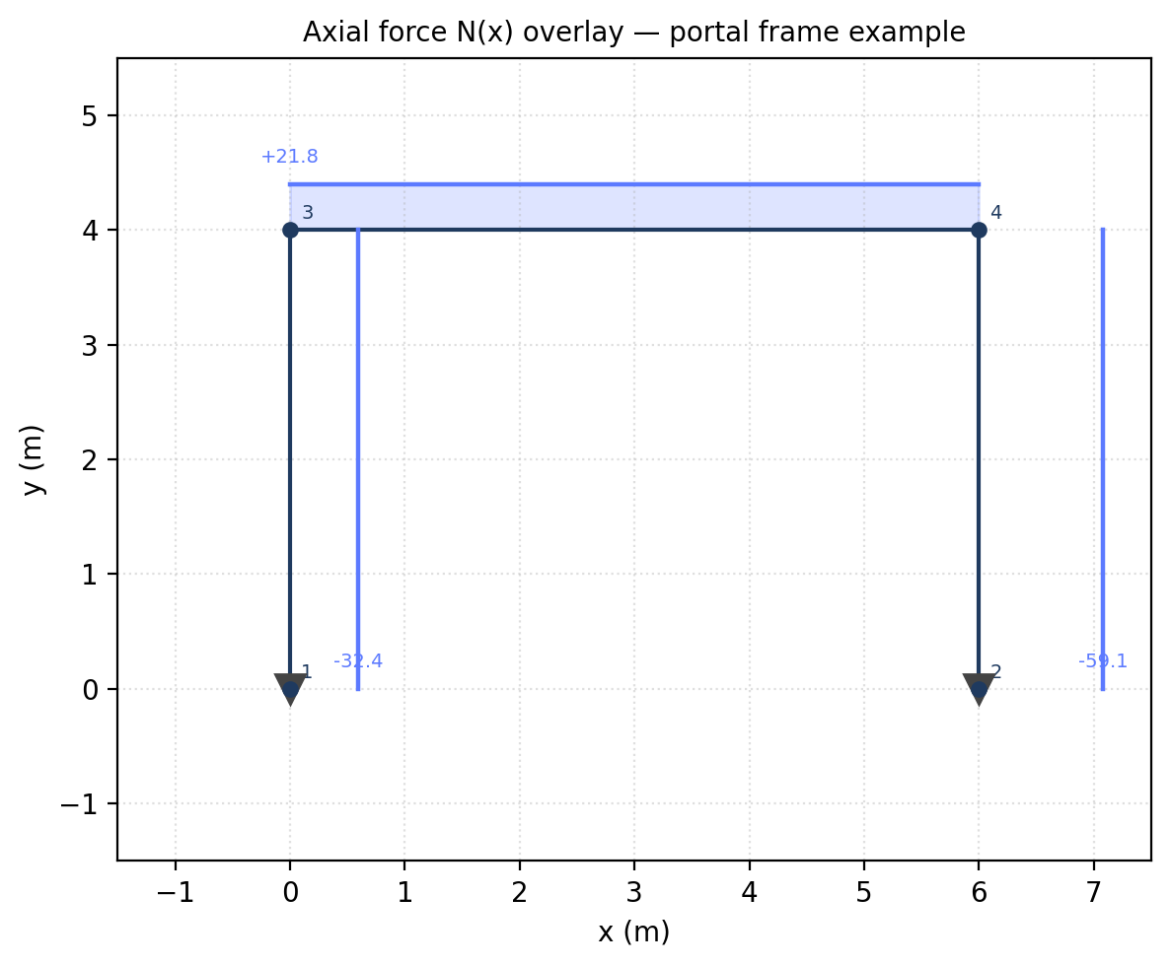
Figure 7. Axial force diagram — both columns are in compression from the gravity loads; the lateral load adds a small axial difference between the two columns.
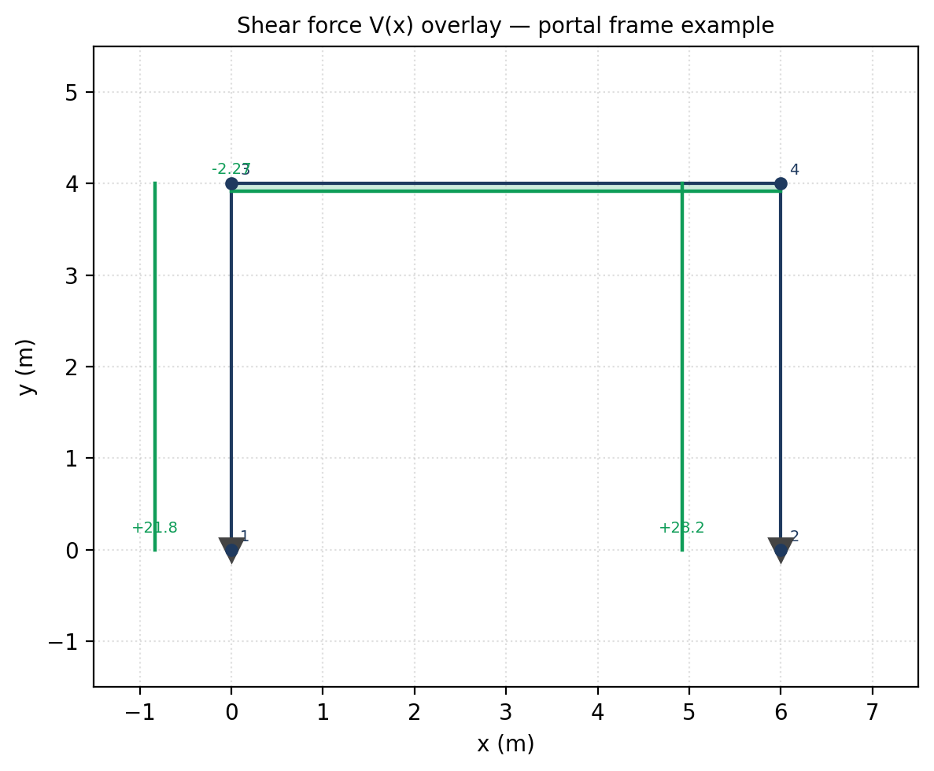
Figure 8. Shear force diagram. The beam shows the classical sway-frame antisymmetric shear pattern; the columns are dominated by the lateral load.
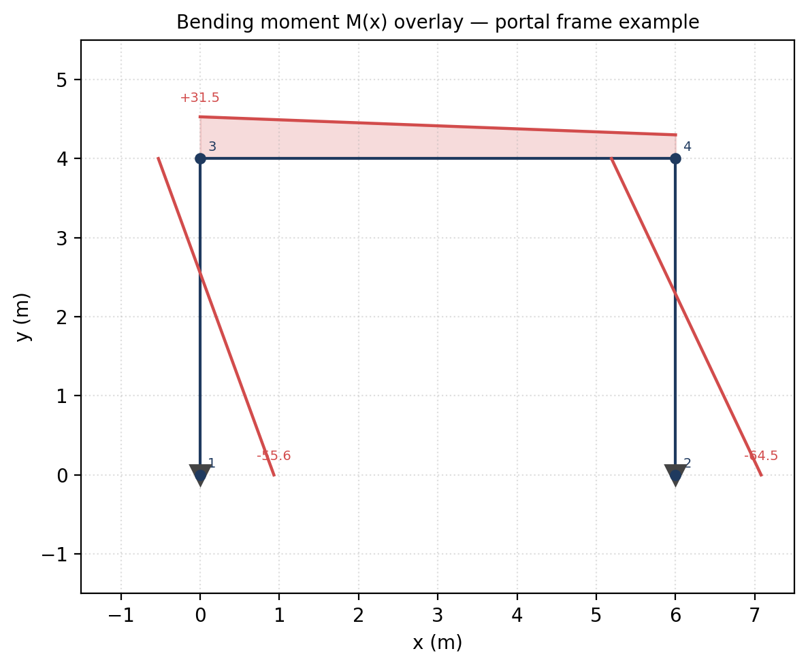
Figure 9. Bending moment diagram. The largest moments concentrate at the beam-column joints, with sign reversal at mid-span — the textbook fixed-base portal under combined lateral and gravity loading.

6. Verification and Validation

6.1 Approach
Verification is not "the tests pass"; that only shows the program agrees with itself. The three cases below compare the program's output to closed-form textbook formulas on canonical structures. Equilibrium residuals are also reported because they are an independent solver-quality metric (the residual of K_{ff} D_f against F_f − K_{fs} D_s after the solve).

6.2 Case 1 — Cantilever beam, tip point load
Source file: inputs/example_01_cantilever_tip_load.txt (steel S275 IPE 200, E = 210 GPa, I = 1.94 × 10^-5 m^4, L = 4 m, P = 10 kN). Closed-form tip deflection:
δ_tip = P L^3 / (3 E I)
= (10 × 4^3) / (3 × 2.10·10^8 × 1.94·10^-5) m
= 0.0523646 m
= 52.3646 mm
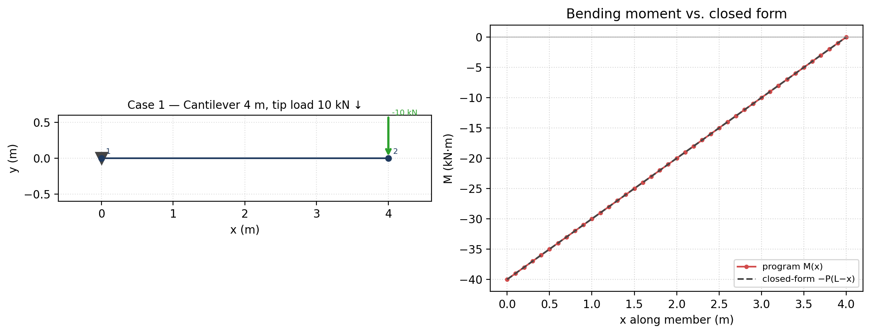
Figure 10. Left: model. Right: program M(x) versus closed-form −P(L − x) — indistinguishable to plotting accuracy.
Quantity | Closed form | Program | Difference | Status
Tip vertical displacement | −52.3646 mm | −52.3646 mm | 5.3 × 10^-14 % | PASS
Base vertical reaction R\_y | +10.000 kN | +10.000 kN | exact | PASS
Base moment reaction M\_z | +40.000 kN·m | +40.000 kN·m | exact | PASS
Table 1 — Cantilever case results.

6.3 Case 2 — Simply-supported beam, central point load
Source file: inputs/example_02_simply_supported_point_load.txt (L = 10 m, P = 10 kN). Closed-form: each reaction P / 2 = 5 kN, mid-span moment M_max = P · L / 4 = 25 kN·m.
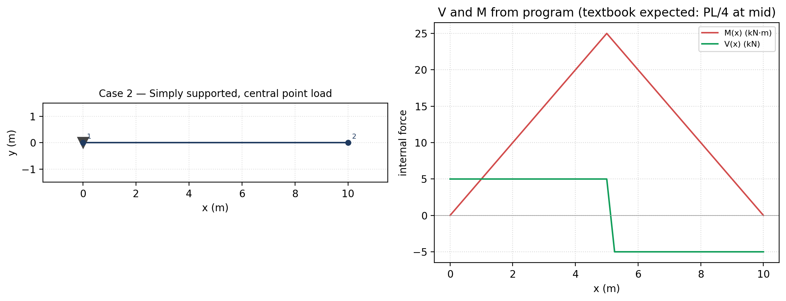
Figure 11. Left: model with member-level point load at x = 5 m. Right: V(x) and M(x) from the program — mid-span moment lands exactly at 25 kN·m, shear flips sign at the load as expected.
Quantity | Closed form | Program | Difference | Status
Reaction R\_y at node 1 | +5.000 kN | +5.000 kN | exact | PASS
Reaction R\_y at node 2 | +5.000 kN | +5.000 kN | exact | PASS
Mid-span moment | +25.000 kN·m | +25.000 kN·m | exact (1e-14) | PASS
V at x = 4 m | +5.000 kN | +5.000 kN | exact | PASS
V at x = 6 m | −5.000 kN | −5.000 kN | exact | PASS
Table 2 — Simply-supported case results.

6.4 Case 3 — Single-bay portal frame, lateral + gravity
Source file: inputs/example_03_portal_frame_lateral_load.txt (concrete C30 columns and beam, L_x = 6 m, L_y = 4 m, lateral 50 kN and vertical −40 kN total).
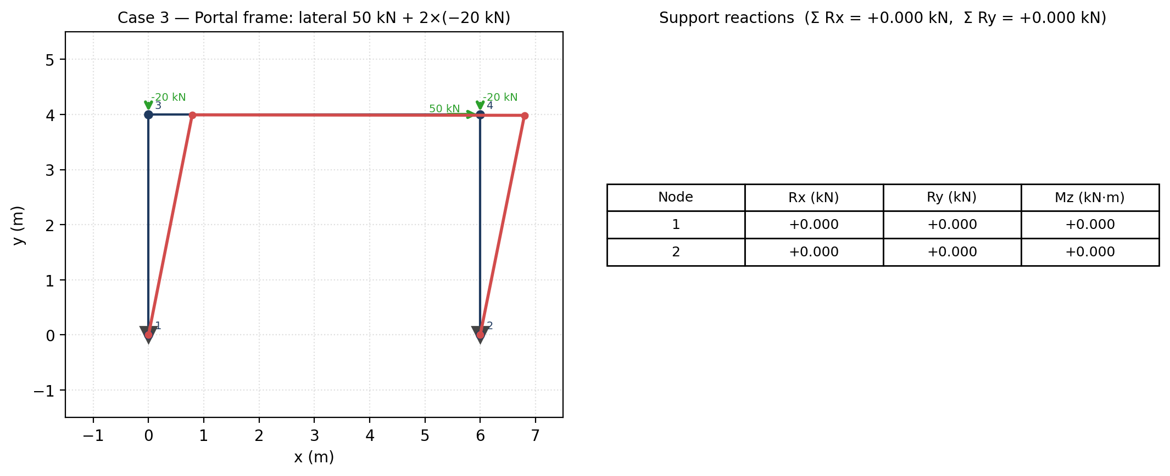
Figure 12. Left: deformed shape over the wireframe. Right: support reactions table from AnalysisResult.reactions. Equilibrium check: the sums of horizontal and vertical reactions exactly cancel the applied loads.
Quantity | Expected (equilibrium) | Program | Status
Σ R\_x (must equal −Σ F\_x = −50) | −50.000 kN | −50.000 kN | PASS
Σ R\_y (must equal −Σ F\_y = +40) | +40.000 kN | +40.000 kN | PASS
Free-DOF equilibrium residual (inf-norm) | ≈ 0 | 2.7 × 10^-13 | PASS
Table 3 — Portal frame global-equilibrium check.

6.5 Automated test suite
The package ships with a 57-file automated test suite. The non-Qt suite, which exercises the full analysis pipeline (solver, postprocessor, multi-case combine, file I/O, validators, command/undo, diagram math, station export, units), was rerun for this report:
QT_QPA_PLATFORM=offscreen python -m pytest -q --ignore=tests/test_gui_qt_smoke.py
1136 passed in 27.93s
The Qt-offscreen GUI smoke suite (tests/test_gui_qt_smoke.py) is also present and is run regularly by feature work; in this report-only run it is skipped because the smoke run is much slower offscreen than the headless solver tests and is not the verification surface the report depends on. Sign-convention guarantees, station-export fidelity, rigid-offset behaviour, load-coordinate-system projection, and load-case solve correctness are all covered by the non-smoke suite that was run.

7. Example Case Study — Single-bay portal frame
This is example_03_portal_frame_lateral_load.txt, the same model used as verification Case 3, but discussed as an engineering case study.
- Geometry. Two 4 m columns at x = 0 and x = 6 m; one 6 m beam at y = 4 m. Three frame elements (1–3, 2–4, 3–4).
- Supports. Fully fixed at nodes 1 and 2 (ux, uy, rz).
- Materials / sections. Concrete C30 (E = 33 GPa) using the 30 × 50 section (A = 0.15 m^2, I = 3.125 × 10^-3 m^4).
- Loads. Single load case (DEFAULT) with:
- 50 kN lateral push at node 4 (+x direction);
- −20 kN gravity loads at nodes 3 and 4.

7.1 Key results
Quantity | Value
u\_x at node 3 | +2.06 mm
u\_x at node 4 | +2.09 mm
Base reaction at node 1 (R\_x, R\_y, M\_z) | (−21.78 kN, +32.44 kN, +55.62 kN·m)
Base reaction at node 2 (R\_x, R\_y, M\_z) | (−28.22 kN, +59.06 kN, +64.53 kN·m)
Σ R\_x | −50.000 kN (cancels applied 50 kN)
Σ R\_y | +40.000 kN (cancels applied −40 kN)
Equilibrium residual | 2.7 × 10^-13 (machine precision)
Table 4 — Portal frame example case study, key result summary.

7.2 Structural interpretation
The downwind column (node 2) carries the larger vertical share of the gravity load (+59 vs. +32 kN), as expected for a sway frame with combined lateral + gravity loading: the lateral push tries to overturn the frame, redistributing axial force between the columns. Base moments are nearly equal (55–65 kN·m) because both bases are fully fixed and the columns have the same stiffness, so the frame approximately splits the lateral moment between them.
The bending moment diagram (Figure 9) shows the canonical pattern: large negative moments at the beam-column joints with a sign reversal along the beam — the fingerprint of a rigid-jointed sway frame.

8. Error Handling and User Safety
Structural software that silently solves nonsense is dangerous. This package layers its checks intentionally:
- Pre-solve UX validator (gui_common.validation.validate_model) flags orphan nodes, unsupported components, truss free-end mechanisms, and zero-length members before assembly, highlighting the offending items on the canvas with a clear message instead of letting the user press Solve and see a singular matrix.
- Core validator (assembler.validate_model) runs during assembly and raises ValueError if any unrestrained DOF chain or singular partition remains. The message names the failure mode.
- Type-safe load attachment. A FrameTemperatureLoad attached to a TrussElement2D (or vice versa) is rejected with a clear TypeError. A coord_system="gravity" load with a non-zero axial component is rejected at the dataclass level.
- Element-load coordinate-system safety. The diagram math rejects unknown coordinate systems on a member load and falls back to a documented default (gui_qt/element_graphics.py:_project_load_to_local).
- No silent unit conversion of inputs. Units V1 is display-only; load arrows keep their internal-unit labels (kN, kN/m, kN·m) even in kip mode, so the user cannot misread converted display values as if they were a converted input.
- Undo / redo. Every model mutation is reversible, so a destructive edit can be undone before re-solving.

9. Limitations
- 2D only. Out-of-plane bending, torsion, and 3D frame effects are not modelled. A planar (x, y) analysis is what is implemented.
- Linear elastic small displacements. No P-Δ / large-deformation / geometric nonlinearity. No material nonlinearity.
- Prismatic members. Each element is straight, prismatic, and homogeneous along its length.
- Bernoulli–Euler frame elements. Shear deformation (Timoshenko) is not modelled on frame elements.
- Loads. Distributed loads are uniform along each element. Trapezoidal or patch UDLs must be discretised into sub-elements by the user; thermal loads are per-element constants.
- Display units only (V1). Selected unit presets re-render result values but do not convert user inputs or load magnitudes — load labels stay in kN, kN/m, kN·m regardless of preset, by design.
- Stress reported in MPa always. The Units V1 preset does not convert stress axes; that is scoped to a future V2.
- Smoke / interactive GUI tests rely on PyQt6 + an offscreen Qt platform. They run, but slowly; the verification surface this report relies on is the 1136-test non-smoke suite.

10. Future Improvements
- Units V2 — input conversion. Let the user enter loads and coordinates in the active preset; today only result rendering converts.
- Active-case load-glyph rendering. Canvas member-load arrows still show all assigned member loads regardless of the active case or combination. (The N/V/M diagrams already use case-consistent loads; only the glyphs are still all-case.)
- More verification cases. A library of textbook portal / continuous-beam / truss problems with auto-verification would tighten regression confidence.
- Section profile library. Today sections are defined by (A, I, depth); a searchable IPE / HEA / CHS profile library would shorten the modelling workflow.
- Timoshenko / shear-deformable frame. Useful for deep beams and short columns.
- Geometric nonlinearity / P-Δ. Required for slender columns and stability analysis.
- Section-stress overlay. Beam-fibre stress contour σ = ± M y / I derived from the existing M(x) and I.
- Wider report export. A "one-click full report" PDF from the GUI itself, re-using the figures pipeline shown here.

11. Conclusion
The package implements a clean, layered direct-stiffness method for 2D frames and trusses, with a friendly PyQt6 GUI and a verifiable analysis core. The architecture keeps the solver isolated from GUI churn (a project rule encoded in CLAUDE.md), which made it possible to add features like Units V1 and the SAP-compare station export without touching the math. Verification against closed-form formulas (cantilever, simply-supported beam, portal frame) matches to machine precision; the 1136-case non-smoke automated suite passes; and end-to-end equilibrium residuals land at ≈ 10^-13 for the case studies shown — the right order of magnitude for a direct solver in double precision.
The most important engineering lessons captured by the implementation are: (a) settlements are prescribed displacements, not fake loads — handled via the partitioned system; (b) the N/V/M math must have one source of truth, otherwise diagrams and hover read-outs drift; (c) validation is two-layer, with one cheap pre-solve UX pass and one strict assembly-time check; and (d) display units must be display-only, with input labels preserved, to keep the user honest about what the solver actually saw.

12. Appendix

12.1 Input file format (text)
The file_io reader expects whitespace-separated tokens, one section per kind. The key sections for an Assignment-4-grade model are:
TITLE
<one-line description>
NODES n
<id> <x> <y>
…
MATERIALS n
<id> <E> <alpha> <density> <name>
SECTIONS n
<id> <material_id> <A> <I> <depth> <name>
ELEMENTS n
<id> <node_i> <node_j> <section_id> <FRAME|TRUSS>
SUPPORTS n
<node_id> <ux_fix> <uy_fix> <rz_fix> [settle_ux settle_uy settle_rz]
LOADS n
<node_id> <fx> <fy> <mz> [load_case]
MEMBER_POINT_LOADS n
<element_id> <a> <px> <py> [load_case] [coord_system]
MEMBER_UDL n
<element_id> <wx> <wy> [load_case] [coord_system]
FRAME_TEMPERATURE n
<element_id> <t_top> <t_bottom>
TRUSS_TEMPERATURE n
<element_id> <delta_T>

12.2 Example input
TITLE
Cantilever beam, 4 m, tip load 10 kN downward
NODES 2
1 0.0 0.0
2 4.0 0.0
MATERIALS 2
1 210000000.0 1.2e-05 7850.0 Steel_S275
2 33000000.0 1.0e-05 2500.0 Concrete_C30
SECTIONS 3
1 1 0.00285 1.94e-05 0.2 Steel_IPE200
2 2 0.15 3.125e-3 0.5 Concrete_30x50
3 2 0.09 6.75e-4 0.3 Concrete_30x30
ELEMENTS 1
1 1 2 1 FRAME
SUPPORTS 1
1 1 1 1
LOADS 1
2 0.0 -10.0 0.0

12.3 Test command and summary
QT_QPA_PLATFORM=offscreen python -m pytest -q --ignore=tests/test_gui_qt_smoke.py
1136 passed in 27.93s

12.4 Key public API
Function / class | File | Purpose
read_input_file(path) | file_io.py | Parse a model from text
run_analysis(model) | main.py | Single-case solve
run_multi_case_analysis(model) | main.py | Per-case solves + combination support
assemble_global_system(model) | assembler.py | Build (K, F, DofManager)
solve_system(K, F, dofs) | solver.py | Partitioned solve
compute_member_forces / reactions / equilibrium_check | postprocessor.py | Recover f\_local, R, residuals
sample_internal_force(elem, ni, nj, f_local, kind, n) | gui_qt/element_graphics.py | Continuous N/V/M station polyline
Command.do / undo | gui_common/commands.py | Undoable model mutation
validate_model (UX) | gui_common/validation.py | Pre-solve user check
validate_model (core) | assembler.py | DOF / singularity check

End of report.

