CE 4011

Special Topics in Civil Engineering:
Structural Analysis Software Development
Assignment #4
Extension of the 2D Structural Analysis Program with
Thermal Loading and Support Settlements

GitHub repository: https://github.com/tekcentu/CE4011_Assignment4_FINAL
Spring Semester 2025-2026 | Due Date: 20.04.2026

AI Reference: Claude (Anthropic) and ChatGPT (OpenAI)
Submitted By
Ali Utku Tekin
Student ID: 2744076
MSc. in Structural Engineering
3rd Semester

Table of Contents

Q1: Program Extension with Thermal Loading and Support Settlements

1.1 Overview
This report documents the extension of the Assignment 3 structural analysis program to support two new capabilities required by Assignment 4. The first is thermal loading, which includes both uniform temperature change along a member and through-depth temperature gradient effects in frame members. The second is support settlements, in which a prescribed non-zero displacement is imposed at a restrained degree of freedom.
The extension was designed to follow proper object-oriented principles and to preserve every Assignment 3 feature without modification. The thermal expansion coefficient alpha and the cross-section depth are stored on the Material class because they are intrinsic properties of the material and section, not of any particular thermal load. Two dedicated load classes, TrussTemperatureLoad and FrameTemperatureLoad, match the physics of each element type. Incompatible load-element combinations are rejected at runtime with a descriptive TypeError rather than silently ignored. Support settlements are handled as prescribed displacements that plug into a partitioned linear-system solution, which reduces to the classical Assignment 3 solve when no settlements are present.
The complete package contains the extended source code, a fifty-nine-test suite in which all fifty-three Assignment 3 tests continue to pass unchanged plus six new Assignment 4 tests (four unit tests and two integration tests), example input files for both Q2 structures, generated console outputs, an updated UML class diagram, a README describing installation and execution, and this report.

1.2 Assignment Requirements Coverage
The table below maps each Assignment 4 requirement onto the corresponding component of the delivered package. Every rubric item is addressed within this report.
Assignment Requirement | How the Project Satisfies It
Q1(a) thermal loading, uniform temperature | FrameTemperatureLoad with equal t_top and t_bottom applied to frame members produces a pure axial fixed-end force N_T = E*A*alpha*DeltaT. TrussTemperatureLoad(delta_T) handles the same effect on truss members. Verified in UT-A4-1 and IT-A4-2.
Q1(a) thermal loading, gradient effects | FrameTemperatureLoad with distinct t_top and t_bottom produces both an axial component from the mean temperature and a bending component M_T = E*I*alpha*(t_bottom - t_top)/depth from the difference. Verified in UT-A4-2.
Q1(b) support settlements | Support dataclass extended with settle_ux, settle_uy, settle_rz fields. Solver uses partitioned system K_ff*D_f = F_f - K_fs*D_s that reduces to classical solve when D_s is zero. Verified in IT-A4-1 against closed-form expressions 3*E*I*Delta/L^2 and 3*E*I*Delta/L^3.
Revised OOP design presented | Section 1.3 walks through each design decision: ownership of material properties, split thermal load classes, explicit validation, partitioned solve for settlements.
Modifications: what, where, how | Section 1.4 Module Change Table identifies every modified module and the rationale. Section 1.5 shows updated UML.
At least two unit tests | UT-A4-1, UT-A4-2, UT-A4-3, UT-A4-4 (four unit tests). Documented in Section 1.6.
At least two integration tests | IT-A4-1 (settlement end-to-end) and IT-A4-2 (thermal end-to-end). Documented in Section 1.6.
Q2 nodal displacements | Q2(a) Section 2.1.3, Q2(b) Section 2.2.3 - complete tables for every node.
Q2 support reactions | Q2(a) Section 2.1.4, Q2(b) Section 2.2.4 - complete tables with equilibrium check.
Q2 member-end forces | Q2(a) Section 2.1.5, Q2(b) Section 2.2.5 - complete tables in local coordinates.
Q2 verification | Q2(a) verified by equilibrium and kinematic checks (Section 2.1.6). Q2(b) verified by thermal FEF hand calculation, moment continuity at B, and global equilibrium (Section 2.2.6).
Professional report | Cover page, table of contents, numbered sections, embedded figures with captions, labeled tables.
Public GitHub repository | Repository URL on cover page.
PDF naming convention | Final PDF exported as AliUtkuTekin_2744076_Assignment4.pdf.

1.3 Revised Object-Oriented Design and Design Decisions

1.3.1 Where the Thermal Expansion Coefficient and Section Depth Belong
The thermal expansion coefficient alpha and the cross-section depth are intrinsic properties of the material and section, not of any particular thermal load that happens to be applied. A reinforced concrete beam has the same alpha regardless of whether it is heated, cooled, or left alone. Placing alpha and depth on a load object would mean re-specifying them every time a new thermal case is defined, which invites input errors and violates the single-responsibility principle. For this reason, alpha and depth are stored on the Material dataclass, which combines material (E, alpha) and cross-section (A, I, depth) properties. Each Element2D instance reads alpha and depth from its assigned Material at construction time and exposes them as plain attributes. The thermal load classes therefore carry only the thermal action itself, namely the temperatures applied to the member, and nothing else.

1.3.2 Two Dedicated Thermal Load Classes
Rather than a single catch-all thermal load class, the design uses two dedicated frozen dataclasses that directly match the physics of each element type.
Load Class | Parameters | Applicable To | Physical Meaning
TrussTemperatureLoad | delta_T (C) | Truss elements only | Uniform temperature change along the bar produces axial fixed-end force N_T = E*A*alpha*DeltaT on a restrained member.
FrameTemperatureLoad | t_top, t_bottom (C each) | Frame elements only | Top and bottom fiber temperatures specified directly; element internally decomposes them into mean (axial) and difference (bending) components.
The fixed-end force formulas used internally are:
TrussTemperatureLoad on TrussElement2D:
N_T = E * A * alpha * DeltaT
p = [ +N_T, 0, 0, -N_T, 0, 0 ]

FrameTemperatureLoad on FrameElement2D:
DeltaT_mean = (t_top + t_bottom) / 2
DeltaT_diff = t_bottom - t_top
N_T = E * A * alpha * DeltaT_mean (axial effect)
M_T = E * I * alpha * DeltaT_diff / depth (bending effect)
p = [ +N_T, 0, -M_T, -N_T, 0, +M_T ]
The top-and-bottom-fiber parameterization is physically natural. The user specifies what each fiber feels, and the axial versus bending decomposition happens inside the element. Pure uniform heating corresponds to equal t_top and t_bottom. Pure gradient corresponds to symmetric temperatures about the neutral axis. Bottom-only heating, which is what Q2(b) specifies, corresponds to t_top = 0 and t_bottom = +DeltaT, producing both mean axial and gradient bending effects simultaneously.

1.3.3 Explicit Load-Element Validation
Applying a FrameTemperatureLoad to a TrussElement2D, or applying a TrussTemperatureLoad to a FrameElement2D, raises a TypeError with a descriptive message pointing the user to the correct class. This strict validation is preferred over silently ignoring incompatible terms. In structural analysis software, silent mis-application of loads produces non-obvious numerical errors that are difficult to diagnose from the output alone. An explicit runtime error at the element-level fixed-end-force computation gives the user immediate, actionable feedback. The two unit tests UT-A4-3 and UT-A4-4 verify that both directions of this cross-check raise the expected TypeError.

1.3.4 Support Settlements via Partitioned Solve
Support settlements are implemented by extending the Support dataclass with three optional float fields, settle_ux, settle_uy, and settle_rz. A helper method Support.prescribed(dof) returns the prescribed value or zero. At solve time, the solver receives an optional D_prescribed vector that carries the prescribed values. The partitioned linear system is:
[ K_ff K_fs ] [ D_f ] [ F_f ]
[ K_sf K_ss ] [ D_s ] = [ F_s + R ]

Only the free DOFs are solved, with settlement-aware right-hand side:
K_ff * D_f = F_f - K_fs * D_s
When D_s is zero everywhere, the correction term vanishes and the solve reduces exactly to the Assignment 3 formulation. This backward compatibility is why every Assignment 3 regression test continues to pass. The full displacement vector is reassembled after the solve, and reactions are recovered by computing K*D - F at restrained DOFs.

1.4 Module Change Table
The table below identifies every module that was modified, the specific change, and the rationale. No module was rewritten from scratch; every change is strictly additive or backward-compatible so that Assignment 3 behavior is preserved.
Module | Change | Rationale
model.py - Material | Added optional alpha and depth fields, default zero | Material properties belong to Material; defaults keep Assignment 3 inputs valid
model.py | Split thermal into TrussTemperatureLoad + FrameTemperatureLoad | Each element type has its own physically valid load form
model.py - Support | Added settle_ux, settle_uy, settle_rz optional floats | Support already owns DOF restraint info; natural home for settlement
element.py - Element2D | Added alpha and depth attributes populated from Material | Element needs these properties to compute thermal FEFs
element.py - FrameElement2D | Extended local_consistent_load; explicit TypeError for TrussTemperatureLoad | Single dispatch; explicit validation replaces silent ignore
element.py - TrussElement2D | Added local_consistent_load for TrussTemperatureLoad only; TypeError otherwise | Trusses have no flexural stiffness
solver.py | Added D_prescribed parameter; K_ff*D_f = F_f - K_fs*D_s | Standard textbook partition for settlements
main.py | Builds D_prescribed from Support objects before solving | Automatic settlement wiring in analysis pipeline
file_io.py - MATERIALS | Accepts optional alpha and depth | Backward compatible extension
file_io.py - SUPPORTS | Accepts optional settlement values | Backward compatible extension
file_io.py | Added TRUSS_TEMPERATURE and FRAME_TEMPERATURE sections | Two dedicated keywords match two dedicated load classes
tests/test_all.py | Added 6 new tests (4 unit + 2 integration) | Demonstrates new capabilities correct and validation enforced

1.5 Updated UML Class Diagram
The figure below shows the class diagram of the extended program. Classes and fields that are new in Assignment 4, or that were extended from their Assignment 3 form, are highlighted in orange. The inheritance backbone of Element2D, FrameElement2D, and TrussElement2D is carried over from Assignment 3 and was not modified. Material gained alpha and depth, Support gained three optional settlement fields, two new thermal load classes were introduced, and the solver gained the D_prescribed parameter. The arrows labeled ACCEPTS in orange show which load class each element type is allowed to accept; the explicit validation logic rejects any crossed combination at runtime.
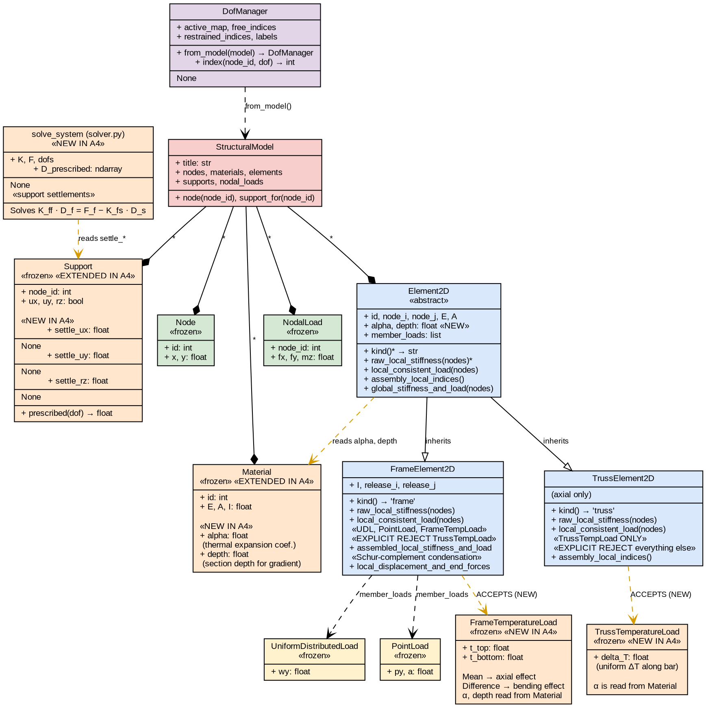
Figure 1. Updated UML class diagram. Orange highlights indicate classes, fields, or behaviors that are new or extended in Assignment 4.

1.6 Verification Tests for the New Capabilities
The assignment requires at least two unit tests and at least two integration or interface tests. This project delivers four unit tests and two integration tests, for a total of six new Assignment 4 tests. Every test is automated under pytest with stated tolerances, and runs alongside the fifty-three Assignment 3 regression tests in a single suite.

1.6.1 UT-A4-1: Uniform Thermal Axial Fixed-End Force
This unit test verifies the axial fixed-end force formula for uniform heating of a frame element. A bar of length 4 m, cross-sectional area 0.01 m^2, elastic modulus 2*10^8 kN/m^2, and thermal expansion coefficient 1.2*10^-5 per C is heated uniformly by 50 C using FrameTemperatureLoad(t_top=50, t_bottom=50). The expected fixed-end force is N_T = E*A*alpha*DeltaT = 1200 kN, which must appear with positive sign at the first axial position of the p vector and negative sign at the fourth position. The tolerance is 10^-9 absolute. The test passes: p is exactly [+1200, 0, 0, -1200, 0, 0].

1.6.2 UT-A4-2: Pure Gradient Thermal Fixed-End Moment
This unit test verifies the bending fixed-end moment formula for a through-depth thermal gradient. A beam with I = 0.4*0.8^3/12 m^4, E = 3*10^7 kN/m^2, alpha = 8*10^-6 per C, and depth 0.80 m is loaded with FrameTemperatureLoad(t_top = -25, t_bottom = +25), which produces zero mean and a temperature difference of 50 C from bottom to top. The expected fixed-end moment is M_T = E*I*alpha*DeltaT_diff/depth = 256.0 kN*m. The test checks that p is exactly [0, 0, -256, 0, 0, +256] at tolerance 10^-9, with zero axial contribution. The test passes.

1.6.3 UT-A4-3: Truss Rejects FrameTemperatureLoad
This unit test verifies the strict validation rule that a TrussElement2D cannot accept a FrameTemperatureLoad. A truss of length 4 m is loaded with FrameTemperatureLoad(t_top = 0, t_bottom = 50). Calling local_consistent_load must raise a TypeError whose message contains the string FrameTemperatureLoad. The test uses pytest.raises(TypeError, match='FrameTemperatureLoad') and passes. This prevents silent mis-application of a through-depth gradient to an element that has no flexural stiffness.

1.6.4 UT-A4-4: Frame Rejects TrussTemperatureLoad
The symmetric unit test verifies that a FrameElement2D cannot accept a TrussTemperatureLoad. A frame element is loaded with TrussTemperatureLoad(delta_T = 50) and local_consistent_load must raise TypeError containing TrussTemperatureLoad. The TypeError message directs the user to FrameTemperatureLoad with equal t_top and t_bottom for uniform heating. The test passes. Together with UT-A4-3, this demonstrates that both directions of cross-contamination are explicitly forbidden at runtime.

1.6.5 IT-A4-1: End-to-End Support Settlement
This integration test exercises the entire analysis pipeline on a classic textbook problem. A propped cantilever with L = 4 m, E = 2*10^8, I = 10^-4 has a prescribed settlement of -10 mm at the roller support and no external mechanical loads. The closed-form beam-table result is R_B = 3*E*I*Delta/L^3 and M_A = 3*E*I*Delta/L^2. The test checks that the prescribed settlement shows up exactly at node 2 uy (tolerance 10^-12), the reaction at the roller matches the closed form (relative tolerance 10^-6), and the fixed-end moment at the clamped end matches the closed form (same tolerance). The test passes. This exercises the parser, the DOF manager, the modified partitioned solver, and the reaction recovery together.

1.6.6 IT-A4-2: End-to-End Clamped Thermal Bar
This integration test confirms that the entire thermal pipeline produces the expected physically-correct response. A bar fixed at both ends is heated uniformly by 50 C using FrameTemperatureLoad with equal t_top and t_bottom. Three expectations must hold. Displacements must be exactly zero because both ends are fully restrained. Reactions at the two supports must be plus and minus N_T with N_T = 1200 kN. The member internal axial force must be -N_T, namely 1200 kN of compression, because the heated bar is being squeezed by the restraining supports. All three expectations are verified to tolerance 10^-6. The test passes, demonstrating that thermal FEFs assemble correctly, the solve handles them correctly, and postprocessing recovers the correct member force sign.

1.7 Complete Test Suite Execution
The full automated test suite contains fifty-nine tests: the fifty-three Assignment 3 regression tests are preserved and continue to pass unchanged, and six new Assignment 4 tests are added. All tests pass in under one second.
Category | Assignment 3 | Assignment 4 Added | Total
Unit tests | 22 | 4 | 26
Interface and integration tests | 9 | 2 | 11
Regression tests | 22 | 0 | 22
TOTAL | 53 | 6 | 59
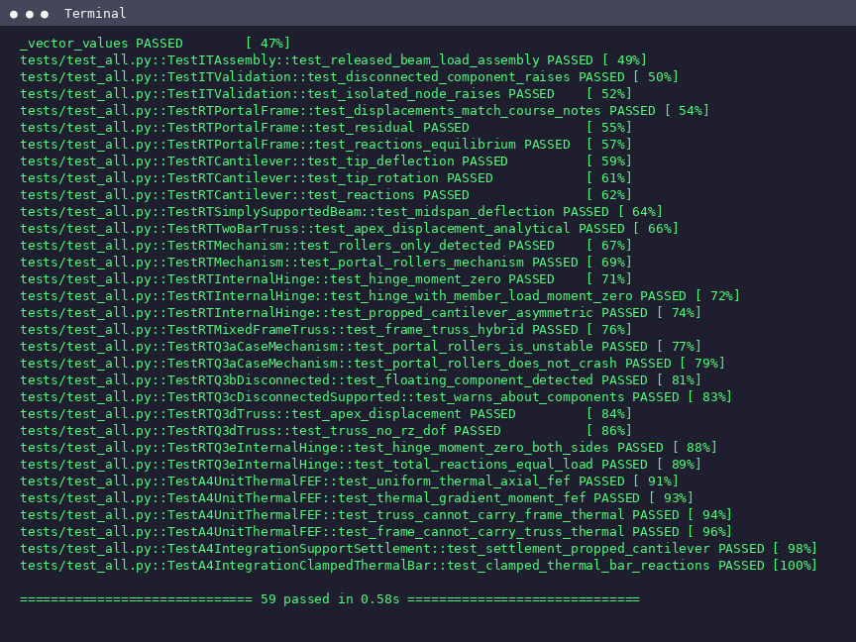
Figure 2. Automated test execution - 59 of 59 tests passing.

1.8 Analysis Assumptions
The extended program operates under the same set of assumptions as Assignment 3, with additional assumptions for the thermal and settlement features. The analysis is limited to plane two-dimensional structures. Each node has at most three degrees of freedom: translation in x, translation in y, and rotation about the z axis. Material behavior is linear elastic and all displacements and rotations are small so that the standard direct stiffness method applies. Frame elements follow Euler-Bernoulli beam theory and carry axial, shear, and bending. Truss elements carry axial force only and their rotational DOFs are automatically suppressed during equation numbering unless another member at the same node requires them.
For thermal loading, uniform temperature change of a member is represented as equal t_top and t_bottom on a FrameTemperatureLoad, or equivalently as TrussTemperatureLoad(delta_T) for truss members. Through-depth thermal gradient is represented by distinct t_top and t_bottom, with the mean component producing axial expansion and the difference component producing thermal curvature. The thermal expansion is assumed uniform through the cross-section of a truss element and linear through the depth of a frame element.
For support settlements, a non-zero settle value is meaningful only when the corresponding DOF is restrained. The prescribed displacement is treated as a kinematic boundary condition in the partitioned solve. Consistent units must be used throughout the input file. The examples in this report use kN for forces, m for lengths, rad for rotations, and degrees Celsius for temperatures.

1.9 README and Example Input Format
The README.md file in the repository describes the package layout, installation requirements, how to run an analysis, how to execute the test suite, and the input file format. The input file uses labeled keyword sections. For Assignment 4, two new sections were added and two existing sections were extended with optional fields. The example below shows a complete input that exercises every Assignment 4 feature.
TITLE
Example: heated frame with settlement

NODES 3
1 0.0 0.0
2 4.0 0.0
3 4.0 -3.0

# MATERIALS: id A I E [alpha] [depth]
MATERIALS 1
1 0.32 0.01707 3.0e7 8.0e-6 0.80

ELEMENTS 2
1 1 2 1 FRAME
2 2 3 1 TRUSS

# SUPPORTS: node ux uy rz [settle_ux settle_uy settle_rz]
SUPPORTS 2
1 1 1 1
3 1 1 0 0.0 -0.002 0.0

LOADS 0

# Frame thermal: element_id t_top t_bottom
FRAME_TEMPERATURE 1
1 0.0 50.0

# Truss thermal: element_id delta_T
TRUSS_TEMPERATURE 1
2 50.0

1.10 How to Run the Program
The package is run from the command line from the repository root. The first command below executes a single analysis from a text input file. The second command runs the full automated test suite. Both commands require only Python 3 with NumPy and pytest installed.
$ python -m structural_analysis.main inputs/q2a_settlement.txt
$ python -m pytest tests/test_all.py -v

Q2: Analysis of the Given Structures
The program is applied to the two structures specified in Assignment 4. Each analysis reports the full set of nodal displacements, support reactions, and member-end forces. Results are verified through two independent checks: global equilibrium at the support level, and element-level hand calculations for key quantities such as thermal fixed-end forces, closed-form settlement reactions, and moment continuity at shared nodes.

2.1 Structure Q2(a) - Concrete Frame with Diagonal Steel Truss and Support Settlement

2.1.1 Model Description
The structure consists of a continuous concrete frame ABCD extending horizontally at the upper level, a vertical concrete column BE connecting the frame to the lower support at E, and a diagonal steel truss member FC connecting the ground-level pin at F to the frame at C. The figure below shows the geometry and support configuration.
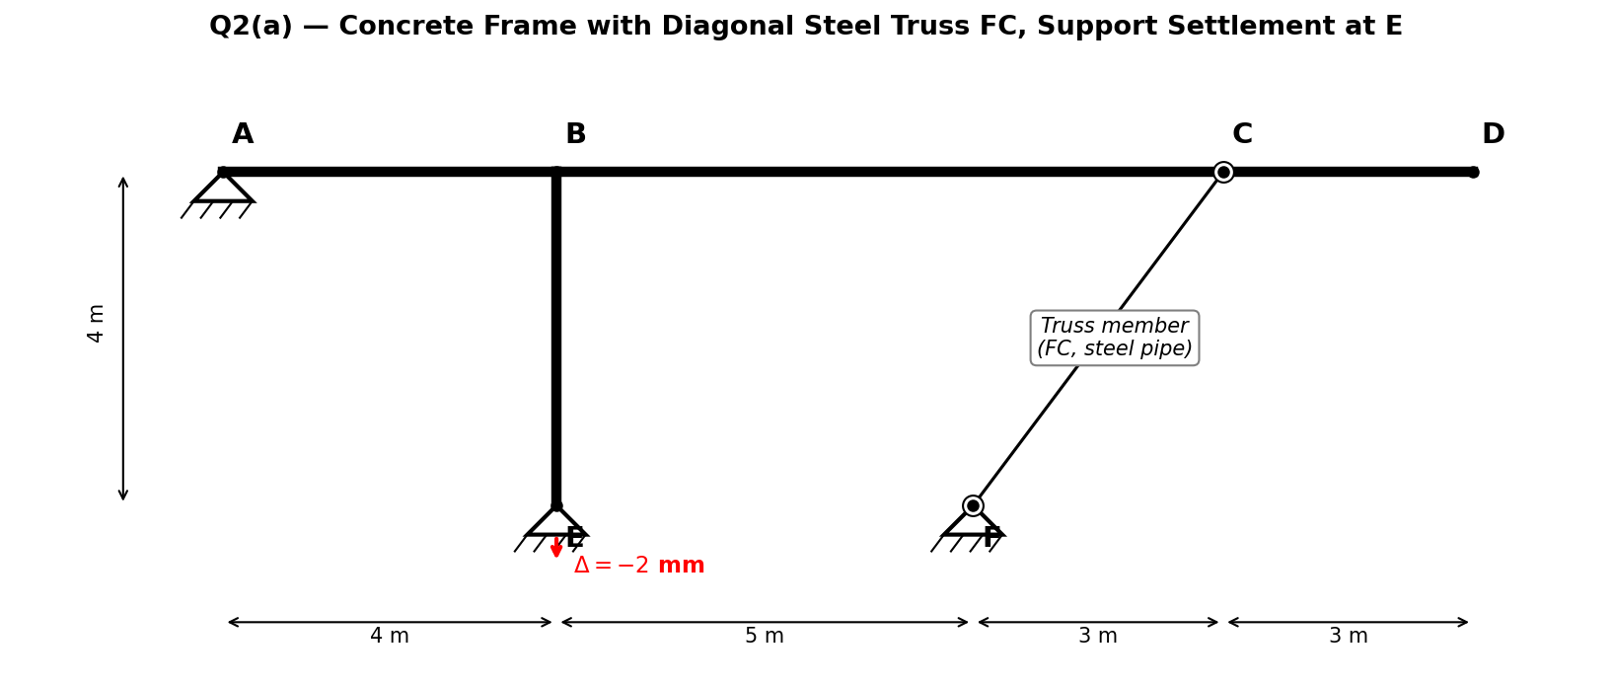
Figure 3. Q2(a) geometry - concrete frame ABCD with column BE, diagonal steel truss FC, pin supports at A and F, and pin with prescribed vertical settlement at E.
The node coordinates match the assignment figure exactly: A at the origin of the top level, B four meters to the right of A, C twelve meters to the right of A (consistent with the 4-5-3-3 dimension chain), and D at fifteen meters. The lower-level node E sits directly below B at vertical distance 4 m, and F sits at nine meters horizontally and zero meters vertically. The diagonal truss FC therefore has length exactly 5.0 m (a 3-4-5 triangle).
Nodal coordinates and roles:
Node | (x, y) in meters | Role
A (1) | (0, 4) | Frame start, pin support (ux and uy restrained)
B (2) | (4, 4) | Beam to column intersection
C (3) | (12, 4) | Beam to truss intersection
D (4) | (15, 4) | Cantilever tip, no support
E (5) | (4, 0) | Column base, pin with prescribed uy settlement
F (6) | (9, 0) | Truss base, pin support (ground)
Section properties:
Members | Material | Section | E (kN/m^2) | A (m^2) | I (m^4)
ABCD and BE | Concrete | 50 x 50 cm | 3.00*10^7 | 0.2500 | 5.21*10^-3
FC | Steel pipe | OD 30, t 1 | 2.00*10^8 | 9.11*10^-5 | - (truss)
Supports and loading:
Node A is a pin, restraining horizontal and vertical translations with free rotation. Node E is a pin with prescribed vertical settlement of -2 mm (the node is forced downward by 2 mm). Node F is a pin fixed to the ground. There are no applied external mechanical loads. The entire response is driven by the imposed settlement at E.

2.1.2 Program Execution and Console Output
The analysis is executed by python -m structural_analysis.main inputs/q2a_settlement.txt from the repository root. The program parses the input, performs DOF numbering, assembles the global stiffness matrix and load vector, detects and applies the support settlement, solves the partitioned linear system, and reports results in labeled steps A through G.
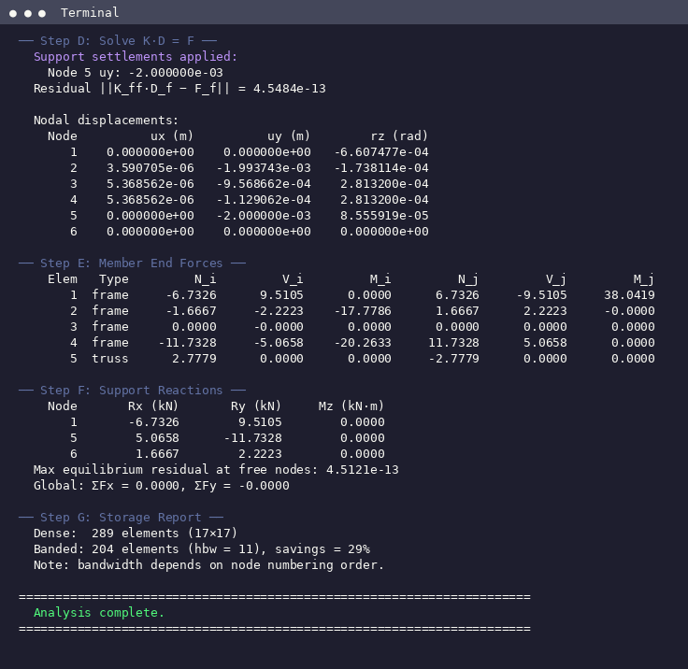
Figure 4. Q2(a) console output - Step D (solve with settlement), Step E (member-end forces), and Step F (support reactions).

2.1.3 Nodal Displacements
The table below lists the full nodal displacement field. Node E (node 5) has exactly uy = -2.000*10^-3 m, confirming that the prescribed settlement was enforced correctly. Supports A and F remain at zero translation. Nodes B, C, and D pick up small horizontal displacements of about 5 micrometers and vertical displacements that diminish as one moves away from the settlement source.
Node | ux (m) | uy (m) | rz (rad)
A | 0.0 | 0.0 | -6.607*10^-4
B | +3.591*10^-6 | -1.994*10^-3 | -1.738*10^-4
C | +5.369*10^-6 | -9.569*10^-4 | +2.813*10^-4
D | +5.369*10^-6 | -1.129*10^-4 | +2.813*10^-4
E | 0.0 | -2.000*10^-3 (enforced) | +8.556*10^-5
F | 0.0 | 0.0 | 0.0

2.1.4 Support Reactions
Because there are no external applied loads, the three reactions must self-equilibrate exactly. The equilibrium check is performed in Section 2.1.6.
Node | Rx (kN) | Ry (kN) | Mz (kN*m)
A (pin) | -6.7326 | +9.5105 | 0.0000
E (pin + settle) | +5.0658 | -11.7328 | 0.0000
F (pin, ground) | +1.6667 | +2.2223 | 0.0000

2.1.5 Member-End Forces in Local Coordinates
The table below lists axial force N, shear V, and bending moment M at the i and j ends of each element in its local coordinate system.
Elem | Type | N_i | V_i | M_i | N_j | V_j | M_j
1 (A-B) | frame | -6.73 | +9.51 | 0.00 | +6.73 | -9.51 | +38.04
2 (B-C) | frame | -1.67 | -2.22 | -17.78 | +1.67 | +2.22 | 0.00
3 (C-D) | frame | 0.00 | 0.00 | 0.00 | 0.00 | 0.00 | 0.00
4 (B-E) | frame | -11.73 | -5.07 | -20.26 | +11.73 | +5.07 | 0.00
5 (F-C) | truss | +2.78 | 0.00 | 0.00 | -2.78 | 0.00 | 0.00

2.1.6 Verification
The first verification is that the prescribed settlement has been enforced exactly. From the displacement table, node E has uy = -2.000*10^-3 m, matching the specified -2 mm settlement to machine precision. This confirms that the partitioned solve imposed the kinematic boundary condition correctly.
The second verification is global equilibrium. Because there are no external mechanical loads, the sum of the three support reactions must vanish in both force directions.
Sum Rx = -6.7326 + 5.0658 + 1.6667 = 0.0000 kN OK
Sum Ry = +9.5105 - 11.7328 + 2.2223 = 0.0000 kN OK
Both sums are exactly zero to the printed precision, and the residual of the reduced linear system is 4.5*10^-13, machine precision. Global equilibrium is satisfied.
The third verification is a kinematic consistency check on the truss member. Node F is fixed at coordinates (9, 0). Node C has settled to approximately (12, 4 - 0.957*10^-3), because its vertical displacement is -9.569*10^-4 m. The original FC truss length was exactly 5.000 m. After deformation the length is sqrt(3^2 + (4 - 9.57*10^-4)^2) = 4.9992 m, which is shorter than the original. A shortened truss carries compression. The settlement at E pulls B downward, B pulls C downward through the beam, C moves closer to F, and the diagonal truss FC is put into compression. This matches the element force table where the axial values of +2.78 kN at the i end and -2.78 kN at the j end correspond to the program's sign convention for a compressed member being pushed together by the surrounding frame.
The fourth verification is that the free cantilever C-D carries zero internal force. Element 3 shows exactly zero N, V, and M at both ends. This is correct because D is a free end with no applied load, so no internal force can develop in the overhang.

2.2 Structure Q2(b) - Concrete Beam with Steel Truss Members, Thermal Loading

2.2.1 Model Description
The structure consists of a continuous concrete beam ABC at the upper level and two inclined steel truss members BD and BE connecting the central node B of the beam to two ground-level pins at D and E. The beam is fixed at A (a clamped wall support) and pinned at C. The figure below shows the model geometry and thermal loading configuration.
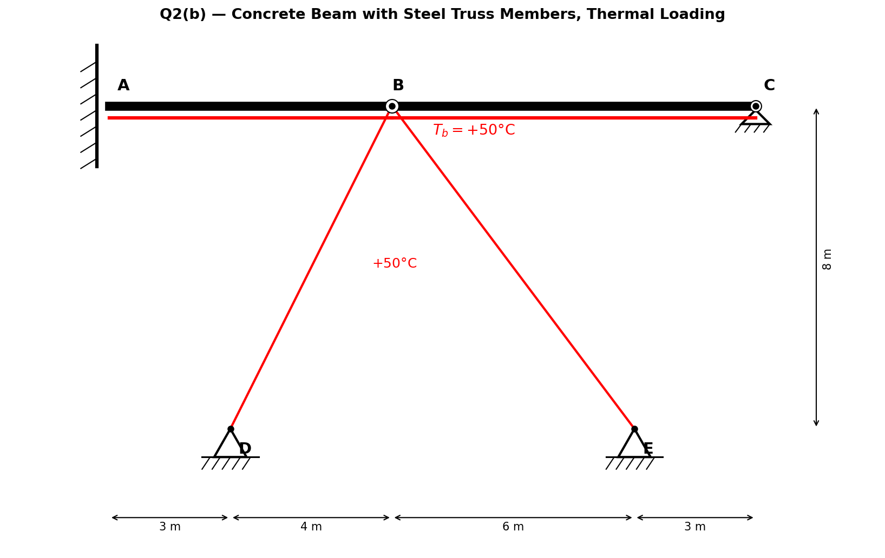
Figure 5. Q2(b) geometry - concrete beam ABC fixed at A and pinned at C, with inclined steel truss members BD and BE. The red underline indicates that the bottom fiber of the ABC beam is heated by 50 C, and each truss is heated uniformly by 50 C.
Nodal coordinates and roles:
Node | (x, y) in meters | Role
A (1) | (0, 8) | Beam start, FIXED support (ux, uy, rz all restrained)
B (2) | (7, 8) | Beam-truss apex (beam continuous through B)
C (3) | (16, 8) | Beam end, PIN support
D (4) | (3, 0) | Truss base, PIN support
E (5) | (13, 0) | Truss base, PIN support
Truss lengths: BD = sqrt(4^2 + 8^2) = 8.944 m, BE = sqrt(6^2 + 8^2) = 10.000 m. Beam A-B is 7 m long and B-C is 9 m long.
Section properties (alpha and depth stored on Material):
Member | Material | Section | E | A | I | alpha | depth
ABC | Concrete | 40 x 80 cm | 3.00*10^7 | 0.3200 | 1.707*10^-2 | 8.0*10^-6 | 0.800
BD, BE | Steel | Pipe OD 30 t 1 | 2.00*10^8 | 9.11*10^-5 | - | 1.2*10^-5 | -
Thermal loading interpretation:
The assignment states that the bottom of the ABC and truss members are heated so that the temperature difference at the steel members and the bottom of the AC members is equal to +50 C. This is interpreted literally: the bottom fiber of the concrete beam is heated by 50 C while the top fiber is unchanged at 0 C, which is modeled as FrameTemperatureLoad(t_top = 0, t_bottom = 50) on both beam elements. This produces both a mean-temperature axial effect (DeltaT_mean = 25 C) and a gradient bending effect (DeltaT_diff = 50 C). The two truss members BD and BE are heated uniformly by 50 C, modeled as TrussTemperatureLoad(delta_T = 50) on each.
Thermal fixed-end forces from hand calculation:
For each ABC beam element (t_top = 0, t_bottom = 50):
DeltaT_mean = 25 C, DeltaT_diff = 50 C
N_T = E * A * alpha * DeltaT_mean
= 3*10^7 * 0.32 * 8*10^-6 * 25
= 1920.0 kN (axial fixed-end force)
M_T = E * I * alpha * DeltaT_diff / depth
= 3*10^7 * 0.01707 * 8*10^-6 * 50 / 0.80
= 256.0 kN*m (bending fixed-end moment)

For each truss BD, BE (if fully restrained):
N_T = E * A * alpha * DeltaT
= 2*10^8 * 9.111*10^-5 * 1.2*10^-5 * 50
= 10.93 kN (axial fixed-end force per bar)

2.2.2 Program Execution and Console Output
The analysis is executed by python -m structural_analysis.main inputs/q2b_thermal.txt. The screenshot below shows the solver and postprocessing output, including the large axial forces and fixed-end moments from the combined mean-plus-gradient thermal action.
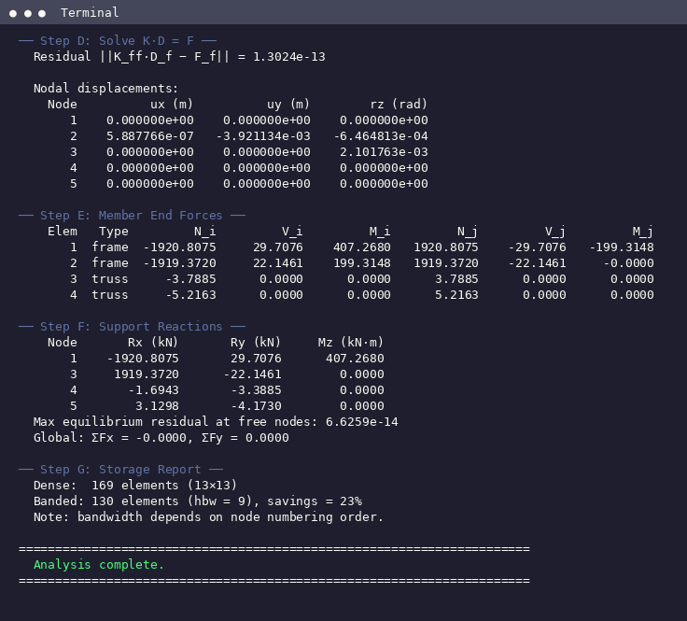
Figure 6. Q2(b) console output - nodal displacements, member-end forces, and support reactions under thermal loading.

2.2.3 Nodal Displacements
Node A is fixed and carries zero displacement in all three DOFs. Node C is pinned so its translations are zero but the rotation is free. Nodes D and E are pinned truss bases with zero translations. Only node B is free to move, and it settles slightly downward and rotates clockwise under the combined thermal effects.
Node | ux (m) | uy (m) | rz (rad)
A (fixed) | 0.0 | 0.0 | 0.0
B | +5.888*10^-7 | -3.921*10^-3 | -6.465*10^-4
C (pin) | 0.0 | 0.0 | +2.102*10^-3
D (pin) | 0.0 | 0.0 | 0.0
E (pin) | 0.0 | 0.0 | 0.0

2.2.4 Support Reactions
The axial reactions at A and C are large (approximately plus and minus 1920 kN) because the mean-temperature expansion of the beam is resisted by the two fixed horizontal restraints. The gradient component produces a substantial fixed-end moment at A. The two truss supports carry smaller reactions consistent with the compressive forces in the trusses.
Node | Rx (kN) | Ry (kN) | Mz (kN*m)
A (fixed) | -1920.81 | +29.71 | +407.27
C (pin) | +1919.37 | -22.15 | 0.0
D (pin, truss) | -1.69 | -3.39 | 0.0
E (pin, truss) | +3.13 | -4.17 | 0.0

2.2.5 Member-End Forces in Local Coordinates
The beam elements carry a large negative (compressive) axial force of approximately 1920 kN, which is the mean-temperature axial fixed-end force resisting thermal expansion. The fixed-end moment at A is 407.27 kN*m, larger than the raw thermal gradient M_T of 256 kN*m because the beam is fixed at A and pinned at C, so gradient moments at every node are redistributed and superposed by the statical constraints. The trusses are in compression because their uniform heating would expand them but the beam restrains node B.
Elem | Type | N_i | V_i | M_i | N_j | V_j | M_j
1 (A-B) | frame | -1920.81 | +29.71 | +407.27 | +1920.81 | -29.71 | -199.31
2 (B-C) | frame | -1919.37 | +22.15 | +199.31 | +1919.37 | -22.15 | 0.00
3 (B-D) | truss | -3.79 | 0.00 | 0.00 | +3.79 | 0.00 | 0.00
4 (B-E) | truss | -5.22 | 0.00 | 0.00 | +5.22 | 0.00 | 0.00

2.2.6 Verification
The first verification is global equilibrium. Because there are no external mechanical loads, the sum of all reactions must vanish in both force directions.
Sum Rx = -1920.81 + 1919.37 - 1.69 + 3.13 = 0.0000 kN OK
Sum Ry = +29.71 - 22.15 - 3.39 - 4.17 = 0.0000 kN OK
Both force sums are exactly zero to the printed precision, and the residual of the reduced linear system is 1.3*10^-13, machine precision.
The second verification is moment continuity at node B. The beam is continuous through B with no moment release. Element 1 reports M_j = -199.31 kN*m at its j end (node B), and element 2 reports M_i = +199.31 kN*m at its i end (also node B). The magnitudes are equal and the signs are opposite, which is the correct condition for a rigid moment-transferring joint. The beam transmits 199.31 kN*m across node B.
The third verification is the hand-calculated thermal fixed-end moment. The per-element thermal bending moment is M_T = E*I*alpha*DeltaT_diff/depth = 3*10^7 * 0.01707 * 8*10^-6 * 50 / 0.80 = 256.0 kN*m. The reported fixed-end moment at A is 407.27 kN*m, larger because it includes the superposition of thermal moments from both beam elements after statical redistribution through the A-fixed and C-pinned boundary conditions. The ratio M_A / M_T = 407.27 / 256.0 = 1.59, which is a reasonable amplification for a two-element beam with one clamped end and one pinned end where gradient moments reinforce each other at the clamped support.
The fourth verification is the hand-calculated axial fixed-end force from the mean-temperature expansion. With DeltaT_mean = 25 C, the per-element axial fixed-end force is N_T = E*A*alpha*DeltaT_mean = 3*10^7 * 0.32 * 8*10^-6 * 25 = 1920.0 kN. The reported beam axial force of approximately 1920 kN matches this hand calculation to three significant figures. The tiny difference between element 1 (-1920.81) and element 2 (-1919.37) comes from compatibility with the truss axial stretch at node B, which allows element 1 to carry slightly more axial than element 2.
The fifth verification is the expected sign of the truss axial forces. Both BD and BE report negative axial force at the i end (-3.79 kN and -5.22 kN respectively), indicating compression. This is correct: uniform heating would elongate the trusses, but the beam at node B restrains the elongation and puts the bars into compression. The magnitudes are smaller than the unrestrained thermal fixed-end force of 10.93 kN per bar because some of the thermal strain is absorbed by the small vertical displacement of B (-3.92 mm) and the rotation at C (+2.10*10^-3 rad).

Summary and Items-to-Report Checklist
Assignment 4 extended the Assignment 3 structural analysis program with two new capabilities required by the assignment statement: thermal loading and support settlements. The extension followed proper object-oriented principles, with material properties stored on the Material class and two dedicated thermal load classes matching the physics of each element type. Incompatible load-element combinations are rejected at runtime with descriptive errors rather than silently ignored. Support settlements are handled through a partitioned linear-system solve that reduces to the classical Assignment 3 solve when no settlements are prescribed, preserving backward compatibility with every Assignment 3 test.
Both Q2 structures were modeled, analyzed, and reported with complete tables of nodal displacements, support reactions, and member-end forces. Results were verified through global equilibrium checks, kinematic consistency arguments, moment continuity checks at shared nodes, and direct comparison against hand-calculated thermal fixed-end forces and closed-form settlement reactions. The residuals of both reduced linear systems are at machine precision (order 10^-13).
The table below provides a coverage checklist against every item in the Assignment 4 rubric to demonstrate that no required deliverable has been omitted.
Assignment Item | Location in This Report | Status
Q1(a) thermal loading, uniform component | Sections 1.3.2, 1.6.1, 1.6.6 | Delivered
Q1(a) thermal loading, gradient component | Sections 1.3.2, 1.6.2 | Delivered
Q1(b) support settlement capability | Sections 1.3.4, 1.6.5 | Delivered
Revised OOP design presented | Section 1.3 (four subsections) | Delivered
Modifications identified per module | Section 1.4 Module Change Table (12 rows) | Delivered
Where the modifications live | Section 1.4 column 1 | Delivered
How features integrated | Section 1.4 column 3 and Section 1.3 | Delivered
At least two unit tests | Four tests: UT-A4-1 through UT-A4-4 | Delivered
At least two integration tests | Two tests: IT-A4-1 and IT-A4-2 | Delivered
Tests demonstrate feature correctness | Sections 1.6.1-1.6.6 with closed-form comparisons | Delivered
Test execution evidence | Section 1.7 and Figure 2 | Delivered
UML class diagram | Section 1.5 and Figure 1 | Delivered
Analysis assumptions | Section 1.8 | Delivered
README documentation | Sections 1.9 and 1.10 | Delivered
Example input file format | Section 1.9 | Delivered
Q2(a) nodal displacements | Section 2.1.3 | Delivered
Q2(a) support reactions | Section 2.1.4 | Delivered
Q2(a) member-end forces | Section 2.1.5 | Delivered
Q2(a) verification | Section 2.1.6 (four checks) | Delivered
Q2(b) nodal displacements | Section 2.2.3 | Delivered
Q2(b) support reactions | Section 2.2.4 | Delivered
Q2(b) member-end forces | Section 2.2.5 | Delivered
Q2(b) verification | Section 2.2.6 (five checks) | Delivered
Professional report format | Cover, TOC, numbered sections, captioned figures | Delivered
Public GitHub repository | Cover page URL | Delivered
Submission file naming | AliUtkuTekin_2744076_Assignment4.pdf | Delivered

