Solutions for the Module 10 Exercise Problems
The exercise problems in Module 10 provide practice with schema conversion using the conversion rules presented in module 10.
- Convert the ERD shown in Figure 1 into tables. List the conversion rules used and the resulting tables with primary keys, foreign keys, other columns, and not null constraints for foreign keys. You do not need to provide CREATE TABLE statements.
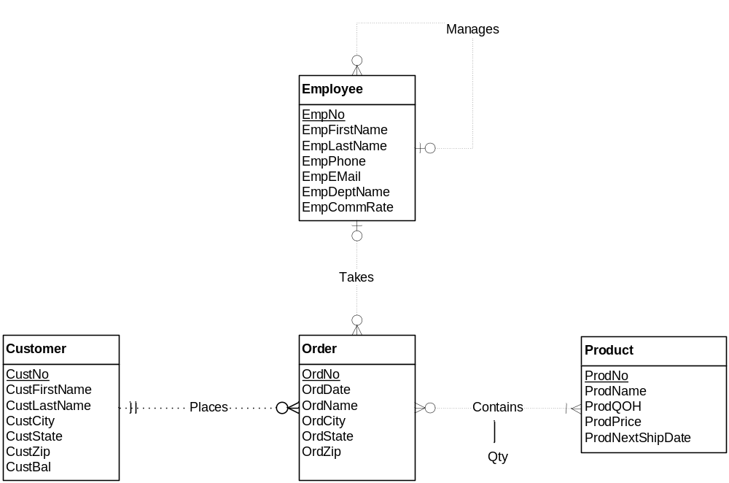
Figure 1: ERD for Problem 1

Result after conversion
Customer(CustNo, CustFirstName, CustLastName, CustCity, CustState, CustZip, CustBal)

Employee(EmpNo, supempno, EmpFirstName, EmpLastName, EmpPhone, EmpEmail, EmpDeptName, EmpCommRate)
FOREIGN KEY(supempno) REFERENCES Employee

Product(ProdNo, ProdName, ProdQOH, ProdPrice, ProdNextShipDate)

Order(OrdNo, CustNo, EmpNo, OrdDate, OrdName, OrdCity, OrdZip)
FOREIGN KEY(custno) REFERENCES customer
FOREIGN KEY(empno) REFERENCES employee
CustNo NOT NULL

Contains(OrdNo, ProdNo, Qty)
FOREIGN KEY(ordno) REFERENCES order
FOREIGN KEY(prodno) REFERENCES product

Conversion rules
- Use the entity type rule to convert each entity type
- Use the 1-M relationship rule for all relationships except the contains relationship
- Use the M-N rule to convert the contains relationship

- Convert the ERD shown in Figure 2 into tables. This ERD is identical to problem 1 except for the use of an associative entity type instead of the M-N relationship. You only need to indicate the conversion rules and table design for the associative entity type.
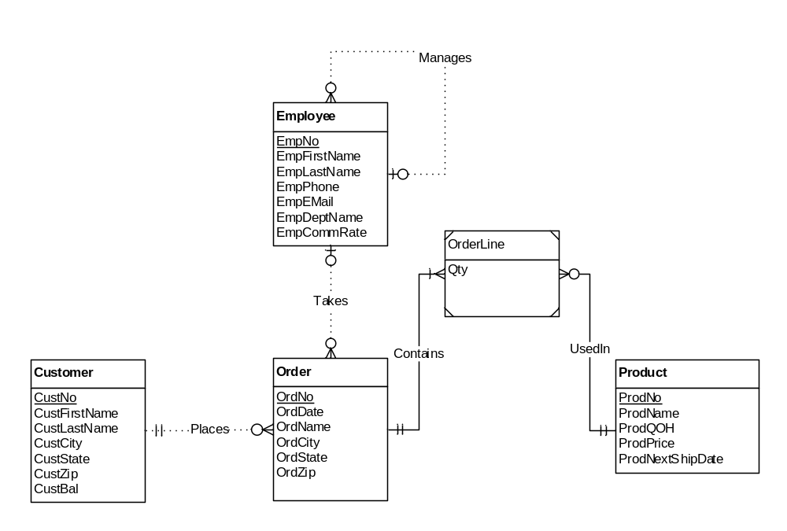 Figure 2: ERD for Problem 2

Answer
The only difference in the solution for problem 2 from problem 1 is the usage of the identification dependency rule in problem 2 versus the M-N relationship rule in problem 1.

Result after conversion
Customer(CustNo, CustFirstName, CustLastName, CustCity, CustState, CustZip, CustBal)

Employee(EmpNo, supempno, EmpFirstName, EmpLastName, EmpPhone, EmpEmail, EmpDeptName, EmpCommRate)
FOREIGN KEY(supempno) REFERENCES Employee

Product(ProdNo, ProdName, ProdQOH, ProdPrice, ProdNextShipDate)

Order(OrdNo, CustNo, EmpNo, OrdDate, OrdName, OrdCity, OrdZip)
FOREIGN KEY(custno) REFERENCES customer
FOREIGN KEY(empno) REFERENCES employee
CustNo NOT NULL

OrderLine(OrdNo, ProdNo, Qty)
FOREIGN KEY(ordno) REFERENCES order
FOREIGN KEY(prodno) REFERENCES product

Conversion rules
- Use the entity type rule to convert each entity type
- Use the 1-M relationship rule for all relationships
- Use the identification dependency rule to add two components (OrdNo and ProdNo) to the primary key of the OrderLine table

- Convert the ERD shown in Figure 4 into tables. List the conversion rules used and the resulting tables with primary keys, foreign keys, other columns, and not null constraints for foreign keys. You do not need to provide CREATE TABLE statements.
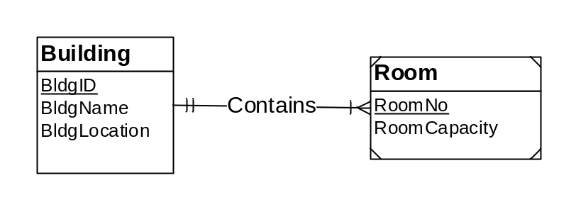
Figure 4: ERD for Problem 4

Result after conversion
Building(BldgId, BldgName, BldgLocation)

Room(BldgId, RoomNo, RoomCapacity)
FOREIGN KEY(BldgId) REFERENCES Building

Conversion rules
- Use the entity type rule to convert the Building and Room entity types.
- Use the 1-M relationship rule to convert the Contains relationship into the BldgId FK in the Room table.
- Use the identification dependency rule to make BldgId a component of the PK of Room. The PK of the Room table is a combination of BldgId and RoomNo.
- In the final conversion result, a not null constraint is not needed for Room.BldgId because this column is part of the primary key of Room.

