Module 7 Exercise Solutions
Most of these problems are covered in the Module 7 video lessons and associated slides. The full solutions are given in this document for all problems.
- Draw an ERD containing the Order and Customer entity types connected by a 1-M relationship from Customer to Order. Choose an appropriate relationship name using your common knowledge of interactions between customers and orders. Define minimum cardinalities so that an order is optional for a customer and a customer is mandatory for an order. For the Customer entity type, add attributes CustNo (primary key), CustFirstName, CustLastName, CustStreet, CustCity, CustState, CustZip, and CustBal (balance). For the Order entity type, add attributes for the OrdNo (primary key), OrdDate, OrdName, OrdStreet, OrdCity, OrdState, and OrdZip. If you are using a data modeling tool that supports data type specification, choose appropriate data types for the attributes based on your common knowledge.
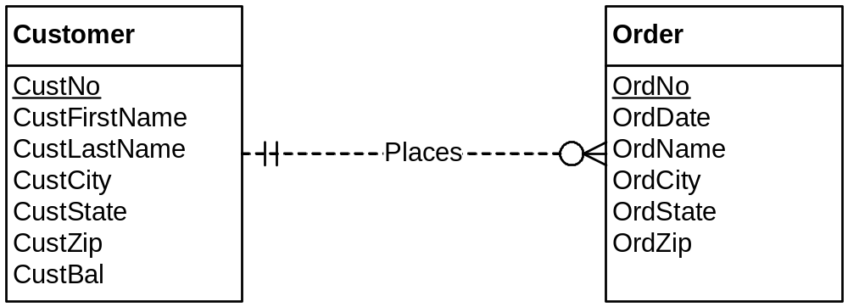
All data types should be variable length character strings (VARCHAR) except for CustNo, OrdNo, and OrdDate. CustNo and OrdNo should be INTEGER. OrdDate can be either DATE or TIMESTAMP (include time and date).

- Extend the ERD from problem 1 with the Employee entity type and a 1-M relationship from Employee to Order. Choose an appropriate relationship name using your common knowledge of interactions between employees and orders. Define minimum cardinalities so that an employee is optional to an order and an order is optional to an employee. For the Employee entity type, add attributes EmpNo (primary key), EmpFirstName, EmpLastName, EmpPhone, EmpEmail, EmpCommRate (commission rate), and EmpDeptName. If you are using a data modeling tool that supports data type specification, choose appropriate data types for the attributes based on your common knowledge.
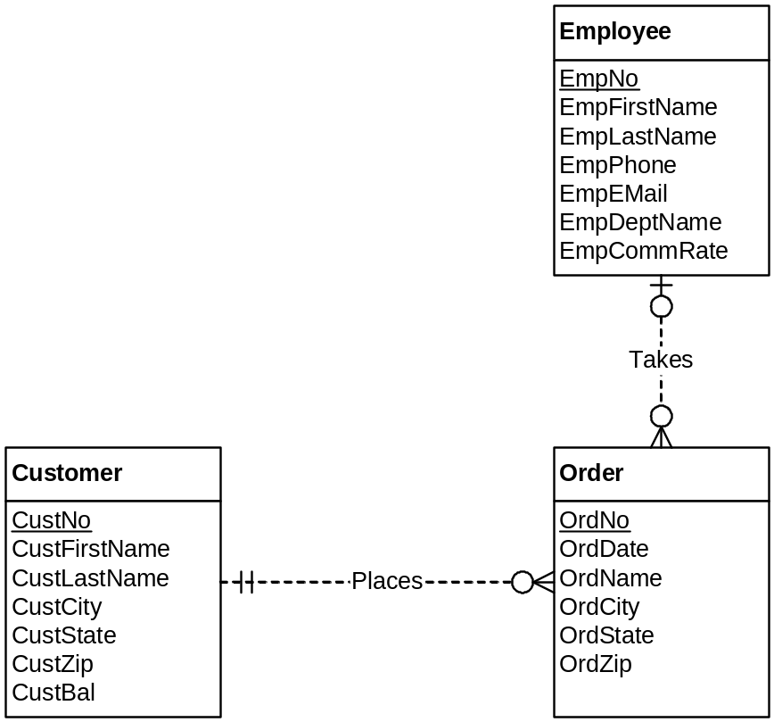

All data types should be variable length character strings (VARCHAR) except for EmpNo and EmpCommRate. EmpNo should be INTEGER, and EmpCommRate should be DECIMAL.
- Extend the ERD from problem 2 with a self-referencing 1-M relationship involving the Employee entity type. Choose an appropriate relationship name using your common knowledge of organizational relationships among employees. Define minimum cardinalities so that the relationship is optional in both directions. In the slides, problem 3 is combined with problem 2.
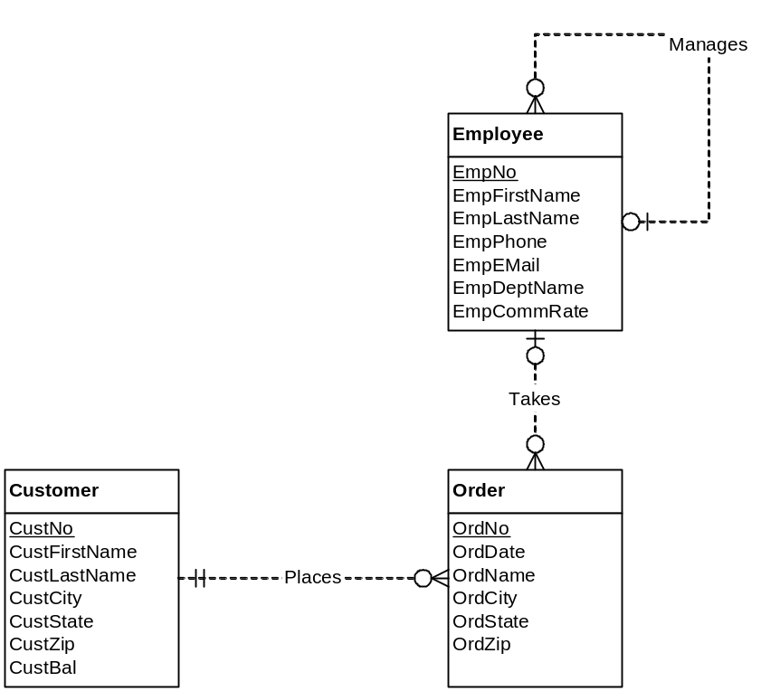
- Extend the ERD from problem 3 with the Product entity type and an M-N relationship between Product and Order. Choose an appropriate relationship name using your common knowledge of connections between products and orders. Define minimum cardinalities so that an order is optional to a product, and a product is mandatory to an order. For the Product entity type, add attributes ProdNo (primary key), ProdName, ProdQOH, ProdPrice, and ProdNextShipDate. For the M-N relationship, add an attribute for the order quantity. If you are using a data modeling tool that supports data type specification, choose appropriate data types for the attributes based on your common knowledge.
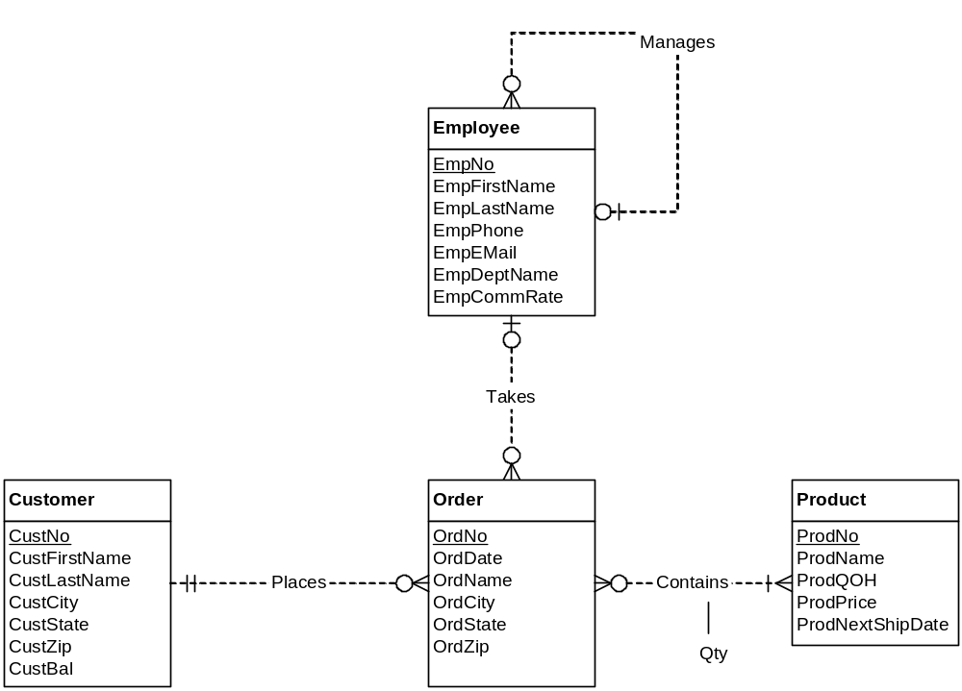
For data types, ProdNo should be INTEGER, ProdName should be VARCHAR, ProdQOH should be INTEGER, ProdPrice should be fixed decimal (DECIMAL) with two digits to the right of the decimal point, and ProdNextShipDate should be DATE or DATETIME.
- Revise the ERD from problem 4 by transforming the M-N relationship into an associative entity type and two identifying, 1-M relationships.
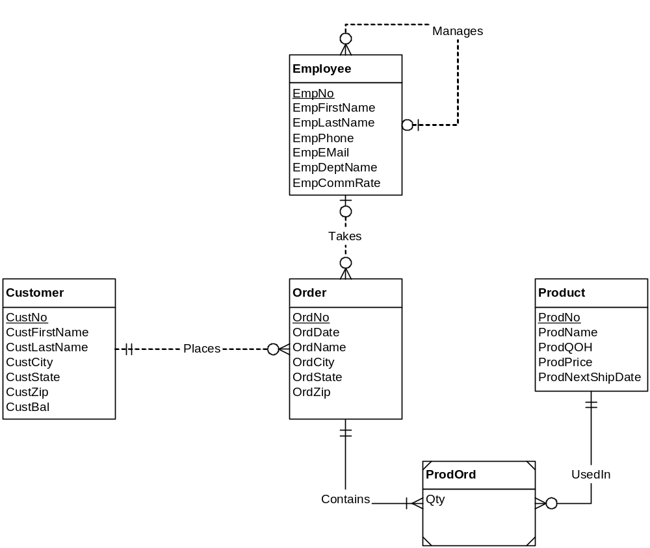
- Using your ERD from problem 5, add violations of the three identification dependency rules and the redundant foreign key rule.
Rule violations are noted in the ERD below. Many other solutions are possible.
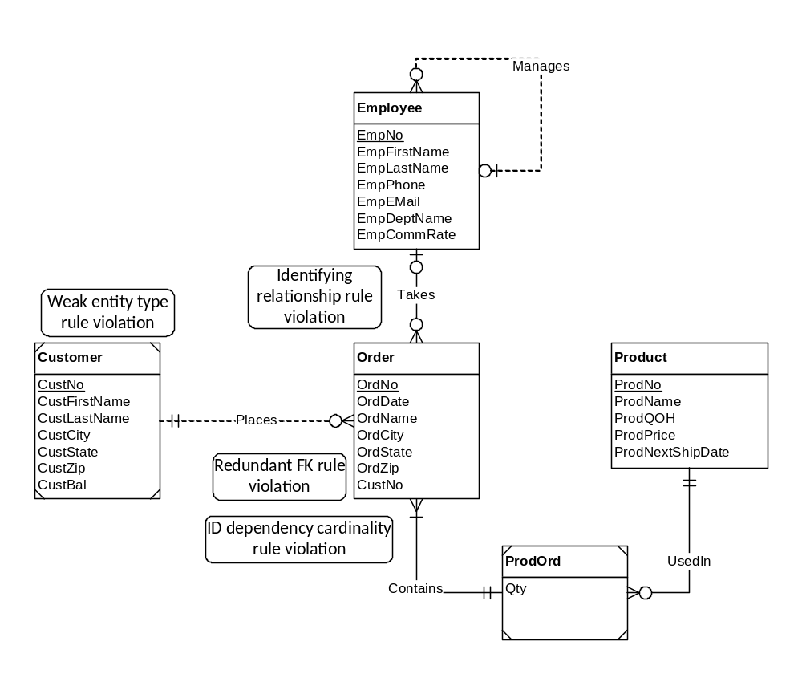
- For each diagram error in Figure P7, identify the consistency rule violated and suggest possible resolutions of the error. The ERD has generic names so that you will concentrate on finding diagram errors rather than focusing on the meaning of the diagram.
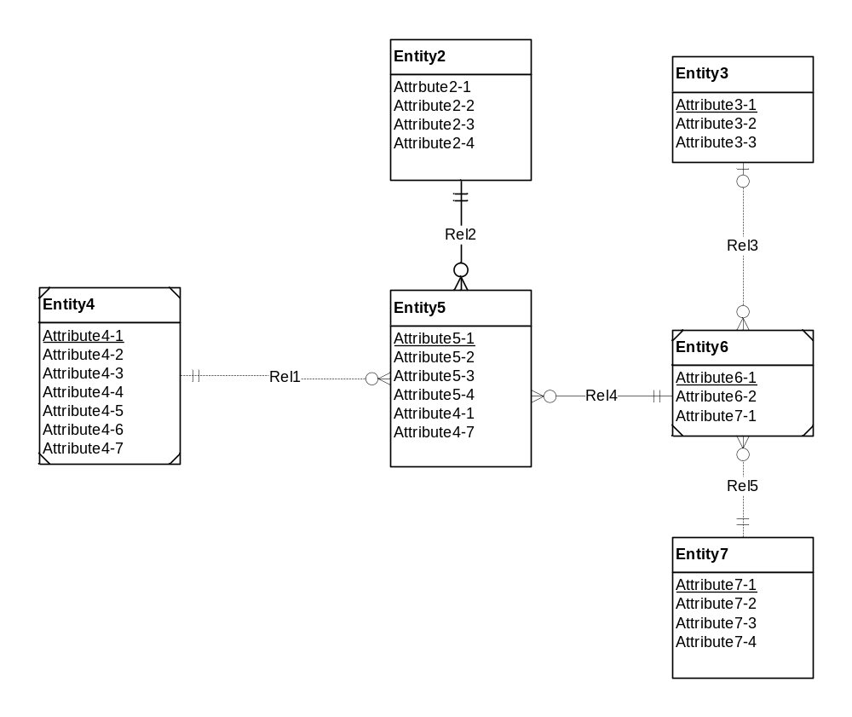
Figure P7: ERD for Problem 7

The following ERD shows diagram errors in the ERD for problem 7.

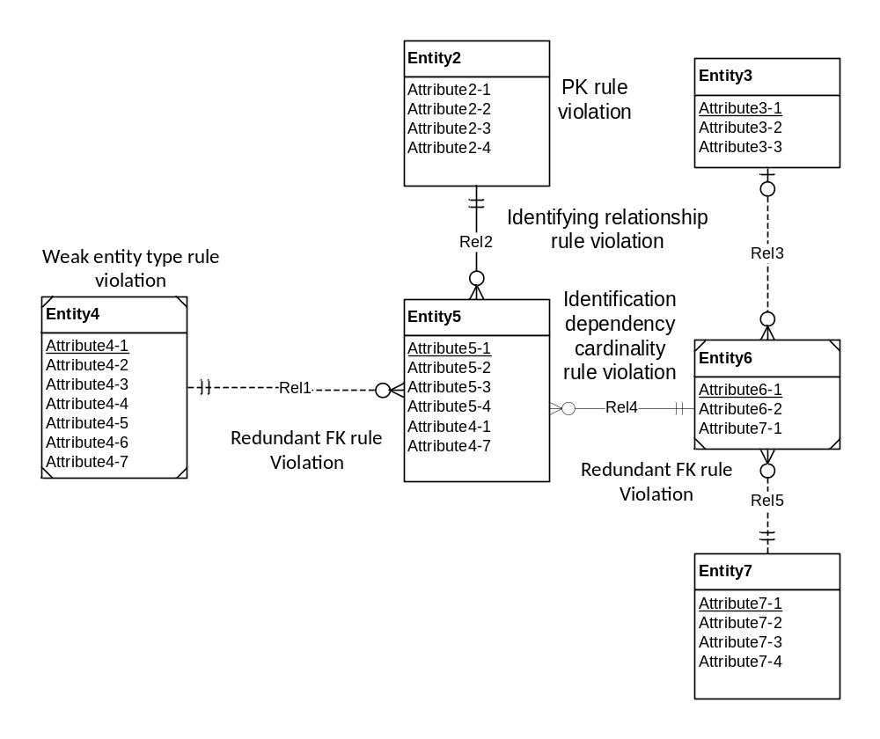
The following list identifies possible ways to fix the diagram errors:
- Resolution of primary key rule violation: The problem can be resolved by specifying a primary key such as Attribute2-1.
- Resolution of the weak entity type rule: The problem can be resolved by either adding one or more identifying relationships or by changing the weak entity (Entity4) into a regular entity.
- Resolution of the identifying relationship rule: The problem can be resolved by adding one or more weak entities or making the relationship (Rel2) non-identifying.
- Resolution of the identification dependency cardinality rule: The problem can be resolved by changing the weak entity’s cardinality in Rel4 to (1,1).
- Resolution of the redundant FK rule: Normally the problem can be resolved by removing the redundant foreign keys (Entity5.Attribute4-1 and Entity6.Attribute7-1). If the attribute does not represent a foreign key, it should be renamed instead of removed. Note that Entity5.Attribute4-7 is not a violation of rule 9 because Attribute4-7 is not the primary key in Entity4.
- The ERD below shows one set of changes to remove the diagram errors.

