Module 8 Exercise Solutions

- Define an ERD for the following narrative. The database should track homes and owners. A home has a unique home identifier, a street address, a city, a state, a zip, a number of bedrooms, a number of bathrooms, and square feet. A home is either owner occupied or rented. An owner has a unique owner number, a Social Security number (used for government reporting requirements), a name, an optional spouse name, a profession, an optional spouse profession, and an optional spouse Social Security number. An owner can possess one or more homes. Each home has only one owner.

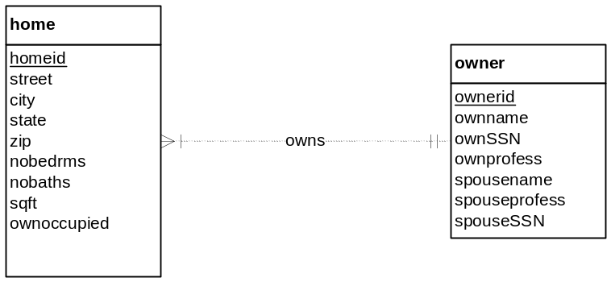

The problem narrative indicates that an owner can possess one or more homes. This statement is a somewhat unclear about the minimum cardinality. A minimum cardinality of 1 is consistent with the narrative but 0 is also acceptable because the problem narrative does not definitively indicate that an owner must possess at least one home.

SSN is a poor choice for a primary key as noted in module 8. The problem narrative indicates that ownerid is unique so it is used as the primary key. The user should be told that SSN is a poor choice for the primary key.

- Refine the ERD from problem 1 by adding an agent entity type. Agents represent owners in the sale of a home. An agent can list many homes, but only one agent can list a home. An agent has a unique agent identifier, a name, an office identifier, and a phone number. When an owner agrees to list a home with an agent, a commission (percentage of the sales price) and a selling price are determined.

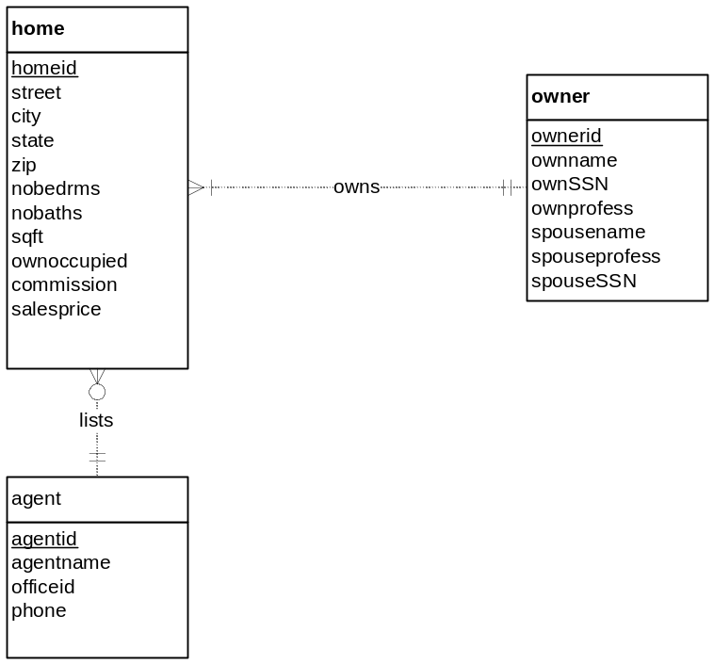

The problem narrative does not specify the minimum cardinalities of the lists relationship. Either 0 or 1 are acceptable for minimum cardinalities for both sides of the lists relationship. The commission attribute can be considered an attribute of the lists relationship if an agent is optional for a home although the more conventional representation is for the commission attribute as an attribute of the home entity type.

- In the ERD from problem 2, transform the attribute, office identifier, into an entity type. Data about an office include the phone number, the manager name, and the address.

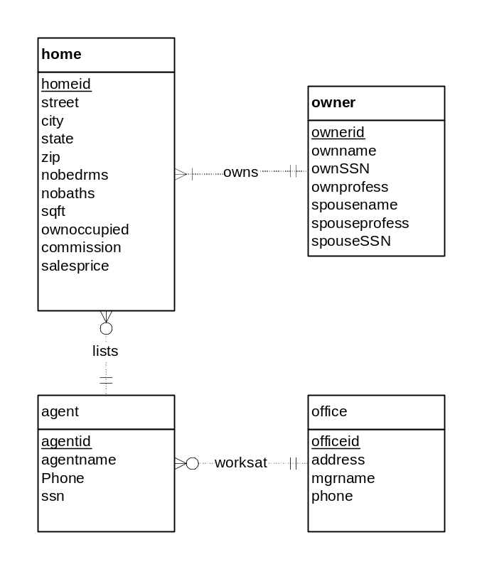
The solution involves the attribute expansion transformation presented in lesson 3 of module 8. In the solution ERD, OfficeId is transformed into an entity type (Office) and 1-M relationship (WorksAt). Note that the minimum cardinalities are not indicated in the problem narrative. Without an indication in the problem narrative, you can inject your own judgement, but you should note that additional requirements collection is necessary for both minimum cardinalities.

- In the ERD from problem 3, add a buyer entity type. A buyer entity type has a Social Security number, a name, a phone, preferences for the number of bedrooms and bathrooms, and a price range. An agent can work with many buyers, but a buyer works with only one agent.

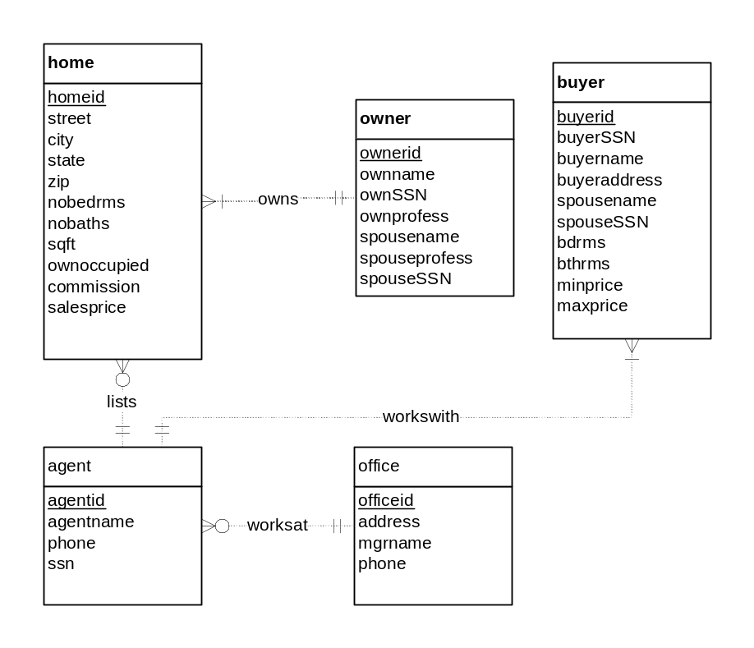
SSN is a poor choice for a primary key as noted in module 8. The problem narrative indicates that buyerid is unique so it is used as the primary key. The user should be told that SSN is a poor choice for the primary key.

The problem narrative does not specify the minimum cardinalities of the workswith relationship. Either 0 or 1 are acceptable for minimum cardinalities for both sides of the lists relationship.

- Revise the ERD from problem 4 by adding an offer entity type. A buyer makes an offer on a home for a specified sales price. The offer starts on the submission date and time and expires on the specified date and time. A unique offer number identifies an offer. A buyer can submit multiple offers for the same home.
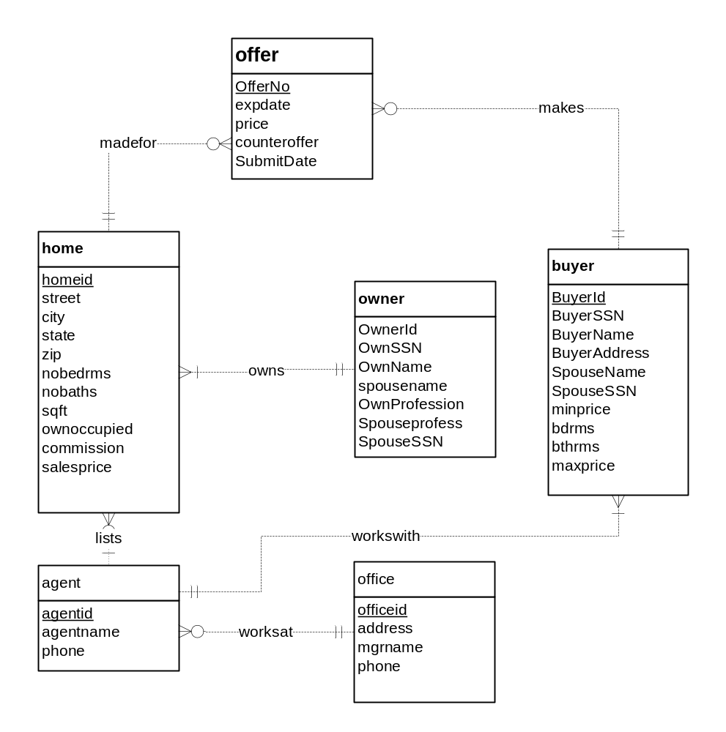

The madefor and makes relationships are 1-M because an offer involves a home and buyer. A buyer can submit multiple offers on the same home.

6. Design an ERD to represent a credit card statement. The statement has two parts: a heading containing the unique statement number, the account number of the credit card holder, and the statement date; and a detail section containing a list of zero or more transactions for which the balance is due. Each detail line contains a line number, a transaction date, a merchant name, and the amount of the transaction. The line number is unique within a statement.
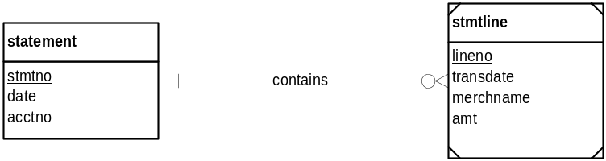

7. Modify your ERD from problem 10. Everything is the same except that each detail line contains a unique transaction number in place of the line number. Transaction numbers are unique across statements.
