Exercise Problems for Module 9
- For the following problem, define an ERD for the initial requirements and then revise the ERD for the new requirements. Your solution should have an initial ERD, a revised ERD, and a list of design decisions for each ERD. In performing your analysis, you may want to follow the approach presented in module 8.
The database supports the placement office of a leading graduate school of business. The primary purpose of the database is to schedule interviews and facilitate searches by students and companies. Consider the following requirements in your initial ERD:
- Student data include a unique student identifier, a name, a phone number, an e-mail address, a web address, a major, a minor, and a GPA. Students may attend multiple interviews.
- The placement office maintains a standard list of positions based on the Labor Department’s list of occupations. Position data include a unique position identifier and a position description. Because the position list is standardized, multiple companies may interview for the same position.
- Company data include a unique company identifier, a company name, and a list of positions and interviewers. Each company must map its positions into the position list maintained by the placement office. For each available position, the company lists the cities in which positions are available.
- Interviewer data include a unique interviewer identifier, a name, a phone, an e-mail address, and a web address. Each interviewer works for one company. An interviewer may conduct multiple interviews.
- An interview includes a unique interview identifier, a date, a time, a location (building and room), an interviewer, and a student.
After reviewing your initial design, the placement office decides to revise the requirements. Make a separate ERD to show your refinements. Refine your original ERD to support the following new requirements:
- Allow companies to use their own language to describe positions. The placement office will not maintain a list of standard positions.
- Allow companies to indicate availability dates and number of openings for positions.
- Allow companies to reserve blocks of interview time. The interview blocks will not specify times for individual interviews. Rather a company will request a block of X hours during a specified week. Companies reserve interview blocks before the placement office schedules individual interviews. Thus, the placement office needs to store interviews as well as interview blocks.
- Allow students to submit bids for interview blocks. Students receive a set amount of bid dollars that they can allocate among bids. The bid mechanism is a pseudo-market approach to allocating interviews, a scarce resource. A bid contains a unique bid identifier, a bid amount, a student, and a company. A student can submit many bids and an interview block can receive many bids.
- For the Expense Report ERD shown in Figure 1, identify and resolve errors and note incompleteness in the specifications. Your solution should include a list of errors and a revised ERD. For each error, identify the type of error (diagram or design) and the specific error within each error type. Note that the ERD may have both diagram and design errors. If you are using the ER Assistant, you can use the Check Diagram feature after checking the diagram rules yourself. Specifications for the ERD appear below:
- The Expense Reporting database tracks expense reports and expense report items along with users, expense categories, status codes, and limits on expense category spending.
- For each user, the database records the unique user number, the first name, the last name, the phone number, the e-mail address, the spending limit, the organizational relationships among users, and the expense categories (at least one) available to the user. A user can manage other users but have at most one manager. For each expense category available to a user, there is a limit amount.
- For each expense category, the database records the unique category number, the category description, the spending limit, and the users permitted to use the expense category. When an expense category is initially created, there may not be related users.
- For each status code, the database records the unique status number, the status description, and the expense reports using the status code.
- For each expense report, the database records the unique expense report number, the description, the submitted date, the status date, the status code (required), the user number (required), and the related expense items.
- For each expense item, the database records the unique item number, the description, the expense date, the amount, the expense category (required), and the expense report number (required).
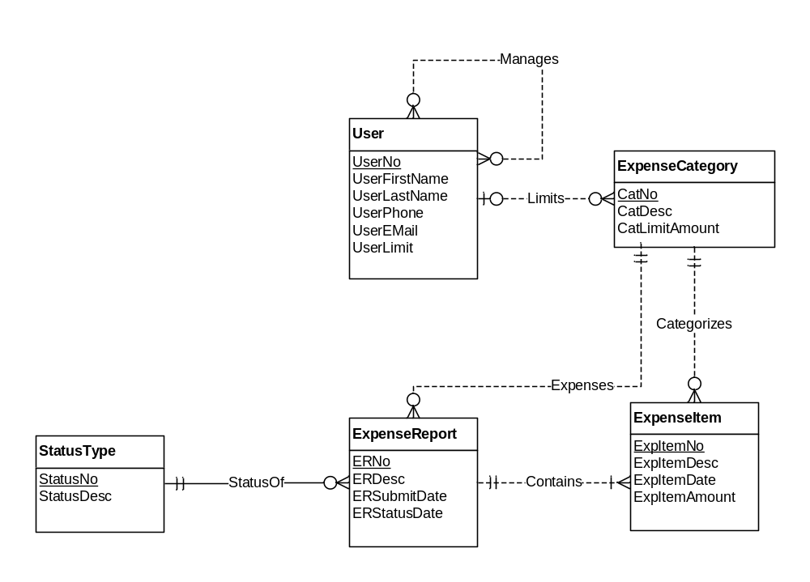
Figure 1: ERD for the Expense Reporting Database

