Te’Keyah Bennett

Assignment 11 – Query Performance

Objective
The objective of this assignment is to analyze query performance on the CensusDB housing database built in Assignment 8 and apply indexing techniques to improve execution speed. The query used for optimization is the ACR lot size breakdown query, which joins the RawData table (273,060 rows) with the Codes and Categories lookup tables. Performance is measured using SQL Server's STATISTICS TIME and STATISTICS IO outputs and the Actual Execution Plan before and after optimization.

Pre-Optimization Performance
Query Analyzed
SELECT [Codes].[Description], COUNT(*) AS 'Number Units'
FROM RawData, Codes, Categories
WHERE RawData.ACR = Codes.Name
AND Codes.CategoryName = 'ACR'
AND Categories.Name = Codes.CategoryName
GROUP BY [Codes].[Description];

Statistics Output
The following statistics were captured by running SET STATISTICS TIME ON and SET STATISTICS IO ON before executing the query:
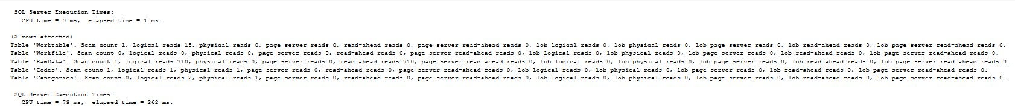

Key metrics recorded:
CPU time: 93 ms
Elapsed time: 337 ms
RawData logical reads: 710
Worktable logical reads: 15

Execution Plan
The Actual Execution Plan revealed two major cost operations:
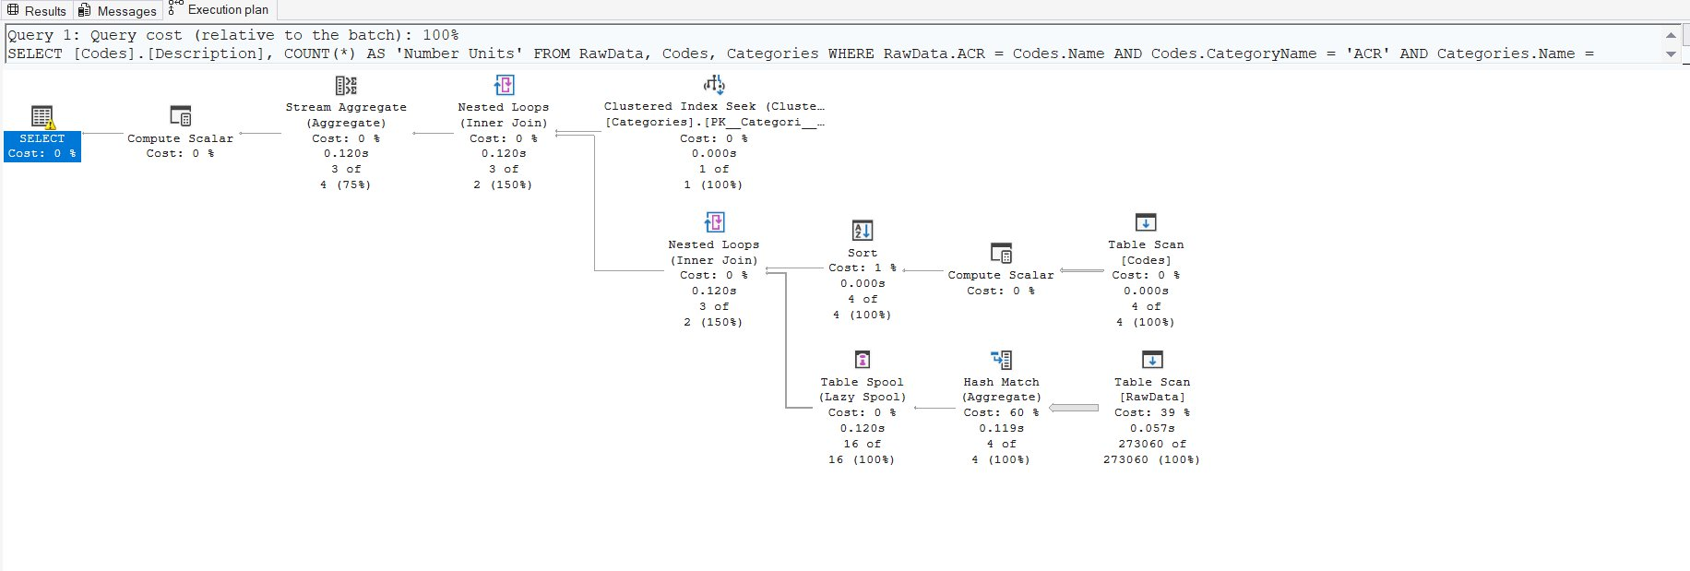

Table Scan [RawData] — Cost 39%: SQL Server was forced to scan all 273,060 rows in RawData because there was no index on the ACR column. Every row had to be read and evaluated even though only a small subset matched the filter condition.

Hash Match (Aggregate) — Cost 60%: The absence of an index meant SQL Server could not pre-sort data, forcing it to use a Hash Match aggregate which is significantly more expensive than a Stream Aggregate. This operation accounted for the majority of the query cost.

Together these two operations confirm that the lack of an index on RawData.ACR was the primary performance bottleneck.

Optimization
Technique Selected: Non-Clustered Indexes
The optimization technique selected was the addition of non-clustered indexes on the columns used in the WHERE clause join conditions. Non-clustered indexes create a separate sorted structure that allows SQL Server to seek directly to matching rows rather than scanning the entire table. This is the most effective optimization for this query because the bottleneck was clearly a full table scan caused by the unindexed ACR column.

Indexes Created
-- Primary optimization: index on the join/filter column in RawData
CREATE INDEX IX_RawData_ACR
ON RawData (ACR);

-- Supporting indexes on the lookup tables
CREATE INDEX IX_Codes_CategoryName
ON Codes (CategoryName);

CREATE INDEX IX_Categories_Name
ON Categories ([Name]);

The most impactful index is IX_RawData_ACR on the large RawData table. The indexes on Codes and Categories are supporting optimizations since those tables are small, but they ensure SQL Server can seek efficiently on all join conditions.

Post-Optimization Performance
Statistics Output
After creating the indexes the same query was re-executed with statistics enabled:
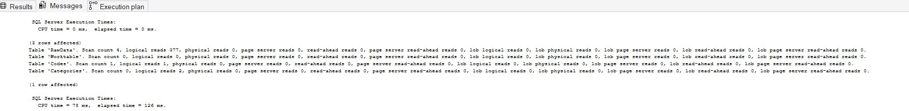

Key metrics recorded:
CPU time: 78 ms
Elapsed time: 126 ms
RawData logical reads: 377

Execution Plan
The post-optimization execution plan confirms the index was used:
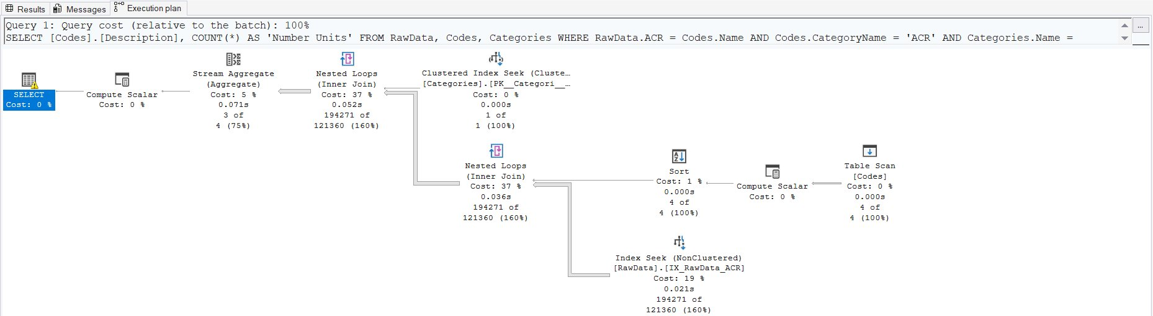

The Table Scan [RawData] was replaced by an Index Seek (NonClustered) [IX_RawData_ACR] at a cost of only 19%. SQL Server now navigates directly to matching ACR values instead of scanning all 273,060 rows. The expensive Hash Match aggregate was also eliminated from the plan.

Conclusion
The table below summarizes the performance improvement achieved through indexing:

CPU time: 93 ms → 78 ms (16% improvement)
Elapsed time: 337 ms → 126 ms (63% improvement)
RawData logical reads: 710 → 377 (47% reduction)
RawData operation: Table Scan → Index Seek

Adding a non-clustered index on RawData.ACR reduced elapsed query time by 63% and cut logical reads nearly in half. The execution plan shift from a full Table Scan to an Index Seek confirms that the index is being used as intended. For even larger datasets this improvement would be proportionally greater, demonstrating the critical importance of proper indexing when working with large coded datasets like Census PUMS data.

