Te’Keyah Bennett

CREATE TABLE FoodTruck (
TruckID INT PRIMARY KEY IDENTITY (1,1),
TruckName VARCHAR(100),
CuisineType VARCHAR(50)
);

CREATE TABLE MenuItems (
ItemID INT PRIMARY KEY IDENTITY(1,1),
ItemName VARCHAR(100),
Price DECIMAL(5,2),
TruckID INT
);

CREATE TABLE Customers (
CustomerID INT PRIMARY KEY IDENTITY(1,1),
FirstName VARCHAR(50),
LastName VARCHAR(50),
);

CREATE TABLE Orders (
OrderID INT PRIMARY KEY IDENTITY(1,1),
CustomerID INT,
OrderDate DATETIME
);

CREATE TABLE OrderItems (
OrderItemID INT PRIMARY KEY IDENTITY(1,1),
OrderID INT,
ItemID INT,
Quantity INT
);

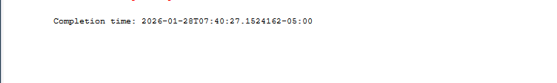

Data Dictionary – FoodTruckFestDB

Table: FoodTrucks
Field Name | Data Type | Description
TruckID | INT (PK) | Unique identifier for each food truck
TruckName | VARCHAR(100) | Name of the food truck
CuisineType | VARCHAR(50) | Type of cuisine served

Table: MenuItems
Field Name | Data Type | Description
ItemID | INT (PK) | Unique identifier for each menu item
ItemName | VARCHAR(100) | Name of the menu item
Price | DECIMAL(5,2) | Price of the menu item
TruckID | INT | Identifier of the food truck offering the item

Table: Customers
Field Name | Data Type | Description
CustomerID | INT (PK) | Unique identifier for each customer
FirstName | VARCHAR(50) | Customer first name
LastName | VARCHAR(50) | Customer last name

Table: Orders
Field Name | Data Type | Description
OrderID | INT (PK) | Unique identifier for each order
CustomerID | INT | Identifier of the customer placing the order
OrderDate | DATETIME | Date and time the order was placed

Table: OrderItems
Field Name | Data Type | Description
OrderItemID | INT (PK) | Unique identifier for each order item record
OrderID | INT | Identifier of the order
ItemID | INT | Identifier of the menu item
Quantity | INT | Quantity of the item ordered

