Assignment 3 – Stored Procedures
Te’Keyah Bennett

Objective
The objective of this assignment is to create stored procedures in SQL Server that insert data into a relational database. The procedures must check whether related records already exist before inserting new ones and must correctly handle a many-to-many relationship between menu items and ingredients using a join table.

Methodology
The MenuDatabase contains five tables. The Menu table holds the top-level menu and has a one-to-many relationship with MenuGroups. MenuGroups has a one-to-many relationship with MenuItems. Ingredients stores a master list of ingredients, and IngredientsInItems is the join table that links ingredients to menu items in a many-to-many relationship. All primary key fields use IDENTITY(1,1) so SQL Server generates IDs automatically.

Two stored procedures were created for this assignment.

The first procedure, sp_InsertNewMenuItem, accepts a MenuTitle, MenuGroupText, and MenuItemTitle as parameters. It first checks whether the given MenuTitle already exists in the Menu table. If it does, the existing ID is reused. If not, a new record is inserted and the ID is captured using SCOPE_IDENTITY(). The same check is then performed for MenuGroupText. Finally, the new menu item is inserted under the resolved group and the new ID is returned via an OUTPUT parameter.

The second procedure, sp_InsertIngredient, accepts a MenuItemID and an ingredient name. It checks whether the ingredient already exists in the Ingredients table. If it does, the existing ID is reused. If not, a new ingredient is created. Either way, a record is inserted into the IngredientsInItems join table to link the ingredient to the menu item. This ensures shared ingredients like Lettuce and Salsa are stored only once but linked to multiple items.

Stored Procedure Code

sp_InsertNewMenuItem:
CREATE OR ALTER PROCEDURE sp_InsertNewMenuItem
@MenuTitle NVARCHAR(50),
@MenuGroupText NVARCHAR(50),
@MenuItemTitle NVARCHAR(50),
@MenuDescText NVARCHAR(50) = NULL,
@MenuGroupDescText NVARCHAR(50) = NULL,
@MenuItemDescText NVARCHAR(50) = NULL,
@NewMenuItemID INT OUTPUT
AS
BEGIN
SET NOCOUNT ON;
DECLARE @MenuID INT
DECLARE @MenuGroupID INT

-- Check if Menu exists; if not, create it
SELECT @MenuID = ID FROM dbo.Menu WHERE MenuTitle = @MenuTitle

IF @MenuID IS NULL
BEGIN
INSERT INTO dbo.Menu (MenuTitle, MenuDescriptionText)
VALUES (@MenuTitle, @MenuDescText)
SET @MenuID = SCOPE_IDENTITY()
PRINT 'New Menu created: ' + @MenuTitle
END
ELSE
PRINT 'Existing Menu found: ' + @MenuTitle

-- Check if MenuGroup exists; if not, create it
SELECT @MenuGroupID = ID FROM dbo.MenuGroups
WHERE MenuGroupText = @MenuGroupText AND MenuID = @MenuID

IF @MenuGroupID IS NULL
BEGIN
INSERT INTO dbo.MenuGroups (MenuID, MenuGroupText, MenuGroupDescriptionText)
VALUES (@MenuID, @MenuGroupText, @MenuGroupDescText)
SET @MenuGroupID = SCOPE_IDENTITY()
PRINT 'New MenuGroup created: ' + @MenuGroupText
END
ELSE
PRINT 'Existing MenuGroup found: ' + @MenuGroupText

-- Insert the new MenuItem
INSERT INTO dbo.MenuItems (MenuGroupsID, MenuItemTitle, MenuItemDescriptionText)
VALUES (@MenuGroupID, @MenuItemTitle, @MenuItemDescText)
SET @NewMenuItemID = SCOPE_IDENTITY()
PRINT 'New MenuItem created: ' + @MenuItemTitle
END
GO

sp_InsertIngredient:
CREATE OR ALTER PROCEDURE sp_InsertIngredient
@MenuItemID INT,
@IngredientTitle NVARCHAR(50),
@IngredientDescText NVARCHAR(200) = NULL,
@LinkDescText NVARCHAR(200) = NULL
AS
BEGIN
SET NOCOUNT ON;
DECLARE @IngredientID INT

-- Check if ingredient already exists
SELECT @IngredientID = ID FROM dbo.Ingredients
WHERE IngredientTitleText = @IngredientTitle

IF @IngredientID IS NULL
BEGIN
INSERT INTO dbo.Ingredients (IngredientTitleText, IngredientDescriptionText)
VALUES (@IngredientTitle, @IngredientDescText)
SET @IngredientID = SCOPE_IDENTITY()
PRINT 'New Ingredient created: ' + @IngredientTitle
END
ELSE
PRINT 'Existing Ingredient found: ' + @IngredientTitle

-- Link ingredient to menu item
INSERT INTO dbo.IngredientsInItems (IngredientsID, MenuItemID, DescriptionText)
VALUES (@IngredientID, @MenuItemID, @LinkDescText)
PRINT 'Ingredient linked to MenuItemID ' + CAST(@MenuItemID AS VARCHAR)
END
GO

Test Data
The following items were inserted using the stored procedures:

- Classic American Taco (Tacos group) – Ground Beef, Tomatoes, Onions, Lettuce, Salsa
- Spicy Chicken Taco (Tacos group) – Grilled Chicken, Jalapenos, Pepper Jack Cheese, Chipotle Sauce, Lettuce
- Caesar Salad (Salads group) – Romaine Lettuce, Caesar Dressing, Parmesan Cheese, Croutons
- Cheese Quesadilla (Appetizers group) – Flour Tortilla, Cheddar Cheese, Salsa

Results
Both stored procedures executed successfully. The verification queries confirmed that all records were inserted correctly. Shared ingredients (Lettuce, Salsa) were stored once in the Ingredients table and linked to multiple items through the join table as expected.

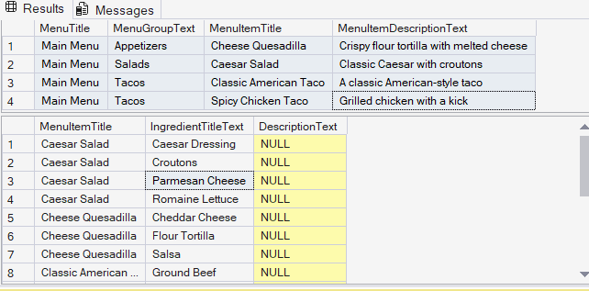
Conclusion
This assignment demonstrated how stored procedures can handle conditional data insertion across related tables. The existence checks prevent duplicate records for shared data such as menu groups and ingredients. SCOPE_IDENTITY() captured the correct ID after each insert. The many-to-many relationship between menu items and ingredients was correctly implemented using the IngredientsInItems join table.

