Assignment 4 – Stored Functions
Te’Keyah Bennett
Objective
The objective of this assignment is to demonstrate the creation and use of two SQL Server stored functions. The first is a table-valued function that returns all menu items belonging to a given menu. The second is a scalar function that returns the description of a single menu item by its ID. A final query demonstrates both functions working together in a single SQL statement.
Methodology
Three tables were created to support the functions: Menu, MenuItem, and MenuMenuItems. Menu stores named menus. MenuItem stores individual dishes with a name, description, and price. MenuMenuItems is a junction table that links menus to menu items in a many-to-many relationship.

Function 1 – func_GetMenuItemsForMenu (Table-Valued Function)
Accepts a MenuID and returns a table of all menu items linked to that menu.

CREATE FUNCTION dbo.func_GetMenuItemsForMenu
(
@MenuID INT
)
RETURNS TABLE
AS
RETURN
(
SELECT
mi.MenuItemID,
mi.MenuItemName,
mi.Price
FROM MenuItem AS mi
INNER JOIN MenuMenuItems AS mmi ON mi.MenuItemID = mmi.MenuItemID
WHERE mmi.MenuID = @MenuID
);
GO

Function 2 – func_GetMenuItemDescriptionForMenuItemID (Scalar Function)
Accepts a MenuItemID and returns the description of that item as a VARCHAR value.

CREATE FUNCTION dbo.func_GetMenuItemDescriptionForMenuItemID
(
@MenuItemID INT
)
RETURNS VARCHAR(500)
AS
BEGIN
DECLARE @Description VARCHAR(500);

SELECT @Description = MenuItemDescription
FROM MenuItem
WHERE MenuItemID = @MenuItemID;

RETURN @Description;
END;
GO

Demonstration Query
The query below calls the table-valued function in the FROM clause and the scalar function inline in the SELECT list to return all items on Menu 1 with their descriptions.

SELECT
items.MenuItemID,
items.MenuItemName,
items.Price,
dbo.func_GetMenuItemDescriptionForMenuItemID(items.MenuItemID) AS MenuItemDescription
FROM
dbo.func_GetMenuItemsForMenu(1) AS items
ORDER BY
items.MenuItemID;
Results
Both functions were created successfully in SQL Server Management Studio. The demonstration query returned five rows, one for each menu item on the Dinner Menu, with the description column populated by the scalar function for each row.

Screenshot – Function 1 created successfully:
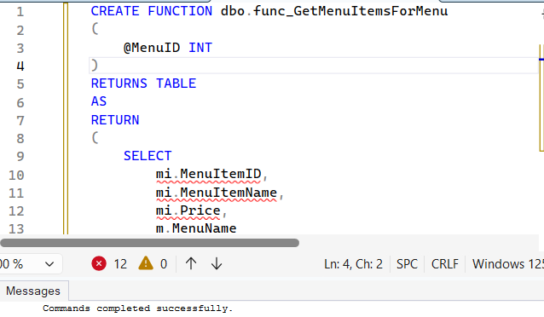
Screenshot – Function 2 created successfully:
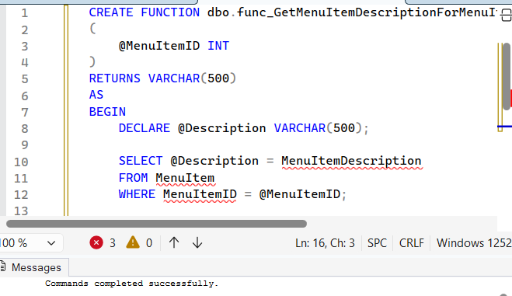
Screenshot – Demonstration query and results:
