Te’Keyah Bennett

Assignment 5 – Transactions: ACID Principles & SQL Server Transaction Management
1. Problem Statement
This assignment required a paper on how SQL Server implements the ACID properties and a stored procedure that transfers credits between two user accounts. Every successful transfer must commit exactly two Transactions rows—one withdrawal and one credit—as a single atomic unit. If any step fails, the database must return to its exact pre-call state. The guiding constraint: thou shalt not create, nor destroy money.
2. Approach and Methodology
ACID explanations draw from course lecture material and Microsoft's official documentation. The stored procedure was designed around four decisions: validating all inputs before the transaction opens to minimize lock duration; using UPDLOCK and ROWLOCK on the balance read to prevent concurrent overdrafts; using explicit ROLLBACK TRANSACTION inside TRY/CATCH with RAISERROR to ensure every error path resolves cleanly; and placing both Transactions INSERTs inside the same transaction so the withdrawal and credit records are always committed or rolled back together.
3. Solution and Results
3.1 ACID Properties – SQL Server Implementation
Atomicity
All-or-nothing execution. SQL Server logs every change before applying it to data pages. On failure, log records are reversed in order, undoing each change. In the procedure, any error transfers to CATCH where ROLLBACK TRANSACTION reverses all applied changes.
Consistency
The database moves between valid states only. The schema-level CHECK (CreditBalance >= 0) enforces a hard floor independent of application logic. The procedure adds an explicit balance check and ownership validation before any data is touched.
Isolation
Concurrent transactions execute independently. UPDLOCK and ROWLOCK on the balance SELECT prevent a second session from reading the same balance and issuing a competing debit before this transaction commits, closing the lost-update race condition.
Durability
Committed changes survive failures. Before COMMIT TRANSACTION returns, SQL Server flushes all log records to disk. Even an immediate power failure after the commit cannot lose the changes—they will be replayed during crash recovery.
3.2 Database Schema

CREATE TABLE Users (UserId INT NOT NULL IDENTITY(1,1) PRIMARY KEY,
UserName NVARCHAR(100) NOT NULL, UserInformation NVARCHAR(255) NOT NULL);

CREATE TABLE UserAccount (UserAccountId INT NOT NULL IDENTITY(1,1) PRIMARY KEY,
UserId INT NOT NULL REFERENCES Users(UserId), AccountType NVARCHAR(50) NOT NULL,
CreditBalance DECIMAL(18,2) NOT NULL
CONSTRAINT CK_CreditBalance CHECK (CreditBalance >= 0));

CREATE TABLE Transactions (TransactionId INT NOT NULL IDENTITY(1,1) PRIMARY KEY,
UserAccountId INT NOT NULL REFERENCES UserAccount(UserAccountId),
TransferAmount DECIMAL(18,2) NOT NULL CONSTRAINT CK_Amt CHECK (TransferAmount > 0),
CreditOrWithdrawal CHAR(1) NOT NULL CONSTRAINT CK_CW CHECK (CreditOrWithdrawal IN ('C','W')),
TransferCode NVARCHAR(100) NULL,
TransactionDateTime DATETIME2 NOT NULL DEFAULT SYSUTCDATETIME());
3.3 Stored Procedure – usp_TransferCredits

CREATE OR ALTER PROCEDURE dbo.usp_TransferCredits
@UserId INT, @UserAccountIdFrom INT, @UserAccountIdTo INT,
@TransferAmount DECIMAL(18,2), @TransferCode NVARCHAR(100) = NULL
AS BEGIN
SET NOCOUNT ON; SET XACT_ABORT ON;

-- Validation before transaction: no locks held yet
IF @TransferAmount <= 0
BEGIN RAISERROR('TransferAmount must be greater than zero.', 16, 1); RETURN; END
IF @UserAccountIdFrom = @UserAccountIdTo
BEGIN RAISERROR('Source and destination accounts must differ.', 16, 1); RETURN; END
IF NOT EXISTS (SELECT 1 FROM dbo.UserAccount
WHERE UserAccountId = @UserAccountIdFrom AND UserId = @UserId)
BEGIN RAISERROR('Source account does not belong to the specified user.', 16, 1); RETURN; END
IF NOT EXISTS (SELECT 1 FROM dbo.UserAccount WHERE UserAccountId = @UserAccountIdTo)
BEGIN RAISERROR('Destination account does not exist.', 16, 1); RETURN; END

BEGIN TRY
BEGIN TRANSACTION;
DECLARE @CurrentBalance DECIMAL(18,2);
-- UPDLOCK + ROWLOCK closes the lost-update race condition
SELECT @CurrentBalance = CreditBalance FROM dbo.UserAccount WITH (UPDLOCK, ROWLOCK)
WHERE UserAccountId = @UserAccountIdFrom;

IF @CurrentBalance < @TransferAmount
BEGIN RAISERROR('Insufficient credits in source account.', 16, 1); END

UPDATE dbo.UserAccount SET CreditBalance = CreditBalance - @TransferAmount
WHERE UserAccountId = @UserAccountIdFrom;
UPDATE dbo.UserAccount SET CreditBalance = CreditBalance + @TransferAmount
WHERE UserAccountId = @UserAccountIdTo;

INSERT INTO dbo.Transactions (UserAccountId,TransferAmount,CreditOrWithdrawal,TransferCode)
VALUES (@UserAccountIdFrom, @TransferAmount, 'W', @TransferCode);
INSERT INTO dbo.Transactions (UserAccountId,TransferAmount,CreditOrWithdrawal,TransferCode)
VALUES (@UserAccountIdTo, @TransferAmount, 'C', @TransferCode);

COMMIT TRANSACTION;
SELECT 'Transfer successful' AS Status, @UserAccountIdFrom AS FromAccount,
@UserAccountIdTo AS ToAccount, @TransferAmount AS Amount;
END TRY
BEGIN CATCH
IF @@TRANCOUNT > 0 ROLLBACK TRANSACTION;
DECLARE @ErrMsg NVARCHAR(4000) = ERROR_MESSAGE();
DECLARE @ErrSev INT = ERROR_SEVERITY();
DECLARE @ErrStat INT = ERROR_STATE();
RAISERROR(@ErrMsg, @ErrSev, @ErrStat);
END CATCH;
END;
GO

4. Conclusion
Prior to this assignment, ACID was a concept I understood in the abstract. Working through the implementation made it concrete: each property is the direct result of a specific mechanism, and every design decision in the procedure—where validation runs, which lock hints are used, how errors are handled—has a measurable effect on whether those guarantees hold. The most transferable lesson was the shift in thinking from 'how do I make this work' to 'how do I make this impossible to break.'

Appendix – Screenshots
The following screenshots confirm correct execution of the stored procedure in both the success and failure cases.
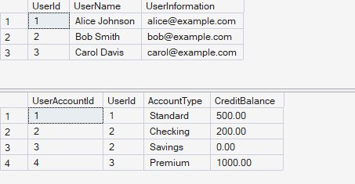  Figure 1: Starting data — Alice 500.00, Bob Checking 200.00, Bob Savings 0.00, Carol 1000.00. | 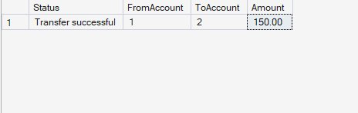  Figure 2: Successful transfer of 150.00 from Alice (account 1) to Bob Checking (account 2).

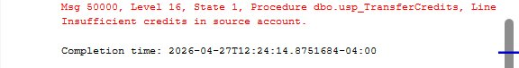  Figure 3: Overdraft rejected — RAISERROR fired, ROLLBACK TRANSACTION executed, no data changed. | 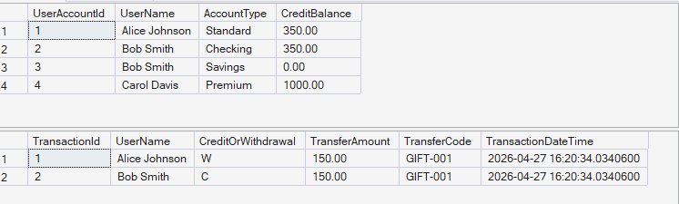  Figure 4: Final state — Alice 350.00, Bob Checking 350.00. Exactly two Transactions rows; failed attempt left no trace.
References
- Course lecture material: Introduction to Transactions, ACID Properties, T-SQL Transaction Basics, Isolation Levels, Locking and Concurrency, Transactions in Stored Procedures.
- Microsoft Corporation. (2024). Transaction locking and row versioning guide. Microsoft Learn. https://learn.microsoft.com/en-us/sql/relational-databases/sql-server-transaction-locking-and-row-versioning-guide
- Microsoft Corporation. (2024). Transaction log architecture and management guide. Microsoft Learn. https://learn.microsoft.com/en-us/sql/relational-databases/sql-server-transaction-log-architecture-and-management-guide
- Microsoft Corporation. (2024). RAISERROR (Transact-SQL) – raises a custom error with severity and state codes. Microsoft Learn. https://learn.microsoft.com/en-us/sql/t-sql/language-elements/raiserror-transact-sql
- Microsoft Corporation. (2024). Table hints (Transact-SQL) – UPDLOCK and ROWLOCK; controls lock type and granularity on SELECT. Microsoft Learn. https://learn.microsoft.com/en-us/sql/t-sql/queries/hints-transact-sql-table
- Microsoft Corporation. (2024). Deadlocks guide – explains concurrent transaction conflicts and the lost-update problem UPDLOCK prevents. Microsoft Learn. https://learn.microsoft.com/en-us/sql/relational-databases/sql-server-deadlocks-guide
- Microsoft Corporation. (2024). SET XACT_ABORT (Transact-SQL) – when ON, automatically rolls back the entire transaction on any run-time error. Microsoft Learn. https://learn.microsoft.com/en-us/sql/t-sql/statements/set-xact-abort-transact-sql
- Microsoft Corporation. (2024). @@TRANCOUNT (Transact-SQL) – returns the number of open transactions; used to safely check before issuing ROLLBACK. Microsoft Learn. https://learn.microsoft.com/en-us/sql/t-sql/functions/trancount-transact-sql
- Microsoft Corporation. (2024). SYSUTCDATETIME (Transact-SQL) – returns the current UTC date and time with higher precision than GETDATE(). Microsoft Learn. https://learn.microsoft.com/en-us/sql/t-sql/functions/sysutcdatetime-transact-sql
- Microsoft Corporation. (2024). IDENTITY property (Transact-SQL) – auto-increments a column on each insert to generate primary key values automatically. Microsoft Learn. https://learn.microsoft.com/en-us/sql/t-sql/statements/create-table-transact-sql-identity-property
- Microsoft Corporation. (2024). decimal and numeric (Transact-SQL) – fixed-precision type used for monetary values to avoid floating-point rounding errors. Microsoft Learn. https://learn.microsoft.com/en-us/sql/t-sql/data-types/decimal-and-numeric-transact-sql
- Microsoft Corporation. (2024). ERROR_MESSAGE, ERROR_SEVERITY, ERROR_STATE (Transact-SQL) – functions used inside CATCH blocks to retrieve error details. Microsoft Learn. https://learn.microsoft.com/en-us/sql/t-sql/functions/error-message-transact-sql
- Microsoft Corporation. (2024). COMMIT TRANSACTION (Transact-SQL) – makes all changes performed in a transaction a permanent part of the database and ends the transaction. Microsoft Learn. https://learn.microsoft.com/en-us/sql/t-sql/language-elements/commit-transaction-transact-sql

