Te’Keyah Bennett

Assignment #6 – Cursors
1. Problem Statement
Create a stored procedure named sp_DisplayCollege that accepts a college name, finds all partial matches, and uses a cursor to iterate through each match. For each institution, produce a report comparing its cumulative loan debt at the 10th, 25th, 75th, and 90th percentiles against the national simple average and enrollment-weighted average.

2. Methodology
The procedure is structured in three steps. First, two aggregate queries pre-compute the simple average (AVG) and weighted average (SUM(debt × enrollment) / SUM(enrollment)) for all four percentile fields across all schools — calculated once before the cursor opens to avoid redundant computation. Second, a cursor is declared using a LIKE '%input%' partial match filtered to rows with valid numeric values. Third, the cursor iterates row by row using FETCH NEXT inside a WHILE loop, printing a formatted comparison report for each match, then closes and deallocates the cursor.

3. Solution & Results
The stored procedure code is shown below. Screenshots of the procedure in SSMS and the execution output are in the Appendix.

CREATE PROCEDURE sp_DisplayCollege @CollegeName VARCHAR(255) AS
BEGIN
SET NOCOUNT ON;
DECLARE @INSTNM VARCHAR(255), @N FLOAT, @P10 FLOAT, @P25 FLOAT, @P75 FLOAT, @P90 FLOAT
DECLARE @AvgP10 FLOAT, @AvgP25 FLOAT, @AvgP75 FLOAT, @AvgP90 FLOAT
DECLARE @WAvgP10 FLOAT, @WAvgP25 FLOAT, @WAvgP75 FLOAT, @WAvgP90 FLOAT

-- Simple averages
SELECT @AvgP10=AVG(CAST(CUML_DEBT_P10 AS FLOAT)), @AvgP25=AVG(CAST(CUML_DEBT_P25 AS FLOAT)),
@AvgP75=AVG(CAST(CUML_DEBT_P75 AS FLOAT)), @AvgP90=AVG(CAST(CUML_DEBT_P90 AS FLOAT))
FROM CollegeData WHERE ISNUMERIC(CUML_DEBT_P10)=1 AND ISNUMERIC(CUML_DEBT_N)=1;

-- Weighted averages
SELECT @WAvgP10=SUM(CAST(CUML_DEBT_P10 AS FLOAT)*CAST(CUML_DEBT_N AS FLOAT))/SUM(CAST(CUML_DEBT_N AS FLOAT)),
@WAvgP25=SUM(CAST(CUML_DEBT_P25 AS FLOAT)*CAST(CUML_DEBT_N AS FLOAT))/SUM(CAST(CUML_DEBT_N AS FLOAT)),
@WAvgP75=SUM(CAST(CUML_DEBT_P75 AS FLOAT)*CAST(CUML_DEBT_N AS FLOAT))/SUM(CAST(CUML_DEBT_N AS FLOAT)),
@WAvgP90=SUM(CAST(CUML_DEBT_P90 AS FLOAT)*CAST(CUML_DEBT_N AS FLOAT))/SUM(CAST(CUML_DEBT_N AS FLOAT))
FROM CollegeData WHERE ISNUMERIC(CUML_DEBT_P10)=1 AND ISNUMERIC(CUML_DEBT_N)=1;

-- Cursor declaration
DECLARE CollegeCursor CURSOR FOR
SELECT INSTNM, CAST(CUML_DEBT_N AS FLOAT), CAST(CUML_DEBT_P10 AS FLOAT),
CAST(CUML_DEBT_P25 AS FLOAT), CAST(CUML_DEBT_P75 AS FLOAT), CAST(CUML_DEBT_P90 AS FLOAT)
FROM CollegeData WHERE INSTNM LIKE '%' + @CollegeName + '%'
AND ISNUMERIC(CUML_DEBT_P10)=1 AND ISNUMERIC(CUML_DEBT_N)=1;

OPEN CollegeCursor;
FETCH NEXT FROM CollegeCursor INTO @INSTNM, @N, @P10, @P25, @P75, @P90;

WHILE @@FETCH_STATUS = 0
BEGIN
PRINT '================================================'
PRINT 'College: ' + @INSTNM
PRINT '================================================'
PRINT 'Statistic | Institution | Average | Weighted Avg'
PRINT '-----------------------|-------------|---------|-------------'
PRINT 'Cumulative Debt at 10% | $'+FORMAT(@P10,'N0')+' | $'+FORMAT(@AvgP10,'N0')+' | $'+FORMAT(@WAvgP10,'N0')
PRINT 'Cumulative Debt at 25% | $'+FORMAT(@P25,'N0')+' | $'+FORMAT(@AvgP25,'N0')+' | $'+FORMAT(@WAvgP25,'N0')
PRINT 'Cumulative Debt at 75% | $'+FORMAT(@P75,'N0')+' | $'+FORMAT(@AvgP75,'N0')+' | $'+FORMAT(@WAvgP75,'N0')
PRINT 'Cumulative Debt at 90% | $'+FORMAT(@P90,'N0')+' | $'+FORMAT(@AvgP90,'N0')+' | $'+FORMAT(@WAvgP90,'N0')
PRINT 'Sample Size | '+FORMAT(@N,'N0')+' | (national) | (national)'
PRINT ''
FETCH NEXT FROM CollegeCursor INTO @INSTNM, @N, @P10, @P25, @P75, @P90;
END

CLOSE CollegeCursor;
DEALLOCATE CollegeCursor;
END

Results for EXEC sp_DisplayCollege 'Daytona' (Daytona College):

Statistic | Institution | Avg (National) | Weighted Avg | Sample Size
Cumulative Debt at 10% | $3,500 | $3,477 | $2,818 | 521
Cumulative Debt at 25% | $6,050 | $6,289 | $5,992 | 521
Cumulative Debt at 75% | $12,043 | $19,077 | $27,992 | 521
Cumulative Debt at 90% | $17,856 | $25,671 | $39,182 | 521

The institution's debt falls below both national averages at every percentile, most notably at the 75th and 90th percentile levels where the gap exceeds $10,000 and $21,000 respectively.

4. Conclusion
The stored procedure sp_DisplayCollege successfully demonstrates cursor creation, row-by-row iteration, and formatted output in SQL Server. A limitation of using PRINT is that output is confined to the Messages pane and cannot be returned as a query result set — a future improvement could write results to a temp table for easier consumption.

Appendix – SSMS Screenshots

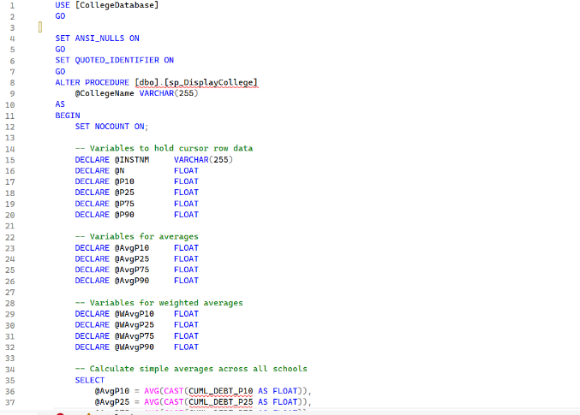
Figure A1: Stored procedure code – variable declarations and average calculations
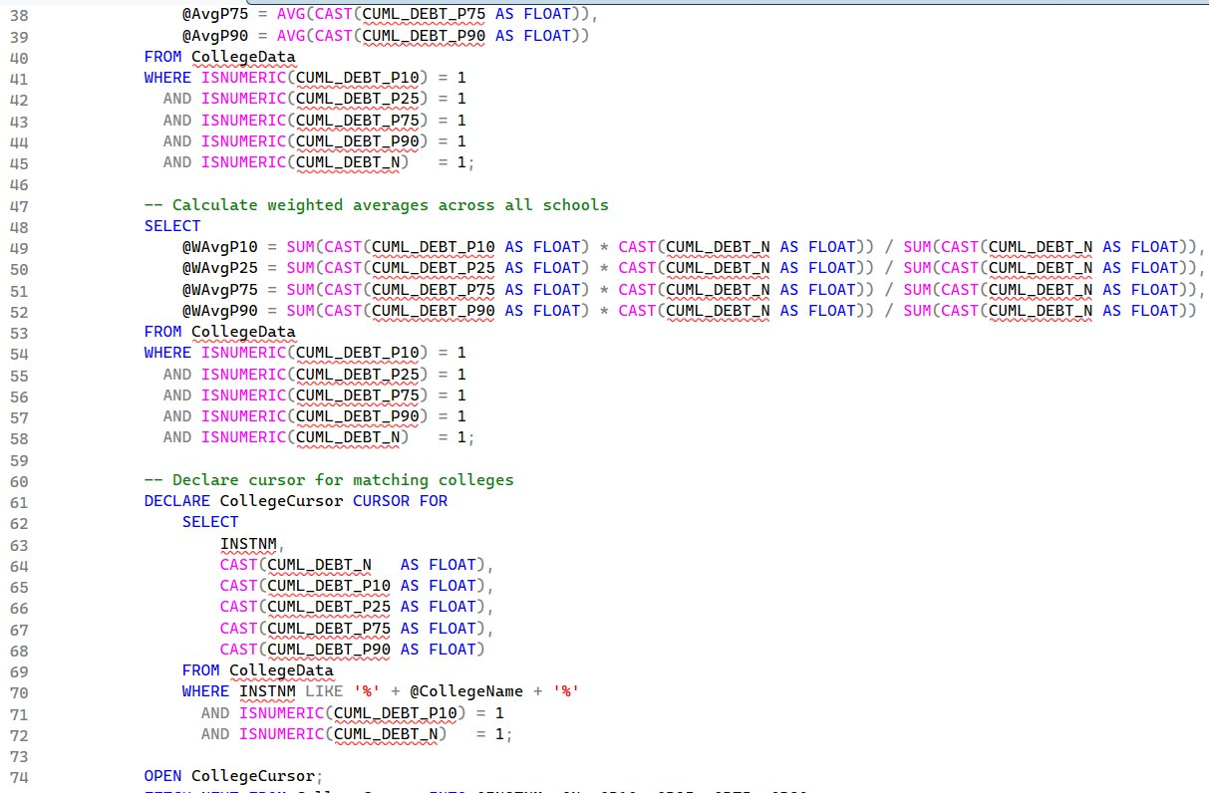
Figure A2: Weighted averages and cursor declaration
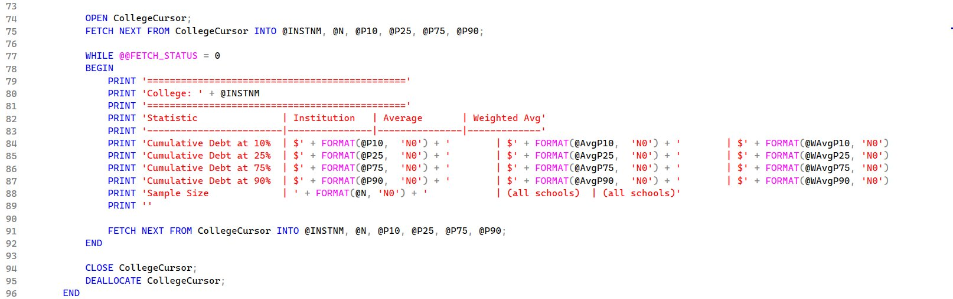
Figure A3: Cursor loop, PRINT statements, CLOSE and DEALLOCATE
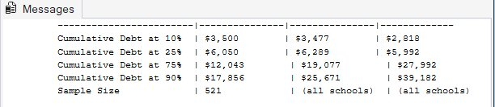
Figure A4: Messages tab output after EXEC sp_DisplayCollege 'Daytona'

