Te’Keyah Bennett
Assignment 9 – SQL Operators

1. Objective
This assignment uses SQL Server window functions, views, and stored procedures to analyze the USDA SuperTracker Food Database (FNDDS 6.0), which contains 6,454 food items. Foods are divided into four quartiles based on their fat-to-energy ratio, then ranked within the top and bottom quartiles by total sugar and Vitamin C content, producing eight result sets of 10 foods each.
2. Methodology
The USDA SuperTracker Food Database was imported into SQL Server using the Import Flat File wizard, loading 6,454 food records. Five columns were used: food name, energy (kcal), total fat (g), total sugar (g), and Vitamin C (mg). To define quartiles, a fat-to-energy ratio was calculated for each food by dividing total fat by energy. The T-SQL window function NTILE(4) was then applied to split all foods into four equal groups based on that ratio. Quartile 1 represents the lowest fat-to-energy ratio and Quartile 4 the highest. All eight queries pull from a view that stores these calculations, and a stored procedure handles the ranking logic by accepting the quartile number and nutritional column as inputs.
3. Stored Procedure Code
View: dbo.vw_food_quartiles
CREATE VIEW dbo.vw_food_quartiles AS
SELECT
food_name, energy_kcal, fat_total_g, sugar_total_g, vitamin_c_mg,
ROUND(fat_total_g / energy_kcal, 6) AS fat_energy_ratio,
NTILE(4) OVER (ORDER BY fat_total_g / energy_kcal) AS fat_quartile
FROM dbo.usda_food
WHERE energy_kcal > 0;

Stored Procedure: dbo.sp_food_quartile_rank
CREATE PROCEDURE dbo.sp_food_quartile_rank
@quartile_target TINYINT,
@ranking_col VARCHAR(10)
AS
BEGIN
SET NOCOUNT ON;
IF LOWER(@ranking_col) = 'sugar'
BEGIN
SELECT TOP 10 food_name, energy_kcal, fat_total_g,
ROUND(fat_energy_ratio,4) AS fat_energy_ratio,
fat_quartile, sugar_total_g AS ranking_value,
'Sugar (g) - TOP 10' AS result_label
FROM dbo.vw_food_quartiles
WHERE fat_quartile = @quartile_target AND sugar_total_g > 0
ORDER BY sugar_total_g DESC;
SELECT TOP 10 food_name, energy_kcal, fat_total_g,
ROUND(fat_energy_ratio,4) AS fat_energy_ratio,
fat_quartile, sugar_total_g AS ranking_value,
'Sugar (g) - BOTTOM 10' AS result_label
FROM dbo.vw_food_quartiles
WHERE fat_quartile = @quartile_target AND sugar_total_g > 0
ORDER BY sugar_total_g ASC;
END
ELSE
BEGIN
SELECT TOP 10 food_name, energy_kcal, fat_total_g,
ROUND(fat_energy_ratio,4) AS fat_energy_ratio,
fat_quartile, vitamin_c_mg AS ranking_value,
'Vitamin C (mg) - TOP 10' AS result_label
FROM dbo.vw_food_quartiles
WHERE fat_quartile = @quartile_target AND vitamin_c_mg > 0
ORDER BY vitamin_c_mg DESC;
SELECT TOP 10 food_name, energy_kcal, fat_total_g,
ROUND(fat_energy_ratio,4) AS fat_energy_ratio,
fat_quartile, vitamin_c_mg AS ranking_value,
'Vitamin C (mg) - BOTTOM 10' AS result_label
FROM dbo.vw_food_quartiles
WHERE fat_quartile = @quartile_target AND vitamin_c_mg > 0
ORDER BY vitamin_c_mg ASC;
END
END

4. Test Data
Row Count Verification
SELECT COUNT(*) AS total_rows FROM dbo.usda_food;
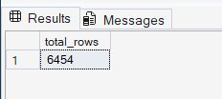

Quartile Distribution Verification
SELECT fat_quartile, COUNT(*) AS food_count
FROM dbo.vw_food_quartiles
GROUP BY fat_quartile ORDER BY fat_quartile;
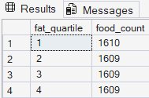

Stored Procedure Test Calls
EXEC dbo.sp_food_quartile_rank @quartile_target = 4, @ranking_col = 'sugar';
EXEC dbo.sp_food_quartile_rank @quartile_target = 1, @ranking_col = 'sugar';
EXEC dbo.sp_food_quartile_rank @quartile_target = 4, @ranking_col = 'vitamin';
EXEC dbo.sp_food_quartile_rank @quartile_target = 1, @ranking_col = 'vitamin';

5. Results
Query 1 — High Fat Quartile (Q4): Highest Sugar — Top 10
Foods with the highest fat-to-energy ratio ranked by most sugar. Dominated by chocolate products and sweetened powders.
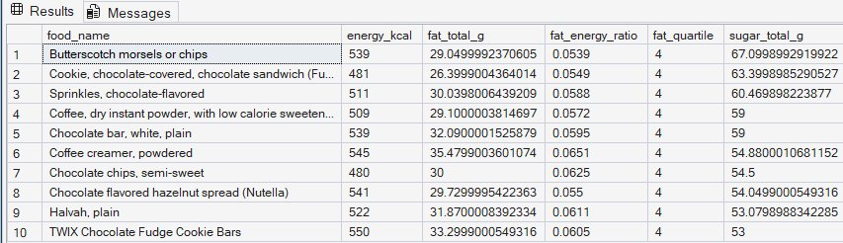
Query 2 — Low Fat Quartile (Q1): Highest Sugar — Top 10
Foods with the lowest fat-to-energy ratio ranked by most sugar. Almost entirely pure sugar products and sweetened drink mixes.
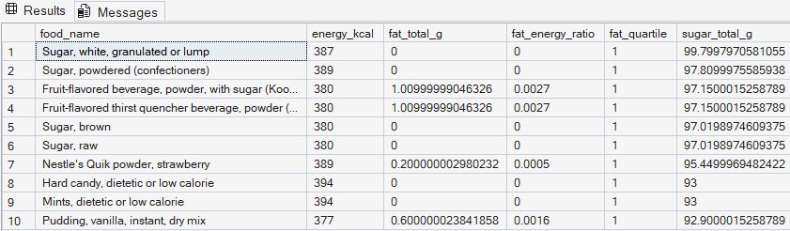
Query 3 — High Fat Quartile (Q4): Highest Vitamin C — Top 10
Foods with the highest fat-to-energy ratio ranked by most Vitamin C. Peppers and cooked greens prepared with fats or oils.
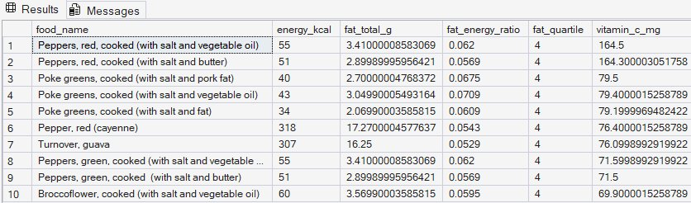
Query 4 — Low Fat Quartile (Q1): Highest Vitamin C — Top 10
Foods with the lowest fat-to-energy ratio ranked by most Vitamin C. Fortified cereals and low-calorie beverage powders.
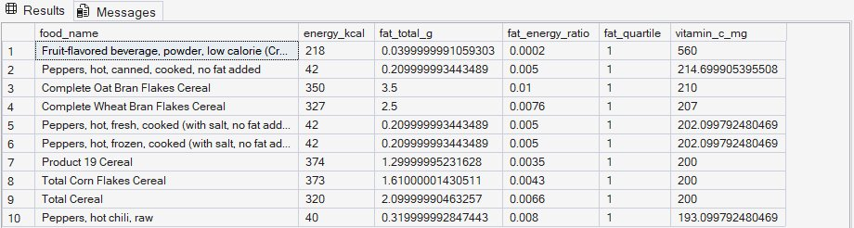
Query 5 — High Fat Quartile (Q4): Lowest Sugar — Bottom 10
Foods with the highest fat-to-energy ratio ranked by least sugar. Savory items such as oysters, gravies, and seafood in butter or oil.
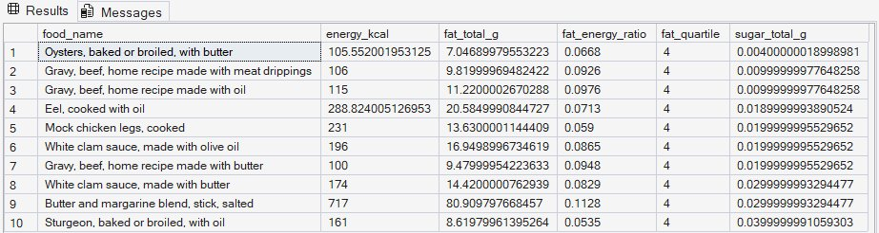
Query 6 — Low Fat Quartile (Q1): Lowest Sugar — Bottom 10
Foods with the lowest fat-to-energy ratio ranked by least sugar. Unsweetened teas, sugar substitutes, and plain cooked grains.
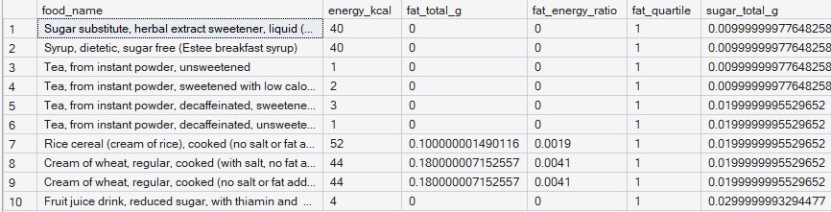
Query 7 — High Fat Quartile (Q4): Lowest Vitamin C — Bottom 10
Foods with the highest fat-to-energy ratio ranked by least Vitamin C. Processed meats, cream-based soups, and pastries.
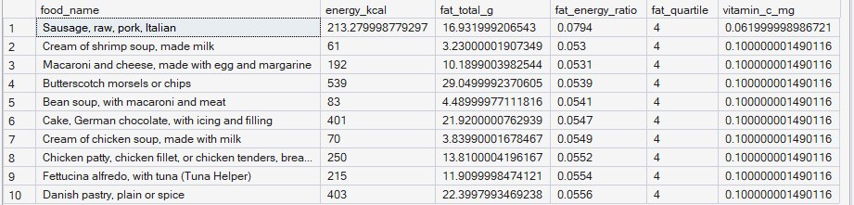
Query 8 — Low Fat Quartile (Q1): Lowest Vitamin C — Bottom 10
Foods with the lowest fat-to-energy ratio ranked by least Vitamin C. Low-fat condiments, soups, and grain-based foods.
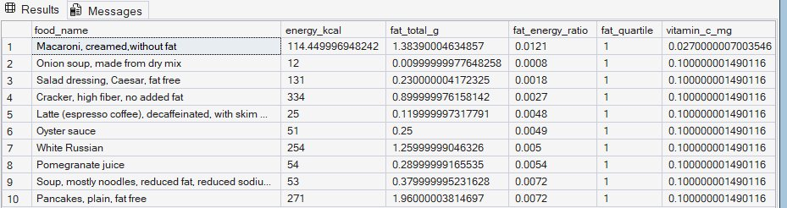

6. Conclusion
The analysis confirmed clear nutritional patterns across the dataset. High fat-ratio foods (Q4) are dominated by processed, calorie-dense items such as chocolates, cream soups, and cured meats, while low fat-ratio foods (Q1) include pure sugars, unsweetened beverages, and grain-based products. Vitamin C results show that fat content alone does not define nutritional quality — peppers cooked in fat rank high in Vitamin C, while many low-fat foods rank low. The stored procedure approach reduced eight queries to four EXEC calls, making the solution efficient and easy to maintain.

