**ASSESSMENT TASK 2**

**Design Workbook**

**Due week: 8**

Student name:

Student number:

Email address:

**Exploring 3D through Objects and Space**

**COURSE TITLE**

CUA30720 Certificate III in Design Fundamentals

**SUBJECT TITLE**

A10156 Exploring 3D through Objects and Space

**TRAINING UNITS**

A: CUAACD311 Produce drawings to communicate ideas

B: CUADES303 Explore and apply the creative design process to 3D forms

C: CUAACD312 Produce computer-aided drawings

Instructions for completing this workbook

This workbook is made up of a series of activities to be completed for Assessment Task 1.

Use the lectures and templates provided in the online classroom, your own research, and the supplied resources to complete the activities.

You must complete all activities in this workbook.

Include supporting documentation as an appendix with submission of this workbook.

Supporting documentation includes but is not limited to:

* Case studies
* Photographs
* References of sources of information (books/websites)
* Any additional pages added due to lack of space in workbook

**CONTENTS**

1. **Client Feedback**
2. **Design Development**
3. **Prepare to Model**
4. **Model in SketchUp**
5. **Prepare and Present**
6. **Self reflection**
7. **References**
8. **Additional pages**

**1. Client Feedback**

For this task, your Trainer is your simulated client. Gather the feedback received from Assessment Task 1.

1. Which floor plan option did the client prefer?
2. Did they give you feedback, recommendations or suggest changes? What were they?
3. What feedback did you receive on your screen design?
4. Based on this feedback, how will you change/develop your designs?
5. How does individual interpretation affect the drawing and feedback process?

**2. Design Development**

Examine the feedback carefully and use handwritten notes and sketches to document design development.   
Include notes on measurements, materials, and 3D forms that you will use in your final design.

Document your design development work below:

|  |
| --- |
| {Design Development} |
| {Design Development} |
| {Design Development} |

**3. Prepare for 3D Modelling**You will need to prepare any materials and equipment you will need to create the 3D design solution.

1. List 2 pieces of hardware you will use for creating 3D computer-aided designs.
2. List 2 pieces of software you will use for creating 3D computer-aided designs.
3. List 2 tools you will use for creating 3D computer-aided designs.
4. List 2 pieces of equipment you will use for creating 3D computer-aided designs.
5. In what ways do interior designers use SketchUp? How is this software useful for designers in the workplace?
6. How effective are 3D models in communicating an idea to a client?
7. Refer to the SketchUp quick reference guide. Keep it handy as you start using SketchUp and you’ll learn to model quickly and efficiently.

From the SketchUp reference card:

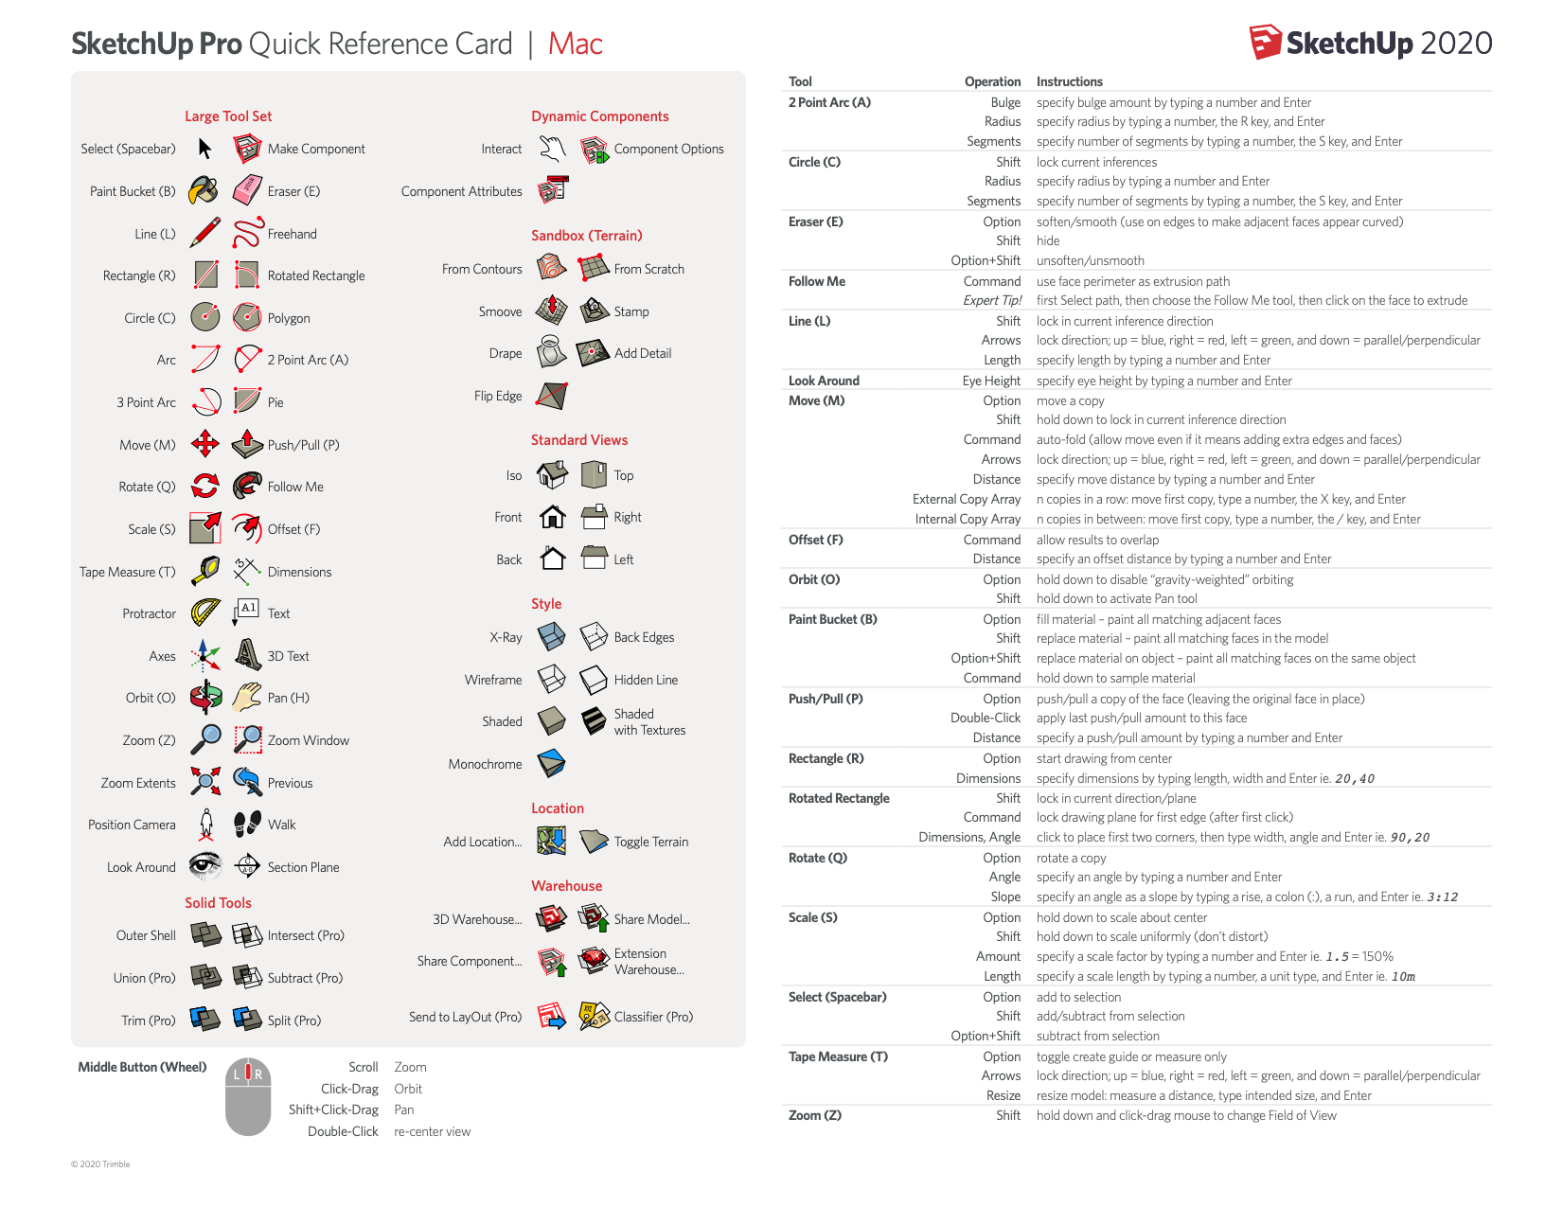

The Quick Reference Card is an easy-to-print guide to all the SketchUp tools.

SketchUp (2021) Available at: <https://www.sketchup.com/quick-reference-cards/sketchup-2020/en> (Accessed: 11 March 2021)

1. List and describe the features of the following drawing tools to draw in 3D.

* Lines
* Polylines
* Arcs
* Dimensions
* Text

1. How many different model views can you display on SketchUp? (e.g., front, top etc.)
2. What is a component in SketchUp? Why is it necessary to create them?
3. How do you edit a component?
4. What is the purpose of working with layers/tags?
5. List the steps you need to take to print a 3D model.

**4. Model in SketchUp**

Follow the below steps to produce a 3D model of your design proposal, using your developed design sketches as reference. Capture one screenshot of the tools and features used in each of the steps. Save the screenshots for submission below.

1. Open SketchUp Software.
2. Create a New Model by selecting the template with the correct unit of measurement in **Millimeters (mm).**
3. Name and save your 3D model as a .skp file called: **3D Sketch Up Model_Your Name_AT 2**
4. Start to model by drawing the external walls of the apartment as per the measurements on the supplied Floor Plan
5. Use the **3D warehouse** to insert existing furniture items
6. Model the 4-panel folding screen.
7. Add the Screen to a **“Layer”** called Folding Screen, by using the Tag feature.
8. Apply materials to your 3D Model. In the **“Materials”** panel, select and apply colours from the drop-down menu. Experiment with different texture, colour and pattern options.
9. Select a ‘Style’ to create a sketch effect. In the **"Styles”** panel, select a drawing style from the drop-down menu. Experiment with different style options. Select one style.
10. Create and save perspective views as **‘Scenes’**. Save 4 x views of the Screen and 4 x views of the Studio space. Save your final images as .jpg files named perspective Images 1, 2, 3 etc.
11. You will now produce a **Floor Plan** of the final design of the Studio space.
12. The plan drawing should be rendered. Include dimensions and room names. Save your rendered plan as a .jpg image named Floor Plan.
13. Save your final 3D model and show your saved views to one other person in your class or at home.   
    What feedback did they give you? How you will use this feedback to make necessary changes to the model prior to presenting to the client.

|  |
| --- |
| {Peer Feedback & Captured screenshots} |

**5. Prepare and Present views.**

For assessment Task 1, submit the following:

1. Complete Assessment Task 2 Workbook
2. From the 3D model images and the Floor plan you have saved, you are to produce a creative and professional presentation your final design concept. You can choose a creative presentation option, for example, animation, digital boards, slide show, etc., but your presentation must include:
   * title page,
   * floor plan (scaled and rendered) - a title block with your name and project name,
   * six (6) perspective view images of the 3D model (the screen and the studio space) - label each image,
   * a screenshot of your images and files properly organised and stored on your computer or the cloud.

**6. Self-Reflection**

1. Reflect on your design and 3D drawings. Are they successful in communicating the concept or idea? Explain how and why.
2. What challenges and issues did you have in the design of your 3D model?
3. What could you do differently in the future to improve your drawings?

**7. References**

You must list *all*sources of information in the ‘references’ section of this workbook. Include books, websites, magazines, or any other sources of information you have gathered to complete your assessment task using the *Harvard Referencing Style* ([www.citethisforme.com](http://www.citethisforme.com)).

See additional resource for referencing requirements.

**8. Additional Pages**

You may insert additional pages as evidence at the end of the workbook if necessary.