**COURSE TITLE**

CUA30720 Certificate III in Design Fundamentals

**SUBJECT TITLE**

A10154 The Design Process

**TRAINING UNITS**

A: CUADES201 Follow a design process

B: CUADES301 Explore the use of colour

C: CUADES302 Explore and apply the creative design process to 2D forms

**ASSESSMENT TASK 1**

**Design Workbook**

Student name: Tek Huynh

Student number: S60001164

Email address: s60001164@student.apc.edu.au

**The Design Process**

**Contents**

1. The Design Brief 3

2. Schedule 4

3. Critical Analysis 5

4. Design Development 8

5. Colour Theory 14

6. Feedback 19

7. WHS 20

8. References 21

9. Additional Pages 22

Submission Instructions 23

## **1. The Design Brief**

Read Assessment Tasks 1 and 2. Complete the template below with the design brief requirements.

|  |  |
| --- | --- |
| **Design Brief** | |
| Project Name/Event | Truth and Beauty  The Graduate Design Exhibition |
| Client (*e.g. Trainer*) | Consortium for Creative Arts (fictional scenario) |
| Due Date | 25/02/24 – Preliminary Submission  24/03/24 – Final Submission |
| Audience | General Public   * Other graduates * Family * Headhunters * Mentors * People who like or are connected to art * Friends |
| Responsibility | To outline the design requirements for the project in the form of briefing documentation.  To clarify and confirm requirements with required personnel.  To present a preliminary overview presentation of the direction and choices made.  To produce 2 posters advertising the exhibition |
| Objectives | Create 2 independent poster designs – 1 will be selected. The designs must include   * Event Location * Event Dates * Cohesive Colour pallet * Carefully Chosen Text/Imagery * Other important event details such as the theme of the exhibition * Create a presentation summarising the key ideas and choices they’ve made |
| Constraints | Fixed Deadline - Time  Fixed Budget - Money  Inexperience – Skill  Possible Sickness – Biology  Possible tool and service failure – Technology  Liaison consultations – Scheduling |
| Resources Required | A computer (with enough RAM)  Adobe Design software (which is a paid subscription)  An internet connection  Transport (to see the liaison)  Workspace (to work in)  Stationary |

## 

## **2. Schedule**

Read Assessment Tasks 1 and 2. Use the table below to schedule key tasks and deadlines for both assessment tasks.

You may add or delete rows as required.

| **Task Description** | **DEADLINE** | **Tools/Materials/Equipment Required** |
| --- | --- | --- |
| Preliminary Submission | 25/02/24 | Computer  Adobe Design Software  Internet  Workspace  Transport  Stationary |
| Final Submission | 24/03/24 | Computer  Adobe Design Software  Internet  Workspace  Transport  Stationary |
| Key Tasks |  |  |
| Analyse an existing event poster for its use of colour. |  | Computer  Internet |
| Answer colour theory questions. |  | Computer  Internet |
| Experiment with colour |  | Adobe Design Software  Internet  Computer |
|  |  |  |
|  |  |  |
|  |  |  |
|  |  |  |
|  |  |  |
|  |  |  |

## **3. Critical Analysis**

Research event poster designs and select one poster that you like. Critically analyse it for the use of the colour.

Insert your chosen poster here and answer the questions below.

|  |
| --- |
|  |

Answer the questions below by writing a minimum of 3-4 sentences in response to each question.

| 3.1. Who is the artist/designer? |
| --- |
|  |

| 3.2. Where did you find the poster? List the source using the *Harvard Referencing Style* ([www.citethisforme.com](http://www.citethisforme.com)) |
| --- |
|  |

| 3.3. What is the poster trying to communicate? |
| --- |
|  |

| 3.4. Which colours have been used? |
| --- |
|  |

| 3.5. What do these colours communicate or represent? |
| --- |
|  |

| 3.6. How is this relevant to what the poster is trying to communicate? |
| --- |
|  |

| 3.7. What Elements and Principles of Design have been used in this poster design? List at least 3. |
| --- |
|  |

| 3.8. Do you think that the poster communicates its idea successfully? Explain why? |
| --- |
|  |

## **4. Design Development**

Begin working on your poster design for Assessment Task 2 ‘Design Brief’.

Answer the questions below and use the following pages to insert your design development for the design brief in Assessment Task Two.

You may insert scanned or photographed pages, photographs, mood boards, sketches, or anything else that shows your design development.

Show a minimum of two (2) unique concepts in your design development. You may add or delete pages as required.

| 4.1. What creative thinking techniques have you used in your design development process? List at least 2. |
| --- |
| * Designing a design development analysis template from my experience in other fields and from personal reflection. It is for my own reference to remind me about how everything works. * Matrix colour comparison which helps distinguish between variances which help add refinement. |

| 4.2. Design is a way of thinking and solving problems. What are the key steps in the design process? |
| --- |
| For design projects in general:  1. Understand the intended look, feel, use case and interaction with other elements within the context (including audience).  2. Classify the theme or category that best make up the context.  3. Research the existing works of that category and record relevant candidates that you may use or take inspiration from.  4. Decide how much to create, edit, and/or adapt based on theme and the intent of the design. (Our hopes and dreams)  5. Assess the resources required to execute such a decision.  6. Reassess the constraints of the project.  7. Decide whether to create, edit or adapt, based on the constraints of the briefing. (Our hopes and dreams crushed)  8. If Happy (because of 7), Goto step 5. Else, Continue.  9. Make some progress on the design and gauge the time taken. Extrapolate and assess time and resources.  10. Update key contacts on progress and integrate feedback. Goto step 6. |

|  |  |  |
| --- | --- | --- |
| |  |  | | --- | --- | |  | My original inspiration.  I was trying to figure out the behaviour of the exponential function (2^x) and the way it may fold space in on itself. The rules are simple. You grow outward 1 triangle in all directions on every iteration. You do cannot go backwards. You turn brown when you intersect the same colour. Cavities that form are coloured dark green. I used a colour cycle of 7 to represent the iterations  It is a simple algorithm that yields an unexpectedly complex and beautiful geometry.  I tried it on a square grid after, but it didn’t do anything cool.  I then gave it to my friend for their birthday.  I feel that the more we reflect, the more we refine our processes which buys us more with less through efficiency. | |

## **5. Colour Theory**

Answer the questions below:

| 5.1. Research colour and write a short paragraph on how colour might be used to communicate a particular idea or concept. |
| --- |
|  |

| * 1. List at least two (2) sources of information using the *Harvard Referencing Style* ([www.citethisforme.com](http://www.citethisforme.com)) |
| --- |
|  |

| * 1. Colour psychology suggests that colours can influence our emotions and our behaviour. What might be a limitation with following this traditional colour theory in design? List at least one (1) answer. |
| --- |
|  |

| * 1. Traditional colour theory suggests that certain colours work better together depending on their placement on the colour wheel.  What might be a limitation with following this traditional colour theory in design? List at least one (1) answer. |
| --- |
|  |

**Colour Experimentation**

Complete some colour experiments using various colour combinations that you think will work well together and communicate your idea for the design brief. Submit a minimum of 3 options.

You may complete these digitally and insert them here or you may complete them by hand using markers, pencils, or paints, and insert them as a scanned or photographed image.

An example from *‘Dictionary Of Colour Combinations - Volume 2*’ has been provided below:

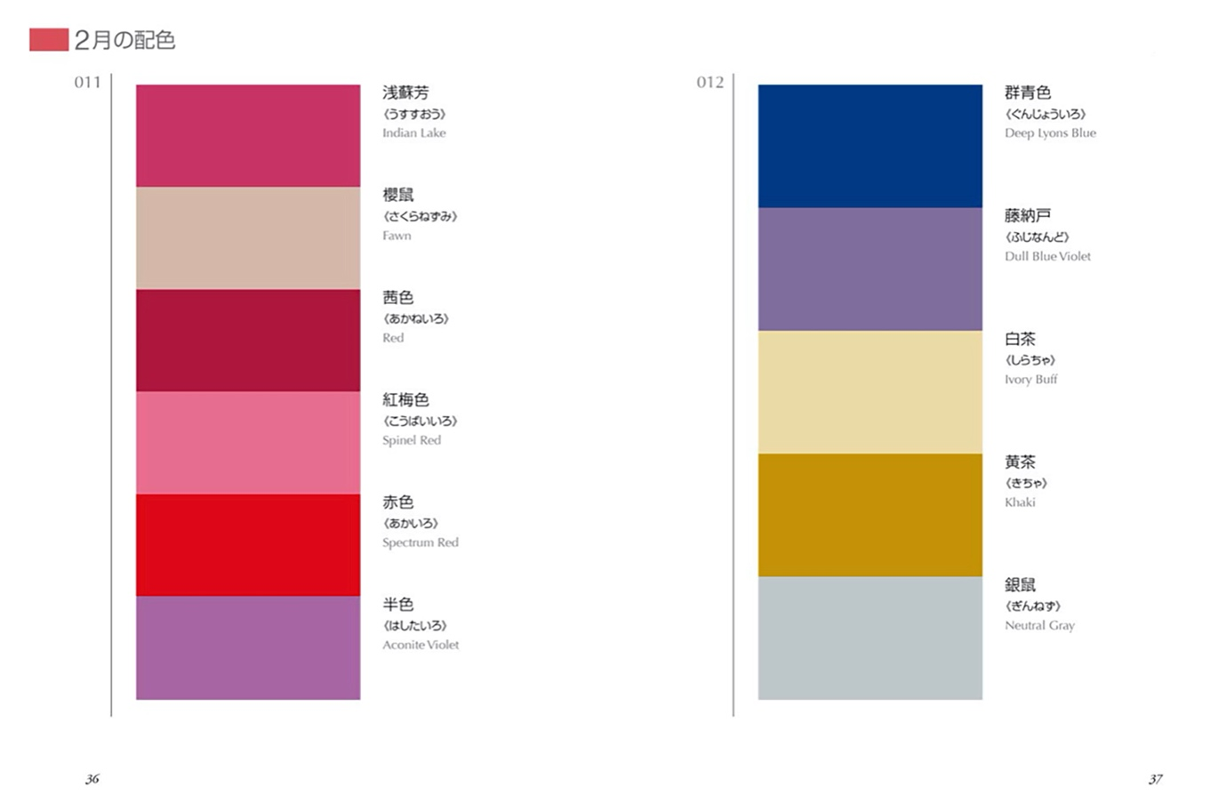

|  |
| --- |
|  |

|  |
| --- |
|  |

For each of your colour experiments, answer the following questions with a minimum of 3 sentences:

| * 1. Why do you think these colours work well together? |
| --- |
|  |

| * 1. Why do you think these colours will work in communicating your concept? |
| --- |
|  |

## **6. Feedback**

Book a feedback session with your trainer during Studio Time to discuss your design development and ideas for progressing to Assessment Task 2.

In response to the feedback session, write a paragraph in answer to each of these questions:

| 6.1. What was the feedback you received on your initial ideas and your use of colour? |
| --- |
|  |

| 6.2. How are you going to use the feedback to move forward with your poster designs? |
| --- |
|  |

| 6.3. Which concepts did your trainer encourage you to move forward with? Why? |
| --- |
|  |

| 6.4. Did you identify any problems or challenges with your design? If so, what are they? |
| --- |
|  |

## **7. WHS**

Using the table below, list any tools, materials, or equipment you have used.   
You will also need to list the steps you have taken you ensure you have worked in a safe way.

This may include, but is not limited to: Any necessary personal protective equipment used *or* safe work practices when sitting at a desk, for example.

You may add or delete rows as required.

| Tool, Material or Equipment used | Measures taken to ensure safe use |
| --- | --- |
| Laptop | Visually inspect cables and replace any that have frayed.  Pack away chargers and cables when not in use |
| Monitor | Ensure monitor is adjusted correctly to prevent eye, neck and back strain. |
| Lighting | Ensure the appropriate type of light and brightness when no access to natural light |
| Chair | Ensure chair supports and encourages good posture |
| Table | Ensure table is at the appropriate height |
| Stationary | Ensure stationary is packed away after use |
| Internet | Ensure basic understanding of cybersecurity practices |
| Keyboard and mouse | Ensure ergonomic placement  Ensure type of mouse/keyboard is used is ergonomic |
|  |  |
|  |  |
|  |  |
|  |  |

## **8. References**

You must list *all*sources of information in the ‘references’ section of this workbook.

Include books, websites, magazines, or any other sources of information you have gathered in order to complete your assessment task.   
APC use the *Harvard Referencing Style* ([www.citethisforme.com](http://www.citethisforme.com))

See additional resource for referencing requirements.

## **9. Additional Pages**

You may insert additional pages as evidence at the end of the workbook if necessary.

## **Submission Instructions**

1. To submit this workbook, complete all activities in this workbook.
2. Save it as a PDF.
3. Use the naming convention: FirstLast_A10154_AT1_DDMMYY
4. Go to the Submissions Area in myAPC.hub and select ASSESSMENT TASK 1. Submit your work.