State transition diagram lightswitch

I’ve got a lamp in my kitchen which is controlled by a light switch and I was wondering
how the technique behind this little device works.
I wanted to analyse the state transitions of this lamp and which paths it can take to get to
the desired “light brightness”. First off I’ve made a simple state transition diagram of the lamp.

Figure 1
State transition diagram lightswitch
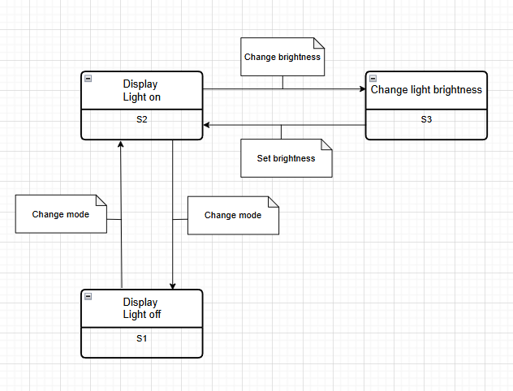
In figure 1 one can identify the following states:
S1: Display: Light off
S2: Display: Light on
S3: Change light brightness

The following events can also be identified:
- Change mode
- Change brightness
- Set brightness

In table 1 I’ve made an overview of the different states and events. Hereby the possible state transitions are made visible. For example you can see that there is a connection between S1 state and the change mode event. Because State S1 cannot directly access the event of “Change brightness” nor “Set brightness” this cell is kept empty.

Table 1
Overview of states and corresponding events

State | Event
State | Change mode | Change brightness | Set brightness
S1 | S2
S2 | S1 | S3
S3 |  |  | S2

Figure 2
State transition diagram with linenumbers

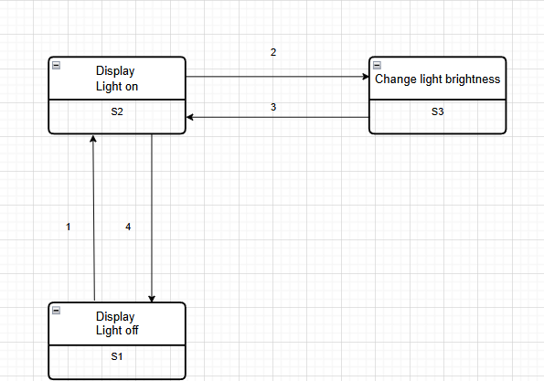
Test situations
Now that we’ve identified the possible states of the lamp device we can now identify the test situations. In table 2 you can find the possible paths based upon 0-switch,1-switch and 2-switch.

Table 2
Test situations paths by 0-switch, 1-switch and 2-switch.

0-switch |  | 1-switch |  | 2- switch
S1-1 |  | S1-1;S2-4 | S1-1;S2-2 | S1-1;S2-2;S3-3 | S1-1;S2-4;S1-1
S2-2 | S2-4 | S2-2;S3-3 | S2-4;S1-1 | S2-2;3-3;S2-4 | S2-4;S1-1;S2-4
 |  |  |  | S2-2;3-3;S2-2 | S2-4;S1-1;S2-2
S3-3 |  | S3-3;S2-2 | S3-3;S2-4 | S3-3;S2-2;3-3 | S3-3;S2-4;S1-1

In order to make the appropiate physical testcases I’ve made a testtree which illustrates a clean overview of the possible paths.

Figure 4
Testtree of lamp with brightness switch
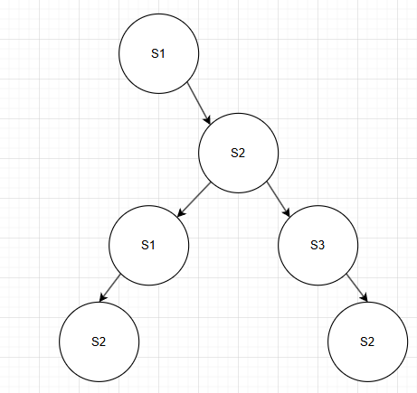

Physical testcases

N-switch 2

Table 3
N-switch 2 physical testcase of path S1-1;S2-2;S3-3
S1-1;S2-2;S3-3 | Step 1 | Step 2 | Step 3
Start condition | Light off | Light on | Change light brightness
Input | Change mode | Change brightness | Set brightness
Output | Light on | Change light brightness | Light on
End condition | Light on | Change light brightness | Light on

Table 4
N-switch 2 physical testcase of path S1-1;S2-4;S1-1
S1-1;S2-4;S1-1 | Step 1 | Step 2 | Step 3
Start condition | Light off | Light on | Light off
Input | Change mode | Change mode | Change mode
Output | Light on | Light off | Light on
End condition | Light on | Light off | Light on

Table 5
N-switch 2 physical testcase of path S2-2;3-3;S2-4
S2-2;3-3;S2-4 | Step 1 | Step 2 | Step 3
Start condition | Light on | Change light brightness | Light on
Input | Change brightness | Set brightness | Change mode
Output | Change light brightness | Light on | Light off
End condition | Change light brightness | Light on | Light off

Table 6
N-switch 2 physical testcase of path S2-4;S1-1;S2-4
S2-4;S1-1;S2-4 | Step 1 | Step 2 | Step 3
Start condition | Light on | Light off | Light on
Input | Change mode | Change mode | Change mode
Output | Light off | Light on | Light off
End condition | Light off | Light on | Light off

Table 7
N-switch 2 physical testcase of path S2-2;3-3;S2-2
S2-2;3-3;S2-2 | Step 1 | Step 2 | Step 3
Start condition | Light on | Change light brightness | Light on
Input | Change brightness | Set brightness | Change brightness
Output | Change light brightness | Light on | Change light brightness
End condition | Change light brightness | Light on | Change light brightness

Table 8
N-switch 2 physical testcase of path S2-4;S1-1;S2-2
S2-4;S1-1;S2-2 | Step 1 | Step 2 | Step 3
Start condition | Light on | Light off | Light on
Input | Change mode | Change mode | Change brightness
Output | Light off | Light on | Change light brightness
End condition | Light off | Light on | Change light brightness

Table 9
N-switch 2 physical testcase of path S3-3;S2-2;3-3
S3-3;S2-2;3-3 | Step 1 | Step 2 | Step 3
Start condition | Change light brightness | Light on | Change light brightness
Input | Set brightness | Change brightness | Set brightness
Output | Light on | Change light brightness | Light on
End condition | Light on | Change light brightness | Light on

Table 10
N-switch 2 physical testcase of path S3-3;S2-4;S1-1
S3-3;S2-4;S1-1 | Step 1 | Step 2 | Step 3
Start condition | Change light brightness | Light on | Light off
Input | Set brightness | Change mode | Change mode
Output | Light on | Light off | Light on
End condition | Light on | Light off | Light on

Acceptance tests with Playwright (Acceptation tests using Playwright)

The actuals tests can be found in the folder: caselamp.

Files:
lightswitch feature - Tests switching a light on.
LampPage.spec.js - Page Object Model with constructor and common used functions.
lightswitch.step.js - Step definition file.

The corresponding webapplication can be found in the map: caselamp app

