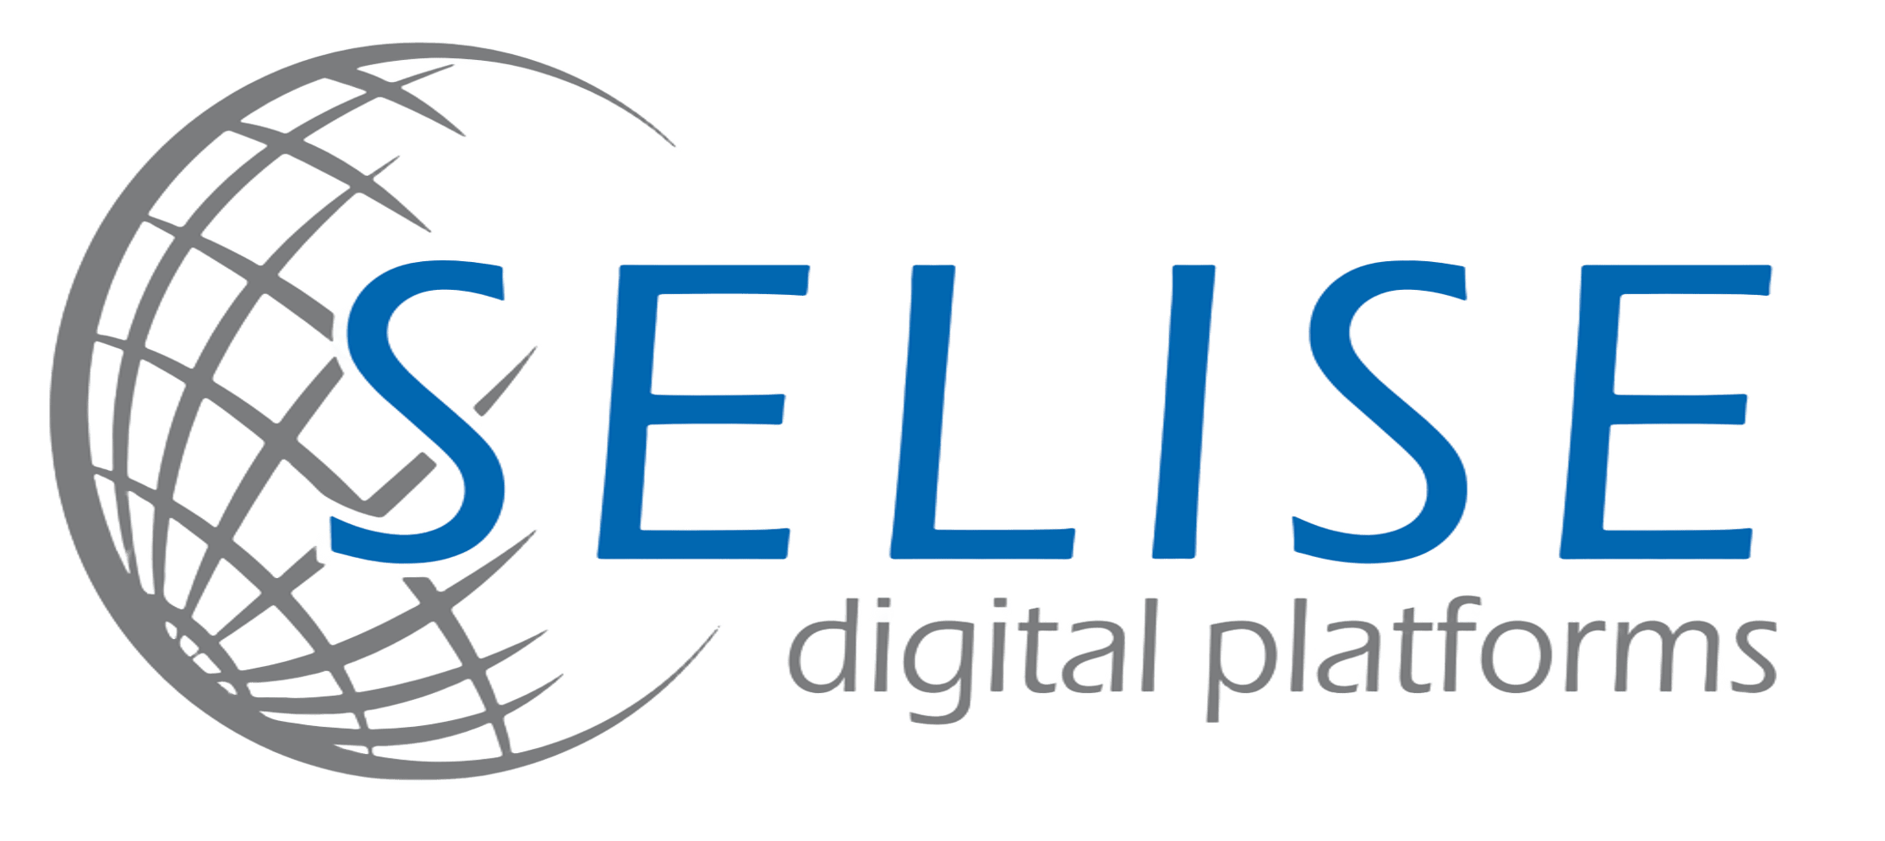 | PELSUNG × COHORT 3  Progress Report · 2026-05  Cohort · 42 Trainees

COHORT 3 · MID-PROGRAM UPDATE
Curriculum delivered.
Capstone underway.
Foundation, the full Dev specialization track, and every BA + QA shared block — opener, spec stack, diagrams, and quality & compliance — are all complete. The cohort has now moved into the Capstone phase: four real-product builds, eight parallel teams, all in flight.

AT A GLANCE
FOUNDATION  12 / 12 classes | DEV SPECIALIZATION  18 / 18 classes | BA + QA SHARED  23 / 23 classes | CAPSTONE PROJECTS  4 · 8 teams

PHASE 01 · PHASE 02 — WHAT'S BEEN COMPLETED
What's been completed
All 42 trainees finished the shared Foundation phase together. From there the Dev cohort completed its full eighteen-class frontend specialization, while BA and QA trainees worked through every shared block — the combined opener, the spec stack, the diagrams series, and the quality & compliance block.
Foundation COMPLETE
All 42 trainees together — shared knowledge base before verticals split.
Progress · 12 / 12 · 100%
01 ✓ Welcome & Orientation | 02 ✓ Professional Skills
03 ✓ AI Basics & Prompting | 04 ✓ How the Internet Works
05 ✓ APIs, Data & Databases | 06a ✓ Dev Tools & Version Control
06b ✓ HTML & CSS Basics | 07 ✓ SDLC, Agile & the AI Era
08 ✓ Teams: Traditional vs AI-Era | 09 ✓ Spec-Driven Product Thinking
10 ✓ Build Personal Site & Present | 11 ✓ Vertical Assignment
Software Development COMPLETE
Frontend-focused track — JavaScript, TypeScript, React, and AI-assisted workflows.
Progress · 18 / 18 · 100%
01 ✓ Dev Environment Deep Dive | 02 ✓ JavaScript Fundamentals I
03 ✓ JavaScript Fundamentals II | 03b ✓ JavaScript Practice Day
04 ✓ DOM, Browser APIs & Async | 05 ✓ TypeScript Foundations
06 ✓ Intro to React | 07 ✓ React Hooks
08 ✓ React Patterns | 09 ✓ Routing & Navigation
10 ✓ Working with APIs | 11 ✓ Forms & Validation
12 ✓ Styling in React | 13 ✓ Build & Deployment
14 ✓ AI-Assisted Development | 15 ✓ Working with a Backend
16 ✓ Mini Project Week | 17 ✓ Code Review & Shipping
BA + QA · Foundations COMPLETE
Role clarity, spec-reading, FR vs NFR, acceptance criteria, estimation.
Progress · 5 / 5 · 100%
01 ✓ Role Deep-Dive | 02 ✓ Reading Requirements
03 ✓ FR vs NFR | 04 ✓ Acceptance Criteria
05 ✓ Estimation & Prioritization
BA + QA · Spec Stack COMPLETE
The artifact stack BAs and QAs work with daily — anatomy, BRD, SRS, HLD/LLD, writing mechanics, teardown.
Progress · 6 / 6 · 100%
01 ✓ Anatomy of a Dev-Ready Spec | 02 ✓ The BRD Document
03 ✓ The SRS Document | 04 ✓ HLD & LLD Workshop
05 ✓ Writing Mechanics for Specs | 06 ✓ Spec Teardown Workshop
BA + QA · Diagrams COMPLETE
The seven diagrams every software professional should read fluently — one session per type.
Progress · 7 / 7 · 100%
01 ✓ Use Case Diagrams | 02 ✓ BPMN
03 ✓ Flowcharts | 04 ✓ Swimlane Diagrams
05 ✓ UML Activity Diagrams | 06 ✓ Data Flow Diagrams
07 ✓ Sequence Diagrams
BA + QA · Quality & Compliance COMPLETE
Testing fundamentals, bug reporting, risk, data protection, security & observability.
Progress · 5 / 5 · 100%
01 ✓ Software Testing Fundamentals | 02 ✓ Bug Reporting & Defect Lifecycle
03 ✓ Risk Management | 04 ✓ Data Protection & Compliance
05 ✓ Security, Observability & Telemetry

PHASE 03 · CAPSTONE — WHAT WE'RE WORKING ON NOW
What we're working on now
4  REAL PROJECTS | Every trainee is now on a Capstone team. Four product ideas, two parallel groups per idea, eight teams in total. Each team has a Dev Lead, a second Dev, BAs and a QA — a small, self-sufficient unit shipping a working web product by Demo Day.

PROJECT · 01 2 TEAMS
GMC Service Directory
Essential Services Registry for Gelephu Mindfulness City
A searchable, categorized directory of essential services across GMC — every service with its own informational page so residents and newcomers can find what they need without guesswork. Built as a public-facing reference: clear categories, fast lookup, authoritative service detail pages.
Inspired by a project idea carried over from a previous Pelsung cohort, now picked up and built out by Cohort 3.
STATUS · IN BUILD
PROJECT · 02 2 TEAMS
Pelsung Project Catalog
A one-stop directory of Pelsung project ideas
A single home for every Pelsung project idea, with the flexibility to link out to external documentation or host docs directly. The catalog is designed to make Pelsung's ideation pipeline visible, browsable, and reusable across cohorts — keeping institutional memory in one place instead of scattered across drives.
STATUS · IN BUILD
PROJECT · 03 2 TEAMS
ZorigHub
An online marketplace for Bhutanese artisans
An e-commerce-style platform that lets Bhutanese artists register their craft and lets buyers browse and purchase products. ZorigHub gives traditional artisans a modern storefront — surfacing local craftsmanship to a national and international audience while keeping registration, listing, and purchase flows simple enough for non-technical sellers.
Inspired by a project idea carried over from a previous Pelsung cohort, now picked up and built out by Cohort 3.
STATUS · IN BUILD
PROJECT · 04 2 TEAMS
Migsel — GMC Resonance Portal
Citizen-to-city reporting for utilities and public services
A proactive digital response to the daily frustrations of residents — overflowing trash bins, dark streetlights, choked drainage, crumbling roads — that often go ignored. Migsel pairs a live map of waste centers with a simple, direct way to report utility failures, closing the gap between community needs and city action. The aim is to convert reactive maintenance into a data-driven, accountable partnership between residents and GMC services — turning every neighbor into a participant in keeping their streets healthy, safe, and clean.
STATUS · IN BUILD

SELISE × PELSUNG · COHORT 3 PROGRESS REPORT INTERNAL · CONFIDENTIAL

