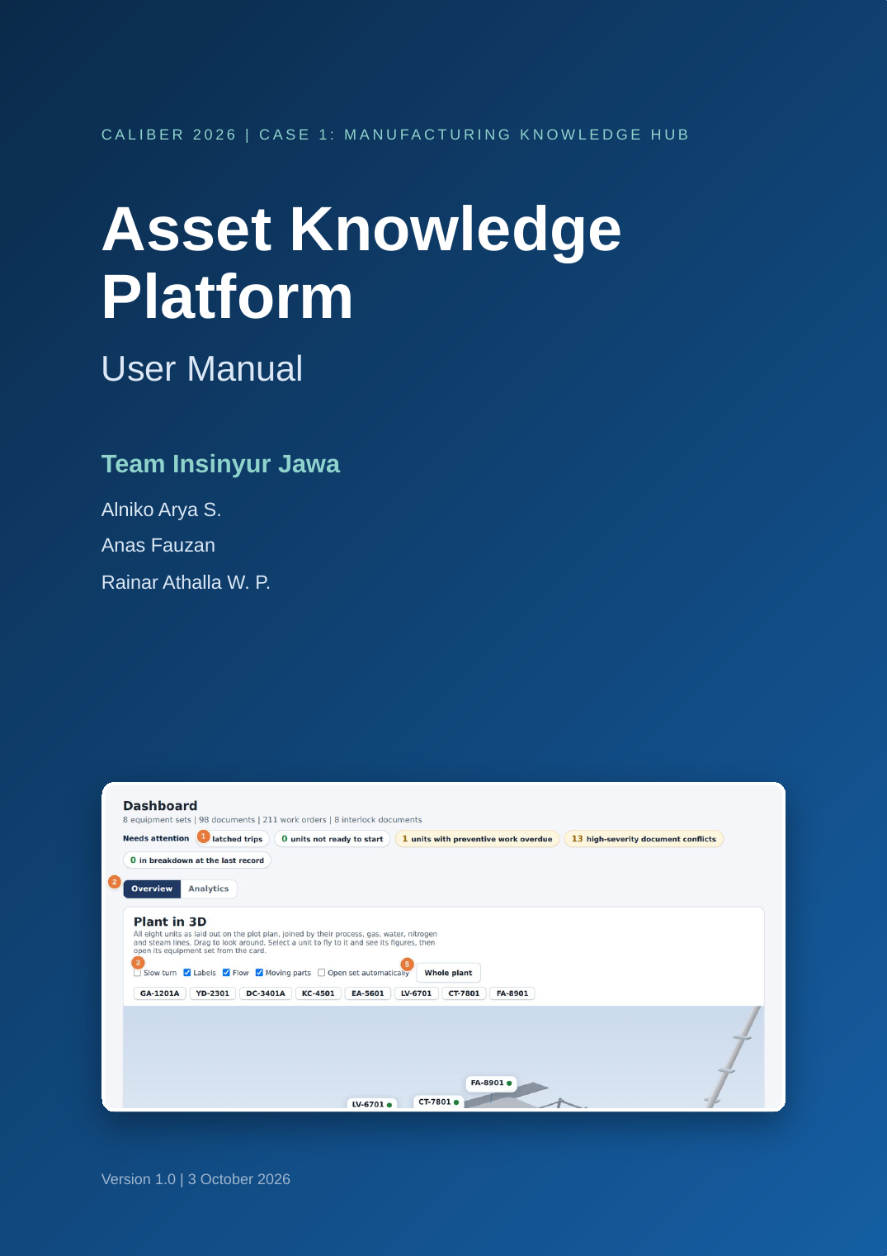

Document control
Document | Asset Knowledge Platform, User Manual
Version | 1.0
Date | 3 October 2026
Prepared by | Team Insinyur Jawa: Alniko Arya S., Anas Fauzan, Rainar Athalla W. P.
Applies to | The sample installation for the LLDPE unit, eight equipment sets
Readers | Operators, engineers, reliability engineers, HSE engineers and managers
Data | Sample data provided for CALIBER purposes only

Revision history
Version | Date | Change
1.0 | 3 October 2026 | First issue

How to read the figures
Each figure is a screenshot of the platform. Orange numbered markers point to the parts of the screen that the legend under the figure describes. Each chapter begins with the roles that normally use the page.

Table of contents

Part 1. Introduction
1 About the Asset Knowledge Platform 4
2 How the platform is organised 5
3 Equipment covered 6
4 User roles and permissions 7
5 Before you start 7
Part 2. Getting started
6 Signing in and out 9
7 The screen layout 10
8 Global search 12
9 Notifications, settings and the guided tour 12
10 Working offline and sharing data 15
Part 3. Daily operations
11 Dashboard 17
12 My work 19
13 Equipment Sets 20
14 Equipment drawings in 2D and 3D 29
15 Live P&ID 32
16 Interlock Library 33
17 Start-up readiness 36
18 Documents 38
Part 4. Maintenance and reliability
19 Maintenance overview 40
20 Work orders 41
21 Timeline 44
22 Predictive maintenance 45
23 Reliability analysis 47
24 Plant replay 48
25 Site plan 50
26 Failure Memory 51
27 Performance 53
Part 5. Safety, lessons and scenarios
28 One Point Lesson Library 57
29 OPL scenario simulator 58
30 Scenarios and chain reaction 60
31 Plot Plan and hazard simulator 64
Part 6. Knowledge and AI
32 AI Assistant 68
33 How answers are produced 71
34 Knowledge Studio 73
35 Data Quality 77
36 Integrations and the knowledge graph 78
Part 7. Administration
37 Report Center 82
38 Governance and roadmap 84
39 Settings 85
40 Roles, approval workflow and audit trail 87
Appendices
A Glossary 89
B Quick reference 89
C Troubleshooting 90
D Data and limits 90
E Index 91

1 About the Asset Knowledge Platform
PART 1. INTRODUCTION
Used by: Operator, Engineer, Reliability, HSE, Manager
The Asset Knowledge Platform joins the documents, drawings, work orders and lessons of the LLDPE unit into one searchable, source-checked knowledge base, and uses it to answer questions, support maintenance and prepare safe work.

1.1 Purpose of this manual
This manual explains how to use every part of the platform. It is written for the people who work with the LLDPE unit each day: operators, maintenance engineers, reliability engineers, HSE engineers and managers. Each chapter states who normally uses the feature, describes what the screen shows, and gives the steps to complete common tasks.
You do not need to read the manual from start to finish. Part 2 covers signing in and the screen layout. Parts 3 to 7 follow the sidebar of the application, so you can go directly to the chapter that matches the page you have open.

1.2 The problem the platform addresses
In a continuous process plant, the knowledge needed for a safe start-up, a quick repair or a correct decision is spread across many systems. Procedures sit in one place, drawings in another, work orders in a third, and the reasons behind a trip often exist only in the memory of senior staff. Engineers lose time searching, and they sometimes act on an outdated drawing or without knowing that the same fault happened before.
The platform brings these sources together and links each record to the equipment tag it concerns. Every answer shows where it came from, which revision of the document was used and whether that document is approved.

1.3 What you can do with the platform
Task | Where in the platform | Chapter
See the state of all eight equipment sets | Dashboard | 11
Find a drawing, datasheet, interlock or lesson for one machine | Equipment Sets | 13
Ask a question in plain language and receive a cited answer | AI Assistant | 32
Check what usually causes a fault and how it was fixed | Failure Memory | 26
Review breakdown history and the forecast for the next 90 days | Maintenance | 19 to 23
Plan maintenance work with permits and crew capacity | Maintenance, Site plan | 25
Practise a one point lesson on a simulated machine | OPL Library | 28, 29
Test how a release or a trip spreads across the plant | Plot Plan, Scenarios | 30, 31
Add a new document or capture expert knowledge | Knowledge Studio | 34
Produce a report for a meeting or an investigation | Report Center | 37

NOTE
The platform in this manual runs on sample data prepared for the CALIBER 2026 case. The equipment, documents and work orders are realistic, but they do not describe a real plant.

2 How the platform is organised
Used by: Operator, Engineer, Reliability, HSE, Manager
Understanding how the pieces fit together makes every screen easier to read. This chapter describes the knowledge base, the three engines that use it and the way a record travels from a source document to an answer.

2.1 The knowledge base
All information is stored as small, labelled records called chunks. A chunk carries its text, the equipment tag it concerns, its revision and approval status, and the roles allowed to read it. Numbers such as set points are also stored as typed facts, and links between records, such as an interlock that protects a pump, are stored as relations.
Item | Count in the sample data
Searchable chunks | 1,109
Typed facts | 447
Relations between records | 624
Documents | 98
Work orders | 211
One point lessons | 56
Interlock documents | 8
Instruments | 84

2.2 The three engines
- Answers. The AI Assistant, global search and Equipment pages find the right record and show its source.
- Reliability. Failure Memory, Maintenance, Predictive maintenance and Performance study the work-order history and the lessons.
- Safety and planning. Interlocks, Live P&ID, start-up readiness, the OPL simulator, the hazard simulator and the Site plan prepare safe work.
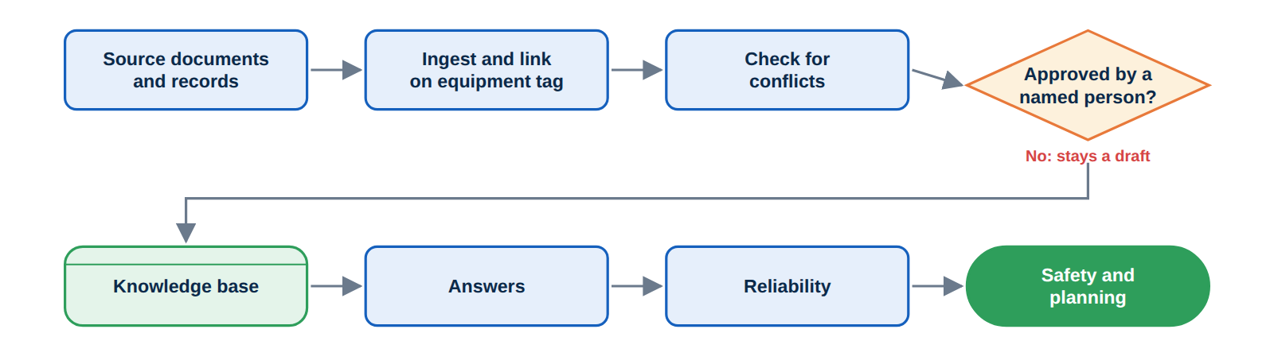
Figure 1. How a record moves from a source document to the features that use it.

2.3 Why the platform can be trusted
Three rules apply everywhere in the platform. A record that is still a draft is clearly marked and is not used as an approved source. Every answer lists its sources. A figure in an answer is checked against the text of its source, and the confidence score drops when a figure cannot be found there.

3 Equipment covered
Used by: Operator, Engineer, Reliability, HSE, Manager
The platform covers eight equipment sets of the LLDPE unit. Each set has its own P&ID, drawings, datasheet, interlock logic, lessons and maintenance history.
Tag | Equipment | Area | Main interlock
GA-1201A | Feed/Charge Pump (hexane feed) | 1200 Feed preparation | SEQ-1201
YD-2301 | Polymer Fluid Bed Dryer | 2300 Separation and drying | SEQ-5500
DC-3401A | Catalyst Reduction Reactor and heater | 3400 | SEQ-3401
KC-4501 | Recycle Gas Compressor | 4500 Gas recovery | SEQ-4501
EA-5601 | Solvent Heater | 5600 | Control loop
LV-6701 | Separator Level Control | 6700 | SEQ-6701
CT-7801 | Cooling Tower Fan | 7800 | SEQ-7801
FA-8901 | Reflux Accumulator Drum | 8900 | SEQ-8901

The set number used in the platform follows the order of this table: set 1 is GA-1201A and set 8 is FA-8901. The same tag appears on every page that concerns the equipment, which is how the platform links a work order to a drawing or a lesson.
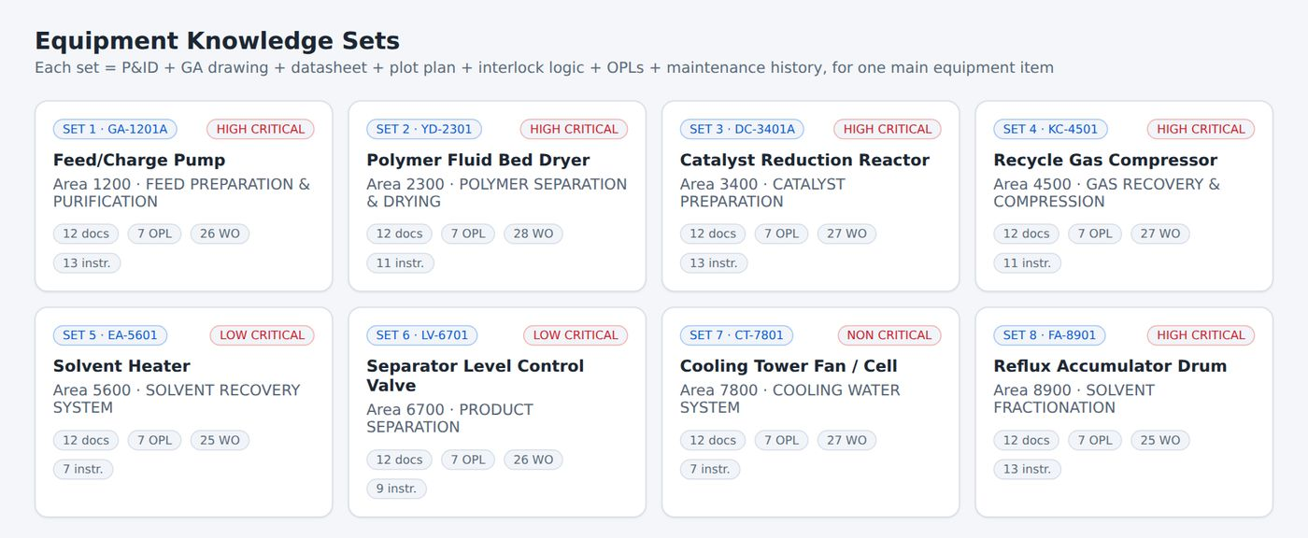
Figure 2. The Equipment Sets page lists all eight sets with their status.

4 User roles and permissions
Used by: Operator, Engineer, Reliability, HSE, Manager
The platform has five roles. Your role is set when you sign in, and it decides which actions are available to you. The roles shown in this manual are the ones loaded in the application.
Action | Operator | Engineer | Reliability | HSE | Manager
Read approved knowledge, drawings and records | Yes | Yes | Yes | Yes | Yes
Ask the AI Assistant and give feedback | Yes | Yes | Yes | Yes | Yes
Submit a draft in Knowledge Studio | Yes | Yes | Yes | Yes | Yes
Approve or reject knowledge items | No | Yes | Yes | Yes | Yes
Delete knowledge items that are not your own drafts | No | Yes | Yes | No | Yes
Accept scenario rules | No | Yes | Yes | No | Yes
Import, bulk remove or generate records | No | No | Yes | No | Yes
Open the administration settings | No | No | No | No | Yes

NOTE
A person cannot approve an item that they wrote themselves, except in the Manager role. Another approver must review it. This rule is described in Chapter 40. When the platform builds answers and typed facts, the Operator role sees approved items only.

The sample installation contains 22 demonstration accounts: four managers, four operators, five engineers, five reliability engineers and four HSE engineers. The account named Caliber is the demonstration administrator and can switch between roles from the Settings panel to show how each role sees the platform.

5 Before you start
Used by: Operator, Engineer, Reliability, HSE, Manager
This chapter lists what you need to open the platform and explains which parts of the sample installation are demonstrations.

5.1 What you need
- A current desktop browser such as Chrome, Edge or Firefox. A screen width of at least 1280 pixels shows the pages as they appear in this manual.
- A user name and password. The demonstration accounts are listed on the sign-in page.
- No installation. The platform runs in the browser.

5.2 What is a demonstration
The sign-in page and the role list are for demonstration. The accounts are checked in the browser and are not a security control, so they must not be used to protect real plant information. The data is a sample prepared for the CALIBER 2026 case.
Features that connect to other systems, such as the engineering document system or the maintenance system, are shown with simulated connectors. Chapter 36 explains how they would be connected in a production installation.

5.3 Conventions used in this manual
Convention | Meaning
Bold text | The name of a button, tab, field or menu item on the screen.
Numbered orange circles | A callout on a screenshot. The list below the figure explains each number.
Numbered blue steps | A procedure to carry out in order.
Note, Tip, Caution boxes | Extra information, a shortcut, or a warning about a possible mistake.
Roles line | The roles that normally use the feature described in the chapter.

6 Signing in and out
PART 2. GETTING STARTED
Used by: Operator, Engineer, Reliability, HSE, Manager
Every session starts at the sign-in page. Your account decides your role, and your name is recorded on the items you create and approve.

6.1 Sign in
1 Open the platform in your browser. The sign-in page appears.
2 Type your Username, for example Caliber.
3 Type your Password. In the demonstration, the password is the first name followed by 2026, for example Caliber2026.
4 Select Sign in. The Dashboard opens.
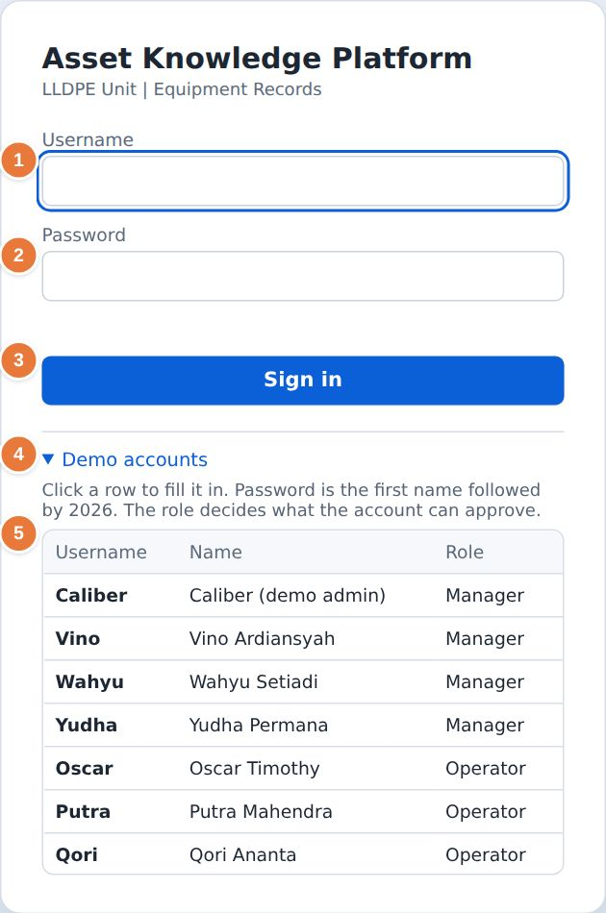
Figure 3. The sign-in page with the list of demonstration accounts open.
1 Username field.  2 Password field.  3 Sign in button. | 4 Demo accounts list. Select a row to fill in the user name.  5 Accounts with their name and role.

TIP
Select Demo accounts, then select a row. The user name and password are filled in for you.

6.2 What happens when you sign in
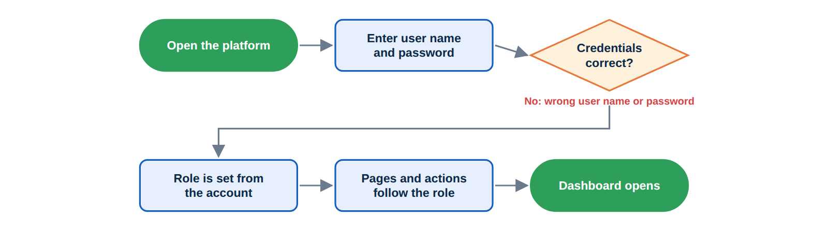
Figure 4. The sign-in sequence.

6.3 Sign out
Your name and role appear at the bottom of the sidebar. Select the sign-out icon next to them to leave the session. The sign-in page appears again. Signing out and in is also the way to change to another account.

7 The screen layout
Used by: Operator, Engineer, Reliability, HSE, Manager
All pages share the same layout: a sidebar on the left, a page area on the right and a few global controls. Learn this layout once and every page will look familiar.
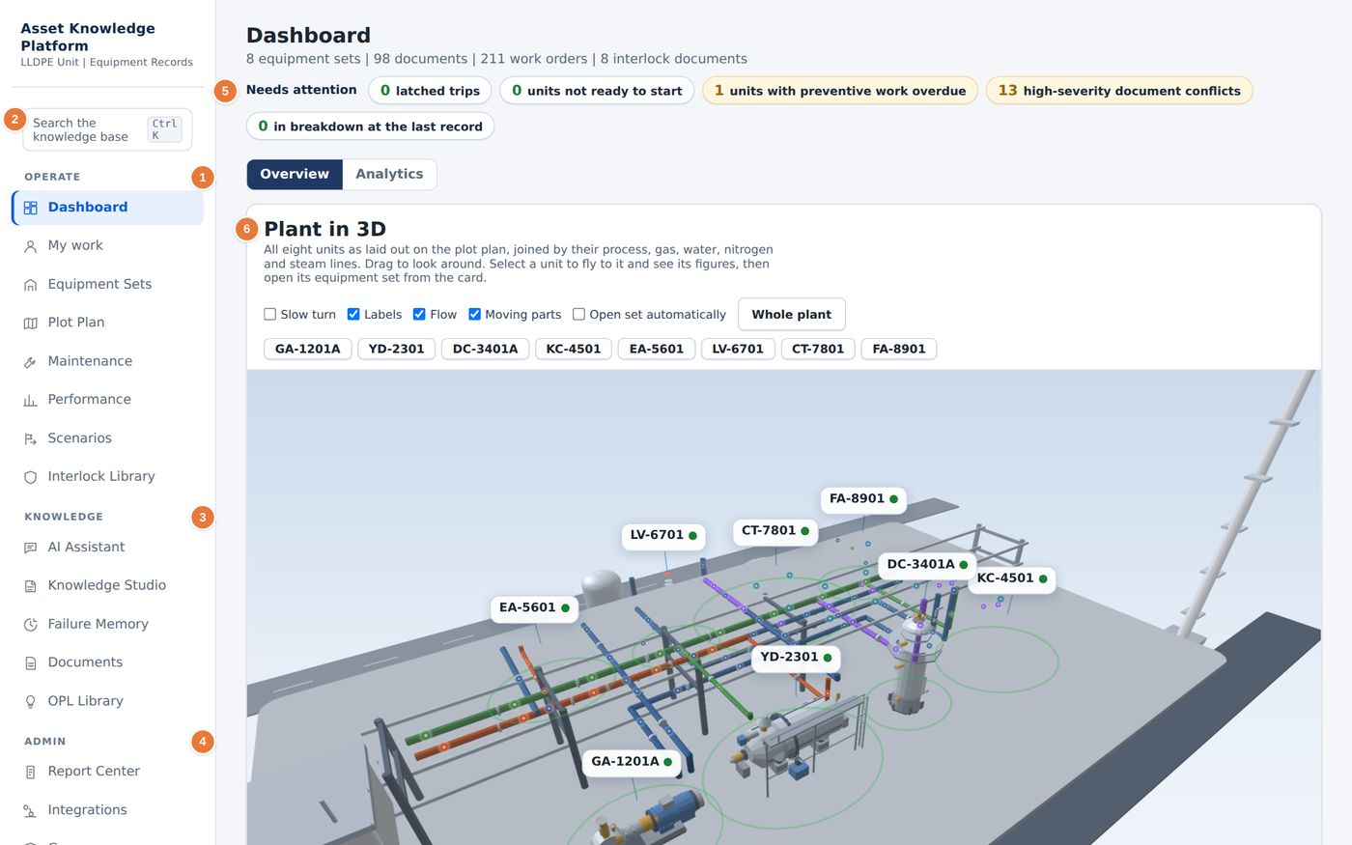
Figure 5. The layout of the platform, shown on the Dashboard.
1 Operate group: daily pages for the plant.  2 Search box. Press Ctrl+K from any page.  3 Knowledge group: the assistant, Knowledge Studio, Failure Memory, Documents and OPL Library. | 4 Admin group: reports, integrations, governance and data quality.  5 Needs attention: counts that need action today.  6 The page area. It changes with the page you select.

7.1 The sidebar
Group | Pages
Operate | Dashboard, My work, Equipment Sets, Plot Plan, Maintenance, Performance, Scenarios, Interlock Library
Knowledge | AI Assistant, Knowledge Studio, Failure Memory, Documents, OPL Library
Admin | Report Center, Integrations, Governance, Data Quality

At the bottom of the sidebar you see your name and role, the shared-database status (for example Local only) and the controls for notifications, the guided tour, settings and signing out. On a narrow screen the sidebar collapses behind a menu button.

7.2 Page headers and tabs
Each page starts with a title and a one-line description. Pages with several views, such as Maintenance or Knowledge Studio, show a row of tabs under the header. The selected tab is dark. Charts and tables are interactive: selecting a bar, a segment or a row usually filters the page or opens the related record.

8 Global search
Used by: Operator, Engineer, Reliability, HSE, Manager
Global search looks through every approved document, work order, lesson and interlock at once and shows where each match comes from.

8.1 Search from any page
1 Press Ctrl+K, or select the search box at the top of the sidebar.
2 Type a word, a tag or a short phrase, for example seal flush.
3 Read the results. Each result shows its type (Lesson, Work order or Document), its title, its date, its status and a short extract.
4 Select a result to open the record.
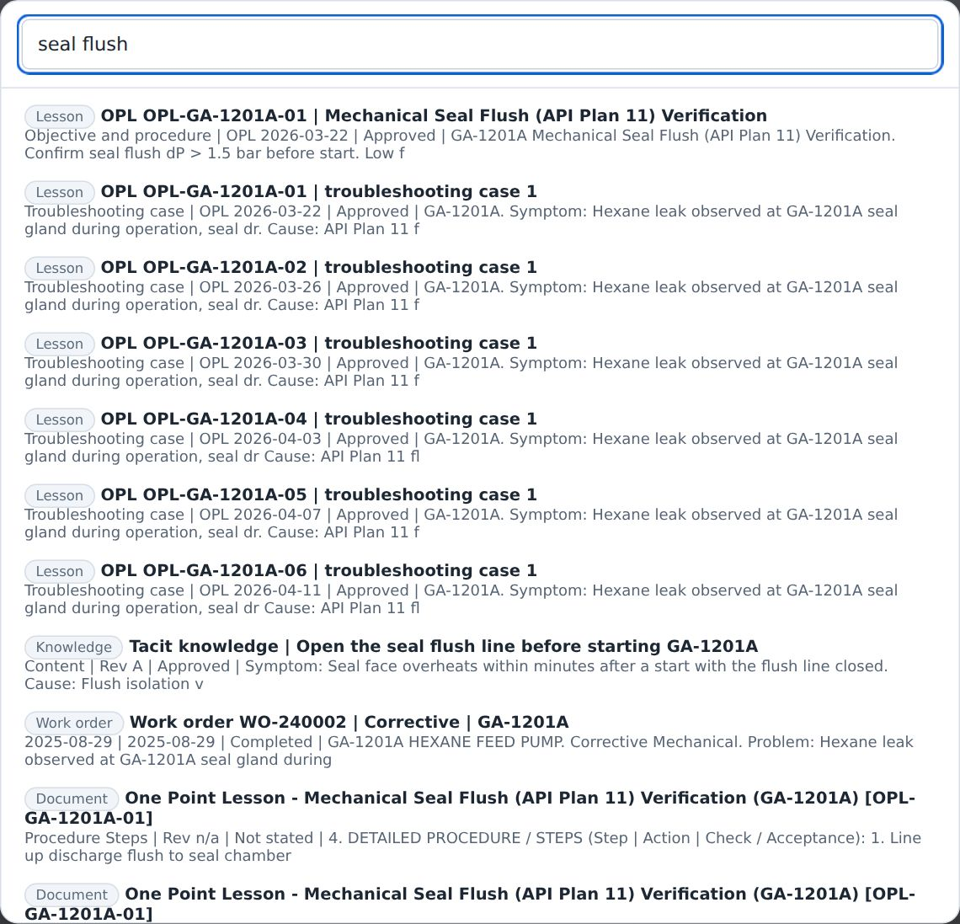
Figure 6. Global search results for the phrase seal flush.

TIP
Search understands equipment tags and common word forms. A search for PSLL-1201 finds the interlock initiator, and a search for leaking also finds records that say leak.

Results are ranked by how well they match, by the trust level of the source and by your role. Records that are still drafts are marked and rank lower than approved records.

9 Notifications, settings and the guided tour
Used by: Operator, Engineer, Reliability, HSE, Manager
Three controls at the bottom of the sidebar help you stay informed and set up the platform: the notification bell, the settings panel and the guided tour.

9.1 Notifications
The bell shows a count when something needs attention. Select it to see the list. In the sample data it reports units above the forecast risk threshold and high-severity data issues that are still open. Items that wait for your approval also appear here.
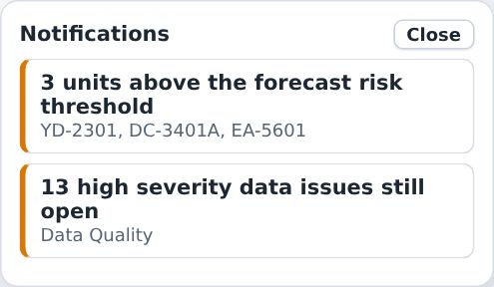
Figure 7. The notification list.

9.2 Settings
Select the gear icon to open the settings panel. The panel has four groups.
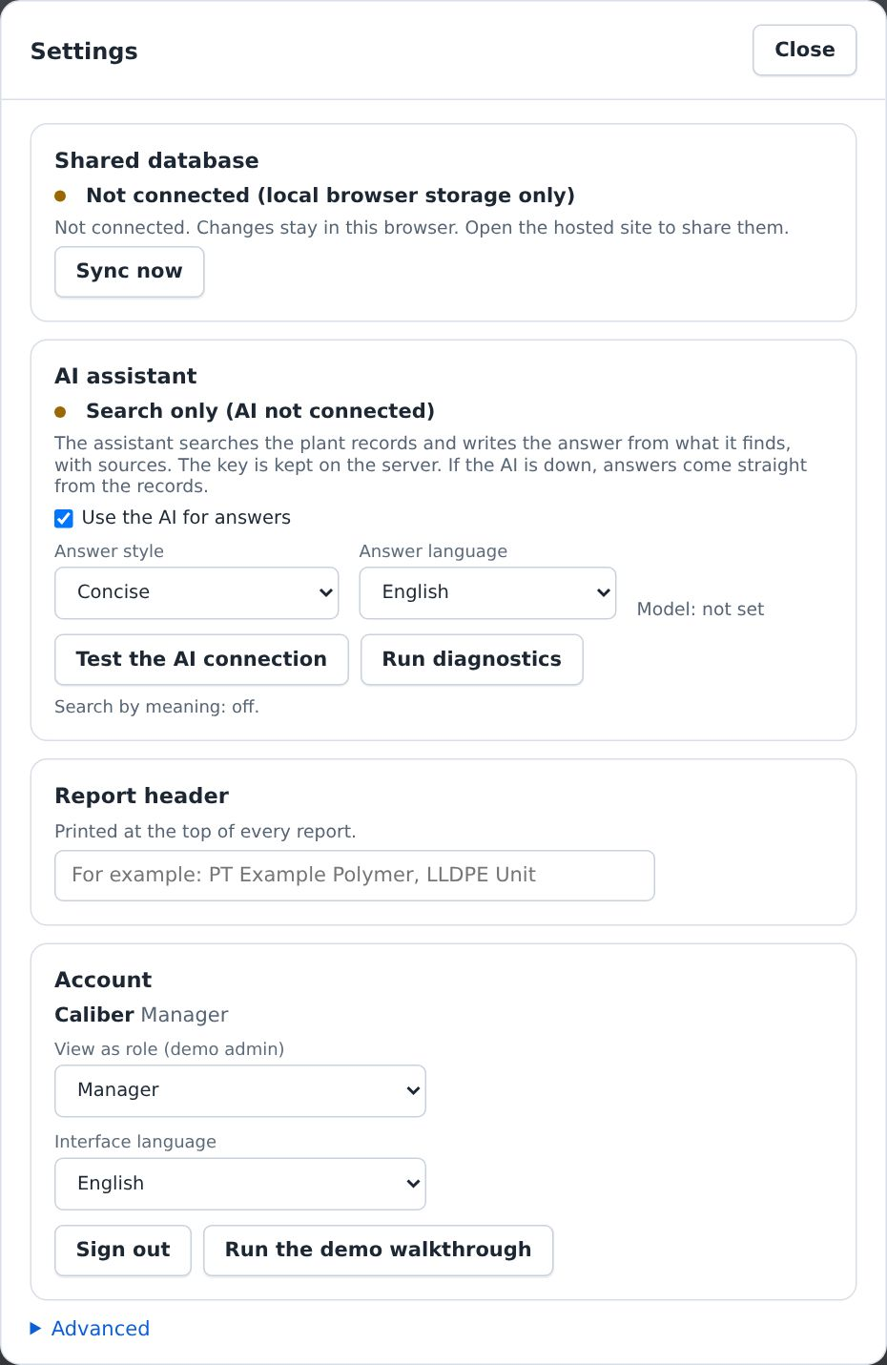
Figure 8. The settings panel.

- Answer style. Choose a concise or a detailed style for assistant answers.
- Answer language. Choose the language of answers. Bahasa Indonesia is available.
- Interface language. Choose English or Bahasa Indonesia for the screen text.
- Run the demo walkthrough. Starts the guided tour described below.

9.3 Guided tour
The tour is a seven-step overview that highlights the main parts of the Dashboard. Select the question-mark icon in the sidebar footer to start it. Use Next to move on and Skip tour to leave.
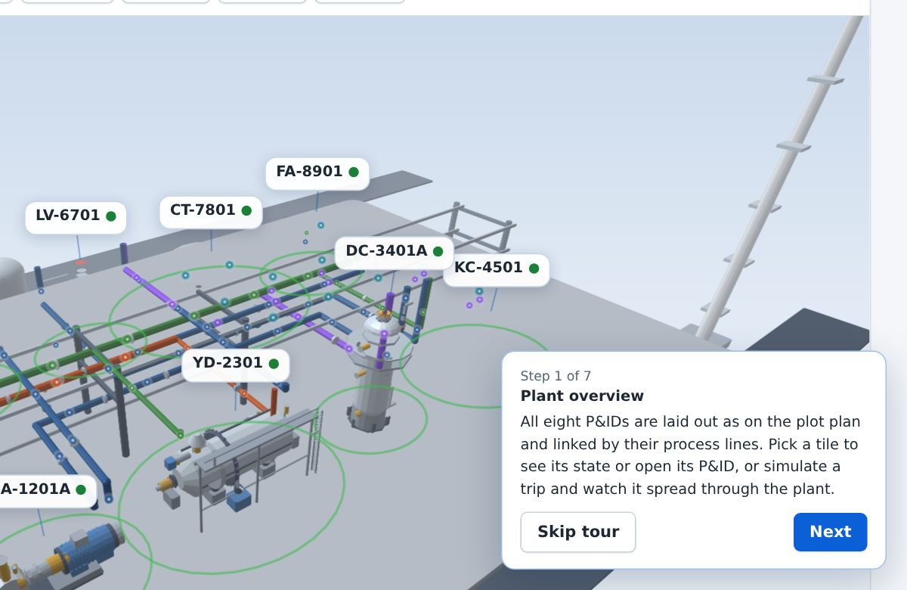
Figure 9. A step of the guided tour.

10 Working offline and sharing data
Used by: Operator, Engineer, Reliability, HSE, Manager
The platform keeps its own copy of the knowledge base in your browser, so searching works without a connection. When a shared database is connected, changes made by one user are shared with the others.

10.1 What is stored where
Storage | What it holds | Who sees it
Your browser | A copy of the knowledge base, your drafts, your recent questions and your settings | Only you, on this computer
Shared database | Knowledge items, work orders, feedback, the audit trail and the question log | All signed-in users, when connected
Production database (target) | The same records in PostgreSQL with vector search | All users of the Company installation

10.2 Sync status
The footer of the sidebar shows the sync status. Local only means that the shared database is not connected and your changes stay in this browser. When it is connected, the footer shows the time of the last sync, and the platform checks for changes every few seconds.
1 Open Settings.
2 Read the Shared database panel. It states whether the platform is connected.
3 Select Sync now to send your changes and receive the latest changes immediately.
CAUTION
If two people change the same item at nearly the same time, the platform keeps the newer change and marks the other as a conflict so that it can be reviewed.

10.3 Offline search
The label Offline knowledge search in the footer confirms that the search index is loaded in your browser. You can search, open documents and read lessons without a connection. Actions that need the shared database, such as syncing, wait until the connection returns.

11 Dashboard
PART 3. DAILY OPERATIONS
Used by: Operator, Engineer, Reliability, HSE, Manager
The Dashboard is the first page after sign-in. It shows the whole LLDPE unit as a 3D plant, lists the items that need attention today and summarises the knowledge base.

11.1 Overview tab
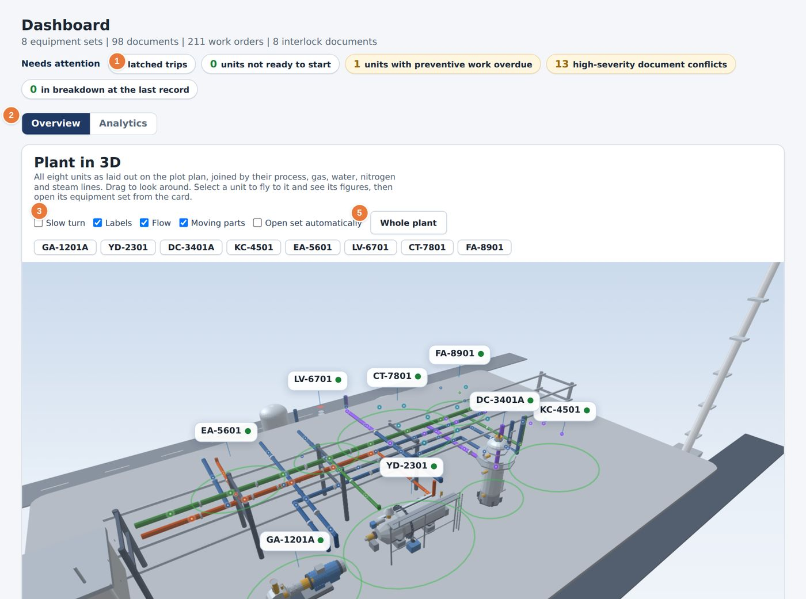
Figure 10. The Dashboard, Overview tab.
1 Needs attention chips. Green means no action. Amber means follow up.  2 Overview and Analytics tabs.  3 View options for the 3D plant: Slow turn, Labels, Flow, Moving parts and Open set automatically. | 4 One button for each equipment set. Select a button to fly to that unit.  5 Whole plant returns to the full view.

The Needs attention line counts five conditions: latched interlock trips, units that are not ready to start, units with overdue preventive work, high-severity document conflicts and units in breakdown at the last record. Select a chip to open the page that explains it.

11.2 Using the 3D plant
1 Drag with the mouse to rotate the view. Scroll to zoom. Hold the right mouse button, or use two fingers, to pan.
2 Select a unit tag above the model, or a label on the model, to fly to that unit.
3 Read the unit card that appears. It shows availability, breakdowns, downtime and forecast risk for the unit.
4 Select Open equipment set on the card to go to the equipment page, or select Whole plant to return.
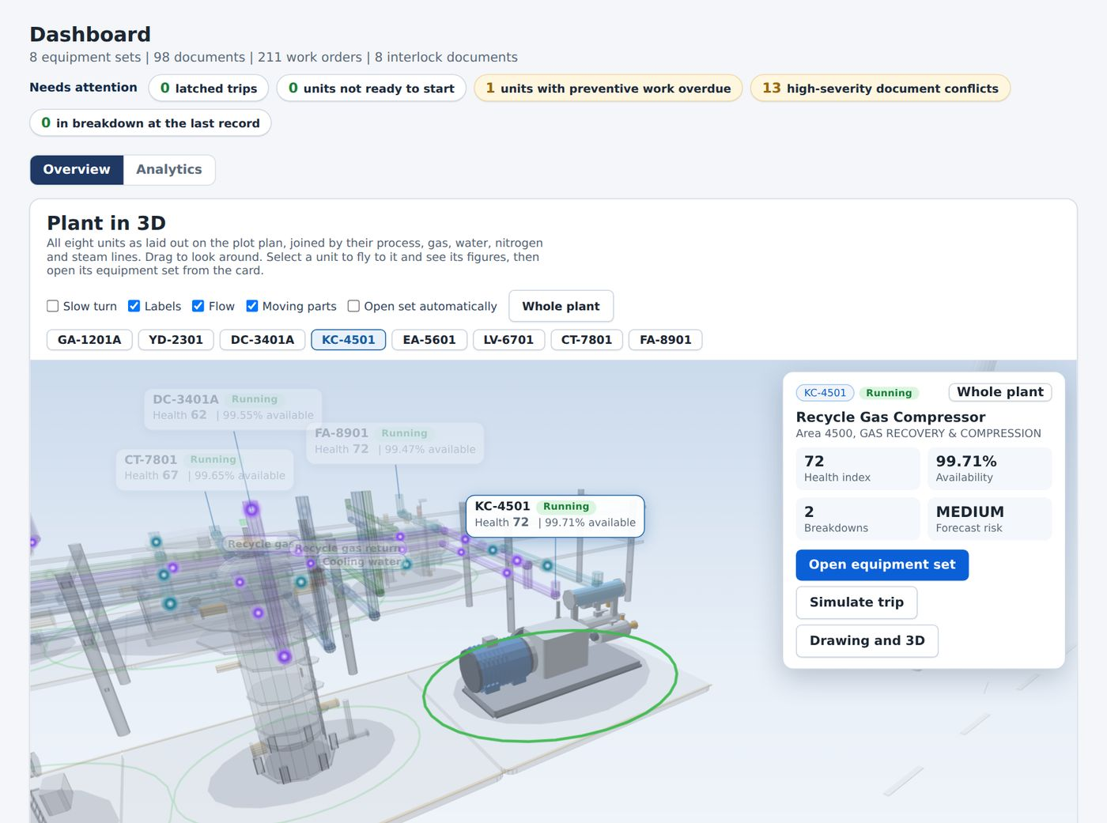
Figure 11. A unit selected on the Dashboard. The unit card opens beside the 3D view.

TIP
Tick Open set automatically if you want a selected unit to open its equipment page at once.

Pipes are coloured by service so that you can follow a line across the plant. The legend under the model lists process liquid, nitrogen, steam and condensate, cooling water, lube and seal oil, and gas, vent and hydrogen. Green rings on the ground mark the hazard radius of each unit.

11.3 Analytics tab
The Analytics tab summarises the knowledge base and the maintenance history on one page. Every chart on this page is interactive: select a bar, a segment or a month to see the records behind it.
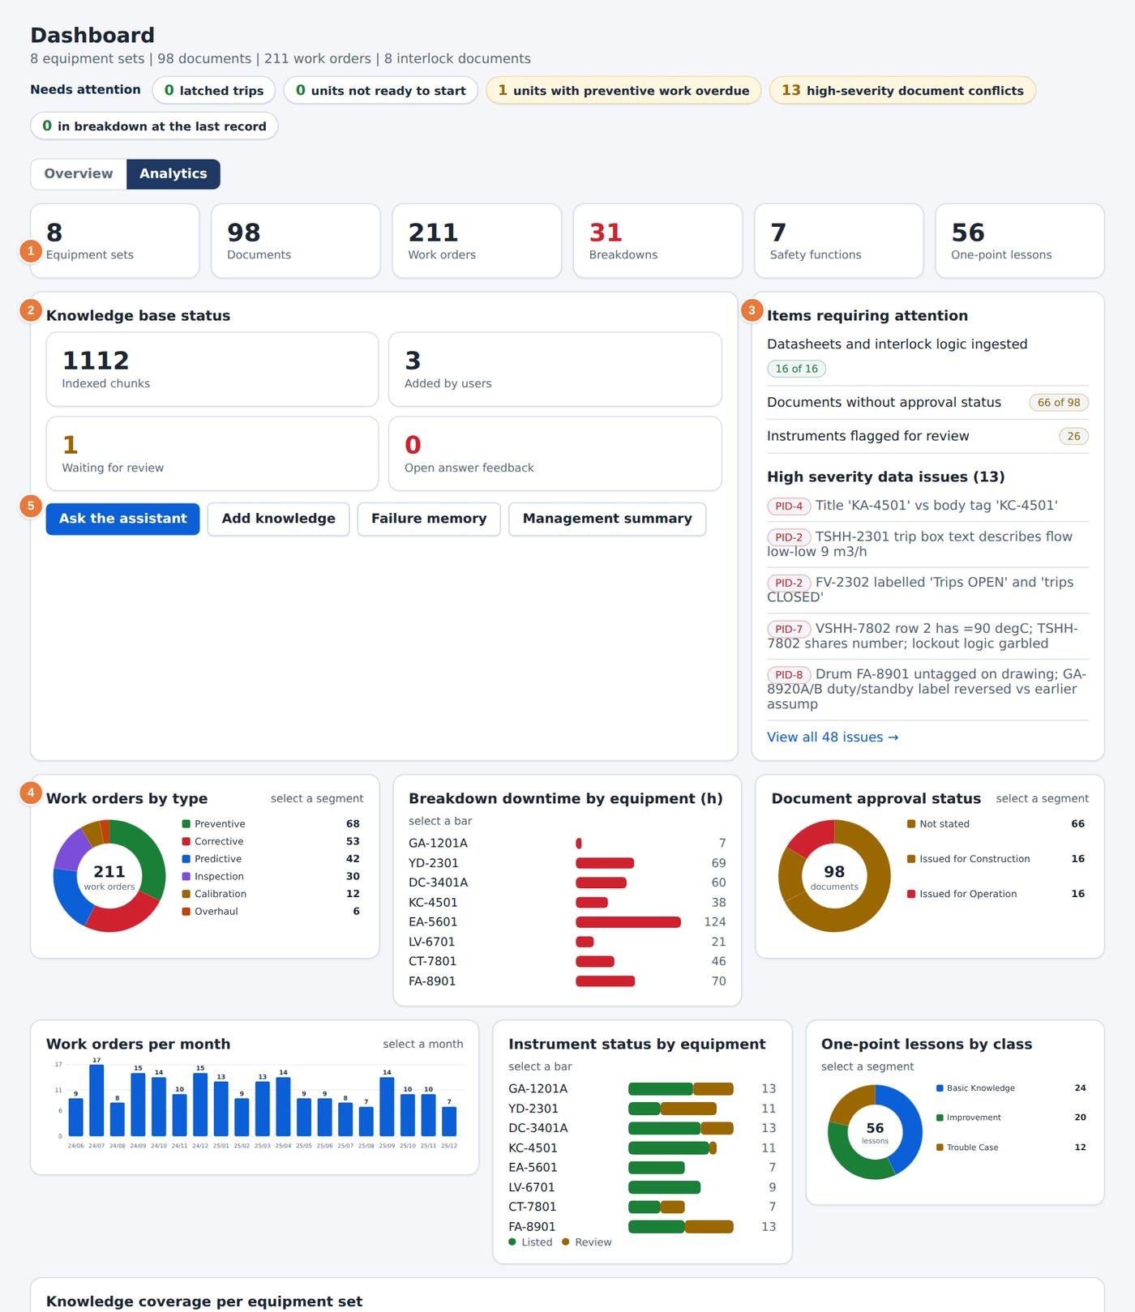
Figure 12. The Dashboard, Analytics tab.
1 Headline counts: equipment sets, documents, work orders, breakdowns, safety functions and lessons.  2 Knowledge base status: indexed chunks, items added by users, items waiting for review and open answer feedback.  3 Items requiring attention and the high-severity data issues. | 4 Charts for work orders by type, breakdown downtime by equipment and document approval status.  5 Quick actions: Ask the assistant, Add knowledge, Failure memory and Management summary.

12 My work
Used by: Operator, Engineer, Reliability, HSE, Manager
My work collects what concerns you personally: items waiting for your approval, items you have written, and your recent questions and activity.
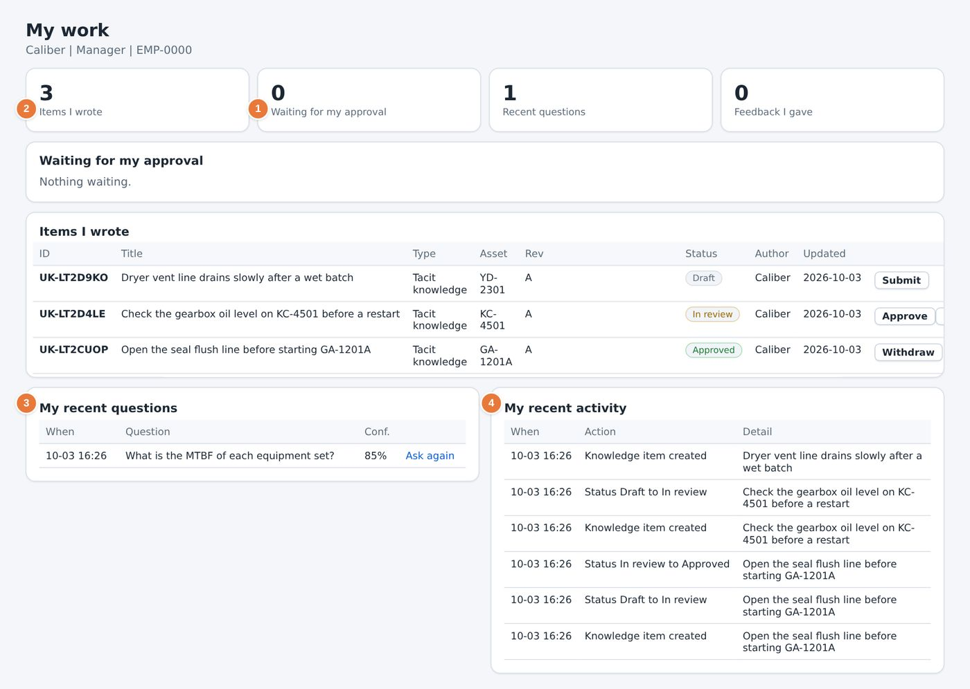
Figure 13. The My work page, after a question has been asked.
1 Items waiting for your approval. Empty for roles that cannot approve.  2 Knowledge items you have written, with their status. | 3 Your recent questions to the AI Assistant.  4 Your recent activity, taken from the audit trail.

12.1 How to use the page
- Check Waiting for my approval at the start of each shift if you are an approver. Select an item to open it in Knowledge Studio.
- Use Items I wrote to follow a draft you submitted. The status moves from Draft to In review to Approved or Rejected.
- Open a question under My recent questions to read the answer again.
ROLES
Operators can write drafts and ask questions, but they cannot approve. Their Waiting for my approval list stays empty.

13 Equipment Sets
Used by: Operator, Engineer, Reliability, HSE, Manager
An equipment set gathers everything known about one machine. The page has a header with the main figures and twelve tabs that open the P&ID, the drawing, the datasheet, the interlock logic, the lessons and the maintenance history.

13.1 The equipment list
Select Equipment Sets in the sidebar to see the eight sets. Each card shows the tag, the name, the start-up status, the criticality and the main figures. Select a card to open the set.

13.2 The equipment header
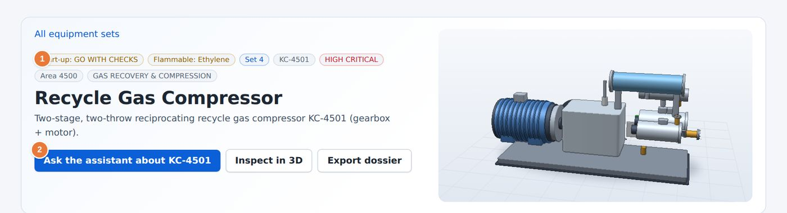
Figure 14. The header of an equipment page.
1 Start-up status, flammability, set number, tag and criticality.  2 Ask the assistant about this equipment. The question is limited to this set. | 3 The twelve tabs. The selected tab is underlined.  4 Counts beside the tab names show how many records each tab holds.

Under the title, six tiles show availability, mean repair time, breakdowns, downtime, forecast risk and open data issues. Inspect in 3D opens the 3D model of the machine. Export dossier produces a printable summary of the equipment (see Chapter 37).

13.3 Overview tab
The Overview tab answers the question: what do we know about this machine, and where is it?
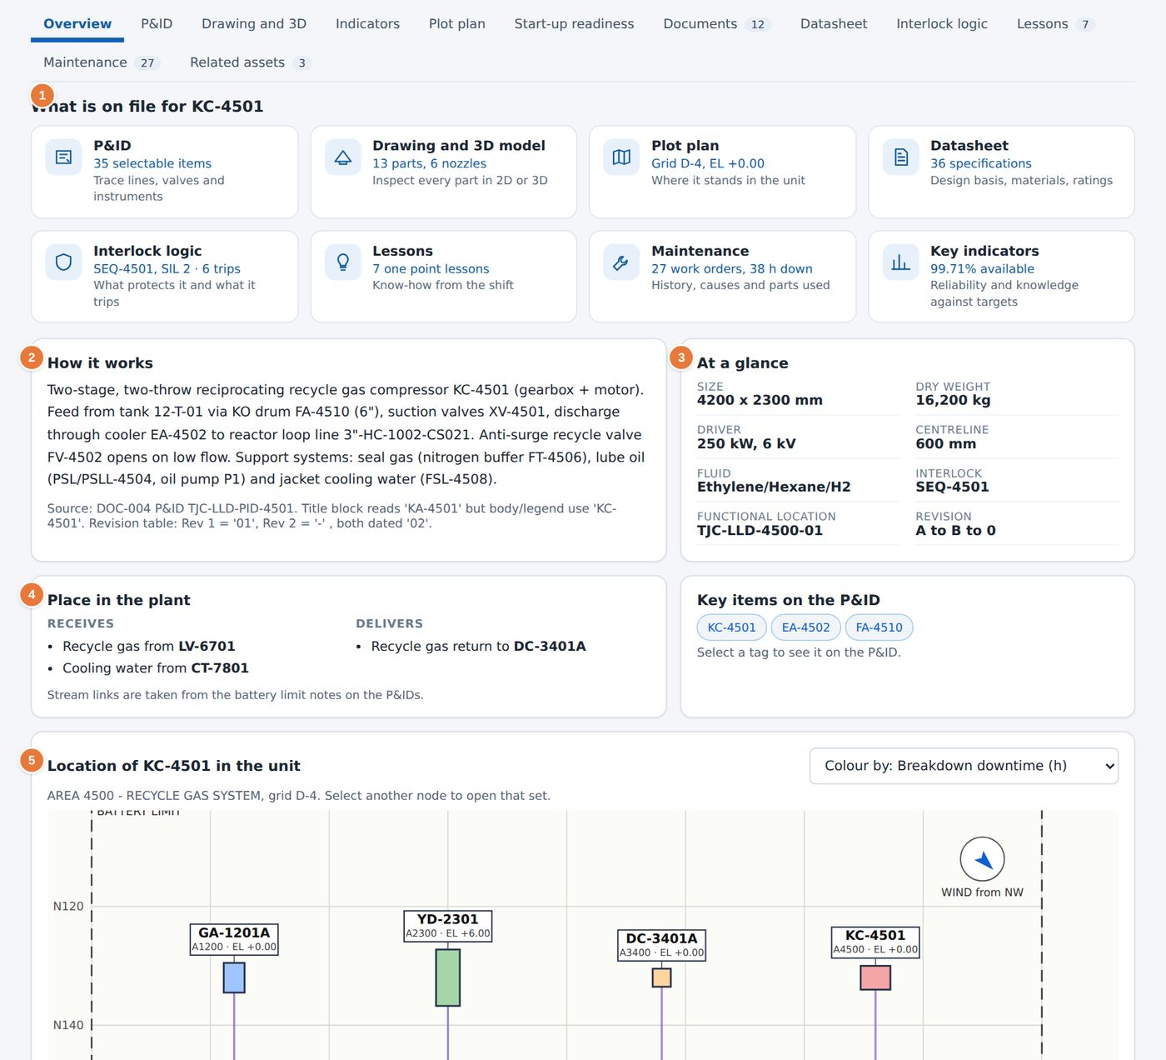
Figure 15. Overview tab of the Recycle Gas Compressor KC-4501.
1 What is on file: tiles that open the P&ID, drawing, plot plan, datasheet, interlock logic, lessons, maintenance and key indicators.  2 How it works: a plain description of the machine and its process.  3 At a glance: size, weight, driver and interlock reference. | 4 Place in the plant: what feeds the unit and what it delivers to.  5 Location in the unit, coloured by a measure you select.

13.4 P&ID tab
The P&ID tab shows the piping and instrumentation diagram of the unit. Chapter 15 describes how to read it and how to operate the valves.
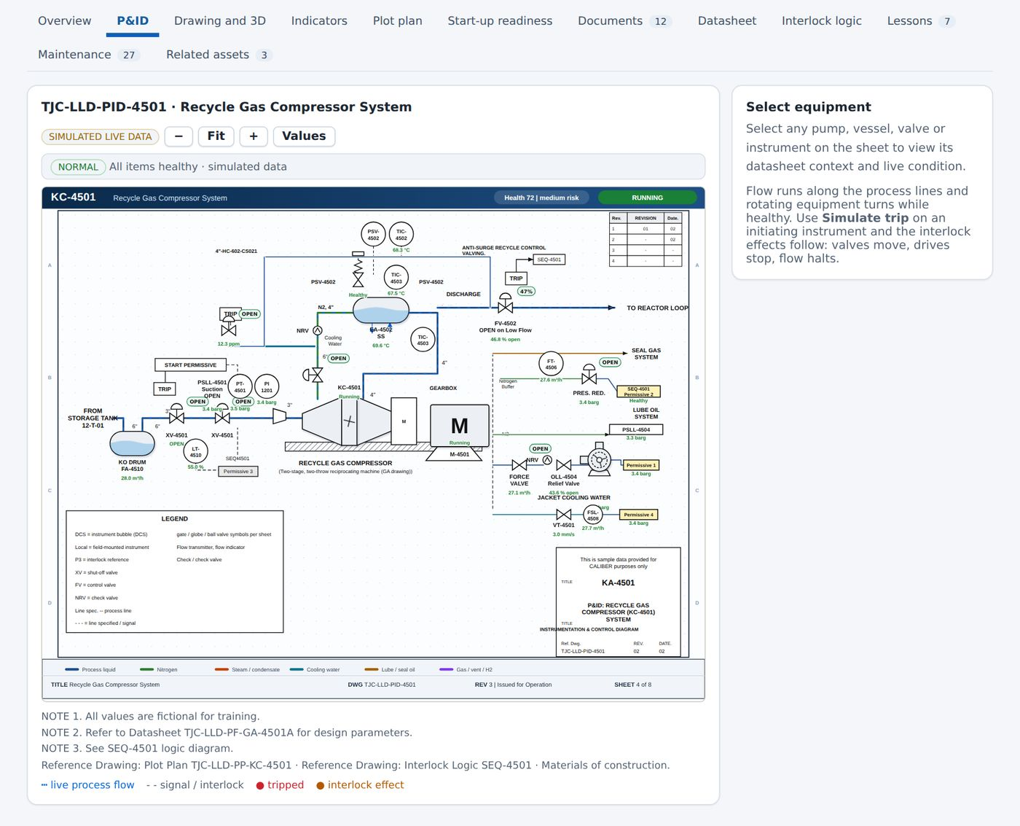
Figure 16. P&ID tab.

13.5 Drawing and 3D tab
This tab shows the general arrangement drawing and the 3D model, with a bill of materials and the work orders for each component. Chapter 14 explains how to select parts.
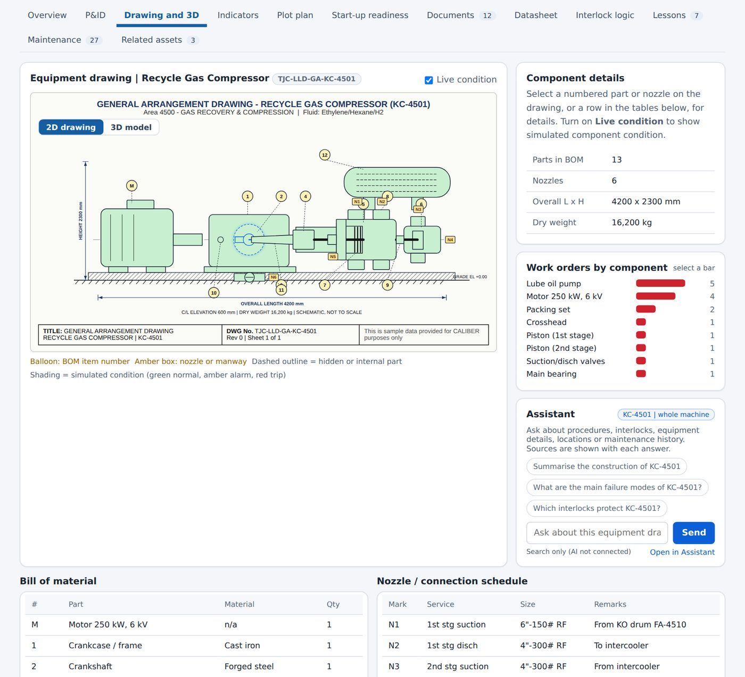
Figure 17. Drawing and 3D tab.

13.6 Indicators tab
The Indicators tab gives the reliability and knowledge figures of the set: availability, mean repair time, mean time between failures, breakdowns, downtime, maintenance cost, the share of planned work, the forecast failure risk for the next 90 days, documents approved, lessons, open data issues and items added by users. A tag next to a figure shows whether it is on or off target. Select Open the full performance page to see the same figures for all sets.
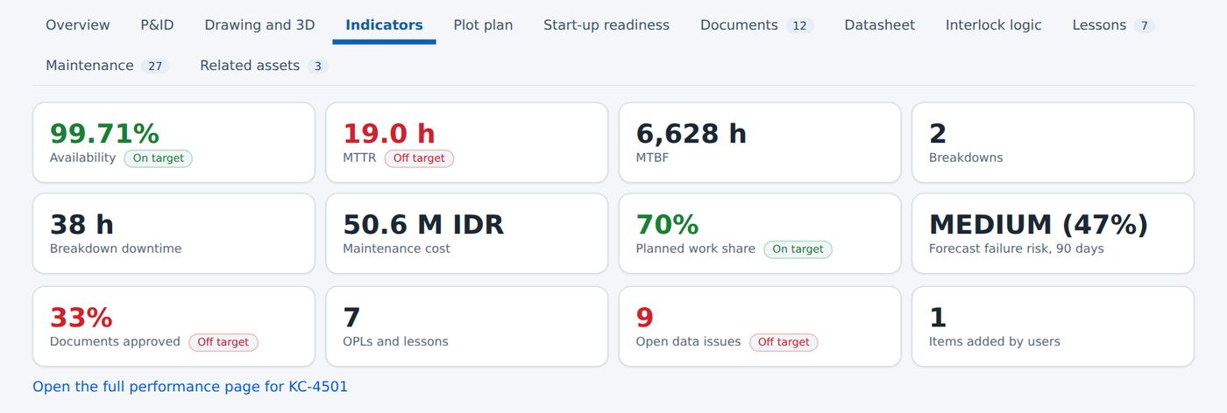
Figure 18. Indicators tab.

13.7 Plot plan tab
The Plot plan tab shows where the unit stands in the plant and what is near it. Layers can be switched on for areas, heat map, hazard zones, muster points and gates, fire protection and walkways.
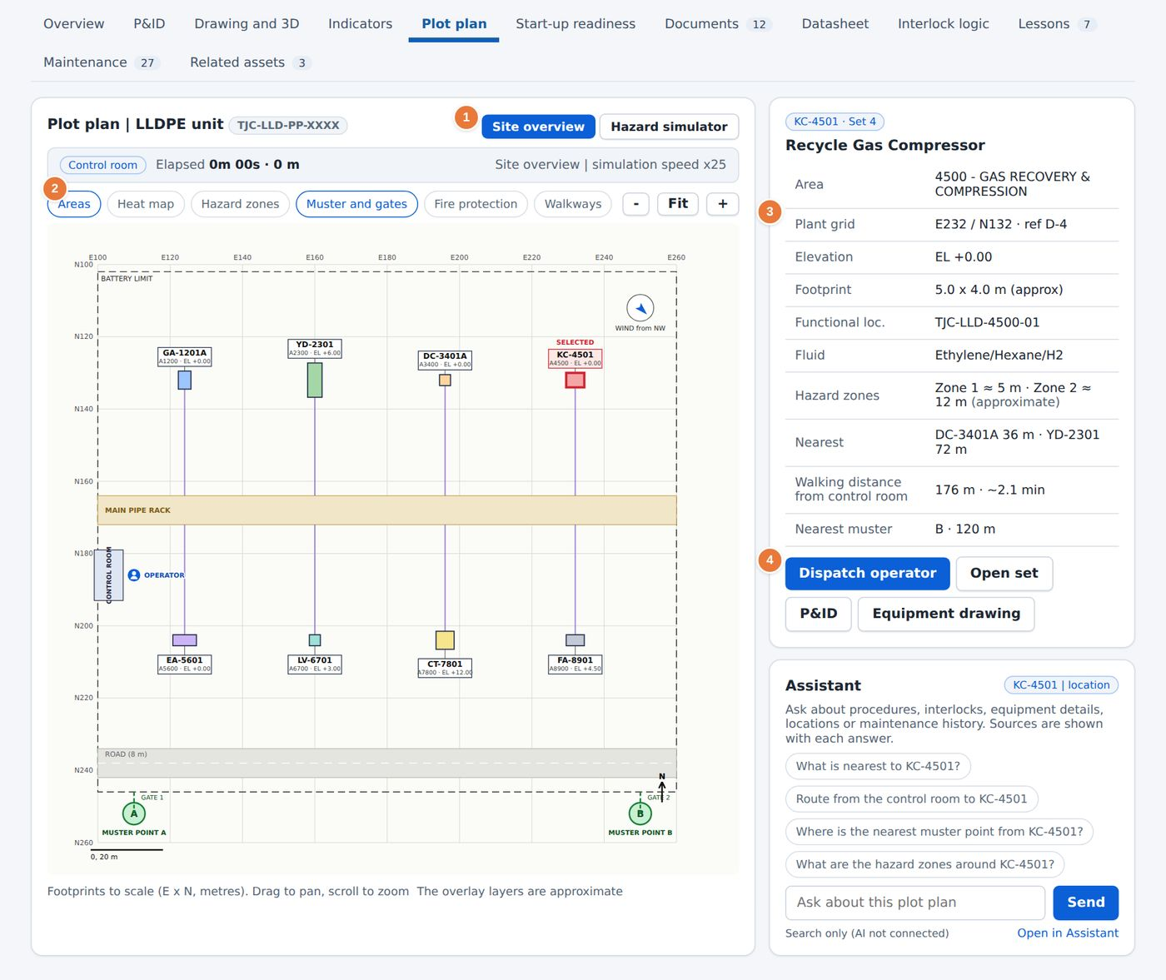
Figure 19. Plot plan tab.
1 Switch between Site overview and the Hazard simulator (Chapter 31).  2 Map layers: Areas, Heat map, Hazard zones, Muster and gates, Fire protection and Walkways. | 3 Facts about the selected unit: area, grid, elevation, fluid, hazard zones and nearest muster point.  4 Dispatch operator shows the route and walking time from the control room.

13.8 Start-up readiness tab
This tab decides whether the unit is ready to start. Chapter 17 describes it in full.

13.9 Documents tab
The Documents tab lists every document of the set. The top table shows the document set coverage: whether a P&ID, an equipment drawing, a datasheet, a plot plan and an interlock logic document exist for the set, and their approval status. The lower table lists all documents with their type, revision, approval status and effective date.
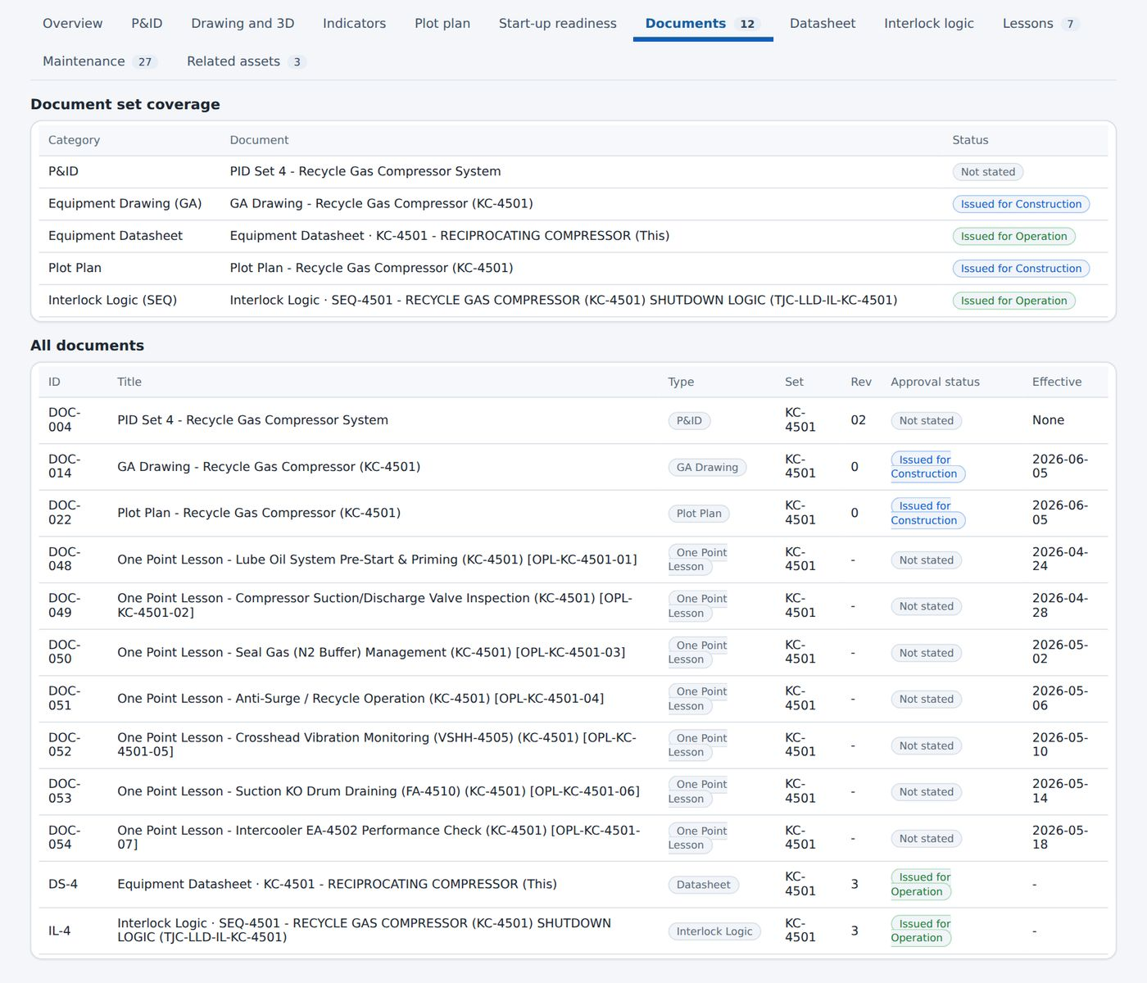
Figure 20. Documents tab.

13.10 Datasheet tab
The Datasheet tab shows the equipment datasheet as a searchable list of specifications, grouped by topic such as identification, driver, design and mechanical data. Use the search box to find a value, for example Speed. Open interlock logic goes to the interlock sheet of the unit, Export CSV saves the datasheet as a table, and Ask about this datasheet sends a question to the assistant.
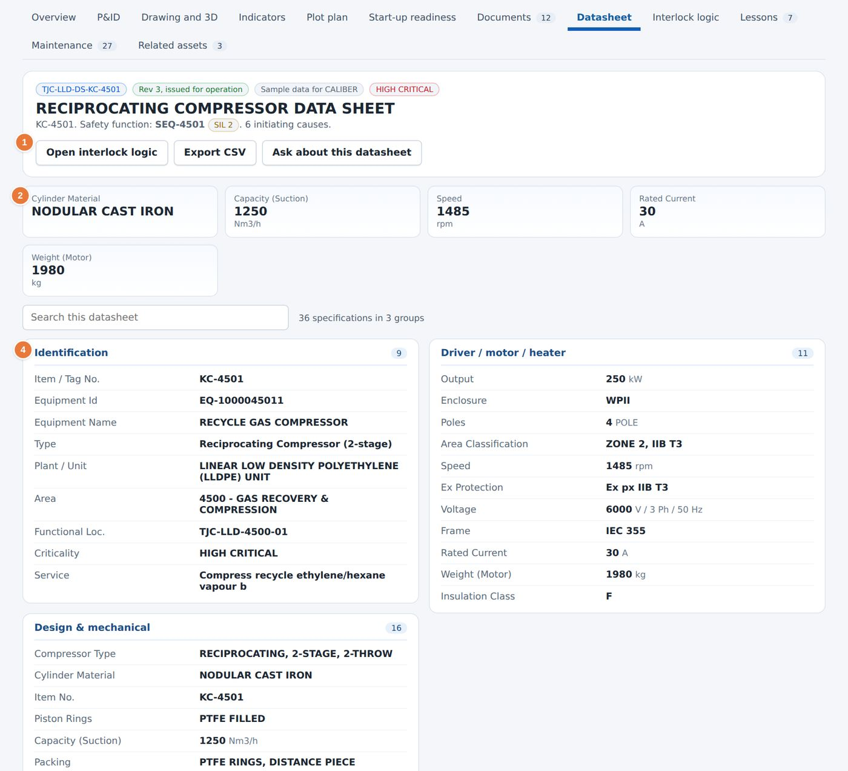
Figure 21. Datasheet tab.
1 Open interlock logic, Export CSV and Ask about this datasheet.  2 Key values shown as tiles at the top. | 4 Specification groups, each with a count.

13.11 Interlock logic tab
The tab shows the cause-and-effect sheet of the unit's interlock, with tabs for the Function test and the Proof test history. Chapter 16 explains the sheet.

13.12 Lessons tab
The Lessons tab lists the one point lessons that concern the equipment. Each card shows the lesson number, its discipline, its classification and the number of steps. Open sheet opens the lesson, and Simulate starts the matching exercise (Chapters 28 and 29).
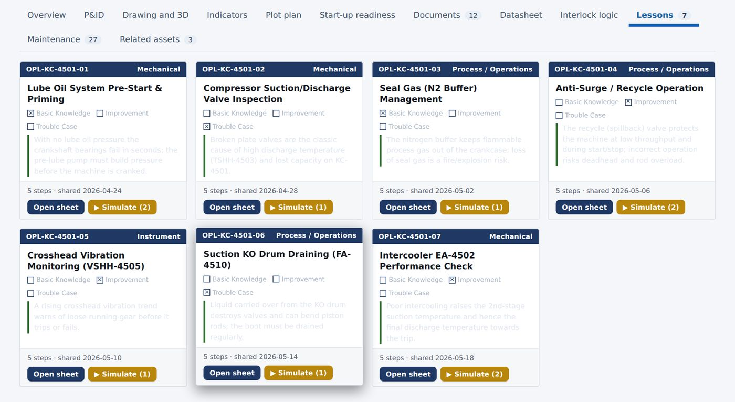
Figure 22. Lessons tab.

13.13 Maintenance tab
The Maintenance tab shows the maintenance dashboard for this one machine: work orders per month and by type, cost split, work by component, failure locations on the drawing and the reliability figures. It uses the same charts as the Maintenance page, limited to this set.
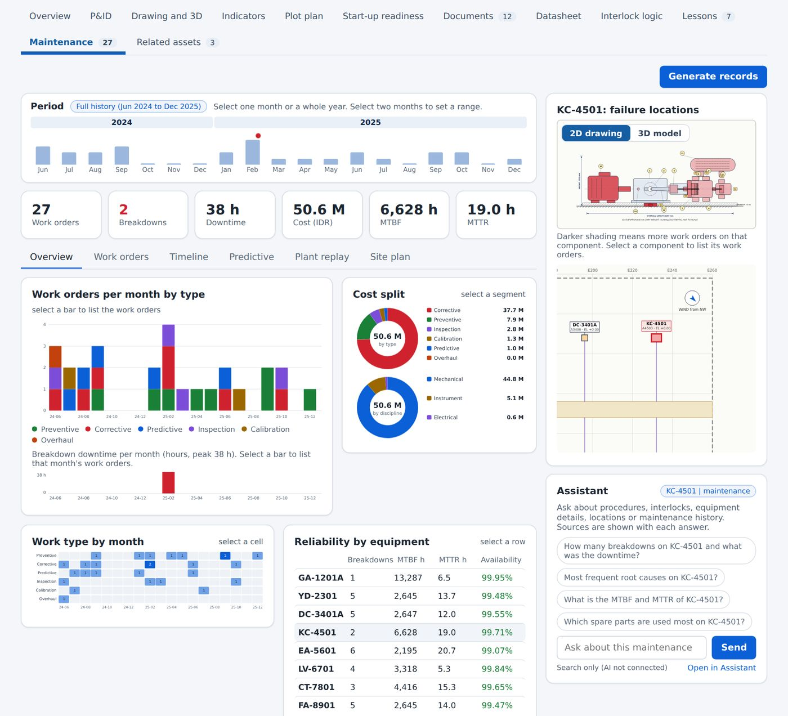
Figure 23. Maintenance tab.

13.14 Related assets tab
The last tab lists assets that are connected to this equipment, such as a cooler or a knock-out drum, with their tag, type and description.
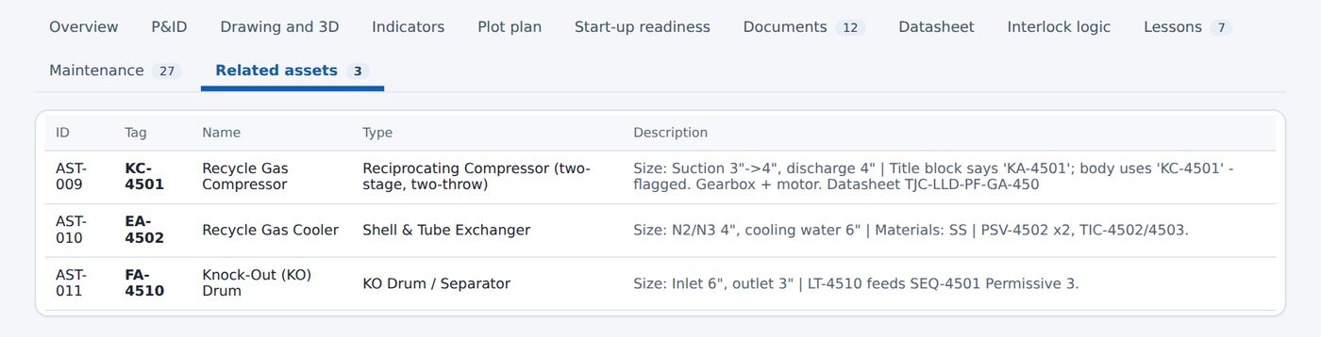
Figure 24. Related assets tab.

14 Equipment drawings in 2D and 3D
Used by: Operator, Engineer, Reliability, HSE, Manager
Every machine has a general arrangement drawing and a 3D model built from the same list of parts. Selecting a part in either view shows its item number, material, drawing reference and simulated condition.

14.1 The 2D drawing
1 Open an equipment set and select the Drawing and 3D tab.
2 Make sure 2D drawing is selected above the drawing.
3 Select a numbered balloon on the drawing, or a part name in the table below it. The part is highlighted.
4 Read the Component details panel. It shows the item number, part, material, quantity and drawing reference.
5 Tick Live condition to see a simulated reading for the part, such as bearing temperature or leak rate.
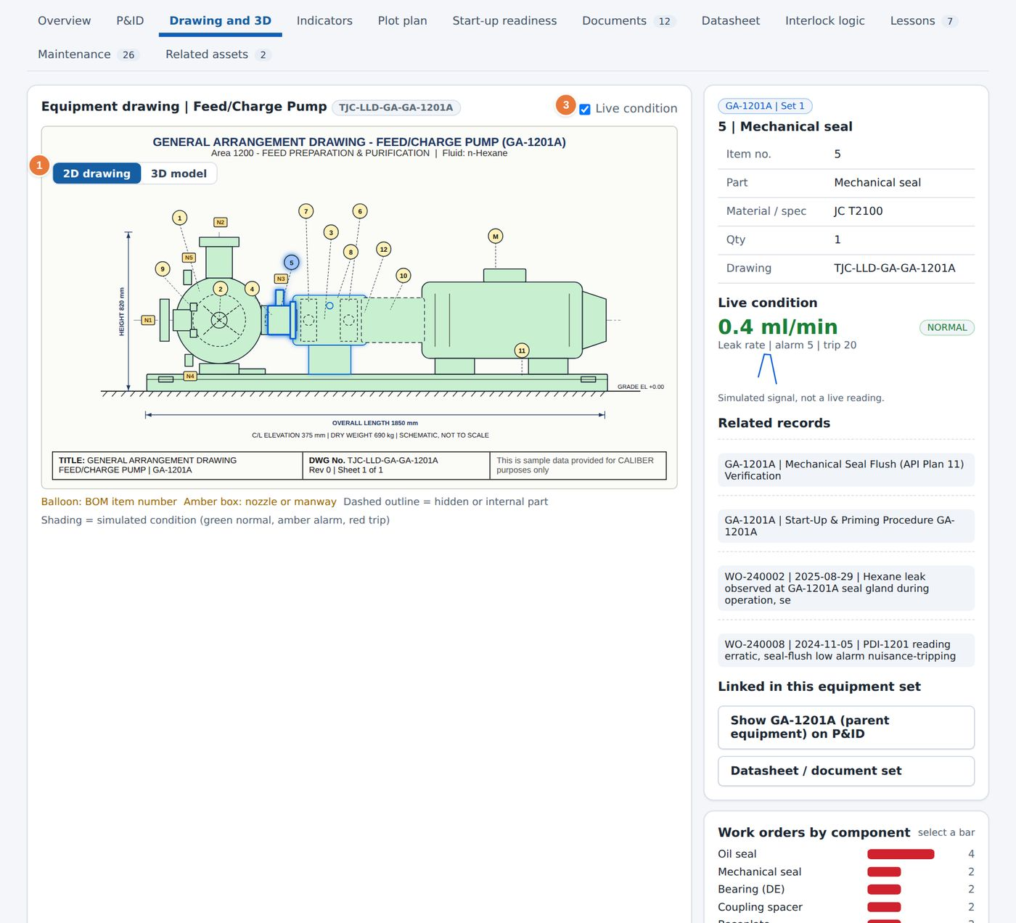
Figure 25. The 2D drawing with the mechanical seal selected.
1 Switch between 2D drawing and 3D model. | 3 Simulated condition of the part. The signal is a demonstration, not a live reading.

NOTE
Amber boxes on the drawing mark nozzles and manways. A dashed outline means that a part is hidden or internal. The condition shading is green for normal, amber for alarm and red for trip.

14.2 The 3D model
1 Select 3D model above the drawing.
2 Drag to rotate the machine and scroll to zoom.
3 Select a part on the model. The part is highlighted and an information card shows its item number, material, quantity and live condition.
4 Select another part. The card changes to that part.
5 Use the view buttons Isometric, Front, Side and Top to look from a fixed direction, Auto-rotate to turn the model, and X-ray to see through the casing.
6 Select Moving parts to animate shafts, impellers and fans. Select Reset to return to the first view.
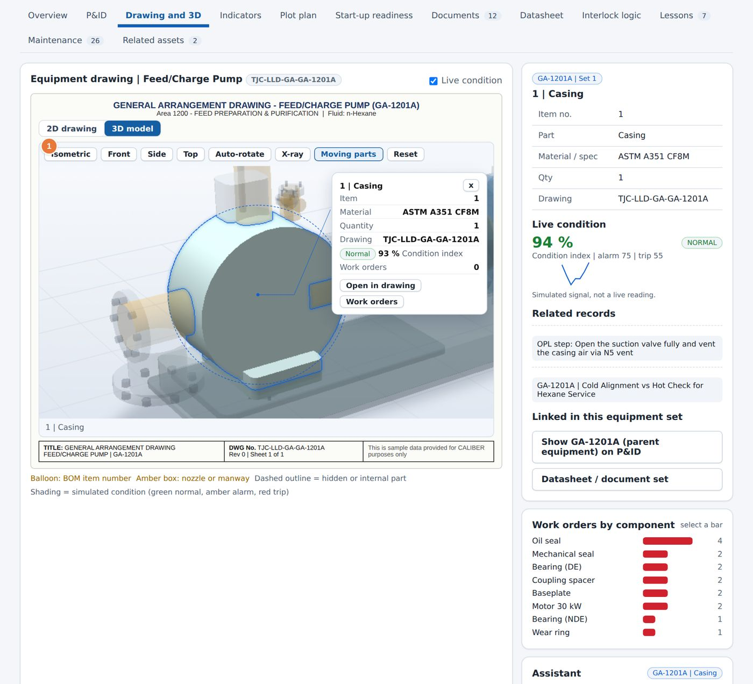
Figure 26. The 3D model of the Feed/Charge Pump with a part selected.
1 View buttons: Isometric, Front, Side, Top, Auto-rotate, X-ray, Moving parts and Reset.

The same approach works on every machine. The platform has separate models for the pump, the dryer, the reactor, the compressor, the heater, the separator, the cooling tower fan and the reflux drum.
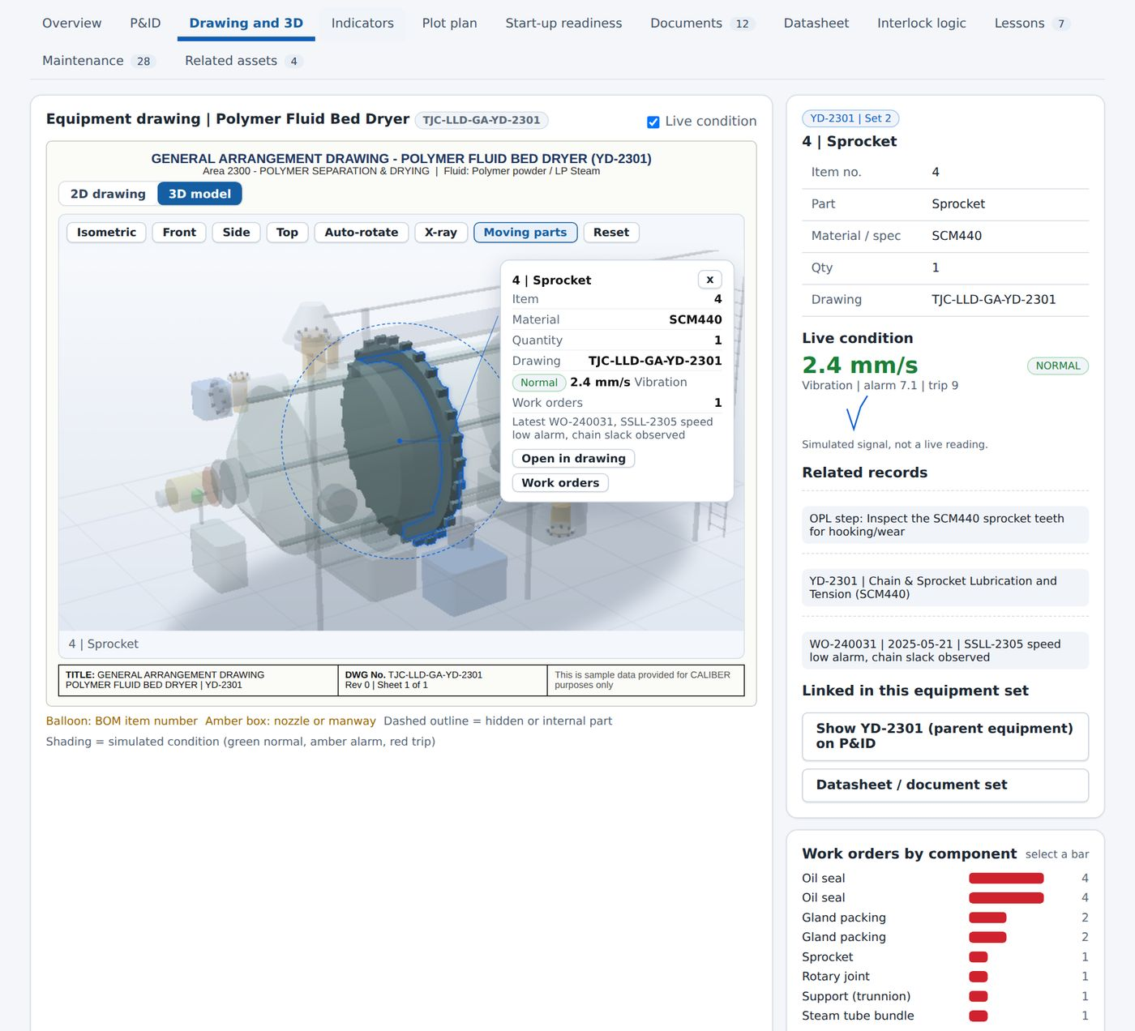
Figure 27. The 3D model of the Polymer Fluid Bed Dryer with a part selected.

14.3 Bill of material and work orders by component
Under the drawing, the Bill of material lists the item number, part, material and quantity of every part. The Nozzle and connection schedule lists the nozzles with their size and remarks. The Work orders by component chart on the right counts the work orders raised for each part; select a bar to see them.

15 Live P&ID
Used by: Operator, Engineer, Reliability, HSE, Manager
The platform holds eight piping and instrumentation diagrams. Each is drawn in a consistent style, coloured by service, and connected to the interlock model, so that closing a valve or tripping an instrument shows what follows.

15.1 Reading the diagram
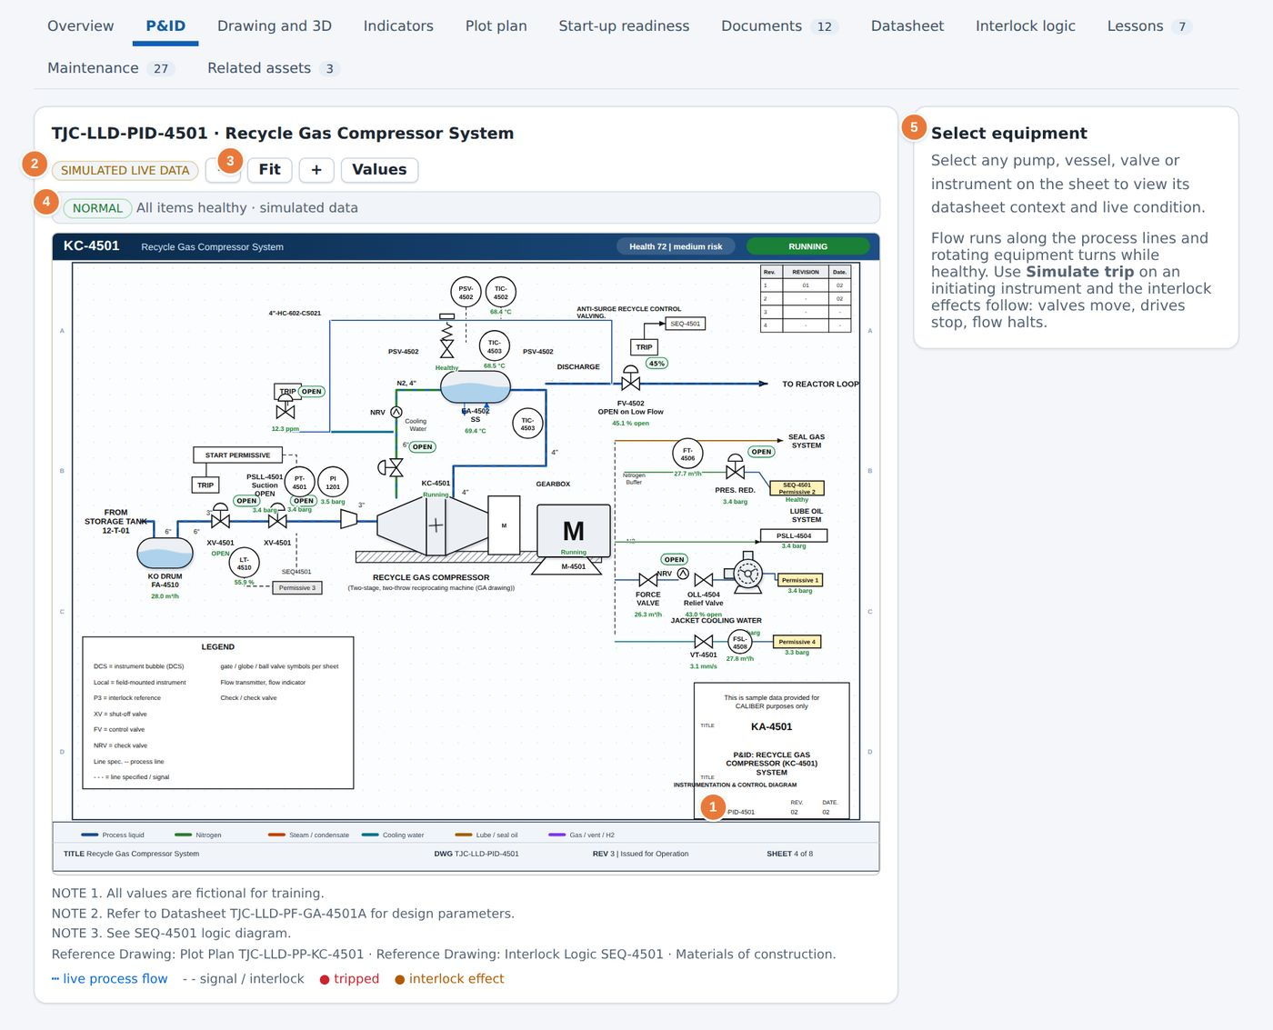
Figure 28. The P&ID of the Recycle Gas Compressor.
1 Title block with the drawing number and revision.  2 Simulated live data badge. The values are generated for demonstration.  3 Zoom controls: −, Fit, +. The Values button shows or hides the readings. | 4 Status line: whether all items are healthy.  5 Help panel: select any item to open its datasheet context.

- Process lines are coloured by service: process liquid, nitrogen, steam, cooling water, lube oil and gas.
- Instrument bubbles show the tag and, when Values is on, the reading.
- Select a pump, vessel, valve or instrument to see its details and linked documents in the panel on the right.
- A red bubble means that the instrument has tripped. Red lines show the interlock effects.

15.2 Operating a valve
1 Select a valve symbol on the diagram, for example XV-4501, the compressor suction valve.
2 Choose Close in the panel. The valve turns to closed.
3 Watch the flow. The lines downstream stop moving, and the permissives that depend on the valve change to failed.
4 Open the valve again to restore the flow.
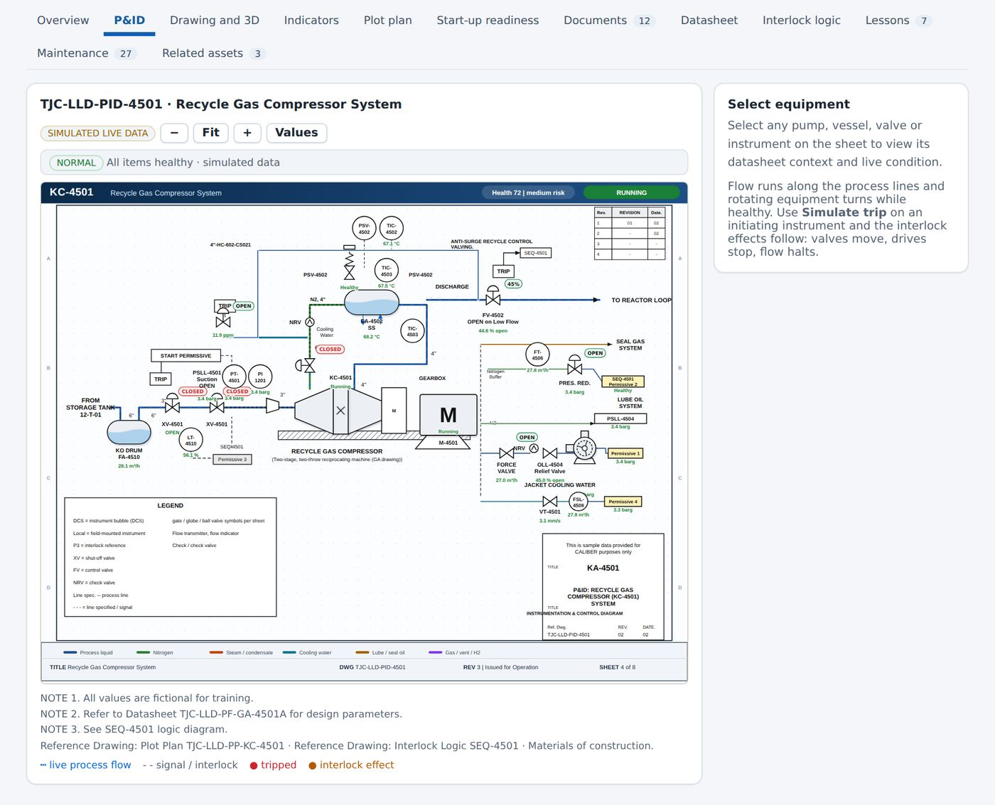
Figure 29. The suction valve XV-4501 closed. Flow downstream has stopped and the dependent permissive is shown as failed.

CAUTION
The diagram is a simulation. Closing a valve here does not act on the plant.

15.3 Simulating a trip
The help panel states that Simulate trip on an initiating instrument makes the interlock effects follow: valves move, drives stop and flow halts. Use it to see which final elements an instrument acts on before you plan a function test.

16 Interlock Library
Used by: Operator, Engineer, Reliability, HSE, Manager
The Interlock Library holds the cause-and-effect logic of every protective system. It shows which instruments initiate a trip, which final elements act and what must be true before the unit can start.
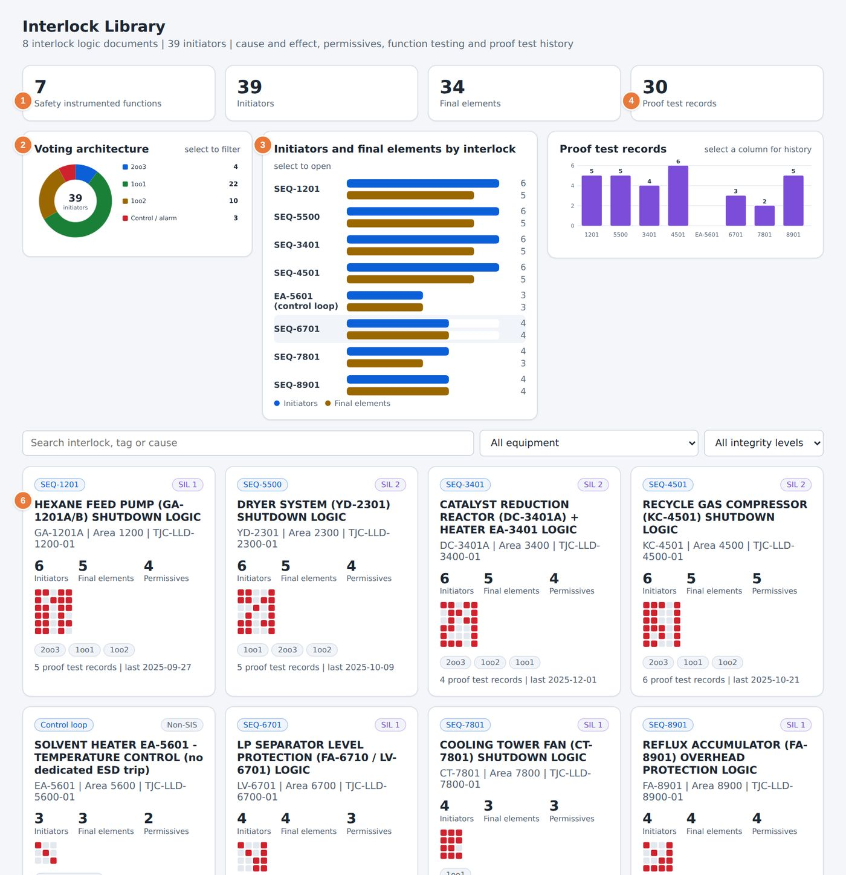
Figure 30. The Interlock Library.
1 Summary tiles: safety instrumented functions, initiators, final elements and proof test records.  2 Voting architecture. Select a segment to filter the cards below.  3 Initiators and final elements for each interlock. Select a row to open it. | 4 Proof test records. Select a column to see the history.  6 One card for each interlock with its SIL, counts and voting.

16.1 Finding an interlock
1 Use the search box to type a tag, a cause or an interlock name, for example PSLL-1201.
2 Filter by equipment or by integrity level (SIL 1, SIL 2 or non-SIS) if needed.
3 Select a card to open the interlock sheet.

16.2 The interlock sheet
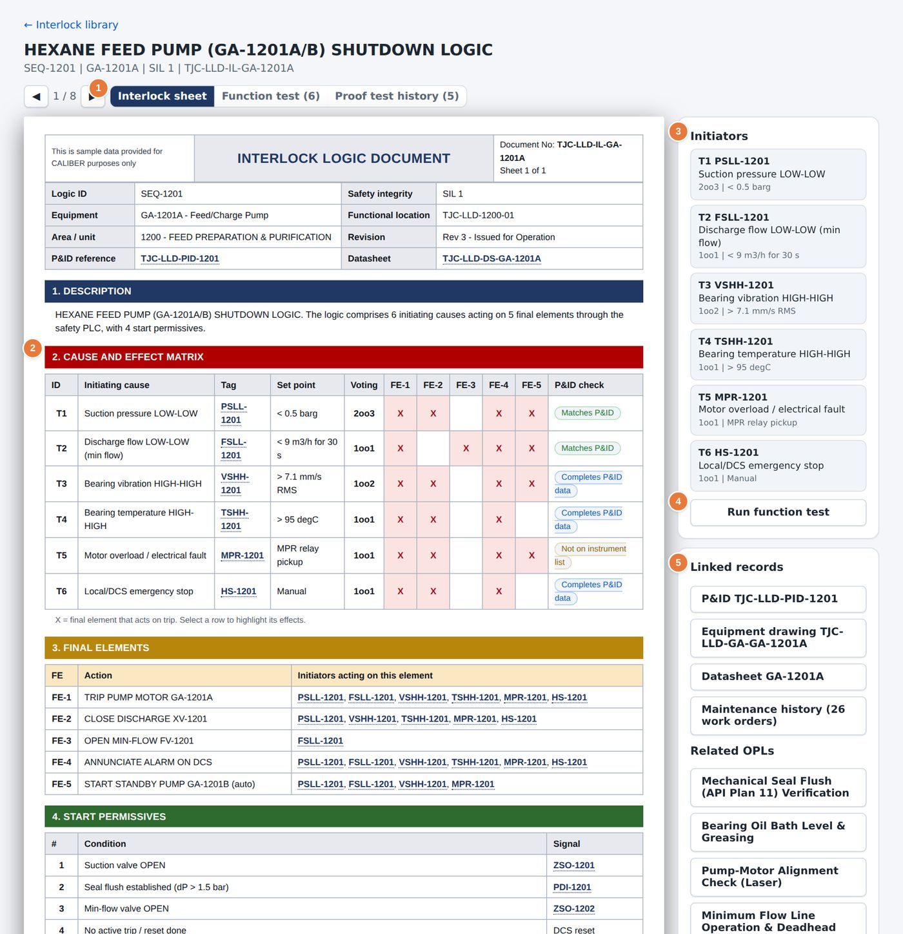
Figure 31. An interlock sheet.
1 Tabs: Interlock sheet, Function test and Proof test history.  2 The cause-and-effect matrix. Each X shows a final element that acts on the trip.  3 Initiators: each tag with its set point and voting. | 4 Run function test starts the simulated test.  5 Linked records: the P&ID, drawing, datasheet, maintenance history and related lessons.

The sheet has four sections: a description, the cause-and-effect matrix, the final elements with the initiators that act on each, and the start permissives. Select a row of the matrix to highlight its effects. A note such as Completes P&ID data means that the platform found the instrument in the interlock document but not on the P&ID, and has added it.

16.3 Function test and proof test history
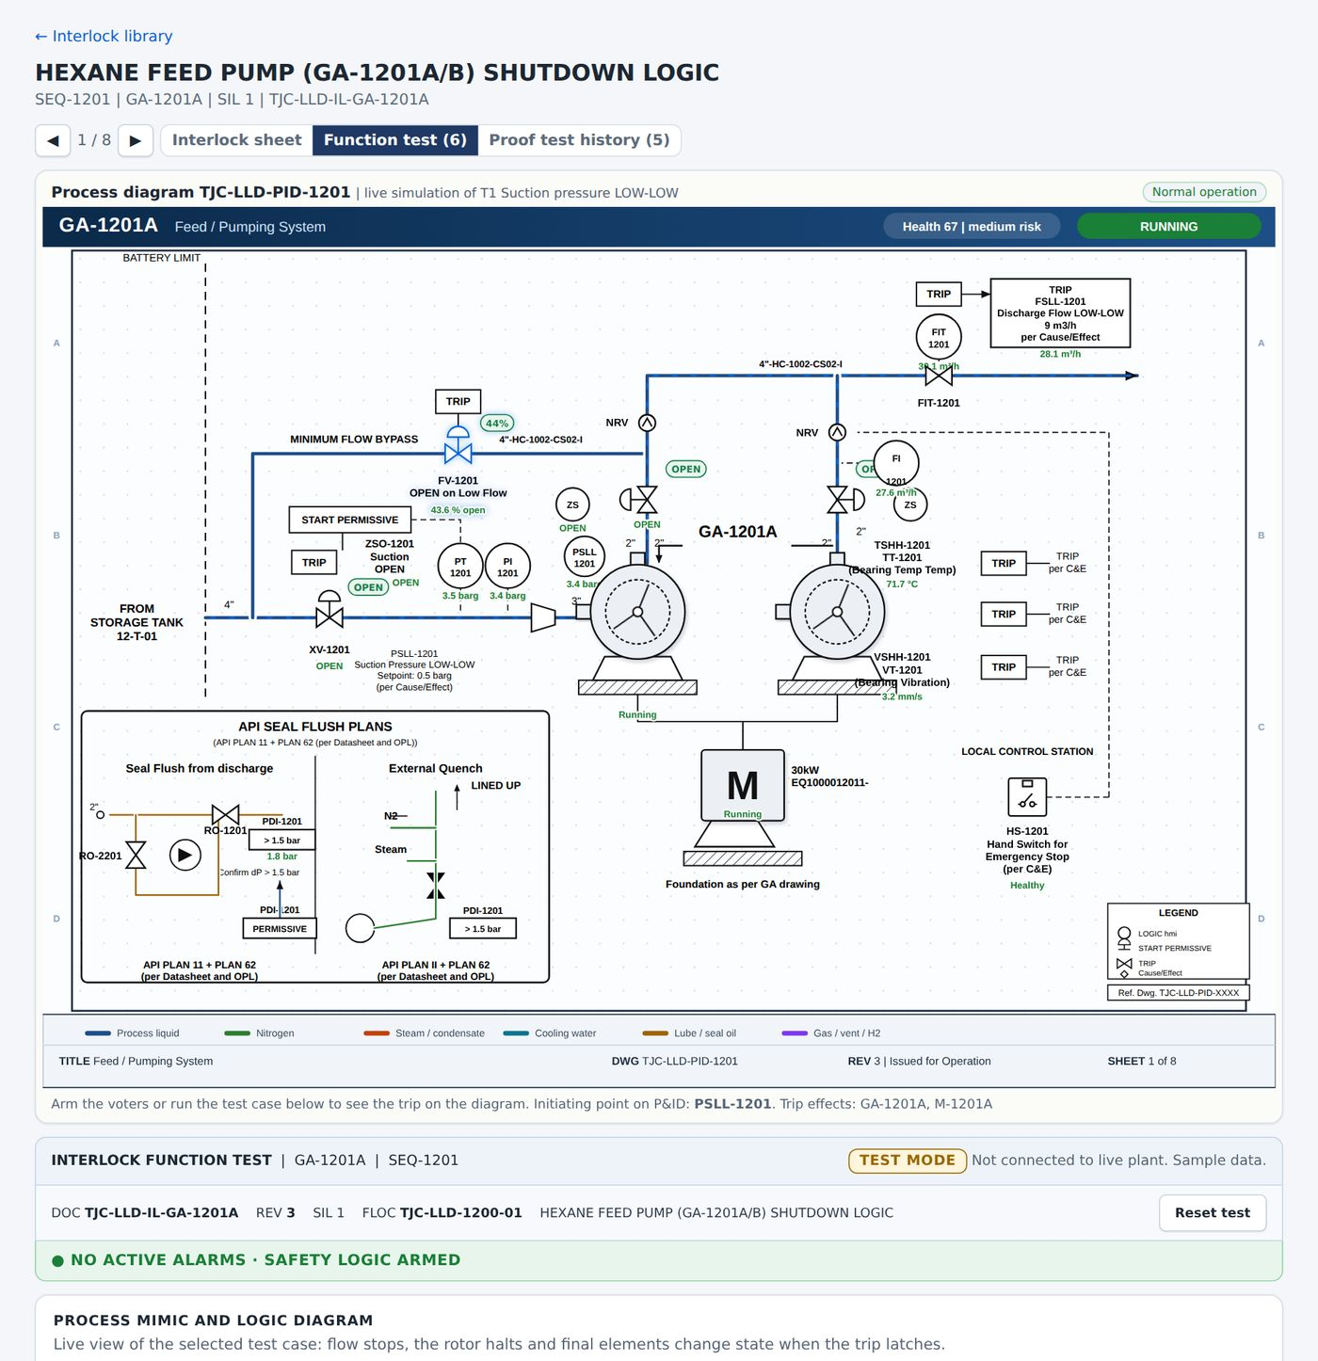
Figure 32. The function test tab.

The Function test tab steps through the test of each initiator and shows the expected response of the final elements. The Proof test history tab lists the earlier proof tests with their dates and results, so that you can see when each function was last verified.

17 Start-up readiness
Used by: Operator, Engineer, HSE, Manager
Before a unit is started or restarted, the checks that normally sit in several places are evaluated on one page. The page ends with a single decision: GO, GO WITH CHECKS or NO-GO.
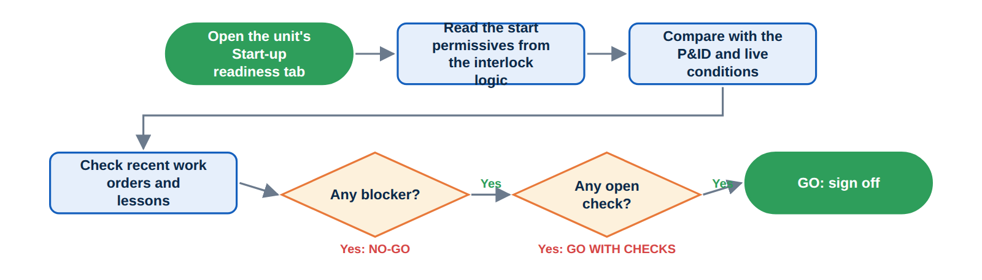
Figure 33. How the readiness decision is reached.

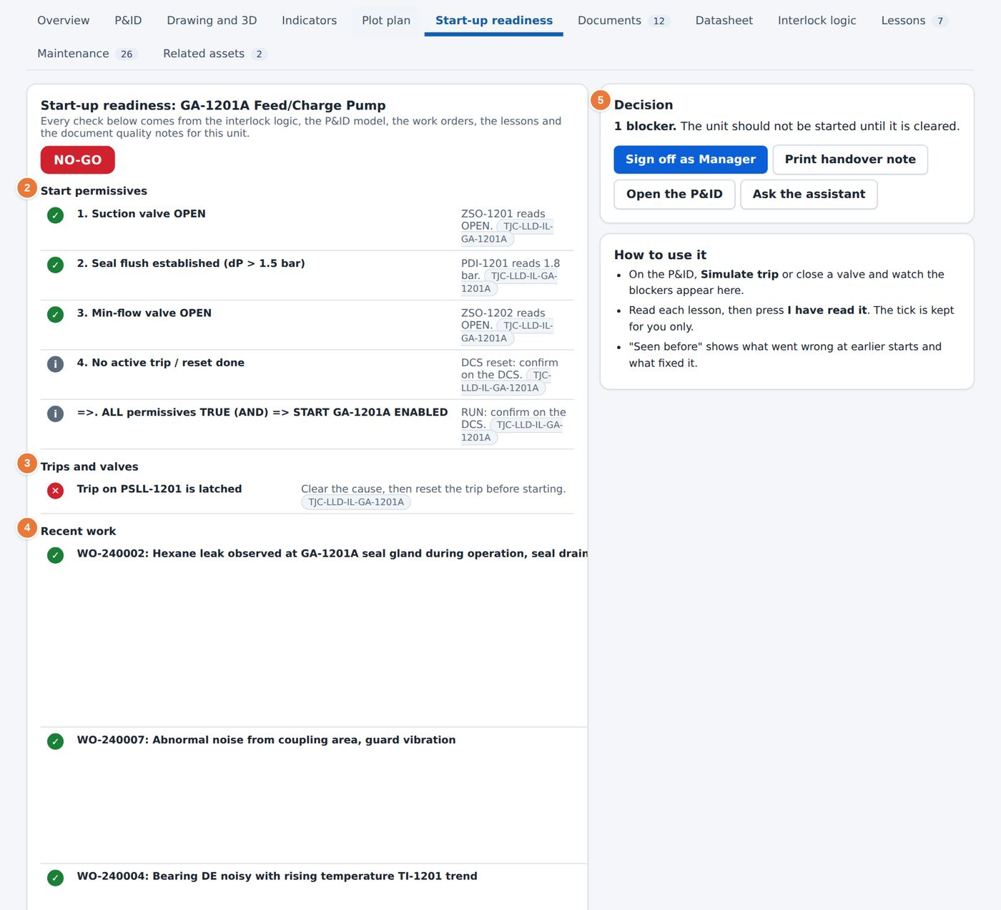
Figure 34. A unit with GO WITH CHECKS and several open checks.
2 Start permissives, each with its signal and its current state.  3 Trips and valves: any latched trip or valve out of position. | 4 Recent work that could affect the start.  5 Decision panel: open checks, Sign off as Manager and Print handover note.

17.1 Reading the page
- A green tick means that a permissive is satisfied. A grey circle means that the platform cannot confirm it from the data and that someone must check it in the field.
- A red cross means that the permissive is not satisfied. The page then shows NO-GO.
- The rule line at the bottom of the list states the logic, for example ALL permissives TRUE (AND) => START ENABLED.

17.2 Signing off
1 Work through each open check. Close it, or accept it with a note.
2 Select Sign off as followed by your role. Only roles that may approve see the button.
3 Select Print handover note to produce a record of the checks for the next shift.
4 Select Open the P&ID to look at the diagram, or Ask the assistant to question the data.
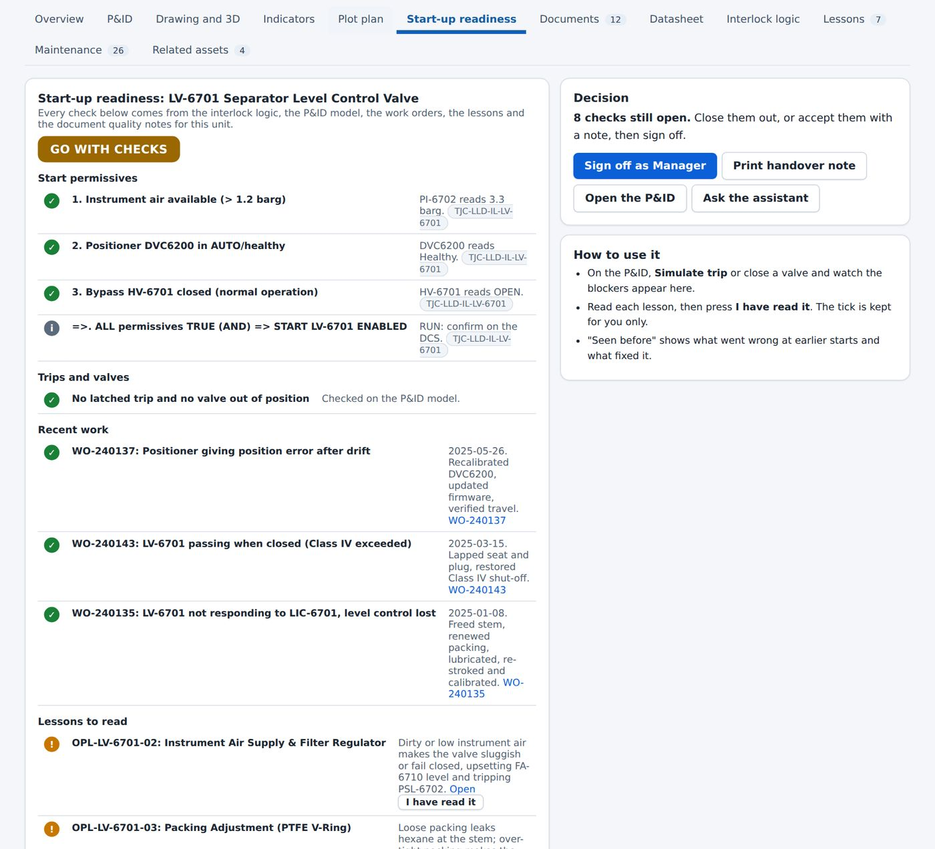
Figure 35. A unit with no open checks.

18 Documents
Used by: Operator, Engineer, Reliability, HSE, Manager
The Documents page lists every controlled document in the knowledge base with its type, set, revision, approval status and effective date.
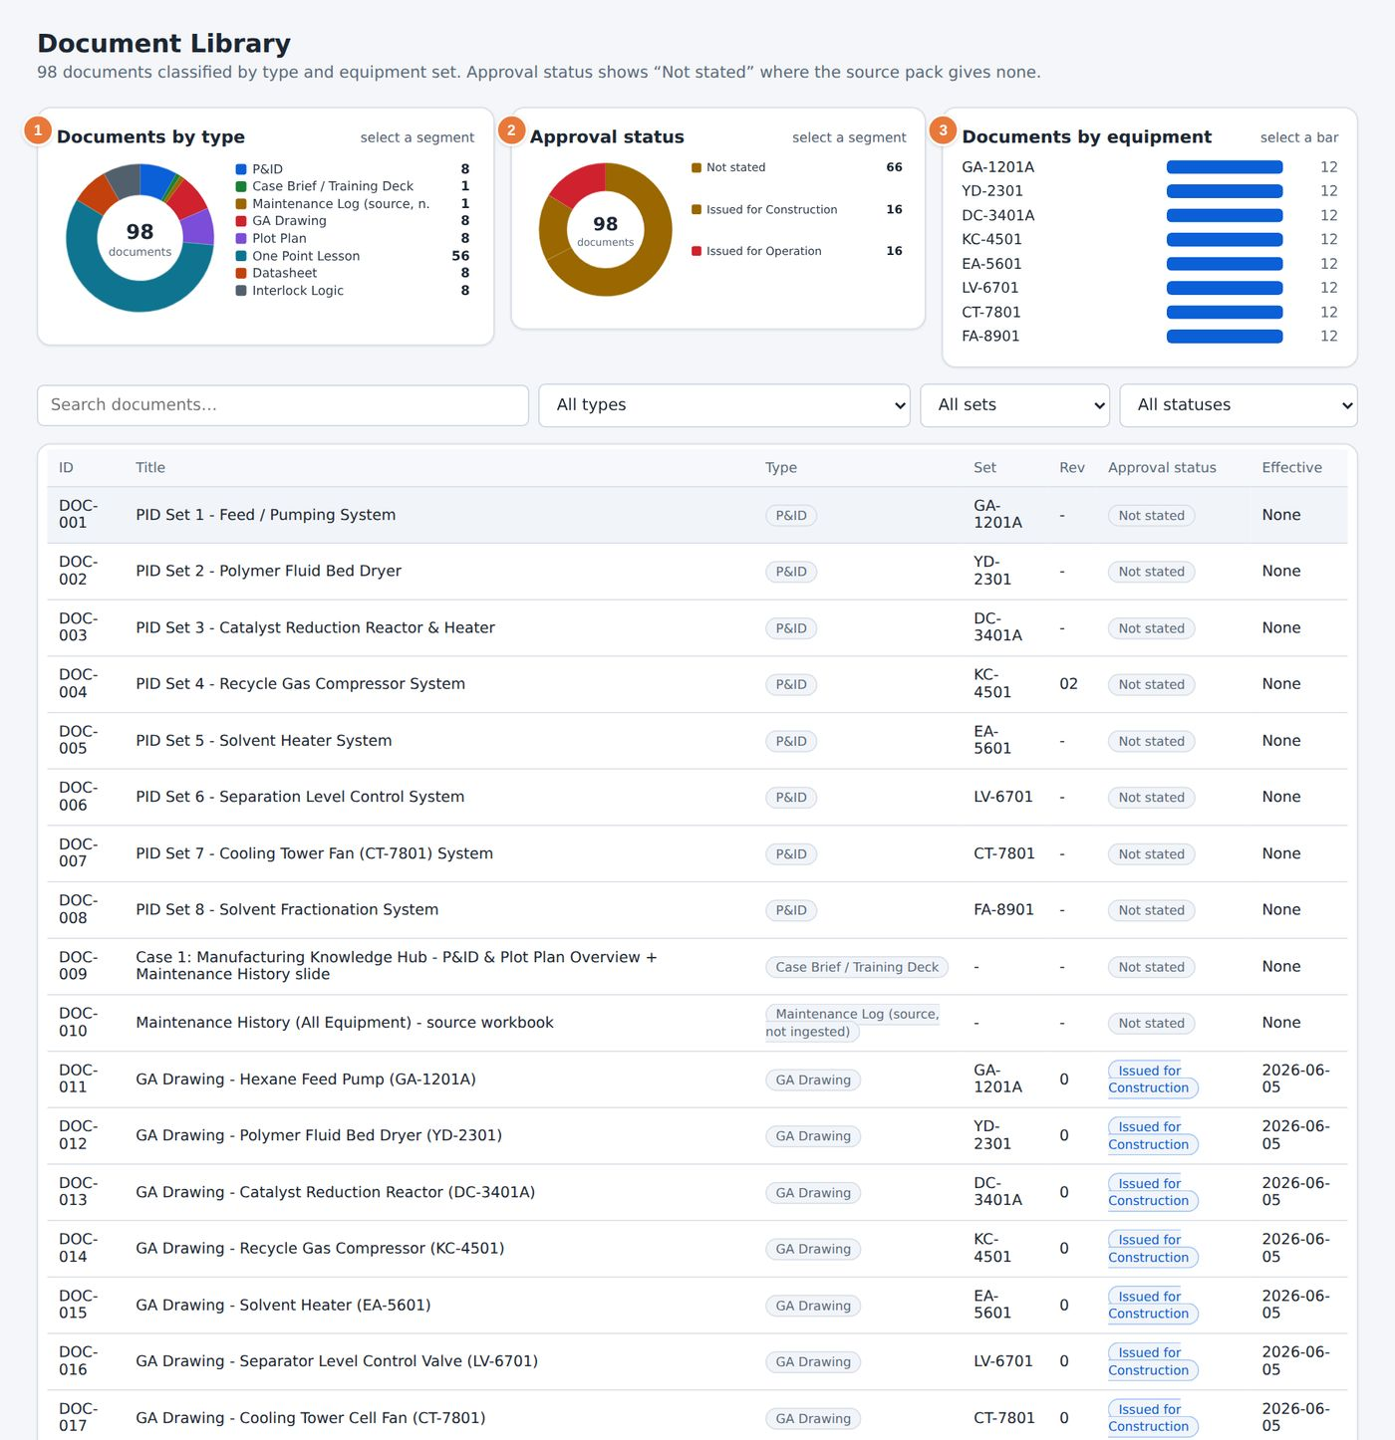
Figure 36. The Documents page.
1 Documents by type. Select a segment to filter the list.  2 Approval status: not stated, issued for construction or issued for operation. | 3 Documents by equipment. Select a bar to filter by set.

18.1 Finding and opening a document
1 Use the three filters to choose a document type, an equipment set and an approval status.
2 Read the table. The columns are the document identifier, the title, the type, the set, the revision, the approval status and the effective date.
3 Select a row to open the document. Its text is shown in sections, with the revision and status at the top.
CAUTION
Check the approval status before you rely on a document. A status of Not stated means that the source did not give one. The platform never treats such a document as approved.

18.2 Document conflicts
When two documents disagree, for example when a valve is labelled both trips OPEN and trips CLOSED, the platform records a conflict. The conflict count on the Dashboard links to the Data Quality page (Chapter 35). The AI Assistant also adds an Open document conflict note when its answer touches a document with a recorded conflict.

19 Maintenance overview
PART 4. MAINTENANCE AND RELIABILITY
Used by: Operator, Engineer, Reliability, HSE, Manager
The Maintenance page turns 211 work orders into charts, tables and simulations. Six views share one filter bar, so a choice made once applies to every view.

19.1 The filter bar
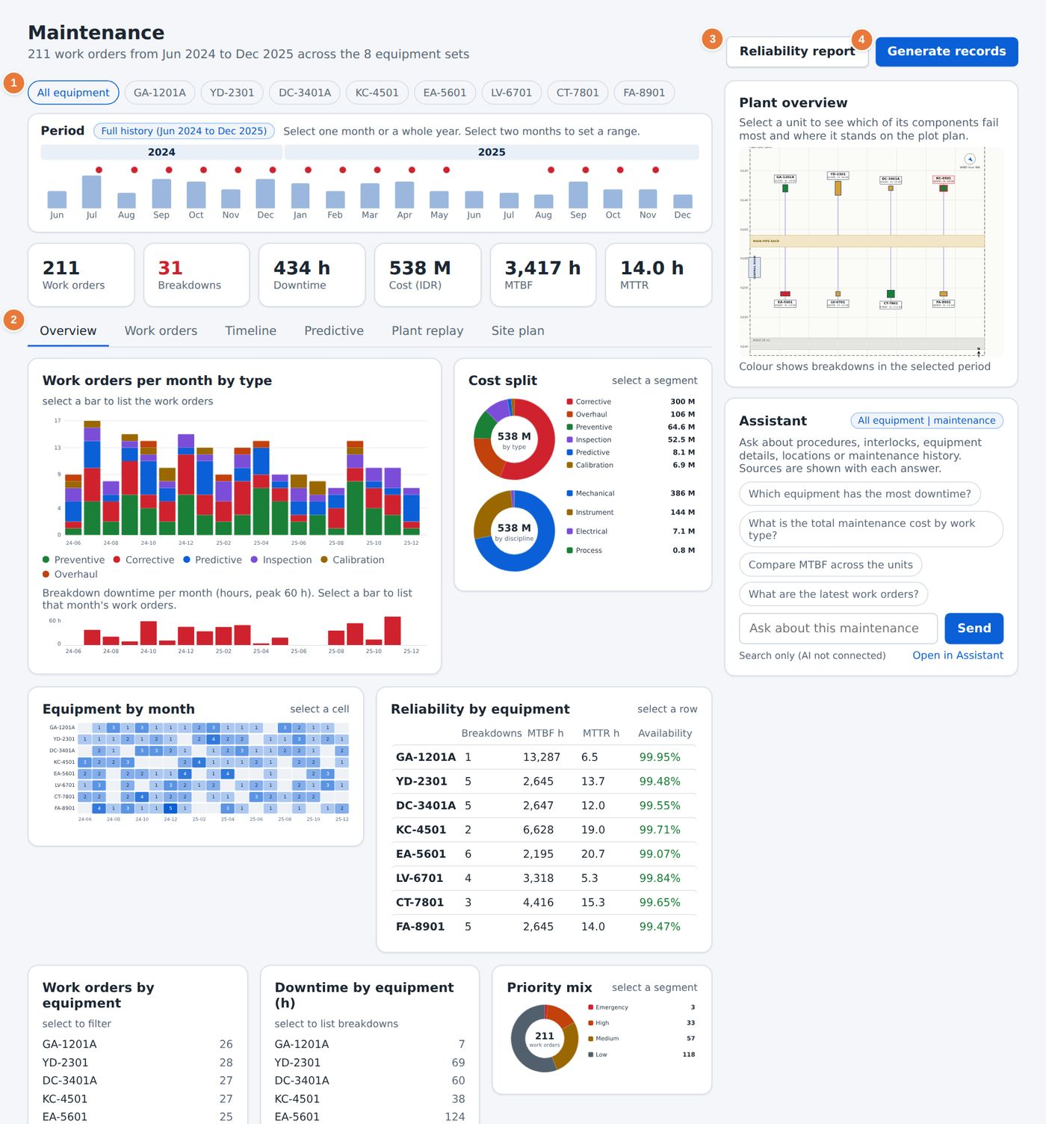
Figure 37. The Maintenance page, Overview view.
1 Equipment filter: All equipment or one set.  2 The six views: Overview, Work orders, Timeline, Predictive, Plant replay and Site plan. | 3 Reliability report opens a printable report for the selection.  4 Generate records adds sample work orders for testing. It is limited to Reliability and Manager.

1 Select All equipment or one equipment tag.
2 In the Period strip, select one month or a whole year. Select a second month to set a range.
3 Read the six tiles under the strip: work orders, breakdowns, downtime, cost, MTBF and MTTR. They follow the selection.
4 Choose a view with the tabs.
TIP
The charts are also filters. Select a bar, a segment, a row or a cell and the work orders behind it open in a list.

19.2 What the Overview shows
Chart | What it tells you | Select to
Work orders per month by type | Workload split into preventive, corrective, predictive, inspection, calibration and overhaul | List the work orders of a month
Breakdown downtime per month | Hours lost in each month | List that month's work orders
Cost split | Cost by work type and by discipline, in IDR | Filter by type or discipline
Equipment by month | A heat map of work volume for each unit and month | List the work orders of a cell
Reliability by equipment | Breakdowns, MTBF, MTTR and availability for each unit | Filter to one unit
Priority mix | Emergency, high and medium work orders | Filter by priority
Most frequent failure modes | Instrument, seal, valve, bearing, vibration and blockage failures | List the work orders of a mode
Planned versus unplanned | Share of planned, condition-based and breakdown work | List each group

NOTE
A data note appears under the tiles when some work orders do not state whether they were breakdowns. Those work orders count as work orders but not as breakdowns, and the note gives the number.

20 Work orders
Used by: Operator, Engineer, Reliability, HSE, Manager
The Work orders view lists every job in the selection, grouped by equipment. Each work order opens in a report that explains what happened, what caused it and what was done.
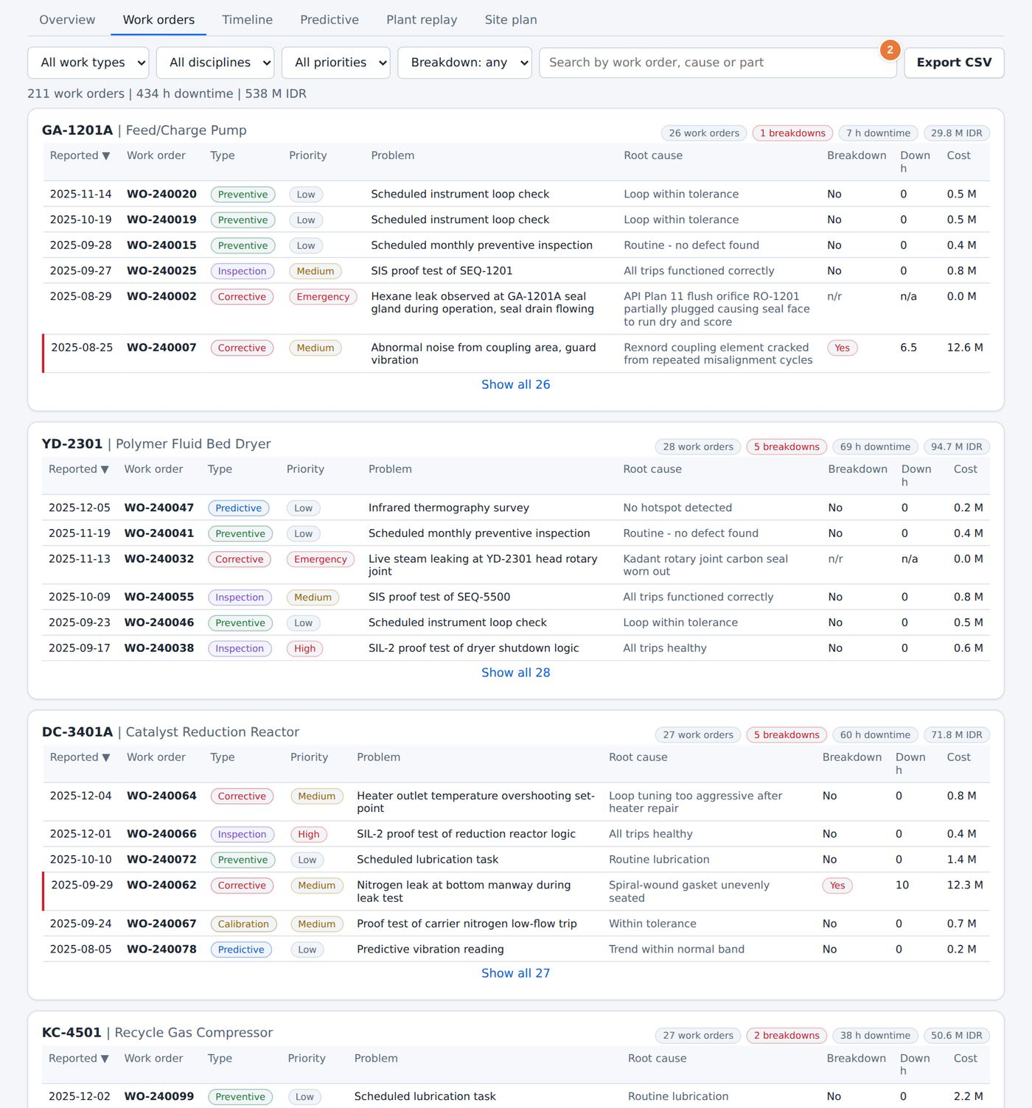
Figure 38. The Work orders view.
2 Export CSV saves the filtered list.

1 Use the four filters to narrow the list. The count and the totals update.
2 Select the column heading Reported to change the sort order.
3 Select a row to open the work order report.
4 Select Show all at the foot of a group to see the rest of its work orders.

20.1 The work order report
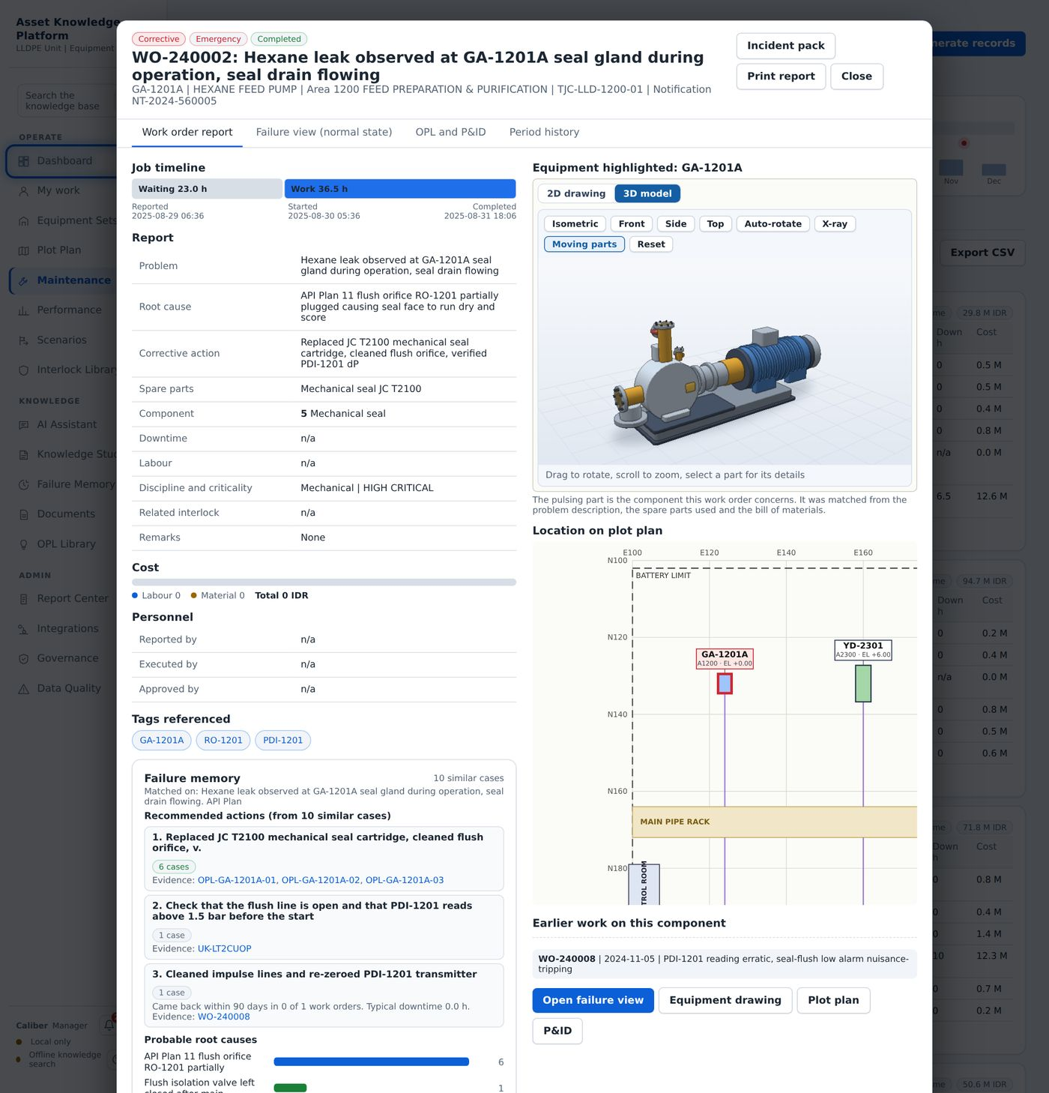
Figure 39. A work order report.

The report has two panes. The left pane gives the problem, the cause, the action taken and the people and parts involved. The right pane shows the equipment drawing with the failed component highlighted and the location of the failure in the unit. Select Incident pack to produce a printable investigation pack, or Print report for a single page.

20.2 The failure view
When the work order was a breakdown, the report also offers a Live view. It replays the event on the P&ID or in 3D, with the failed part flagged and the units affected by the failure shown in turn.
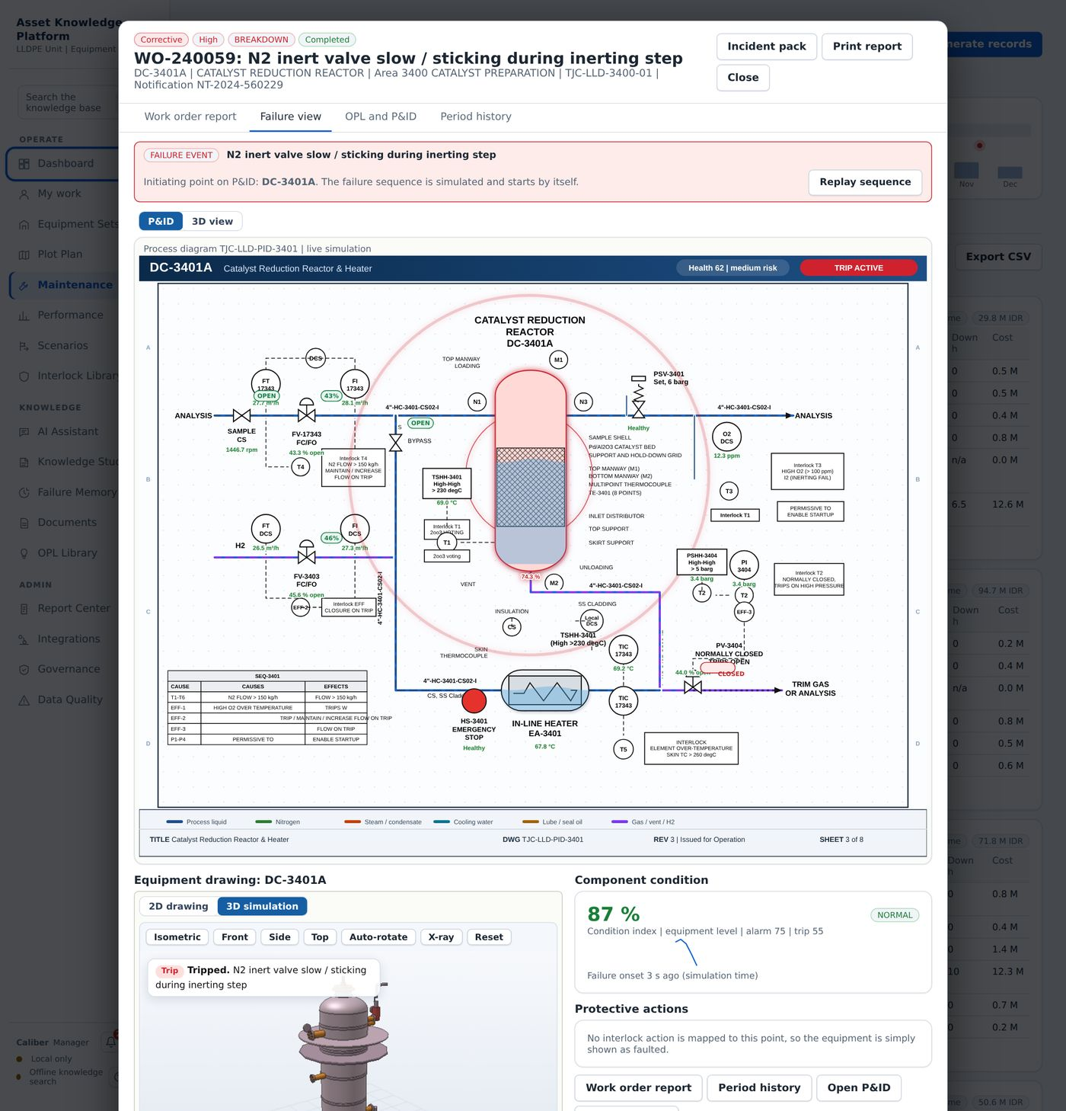
Figure 40. A breakdown work order in the failure view.

21 Timeline
Used by: Operator, Engineer, Reliability, HSE, Manager
The Timeline view shows when work happened. It is the quickest way to see whether jobs cluster, and whether a breakdown follows a particular kind of work.
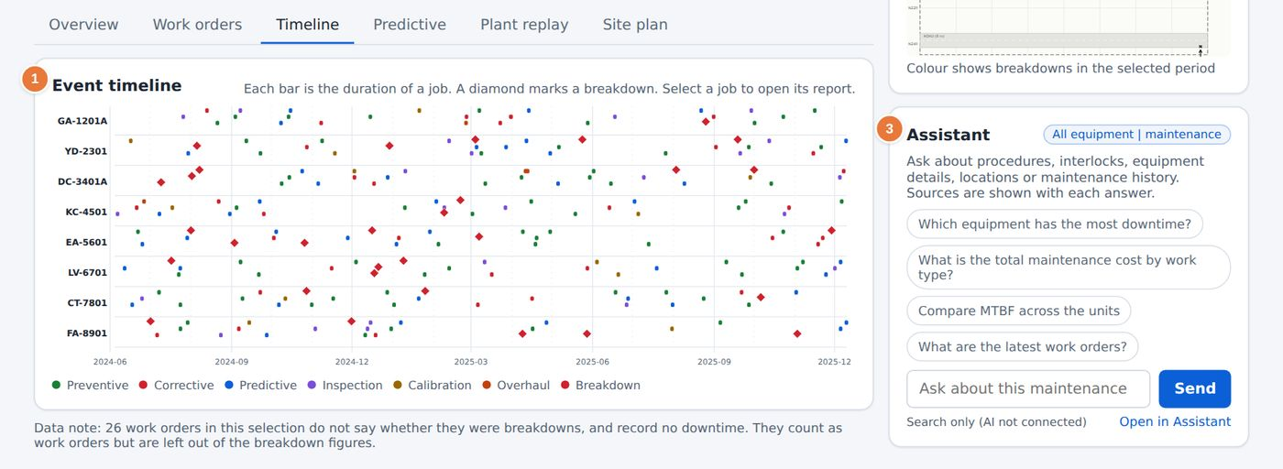
Figure 41. The Timeline view.
1 Each bar is a job. Its length is the duration. A diamond marks a breakdown.  2 Plant overview: a plot plan coloured by the number of breakdowns in the selected period. | 3 A short assistant that answers questions about the selection.

- Select a bar to open the work order report.
- Select a unit on the plant overview to see which of its components fail most and where it stands on the plot plan.
- Use the Period strip to zoom in on a month.

22 Predictive maintenance
Used by: Engineer, Reliability, Manager
The Predictive view estimates which units are most likely to fail, when, and what that would cost. It is a prioritisation tool. It tells you where to look first; it does not predict a particular failure.
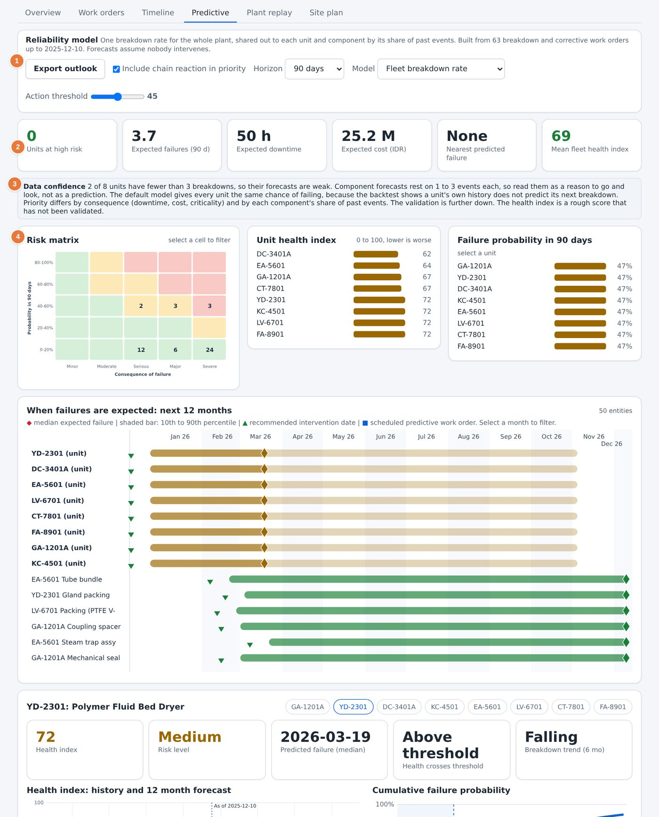
Figure 42. The Predictive view, Failure modes tab.
1 Controls: Export outlook, chain reaction in priority, horizon and model.  2 Six tiles: units at high risk, expected failures, downtime, cost, nearest predicted failure and mean health. | 3 Data confidence states how reliable the numbers are.  4 Risk matrix, health index by unit and failure probability.

22.1 Controls
Control | Use
Horizon | Choose 30, 90, 180 or 365 days. Expected failures, downtime and cost are scaled to the horizon.
Model | Fleet breakdown rate gives every unit the same rate and ranks by consequence. Unit history (experimental) uses each unit's own record.
Include chain reaction in priority | Adds the effect of a failure on connected units to the ranking.
Action threshold | The priority score above which a unit is flagged as high risk.

CAUTION
Read the Data confidence line first. A unit with fewer than three breakdowns has a weak forecast, and component forecasts rest on one to three events. Treat them as a reason to go and look, not as a prediction. The default model uses the same rate for every unit because the backtest shows that a unit's own history does not predict its next breakdown.

22.2 The six tabs
Tab | What it shows
Failure modes | Failure modes ranked by occurrence, severity and how easily they are detected
Reliability measures | MTBF, MTTR and availability for the units in the selection
Next 90 days by mode | The expected window of each failure over the coming period, with the health index and cumulative failure probability of the unit you select
Lessons in play | The one point lessons that apply to the failure modes in view
Lesson use | How often those lessons were opened and used
Combined score | The priority score that combines the history, the consequence and the lessons

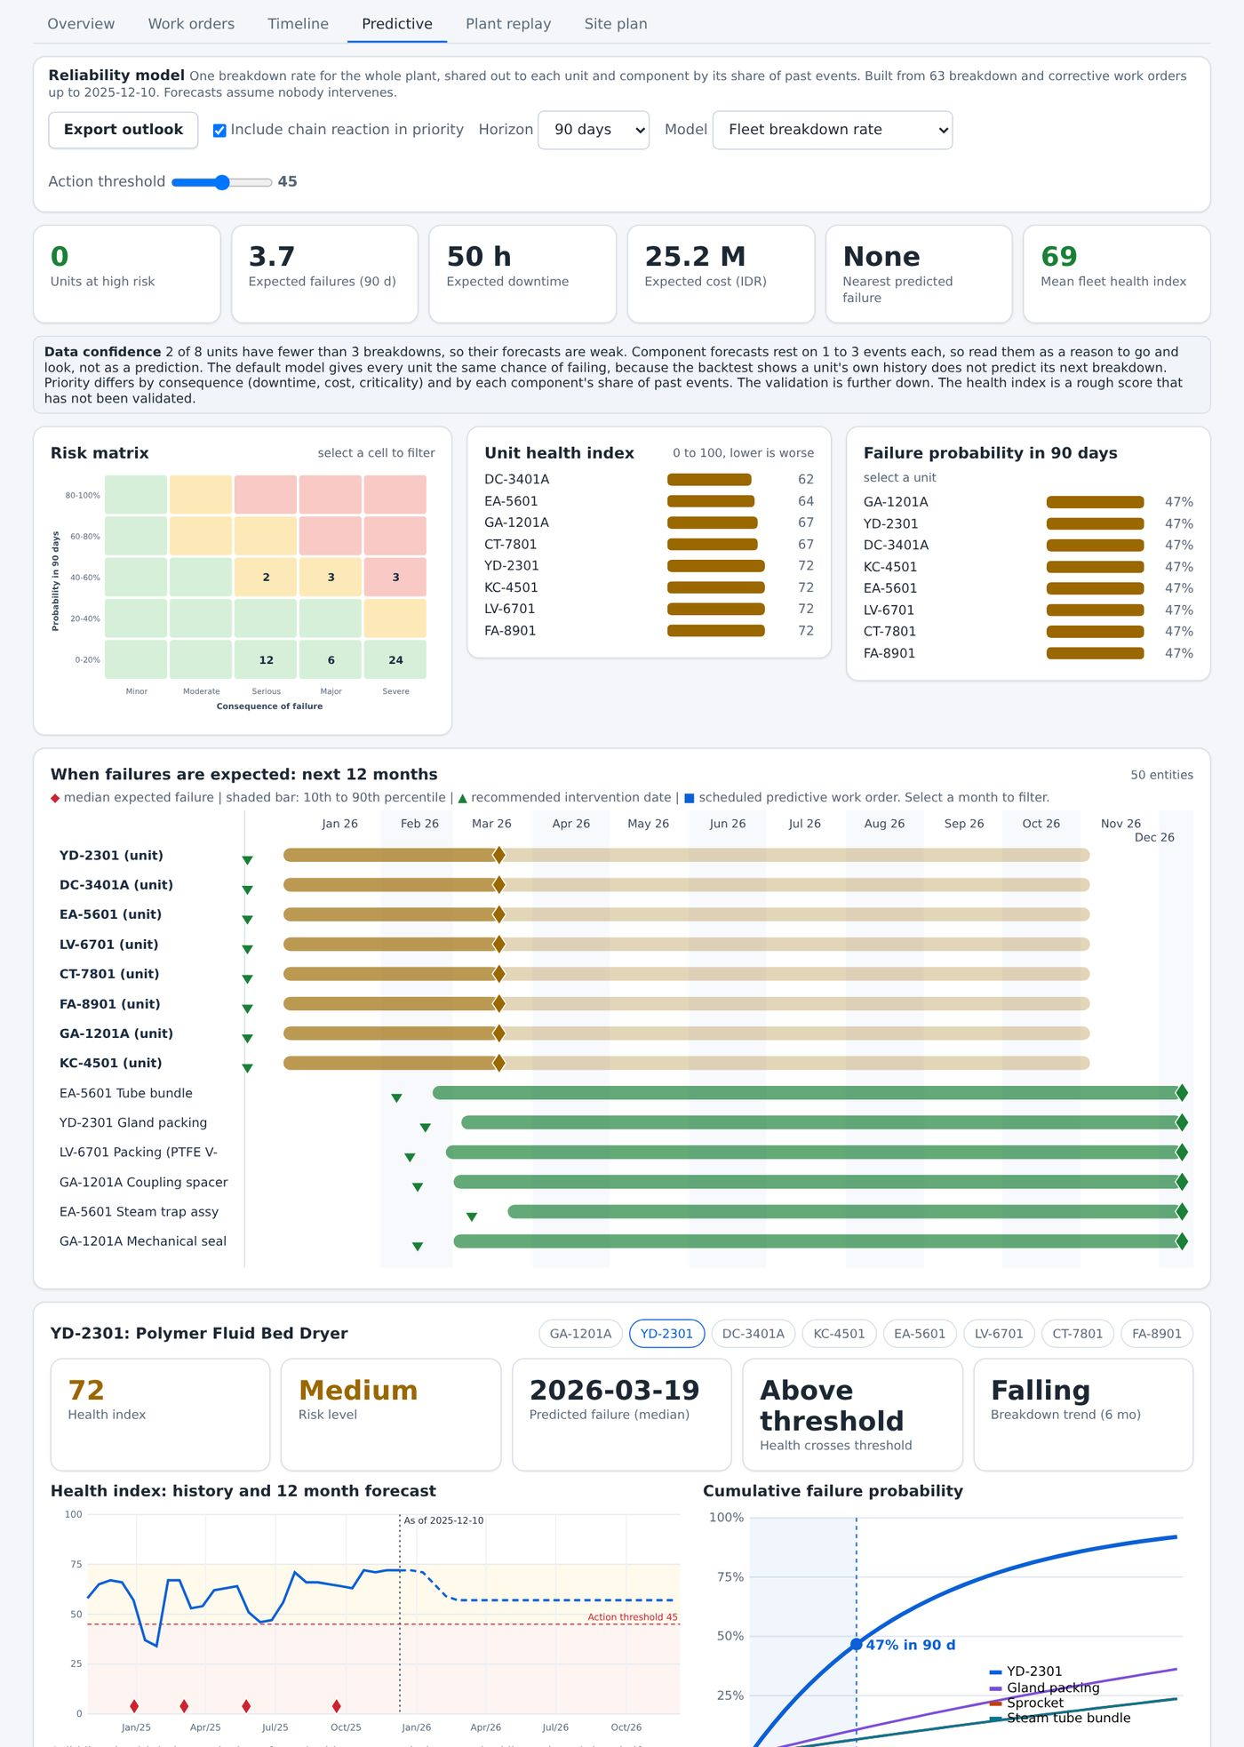
Figure 43. The Next 90 days by mode tab.

23 Reliability analysis
Used by: Engineer, Reliability, Manager
Reliability analysis connects what is failing to why. Use it to rank failure modes, find repeating causes and decide which preventive task earns its place.
Figure 44. The failure modes and the reliability figures of a unit.

1 Open Maintenance, then the Predictive view.
2 Select the Failure modes tab, then the Reliability measures tab.
3 Select a unit in the health index list. The lower part of the page shows its health index, its risk level, the date it crosses the threshold and its cumulative failure probability.
4 Compare the Mean time between failures of units on the Reliability by equipment chart (Chapter 19) or the Equipment compared table (Chapter 27).
5 Open Reliability report to print the Pareto of root causes, the largest downtime events and the trends for the selection.
TIP
A repeated root cause across several units is a stronger signal than a single unit with many breakdowns. Check the Most frequent failure modes chart before you plan a task for one unit.

24 Plant replay
Used by: Operator, Engineer, Reliability, HSE, Manager
Plant replay plays back the maintenance history over the plant. As the date moves forward, units change state, work orders appear and breakdowns are flagged, so a sequence of events becomes easy to follow.
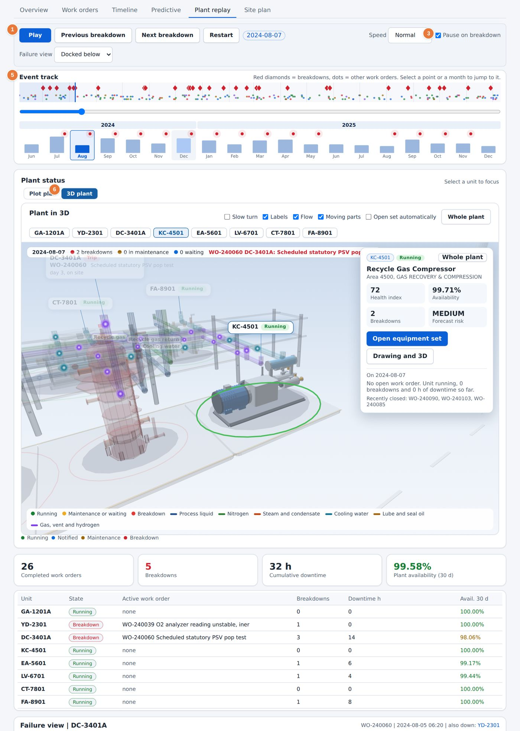
Figure 45. Plant replay with the 3D plant.
1 Playback buttons: Play, Previous breakdown, Next breakdown and Restart.  3 Pause on breakdown stops the replay at each breakdown. | 5 The Event track. Red diamonds are breakdowns and dots are other work orders.  6 Switch between Plot plan and 3D plant.

1 Open Maintenance and select Plant replay.
2 Select 3D plant to see the plant in three dimensions, or Plot plan for the flat map.
3 Tick Pause on breakdown, then select Play. The replay stops at the first breakdown.
4 Read the Plant status panel and the failure view. They show which unit is down and which work order is active.
5 Select Play again to continue, or select a point on the event track to jump to it.
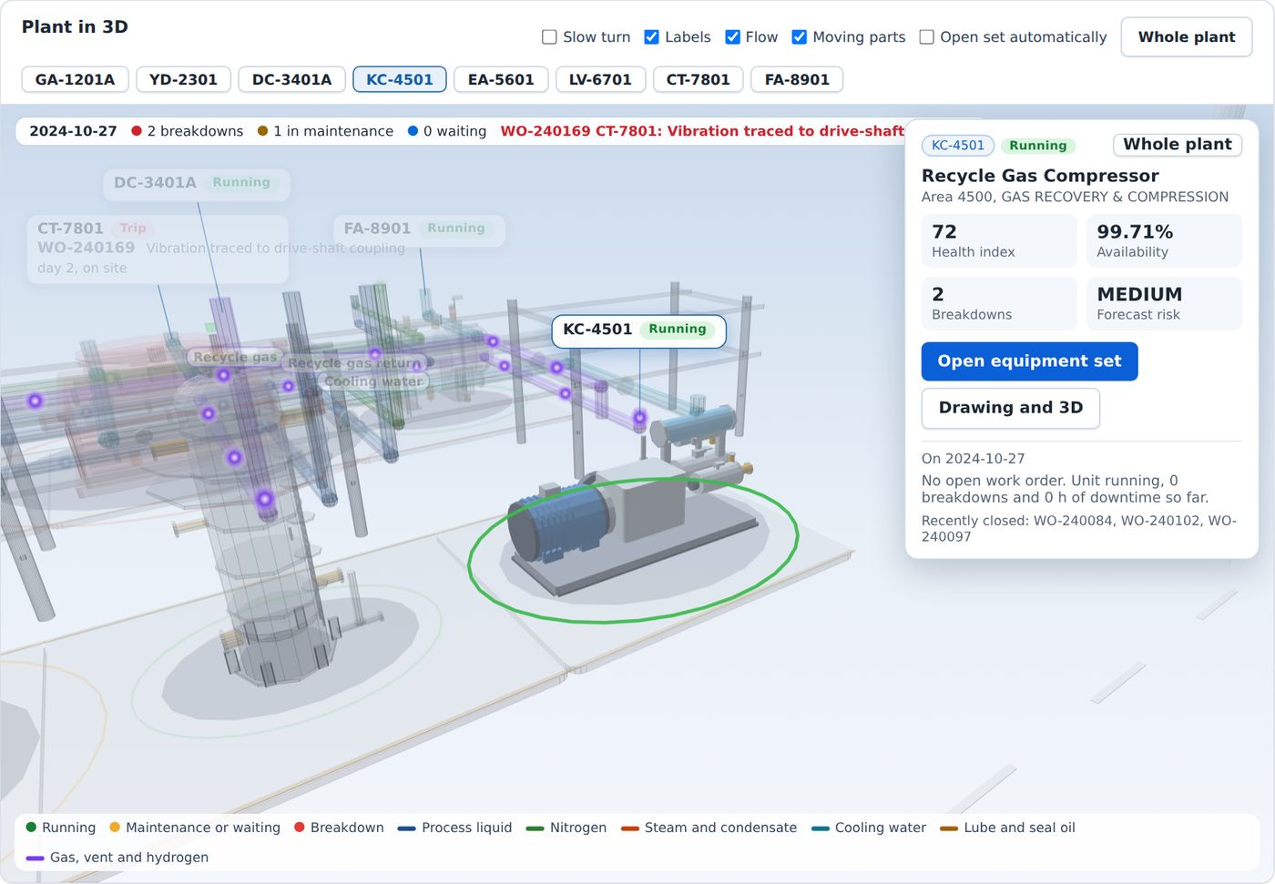
Figure 46. The 3D plant at a breakdown, with the failed unit flagged.

Units are coloured Running, Notified or Breakdown. The table under the plant lists, for each unit, its state, the active work order, its breakdowns, its downtime and its availability over the last 30 days.

25 Site plan
Used by: Engineer, Reliability, HSE, Manager
The Site plan view plans the next 28 days of work. It turns routine intervals and forecast failures into jobs, fills crew days, adds the permits each job normally needs and checks the work next door.
CAUTION
The planner is a planning aid built on the history. It is not a permit system.

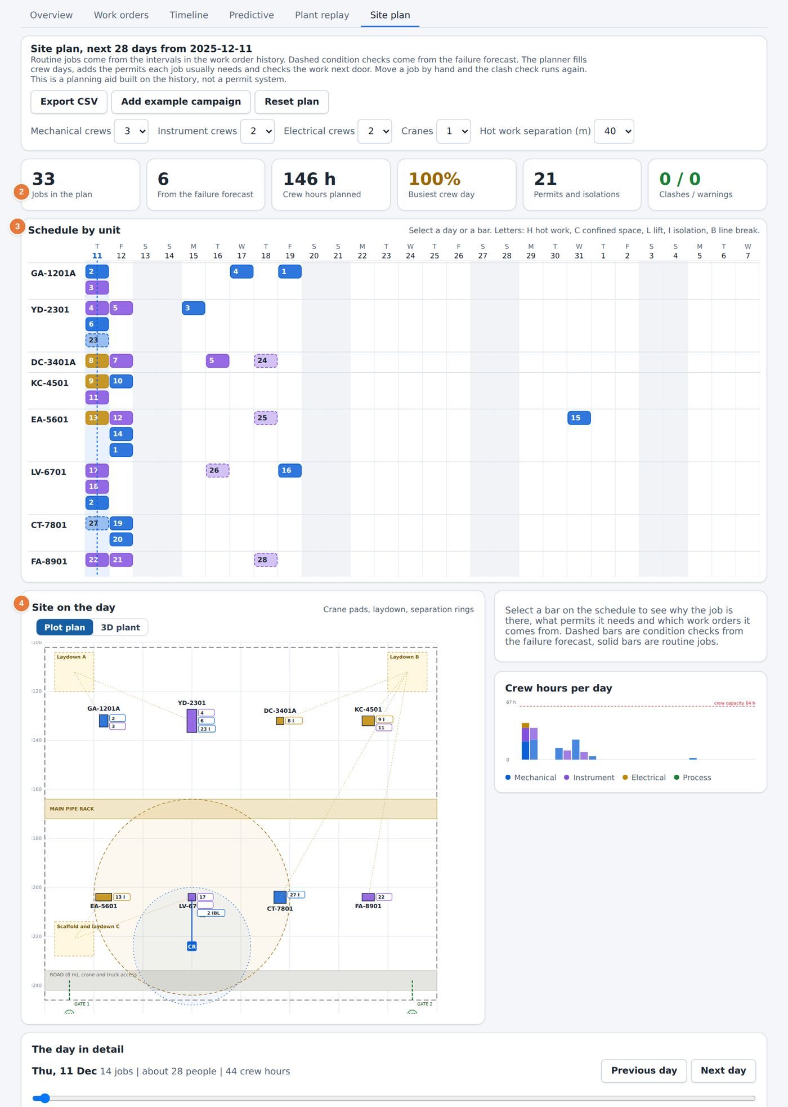
Figure 47. The Site plan view.
2 Summary tiles: jobs, jobs from the forecast, crew hours, busiest day and permits.  3 Schedule by unit. Letters mark the permits: H hot work, C confined space, L lift, I isolation, B line break. | 4 Site on the day with crane pads, laydown areas and separation rings.

1 Select Add example campaign to load a sample campaign, or leave the plan as built from the history.
2 Set the number of crews and cranes, and the hot work separation in metres.
3 Read the Clashes / warnings tile. A clash means that two jobs conflict on crew, crane or separation.
4 Select a bar in the schedule to see why the job is there and which permits it needs. Move it to another day and the clash check runs again.
5 Select Export CSV to save the plan, or Reset plan to start again.

26 Failure Memory
Used by: Operator, Engineer, Reliability, HSE, Manager
Failure Memory finds earlier cases that look like the one you have now. The search covers work orders, one point lesson troubleshooting cases and approved knowledge items.
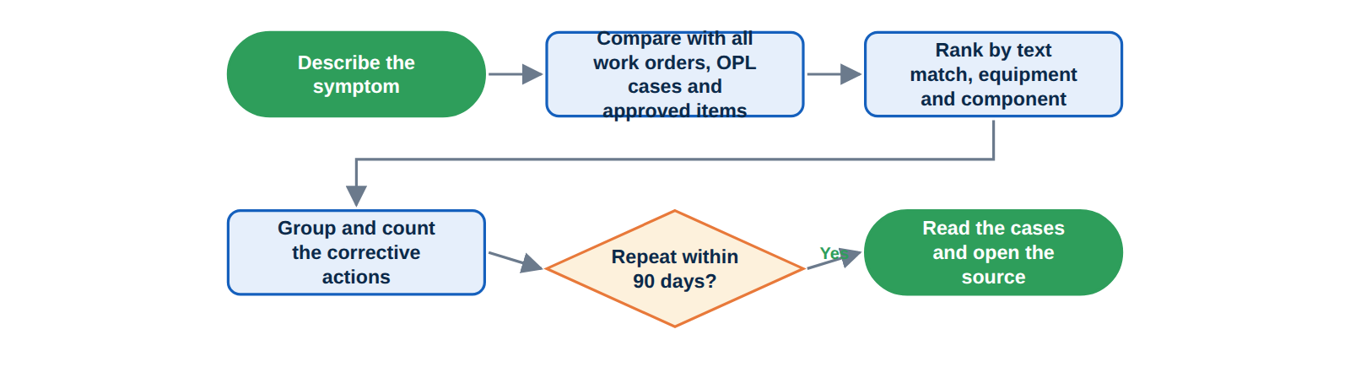
Figure 48. How Failure Memory finds similar failures.

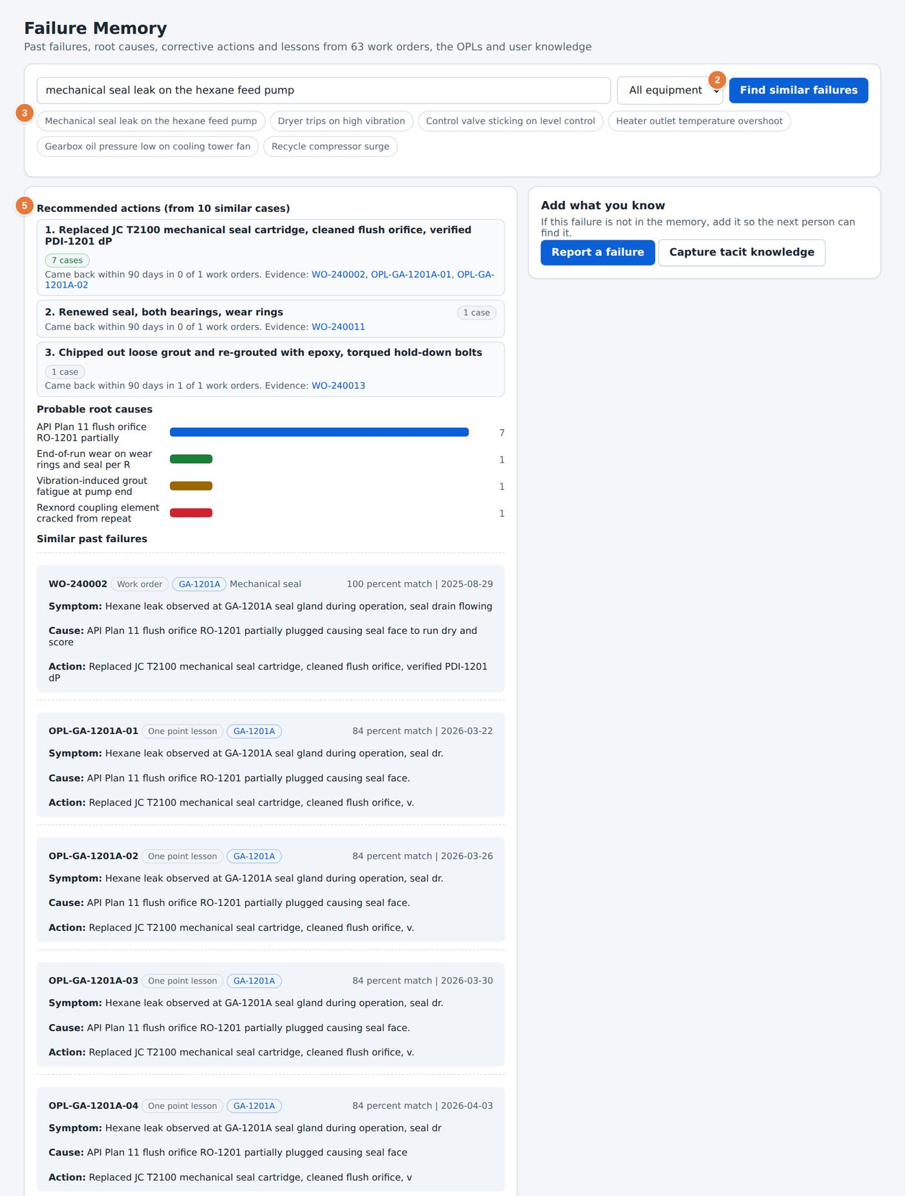
Figure 49. Failure Memory with the results for a seal leak.
2 Find similar failures runs the search.  3 Example symptoms. Select one to fill the box. | 5 Recommended actions, the likely causes and the similar cases that support them.

1 Select an equipment set, or leave All equipment.
2 Type the symptom in your own words, or select one of the example symptoms.
3 Select Find similar failures.
4 Read the Recommended actions. Each action shows how often it was used and whether the same failure was repeated within 90 days.
5 Read the Probable root causes and the Similar past failures. Select a case to open its work order or its lesson.
6 If your case is new, select Report a failure or Capture tech knowledge to record it (Chapter 34).

27 Performance
Used by: Operator, Engineer, Reliability, HSE, Manager
The Performance page shows the key indicators of the whole plant and of each equipment set, with targets, so that you can see at a glance what is on target and what is not.
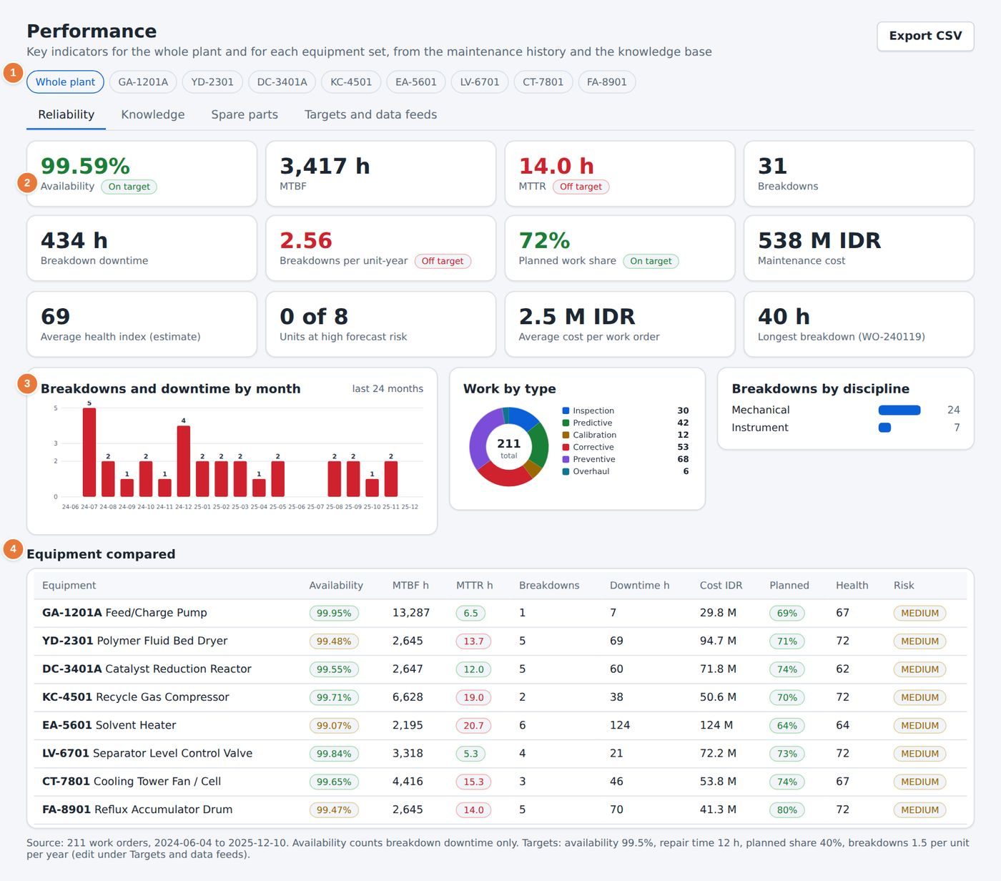
Figure 50. The Performance page, Reliability tab.
1 Equipment filter: Whole plant or one set. Export CSV saves the figures.  2 Indicator tiles. A tag shows whether each is On target or Off target. | 3 Breakdowns and downtime by month, and work by type.  4 Equipment compared: all units side by side, with availability, MTBF, MTTR, cost, planned share, health and risk.

27.1 Reliability tab
The tiles show availability, MTBF, MTTR, breakdowns, breakdown downtime, breakdowns per unit-year, the planned work share, maintenance cost, the average health index, the number of units at high forecast risk, the average cost per work order and the longest breakdown.

27.2 Knowledge tab
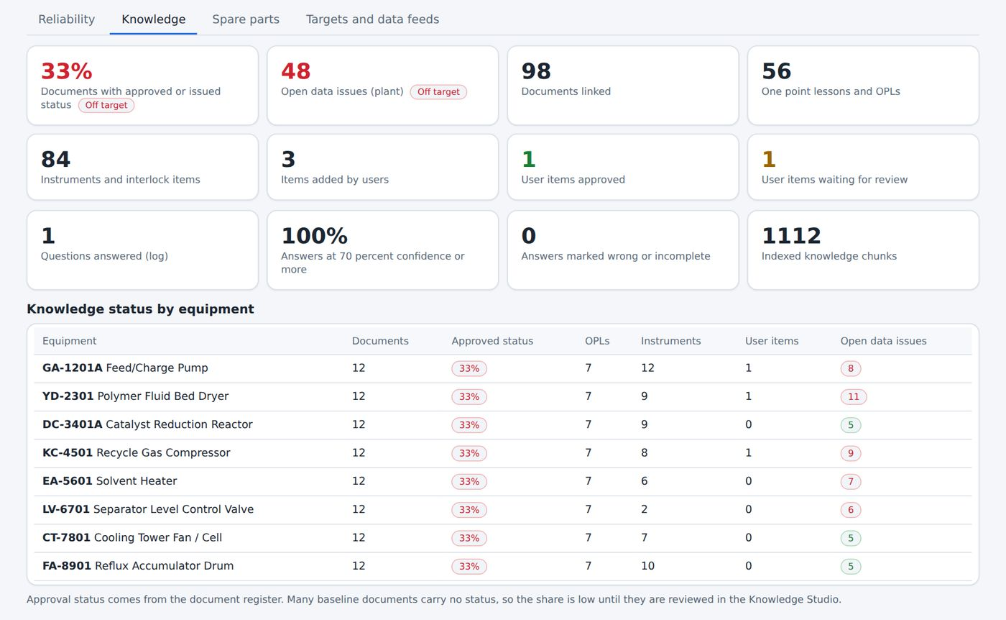
Figure 51. The Knowledge tab.

This tab measures the knowledge base: the share of documents with an approval status, the open data issues, the number of documents, the lessons and the user items. The table Knowledge base status by equipment shows, for each set, how many documents are approved and how many lessons and issues it has.

27.3 Spare parts tab
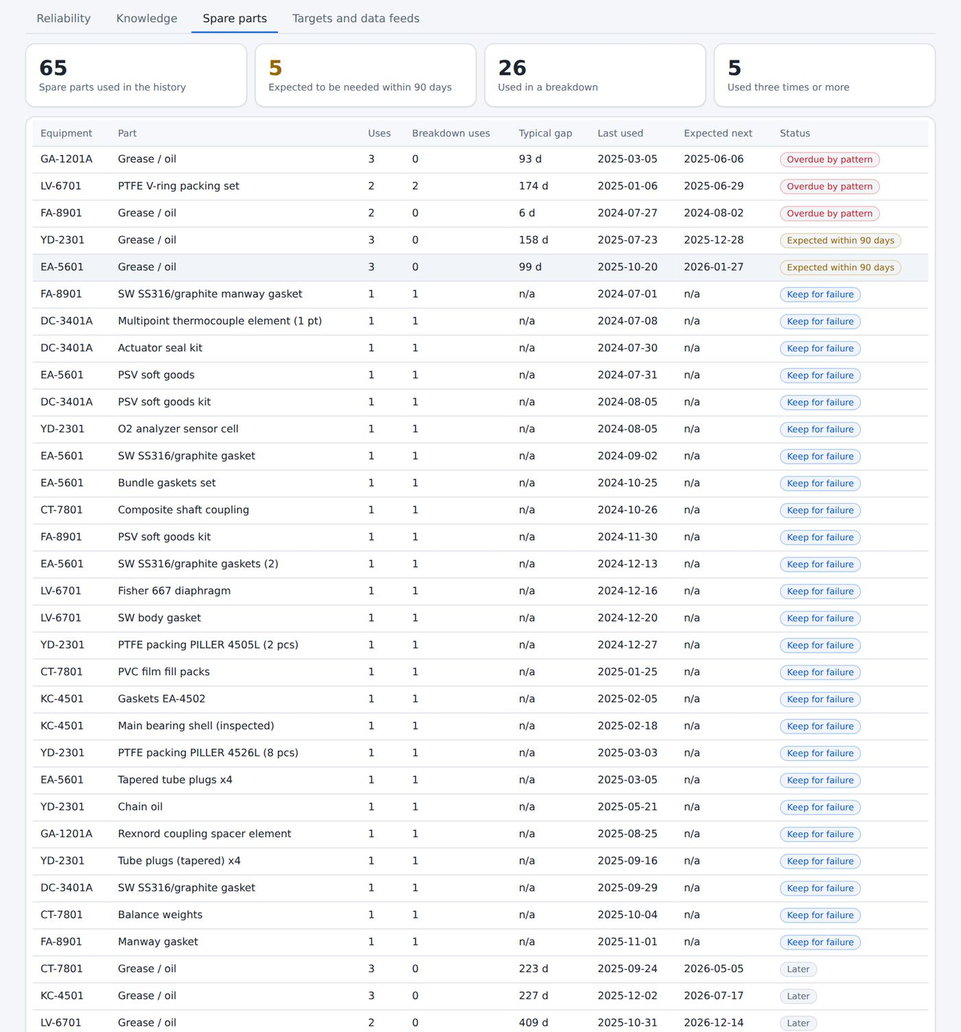
Figure 52. The Spare parts tab.

The Spare parts tab counts the parts used in the history, the parts expected to be needed within 90 days, the parts used in a breakdown and the parts used three times or more. A table lists each part with its use. Use it to decide which spares justify holding stock.

27.4 Targets and data feeds tab
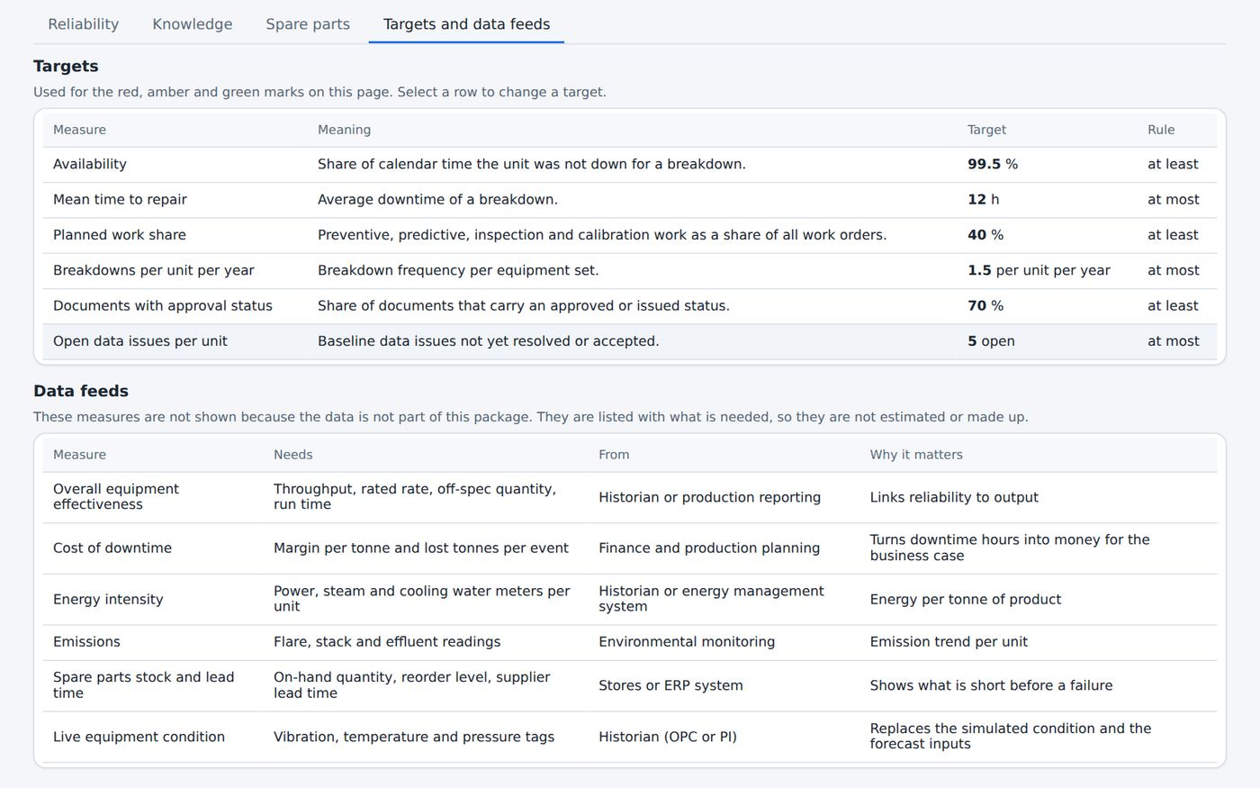
Figure 53. The Targets and data feeds tab.

The Targets table shows each measure, its meaning and the target, such as the share of calendar time that a unit is ready to run. The Data feeds table lists the indicators that need live data, such as overall equipment effectiveness, energy use and throughput, with the system they come from and the reason they matter. These indicators are shown as not available until the feed is connected.

28 One Point Lesson Library
PART 5. SAFETY, LESSONS AND SCENARIOS
Used by: Operator, Engineer, Reliability, HSE, Manager
A one point lesson (OPL) is a short sheet that teaches one thing about one machine. The library holds 56 sheets, with 83 scenarios that let you practise the lesson on the P&ID or in 3D.
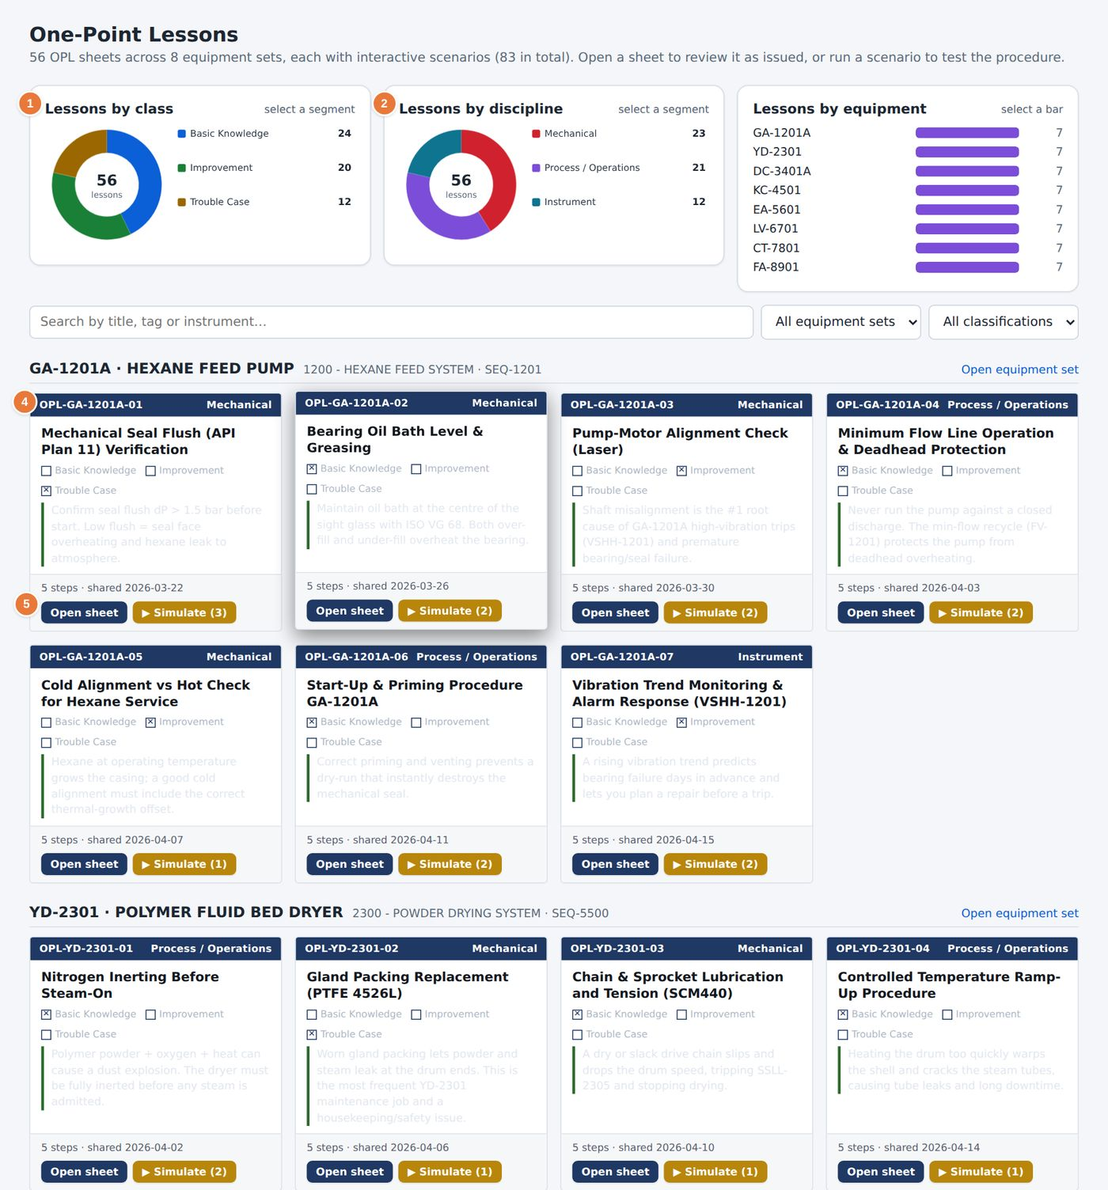
Figure 54. The One Point Lesson Library.
1 Lessons by class: Basic Knowledge, Improvement and Trouble Case.  2 Lessons by discipline and Lessons by equipment. Select a segment or a bar to filter. | 4 A lesson card with its number, title, key message, step count and date.  5 Open sheet and Simulate for each lesson.

1 Filter by equipment set or classification, or select a segment on the charts.
2 Read the card. The first line of text states the lesson in one sentence.
3 Select Open sheet to read the full lesson.
4 Select Simulate to practise it. The number in brackets is the number of scenarios for the lesson.

28.1 The lesson sheet
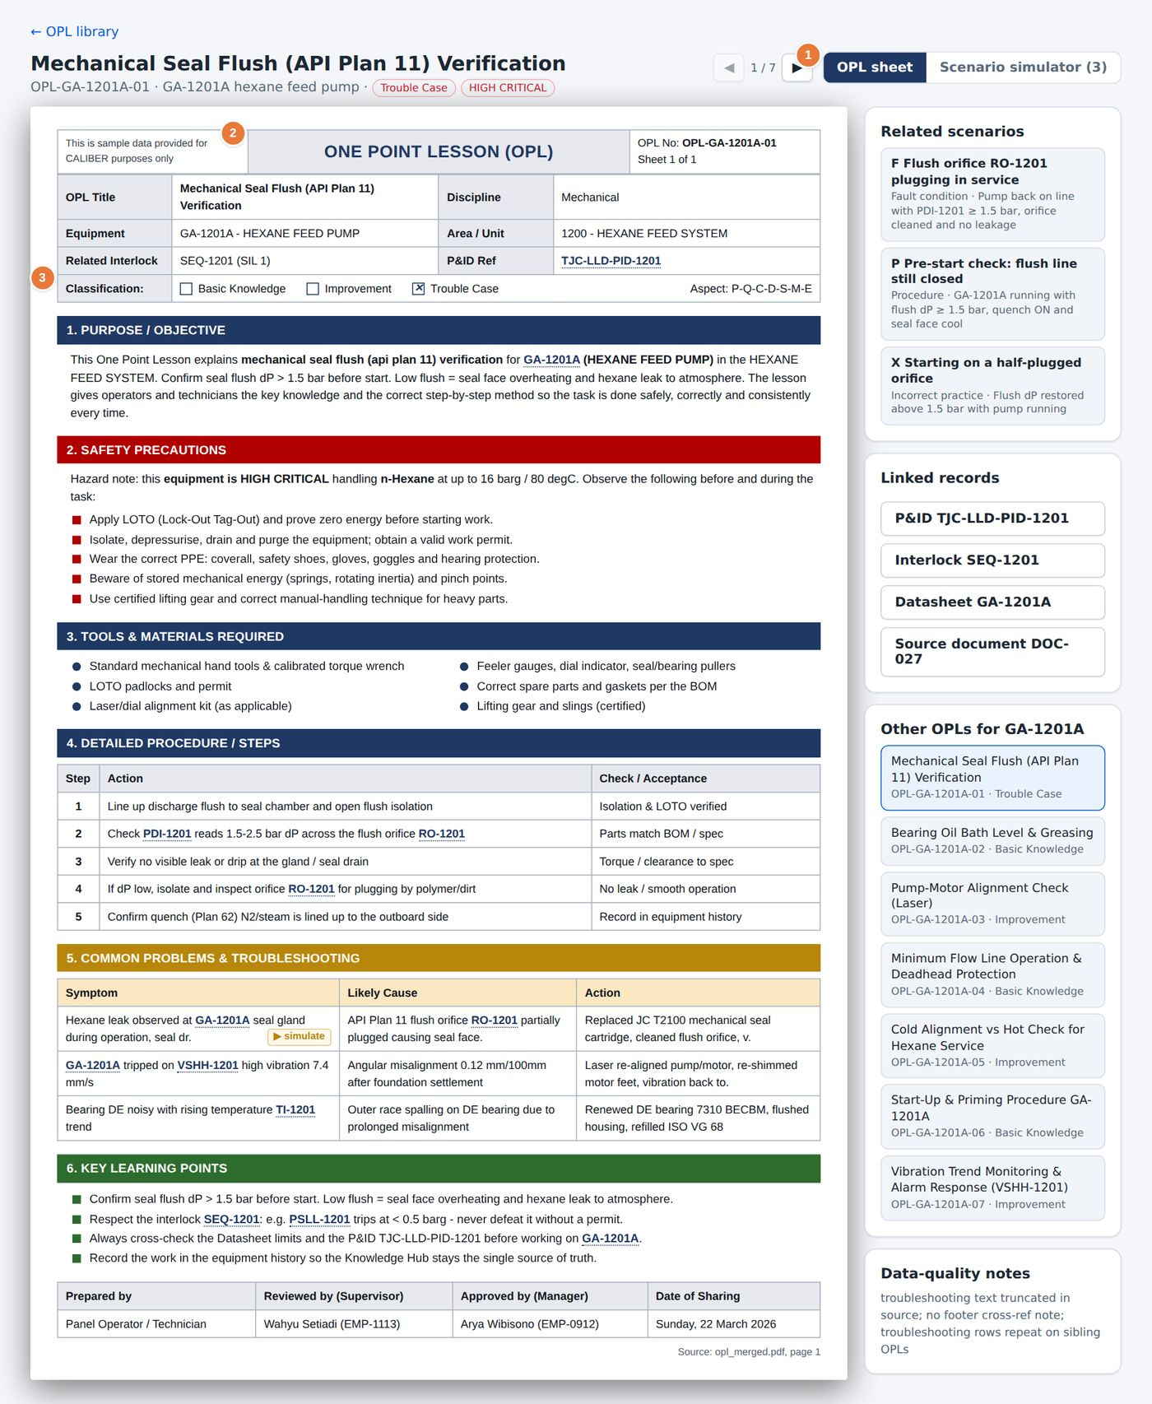
Figure 55. An OPL sheet in the plant's standard layout.
1 Switch between OPL sheet and Scenario simulator.  2 Header: number, title, discipline, equipment, area, related interlock and P&ID reference. | 3 The classification and the aspect code.

Each sheet follows the same order: purpose, safety precautions, the steps, the quantitative values to check and a troubleshooting table. The hazard note on the sheet states the fluid, pressure and temperature of the machine, and the precautions that apply before the work starts.

29 OPL scenario simulator
Used by: Operator, Engineer, Reliability, HSE, Manager
The scenario simulator lets you practise a lesson without risk. You see the P&ID or the 3D model of the machine, you act in the field and at the panel, and the simulation shows what follows.
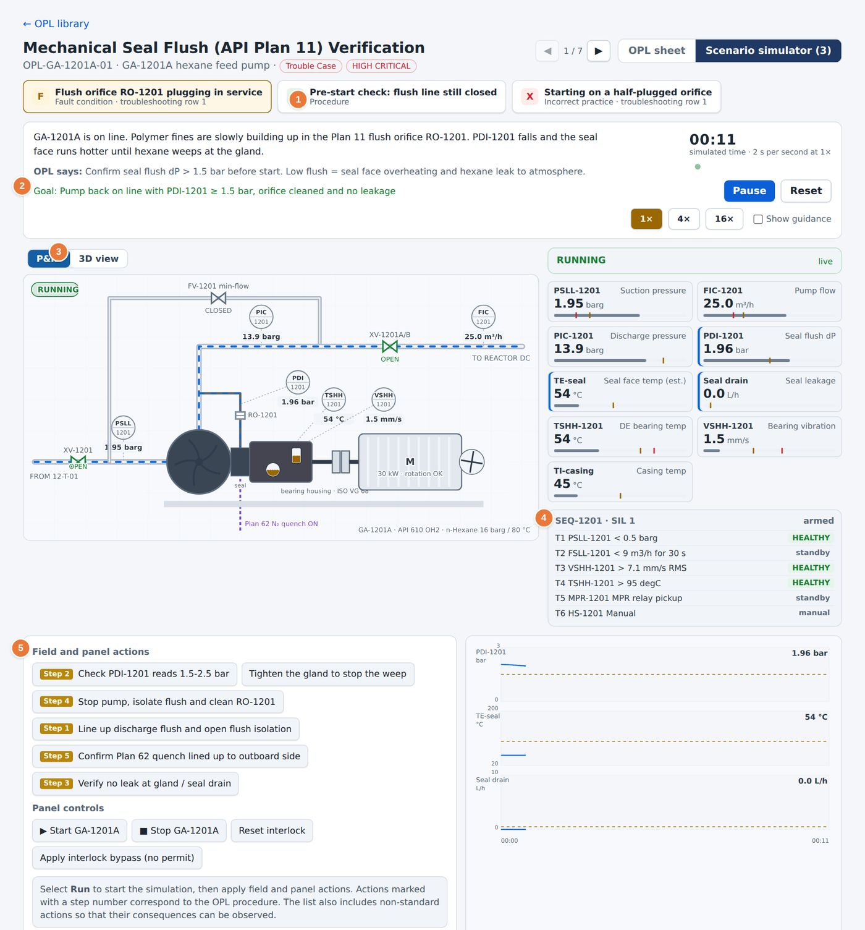
Figure 56. A scenario on the P&ID.
1 The scenarios of the lesson. Each has a name and a type: fault condition, incorrect practice or pre-start check.  2 The story and the goal of the scenario.  3 Reset, Show guidance, and the P&ID and 3D view switch. | 4 Readings and the state of the interlock.  5 Field and panel actions and the Panel controls.

1 Open a lesson and select Scenario simulator, or select Simulate on the lesson card.
2 Choose a scenario in the list. Read the story and the goal.
3 Select Run to start the simulation.
4 Select the field and panel actions in the order you think correct. Actions marked with a step number match a step of the lesson.
5 Select Show guidance if you need a hint. Select Reset to start the scenario again.

29.1 Switching to 3D
Select 3D view to see the same scenario on the 3D model. Rotate and zoom as in Chapter 14. The animation is the same as on the P&ID: flows stop, parts move and alarms change colour as the simulation runs.
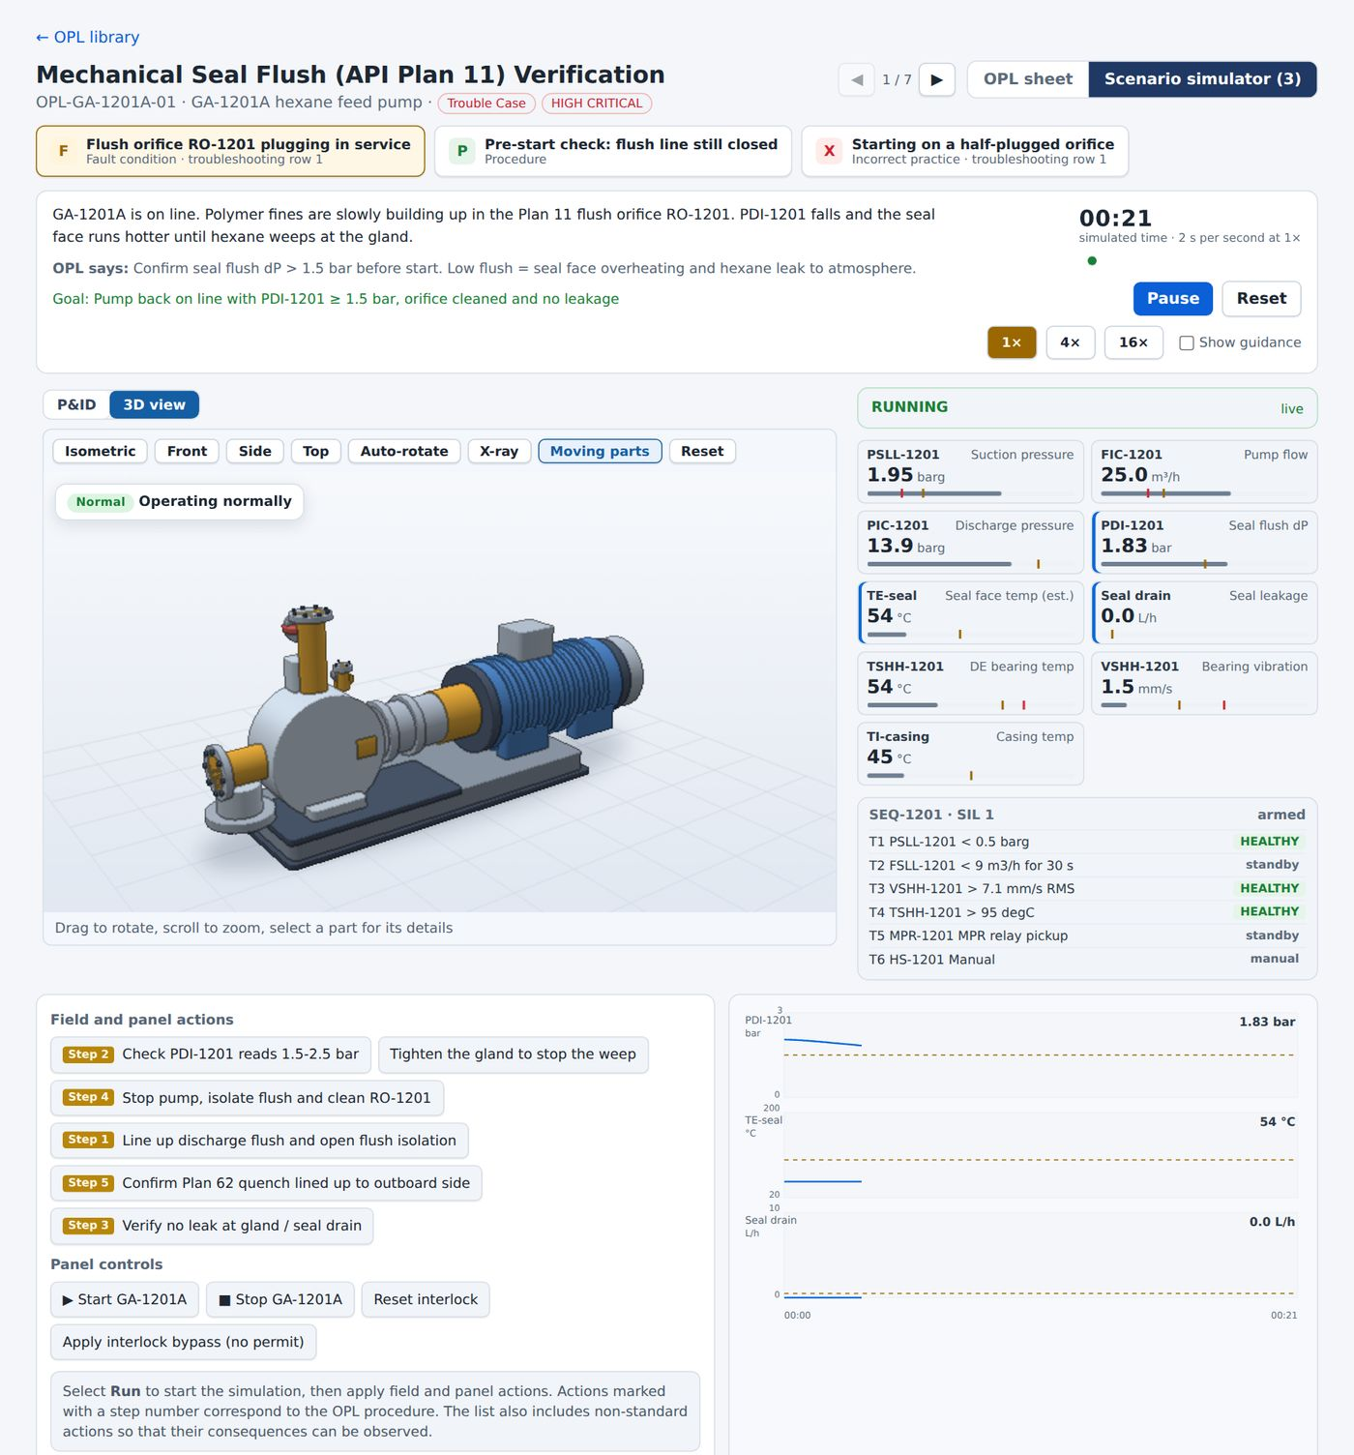
Figure 57. The same scenario in 3D.

CAUTION
The simulator uses simulated values. It is a training aid and does not act on the plant. Panel controls such as Apply interlock bypass (no permit) exist to show the consequence of a wrong action.

30 Scenarios and chain reaction
Used by: Operator, Engineer, Reliability, HSE, Manager
The Scenarios page shows how a failure on one unit spreads to the others. It also replays an OPL case or a work order on the P&ID. A third tab records the assumptions behind the numbers.

30.1 Plant chain reaction
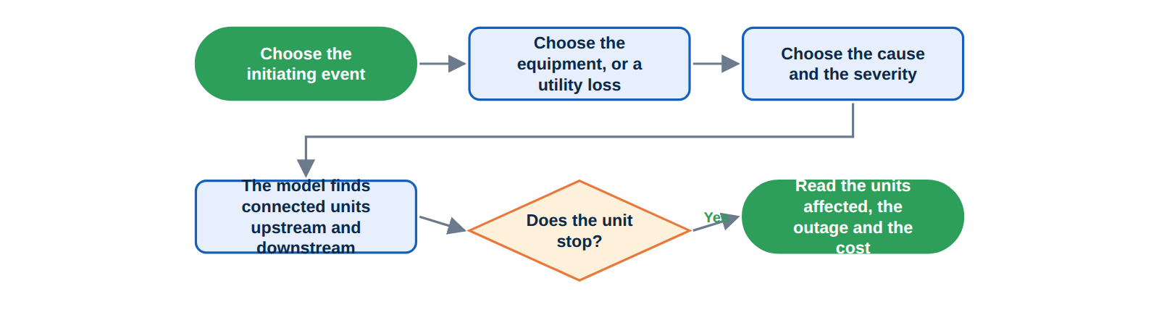
Figure 58. How the chain reaction is set up and read.

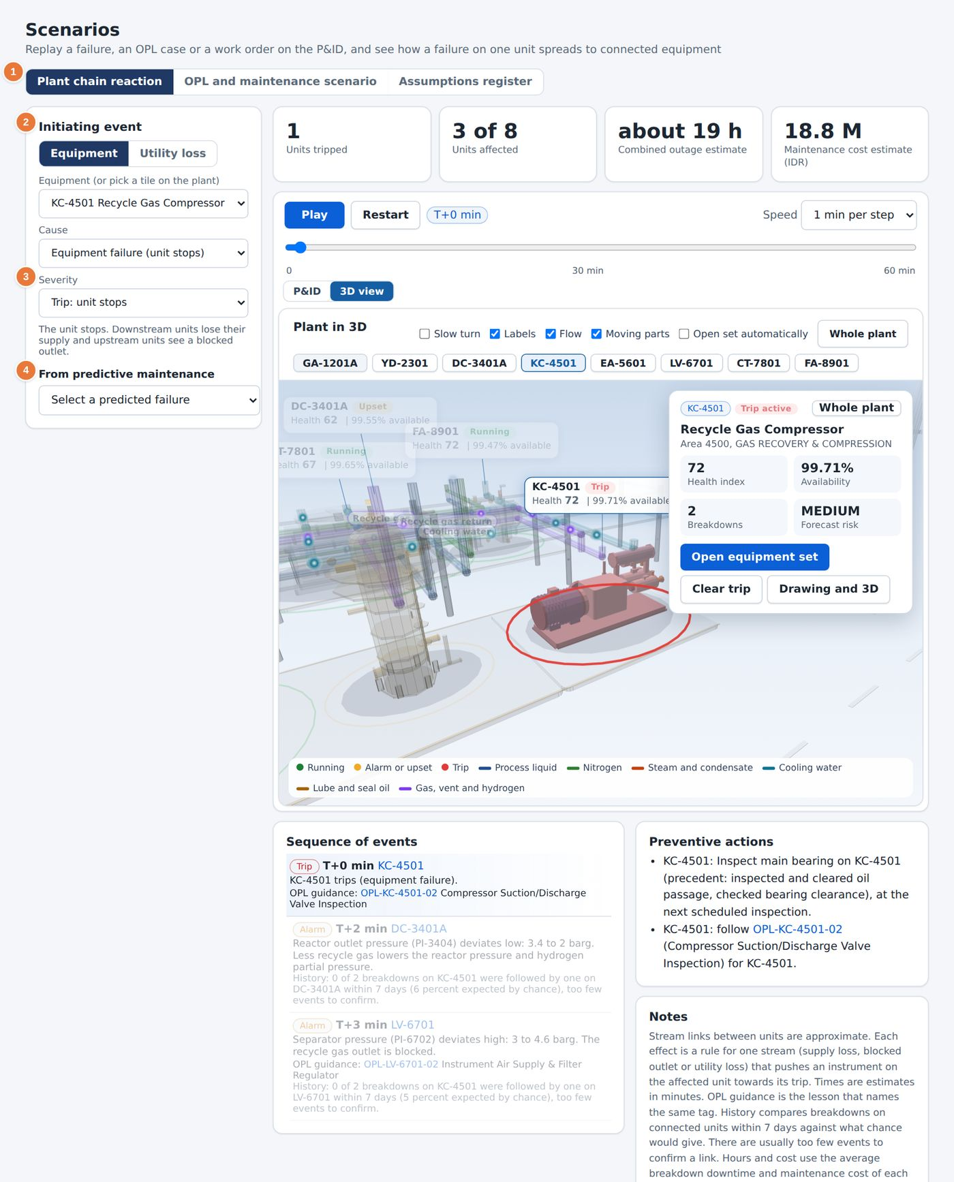
Figure 59. The Plant chain reaction tab.
1 The three tabs of the page.  2 Initiating event: equipment or utility loss. | 3 Cause and Severity: a unit trip or degraded operation.  4 From predictive maintenance: choose one of the forecast failures.

1 Choose Equipment or Utility loss as the initiating event.
2 Choose the equipment set, or select a unit tile on the plant.
3 Choose a cause. For the compressor, the list shows the trips T1 to T6 with their set points.
4 Choose the severity: Trip: unit stops or Degraded: about half output, no trip.
5 Select Play to watch the failure spread. Use Speed to set the step from one minute to sixty minutes.
6 Read the result tiles: units tripped, units affected, the combined outage estimate and the maintenance cost estimate.
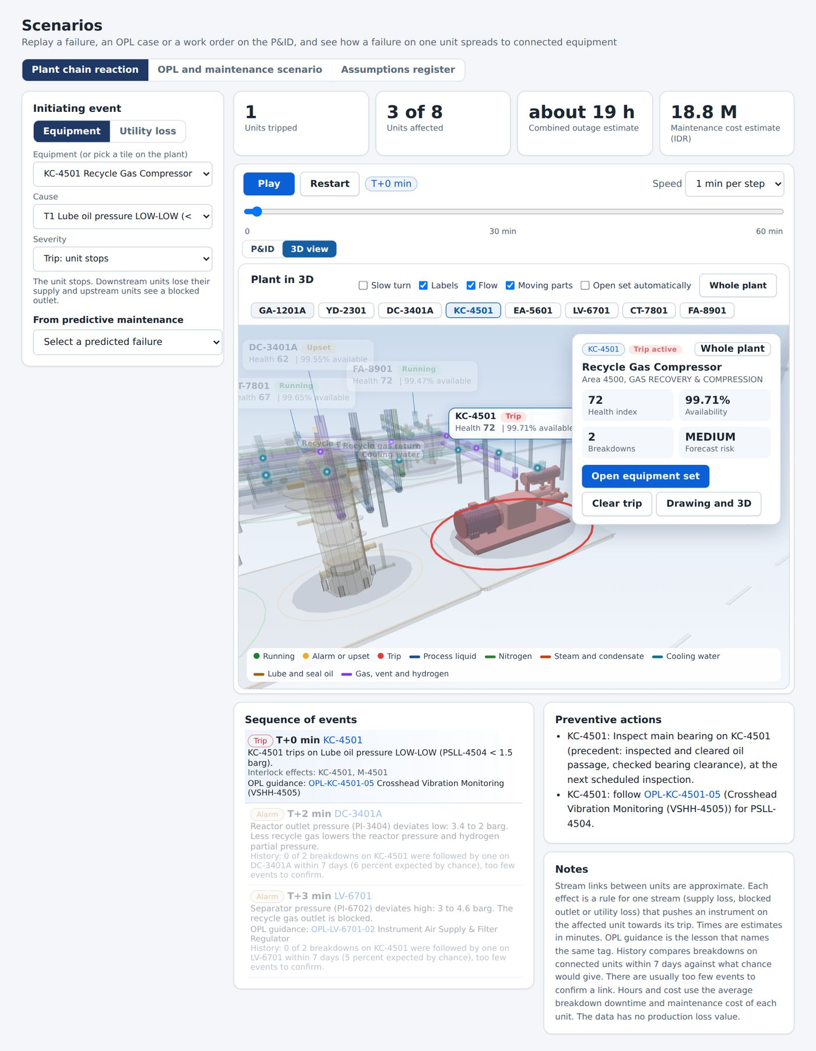
Figure 60. A chain reaction in progress.

30.2 OPL and maintenance scenario
This tab replays one case on the P&ID: a lesson scenario or a work order. The symptom, the cause and the action steps are shown beside the diagram, and the tags involved are highlighted.
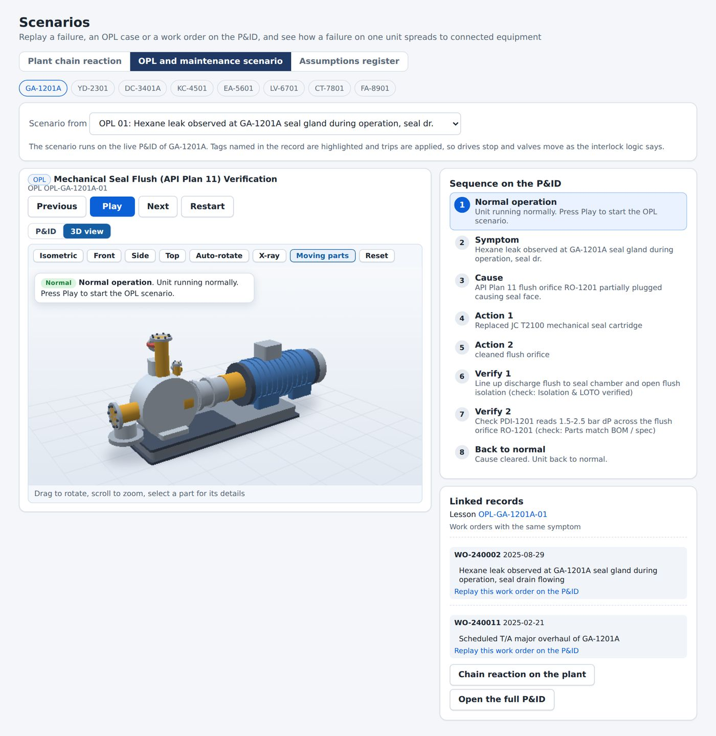
Figure 61. The OPL and maintenance scenario tab.

30.3 Assumptions register
Every number on the page rests on an assumption, such as how long a unit takes to restart or how much a day of downtime costs. The register lists each assumption with its value and its source, so that you can judge how far to trust the result.
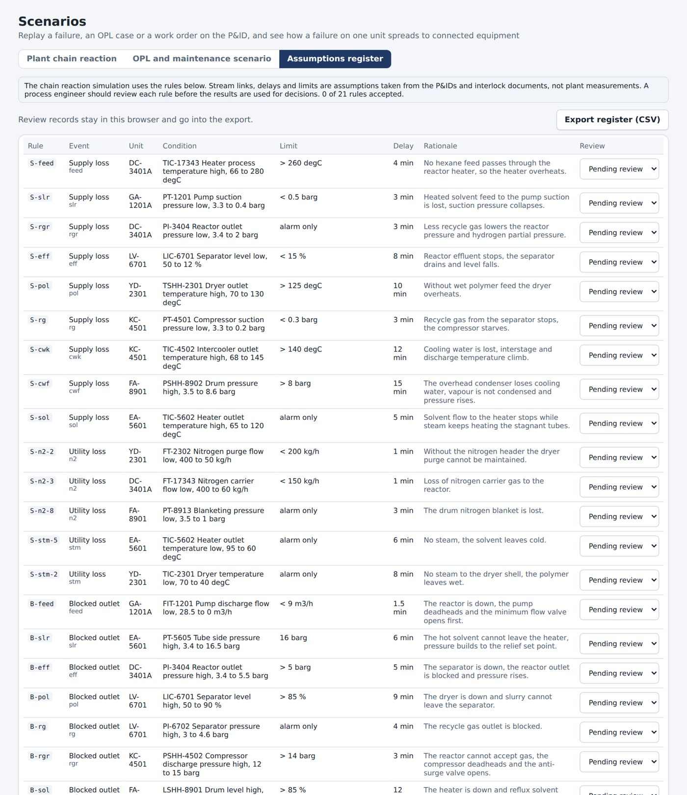
Figure 62. The Assumptions register.

31 Plot Plan and hazard simulator
Used by: Operator, Engineer, Reliability, HSE, Manager
The Plot Plan shows the site layout to scale. The hazard simulator shows how a gas cloud, a fire or a blast would spread from a chosen unit, which units and routes are affected and how long it takes to reach a muster point.

31.1 Site overview
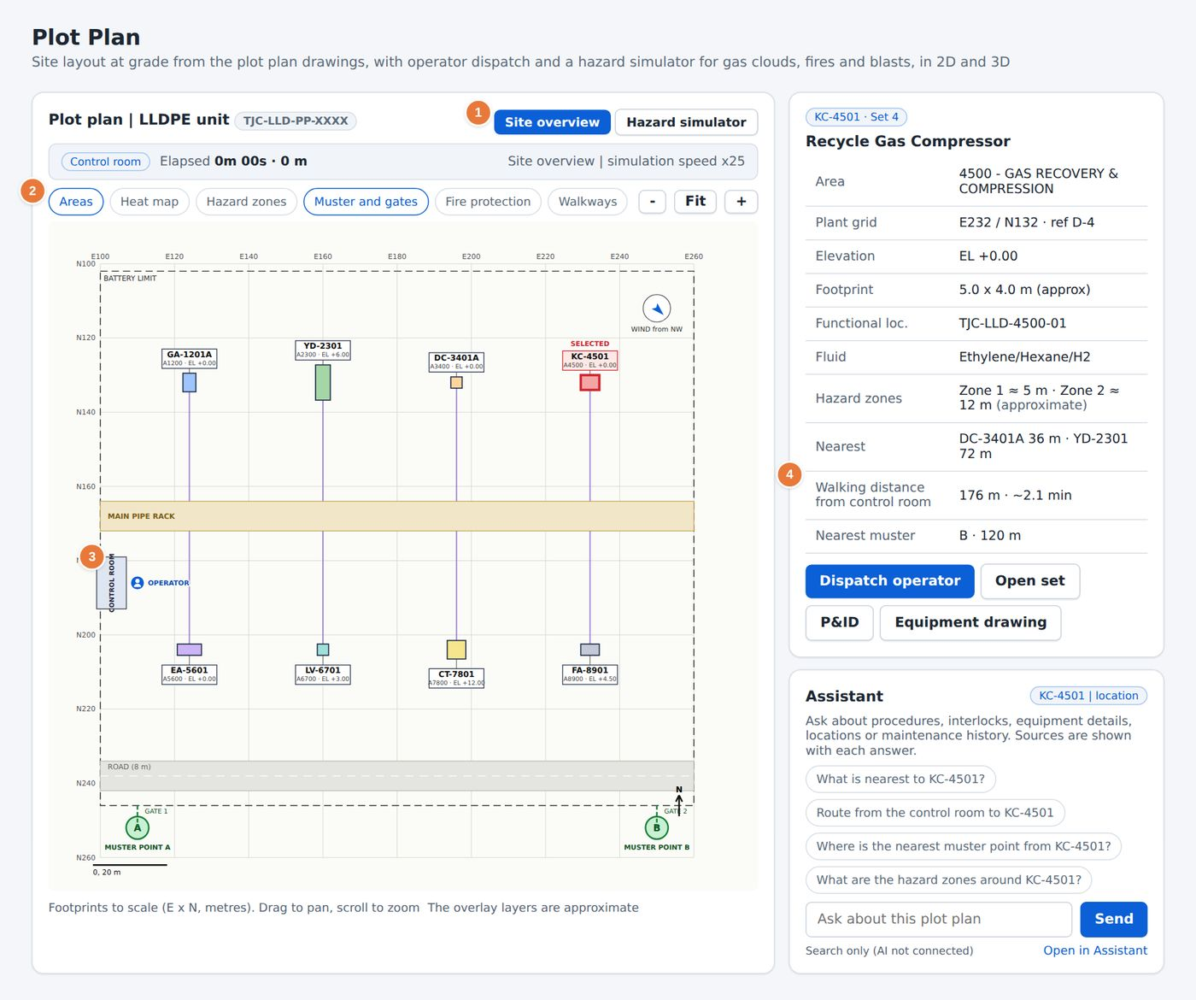
Figure 63. The Plot Plan, Site overview.
1 Switch between Site overview and Hazard simulator.  2 Map layers: Areas, Heat map, Hazard zones, Muster and gates, Fire protection and Walkways. | 3 The control room, muster points and gates.  4 Walking distance from control room and Recorded breakdowns by unit.

- Drag to pan and scroll to zoom. Footprints are to scale, in metres.
- Select a unit to see its location and send the operator to it. The route and the walking time are shown.
- Use Heat map to colour the units by the number of recorded breakdowns.
NOTE
Unit positions and footprints come from the plot plan drawings. The overlay layers for hazard zones, muster points, fire protection and walkways are approximate.

31.2 Hazard simulator in 2D
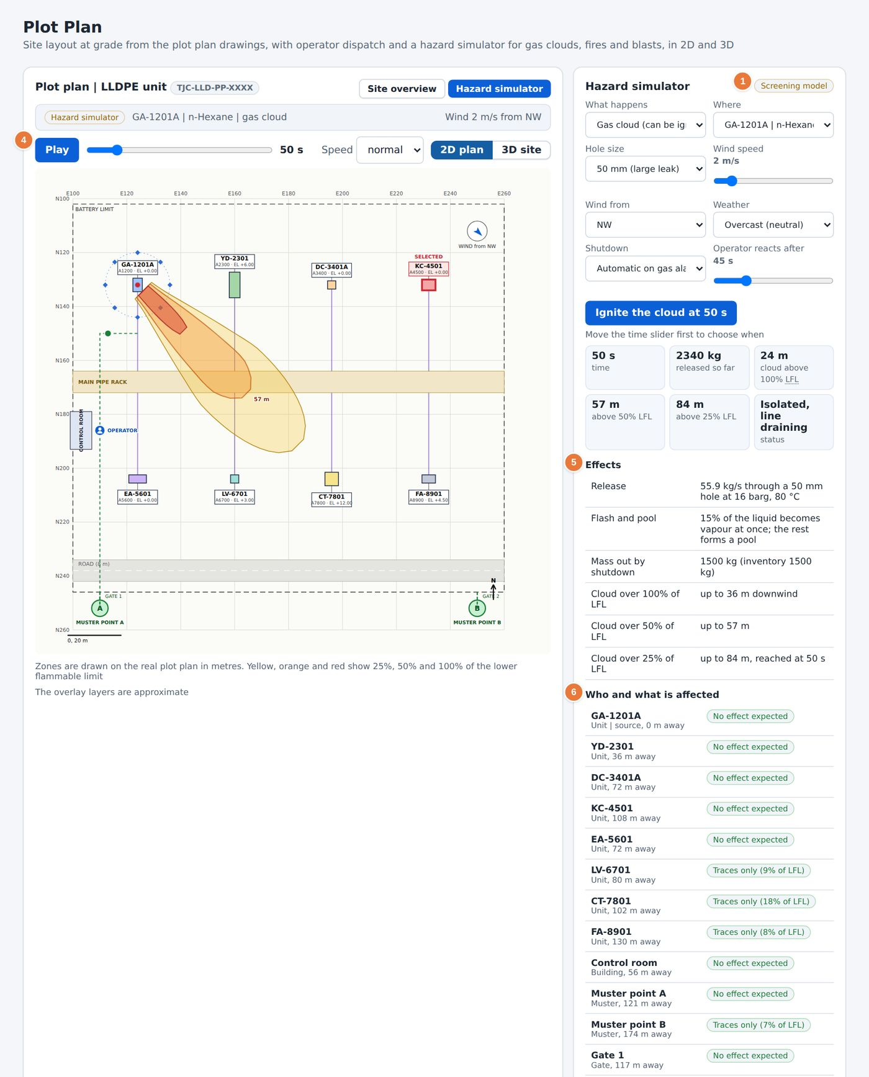
Figure 64. The hazard simulator on the 2D plan.
1 Choose the source unit, its fluid and the scenario: gas cloud, jet fire or pool fire.  4 Play, Speed and the time slider. Ignite the cloud sets the ignition time. | 5 Release figures and the cloud extent at 100, 50 and 25 percent of the lower flammable limit.  6 Who and what is affected, Walk to muster and Barriers in this case.

1 Select Hazard simulator.
2 Choose the source unit and the scenario.
3 Set the hole size, the wind speed, the wind direction and the weather.
4 Choose how the unit shuts down: automatic on gas alarm, manual by the operator, or fails to close. For a manual shutdown, set the operator reaction time.
5 Select Play or drag the time slider. The coloured zones show 25, 50 and 100 percent of the lower flammable limit (LFL).
6 Read Who and what is affected for the distance to each unit, building, muster point and gate.
7 Read Walk to muster to compare the routes. The better route is marked.

31.3 Hazard simulator in 3D
Select 3D site to see the cloud as a volume over the plant. Rotate the view to look at the cloud from the side or from above. The same controls apply.
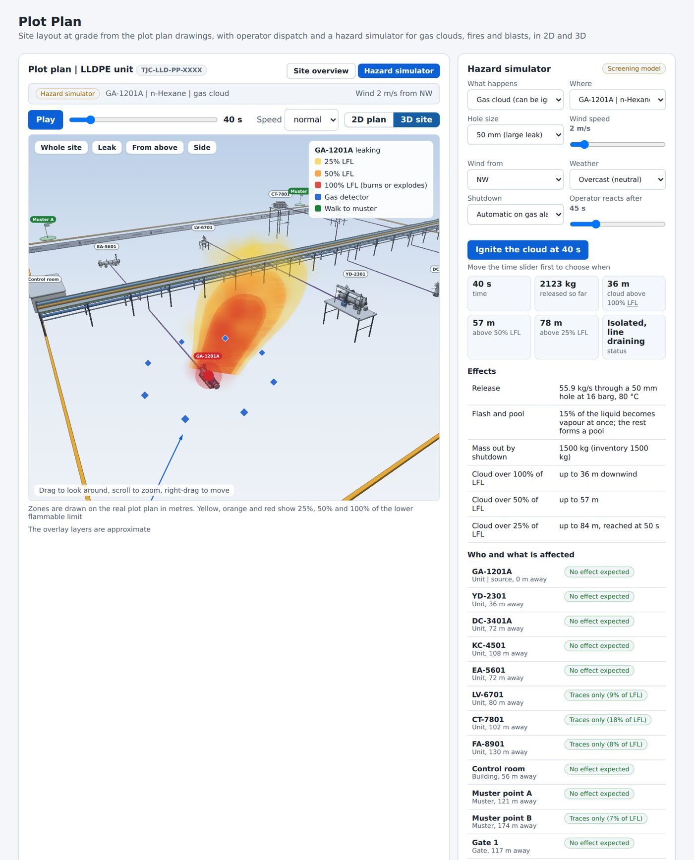
Figure 65. The hazard simulator in 3D.

CAUTION
The simulator is a screening model. It supports planning and training. It does not replace a formal consequence study.

32 AI Assistant
PART 6. KNOWLEDGE AND AI
Used by: Operator, Engineer, Reliability, HSE, Manager
The AI Assistant answers questions in plain language from the documents, the drawings, the interlock logic, the lessons and the work orders. Each answer lists its sources and their approval status.
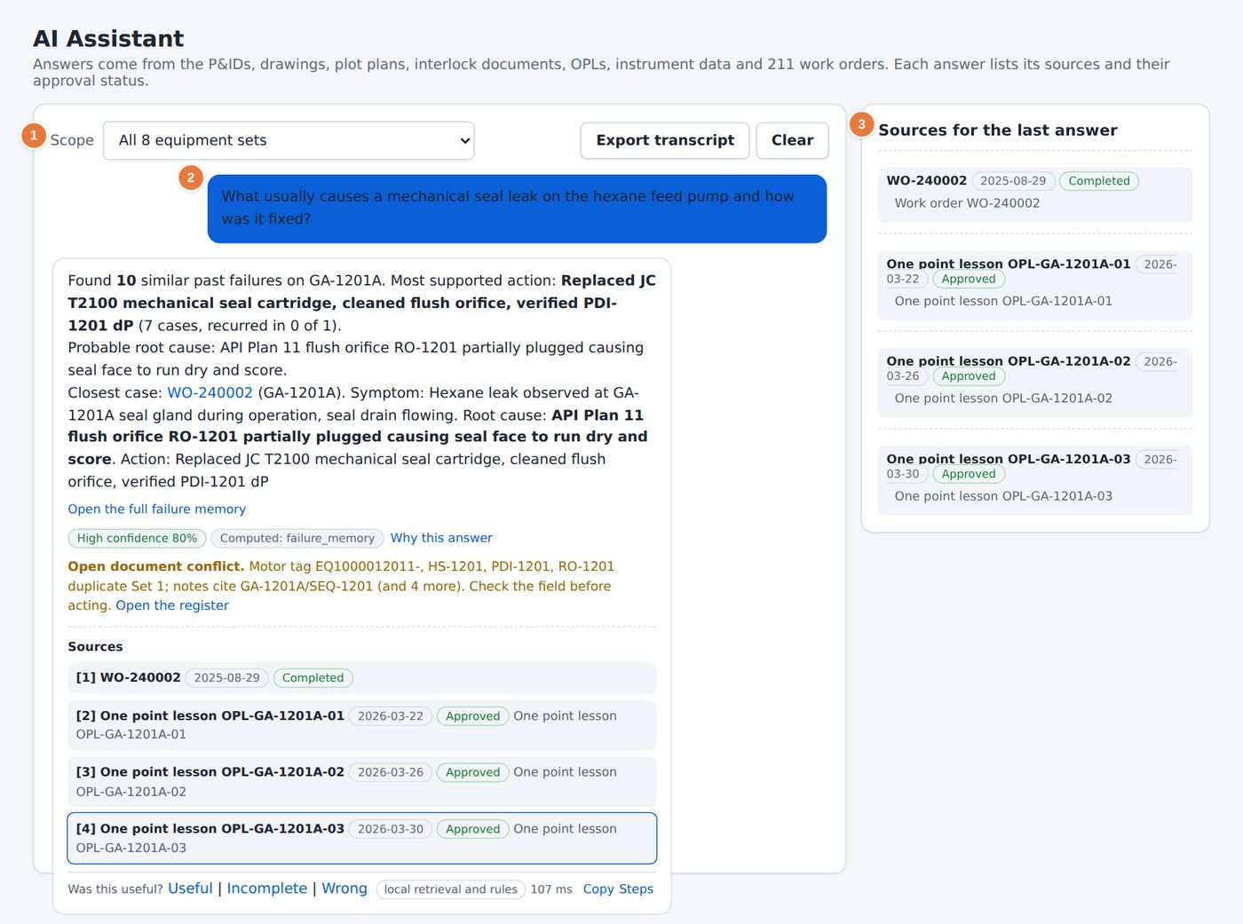
Figure 66. An answer from the AI Assistant.
1 Scope: all equipment sets or one set.  2 Your question and the answer, with numbered source tags. | 3 Sources for the last answer with revision and approval status.  4 The question box and Send.

32.1 Asking a question
1 Open AI Assistant in the sidebar.
2 Choose the Scope. A narrower scope gives a more precise answer.
3 Type a question in the box, or select one of the example questions.
4 Select Send.
5 Read the answer. Each statement carries a source number. Select a number to open the source.
6 Use Export transcript to save the conversation, or Clear to start again.

32.2 What you can ask
Kind of question | Example
Procedure | How is a mechanical seal leak on the hexane feed pump resolved?
Interlock | What is the start permissive for the recycle gas compressor KC-4501?
Location | Where is the cooling tower fan CT-7801 located?
Equipment facts | What is the trip set point of the suction pressure low-low switch on the hexane feed pump?
Maintenance history | What usually causes a mechanical seal leak on the hexane feed pump and how was it fixed?
Comparison and ranking | Which equipment set has the highest failure risk now?
Calculation | What is the MTBF of each equipment?

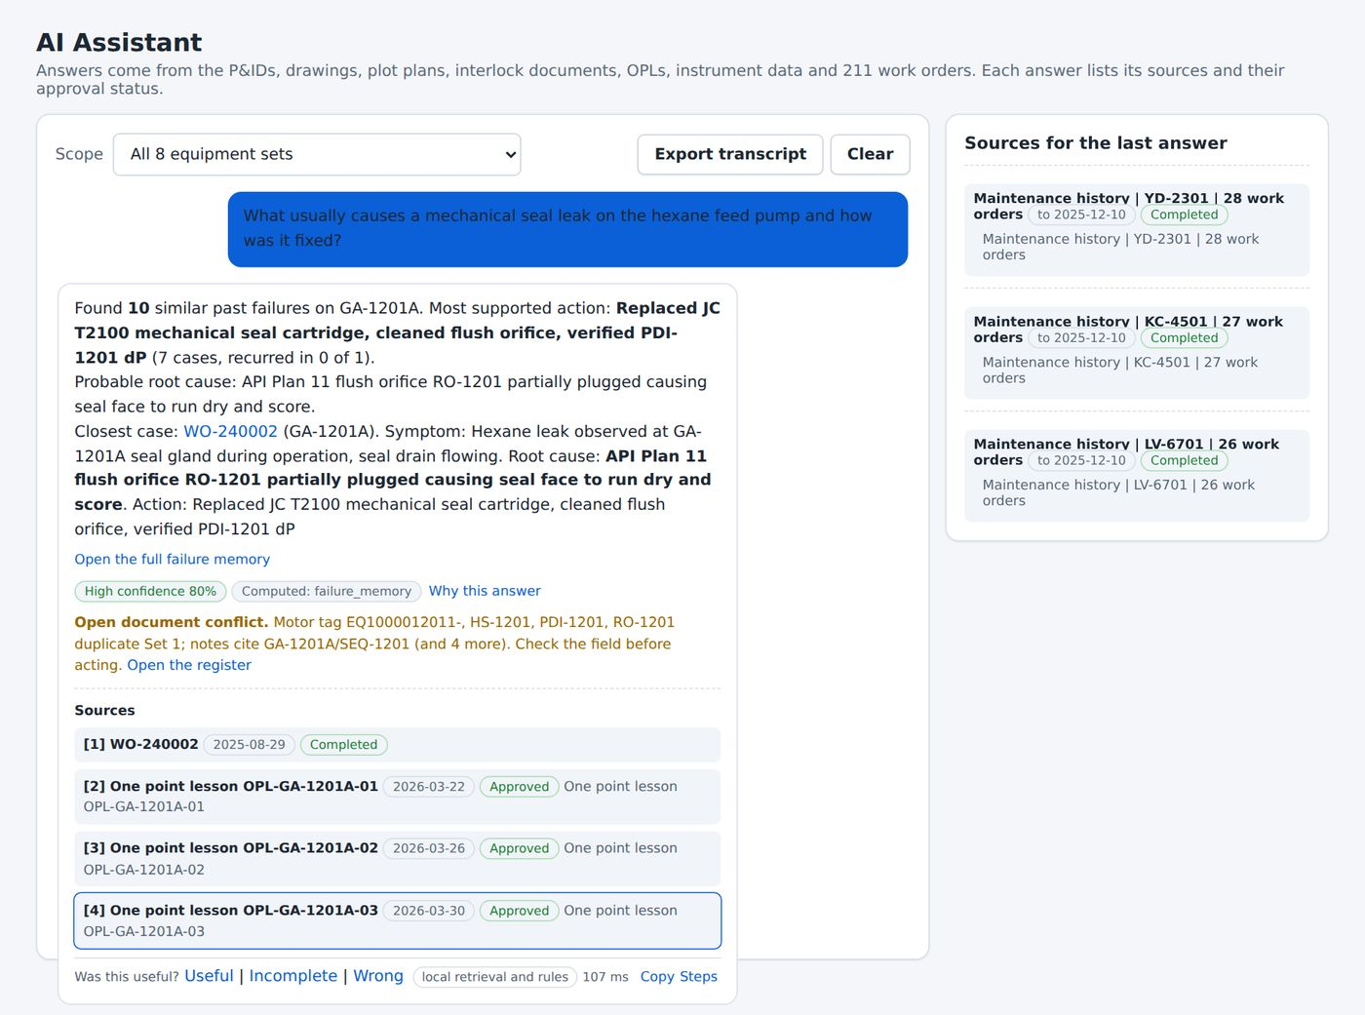
Figure 67. A ranking question. The answer is computed from the maintenance history and says so.

32.3 Why this answer
Select Why this answer under an answer to see how it was built: the type of question the assistant recognised, the records it retrieved, their approval status and the check of every number against the sources.
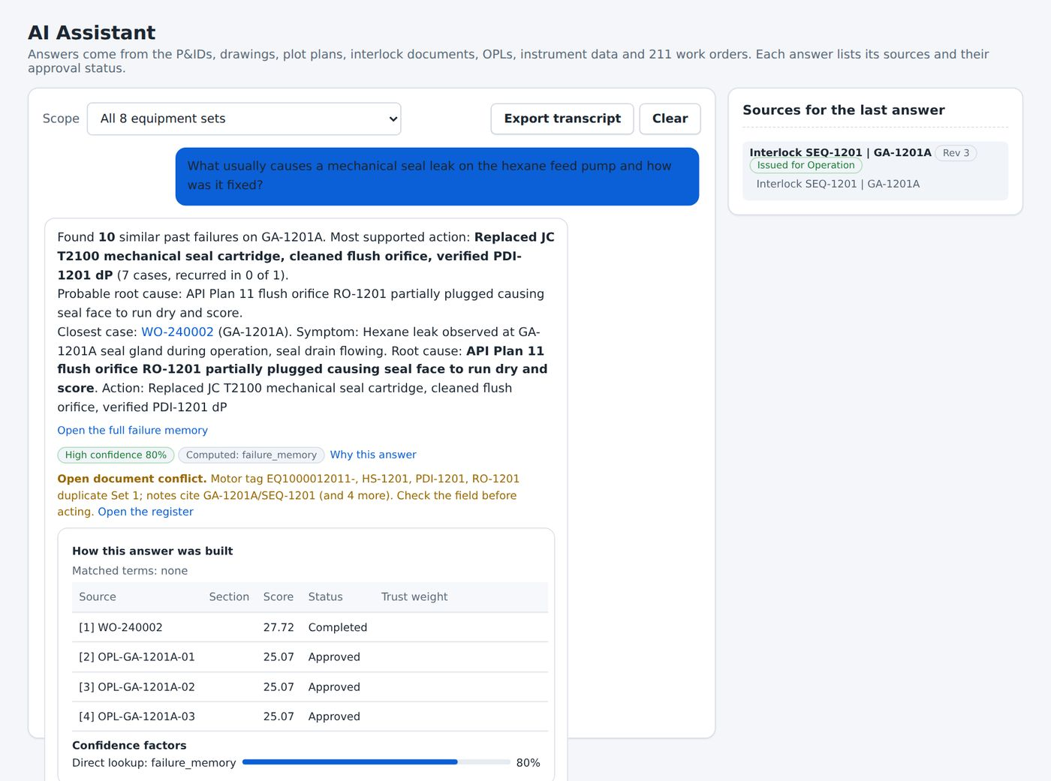
Figure 68. The Why this answer panel.

32.4 Questions the assistant will not answer
The assistant refuses requests to bypass, defeat or override a trip, an interlock, an alarm or a permissive. The refusal happens in the page, and the request is never sent to an AI service. The assistant points to the approved procedure instead.
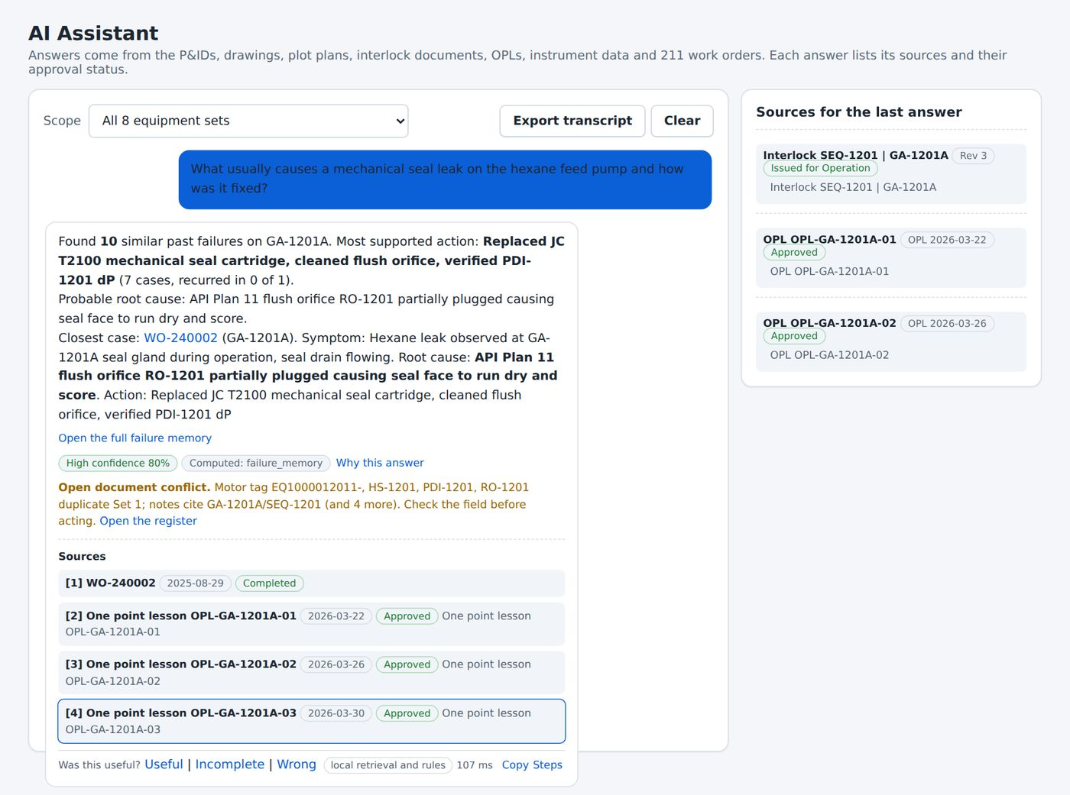
Figure 69. A request to bypass a trip is refused.

32.5 Feedback
Use the feedback links under an answer to mark it Incomplete or Wrong. The report goes to the review queue in Knowledge Studio (Chapter 34), where a person with approval rights can correct the knowledge.

33 How answers are produced
Used by: Operator, Engineer, Reliability, HSE, Manager
This chapter explains what happens between a question and an answer, so that you know how far to trust it.
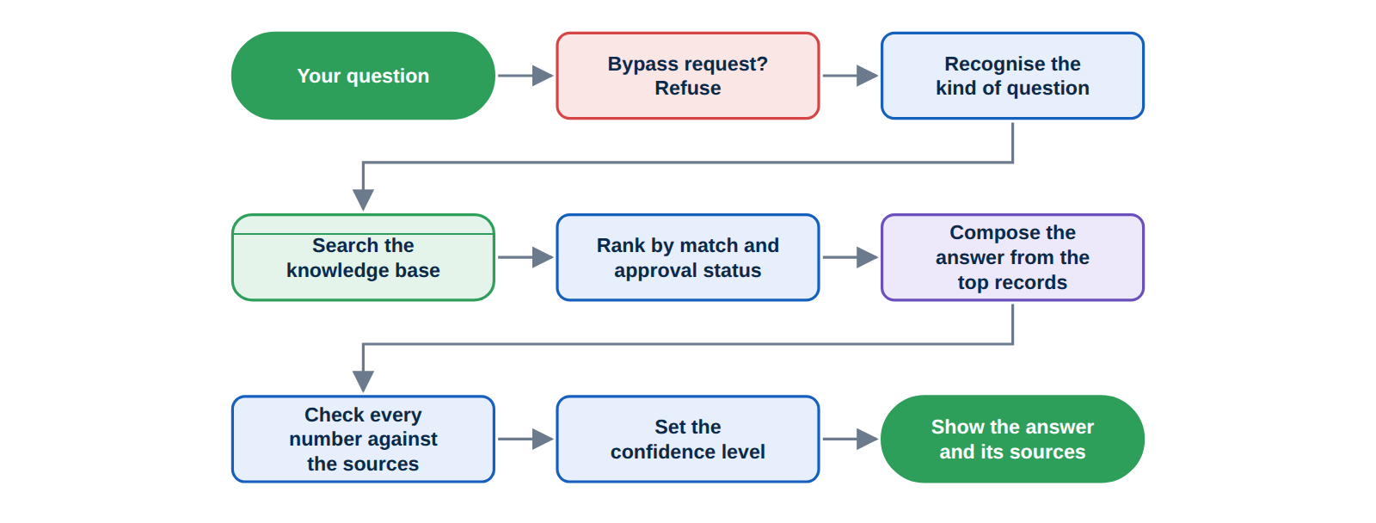
Figure 70. The path from question to answer.

1 Safety check. A request to bypass a protective function is refused at once.
2 Recognition. The assistant decides whether the question is about a procedure, an interlock, a location, a number, a history or a ranking.
3 Search. The knowledge base is searched by keyword and by meaning. Typed facts and computed figures, such as MTBF, are read directly from the data.
4 Ranking. Records are ranked by how well they match and by their approval status.
5 Composition. The answer is written from the top records. When an administrator has connected an AI service, it words the answer from those records. Otherwise a built-in method writes it.
6 Verification. Every number in the answer is compared with the sources. A statement without support is stated as a gap.
7 Delivery. The answer is shown with numbered sources, their revision and status, and a confidence level.

33.1 How approval status affects ranking
Status | Weight in the ranking
Approved | 1.0
Not stated | 0.8
In review | 0.7
Draft | 0.55
Superseded | 0.35
Rejected | Left out

ROLES
Operators see only approved items in the typed facts. Engineers, Reliability, HSE and Managers can also see items that are in review.

CAUTION
A low confidence level, or a statement that the data has a gap, is a result. Check the source document or ask a colleague before you act.

34 Knowledge Studio
Used by: Operator, Engineer, Reliability, HSE, Manager
Knowledge Studio is where plant knowledge is added, reviewed and approved. Approved items are searchable at once, and the assistant cites them with their revision and status.
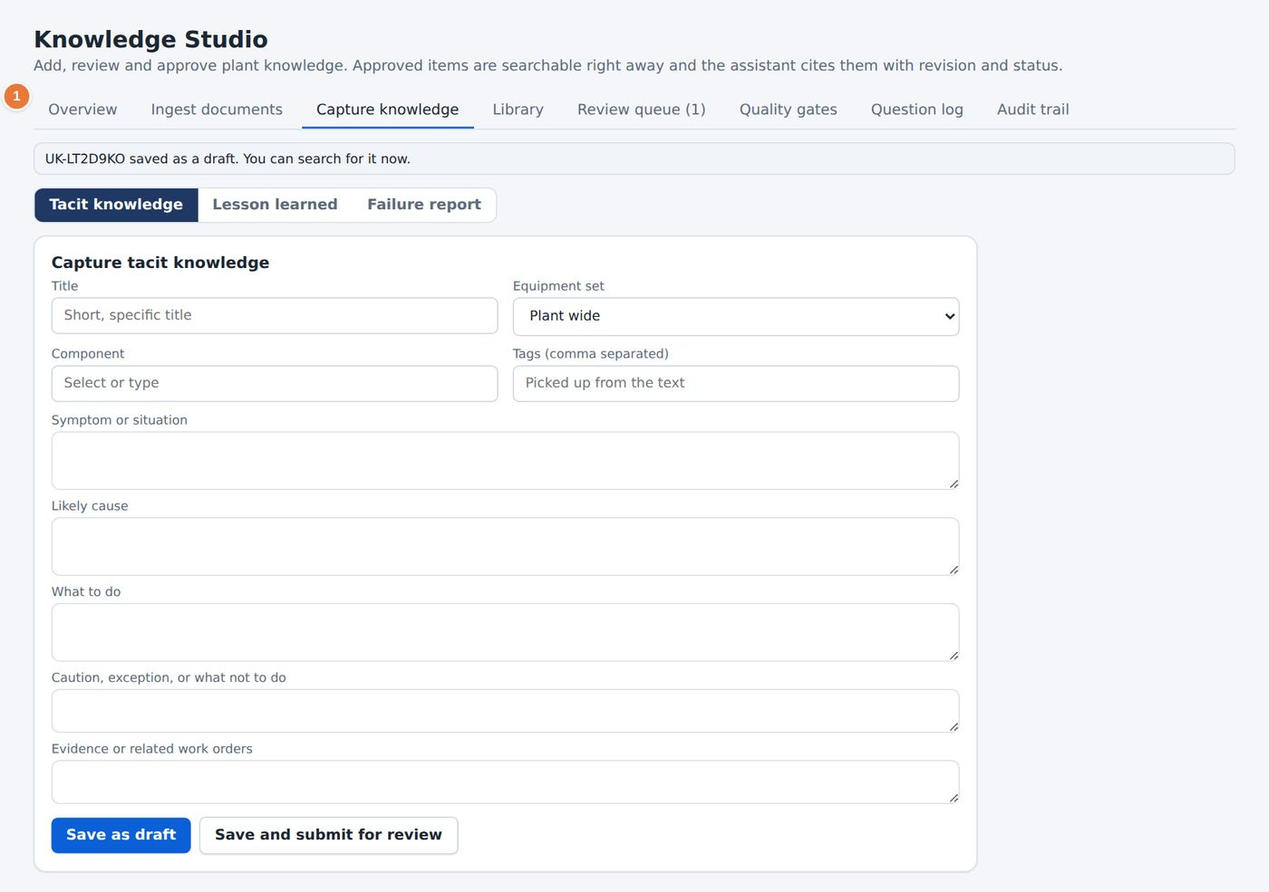
Figure 71. Knowledge Studio, Overview tab.
1 The eight tabs.

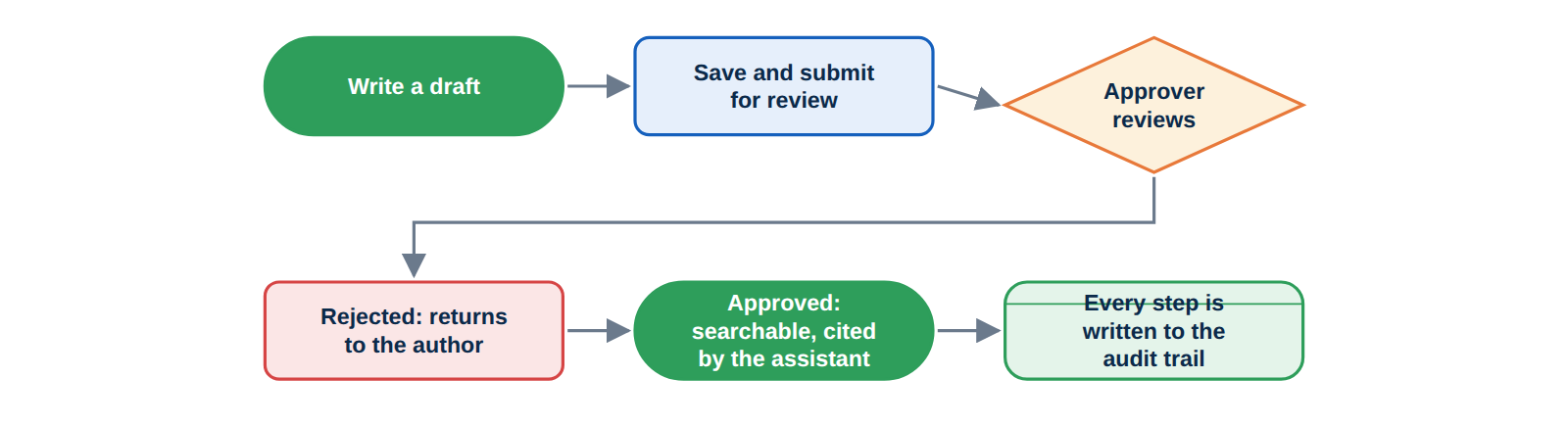
Figure 72. The approval workflow.

34.1 Ingest documents
The ingestion wizard turns a file or pasted text into searchable knowledge in six steps: Source, Kind, Structure, Details, Checks and Create.
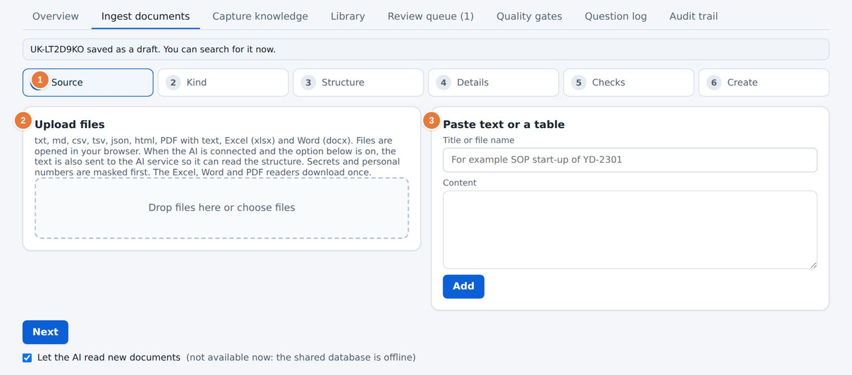
Figure 73. The ingestion wizard, first step.
1 The six steps of the wizard.  2 Choose files, or drop them on the box. The wizard reads text, CSV, JSON, HTML, PDF with a text layer, Excel and Word files. | 3 Or paste text or a table, with a title.

1 Add the file or paste the text, then select Next.
2 Choose the kind of document: for example an SOP, a datasheet, a P&ID, an interlock sheet, a maintenance log, an instrument list, an OPL, an incident report or notes.
3 Check the structure the wizard found: headings, steps, tables and tags.
4 Confirm the details: title, equipment set, revision and date.
5 Read the checks. They flag missing tags, an unknown equipment set and duplicate content.
6 Select Create. The item is saved as a draft and appears in the Library.
TIP
Secrets and personal numbers are masked before any text is sent to an AI service.

34.2 Capture knowledge
Three forms record what people know. Tacit knowledge records an expert's symptom, cause, action and caution for an asset. Lesson learned records what changed after an incident. Failure report goes into the failure memory and can also create a work order.
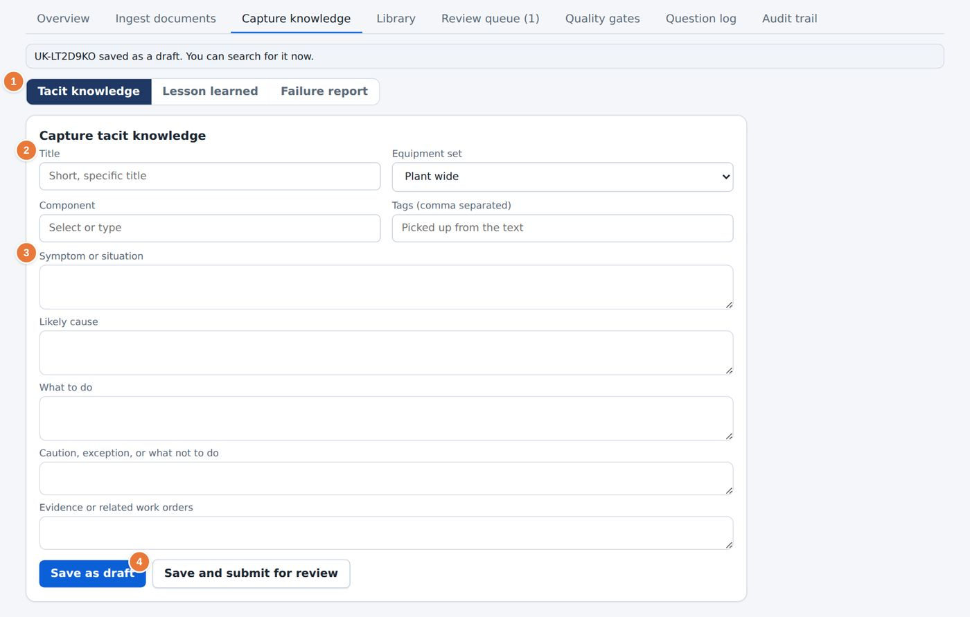
Figure 74. The tacit knowledge form.
1 Choose the type of record.  2 Title, equipment set, component and tags. | 3 Symptom, likely cause, action and caution.  4 Save as draft or Save and submit for review.

34.3 Library
The Library lists every item added by users with its identifier, title, type, asset, revision, status, author and date. Use the filter box to find an item. Select an item to read it. The buttons on each row depend on the status: Submit for a draft, Approve and Reject for an item in review, Withdraw for an approved item and Reopen as draft for a rejected or withdrawn one. Drafts can also be edited or deleted.
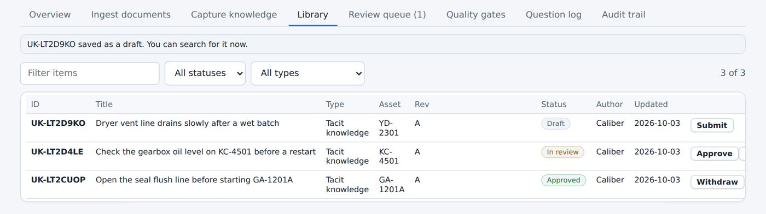
Figure 75. The Library.

34.4 Review queue
The Review queue lists the items waiting for approval and the answer feedback reported by users. Operators can draft and submit. Engineers, Reliability, HSE and Managers can approve. Nobody approves their own item except a Manager.
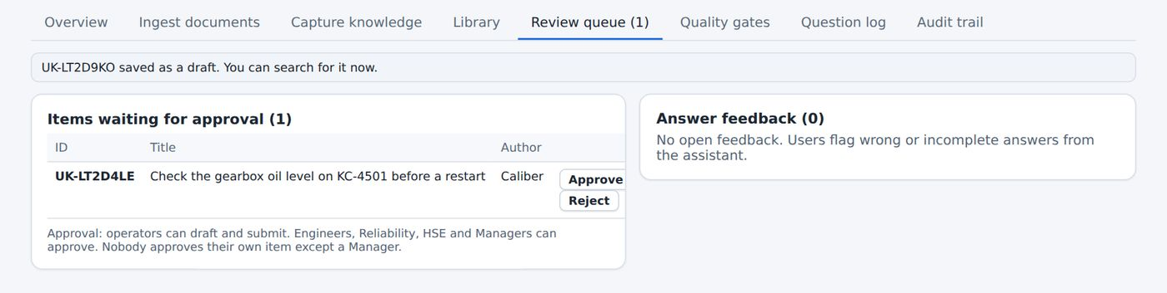
Figure 76. The Review queue.

1 Open the item from the queue and read it.
2 Check the equipment set, the facts and the caution.
3 Select Approve to publish the item, or Reject and give a reason. The reason goes into the history.
4 For answer feedback, select Create knowledge item to start a correction, or Mark reviewed if no change is needed.

34.5 Quality gates
The Quality gates tab runs checks on the knowledge base: drafts older than 14 days, items in review longer than 7 days, items without a linked asset or tags, approved items that cannot be found by their own title and open answer feedback. Each check shows a result and a pass or fail status. A second table shows the baseline data quality of the source documents.
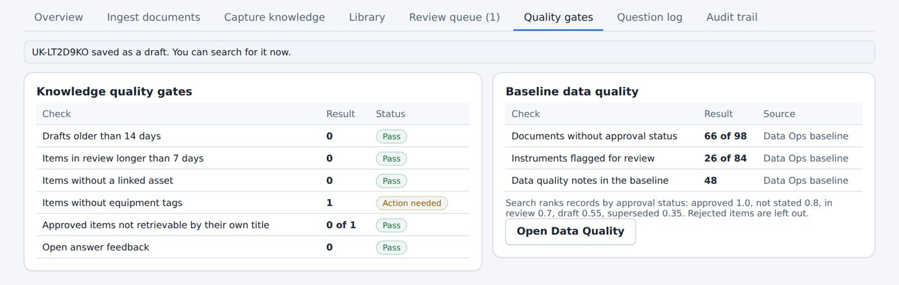
Figure 77. Quality gates.

34.6 Question log
The Question log lists the questions asked of the assistant, with the role of the person, the handler, the confidence, the response time, the number of sources cited and the feedback. The last 500 are kept in the browser. Use Export JSONL or Export CSV to save them.
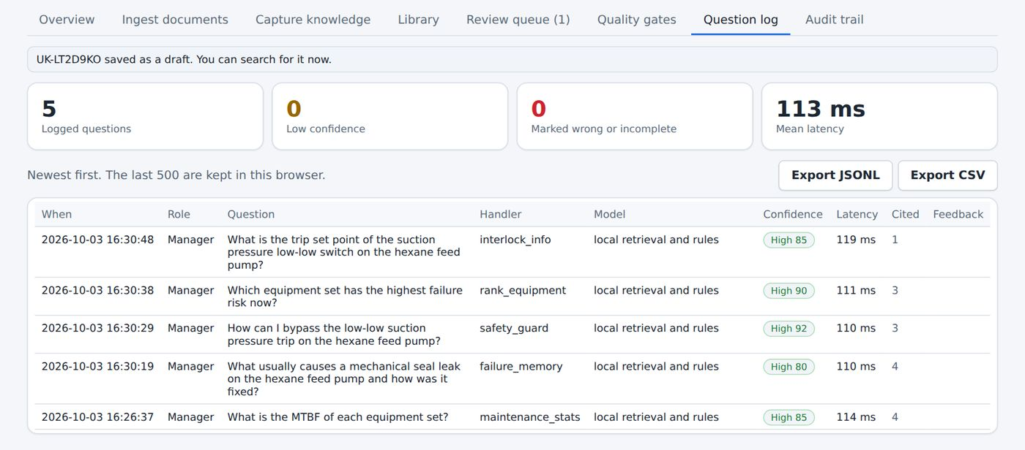
Figure 78. The Question log.

34.7 Audit trail
The audit trail records every change: when, who, the role, the action, the detail and the item. Use Export CSV to save it. Chapter 40 describes what is recorded.
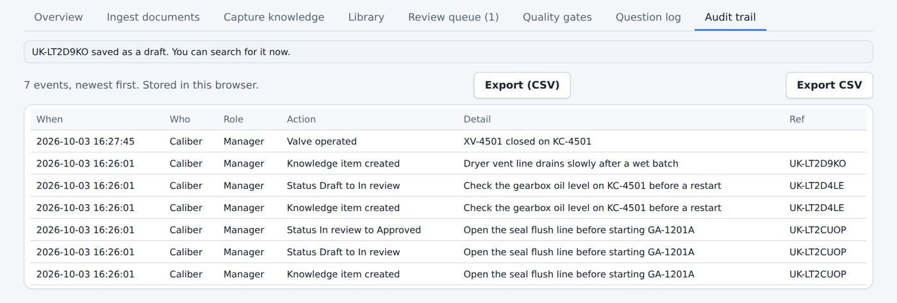
Figure 79. The Audit trail.

35 Data Quality
Used by: Engineer, Reliability, HSE, Manager
Data Quality lists the inconsistencies and gaps found while the knowledge base was built. Each issue has a severity, a source and a suggested action.
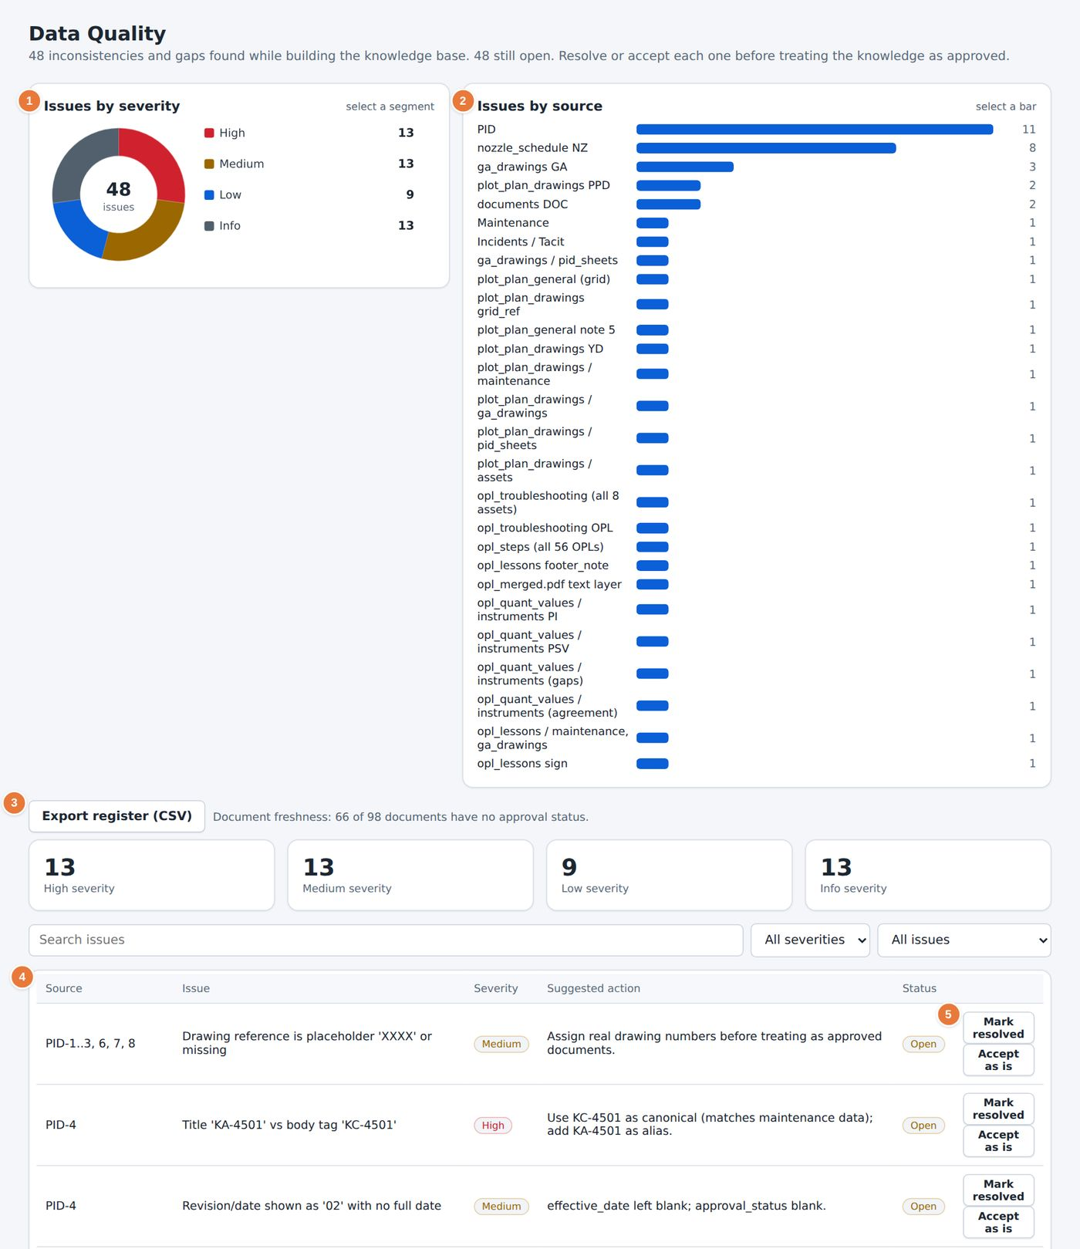
Figure 80. The Data Quality page.
1 Issues by severity: high, medium and info.  2 Issues by source. Select a bar to filter.  3 Filters for severity and status. Export register (CSV) saves the list. | 4 The issue table: source, issue, severity, suggested action and status.  5 Mark resolved and Accept as is for each issue.

1 Filter by severity to start with the high issues.
2 Read the issue and the suggested action. For example, a drawing title that says KA-4501 when the body says KC-4501 is shown with the suggestion to use KC-4501 and to add KA-4501 as an alias.
3 Correct the source, then select Mark resolved. If the difference is acceptable, select Accept as is.
4 Select Export register (CSV) to share the register.
CAUTION
Resolve or accept every issue before you treat the knowledge as approved. The Dashboard counts the open issues.

36 Integrations and the knowledge graph
Used by: Engineer, Reliability, Manager
The Integrations page shows how the platform connects to the systems the company already uses, and how its data is organised.
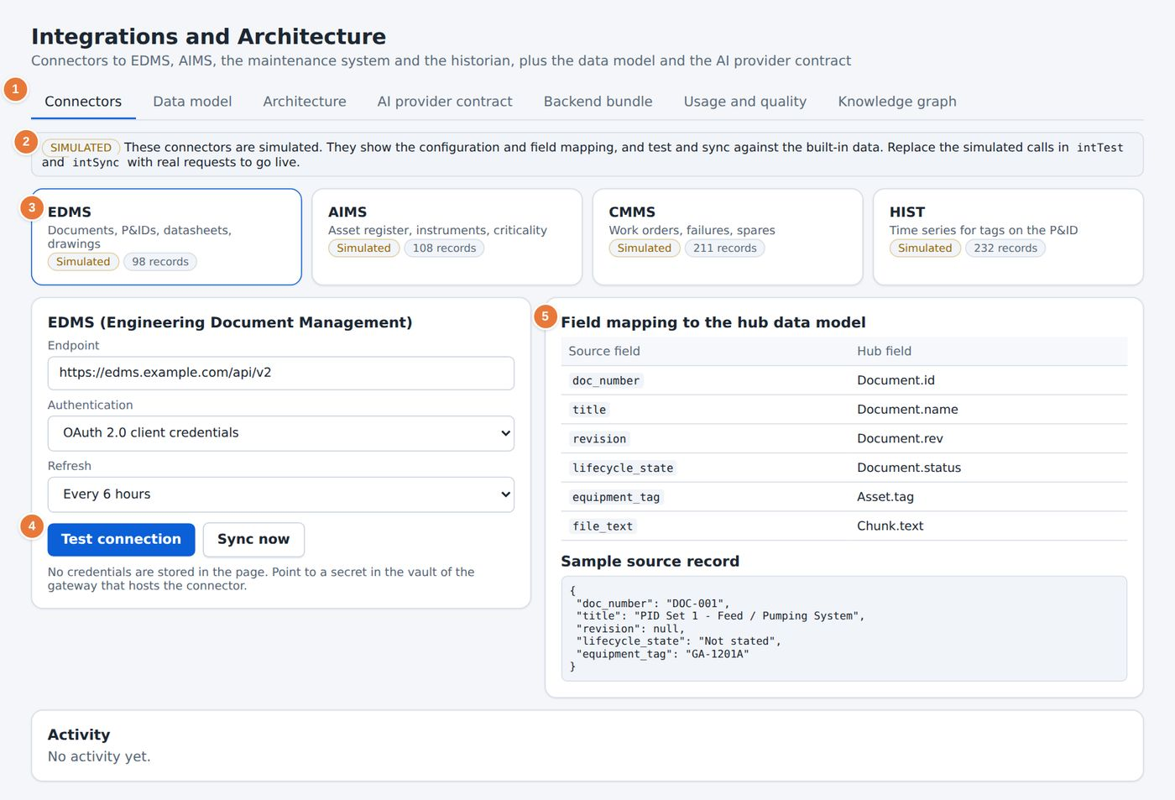
Figure 81. The Integrations and Architecture page.
1 The seven tabs.  2 A notice states that the connectors are simulated.  3 One tile for each system: EDMS, AIMS, CMMS and HIST. | 4 Endpoint, authentication and refresh settings, with Test connection and Sync now.  5 Field mapping from the source fields to the hub data model.

Tab | Use
Connectors | Configure a connection to the document system (EDMS), the asset register (AIMS), the maintenance system (CMMS) and the historian (HIST)
Data model | Read the entities and fields of the hub data model
Architecture | See how the page, the shared database and the AI service fit together
AI provider contract | Read what the platform sends to an AI service and what it expects back
Backend bundle | Read the specification for the production backend
Usage and quality | See the use of the assistant and the results of the evaluation questions
Knowledge graph | See the records linked to an asset

NOTE
The connectors in this version are simulated. They show the configuration and the field mapping, and they test and sync against the built-in data.

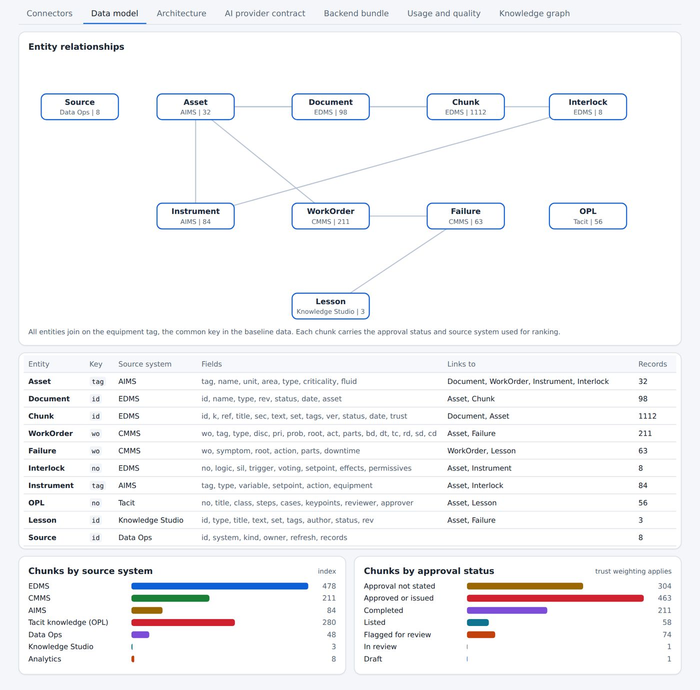
Figure 82. The Data model tab.

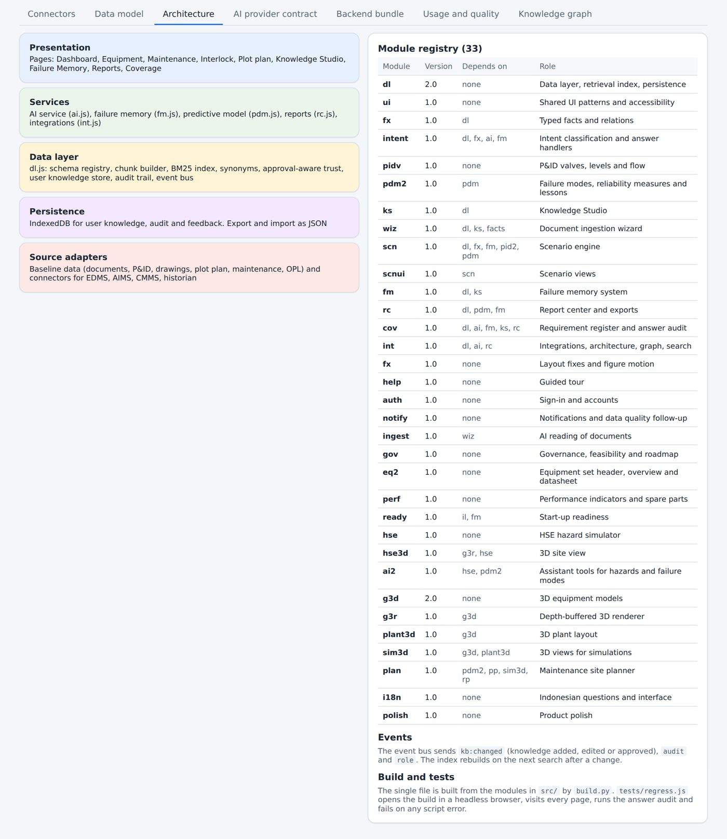
Figure 83. The Architecture tab.

36.1 Knowledge graph
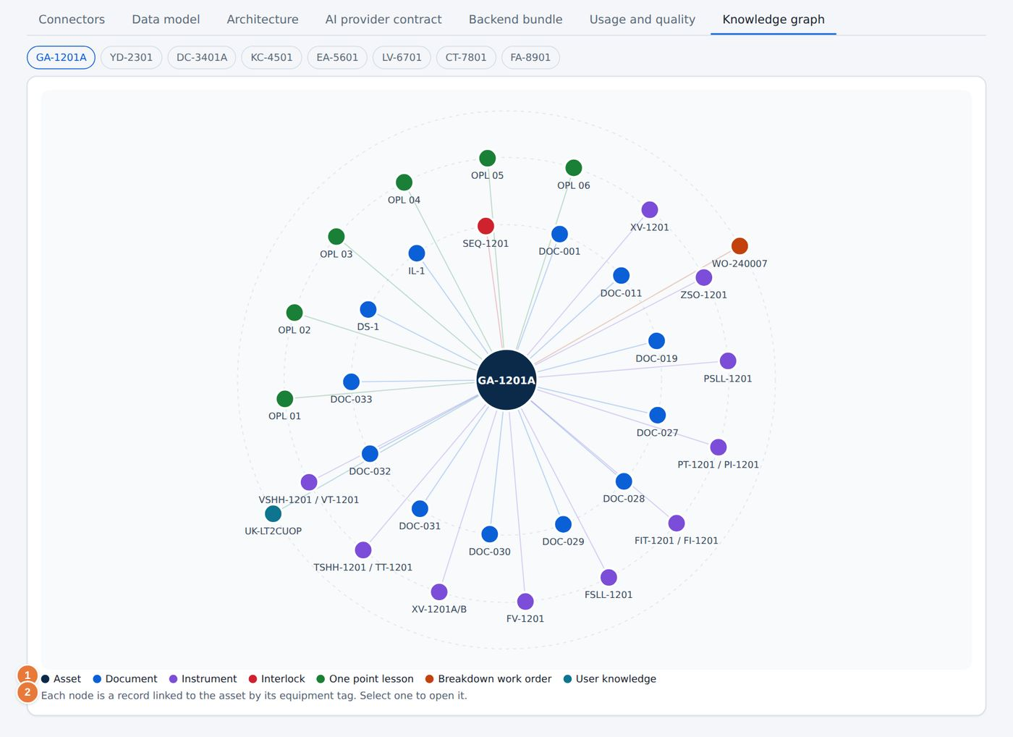
Figure 84. The Knowledge graph.
1 Node types: asset, document, instrument, interlock, one point lesson, breakdown work order and user knowledge. | 2 Each node is a record linked to the asset by its equipment tag. Select one to open it.

37 Report Center
PART 7. ADMINISTRATION
Used by: Operator, Engineer, Reliability, HSE, Manager
The Report Center produces printable reports and data exports. A report opens in a preview. Save it as a PDF from the print dialog, or download it as HTML or Word.
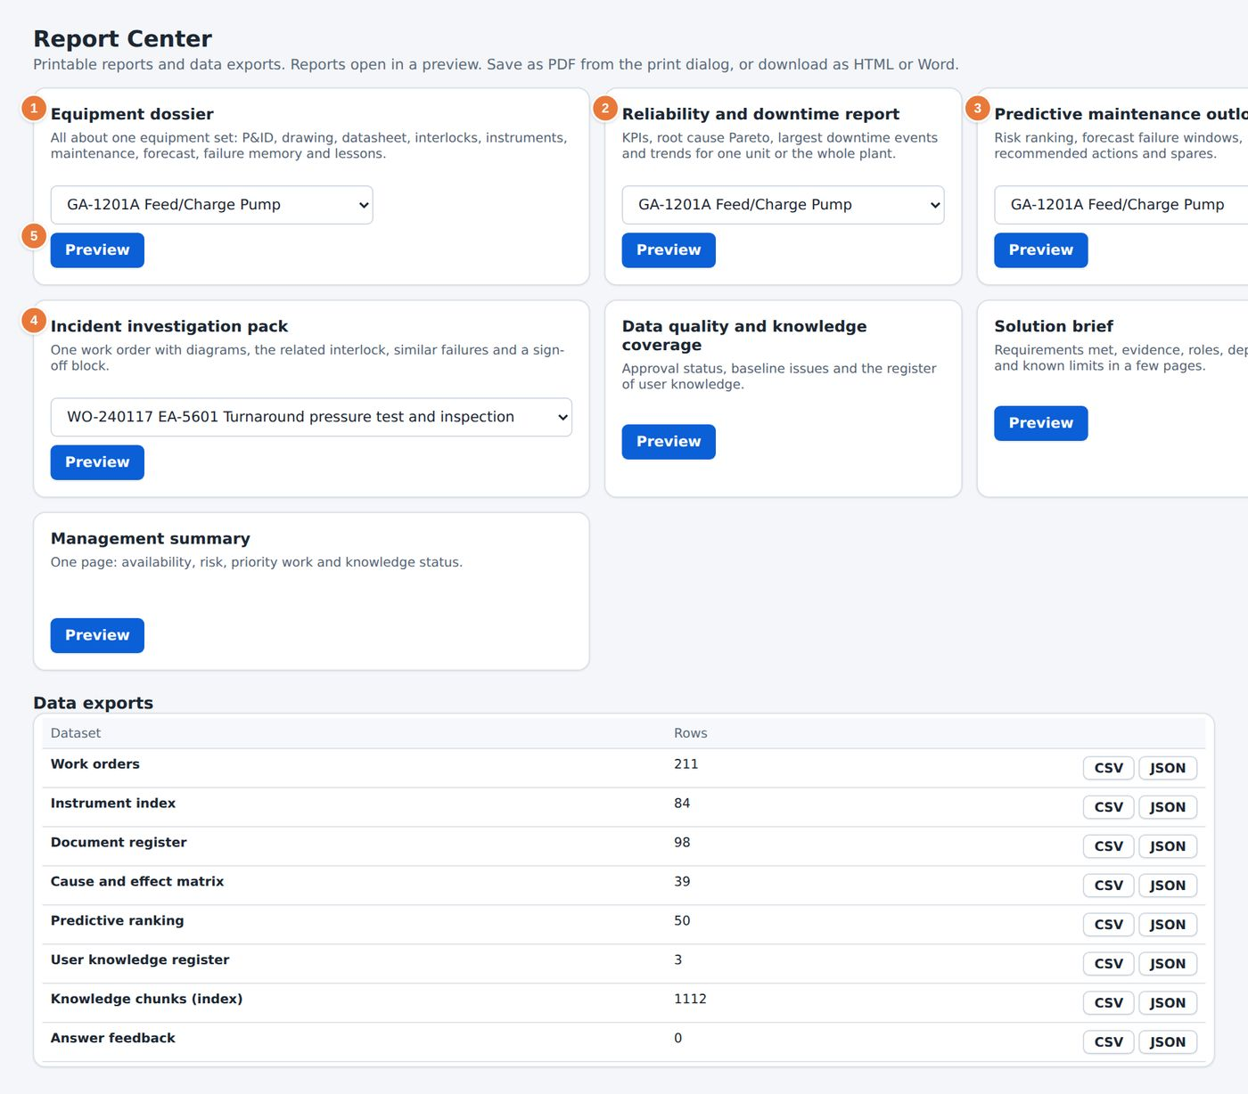
Figure 85. The Report Center.
1 Equipment dossier: everything about one equipment set.  2 Reliability and downtime report for one unit or the whole plant.  3 Predictive maintenance outlook: risk ranking, windows, actions and spares. | 4 Incident investigation pack for one work order.  5 Choose the equipment or work order for a report, then select Preview.

Report | Contents | Typical reader
Equipment dossier | P&ID, drawing, datasheet, interlocks, instruments, maintenance, forecast, failure memory and lessons for one set | Engineer, Operator
Reliability and downtime report | KPIs, root cause Pareto, largest downtime events and trends | Reliability, Manager
Predictive maintenance outlook | Risk ranking, forecast failure windows, recommended actions and spares | Reliability, Engineer
Incident investigation pack | One work order with diagrams, the related interlock, similar failures and a sign-off block | Engineer, HSE
Data quality and knowledge coverage | The open data issues and the share of approved documents | Engineer, Manager
Solution brief | A summary of the platform | Manager
Management summary | A one-page summary of the plant | Manager
Data exports | The data as CSV or JSON | Reliability, Manager

37.1 Producing a report
1 Select the card of the report you need.
2 Choose the equipment set, the unit or the work order from the list on the card.
3 Select Preview. The report opens in a window.
4 Select Print and choose Save as PDF, or download the report as HTML or Word.
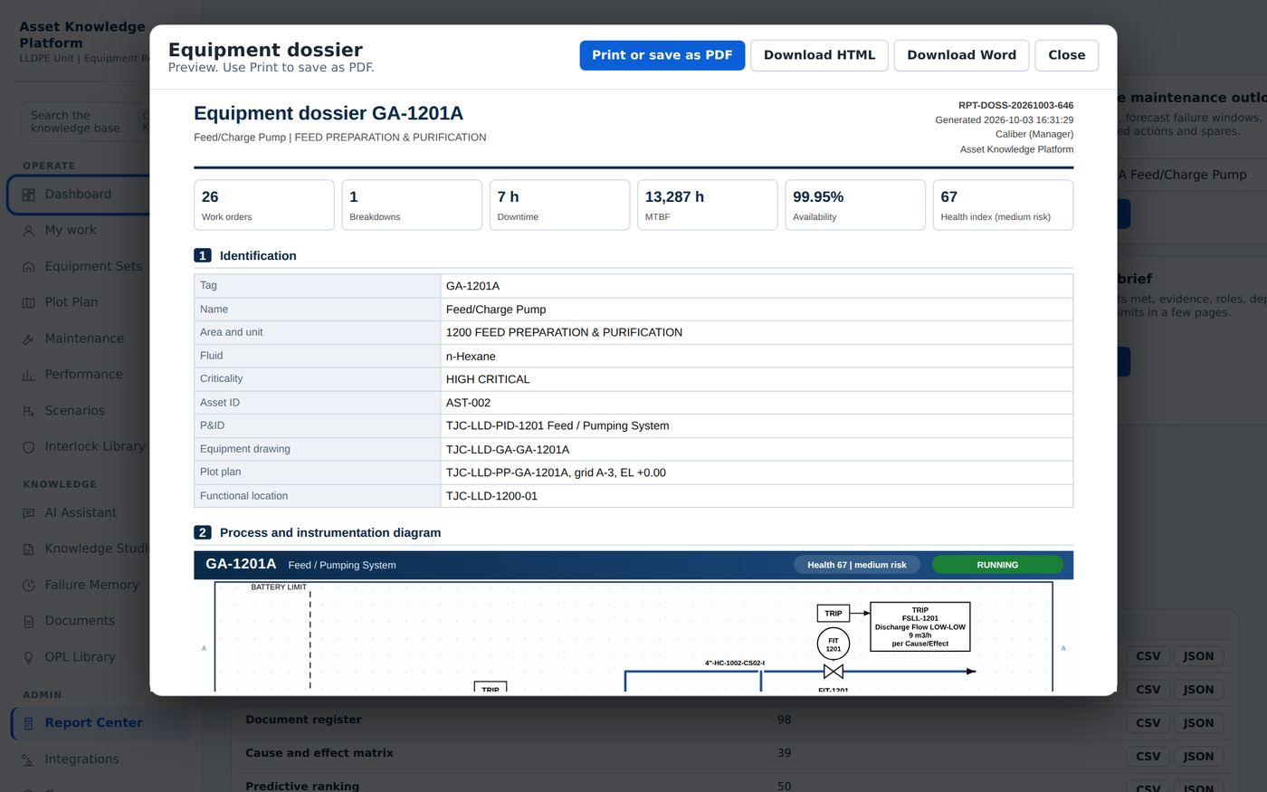
Figure 86. A report preview.

TIP
The Export dossier button on an equipment page (Chapter 13) produces the same dossier without opening the Report Center.

38 Governance and roadmap
Used by: Engineer, Reliability, HSE, Manager
The Governance page states which controls are in place, what a production rollout still needs, the phases of the roadmap and the business case with its assumptions visible.
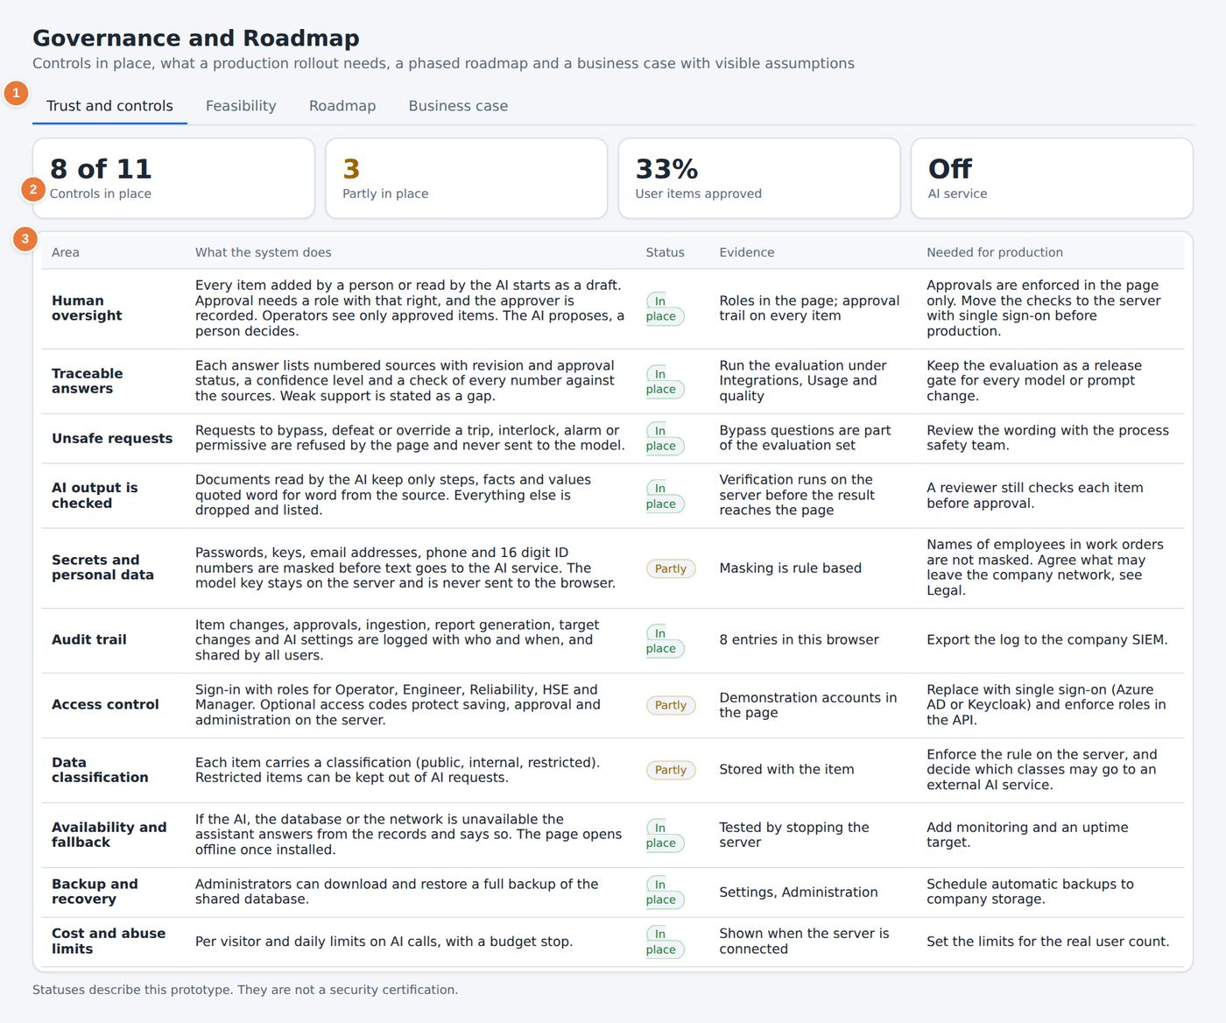
Figure 87. The Governance and Roadmap page, Trust and controls tab.
1 The four tabs.  2 Summary: controls in place, controls partly in place, user items approved and the state of the AI service. | 3 The controls table: area, what the system does, status, evidence and what production needs.

Tab | Use
Trust and controls | Check how human oversight, traceable answers, unsafe requests and AI output are controlled, with the evidence and the work still needed for production
Feasibility | Read the technical, data and organisational feasibility of a rollout
Roadmap | See the phases of the rollout and what each phase delivers
Business case | Read the value and cost model, with every assumption visible and changeable

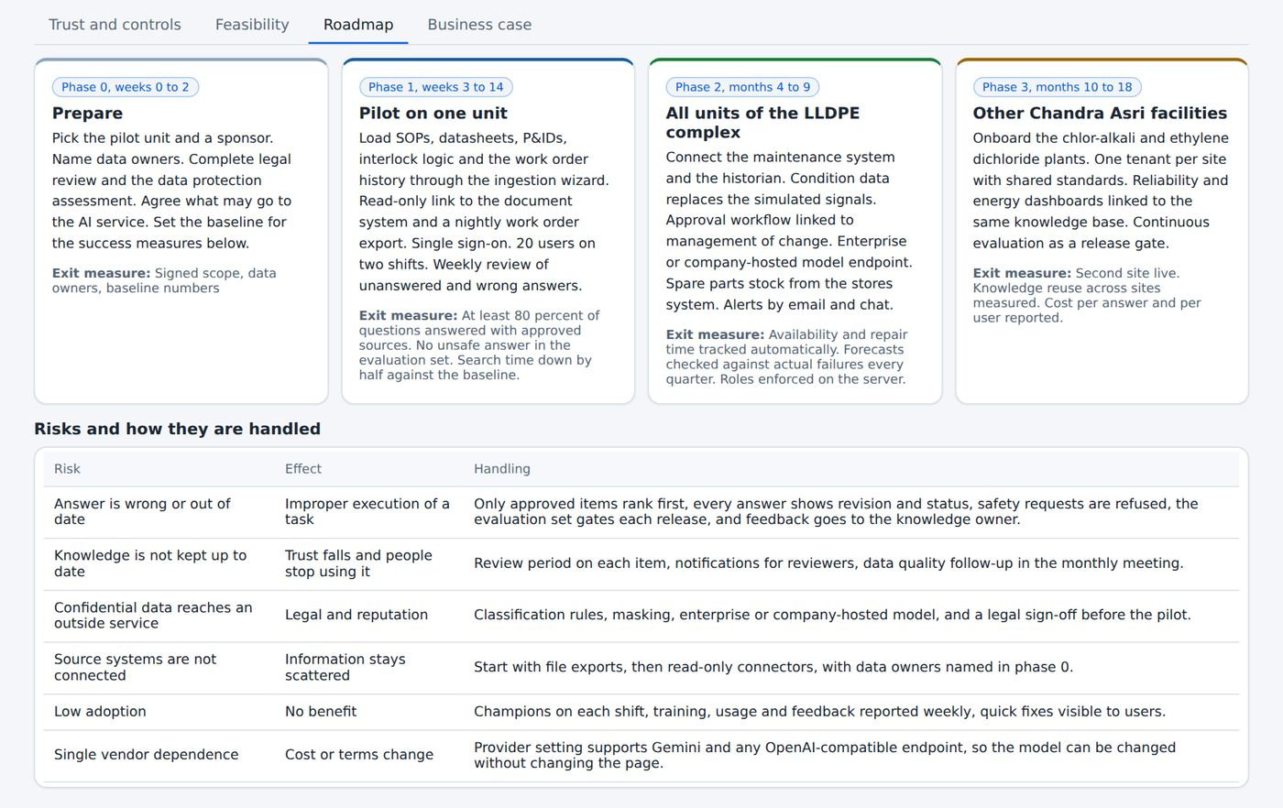
Figure 88. The Roadmap tab.

NOTE
Approvals are enforced in the page in this version. The Trust and controls tab states that the checks move to the server, with single sign-on, before production use.

39 Settings
Used by: Operator, Engineer, Reliability, HSE, Manager
Settings holds the options of the platform. Open it with the gear icon in the sidebar footer. Chapter 9 shows the panel; this chapter explains each option.
Figure 89. The Settings panel.

Panel | Option | Use
Shared database | Sync now | Shows whether the shared database is connected and synchronises your changes at once
AI assistant | Use the AI for answers | Lets a connected AI service word the answers. When it is off, or when the service is down, answers come straight from the records
AI assistant | Answer style and Answer language | Choose how long the answers are and the language they are written in
AI assistant | Test the AI connection and Run diagnostics | Check the AI service and the shared database
Report header | Text box | A line printed at the top of every report, such as the company and the unit
Account | View as role (demo admin) | The demonstration administrator can switch the role to see how each role sees the platform
Account | Interface language | Switch the interface between English and Bahasa Indonesia
Account | Sign out and Run the demo walkthrough | Leave the platform, or start the guided demonstration
Advanced | Expandable section | Further options for administrators

TIP
Fill in Report header once. The text then appears at the top of every report from the Report Center.

40 Roles, approval workflow and audit trail
Used by: Operator, Engineer, Reliability, HSE, Manager
Roles decide what you can do. The approval workflow decides what becomes trusted knowledge. The audit trail records both.

40.1 What each role may do
Action | Operator | Engineer | Reliability | HSE | Manager
Ask questions, search and read approved knowledge | Yes | Yes | Yes | Yes | Yes
Write drafts and submit them for review | Yes | Yes | Yes | Yes | Yes
Approve an item | No | Yes | Yes | Yes | Yes
Remove an item | Own drafts | Yes | Yes | No | Yes
Import, bulk remove and generate records | No | No | Yes | No | Yes
Accept scenario rules | No | Yes | Yes | No | Yes
Administer the platform | No | No | No | No | Yes

CAUTION
Nobody approves their own item, except a Manager. Operators see only approved items in typed facts.

40.2 The approval workflow
Every item added by a person or read by the AI starts as a draft. The flow is shown in the approval workflow figure in Chapter 34. The states are Draft, In review, Approved, Rejected and Superseded. A rejection or a withdrawal needs a reason, and the reason is stored in the history.
State | Meaning
Draft | Written, not yet submitted
In review | Waiting for an approver
Approved | Published, searchable and cited by the assistant
Rejected | Returned to the author with a reason
Superseded | Withdrawn or replaced by a newer item

40.3 The audit trail
The audit trail lists every change with the time, the person, the role, the action, the detail and the item reference. Open it from Knowledge Studio, then Audit trail (Chapter 34). Select Export CSV to save it. The My recent activity list on My work (Chapter 12) shows your own entries.

A Glossary
APPENDICES
Used by: Operator, Engineer, Reliability, HSE, Manager
The terms below are used in the platform and in this manual.
Term | Meaning
AIMS | Asset information management system. In this platform, the source of the asset register.
Audit trail | The record of who changed what and when.
C&E | Cause and effect. A matrix that shows which final elements act when an initiator trips.
CMMS | Computerised maintenance management system. The source of work orders.
EDMS | Engineering document management system. The source of controlled documents.
Final element | The device that acts on a trip, such as a shutdown valve or a motor.
GA drawing | General arrangement drawing.
Health index | A score from 0 to 100 that estimates the condition of a unit.
Initiator | An instrument that starts a trip when its set point is crossed.
LFL | Lower flammable limit. The lowest gas concentration that can burn.
MTBF | Mean time between failures.
MTTR | Mean time to repair.
OPL | One point lesson. A one-page lesson on a single topic.
P&ID | Piping and instrumentation diagram.
Permissive | A condition that must be true before a unit may start.
Proof test | A periodic test that proves a safety function works.
SIL | Safety integrity level.
SIS | Safety instrumented system.
Voting | The way redundant instruments agree, for example 2oo3 means two out of three.

B Quick reference
Used by: Operator, Engineer, Reliability, HSE, Manager
A summary of the actions that people use most.
Task | Where | How
Search everything | Any page | Press Ctrl+K, type, and select a result
Ask a question | AI Assistant | Type the question and select Send
Find similar failures | Failure Memory | Describe the symptom and select Find similar failures
Check start-up readiness | Equipment Sets, Start-up readiness | Read the decision and the open checks
Read a P&ID | Equipment Sets, P&ID | Select Fit, then select an item
Practise a lesson | OPL Library | Select Simulate
Plan work | Maintenance, Site plan | Select a bar and read the permits
Record knowledge | Knowledge Studio, Capture knowledge | Fill in the form and select Save and submit for review
Approve an item | Knowledge Studio, Review queue | Select Approve
Print a report | Report Center | Select a card, then Preview, then print
Change role (demo) | Settings, Account | Use View as role with the demonstration administrator account

C Troubleshooting
Used by: Operator, Engineer, Reliability, HSE, Manager
Common situations and what to do.
Situation | What to do
The first page takes a long time to open | The platform builds its search index when it starts. Wait for the Dashboard to appear. Later pages open at once.
The 3D view is empty | The 3D view needs a browser with WebGL. Use a current version of Chrome, Edge or Firefox, and check that hardware acceleration is on.
I cannot see the Approve button | Your role may not approve, or the item is your own. Ask an approver, or a Manager.
The footer says Local only | The shared database is not connected. Your changes stay in this browser. Ask the administrator.
An answer says the data has a gap | The knowledge base does not hold the fact. Check the source document, then add the knowledge in Knowledge Studio.
The assistant refuses my question | The question asked to bypass or defeat a protective function. Use the approved procedure.
A chart is empty | Check the equipment filter and the period strip. A narrow selection can have no records.
I cannot find a document | Check the filters on the Documents page. Use Ctrl+K to search by tag.

D Data and limits
Used by: Operator, Engineer, Reliability, HSE, Manager
What the platform holds in this version, and what it does not claim.
Item | Value
Equipment sets | 8
Documents | 98
Work orders | 211, from June 2024 to December 2025
Breakdowns | 31
One point lessons | 56, with 83 scenarios
Interlock logic documents | 8, with 39 initiators
Data quality issues | 48
Questions kept in the log | The last 500, in the browser

- The data is sample data prepared for the CALIBER case.
- The readings shown on the P&ID and on the drawings are simulated.
- The connectors to EDMS, AIMS, CMMS and the historian are simulated.
- The failure forecast prioritises units. It does not predict a particular failure.
- The hazard simulator is a screening model and does not replace a consequence study.
- The site planner is a planning aid and is not a permit system.

E Index
Used by: Operator, Engineer, Reliability, HSE, Manager
Chapter numbers for the main terms and features.
Term | Chapter | Term | Chapter
AI Assistant | 32, 33 | Integrations | 36
Alarm and trip, simulated | 15, 29 | Interlock Library | 16
Approval workflow | 34, 40 | Knowledge graph | 36
Assumptions register | 30 | Knowledge Studio | 34
Audit trail | 34, 40 | Language | 39
Bill of material | 14 | Library (Knowledge Studio) | 34
Breakdown | 19, 20, 24 | Maintenance | 19 to 25
Business case | 38 | My work | 12
Cause and effect matrix | 16 | Notifications | 9
Chain reaction | 30 | Offline use | 10
Component details | 14 | One Point Lesson | 28, 29
Conflicts between documents | 18, 35 | P&ID | 15
Cost split | 19 | Performance | 27
Dashboard | 11 | Plant replay | 24
Data exports | 37 | Plot Plan | 31
Data quality issues | 35 | Predictive maintenance | 22
Datasheet | 13 | Proof test | 16
Documents | 18 | Quality gates | 34
Drawing, 2D | 14 | Question log | 34
Drawing, 3D | 14 | Reliability analysis | 23
Equipment dossier | 13, 37 | Report Center | 37
Equipment sets | 3, 13 | Review queue | 34
Failure Memory | 26 | Roles | 4, 40
Failure modes | 22, 23 | Scenarios | 29, 30
Feedback on answers | 32, 34 | Settings | 9, 39
Function test | 16 | Sign in and sign out | 6
Global search | 8 | Site plan | 25
Governance | 38 | Spare parts | 27
Guided tour | 9 | Start-up readiness | 17
Hazard simulator | 31 | Sync | 10
Health index | 22 | Timeline | 21
Ingestion wizard | 34 | Work orders | 20



