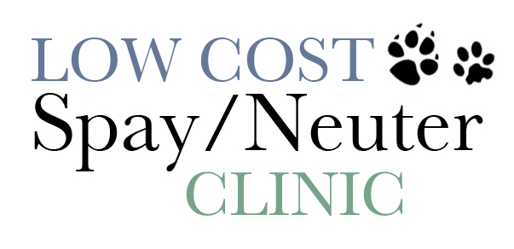
SURGICAL AFTER CARE INSTRUCTIONS

Please read the following guidelines to insure your pet a quick and healthy recovery! How to care for your pet after surgery is VERY important.

- Keep your animal in a temperature-controlled area (inside and warm) for 24 hours, even if your animal is normally kept outside.

- Offer small amounts of water (1/4 cup) in the evening (after 8pm) and if no vomiting occurs offer ¼ cup of food. Feed/water normally the next day. PUPPIES, however, may be fed normally in the evening of their surgery. Your dog may vomit the night of surgery or even the day after, this can be a normal reaction to anesthesia.

- Your DOG may act sedated or sleepy from the medications we used but they should become progressively more active and alert. IF excessive lethargy continues for 2 – 3 days (and no pain medication was given) please let us know or contact your regular veterinarian.

- DOGS should be confined and their activity restricted to leash walks only for 7 – 10 days. Excessive running, jumping and playing may lead to opening of the incision site and infection.

- DOGS may try to lick the surgical site, especially males. Male dogs with larger testicles are more prone to swelling and pain. A medical collar is strongly recommended for every animal undergoing spay/neuter. Licking will lead to swelling, infection and possible failure of the closure.

- Sutures DO NOT need to be removed; they are dissolvable

- A cool compress can be used for the first 24 – 48 hours on the incision site (if the animal allows) for 5 – 10 minutes 2 – 3 times a day. This can help with pain and excessive swelling.

- Male DOGS remain virile and able to reproduce for 3-4 weeks after surgery, so please keep them confined. Female DOGS that were in heat at time of surgery are at greater risk for bleeding and may continue to spot for a short time after surgery. Keep them away from any male dogs for 3 weeks to allow for sutures to heal.

- Please do not bathe animals for at least 10 days after day of surgery.

- These are possible complications with spay/neutering procedure and we make every effort to minimize these occurring. Contact us or your regular veterinarian if you see:
Bleeding
Excessive swelling
Green/yellow discharge at incision site
Excessive pain
If the incision site opens up and abdominal content is seen this is an emergency and needs immediate attention!!!!!
Questions or Concerns?
Please call* between 7 am and 5 pm Monday through Thursday. (928) 692 – 5226

Emergency?
For an Emergency after surgery call our
Emergency hotline after hours at
(928) 224-5990

