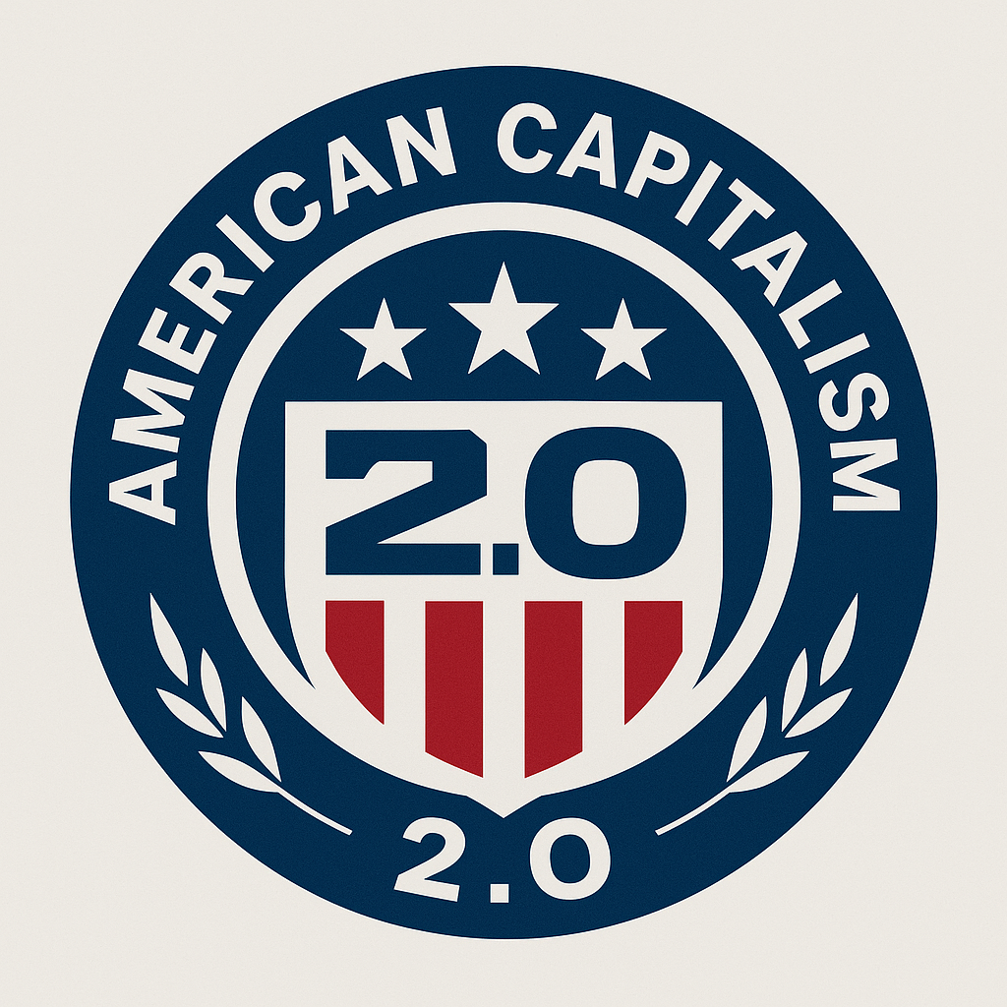
American Capitalism 2.0 — For a Strong America
American Capitalism 2.0 — For a Strong America
A Framework for a Stable, Broad, Middle-Class Future Built on Innovation, Ownership, and Small-Business Prosperity
---
Abstract
American Capitalism 2.0 is a comprehensive economic philosophy designed to restore broad middle-class prosperity, secure long-term national stability, and realign capitalism with its essential purpose: enabling ordinary people to build dignified lives through opportunity, ownership, and meaningful participation in the economy.
This thesis synthesizes the strengths of mid-20th-century American capitalism, the competitive dynamism of modern markets, and the stability mechanisms of successful mixed economies worldwide. It presents a clear, practical, politically viable path that prioritizes small businesses, distributes the benefits of automation, restores fair competition, strengthens local communities, and ensures that the American middle class grows with the economy rather than shrinking beneath it.
This is not socialism, nor is it libertarianism. It is a balanced, innovation-driven capitalist model designed for a 21st-century world.
---
Table of Contents
1. Introduction 2. The Problem: Capitalism in Its Current Form 3. The Historical Baseline: When Capitalism Worked 4. Core Principles of American Capitalism 2.0 5. Policy Pillars - Wage–Productivity Partnership - Anti-Monopoly Revival - Automation Dividend - American Health Guarantee - Reduced Workweek Transition - Skilled Trades & Reshoring Revival - Small Business First 6. Implementation Strategy (Phases 1–4) 7. Expected Outcomes 8. Why This Model Is Politically Salable 9. Conclusion 10. Appendix: 1-Page Platform Summary
---
1. Introduction
American capitalism stands at a crossroads. For the first time in modern history, productivity, innovation, and wealth creation no longer translate into broad middle-class prosperity. The economy grows, but the median household does not. Automation accelerates, but its benefits concentrate. Corporate power expands, but small businesses struggle to survive. The gap between shareholders and workers widens year after year.
American Capitalism 2.0 proposes a straightforward premise:
> If markets are to remain free, they must remain fair. > If capitalism is to remain sustainable, prosperity must remain broad.
The goal is not to replace capitalism, but to fix it — with tools that work in the real world.
---
2. The Problem: Capitalism in Its Current Form
2.1 Wages stagnate while productivity explodes
Since the late 1970s, worker productivity has grown dramatically while real wages have barely moved. The gains of growth accrue primarily to capital owners instead of being shared with the people whose labor and participation make that growth possible.
2.2 Monopolies dominate key markets
In sector after sector, four or five corporations control most of the market:
- Internet advertising - Retail logistics - Pharmaceuticals - Digital marketplaces - Cloud infrastructure
Competition — capitalism’s core engine — is suffocating under concentration and platform dominance.
2.3 Automation concentrates wealth
Automation increases output and reduces costs. But without structural mechanisms to distribute its benefits, the gains flow almost entirely to shareholders and executives. Workers are displaced or deskilled, while the consumer base that capitalism depends on is weakened.
2.4 Healthcare and fixed costs crush small businesses
In the current system, healthcare, childcare, and other fixed costs land heavily on small employers and families. This:
- discourages entrepreneurship - reduces worker mobility - makes small business less competitive than large firms with scale advantages
2.5 The middle class shrinks
Homeownership, savings capacity, and economic security are increasingly out of reach for many households. Debt replaces savings. Instability replaces confidence. A capitalism that cannot reproduce a broad middle class becomes socially and politically fragile.
Modern capitalism, in its current configuration, is no longer producing a self-renewing middle class. That failure threatens both economic stability and national cohesion.
---
3. The Historical Baseline: When Capitalism Worked
Between roughly 1945 and 1975, the United States experienced broad, shared prosperity:
- strong competition and antitrust enforcement - strong unions and collective bargaining - wage growth linked to productivity - reinvestment of profits into domestic production - local business ecosystems and community banks - expanding homeownership and education access - progressive taxation supporting public goods
This system was not perfect, but it did something crucial: it allowed millions of families to enter and remain in the middle class. Capitalism was not only productive — it was broadly legitimized.
American Capitalism 2.0 does not attempt to recreate the mid-20th century. Instead, it updates the underlying logic of that era — shared prosperity, strong competition, and domestic opportunity — for a world of automation, global supply chains, and digital platforms.
---
4. Core Principles of American Capitalism 2.0
American Capitalism 2.0 rests on six core principles.
4.1 Markets must be competitive, not consolidated
Capitalism collapses into a kind of neo-feudalism when dominated by monopolies and oligopolies. Competition must be restored and protected as a first-order principle.
4.2 Workers must benefit from the productivity they help create
When corporate profits rise, wages and worker equity must rise. The link between productivity and broad prosperity cannot remain severed without long-term damage.
4.3 Automation must enrich society, not only shareholders
Automation should strengthen the consumer base, not hollow it out. As machines take over more tasks, the gains must circulate back into households and communities.
4.4 Small business must be restored as the backbone of the economy
Local ownership keeps wealth circulating within communities. Small businesses generate jobs, innovation, and social cohesion in ways large corporations often cannot.
4.5 Essential services must enable mobility and opportunity
Healthcare, childcare, education, and basic security must be structured so that they enable risk-taking, entrepreneurship, and mobility — not trap people in bad jobs or permanent precarity.
4.6 Work should evolve as productivity rises
Over the last century, productivity gains justified the eight-hour workday. In the 21st century, rising productivity should allow shorter workweeks without loss of income. Time prosperity is part of a Strong America.
These principles are the foundation of the model.
---
5. Policy Pillars
Overview
The policy framework for American Capitalism 2.0 is organized into seven mutually reinforcing pillars:
1. Wage–Productivity Partnership 2. Anti-Monopoly Revival 3. Automation Dividend 4. American Health Guarantee 5. Reduced Workweek Transition 6. Skilled Trades & Reshoring Revival 7. Small Business First
Each pillar is described below.
---
5.1 Pillar 1: Wage–Productivity Partnership
A modernized version of the postwar social contract.
**Goal:** When companies grow, workers grow.
**Mechanisms:**
- profit-sharing requirements or incentives for large firms - worker equity pools that grant employees a stake in long-term value - tax credits for firms whose wage growth tracks profitability and productivity - conditioning executive bonuses and certain corporate tax advantages on wage floors and profit-sharing performance
**Impact:**
- reconnects wage growth to economic growth - builds household resilience and savings - reduces the need for excessive debt - helps rebuild a strong and confident middle class
---
5.2 Pillar 2: Anti-Monopoly Revival
Restore competition as the core of the economy.
**Goal:** Level the playing field for small business and new entrants.
**Mechanisms:**
- enforce existing antitrust law with modern understanding of digital markets - block predatory or anti-competitive mergers and acquisitions - regulate dominant digital platforms that function as essential infrastructure - challenge abusive vertical integration that locks out suppliers and competitors
**Impact:**
- lowers prices and increases quality over time - opens space for innovation from startups and local firms - prevents a handful of corporations from dominating key sectors - keeps capitalism dynamic instead of stagnant
---
5.3 Pillar 3: Automation Dividend
Automation must reinforce, not erode, consumer purchasing power.
**Goal:** Ensure that as automation grows, the American people stay strong as consumers and citizens.
**Mechanisms:**
- establish a small levy or micro-tax on automated labor where it directly replaces human roles at scale - route this revenue into a national Automation Dividend Fund - pay regular, modest, universal dividends to citizens, similar to Alaska’s oil dividend model
**Impact:**
- creates a direct link between technological progress and household stability - keeps demand strong as labor income becomes more volatile - helps ease transitions in heavily automated industries
---
5.4 Pillar 4: American Health Guarantee
Universal protection without government-run medicine.
**Goal:** Affordable, predictable healthcare that does not crush families or small businesses.
**Mechanisms:**
- eliminate surprise billing and opaque pricing - cap out-of-pocket costs for essential care - guarantee catastrophic coverage for all residents - maintain private doctors and hospitals but regulate insurance markets for transparency and fairness
**Impact:**
- makes entrepreneurship less risky - reduces job lock, allowing workers to move where they are most productive - stabilizes household finances - keeps small businesses viable and competitive
---
5.5 Pillar 5: Reduced Workweek Transition
Productivity gains should translate into time gains.
**Goal:** More time for family, community, health, and civic life — without cutting pay.
**Mechanisms:**
- encourage an optional transition to a 36–32 hour standard workweek over 8–12 years - maintain full-time pay for full-time roles - offer tax incentives for early adopters and pilot programs - rigorously measure productivity, retention, and health outcomes
**Impact:**
- better mental and physical health - stronger families and communities - higher per-hour productivity - a modern standard of living where a Strong America values time as well as income
---
5.6 Pillar 6: Skilled Trades & Reshoring Revival
Rebuild America’s productive base with modern tools.
**Goal:** Make things in America again, with high-skill, high-wage jobs.
**Mechanisms:**
- national apprenticeship and vocational training systems linked to real employers - new industrial corridors with streamlined permitting and modern infrastructure - reshoring incentives for strategic industries and critical supply chains - vocational-track high school programs aligned with local and regional industry needs
**Impact:**
- stable, non-fragile local economies - viable career paths that do not require a four-year degree - reduced dependence on fragile global supply chains - a workforce matched to 21st-century industrial needs
---
5.7 Pillar 7: Small Business First
Small business is the centerpiece of American Capitalism 2.0.
**Goal:** Make small businesses the primary engine of prosperity and community strength.
**Mechanisms:**
- lower effective tax rates for genuinely small firms, phasing out advantages as companies scale - procurement preferences for local and small vendors in government contracts - simplified regulatory and reporting requirements without weakening core safety and labor protections - improved access to capital through loan guarantees, community banking, and credit unions - zoning and policy measures that give local businesses a fair shot against large chains - technical and tax support for small-business adoption of appropriate automation
**Impact:**
- millions of new and revitalized businesses - stronger Main Streets and local economies - broader ownership of productive assets - a more resilient and diverse national economy
---
6. Implementation Strategy
American Capitalism 2.0 is enacted in four overlapping phases.
Phase 1 (Years 0–2): Stabilization
**Purpose:** Build trust and demonstrate early wins.
Key actions:
- aggressively enforce existing antitrust laws - end surprise billing and improve healthcare price transparency - launch the Automation Dividend Fund with modest initial payouts - expand funding for vocational programs and apprenticeships - initiate tax reforms that favor small businesses
---
Phase 2 (Years 2–6): Restructuring
**Purpose:** Shift the underlying incentives inside capitalism.
Key actions:
- introduce wage–productivity partnership incentives - expand profit-sharing and worker equity mechanisms - pilot reduced workweek programs with robust evaluation - scale up the Automation Dividend alongside automation growth - formally designate new industrial corridors and support reshoring initiatives
---
Phase 3 (Years 6–12): Expansion
**Purpose:** Normalize the new model.
Key actions:
- normalize a 32–36 hour workweek in many sectors - fully implement the American Health Guarantee with catastrophic coverage and caps - deepen small-business advantages in tax and procurement policy - grow the Automation Dividend into a meaningful, predictable supplement to household income - expand modern industrial ecosystems across multiple regions
---
Phase 4 (Years 12–20): Consolidation
**Purpose:** Lock in a Strong America built on broad prosperity.
Key actions:
- monitor and maintain a healthy wage–productivity link - keep market concentration in check through ongoing antitrust enforcement - ensure the Automation Dividend Fund and related institutions are permanent, transparent, and accountable - regularly review and update vocational, trade, and industrial strategies in light of new technology - track middle-class strength, small-business formation, and regional equity as primary success metrics
---
7. Expected Outcomes
If implemented, American Capitalism 2.0 is expected to produce:
- a significantly larger and more secure middle class - stronger small-business ecosystems in urban, suburban, and rural areas - reduced economic inequality without eliminating incentives for innovation and excellence - more robust competition and faster innovation - revitalized communities anchored by local ownership - stable long-term corporate growth in a less fragile macro environment - reduced political extremism fueled by economic insecurity - a capitalism model that can coexist with high automation and global complexity
In short: Strong Markets. Strong Middle Class. Strong America.
---
8. Why This Model Is Politically Salable
American Capitalism 2.0 draws support from across the spectrum:
- **Conservatives** can support its emphasis on small business, entrepreneurship, ownership, and strong markets. - **Liberals** can support its focus on workers, healthcare access, and shared prosperity. - **Libertarians** can support its opposition to monopolies and its preference for market-driven solutions where possible. - **Centrists and independents** can support its pragmatism, balance, and emphasis on stability.
It explicitly opposes:
- predatory monopolistic behavior - exploitative business practices that hollow out communities - policies that crush small business formation - economic structures that shrink the middle class over time
This is a big-tent model built for American political reality and for a Strong America.
---
9. Conclusion
American Capitalism 2.0 is not a rejection of capitalism. It is capitalism repaired and renewed.
It recognizes that:
- markets need real competition - workers need dignity, security, and upside - small businesses need room to breathe - automation must enrich the people as well as the balance sheet - essential services must enable, not block, mobility and opportunity - prosperity must be broad, not narrow, if it is to endure
This model modernizes the strengths of America’s past, adapts them to present realities, and builds a stable, prosperous, dynamic future. It is not utopian. It is pragmatic, actionable, and built from tools that already exist — assembled into a coherent, Strong America framework.
---
10. Appendix: 1-Page Platform Summary
**American Capitalism 2.0 — For a Strong America**
Six Core Goals
1. **Make work pay again** - Profit-sharing, worker equity, wage–productivity link.
2. **Break up monopolies** - Restore competition and opportunity.
3. **Automation pays the people** - A national Automation Dividend that keeps demand strong.
4. **Affordable healthcare without socialized medicine** - American Health Guarantee: no surprise bills, caps on costs.
5. **Shorter workweek, same pay** - Time prosperity as part of a modern standard of living.
6. **Small business first** - Tax, regulatory, and procurement advantages for local businesses.
**Strong Markets. Strong Middle Class. Strong America.**

