ECAA Web Site

Analysis and Development Guide

Revision: 1.0

RevisionDate: 11/02/2014

Version History

| Date | Author | Description |
| --- | --- | --- |
| 11/02/2013 | Tekola | This document is currently at the Draft stage. |
| 11/08/2013 | Tekola | Initial web site review and document current page flow |
|  |  |  |
|  |  |  |
|  |  |  |
|  |  |  |
|  |  |  |

**Initial Requirements**

The ECCA website needs to be updated in order to make it more attractive and add few functional items. The committee formed to find ways to do this website put the following few items to be added or modified:

1. Payment system to enable members to pay online either directly to the Community’s account, or through Square or PayPal.
2. Enabling the Home Page (Front Page) to be modified and added according to the need by the Community’s Website Administrator.
3. Putting very basic information such as address, phone # and e-mails on the front page.
4. Creating access to members and new members’ individual log-ins to update their info, pay membership fee or donate. Or creating an update form so that the members can fill and send to the designated person in the community.
5. An access that leads to the community membership form before being a member to the Idir.
6. Members data base and accessibility
7. Enabling the system to automatically remind members due dates either through e-mails or texts.
8. Re categorizing icons on the front page.
9. Utilizing spaces for commercials
10. Making the website more attractive.
11. Enabling access from mobile phones
12. Creating link to other organizations

**Current Web Site Information**

Site Navigation from the main page http://www.ethiopiancaa.org/Default.aspx

* The site has 6 main pages

[**HOME, ABOUT US, PRESS, FROMS, CONTACT US and LINKKS**]

Each web page navigates to a lower level page of it own as documented below

1. **Current home page [Home]**

* No lower level pages for the HOME page

The HOME page includes

1. The Ethiopian community logo at the top page
2. The websites main menu
3. A photo display section below the menu – pictures are rotated every few sec
4. The main page body includes,

Left side page [“News &Event link, Live Radio Link,

PayPal Donate Button, Membership Form link]

Right side page [ECAA Text and link to [Home](http://www.ethiopiancaa.org/Default.aspx) -> [About Us](http://www.ethiopiancaa.org/About/Default.aspx) -> History,

Sign up and volunteers page link “Apply”]

**HOME page**

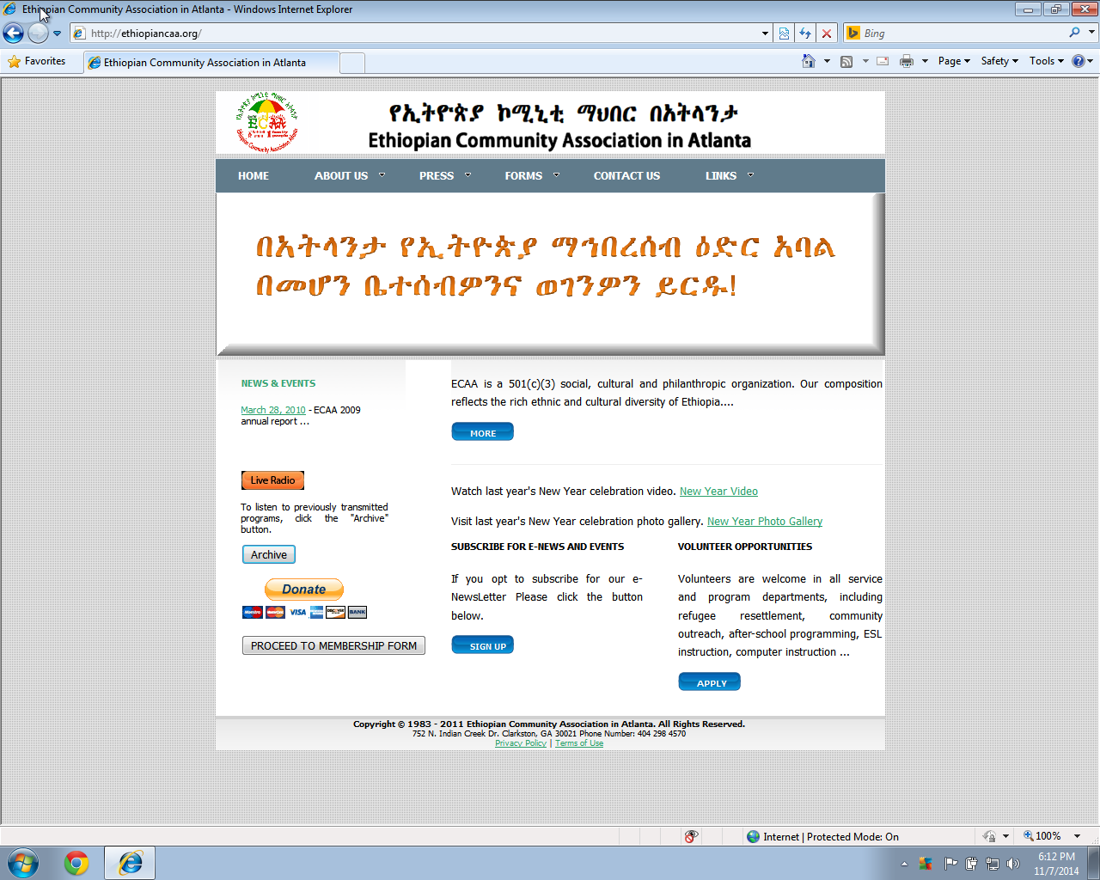

1. **ABOUT US page**

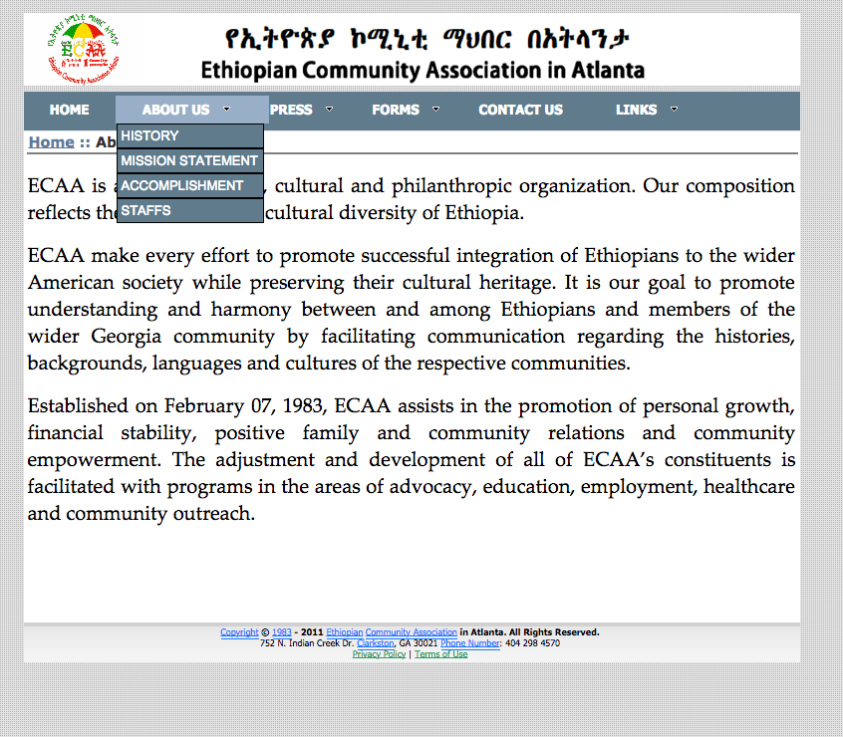

**2.1 About us -> History page**

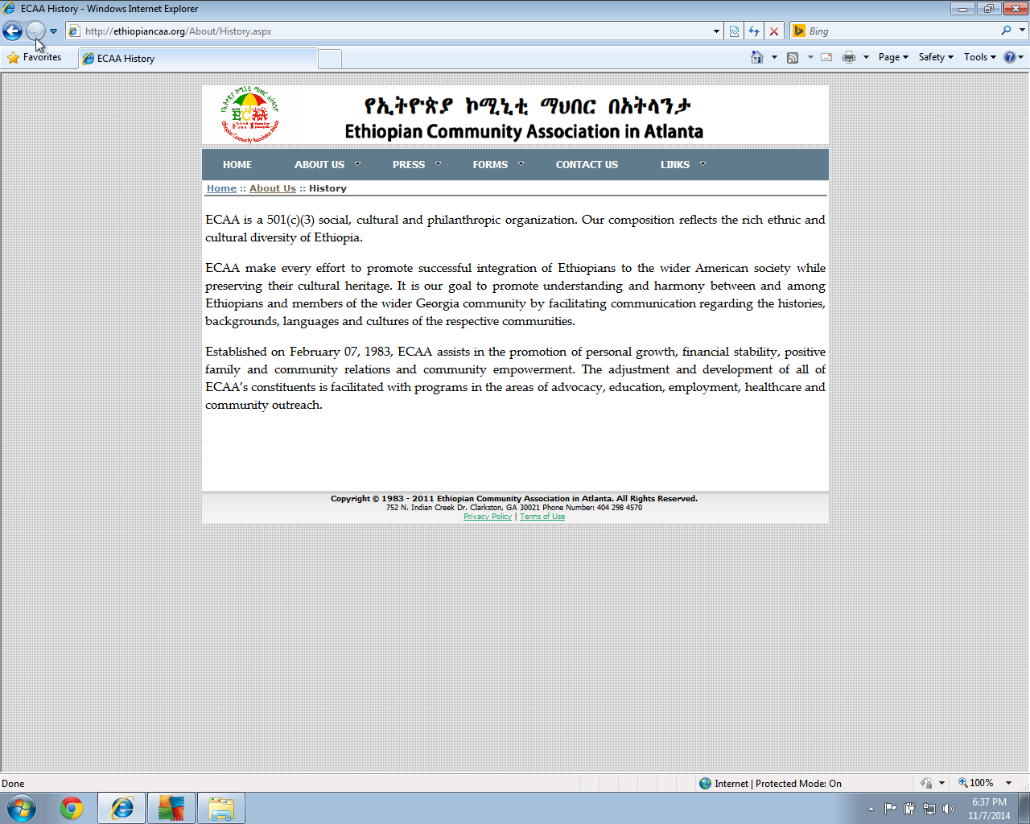

**2.2 About us –> Mission Statement**

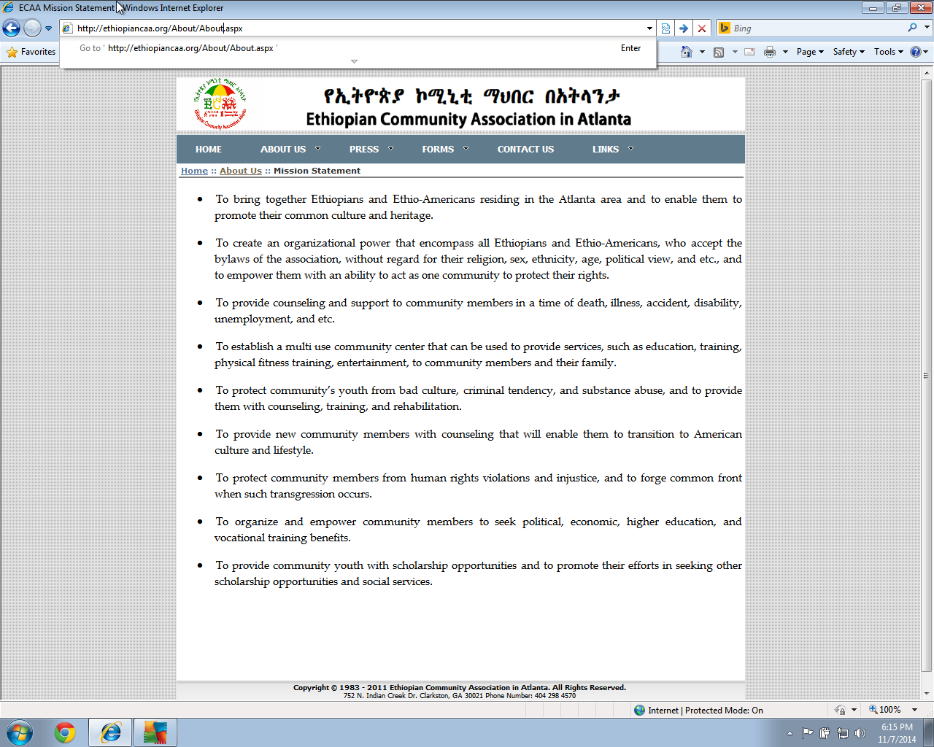

1. **PRESS page**

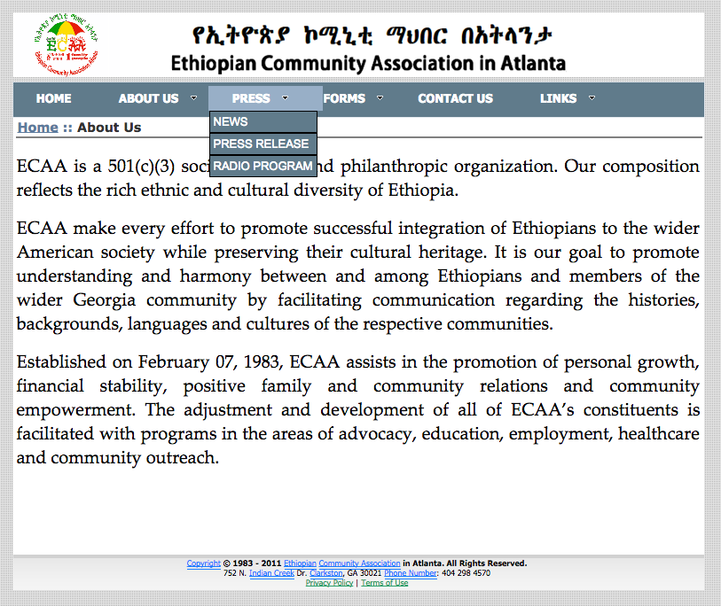

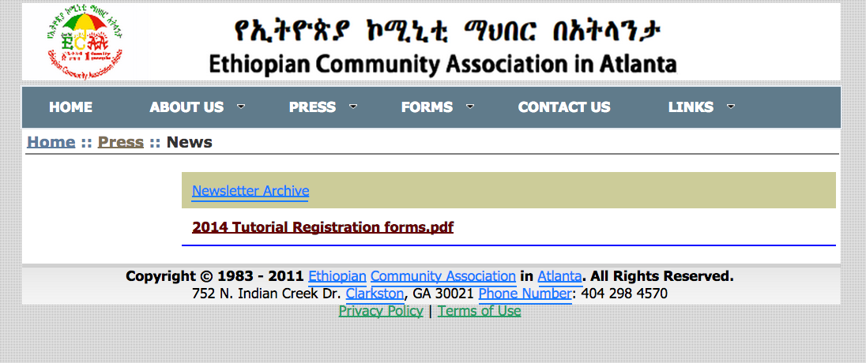

* News page , Text news and radio links .

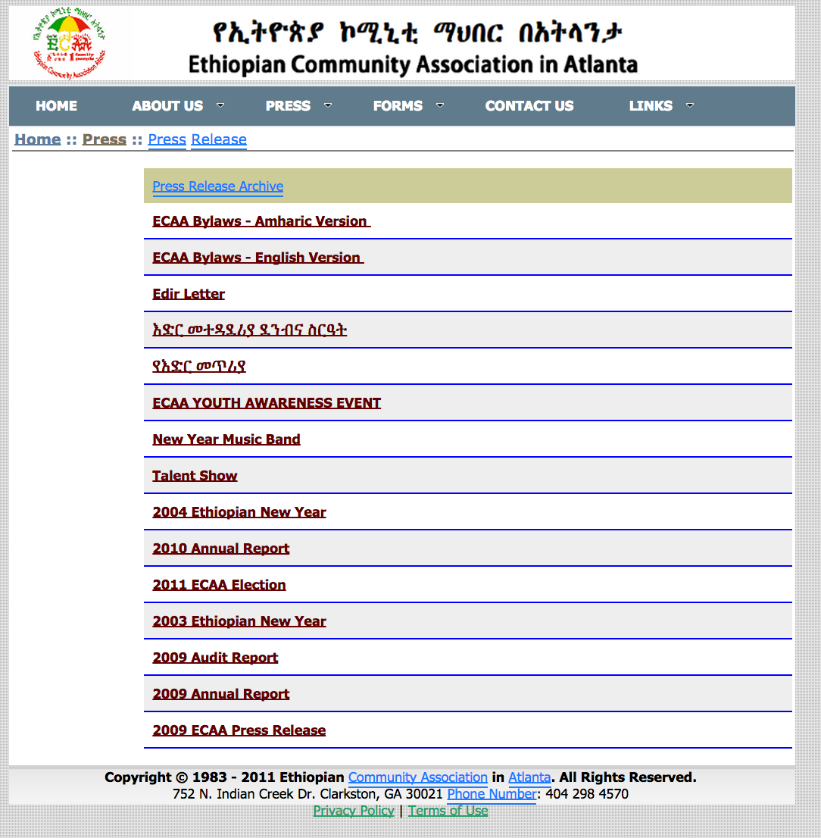

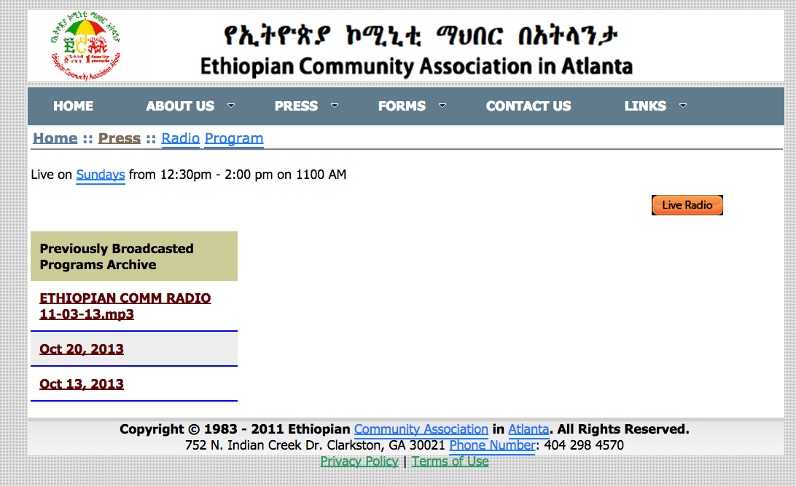

1. **FORMS Page**

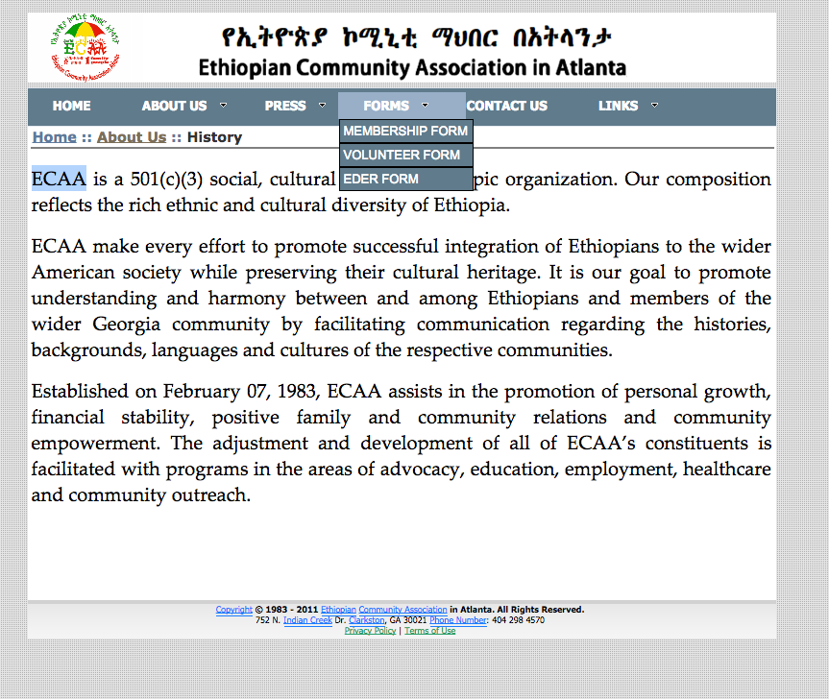

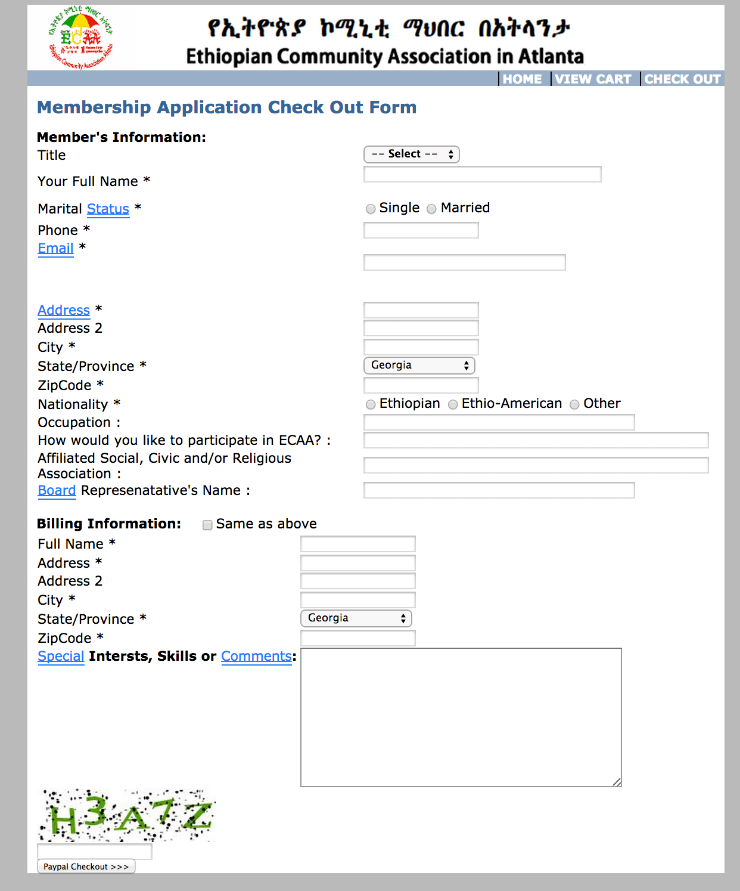

* update the form based the hard copy
* add the volunteer choice on this page and remove the other page .

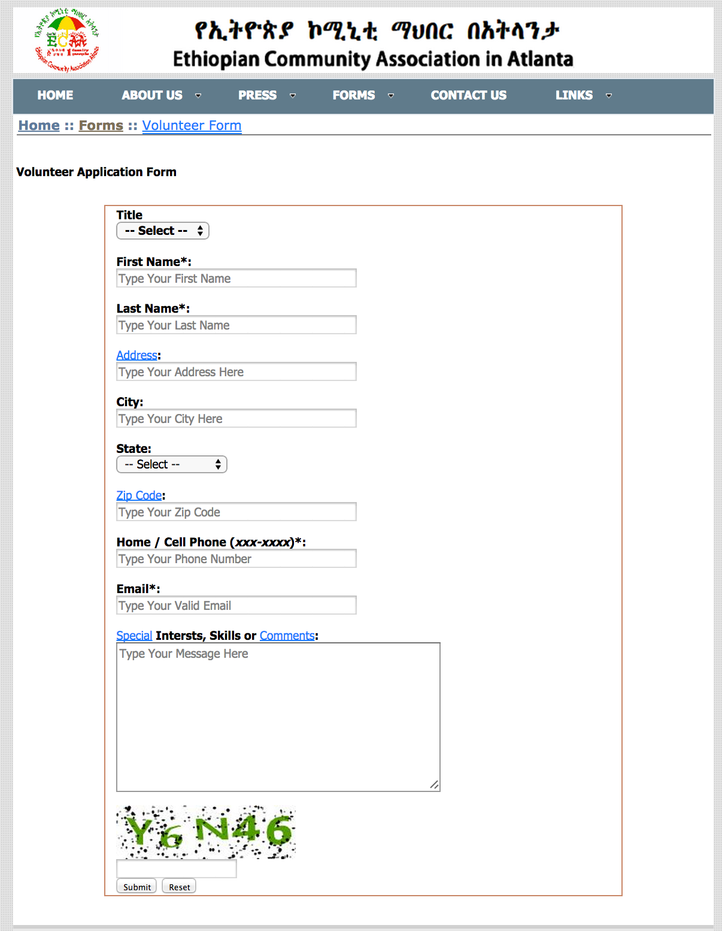

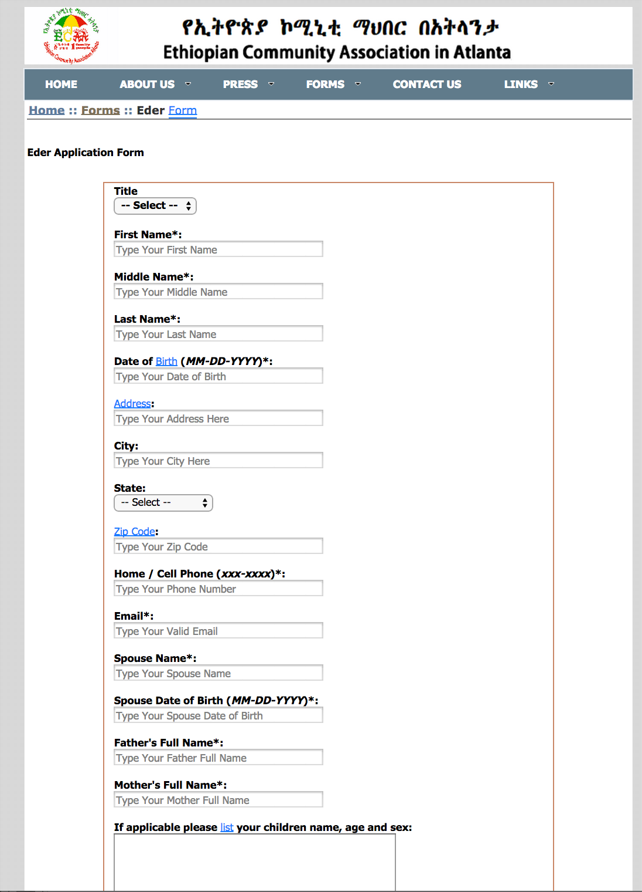

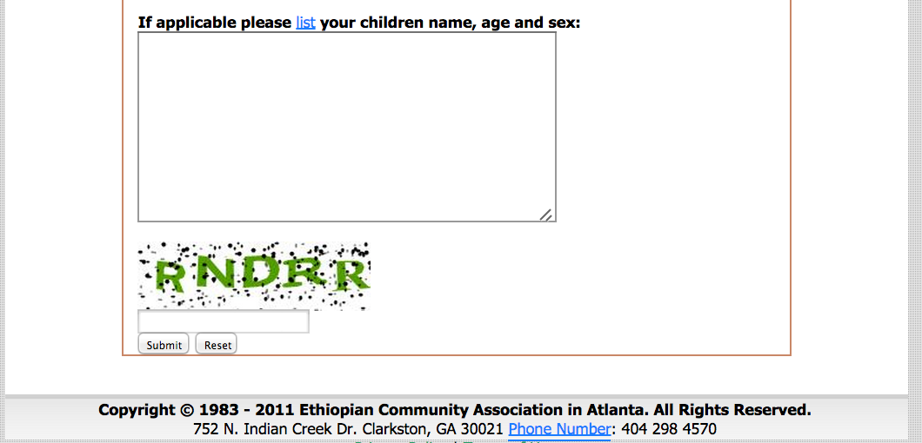

1. **CONTACT US page**

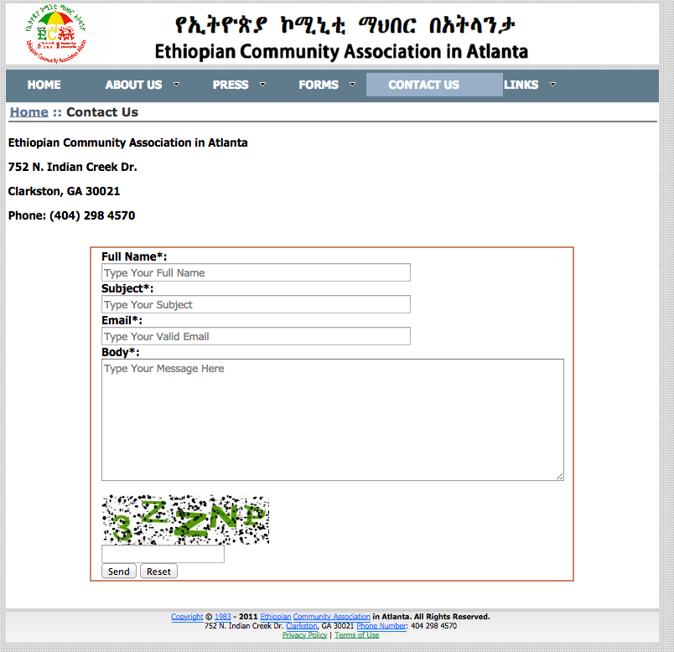

1. **LINK page**

