To
The Principal,
Khwopa College of Engineering,
Libali, Bhaktapur-8
Subject: Consent to Engage as Faculty Member for New Program
Respected Sir/Madam,

I hereby give my full consent to serve as an academic faculty member for a period of 2 years in the proposed BSc CSIT program being introduced under Tribhuvan University. I affirm my commitment to actively participate in teaching, academic duties, and other responsibilities assigned within the program, and to contribute toward its effective implementation and success.
Sincerely,
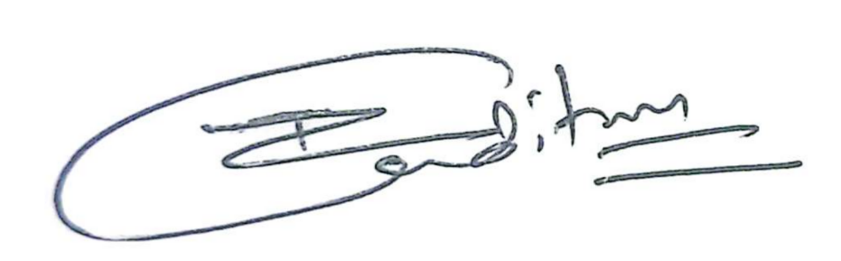
Tek Raj Joshi
4th April 2026

