Bites

Breakfast (served all day)
Breakfast Burrito
Cilantro Lime Black Beans, Peppers, Red Onions, Eggs, and Cheese Wrapped in a Flour Tortilla and Toasted. Served with Salsa.
Breakfast Sandwich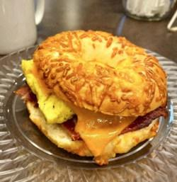
Your Choice of Sausage or Bacon Topped with Egg, Sharp Cheddar, and Smoked Pepper Aioli on an Asiago Bagel.
Bacon Quiche
Made with Bacon and Sharp Cheddar on a Fluffy Puff Pastry Crust.
Veggie Quiche
Made with Mushroom, Spinach, Red Onion, and Feta on a Fluffy Puff Pastry Crust.
Bagels
Everything or Plain with Butter or Cream Cheese

Lunch (served all day)
Bagel Sandwiches
Turkey or Ham with Provolone
Soup of the Week
*More items coming soon!

Pastries
Scones
Baked Fresh Daily; Cranberry Orange or Chocolate Chunk
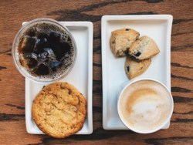Mini Scones
Blueberry or White Chocolate
Large Cookies
Frosted Sugar, Heath, or Reese’s
Small Cookies
Cranberry Oat, Chocolate Chip, or Oatmeal
Cinnamon Rolls
Baked Fresh Daily
Muffins
Apple Cinnamon Streusel, Blueberry, or Wildberry
Large Danish
Cherry, Apple, or Cream Cheese
Bar Pastry
Pumpkin Bar or Lemon Bar
Cake
Coffee Cake, Carrot Cake, or Chocolate Cake

Other
Yogurt
Cheese Stick
Oatmeal
Pro Bar

