Subscriptions
Did you know you can have your Roasters coffee delivered right to your doorstep? With our new subscription program, you’ll never have to worry about running out of your favorite beans again!

Our subscriptions are customized just for you. You decide the frequency at which you’d like to receive your beans, the amount you’d like delivered each time, the type of bean you’d like, as well as if you’d like your beans ground or whole.

You may choose to have 1/2 lb or 1 lb of your bean of choice delivered either once or twice per month. You may also select our popular “Around the World” option to have a different type of bean delivered each time. If you choose our “Flavor of the Month” option, we will send you a different type of flavored bean each time.

Our subscription prices are as follows (per delivery period):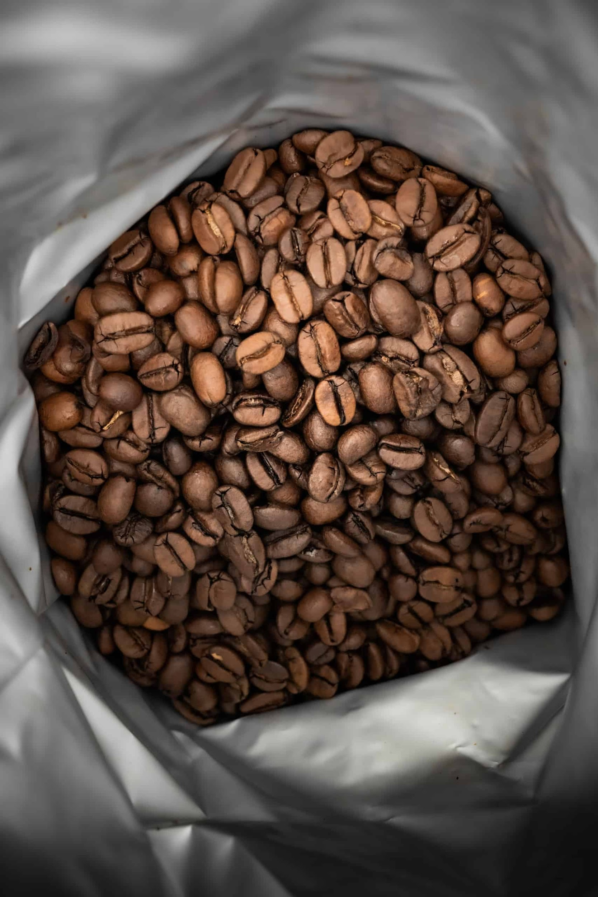

Around the World: 1/2 lb – $16.15, 1 lb – $23.65
Blends, Espresso, Flavored Beans, and Flavor of the Month: 1/2 lb – $15.85, 1 lb – $22.90
Brazil, Colombia, El Triunfo, Guatemala, Malabar, Mexico, Peru: 1/2 lb – $15.85, 1 lb – $22.90
Costa Rica La Minita: 1/2 lb – $17.15, 1 lb – $25.65
Decaf, Papua New Guinea: 1/2 lb – $16.15, 1 lb – $23.65
Ethiopian Sidamo, Ethiopian Yirgacheffe, Harimau, Kenya AA, Sumatra: 1/2 lb – $16.65, 1 lb – $24.65

Please fill out the form below to select your subscription preferences and we will email you a payment link.

Name(Required)
Email(Required)
Phone(Required)
Shipping Address(Required)
Street Address
Address Line 2
City
AlabamaAlaskaAmerican SamoaArizonaArkansasCaliforniaColoradoConnecticutDelawareDistrict of ColumbiaFloridaGeorgiaGuamHawaiiIdahoIllinoisIndianaIowaKansasKentuckyLouisianaMaineMarylandMassachusettsMichiganMinnesotaMississippiMissouriMontanaNebraskaNevadaNew HampshireNew JerseyNew MexicoNew YorkNorth CarolinaNorth DakotaNorthern Mariana IslandsOhioOklahomaOregonPennsylvaniaPuerto RicoRhode IslandSouth CarolinaSouth DakotaTennesseeTexasUtahU.S. Virgin IslandsVermontVirginiaWashingtonWest VirginiaWisconsinWyomingArmed Forces AmericasArmed Forces EuropeArmed Forces Pacific
State
ZIP Code
Type of Bean(Required)
Around the WorldBlend (specify in comments)Brazil DarkColombiaCosta Rica La MinitaDecafEl TriunfoEspressoEthoipia SidamoEthiopia YirgacheffeFlavor of the MonthFlavored (specify in comments)GuatemalaHarimauKenya AAMalabarMexicoPapua New GuineaPeru DarkSumatra
Quantity(Required)
1 Pound
1/2 Pound
Bean(Required)
Whole Bean
Ground Bean
Frequency(Required)
Monthly
Bi-Weekly
Other Notes

