Tell us about yourself?
Well, I am currently a PhD student in North Dakota State University. Since I started my Masters I have been dealing with ASIC and logic design. I have worked on different projects for example I have implemented a reconfigurable and fault tolerant on chip communication structure for SoC. I have used different tools such as Cadence Encounter, ncsim, RTL compiler and in programming especially in Verilog, C++, Python, and Perl. I also have a good understanding of static timing analysis and logic synthesis. I feel certain that my qualifications, experience and education match the job requirements.
On the other hand, I am a 3rd year PhD student and planning to graduate by at most spring of 2013. I am done with the course work requirement of the department and I believe I am in good point regarding my thesis I have been able to publish some papers. I am interested in finding job in industry and right now looking for an internship which can be a jump start me for a full time job after my graduation.

Tell me about yourself?
Well, I am currently a Digital Design and Verification Engineer in John Deere. Since I started my Masters I have been dealing with digital and logic design. During my PhD studies I was working on reconfigurable and low latency communication structure for multiprocessor systems. We proposed different systems and implemented and verified our design on FPGAs. After graduation, in I started to work for John Deere, where I am working on FPGAs. Over this years, dealing with different digital systems, I have a good understanding digital design and specially FPGAs, and that is why I believe I can be a good fit for this position.
Visa
I have started to work on OPT which is valid until June 2015, and can be extended for 17 more months. I am also in process of applying for Green card through NIW program. I don't think I will need visa sponsorship.
What do you know about SIG?
I came across some articles talking about high frequency trading, and how FPGA are used for faster data analysis in these systems. Since I work on highly parallel, and low latency systems and deal with FPGAs, I noticed that this can be good career for me. I was checking the companies in this field. When I noticed that you have this opening for an FPGA engineer and I read (you know there are this sites that lets people to basically rate their company) employee reviews about the company. They had mostly positive view on management and the work environment that is very collaborative, and people talked about the trainings that company provides.
Why do you want to leave your current job?
Since my current job is contract based and for a short time, I am open to new positions.

Tell me about the mistakes you have made? What have you learned from your mistakes?
When you are starting to work on a new project you don’t want to start from scratch. For example in school you can re-use what has been done by other students or even from other schools, use the results of the published researches available online. What I learned hard way was that you should not blindly trust these works. Most often they are not fully tested, and may not work properly under certain conditions.
Also as I said you don’t want to start every project from scratch, and usually you can build the new project on top of the previous work you have done yourself. By time I learned about the importance of the reusability. Now whatever I work on I do make sure that it is reusable in my future projects.
I think one of the most important things I've learned is persistence. Not to give up too soon, because the solution is probably right in front of me.
I'm a strong believer in leaning from my mistakes and even stronger believer in learning from the mistakes of others. If I can learn from other's mistakes I don't have to repeat them myself.

Where do you want to be in 5 years?
Well, I am not sure, I believe for an Electrical Engineer life is a process of non-stop improvement, I am prepared to learn new things and contribute to the overall success of the team I will be working with, and keep my eyes open for opportunities within the company to advance even if it means changing roles.

What’s your biggest weakness?
-You know, I used to help everybody by solving their problems which took my time so that sometimes I did not have enough time to do my own task, nowadays I try to show them how to help themselves and keep better control of my own task.
- I used to like to work on one project to its completion before starting on another, but I've learned to work on many projects at the same time, and I think it allows me to be more creative and effective in each one.

What Do You Expect From a Supervisor?
I would like to be able to go my manager if I have an issue or idea and to be able to feel comfortable to expressing my thoughts. I would also expect my supervisor to be open and honest with me and to let me know if there is anything I could do to improve upon or do differently in my work.
Someone with hands on experience, who is constantly giving me feedback

How Would You Describe Yourself?
-I'm a creative thinker. I like to explore alternative solutions to problems and have an open mind about what will work best.
-I'm efficient and highly organized. This enables me to be as productive as possible on the job.
-I enjoy solving problems, troubleshooting issues, and coming up with solutions in a timely manner.
- Adaptive

What Motivates You?
I've always been motivated by the desire to do a good job at whatever position I'm in. I want to excel and to be successful in my job, both for my own personal satisfaction and for my employer.

Do You Prefer to Work Independently or On a Team
I am equally comfortable working as a member of a team and independently. In researching there are some assignments that require a great deal of independent work and research and others where the team effort was most effective. As I said, I'm comfortable with both.

Describe your troubleshooting process
Troubleshooting is a systematic approach to solving a problem. The goal of troubleshooting is to determine why something does not work as expected and how to resolve the problem. The first step in the troubleshooting process is to describe the problem completely.
This step includes asking yourself basic questions:
- What are the symptoms of the problem?
- Where does the problem occur?
- When does the problem occur?
- Under which conditions does the problem occur?
- Can the problem be reproduced?
The answers to these questions typically lead to a good description of the problem, which can then lead you a problem resolution.
Do some online searching, and check the forums. Were others experiencing the same sort of difficulty?
• Repair/fix/replace the faulty item.
• Verify the repair by testing the product thoroughly. Make sure that your solution hasn’t effected performance of other sections in the system
I isolate the source of the problem by testing a peripheral with a second computer" or "I remove as much hardware as is possible to power up the device, and then add back components one by one until I can reproduce the problem",

How would your past experience translate into success in this job?
The position is looking for someone that is self-motivated. At NDSU, most of my job required independent action. You are also looking for someone with proficiency in both Digital and ASIC design. Ever since I started my graduate school I am dealing with ASIC and Digital design, I have good experience with related softwares and also by time I have because of the nature of the work I have developed and improved my programing skills.

Do you have any questions for me?
Could you tell me a little bit about the job?
How big is the group I will be working with?
What tools you are working with?
What are my responsibilities?

How would you describe your ideal position?
My ideal job is a job that I will be given the opportunity to learn, the power to drive projects, and the time from management to show that I can add positive benefit to the company's bottom line.

Give me an example of a time that you motivated others?
It really depends on the person and the situation. One of the things that I have learned by time is that I can motivate people by complementing their strengths, and recognizing for their achievements.

How you overcome difficulties when someone didn’t cooperate in the team?
When you are the project leader it’s your job to be able to recognize when someone is being difficult and showing signs of being unproductive. Then find out the reasons why by talking with this person. Maybe it’s because they are unqualified, unmotivated, or personal issues at home are the cause. You need to get to the root of the problem and keep that person from bringing down the whole team and putting the project off course. You certainly don’t want to miss deadlines because of one person.
When working in a group, what role do you typically take?
It depends on my experience and my skill level, in general if I have enough experience and skills I like to take leadership role, and guide the group towards the ultimate objective. If I am not qualified enough to take leadership role I would adapt to a leadership or subordinate role depending on the project, tasks, and needs of the group.

Why do you want to work here?
I’ve heard so much about this company and they are a leader in the industry. I’m impressed with the background and stories of the founders. This is the company I have been looking to work and grow with where things are constantly developing and changing and I believe I have a great deal of experience to offer. I believe working for XXX will give me the opportunity to use my skills on working on products that improve people’s life and on the other hand being part of a successful company will give me the opportunity to learn and experience and advance in my professional life.

Why should we hire you?
I should be hired for my skill, ability and my qualifications. With my skill set and abilities I can serve the company well and I am a person who strives for perfection in everything.
I'm a hard worker. I'm self-motivated.
I am a responsible and reliable person.

***************************************************************************
ASIC and FPGA

*****************************************************************************

What are the five stages of a classic Reduced Instruction Set Computing (RISC) pipeline?
Instruction Fetch; Instruction Decode; Memory Access; Execute; Write back

How would you implement a full-adder, both with and without carry-in?
With carry-in, write down the truth table, karnaugh graph, and the expression, then circuit. Without carry-in, it's a half adder.

Half adder
The half adder adds two single binary digits A and B. It has two outputs, sum (S) and carry (C).

Full adder
A full adder adds binary numbers and accounts for values carried in as well as out. A one-bit full adder adds three one-bit numbers, often written as A, B, and Cin

Half subtractor
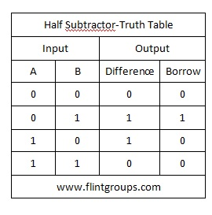

If you got a failure from the customer, how do you debug this? How do you prevent it to happen again?
1. Try to reproduce the problem in your own environment. Try to get customer's vector, so you can inject the same vector to create the problem in house.
2. If you confirm the problem and fix them, you should put the new assertion or test to catch the problem again. Add this new test in the future test plan, so the problem will not happen again.

Design a Gray counter to count 6.
The reflected binary code, also known as Gray code after Frank Gray, is a binary numeral system where two successive values differ in only one bit.
Dec Gray Binary
0 000 000
1 001 001
2 011 010
3 010 011
4 110 100
5 111 101
6 101 110
7 100 111
module gray_counter (
out , // counter out
enable , // enable for counter
clk , // clock
rst // active hight reset
);
//------------Input Ports--------------
input clk, rst, enable;
//----------Output Ports----------------
output [ 2:0] out;
//------------Internal Variables--------
wire [2:0] out;
reg [2:0] count;
//-------------Code Starts Here---------
always @ (posedge clk)
if (rst)
count <= 0;
else if (enable) begin
if(count < 3'b101)
count <= count + 1;
else
count <= 0;
end
assign out = { count[2], (count[2] ^ count[1]), (count[1] ^ count[0]) };
endmodule

Error checking by Gray code
Gray codes are widely used to facilitate error correction in digital communications such as digital terrestrial television and some cable TV systems. The advantage to only one bit changing in Gray code is that it gives you error-checking ability. If you sum the number of bits the bit total will always change by only one. You could also do some error checking knowing that the bit sum will always alternate between even and odd.
Gray Bit Sum
0000 0
0001 1
0011 2
0010 1
0110 2
0111 3
0101 2
0100 1

BCD to Gray converter
G3 = B3
G2 = B3 XOR B2
G1 = B2 XOR B1
G0 = B1 XOR B0

Gray to BCD converter
B3 = G3
B2 = B3 XOR G2
B1 = B2 XOR G1
B0 = B1 XOR G0

Design a circuit with minimum logic that receives a single digit, coded BCD (4 wires) and as an output gives you the result multiplied by 5 – also BCD coded (8 wires).
Let’s first make some order and present the input and required outputs in a table (always a good habit).
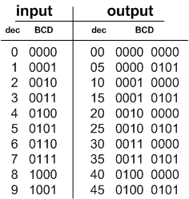
Looking for some patterns we can see that we actually don’t need any logic at all to solve this problem!
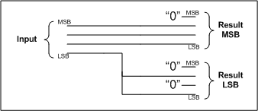

Counting the Number of “1″s
Add them.

One Hot Detection
The vector is one hot coded if only a single logic “1″ is allowed in the set.

Polymorphic Circuits
The basic concept is logic gates which under specific operating conditions behave in a certain way while under different operating conditions behave in another way. For example a circuit when operated with a 2 volt supply might act as an OR gate but when supplied with 1 volt will become an AND gate, or another example might be a circuit which in room temperature behaves as an XOR gate while at 120 degrees, the very same circuit operates as a NAND gate.

Carry-look ahead adder and ripple carry adder

ripple carry adder:
A ripple-carry adder works in the same way as pencil-and-paper methods of addition.
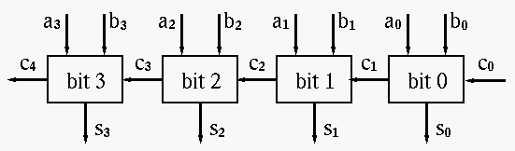
A carry-look-ahead adder improves speed by reducing the amount of time required to determine carry bits. It can be contrasted with the simpler, but usually slower, ripple carry adder for which the carry bit is calculated alongside the sum bit, and each bit must wait until the previous carry has been calculated to begin calculating its own result and carry bits. The carry-look-ahead adder calculates one or more carry bits before the sum, which reduces the wait time to calculate the result of the larger value bits. The Kogge-Stone adder and Brent-Kung adder are examples of this type of adder.
We are adding two n-bit numbers: x_{n-1}...x₀ to y_{n-1}...y₀ which results in z_{n-1}...z₀. In a ripple carry adder, we assign a full adder (call it adder i) to add x_{i} to y_{i}. We'll use the ripple carry adders which only uses full adders. Adder i also has a carry in. We'll call that c_{i}. It generates a carry out, which we'll call c_{i + 1}. We can write the Boolean expression for the carry-out in an alternate way:
c_{i+1} = x_{i}y_{i} + x_{i}c_{i} + y_{i}c_{i}
Let's define two terms:
gi = xiyi
pi = xi + yi
Then, we can rewrite c_{i + 1} using these two terms, as:
c_{i+1} = g_{i} + p_{i}c_{i}
g_{i} is called the generate term. This always generates a carry out. g_{i} = x_{i}.y_{i}, which is 1 only when x_{i} and y_{i} are both 1. Clearly, if two bits are 1, there's a carry.
p_{i} is called the propagate term. p_{i} = x_{i} + y_{i}. This could create a carry, but it may not. We know that at least one of x_{i} or y_{i} must be 1 if p_{i} = 1.
This is called propagate for the following reason. If exactly one of x_{i} or y_{i} is 1, then the carry-in determines whether there is a carry-out of 1 or not. Thus, if c_{i} is 1, there is a carry-in of 1, which will cause a carry-out of 1. If c_{i} is 0, then the carry-out is 0.
Why generate and propagate. If you look at the Boolean expressions for p_{i} and g_{i}, you will see that they both use only x_{i} and y_{i}. Neither depends on the carry. Since x_{i} and y_{i} are available immediately, this gives us hope that we can avoid waiting for carries.
This is how we do it. First, let's write the c₁ which is the carry out for the adding bit 0 of x and y.
c₁ = g₀ + p₀c₀
Now, we write it for c₂.
c₂ = g₁ + p₁c₁
At this point, we've used c₁, which we'd rather avoid, because it means waiting for that carry to be computed. However, we just defined c₁ (see the previous formula) as g₀ + c₀p₀.
Let's plug that in:
c₂ = g₁ + p₁(g₀ + p₀c₀)= g₁ + p₁g₀ + p₁p₀c₀
Notice that we no longer have c₁. That means we no longer have to wait for the carry!
Let's go one more step further:
c₃ = g₂ + p₂c₂
Again, we would prefer to avoid using c₂ since this requires us to wait for the result to propagate across two adders. However, we already have a Boolean expression for c₂ (we just computed it a moment ago) that doesn't use any carries except c₀ which we have right away.
c3 = g2 + p2c2 = g2 + p2(g1 + p1g0 + p1p0c0)
= g2 + p2g1 + p2p1g0 + p2p1p0c0
The idea is to construct a circuit for c_{i} that can be fed into the input of adder i. The carry-out of the adder is not used. In fact, each of the full-adders isn’t directly connected to each other. We simply design the circuit for c_{i} and feed it in.

Pulse Width Modulation (PWM)
The speed of a DC motor is controlled by the voltage across it. The way you control it, you actually put a PWM signal across the motor, and the duty cycle controls the speed. We turn the motor on and off very rapidly to control the speed. By changing the polarity across the motor we can change the direction the motor is turning. Usually for a DC motor we want to generate 2KHz signal.

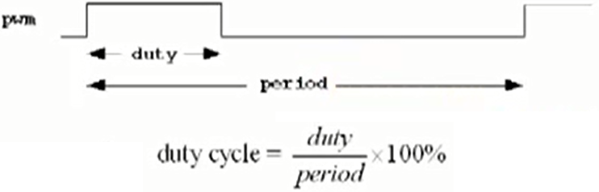
Master Slave flip flop
A positive-edge-triggered D flip-flop combines a pair of D latches.
It samples its D input and changes its Q and Q’ outputs only at the rising edge of a controlling CLK signal.
When CLK = 0, the first latch, called the master, is enabled (open) and the content of D is transferred to QM.
When CLK=1, the master latch is disabled (closed) and its output is transferred to the second latch, called the slave.
The slave latch is open all the while that CLK = 1, but changes only at the beginning of this interval, because the master is closed and unchanging during the rest of the interval.
Advantage: since the master and slave latches are never enabled at the same time, the entire master-slave flip-flop is never transparent.
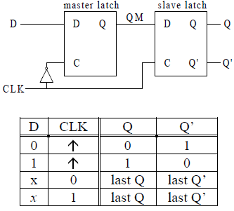

Transistor sizing
- If you have N, FET in series, scale each transistor by N
2. Ignore the parallel ones
3. Scale PUN by 3

FSM for a vending machine, every item is 15 cents, the inputs can only be 5, and 10 cents, and we don’t return the change
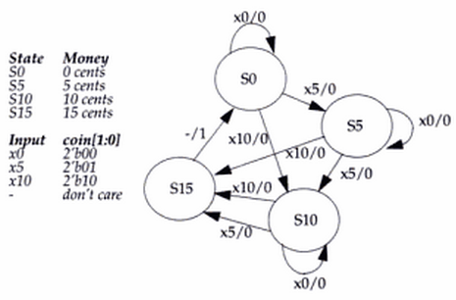

Current State |  | Input |  | Next state |  | Output
Q₁ | Q₀ | I₁ | I₀ | Q₁₊ | Q₀₊ | O
0 | 0 | 0 | 0 | 0 | 0 | 0
0 | 0 | 0 | 1 | 0 | 1 | 0
0 | 0 | 1 | 0 | 1 | 0 | 0
0 | 0 | 1 | 1 | x | x | x
0 | 1
1 | 0
1 | 1
The logic for O, Q₁₊, Q₀₊ logic can be computed using I₁, I₀, Q₁, and Q₀ as input in K-map.

module VendingMachine(input clk, input rst, input [1:0] in, output reg out)

reg [1:0] state; // we have 4 states and therefore we need 2 flip flops

always @(posedge clk) begin
if (rst) begin
out <= 0;
state <= 0;
end

else begin
if (state == 3) begin
state <= 0;
out <= 0
end
case (in)
2’b01: begin case (state)
2’b00: begin state <= 1; end
2’b01: begin state <= 2; end
2’b10: begin state <= 3; end
default: begin state <= state; end
endcase
2’b10: begin case (state)
2’b00: begin state <= 2; end
2’b01: begin state <= 3; end
2’b10: begin state <= 3; end
default: begin state <= state; end
endcase
default: begin state <= state; end
endcase

if (state == 3) begin
out <= 1;
end
end
end
endmodule

The code below is not synthesizable:
That is because we don’t know the value of x and y and therefore we don’t know how many times the loop will be repeated.

input [3:0] x;
input [3:0] y;

while (x != y) begin
…
end

Ripple counter
A ripple counter is a counter in which state transitions of one or more flip flops are triggered by the outputs of other flip flops in the circuit. If all flip flops in the counter are triggered by a common clock pulse, then the counter is called a "synchronous counter".
A ripple counter is a counter that will ripple through the information sequentially.
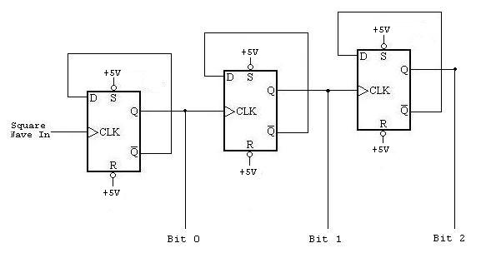
Ring counter
A ring counter is a type of counter composed of a circular shift register. The output of the last shift register is fed to the input of the first register.
There are two types of ring counters:
- A straight ring counter or Overbeck counter: with initial register values of 1000, the repeating pattern is: 1000, 0100, 0010, 0001, 1000….
- A twisted ring counter, also called Johnson counter or Möbius counter: with initial register values of 0000, the repeating pattern is: 0000, 1000, 1100, 1110, 1111, 0111, 0011, 0001, 0000...

Divide by 2:
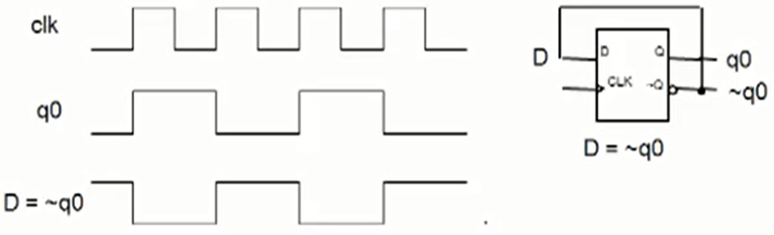
Divide by 3
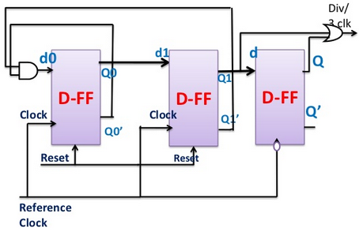
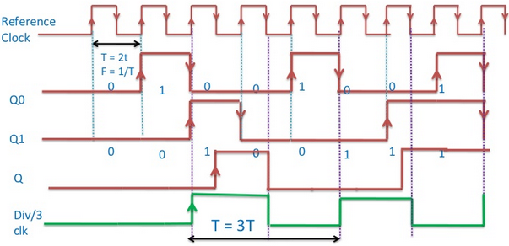
Divide by N circuit
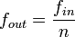
where n is an integer.
For power-of-2 integer division, a simple binary counter can be used, clocked by the input signal. The least-significant output bit alternates at 1/2 the rate of the input clock, the next bit at 1/4 the rate, the third bit at 1/8 the rate, etc. An arrangement of flip flops is a classic method for integer-n division. Such division is frequency and phase coherent to the source over environmental variations including temperature. The easiest configuration is a series where each flip-flop is a divide-by-2. For a series of three of these, such system would be a divide-by-8.
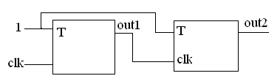
Another popular circuit to divide a digital signal by an even integer multiple is a Johnson counter. This is a type of shift register network that is clocked by the input signal. The last register's complemented output is fed back to the first register's input. The output signal is derived from one or more of the register outputs. For example, a divide-by-6 divider can be constructed with a 3-register Johnson counter. The three valid values for each register are 000, 100, 110, 111, 011, and 001. This pattern repeats each time the network is clocked by the input signal. The output of each register is a f/6 square wave with 60° of phase shift between registers. Additional registers can be added to provide additional integer divisors.

*****************************************************************************
C/C++

Switch
switch (a) {
case 0: cout << “0” << endl; break;
case 1: cout << “1” << endl; break;
default: cout << “default” << endl;
}

Random number generator:
#include<cstdlib> //c standard library
#iclude<ctime>
int main(){
srand(time(0)); //each time it gets a different seed, time(0) gives the time in seconds (it is
//not constant), which is a pretty good unpredictable seed
for (int x = 1; x<7; x++){
cout << 1+ (rand()%6); //gives a random number between 1 and 6
}
}

Constant objects:
Constant objects can only have access to constant functions in the class:
int main(){
const Test testObje;
testObje.print();

}
class Test{
….
void print () const (){}
….
}

Initializing constant variables in a class
Whenever we have a constant variable in a class we should initialize it through the use of member initializer:

class Test{
public:
Test (int a, int b): regVar(a), constVar(b){}
private:
int regVar; const int constVart;
}

Unary scope operator (::):
int x = 100;

int main(){
int x = 20;
cout << x; //print 20
cout << ::x; //print 100
}
This is helpful when we have variables with the same name but different data type. For example in the above example, x could have different data type (float x;)

What is Polymorphism?
Polymorphism basically allows you to use the same function and have different outcomes. For example we want to create a game, and we want to include bunch of enemies, all of these enemies share common functions, like attack function but they work differently like they have different attack power. Since they inherit from the same base enemy class, what polymorphism allows us to do is to call the same attack function on different enemy objects and get a different result. Basically polymorphism allows us to create a frame work for a specific job.

class Enemy{
public: int attackPower;
protected:
void setAttackPower(int a){
attackPower = a
}
}

class Ninja:public Enemy {
public:
void attack(){
cout << “My attack power is: ” << attackPower << endl;
}
}

class Monster:public Enemy {
public:
void attack(){
cout << “My attack power is: ” << attackPower << endl;
}
}

int main(){
Ninja n;
Monster m;
Enemy *Enemy1 = &n;
Enemy *Enemy2 = &m;
n->setAttackPower(10);
m->setAttackPower(20);
}

What is constructor?
Constructor creates an object and initializes it. It is different from other methods in a class. Constructors don’t have return type (so we don’t use void or int with function definition), and has the same name as class. A constructor is a special type of function that gets called every time you define an object of a Class.
What is destructor?
Destructor usually deletes any extra resources allocated by the object. A code that runs automatically upon destruction of your object.
It is defined like: ~ClassName.
We can have destructor overloading, and no return type
For simple classes, a destructor is not needed because C++ will automatically clean up the memory for you. However, if you have dynamically allocated memory, or if you need to do some kind of maintenance before the class is destroyed (eg. closing a file), the destructor is the perfect place to do so.

What is default constructor?
Constructor with no arguments or all the arguments has default values.

What is copy constructor?
A constructor which initializes its object member variables (by shallow copying) with another object of the same class. If you don't implement one in your class then compiler implements one for you, for example:
Boo Obj1 (10); // calling Boo constructor
Boo Obj2 (Obj1); // calling boo copy constructor
Boo Obj2 = Obj1; // calling boo copy constructor

When is copy constructors called?
Copy constructors are called in following cases:
a) when a function returns an object of that class by value
b) when the object of that class is passed by value as an argument to a function
c) when you construct an object based on another object of the same class
d) when compiler generates a temporary object

Recursion
The act of a function calling itself is called recursion.

->
Whenever you want to access things inside a class by pointer we use arrow.
Whenever you want to access things inside a class without using pointers use “.” operator.
Class A
int main{
A hamed;
A *hamedPointer = &hamed;
hamedPointer->functionInClass();
hamed. functionInClass();
}

What is diff between malloc()/free() and new/delete?
In C++ there are multiple ways to allocate and free data and when you call malloc you should call free and when you use the new operator you should pair with delete and it is a mistake to mix the two.
When you new an object, space for the object is not only allocated but the object's constructor is called. And similarly when you delete an object, the object's destructor is called before the memory is released. If you use malloc and free, the destructor and constructor do not get called. Obviously, this simply won't do in C++ except in certain very rare situations where you have classes without any specific destructor/constructors.
class Test{
public:
Test() {
cout << "Test : ctor\r\n";
}
~Test() {
cout << "Test : dtor\r\n";
}
void Hello() {
cout << "Test : Hello World\r\n";
}
};
int main(int argc, _TCHAR* argv[]){
cout << "1\r\n";
Test* t1 = new Test();
t1 -> Hello();
delete t1;

cout << "2\r\n";
Test* t2 = (Test*) malloc(sizeof Test);
t2->Hello();
free(t2);

return 0;
}

1
Test : ctor
Test : Hello World
Test : dtor
2
Test : Hello World

What is the difference between "new" and "operator new"?
"operator new" works like malloc.

What is difference between template and macro??
There are two types of macros, object-like and function-like. Object-like macros do not take parameters; function-like macros do. The generic syntax for declaring an identifier as a macro of each type is like following:
#define PI 3.14159
An example of a function-like macro is:
#define RADTODEG(x) ((x) * 57.29578)
int main() {
cout << " RADTODEG (2) =\t" << RADTODEG(2) << endl;
return 0;
}
Function templates are special functions that can operate with generic types. This allows us to create a function template whose functionality can be adapted to more than one type or class without repeating the entire code for each type.
// function template
#include <iostream>
using namespace std;

template <class T>
T GetMax (T a, T b) {
T result;
result = (a>b)? a:b;
return (result);
}

int main () {
int i=5, j=6, k;
long l=10, m=5, n;
k = GetMax <int> (i,j);
n = GetMax <long> (l,m);
cout << k << endl;
cout << n << endl;
return 0;
}

What are C++ storage classes?
auto: the default. Variables are automatically created and initialized when they are defined and are destroyed at the end of the block containing their definition. They are not visible outside that block
register: a type of auto variable. A suggestion to the compiler to use a CPU register for performance
static: a variable that is known only in the function that contains its definition but is never destroyed and retains its value between calls to that function. It exists from the time the program begins execution
extern: a static variable whose definition and placement is determined when all object and library modules are combined (linked) to form the executable code file. It can be visible outside the file where it is defined.

What are storage qualifiers in C++?
They are: const, volatile, and mutable
Const keyword indicates that memory once initialized, should not be altered by a program.
volatile keyword indicates that the value in the memory location can be altered even though nothing in the program code modifies the contents. The intent of this keyword to improve the optimization ability of the compiler.
mutable keyword indicates that particular member of a structure or class can be altered even if a particular structure variable, class, or class member function is constant.
struct data{
char name[80];
mutable double salary;
}
const data MyStruct = { "Satish Shetty", 1000 }; //initlized by complier
strcpy ( MyStruct.name, "Shilpa Shetty"); // compiler error
MyStruct.salaray = 2000 ; // complier is happy allowed

What is passing by reference?
Thenewboston.org
What is virtual function?
It is related to polymorphism, virtual function is a function which its code can be redefined in classes that are derived from the Event class.

What is overriding?
In C++, overriding is a concept used in inheritance which involves a base class implementation of a method. Then in a subclass, you would make another implementation of the method. This is overriding. Here is a simple example.
class Base
{
public:
virtual void DoSomething() {x = x + 5;}
private:
int x;
};
class Derived : public Base
{
public:
virtual void DoSomething() { y = y + 5; Base::DoSomething(); }
private:
int y;
};
Here you can see that the derived class overrides the base class method DoSomething to have its own implementation where it adds to its variable, and then invokes the parent version of the function by calling Base::DoSomething() so that the x variable gets incremented as well. The virtual keyword is used to that the class variable can figure out which version of the method to call at runtime.

What problem does the namespace feature solve?
Multiple providers of libraries might use common global identifiers causing a name collision when an application tries to link with two or more such libraries. The namespace feature surrounds a library's external declarations with a unique namespace that eliminates the potential for those collisions.
namespace [identifier] { namespace-body }
A namespace declaration identifies and assigns a name to a declarative region.
The identifier in a namespace declaration must be unique in the declarative region in which it is used. The identifier is the name of the namespace and is used to reference its members.
namespace myNamespace
{
int a, b;
}

myNamespace::a
myNamespace::b

What is the use of 'using' declaration?
A using declaration makes it possible to use a name from a namespace without the scope operator.

What is a dangling pointer?
A dangling pointer arises when you use the address of an object after its lifetime is over. This may occur in situations like returning addresses of the automatic variables from a function or using the address of the memory block after it is freed.

What is a container class? What are the types of container classes?
A container class is a class designed to hold and organize multiple instances of another class. By far the most commonly used container in programming is the array. Unlike built-in arrays, array container classes generally provide dynamically resizing (when elements are added or removed) and do bounds-checking. This not only makes array container classes more convenient than normal arrays, but safer too.
Most well-defined containers will include functions that:
- Create an empty container (via a constructor)
- Insert a new object into the container
- Remove an object from the container
- Report the number of objects currently in the container
- Empty the container of all objects
- Provide access to the stored objects
- Sort the elements (optional)
The following containers are defined in the current revision of the C++ standard: array, vector, list.
Example:
std::vector<std::string> v;
string s = "";
v.push_back(s);
s = "hi";
v.push_back(s);

What is inline function?
inline functions are a lot like a place holder. Once you define an inline function, using the 'inline' keyword, whenever you call that function the compiler will replace the function call with the actual code from the function.
Example:
#include <iostream>
using namespace std;
inline void hello()
{
cout<<"hello";
}
int main()
{
hello(); //Call it like a normal function...
cin.get();
}

Template specialization
In many cases when working with templates, you'll write one generic version for all possible data types and leave it at that--every vector may be implemented in exactly the same way. The idea of template specialization is to override the default template implementation to handle a particular type in a different way. For example in the example below any data other than char data type will be handled by the first template and when we pass char variable the second template will be run.

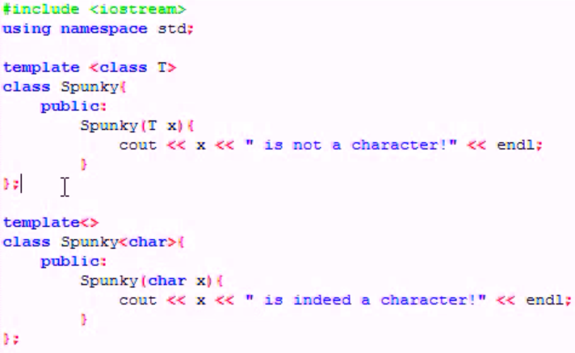
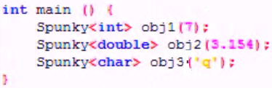

What is overloading?
If you specify more than one definition for a function name or an operator in the same scope, you have overloaded that function name or operator. An overloaded declaration is a declaration that had been declared with the same name as a previously declared declaration in the same scope, except that both declarations have different types. If you call an overloaded function name or operator, the compiler determines the most appropriate definition to use by comparing the argument types you used to call the function or operator with the parameter types specified in the definitions:
#include <iostream>
using namespace std;

void print(int i) {
cout << " Here is int " << i << endl;}
void print(double f) {
cout << " Here is float " << f << endl;}
void print(char* c) {
cout << " Here is char* " << c << endl;}

int main() {
print(10);
print(10.10);
print("ten");}

Pointers and deference operator (*)
A variable which stores a reference to another variable is called a pointer. Pointers are said to "point to" the variable whose reference they store. Using a pointer we can directly access the value stored in the variable which it points to. To do this, we simply have to precede the pointer's identifier with an asterisk (*) that can be literally translated to "value pointed by".

Reference operator (&)
The address that locates a variable within memory is what we call a reference to that variable. This reference to a variable can be obtained by preceding the identifier of a variable with an ampersand sign (&), known as reference operator, and which can be literally translated as "address of". For example:
t = &a;

Difference between pointer and reference
Pointers References
int i; int i;
int *pi = &i; int &ri = i;
Both pi and ri contain addresses that point to the location of i, but the difference lies in the appearance between references and pointers when they are used in expressions.
*pi = 4; ri = 4;
Note that when using pointers, the address must be dereferenced using the *, whereas, when using references, the address is dereferenced without using any operators at all. The main effect of this is that the address can directly be manipulated if it is a pointer. We can do things such as:
pi++; to increment to the next address. This is not possible using references.
In general, you should use a pointer whenever you need to take into account the possibility that there's nothing to refer to (in which case you can set the pointer to null) or whenever you need to be able to refer to different things at different times (in which case you can change where the pointer points). You should use a reference whenever you know there will always be an object to refer to and you also know that once you're referring to that object, you'll never want to refer to anything else.

Pointer to pointer
using namespace std;

int main()
{
int a = 50; // initialize integer variable a
cout << "The value of 'a': " << a <<endl; // show the output of a

int *b; // declare an integer pointer b
b = &a; // transfer the address of 'a' to pointer 'b'
*b = 100; // change the value of 'a' using pointer 'b'
cout<< "The value of 'a' using *b: "<< a <<endl;// show the output of a

int **c; // declare an integer pointer to pointer 'c'
c = &b; // transfer the address of 'b' to pointer to pointer 'c'
**c = 200; // change the value of 'a' using pointer to pointer 'c'
Cout << "The value of 'a' using **c: " << a << endl; // show the output of a
return 0;
}

What is "this" pointer?
Thenewboston.org
“this->”
In a C++ program when you use keyword “this” it stores the address of the current object that you are working with. It is a special type of pointer.

What is the difference between const char *myPointer and char *const myPointer?
Const char *myPointer is a non-constant pointer to constant data; while char *const myPointer is a constant pointer to non-constant data.

How can I handle a constructor that fails?
Throw an exception. Constructors don't have a return type, so it's not possible to use return codes. The best way to signal constructor failure is therefore to throw an exception.

What is multiple inheritances (virtual inheritance)? What are its advantages and disadvantages?
Multiple inheritances are the process whereby a child can be derived from more than one parent class. The advantage of multiple inheritances is that it allows a class to inherit the functionality of more than one base class thus allowing for modeling of complex relationships. The disadvantage of multiple inheritance is that it can lead to a lot of confusion when two base classes implement a method with the same name.

What is a nested class? Why can it be useful?
A nested class is a class enclosed within the scope of another class. For example:
// Example 1: Nested class
class OuterClass
{
class NestedClass
{
// ...
};
// ...
};
Nested classes are useful for organizing code and controlling access and dependencies. Nested classes obey access rules just like other parts of a class do; so, in Example 1, if NestedClass is public then any code can name it as OuterClass::NestedClass. Often nested classes contain private implementation details, and are therefore made private; in Example 1, if NestedClass is private, then only OuterClass's members and friends can use NestedClass.
When you instantiate as outer class, it won't instantiate inside class.

What is a local class? Why can it be useful?
A class declared inside a function becomes local to that function and is called Local Class in C++. For example:
#include<iostream>
using namespace std;

void fun() {
class Test // local to fun {
/* members of Test class */
};
}

int main(){
return 0;
}
A local class type name can only be used in the enclosing function. All the methods of local classes must be defined inside the class only.
Why we use class in C++ if struct can also work for inheritance, overloading, etc.?
Key difference is that for structures all of its members are public and accessible whereas with a class you can make them private or protected. As a result a class is better suited for true OO development where you want abstraction and data hiding, and where you want true inheritance control.

When does a class need a virtual destructor?
If your class has at least one virtual function, you should have a virtual destructor. This allows you to delete a dynamic object through a baller to a base class object. In absence of this, the wrong destructor will be invoked during deletion of the dynamic object.

Do you think the following code is fine? If not, what is the problem?
T *p = 0;
delete p;
No, the code has a problem. The program will crash in an attempt to delete a null pointer.

Explain STL
The Standard Template Libraries (STL's) are a set of C++ template classes to provide common programming data structures and functions such as doubly linked lists (list), paired arrays (map), expandable arrays (vector), large string storage and manipulation (rope), etc. The STL library is available from the STL home page.

What is a string?
String is another name for text.

Iterator
An iterator is any object that has the ability to iterate through the elements of that range using a set of operators (with at least the increment (++) and dereference (*) operators). The most obvious form of iterator is a pointer: A pointer can point to elements in an array, and can iterate through them using the increment operator (++). But other kinds of iterators are possible. For example, each container type (such as a list) has a specific iterator type designed to iterate through its elements.

Binding
Binding refers to the process that is used to convert identifiers (such as variable and function names) into machine language addresses.

Explain how to call C code from C++ code. Explain with an example.
To call a C program in C++, the basic requirement is both the compilers and runtime libraries must be compatible. They must define the primitive data types such as int, float, char etc.
Accessing C Code From Within C++ Source:
A linkage specification is provided by C++, which is used to declare a function that follows the program linkage conventions for a supported language. C++ compilers support C linkage for compatible C compilers.
To access a function with C linkage, the function needs to be declared to have C linkage.
The following code snippet depicts the linkage declaration:

extern "C" {
void f(); // C linkage
extern "C++" {
void g(); // C++ linkage
extern "C" void h(); // C linkage
void g2(); // C++ linkage
}
extern "C++" void k();// C++ linkage
void m(); // C linkage
}

The following code snippet depicts the inclusion of a c header file.

extern "C"
{
#include "header.h"
}

How can an object of a C++ class be passed to or from a C function?
Define a header file for both C and C++ compilers. The following code snippet does this.

Fred.h:

/* This header can be read by both C and C++ compilers */

#ifndef FRED_H
#define FRED_H

#ifdef __cplusplus
class Fred {
public:
Fred();
void wilma(int);
private:
int a_;
};
#else
typedef
struct Fred
Fred;
#endif

#ifdef __cplusplus
extern "C" {
#endif

#if defined(__STDC__) || defined(__cplusplus)
extern void c_function(Fred*); /* ANSI C prototypes */
extern Fred* cplusplus_callback_function(Fred*);
#else
extern void c_function(); /* K&R style */
extern Fred* cplusplus_callback_function();
#endif

#ifdef __cplusplus
}
#endif

#endif /*FRED_H*/
Write C++ code as follows:

Fred.cpp:
// This is C++ code

#include "Fred.h"

Fred::Fred() : a_(0) { }
void Fred::wilma(int a) { }
Fred* cplusplus_callback_function(Fred* fred)
{
fred->wilma(123);
return fred;
}

main.cpp:
// This is C++ code

#include "Fred.h"

int main()
{
Fred fred;
c_function(&fred);
...
}

Write the following C program as follows:

c-function.c:
/* This is C code */

#include "Fred.h"
void c_function(Fred* fred)
{
cplusplus_callback_function(fred);
}

Vector vs. Map
Vectors are used to store contiguous elements like an array. However, unlike arrays, vectors can be resized. Maps on the other hand contain unique key/value pairs and sorted by keys. For example, a telephone guide where a key would be the name initial and value will be the number.
int main ()
{
std::map<char,int> first;

first['a']=10;
first['b']=30;
first['c']=50;
first['d']=70;
}

Linked list
If you want to support images of multiple sizes, you cannot know how big of an array will be required to store the image. One option would be to create a really big array, and then hope that all images will fit in that array. This has two problems: it wastes a lot of memory in the case of a small image and it might not be big enough if the user has a really big image. RAM and image sizes get bigger every year, so the program might not work in the future. In this case, it makes sense to use a dynamic array so that you aren’t wasting space or creating a program that won’t work when you really need it. What if we don’t know how many items we are going to have until we are done? An example of this would be searching through a text file and finding all of the words that start with the letter “a”. In this case, there is no way of knowing how many items there will be in the array until we are finished processing the file. Sure, there are some things that we could do. We could declare an array that has a length that is equal to the number of words in the file. This way we would be guaranteed to have an array that is big enough. Another option is to process the file twice. The first time we would count the number of words. Then we will know how long to make the array and the second time we would store off the words.
A look at vectors as a solution:
Dynamic arrays and vectors allocate sequential memory blocks. This is good for indexing. If the block 10 below is at address 1201, then the 40 block is at address 1204. But this is bad for inserting and erasing. If we want to erase the 20 block in the picture below, we have to shift all the elements over to the right. Inserting and erasing in a vector is an O(N) operation.
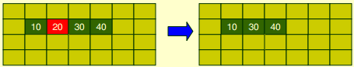
Linked Lists:
Instead of allocating sequential blocks of memory, we can allow the blocks to be anywhere in the memory heap as long as we have pointers from one block to the next. This data structure is called a linked list. Each block is called a node. The pointers are called links. A node has two parts: the data and the link to the next node. The last node points to NULL, so we know where the list ends.
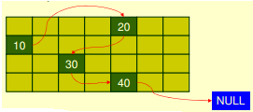
Suppose we want to erase the block indicated by the arrow. A pointer that marks our position in the list is called an iterator. All we have to do is rearrange the pointers. Then we can safely delete the 20 block, freeing up that block for future use. Erasing is an O(1) operation. Inserting is just as easy.
In arrays and vectors, the fact that the blocks are sequential allows us to look up the Nth block very quickly. We just add N to the address of the first block. So look-ups in an array/vector are O(1). In a linked list, to get to the Nth block we have to start at the first block and trace a path through N blocks. So look-ups in a linked list are O(N).
Types of Linked Lists:
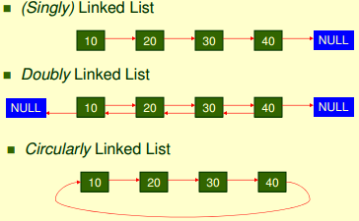
Linked List vs. Vector
We need to ask which operations we’re going to be performing more often: accessing or changing the data.
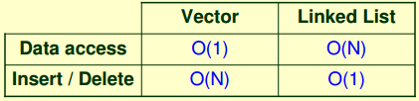

typedef struct LinkedListItem{
int Number;
LinkedListItem* Next;
LinkedListItem (int number){
Number = number;
Next = NULL; //The next variable is always a Null
}
} LinkedListItem;

Usage:
LinkedListItem *head = NULL;

head = new LinkedListItem(1);
head->Next = new LinkedListItem(2);
head->Next->Next = new LinkedListItem(3);
Now we should test our result, to make sure that the list contains the correct numbers (1, 2, 3). To do this, let’s write a function to print out the values in the list:
void Print(LinkedListItem *head){
LinkedListItem* curr = head;
while(curr != NULL){
cout << curr->Number << endl;
curr = curr->Next;
}
}

******************************************************************************
Useful programs
_{Factorial of a number:}
_{#include <stdio.h>}
#define VALUE 6
int i,j;
void main()
{
j=1;
for (i=1; i<=VALUE; i++)
j=j*i;
printf("The factorial of %d is %d\n",VALUE,j);
}
Second way:
int main(){
…
printf(“\n number = %d, factorial=%d”, m, fact(m));
}

long fact(int x){
if (x != 0){
return(x*fact(x-1);}
return 1;
}

Write a code that would tell you how you can make $1, with 1, 5, 10, 25 cents?
int i1, i5, i10, i25
unsigned long int sum;
for (i1=0; i1<=100; i1++)
for (i5=0; i5<=20; i5++)
for (i10=0; i10<=10; i10++)
for (i25=0; i25<=4; i25++)
sum = i1*1+ i5*5+ i10*10 + i25*25;
if (sum == 100){
printf (.......,i1,i5, i10, i25..)}
page 55 of ghomi

If you are asked to write a code to does something with a sentence read from somewhere, if the last character is Enter you can detect it by looking for '\r' character.

Write a code that would read a number and will output the reverse of it:
int num;
int digit = 0;
scanf (“%d”, &num);
printf (“\nThe inverse of number is: ”)
d0 {
digit = num % 10; //gives the remainder of division
printf (“%d”, digit);
num /= 10
} while (num !=0)

If you are asked to write a code that would read a text and detect how many digits are in there, notice that you can detect numbers by ASCII codes. ASCII code of numbers are between 48 to 57.
printf (“Enter a statement: ”);
while ((ch = getche()) != '\r'){
if (ch <= 48 && ch <= 57)}

Finding the most occurrence element in an array/string in c
int main{
…
float arr[k];
findt (arr,k);
return 0;
}

void findt(float arr[], int k){
int i, j, current_count
float max_value
int max_count = -1;

for (i=0; i<k; i++){
current_count = 0;
current_value = arr[i];
for (j=0; j<k; j++){
if (arr[j] = current_value)
current = count++;}
if (current_count > max_count){
max_count = current_count;
max_value = current_value;}}
print the results
Add a part that given a string will return the position of the starting point of the largest reoccurring character. (i.e. given:"AAABBCCCCD" would return 5 (starting point of C))

page 113

From internet:

Fibonacci series
In mathematics, the Fibonacci numbers are the numbers in the following integer sequence:
By definition, the first two numbers in the Fibonacci sequence are 0 and 1, and each subsequent number is the sum of the previous two.

#include "stdio.h"
#include "conio.h"
void main()
{
int a,b,c,i,n;
a = 0;
b = 1;
printf("\n enter n for how many times generate series");
scanf ("%d" , &n);
printf("\n Fibonacci series\n");
printf("%d \t %d", a, b);
for(i = 0; i < n; i++)
{
c = a + b;
a = b;
b = c;
printf ("%d" , c);
}
getch();
}

Binary search
In computer science, a binary search or half-interval search algorithm finds the position of a specified value (the input "key") within a sorted array. In each step, the algorithm compares the input key value with the key value of the middle element of the array. If the keys match, then a matching element has been found so its index, or position, is returned. Otherwise, if the sought key is less than the middle element's key, then the algorithm repeats its action on the sub-array to the left of the middle element or, if the input key is greater, on the sub-array to the right. If the remaining array to be searched is reduced to zero, then the key cannot be found in the array and a special "Not found" indication is returned.

Sorting an array:
- Selection sort
1) Starting at index 0, search the entire array to find the smallest value
2) Swap the smallest value found with the value at index 0
3) Repeat steps 1 & 2 starting from the next index

{30, 50, 20, 10, 40} {30, 50, 20, 10, 40} {10, 50, 20, 30, 40} {10, 50, 20, 30, 40}
{10, 20, 50, 30, 40} {10, 20, 50, 30, 40} {10, 20, 30, 50, 40} {10, 20, 30, 50, 40}
{10, 20, 30, 40, 50} {10, 20, 30, 40, 50} {10, 20, 30, 40, 50}
const int nSize = 5;
int anArray[nSize] = {30, 50, 20, 10, 40};

// Step through each element of the array
for (int nStartIndex = 0; nStartIndex < nSize; nStartIndex++)
{
// nSmallestIndex is the index of the smallest element we've encountered so far.
int nSmallestIndex = nStartIndex;

// Search through every element starting at nStartIndex+1
for (int nCurrentIndex = nStartIndex + 1; nCurrentIndex < nSize; nCurrentIndex++)
{
// If the current element is smaller than our previously found smallest
if (anArray[nCurrentIndex] < anArray[nSmallestIndex])
// Store the index in nSmallestIndex
nSmallestIndex = nCurrentIndex;
}

// Swap our start element with our smallest element
swap(anArray[nStartIndex], anArray[nSmallestIndex]);
}

- Bubble sorting
The bubble sort repeatedly compares adjacent elements of an array. The first and second elements are compared and swapped if out of order. Then the second and third elements are compared and swapped if out of order. This sorting process continues until the last two elements of the array are compared and swapped if out of order. The bubble sort knows that it is finished when it examines the entire array and no "swaps" are needed (thus the list is in proper order).

void BubbleSort(apvector <int> &num)
{
int i, j, flag = 1; // set flag to 1 to start first pass
int temp; // holding variable
int numLength = num.length( );
for(i = 1; (i <= numLength) && flag; i++)
{
flag = 0;
for (j=0; j < (numLength -1); j++)
{
if (num[j+1] > num[j]) // ascending order simply changes to <
{
temp = num[j]; // swap elements
num[j] = num[j+1];
num[j+1] = temp;
flag = 1; // indicates that a swap occurred.
}
}
}
return; //arrays are passed to functions by address; nothing is returned
}

- Insertion sorting
The insertion sort, unlike the other sorts, passes through the array only once. The insertion sort is commonly compared to organizing a handful of playing cards. You pick up the random cards one at a time. As you pick up each card, you insert it into its correct position in your hand of organized cards.
The insertion sort splits an array into two sub-arrays. The first sub-array (such as the cards in your hand) is sorted and increases in size as the sort continues. The second sub-array (such as the cards to be picked up) is unsorted, contains all the elements to yet be inserted into the first sub-array, and decreases in size as the sort continues.

Array at beginning: | 84 | 69 | 76 | 86 | 94 | 91
 | 84 | 69 | 76 | 86 | 94 | 91
  = 1st sub-array
 | 84 | 69 | 76 | 86 | 94 | 91
  = 2nd sub-array
 | 84 | 76 | 69 | 86 | 94 | 91
 | 86 | 84 | 76 | 69 | 94 | 91
 | 94 | 86 | 84 | 76 | 69 | 91
2nd sub-array empty | 94 | 91 | 86 | 84 | 76 | 69

void insertion_sort(int x[],int length){
int key,i;
for(int j = 1;j < length; j++){ //start with 1 not 0
key = x[j];
i = j - 1;
while(x[i] < key && i >= 0){
x[i+1] = x[i];
i--;
}
x[i+1]=key;
}
}

**************************************************************************
Scripting

Python
How do I generate random numbers in Python?
The standard module random implements a random number generator. Usage is simple:
import random
random.random()
This returns a random floating point number in the range [0, 1).

How do you set a global variable in a function in python?
Any variable assigned in a function is local to that function, unless it is specifically declared global. Since a value is bound to x as the last statement of the function body, the compiler assumes that x is local. Consequently the print x attempts to print an uninitialized local variable and will trigger a NameError.
x = 1
def f():
global x
x = 10
print x
-------------
output: 10

Explain about the dictionary function in Python?
A dictionary is mutable and is another container type that can store any number of Python objects, including other container types.
Dictionaries consist of pairs (called items) of keys and their corresponding values.
Python dictionaries are also known as associative arrays or hash tables. The general syntax of a dictionary is as follows:
dict = {'Name': 'Zara', 'Age': 7, 'Class': 'First'};
print "dict['Name']: ", dict['Name'];
print "dict['Age']: ", dict['Age'];
Each key is separated from its value by a colon (:), the items are separated by commas, and the whole thing is enclosed in curly braces. An empty dictionary without any items is written with just two curly braces, like this: {}.

This will produce following result:
dict['Name']: Zara
dict['Age']: 7
How do I copy a file?
The shutil module contains a copyfile() function.

***************************************************************************
Power optimization:

Operand isolation
Operand isolation, also called guarded evaluation, prevents unnecessary operations to be performed. However, instead of halting the clock signal, data path signals are directly disabled and hence no new results are evaluated. Traditionally, data path operators are always active. Due to changing inputs, they dissipate power even when the output of the operators is not used. In a particular clock cycle, the data path operator output is not used if it is an unselected input to a multiplexer or if the data path operator is an input to a register that is currently disabled.
With the operand isolation approach, additional logic (AND or OR gates) called isolation logic is inserted along with an activation signal to hold the inputs of the data-path operators stable whenever their output is not used. Isolation candidates can be identified in the HDL source by using a pragma annotation or at the GTECH level by using commands in the synthesis script.
In Synopsys, operand isolation automatically builds isolation logic for the identified operators. A rollback mechanism is also provided to remove the isolation logic if you determine that the delay penalty is not acceptable.
Consider the example from Figure below. Here, the result from the data path operator is not used in further steps if S0=0 or if S1=1.

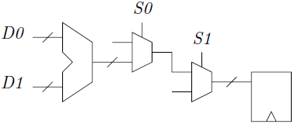

By creating an activation signal (AS) based on this observation, the inputs to the operator are kept stable, see Figure below.
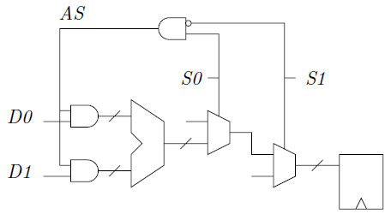

For inputs that mostly stay at logic 1, use OR gates to create the operand isolation since this holds the inputs to the operator at logic 1 during inactive mode, minimizing switching activity at the transition from active to inactive mode. Similarly, AND gates are used for inputs that mostly stay at logic 0.
Ideal candidates for operand isolation are arithmetic modules such as arithmetic logical units (ALUs), adders, and multipliers that frequently perform redundant computations.

Dynamic power management
A simple way to save power is to shut down a function block when it is not used. This method is applicable if it can be predicted when a block is going to be used again. This stems from the fact that the time to power up a block is in the order of a few microseconds. This rather long time duration is due to the risk of interference with other parts on a chip. A way to reduce the power-up time and still save power is to just lower the voltage in a block when it is not used. A disadvantage with these methods is that the block loses its information. To retain this information some memory stages can be inserted in the block that stores the state the block was in before it was shut down.
Microsoft
Two ways to convert a NAND to a NOT gate
1. Short both inputs of a nand gate and give the i/p.
o/p = A.A = A'
2. Tie one i/p of teh nand gate to logic 1 and give i/p to other p = A.1 = A'

How many new cars, on average, are bought in the US each year?
Given a total pop of 300M, I guess 75% are 16 or older (225M). Of those, maybe 40% drive a car (90M). Now assume a new person buys a new car every five years, or 90M * 1/5 = 18M. That was my answer and the guy said I was quite close

3 light bulbs in a room, each bulb is connected to one switch outside the room. Each switch is connected to only one bulb. If you are outside the room and can do anything to the switches but can only go in the room once to see the bulbs, how can you figure out which bulb is attached to which switch?
The answer is to turn one on for long enough for the bulb to heat up, then turn it off, turn another one. Go in the room. You have the on-switch matching the on-bulb, the off-switch matching the off-bulb and the hot bulb matching the remaining switch. This all goes out the window if the up-on, down-off paradigm doesn't hold. It also doesn't work if they are cold light sources like OLEDs, etc.

There are two gates, one to hell and the other to heaven. Two gate keepers, one for each gate. One of them always speaks the truth and the other always lies but you don't know which ones guarding which gate. You are allowed only one question and you need to find out the gate to heaven. What is the question you will ask and remember you do not know which one speaks the truth and which one lies.
Ask one of the guards:" what would the other guard say if I ask him which way is the hell?"
And whatever answer he gives that is the way to heaven.
Explanation:
If you end up asking the question to the truthful one, he will tell the true and he knows the other guard is going to lie so he will so the way to heaven.
If you end up asking the question to the liar he will lie what the answer will be and he lies and instead shows the way to heaven.

There are 3 person in a forest, when they slept at night someone from outside colored their faces black (all three). Now when they wake up in the morning all three started laughing at each other thinking that the other two persons have black faces.
But after some time they realized that their own faces are also black and then they stop laughing at each other.
Here, you have to give a valid LOGICAL REASON that how they realized that their own faces are also black, i.e. all three faces are black.
To mention here, these are not logical reasons... e.g.
1. They are looking on faces of each other so the other person will realize that his face is also black.
2. One will look into others eyes (eyes as mirror) hence he can find that his face is black.
3. He will use water to see his face if something wrong, hence he will find that his face is black.
4. They will tell each other that your face is black. ..... etc.
There are 4 similar situations that could have occurred - the situations where 0, 1, 2 and 3 faces were painted. With the information given, we can show that the only possible situation is where 3 faces are painted.
0 faces: is easy to rule out. In that case, no one would be laughing.
If 1 face was painted, the 2 whose faces weren't painted would see someone with their face painted and would laugh. The person with the face painted would not laugh as they see no one with faces painted.
If 2 faces were painted, the 1 whose face wasn't painted would laugh, as they could see 2 other painted faces. The 2 with faces painted would start laughing initially. However, when noting the other without the black face was also laughing, and noting that they could see no one else with a black face, they would have to assume that their face was black. So the two would then stop laughing, knowing they had their faces painted.
Finally, if all three faces were painted - they would all start laughing. However, each would expect if their faces weren't painted for the other two to stop after a small period (as they would be in the 2 face scenario described above). Since the two didn't stop, they would stop laughing, as the only possible reason would be if their face was painted as well. All three would come to the same conclusion, so they all would stop laughing.
Note that this depends on the three having the same level of intelligence. If two were smarter and one a bit slower, then the two would stop laughing, concluding that they were in the 3 face scenario. Seeing the two stopping, the third slower one would incorrectly conclude they were in the 2 face painted scenario.
3 ants are at 3 vertices of a triangle. They randomly start moving towards another vertex. What is the probability that they don't collide?
Each Ant can move in two directions, either clockwise or anticlockwise. So for 3 ants there are 2^3 possibilities an ant can move, and there is two ways to avoid collision so:
Probability of collision = (2^3 - 2) / 8 = 3 / 4
Probability of no collision = 1 - 3/4 = 1/4

***********************************************************************
Computer architecture
Performance metrics
Performance is measured with benchmark suites: a collection of programs that are likely relevant to the user: for example SPEC CPU 2006: collection of 26 CPU-oriented programs (for desktops) which are meant to stress your processor or memory to some extent. We will run all these 26 programs and measure the execution time, and then try to compress all these numbers to a single number, which is called SPEC rating.
Let’s look at only 3 programs here (the numbers are execution times):
P1 P2 P3
Sys-A 10 8 25
Sys-B 12 9 20
Sys-C 8 8 30

Geometric times of execution times:
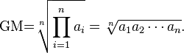
GM gives each program equal importance, and it doesn’t require a reference machine. GM however can lead to some inconsistencies, for example:
Computer-A Computer-B Computer-C
P1 1 sec 10 secs 20 secs
P2 1000 secs 100 secs 20 secs
Conclusion with GMs: (i) A=B, (ii) C is ~1.6 times faster
For a work load of: 100xP1 + P2
GM_{A}= GM_{B} = 1100 sec, GM_{C} = 2020 sec
With the above assumption, (ii) is no longer true.
Clock cycle time = 1 / clock speed
CPU time = clock cycle time x cycles per instruction (CPI) x number of instructions
If we have 5 instructions we get the number of clock cycles required by each instruction and then get the average to compute CPI.
Influencing factors for clock cycle time: technology and pipeline
CPI (cycles per instruction) or IPC (instructions per cycle) cannot be accurately estimated analytically.
IPC (the number of instructions executed per cycle) is a measure of how well a program is doing on a system.
Arithmetic mean (AM):
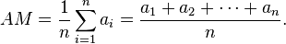
To measure performance each program is assumed to run for an equal number of cycles on all systems, so we are fair to each program. If for example we have two systems, we run a program on two systems and measure IPC.
The appropriate summary measure (of performance) is sum of IPCs or
AM of IPCs = 1.2 instr + 1.8 instr + 0.5 instr
cyc cyc cyc
The alternative perspective would be to use CPI and let each program to run for an equal number of instructions.
The appropriate summary measure (of performance) is sum of CPIs or
AM of CPIs = 0.8 cyc + 0.6 cyc + 2.0 cyc
instr instr instr

The harmonic mean (HM) of the positive real numbers x1, x2, ..., xn > 0 is defined to be:
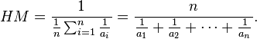

AM of IPCs = 1 / HM of CPIs
AM of CPIs = 1 / HM of IPCs
GM of IPCs = 1 / GM of CPIs

Program counter
The program counter register (PC) always contains the address of the next instruction to be executed.

Fetch-Decode-Execute Cycle
Here we show how increment instruction works (INC A). 3CxH is the code that represents the instruction that will be responsible for incrementing the contents of register A, and that has to be put in the memory. Let’s assume that it is located in memory address AE00. For the microprocessor system to work it has to know the location of the first instruction to be executed, and let’s assume that this address (here AE00) is located in program counter (PC) register. Also assume that register A has the value 00xH. The contents of PC is transferred to Memory Address Register (MAR) and then the content of PC is incremented by 1. The content of MAR is applied to the address buses, and the control unit sends out two low pulses on the control lines. The content of AE00 is then transferred to Buffered Register (BR) and then to Instruction Register (IR). This is the end of fetch operation. We then enter the decoder stage and this is where the CPU figures out what 3CxH means. Fed by the information from the decoder the controller unit takes over and transfers 00xH from register A to the ALU, and asks it to add 1 to it. The result then is transferred via internal bus and is placed in register A, and that is the execute part of the operation.

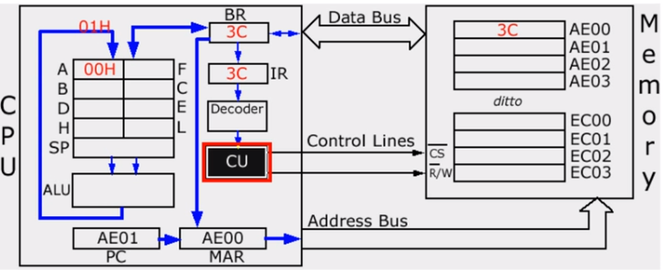

Control Unit (CU)
The control unit is a component of a computer's central processing unit (CPU) which directs operation of the processor. It controls communication between input/output devices. It reads and interprets instructions and determines the sequence for processing the data. It helps in communication between the memory and the arithmetic logical unit. It also aids in the loading of data and instructions residing in the secondary memory to the main memory as required.

ALU
ALU is a digital circuit that performs integer arithmetic and logical operations. The ALU is a fundamental building block of the central processing unit of a computer, and even the simplest microprocessors contain one for purposes such as maintaining timers.
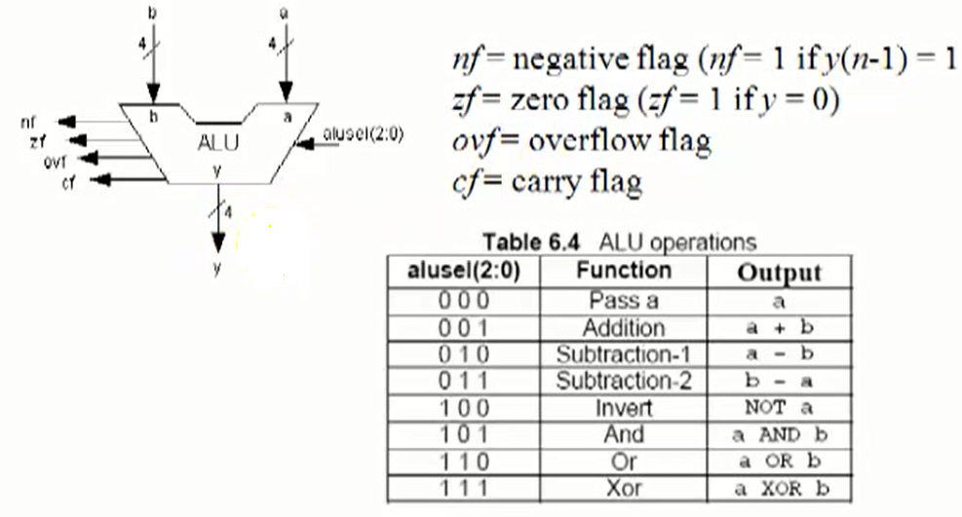
Mention briefly the steps involved in the execution of a program.
The following steps are involved in the execution of a program:
- Fetch: The control unit is given an instruction.
- Decode: The control unit then decodes the newly received instruction.
- Execute: During the execution the control unit first commands the correct part of hardware to take action. Once that is found out the control is handed over to the hardware. Now the task is performed.
- Store: Once the task is saved successfully the end result is stored.

Explain the characteristics of instruction and execution time.
Some of the characteristics of instruction time are as follows:
- The instruction time is also known as the I-time is the time taken by the Control Unit to get an instruction from memory and to load it to the register. It also includes the time taken by the CU for instruction decoding and to find out the location of the required data.
The execution time is the time required by the control unit to move data from the memory to the registers in the ALU; the ALU is responsible for the execution of instructions on this data.

What is pipelining?
In computing, a pipeline is a set of data processing elements connected in series, so that the output of one element is the input of the next one. The elements of a pipeline are often executed in parallel or in time-sliced fashion; in that case, some amount of buffer storage is often inserted between elements.
A pipeline within a processor is similar to a car assembly line. Each assembly station is called a pipe stage or a pipe segment.

Pipelining
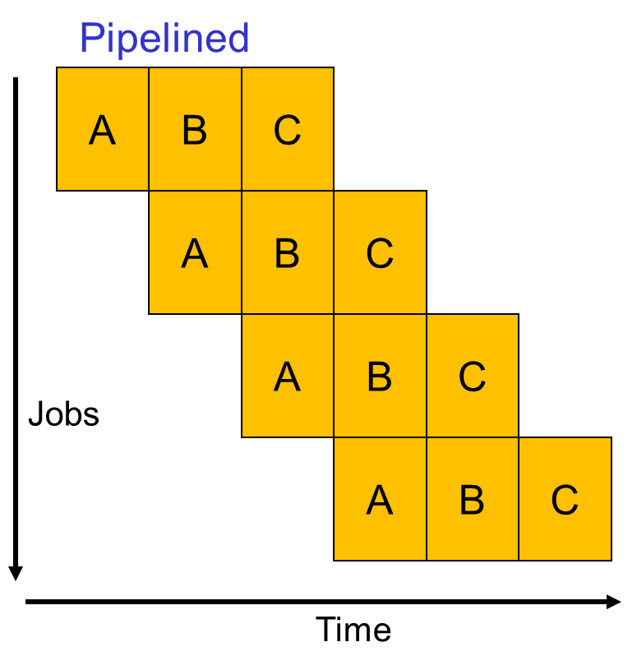
Pipelining can improve clock speed
For example in the above figure if the system is not pipelined, we will do it like this:
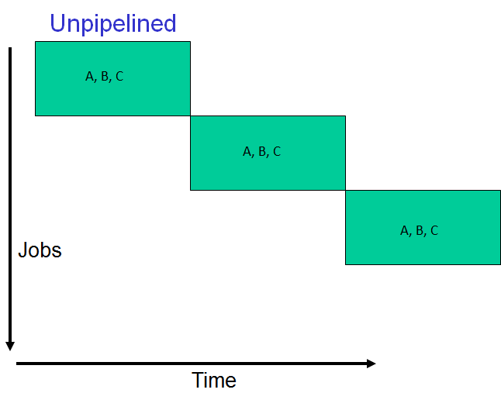

This means the clock period has to be big enough to do A, B, and C, which means lower clock cycle (in Verilog we will have more to do between begin and end of always block).

Pipelining overheads
If we assume that the process goes through two stages:
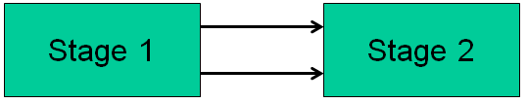
The outputs of stage 1 are the inputs of the stage 2. While the stage 2 is doing its operation, its inputs should remain constant, and these inputs may change during the operation time of stage 2. That is why we need to decouple stage 1, and 2 with registers. This guarantees that the inputs of stage 2 stay constant until the next clock edge. The flip flop adds some timing overheads (T_{ovh}).
Un-pipelined: time to execute one instruction = T + T_{ovh} (We need a register to store results)
For an N-stage pipeline, time per stage = T/N + T_{ovh}
Total time per instruction = N (T/N + T_{ovh}) = T + N T_{ovh}
Clock cycle time = T/N + T_{ovh}
Clock speed = 1 / (T/N + T_{ovh})
Ideal speedup = (T + T_{ovh}) / (T/N + T_{ovh})
Cycles to complete one instruction = N
The clock speed up will be less than N times of un-pipelined system

RISC
RISC stands for Reduced Instruction Set Computer. In RISC we have simple ALU like instructions, like add, load, store, and we deal with registers in input and outputs.
LD[address]--->R4 (load operation)
ST[address]<---R5 (store operation)
CPU

[ALU]
Main memory
RF

RF: Register File (32 words)
As the number of instructions is low, the speed of processing is improved. However, when complex operations are dealt with, they have to be broken down into a series of smaller instructions.

CISC
CISC stands for Complex Instruction Set Computer. Some sequences of instructions are very common, so you can replace a sequence of instructions with one complex instruction. For example:
R1xR2--->R3
R3+R4--->R5
We can do all this with a single instruction: MAC R1, R2, R4 (multiply and accumulate). One example is Intel x86 which has hundreds of instructions.

Trans.
RISC instruction
CISC instruction

Translator (Trans.) converts the CISC instructions into RISC like instructions which are called Macro operations (Mops.), and from that point on the rest of processor is like a RISC processor.
Most often RISC is preferred over CISC, because not only it leads to simpler hardware but also to higher and better performance. The higher performance comes from the simpler hardware which lets you have faster clock speed and allows you easily figure out dependencies between different programs.

Pipelining hazards
Structural hazards:
It happens when different instructions in different stages (or the same stage) compete for the same resource. It usually happens in systems that have unified data and instruction memory. For example in the pipelined system shown below, while in stage 4 the first instruction is trying to access memory for data (DM), the 4th instruction is trying to access memory for instructions (IM). When this happens we can only let one of the instructions proceed and the other one has to wait. Therefore what will happen in the fourth row of the pipelined system is that it will go through bubble (no operation). Therefore we will try to run forth instruction in 5th cycle, but a similar problem will happen. So 5th and 6th cycles have to also be bubbles, and we can only run 4th instruction on 7th cycle. The best way to deal with this problem is to use more hardware, and have two separate memories for instructions and data.

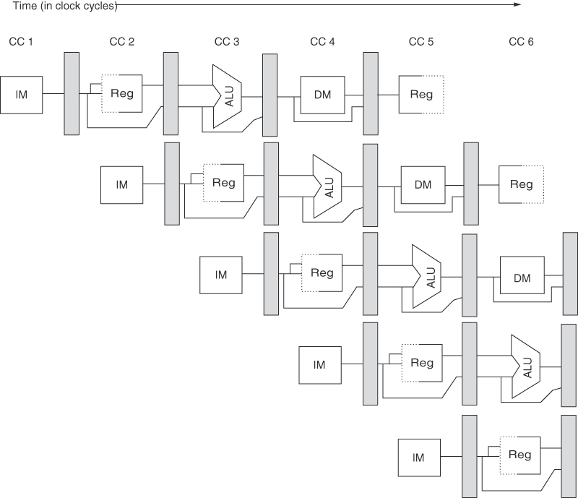

Data hazards:
It happens when an instruction cannot continue because it needs a value that has not yet been generated by an earlier instruction. For example in the above figure if the first instruction adds R1 and R2 and stores the results in R3, and the second instruction needs R3. In this case the second instruction will use the old value of R3 and produce wrong results. The way to deal with it is in the second stage. In this stage two operations happen decode and register read. The decode operation can detect this data dependence, and it knows that the register read will fail, and therefore it will propagate a bubble through the rest of stages and as itself is stalling it will inform the next instruction process to stall as well. It will repeat the process until we can do a valid register read, and when it can read a valid data it will inform the next instruction to continue too. Data hazard reduces IPC considerably.
Forwarding or bypassing technique:
In this method, we try to eliminate or reduce the number of cycles we stalk. The idea is not to wait for the previous instruction to completely finish to get the needed data, but to use it as soon as it is produced. We need to make sure that point of production is before point consumption and if necessary to introduce stall cycles. For example in the example below the first instruction (I1) is adding R1 and R2 and puts the result in R3 and I2 is trying to read R1 (R1, 8(R2) (load the contents of memory whose address is R2+8 in R1)):
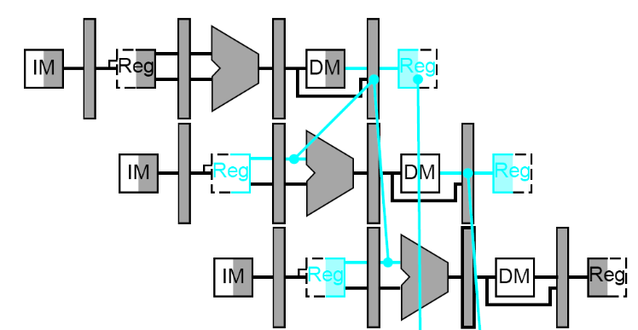
We should first look for point of production (the register after ALU) and point of consumption (the ALU). Since the point of consumption is after point production we are fine, and there is no need for stalling. Now if I1 was (ADD R1, R2, R3) the point of production will be the register after ALU and if I2 is (R4, 8(R1)) then the point of consumption will be the ALU. Therefore we need to introduce one stall cycle. In the above example forwarding or bypassing technique is realized by using multiplexers in the input of ALU that are controlled by decode logic. In the case of this example if the register located after ALU is connected to one of the inputs of the multiplexer connected to the ALU input, we can use the value of R1 as soon as it is produced. However in the case of I1: R2, 8(R1), the point of production is the register after DM, and in case I2: ADD R3, R1, R2. The point of consumption for I2 is ALU. Therefore the decode stage has to stall the instruction for a cycle.
Control or branch hazards:
It happens when fetch cannot continue because it does not know the outcome of an earlier branch–special case of a data hazard– separate category because they are treated in different ways. For example consider the following instruction bez R2, 100 (branch equal zero, if R2 is equal to zero PC = PC + 100 (program counter), if R2 is not zero we will continue with the second instruction (PC = PC + 4):
I1:
IF (Instruction Fetch) | D/R

IF (PC + 4)
IF (PC + 100)
D/R (Decode and register read) can have a small unit that would check to see if R2 is zero, and a logic unit to do PC = PC + 100. By the end of second stage we know that if we should jump to PC + 100 or not. Therefore in the second instruction sequence IF should fetch PC + 100. Meanwhile one instruction has elapsed (started) PC + 4, and we have to negate (nullify) it, and this introduces one wasted/stall cycle. There are certain classes of work load that branches are very frequent and the associated cost can be expensive.
One solution to this problem is that we can assume the branch is not taken and start fetching the next instruction (PC + 4). In case the branch is taken, we will need hardware to cancel the effect of the wrong-path instructions. We can also try to predict the next PC and fetch that instruction. If the prediction is wrong, we will cancel the effect of the wrong-path instructions (this is hardware intensive method, we will discuss in more details later). The second solution is more software intensive solution. It is based on the fact that after a branch there is a high likelihood that the next cycle will be wasted, so what it instead mandates is that the next instruction after branch to be fetched and executed, and it is up to the compiler to put something useful into the slot. This method is called branch delay slot. We three possible options to put something useful into the slot:
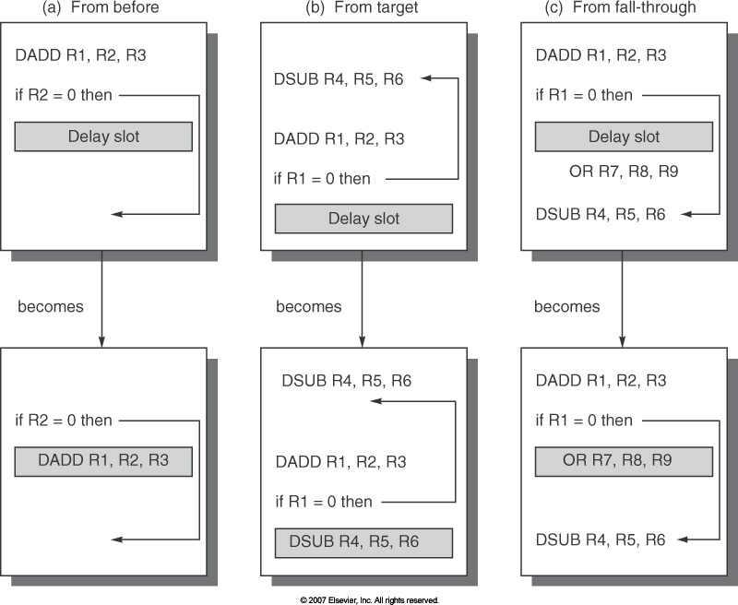
a) We can move one the instructions that was supposed to be executed before the branch. This is the ideal situation. Because we are always doing something useful and we are not wasting any cycle. The only catch is data dependency. In the above example, R2 is not depended on the instruction before the branch and therefore there is no data dependency problem.
b) We can execute the then path in advance. In case the then part happens 80% of the time we end up saving a cycle 80% of the time. Data dependency is again the only catch here. For example if we start executing the instruction that was supposed to be executed after then, it should not alter data in any register that would be fetched if else path is chosen.
c) We can execute the else path in advance subject to the same conditions described in (b).

Multi-cycle instructions
Different instructions are executed in different number of cycles.
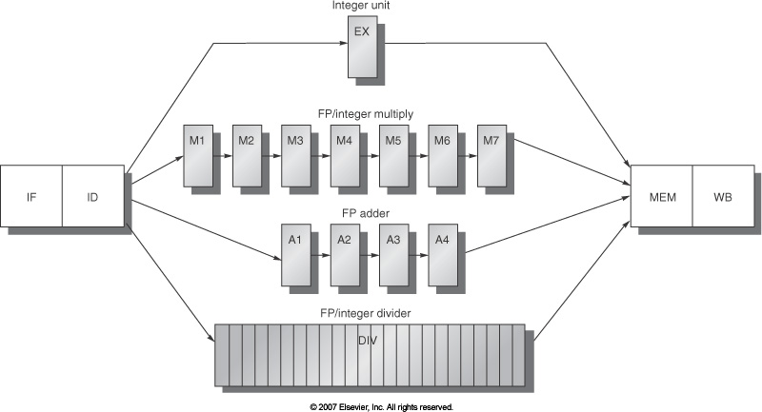

Potentially multiple instructions may try to write to the register file in a cycle. This is a structural hazard (competition over resources). We can solve this problem by providing more write ports. The next problem that we may encounter is Read After Write (RAW) hazard. Basically we should make sure that consumer comes after producer. For example imagine we want to do an add instruction that has to read contents of R1, and contents of R1 will be updated after a division operation which takes a long time to be executed. Therefore the add stage gets stalled. Also all of the instructions after add instructions are stalled.
The next problem we may face is called Write After Write (WAW) hazard. Let’s say the results of division and add operations are supposed to be written in R1, and when we are reading register R1 we are supposed to read the results of add. But since it takes division a longer time to be executed we end up reading the results of division (out of order completion of instructions). Most often this problem is handled automatically because when we do an operation that writes into a register, we need that value and after that we have an instruction that reads the value. In the above example if we have an operation that after division tries to read the value of R1 it has to wait (get stalled) until the R1 is updated and this automatically solves the problem. In the cases like branches (where we have if and else), this may turn to a problem. We can address this problem in decode stage. The decode stage knows that there is a previous write to R1 that is going to be completed after the current instruction, so it can stall the operation until the first instruction is done.
The next problem we may face is called Write After Read (WAR) hazard. It happens when we expect to write after read, but it goes the other way. Since the read happens so early it is impossible to violate WAR dependency.
Imprecise exceptions:
It happens because of out of order completion of instructions. For example if the first operation is a multiplication operation which takes a long time and the second operation is an addition which can be executed faster:
MUL R1 <-- R3 x R9 (10 cycle)
ADD R3 <-- (6 cycle)
LD R9 <-- (4 cycle)
These instructions don’t finish in order. Now if we face some problem in MUL instruction like an exception thrown because of over flow, we may want to inspect the contents of R3 and R9, but the second and third instructions have changed the value of these registers. The solution to this problem is to create an interface where instructions modify the contents of registers in program order, and if we choose to raise an exception in the first instruction of the above example (or in case an interrupt happens) we can save the state of program (PC, RF (register file)). We want to make sure that the RF saved doesn’t have the effects of other instructions. We can introduce a new specific buffer (re-order buffer, figure below). The ADD produces its results, but it notices that it isn‘t the oldest instruction and therefore it writes its results in the re-order buffer (shown in red). If another instruction needs the value of R3, it can get it from re-order buffer. The same thing will happen with LD instruction. When in cycle 10 the MUL is finished, since it is the oldest instruction it goes and changes the value of RF, and removes the MUL entry from re-order buffer. This allows ADD to recognize that it is the oldest instruction and can make its state permanent, and its output can be copied to R3, and so on.

MUL | R1
ADD | R3 | R3
LD | R9 | R9

Pipeline limits
Increase in performance without considering data dependency:
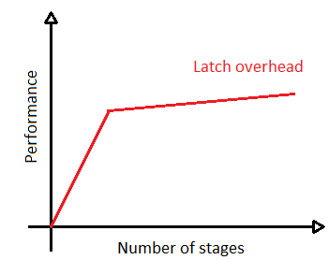

With hazards and stalls a few cycles go by without anything getting done. Therefore as we make pipeline deeper in presence of data dependency the performance will hit a pick and then start to degrade (We cannot pipeline forever).
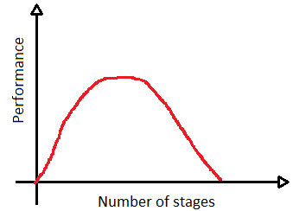

In an un-pipelined system:
Gap between independent instructions: T + Tovh
Gap between dependent instructions: T + Tovh

In a pipelined system:
Assume that there is dependence where the final result of the first instruction is required before starting the second instruction.
Gap between independent instructions: T/3 + 3Tovh
Gap between dependent instructions: T + 3Tovh
A
B
C
A
B
C

In case our program is full of dependence, and we increase the number of stages it can be clearly seen how the performance will be degraded (any additional stage hurts dependent instructions). In most of modern systems and processors it takes 30 to 50 stages before you hit that optimal point.
Dynamic and static scheduling
Dynamic scheduling:
Hardware intensive solutions require complex structures to identify independent instructions (scoreboards, issue queue), high power consumption, low clock speed, high design and verification effort. On the other hand, the compiler can “easily” compute instruction latencies and dependences – complex software is always preferred to complex hardware. Note that hardware intensive solutions can do a better job in minimizing the stalls.
Instruction-level parallelism (ILP):
It refers to how many instructions we are working on concurrently. For example if we built a pipeline with 5 stages we are allowing 5 different instructions to be in 5 different stages of completion within my processor. We can also stretch the width of our instruction and fetch multiple instructions at the same time; a 5 stage instruction with the width of 2 is capable of executing 10 instructions at the same time that is ILP of 10. Whenever we have stall cycles, that is when stage is doing something that is not useful ILP drops. If we want to maximize the ILP we should minimize stall cycles. What determines the degree of ILP? Dependences: property of the program, hazards: property of the pipeline.
Loops: account for most cycles, relatively easy to analyze and optimize. Loop example:
for (i=1000; i>0; i--)
x[i] = x[i] + s;

Loop: L.D F0, 0(R1) ; F0 = array element x[i], initially R1 has the address of x[1000]
ADD.D F4, F0, F2 ; add scalar, F2 is set to the value of s
S.D F4, 0(R1) ; store result
DADDUI R1, R1,# -8 ; decrement address pointer
BNE R1, R2, Loop ; branch if R1 != R2
NOP
It takes 10 cycles to execute the above for loop:
Loop: L.D F0, 0(R1) ; F0 = array element
stall ; Load feeding any instruction causes s stall
ADD.D F4, F0, F2 ; add scalar
2 stalls
S.D F4, 0(R1) ; store result
DADDUI R1, R1,# -8 ; decrement address pointer
stall ;NOP
BNE R1, R2, Loop ; branch if R1 != R2
stall
Smart scheduling
By re-ordering instructions, it takes 6 cycles per iteration instead of 10.
Loop: L.D F0, 0(R1)
DADDUI R1, R1,# -8
ADD.D F4, F0, F2
stall
BNE R1, R2, Loop
S.D F4, 8(R1)
There is dependence between DADDUI and store instructions. Store needs R1. If we move DADDUI up R1 will be decremented by 8, before it can be used by store. Store instruction has an integer offset (0(R1), which is 0 here), and we change this integer from 0 to 8 we will be fine. Notice that the instruction after branch will always be fetched and executed.
Loop Unrolling:
In loop unrolling method instead of doing one loop iteration add a time we do k iteration at a time.
Loop: L.D F0, 0(R1) ;x[i]
ADD.D F4, F0, F2
S.D F4, 0(R1)
L.D F6, -8(R1) ;x[i-1]
ADD.D F8, F6, F2
S.D F8, -8(R1)
L.D F10,-16(R1) ;x[i-2]
ADD.D F12, F10, F2
S.D F12, -16(R1)
L.D F14, -24(R1) ;x[i-3]
ADD.D F16, F14, F2
S.D F16, -24(R1)
DADDUI R1, R1, #-32
BNE R1,R2, Loop
Loop: L.D F0, 0(R1)
L.D F6, -8(R1)
L.D F10,-16(R1)
L.D F14, -24(R1)
ADD.D F4, F0, F2
ADD.D F8, F6, F2
ADD.D F12, F10, F2
ADD.D F16, F14, F2
S.D F4, 0(R1)
S.D F8, -8(R1)
DADDUI R1, R1, # -32
S.D F12, 16(R1)
BNE R1,R2, Loop
S.D F16, 8(R1)

Execution time: 14 cycles or 3.5 cycles per original iteration. Problems: Increase in program size, it requires more registers, and also To unroll an n-iteration loop by degree k, we will need (n/k) iterations of the larger loop, followed by (n mod k) iterations of the original loop. For example if n is equal to 1007, n/k = 251, and n mod k is 3. Therefore with loop unrolling you may need two loops.
Superscalar pipelines
A superscalar processor executes more than one instruction during a clock cycle by simultaneously dispatching multiple instructions to redundant functional units on the processor.
Note that after LD we need a stall cycle and after ADD we need to stall cycles that is why we unrolled by degree of 5 to eliminate stalls. In this case we have 12 cycles per 5 iteration (2.4 cycles per iteration.
Disadvantage:
Assuming that each instruction takes 4 bytes, now we have a larger instruction where every instruction takes 8 bytes. In some cycles we need to put Nop (no operation) in the second 4 bytes, which again will consume 4 bytes. In some cases the compiler may be able to specify instructions that can be issued as one packet (instructions that are independent of each other). For example if [I1, I2, and I3] are independent of each other if it is possible for hardware they can be executed in the same cycle. The next packet can be [I4 and I 5], and we can’t find any parallelism the packet can contain only one instruction.

Integer pipeline Floating point P pipeline
Loop: L.D F0,0(R1)
L.D F6,-8(R1)
L.D F10,-16(R1) ADD.D F4,F0,F2
L.D F14,-24(R1) ADD.D F8,F6,F2
L.D F18,-32(R1) ADD.D F12,F10,F2
S.D F4,0(R1) ADD.D F16,F14,F2
S.D F8,-8(R1) ADD.D F20,F18,F2
S.D F12,-16(R1)
DADDUI R1,R1,# -40
S.D F16,16(R1)
BNE R1,R2,Loop
S.D F20,8(R1)

Software pipelining:
In the example below as soon as we execute DADDUI we can start next loop. In the cycle shown below we are doing everything we do in a loop iteration.

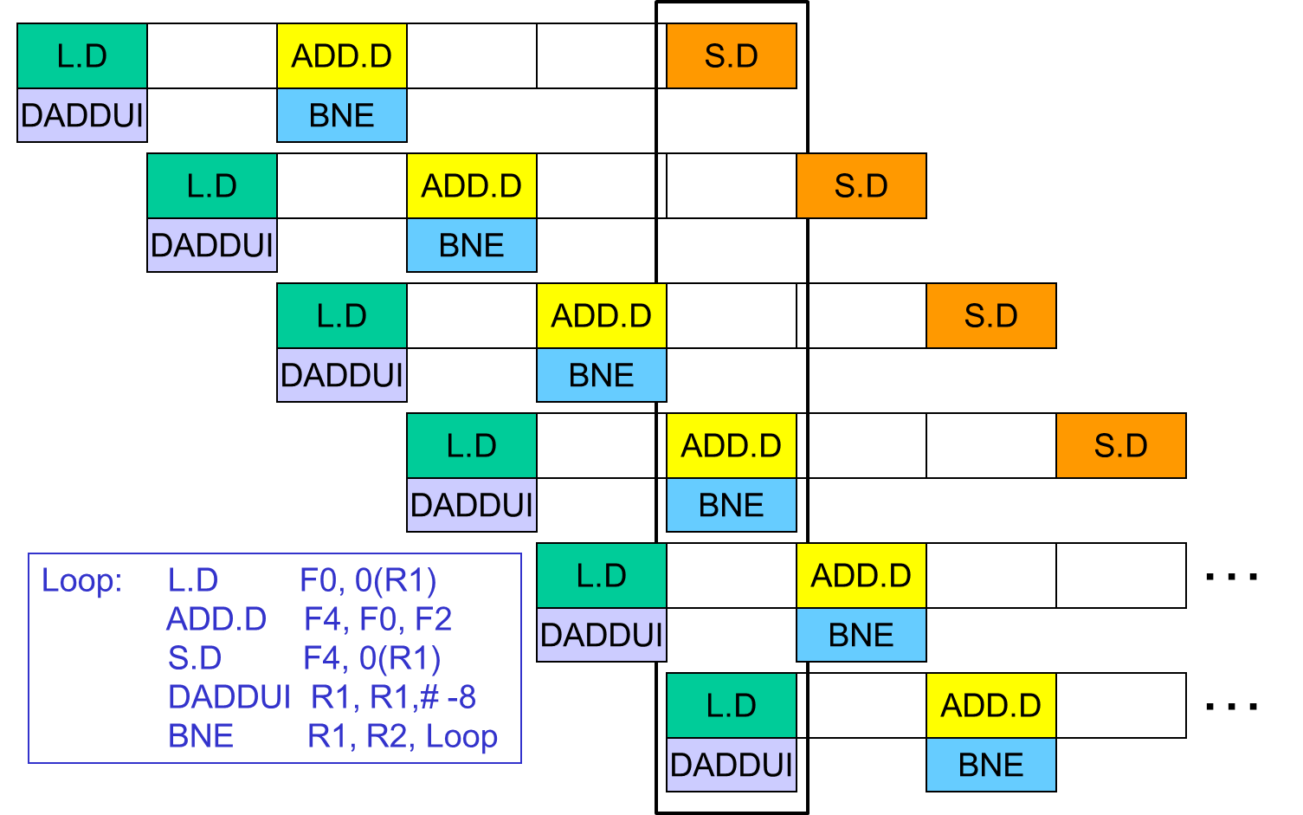

This is another way to see it:
In the first new iteration loop, we do LD for the original iteration 3, ADD for the original iteration 2, and SD for the original iteration 1.
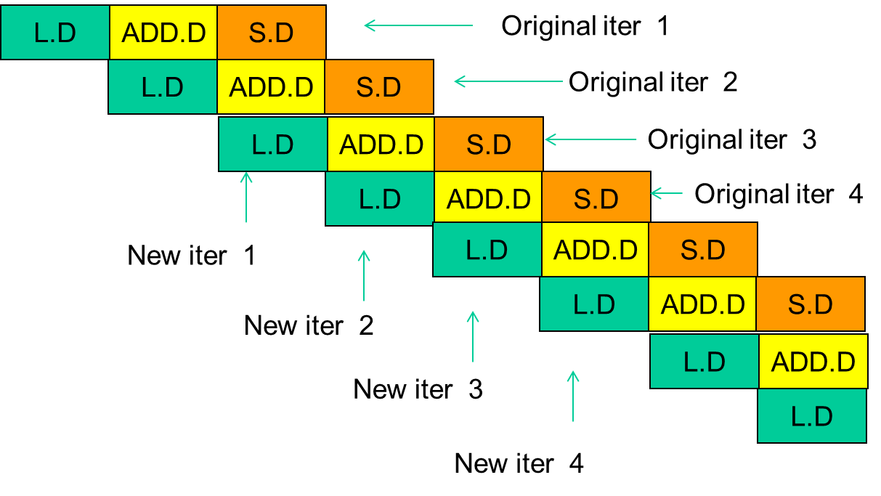

The last point to notice is that we do the LD, ADD, and ST in reverse order.

Loop: L.D F0, 0(R1)
ADD.D F4, F0, F2
S.D F4, 0(R1)
DADDUI R1, R1,# -8
BNE R1, R2, Loop
Loop: S.D F4, 16(R1)
ADD.D F4, F0, F2
L.D F0, 0(R1)
DADDUI R1, R1,# -8
BNE R1, R2, Loop

Advantages: achieves nearly the same effect as loop unrolling (eliminates stalling), but without the code expansion – an unrolled loop may have inefficiencies at the start and end of each iteration, while a software-pipelined loop is almost always in steady state – a sw-pipelined loop can also be unrolled to reduce loop overhead.

Deadlock
Deadlock happens when there is a cycle of resource dependencies – a process holds on to a resource (A) and attempts to acquire another resource (B) – A is not relinquished until B is acquired, and another process holds on B and makes a request to resource C, and this chain can continue on, and if this chain loops back and forms a cycle of dependencies then you have a deadlock. In a network whenever you have a routing algorithm that allows packets to male all of the possible turns, then you are in deadlock situation (because it allows network to create a cycle of dependencies). XY deterministic routing algorithm is deadlock free because in every possible loop it allows only 2 turns:

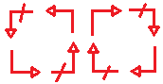
Note that not all of the deterministic routing algorithms are deadlock free. Adaptive routing algorithm can be deadlock free. In the above clock and clockwise loops if we avoid one of the turns the algorithms would be deadlock free. For example we can have a west-first routing algorithm, which means if we need to go to west we should do the west move first and later on we should not make any turn to the west.
Flow control
Flow control refers to how the network resources (buffers, links, …) get allocated along the path of different packets and flits.
Bufferless: flits are dropped if there is contention for a link, NACKs are sent back, and the original sender has to re-transmit the packet.
Circuit switching: a request is first sent to reserve the channels, the request may be held at an intermediate router until the channel is available (hence, not truly bufferless), ACKs are sent back, and subsequent packets/flits are routed with little effort (good for bulk transfers)
Buffered flow control:
Store-and-forward:
In every router you wait for the entire packet (header, body and tail flits) to show up, and after the entire packet is received it can continue (Clearly has low performance).
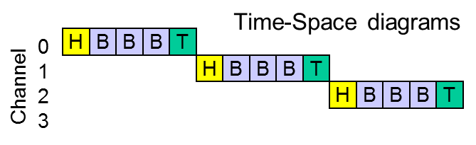

Cut-through:
In this method we basically pipeline the store and forward flow control. As soon as the header flit shows up it jumps across to the other end. With cut-through you can have a large packet that its flits are scattered across many different routers. If that packet were to get stuck because of congestion you end up holding up resources in large number of routers. That is the only disadvantages of this method, but since we are pipelining a transfer and minimizing the latency.
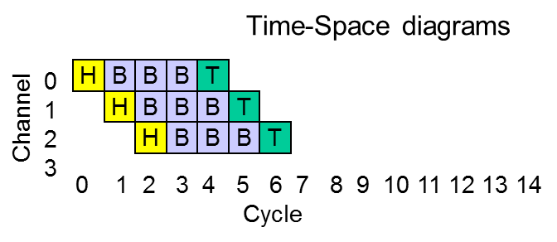

Wormhole routing: same as cut-through, but buffers in each router are allocated on a per-flit basis, not per-packet. That is when a header flit wants to make a jump from a router to another if it makes the jump only when it knows that there is a packet worth of buffer available it is cut-through method and if it makes the jump as soon as a flit worth of buffer is available it is called wormhole method.
Virtual channels


Flits do not carry headers. Once a packet starts going over a channel, another packet cannot cut in. If the packet is stalled, other packets can’t use the channel.
With virtual channels, the flit can be received into one of N buffers. This allows N packets to be in transit over a given physical channel. The packet must carry an ID to indicate its virtual channel.
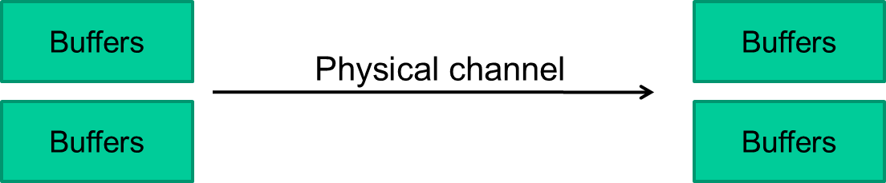

Predication
A branch within a loop can be problematic to schedule. Predication tries to convert data hazards to control hazards which will cost a few cycles but this cost is less than the penalty of going along the wrong path. This is best explained by the following example:

if (R1 == 0)
R2 = R2 + R4
else
R6 = R3 + R5
R4 = R2 + R3
R7 =! R1
R8 = R2
R2 = R2 + R4 (predicated on R7)
R6 = R3 + R5 (predicated on R1)
R4 = R8 + R3 (predicated on R1)

If we assume that 50% of the time we go with then and 50% of the time we go with else part, then ever other time we are going to pay a high price (at least couple cycles). The new code doesn’t have the branch part, it first executes the then part and then the else part. The “predicated on Rx” means check the value of Rx, if it is not 0 write the results in the corresponding register, otherwise discard the results. We are basically converted control dependencies into data dependencies.
The predication has an additional operand that determines whether the instruction completes or gets converted into a no-op. For example: lwc R1, 0(R2), R3 (load-word-conditional) will load the word at address (R2) into R1 if R3 is non-zero; if R3 is zero, the instruction becomes a no-op.
Memory data hazard
In general, when we re-order instructions, register renaming can ensure we do not violate register data dependences. However, we need hardware support to ensure that an exception is raised at the correct point to ensure that we do not violate memory dependences. For example in case below, imagine in LD we do R1 <--- [R2], and in SD we do R3 ---> [R4]:
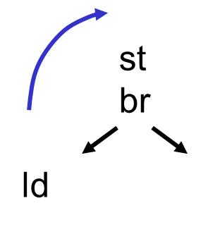
In order to eliminate stalls we can move LD before ST, and since there is no data dependency, there shouldn’t be any problem. But this is not always the case. For example if R4 and R2 have the same value. The register R1 will have a wrong value (RAW hazard). To solve this problem we can use the new code:

LD,S is speculative load (the load instruction has been moved up) . Then the compiler will use a table which is usually called Advanced Address Load Table (ALAT). So whenever we have a load that is being executed in advance the address is being recorded in this table. Later when we execute any store we will check ALAT and in case there is a match we invalidate that advanced load and later when we reach the check instruction (shown above) we will jump to our recovery value and correct the value of R1. This demonstrates the limitations to what the compiler can do. Ultimately if you want high performance you do need to also consider hardware intensive techniques. The compiler based techniques are mostly suitable for embedded processors were you don’t need ultimate highest performance, but you want to keep hardware really simple.

Hardware intensive techniques

Dynamic Frequency Scaling (DFS)
Assume that we have a processor that at 1 GHz consumes 100 W (75W of dynamic power and 25 W of leakage power) power and gets a given task done in 100ms. What DFS does is that at run time depending on the need scales the frequency up and down. Now we reduce the frequency to 0.5 GHz. The dynamic power is linear function of operating frequency therefore the dynamic power will be reduced to half, but the leakage power will not change because depended on number of transistor the supply voltage and leakage current which none of them changes by changing the frequency. So the new power will be 62.5 W. One naive way to look at execution time is to consider that IPC will remain the same and the execution time will be doubled. Therefore our new energy consumption will be 1.25 times of the old energy (E = P.t). Therefore in terms of energy consumption DFS is a bad idea but in terms of power consumption it is a good idea. It allows the processor to work correctly with a given cooling solution. In practice, most systems (processors) are used with an external memory. When you are changing the frequency you are only affecting processor and the memory is operating with the same speed. So if getting something from memory took 100ns in 1 old processor the memory access corresponds to 100 cycles while in the new processor it corresponds to 50 cycles. Therefore when you go to lower frequencies the memory access in terms of cycles reduces. So in the new design IPC increases. Therefore in practice the execution time doesn’t go down with the factor of 2.

Dynamic Voltage and Frequency Scaling
If the power supply for our processor is 1V and we reduce it 0.9V, it will lead to the increase in delay. Therefore if we had clocked the processor with 1GHz, the circuit will not be able to finish its job and this can lead to incorrect results. Therefore we have to reduce the clock frequency (for example to 0.9 GHz) for the correct operation of the circuit. If the original processor was consuming 100 W (75W of dynamic power and 25 W of leakage power) power, the new dynamic power will be 75x0.9x0.9^2 =55 W. Therefore the new power will be 77W. Since power is square function of power supply any small reduction in power leads to big reduction in power consumed and a small reduction frequency. If the execution time in original processor was 100ms, with the reduction of frequency it will increase to 110ms. Therefore the new energy consumed will be: E = 0.84xEold.

What are the steps involved in following a particular instruction given by the CPU?
The following steps are followed-
- The instruction pointer tells the instruction fetch where in the memory the instruction is.
- The fetch takes the instruction and gives it to the decoder, which determines the steps that are necessary to fulfill the instructions.
- The information is then sent to the ALU, which performs the instructions that need to be performed. This includes adding, subtracting, or manipulating the data further.
- Finally, the instructions are sent out into the computer where they are needed.

What do you mean by Parallel Processing?
It is a type of processing in which the CPU divides the problem into two parts. It works as-
- Each part is sent to separate processors.
- Each processor has its own memory. They individually solve the given problems and return the result.
- The CPU assembles the results and hence, the problem is solved.
Some computers operate in terms of teraflops or trillions of floating-point instructions per second.

Difference between heap and stack?
The heap is the section of computer memory where all the variables created or initialized at runtime are stored.
The Stack is more or less responsible for keeping track of what's executing in our code (or what's been "called"). The Heap is more or less responsible for keeping track of our objects (our data, well... most of it).

Explain some Memory Components.
Some of the memory components are-
- Semiconductor Memory: It is used by most by most modern computers. It is reliable, inexpensive and compact. However, it requires continuous power supply and data is lost if current is interrupted.
- RAM and ROM: They stand for Random Access Memory and Read Only Memory respectively.
- Flash Memory: This memory is electrically erasable and reprogrammable.

What does a Microprocessor mean?
A Microprocessor is a miniature CPU unit that is etched on a silicon chip. A CPU (Central Processing Unit) hardware carries out the instructions of a computer system. The Microprocessor unit consists of millions of tiny transistors. It has multi purposes and is programmable. They operate on numbers and symbols represented in Binary Numeral Language.

What all does a Microprocessor comprise of?
They comprise of the following key components-
- Central Processing Unit: It carries out the instructions of a computer system
- Registers: They store bits of information in a way that all the bits can be written to or read out simultaneously.
- System clock: simple count of the number of ticks that have transpired since some arbitrary starting date, called the Epoch.

Explain the characteristics of instruction and execution time.
Some of the characteristics of instruction time are as follows:
- The instruction time is also known as the I-time.
- It is the time taken by the Control Unit to get an instruction from memory and to load it to the register.
- The time also includes the time taken by the CU for instruction decoding and to find out the location of the required data.
Some characteristics of execution time are:
- It is the time required by the control unit to move data from the memory to the registers in the ALU, the ALU is responsible for the execution of instructions on this data.

ARM stands for Advanced RISC Machine:
ARM processors are a family of 32-bit microprocessors developed by Advanced RISC Machines, Ltd. in the 1980s. Today ARM processors power a wide variety of electronic devices, including mobile phones, tablets, multimedia players and more.
ARM processors are based on a reduced instruction set computer (RISC) architecture, and while they do share the low-end market with processors from AMD and Intel, they aren't designed to compete with these companies' higher-end processors.

What is GPU Computing?
GPU computing is the use of a GPU (graphics processing unit) together with a CPU to accelerate general-purpose scientific and engineering applications. Pioneered five years ago by NVIDIA, GPU computing has quickly become an industry standard, enjoyed by millions of users worldwide and adopted by virtually all computing vendors.

CPU + GPU is a powerful combination because CPUs consist of a few cores optimized for serial processing, while GPUs consist of thousands of smaller, more efficient cores designed for parallel performance. Serial portions of the code run on the CPU while parallel portions run on the GPU.

Graphics chips started as fixed-function graphics processors but became increasingly programmable and computationally powerful, which led NVIDIA to introduce the first GPU.

A graphics processing unit (GPU), also occasionally called visual processing unit (VPU), is a specialized electronic circuit designed to rapidly manipulate and alter memory to accelerate the building of images in a frame buffer intended for output to a display. GPUs are used in embedded systems, mobile phones, personal computers, workstations, and game consoles. Modern GPUs are very efficient at manipulating computer graphics, and their highly parallel structure makes them more effective than general-purpose CPUs for algorithms where processing of large blocks of data is done in parallel. In a personal computer, a GPU can be present on a video card, or it can be on the motherboard or—in certain CPUs—on the CPU die. More than 90% of new desktop and notebook computer have integrated GPUs, which are usually far less powerful than those on a dedicated video card

GPU is a graphical processing unit which enables you run high definitions graphics on your PC, which are the demand of modern computing.

What is the race around condition? How can it be overcome?
Race conditions are a severe way crashing the server/ system at times. Generally, this problem arises in priority less systems or the users who have equal priority will be put to this problem. Race condition is a situation in which a resource D is to be serviced to a process A and the process B that holds the resource C is to be given to the process A. So a cyclic chain occurs and no way the resources will be get shared and also the systems with equal priority won’t get the resource so that the system won’t come out of the blocked state due to race condition!

What is cache memory?
Cache is small high speed memory usually Static RAM (SRAM) that contains the most recently accessed pieces of main memory.
In today’s systems, the time it takes to bring an instruction (or piece of data) into the processor is very long when compared to the time to execute the instruction. For example, a typical access time for DRAM is 60ns. A 100 MHz processor can execute most instructions in 1 CLK or 10 ns. Therefore a bottle neck forms at the input to the processor. Cache memory helps by decreasing the time it takes to move information to and from the processor. A typical access time for SRAM is 15 ns. Therefore cache memory allows small portions of main memory to be accessed 3 to 4 times faster than DRAM (main memory).
Cache is a component that transparently stores data so that future requests for that data can be served faster. The data that is stored within a cache might be values that have been computed earlier or duplicates of original values that are stored elsewhere. If requested data is contained in the cache (cache hit), this request can be served by simply reading the cache, which is comparatively faster. Otherwise (cache miss), the data has to be recomputed or fetched from its original storage location, which is comparatively slower. Hence, the more requests can be served from the cache the faster the overall system performance is. Caching is often considered as a performance-enhancement tool than a way to store application data. If you spends more server resources in accessing the same data repeatedly, use caching instead. Caching data can bring huge performance benefits, so whenever u find that u need to frequently access data that doesn’t often change, cache it in the cache object and your application's performance will improve.
The following are two types of Cache-
i. Internal or Level 1: In this, the Cache is built into the Microprocessor.
ii. External or Level 2: In this, the Cache is built on a separate chip.
The Internal Cache is the fastest but it is very expensive.

How is a block found in a cache?
Each place in cache records block's tag (as well as its data). Of course place in cache may be unoccupied so usually place maintains valid bit. So to find block in cache: 1. Use index of block address to determine place (or set of places) 2. For that (or each) place check valid bit is set and compare tag with that of block address --- this can be done in parallel for all places in a set.

What is cache coherency and how is it eliminated?
Cache coherence or Cache coherency refers to a number of ways to make sure all the caches of the resource have the same data, and that the data in the caches makes sense (called data integrity). Cache coherence is a special case of memory coherence. There may be problems if there are many caches of a common memory resource, as data in the cache may no longer make sense, or one cache may no longer have the same data as the others. A common case where the problem occurs is the cache of CPUs in a multiprocessing system.
What is write back and write through caches?
write-back cache a caching method in which modifications to data in the cache aren't copied to the cache source until absolutely necessary. write-through cache performs all write operations in parallel -- data is written to main memory and the L1 cache simultaneously. Write-back caching yields somewhat better performance than write-through caching because it reduces the number of write operations to main memory. With this performance improvement comes a slight risk that data may be lost if the system crashes.

What is a Microprocessor? - Microprocessor is a program-controlled device, which fetches the instructions from memory, decodes and executes the instructions. Most Micro Processors are single- chip devices.
The picture below illustrates general computer structure. There are three subsystems: CPU, Memory, IO ports(periferal devices).
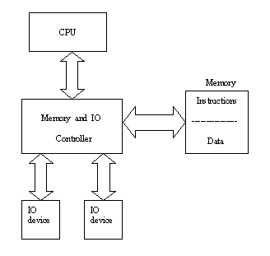
Basic CPU operations:
- fetching the instruction from memory,
- decode the instruction,
- execute command and write the result data back to the memory or to I/O device.
Here is an example of timing diagram. Every bus cycle in this example consists of 4 clock periods. All operations are synchronous with the clock. To write into memory CPU sets the address,during the next clock cycle - DATA. Then CPU activates control signal MEM_WR (active low) and on the rising edge of MEM_WR the DATA is latched into the memory device. In this example (applicable to all x86 systems) memory and IO devices have different address space. To exchange data with IO port CPU activates IO_WR or IO_RD signals.
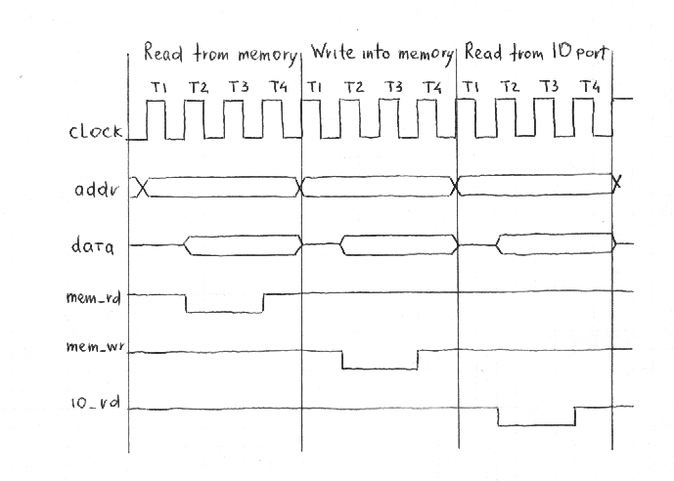
What is Virtual Memory?
This Memory is used extending the capability of physical memory. This memory is simulated by the hard drive. When all the RAM is being used the computer will swap data to the hard drive and back to give the impression that there is more memory

What’s the difference between L1 and L2 cache?
Level 1 cache is internal to the chip, L2 is external. L1 Cache is of Higher speed than that of L2 Cache.

************************************************************************

MOSI
MISO
SS
Sclk
SPI Slave

MOSI
MISO
SS
Sclk
SPI Slave
Sclk
SPI Master
MOSI
MISO
SS1
SS2
SS3

MOSI
MISO
SS
Sclk
SPI Slave

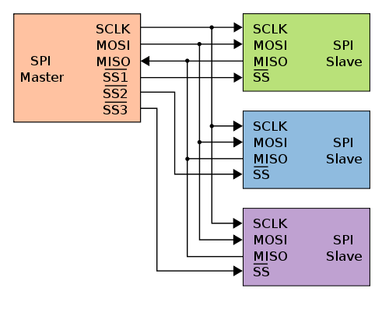
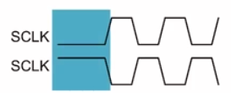

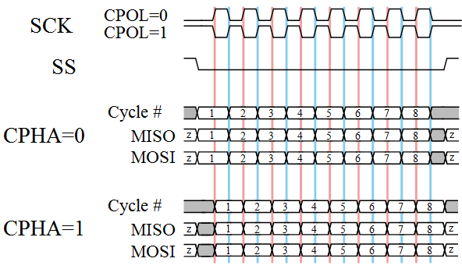

In the above figure pay attention to the location of MSB and LSB.
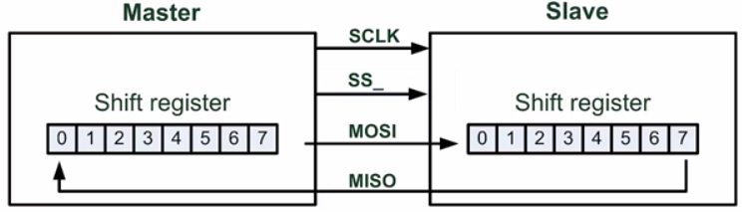

Inter-Integrated Circuit (I2C)
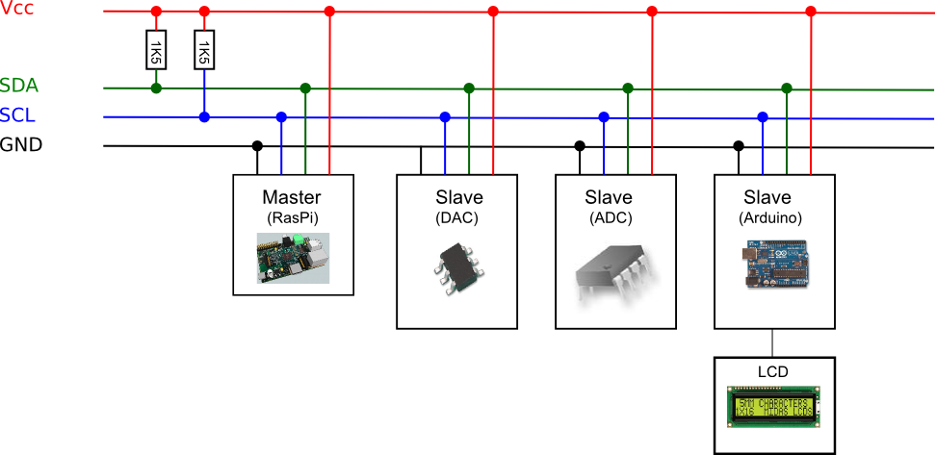
The physical size of ICs has reduced dramatically over the years. The main reason, of course, is attributed to the fact that more and more transistors can be cramped into a smaller space. A less mentioned reason is because the pins for interconnections between ICs have also decreased both in size and in number. As you probably know, the actual circuitry of the IC is much smaller than the packaging of the IC. The reason why the packaging has to be larger is because of the larger pins needed for the connections on the PCB. One solution for reducing the packaging size is therefore to have fewer pins for the connections.
The I2C (Inter IC) bus is a simple bi-directional serial bus that supports multiple masters and slaves. It consists of only two lines; a serial bi-directional data line (SDA) and a serial bi-directional clock line (SCL).
Each device connected to the I2C bus is software addressable by a unique address, and a simple master/slave relationship exists at all times among the devices. The device that controls the sending and receiving of messages by controlling the bus access is referred to as the master. Devices that are controlled by the master are the slaves. Both the master and the slave can send and receive messages. More than one master and more than one slave can all co-exist on the same I2C bus. However, the bus is always controlled by a single master who is responsible for generating the serial clock (SCL), and controlling the bus access by initiating and terminating a message transfer.
Both of these lines are open-drained, and must be pulled up to V_{CC} with a 5.6KΩ resistor. Regardless of how many devices are connected to the bus, only one pull-up resister is needed per line. Furthermore, the SCL line needs to be pulled up with a resistor only if there will be two or more masters in the system, or when the slave will do clock stretching as a flow-control measure. In the first case, the pull-up resistor on the SCL line is required for arbitration purposes when two or more masters try to initiate a data transfer at the same time. In the second case, a receiver may not be ready to receive data from the transmitter, and so it will hold the SCL line low to “stretch” the clock to delay the transmitter.
The I2C bus is idle when both SCL and SDA are at logic 1 level. The master initiates a data transfer by issuing a START condition, which is a high to low transition on the SDA line while the SCL line is high as shown below. The bus is considered to be busy after the START condition. After the START condition, a slave address is sent out on the bus by the master. This address is 7 bits long followed by an eighth bit which is a data direction bit (R/W) where a 0 indicates a write from the master to the slave and a 1 indicates a read from the slave to the master. The master, who is controlling the SCL line, will send out the bits on the SDA line, one bit per clock cycle of the SCL line, with the most significant bit sent out first. The value on the SDA line can be changed only when the SCL line is at a low.
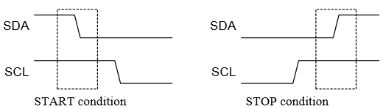

The slave device whose address matches the address that is being sent out by the master will respond with an acknowledgment bit on the SDA line by pulling the SDA line low during the ninth clock cycle of the SCL line as shown below. The direction bit (R/W) determines whether the master or the slave will be the transmitter in the subsequent data transmission after the sending of the slave address.

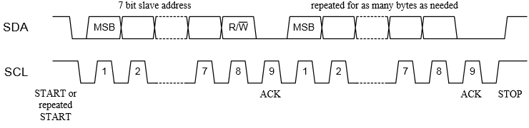
Every byte put on the SDA line for transmission must be 8-bits long with the most significant bit first. Except for the START and STOP conditions, the SDA line must not be changed when the SCL line is high. The number of bytes that can be transmitted is unrestricted. Each byte has to be followed by an acknowledge bit. The acknowledge-related clock pulse is generated by the master. The transmitter releases the SDA line (sets it high) during the acknowledge clock pulse, and the receiver must pull down the SDA line during the acknowledge clock pulse to acknowledge the receipt of the byte. The one exception is when a master-receiver is involved in a transfer. In this case the master-receiver must signal the end of data to the slave-transmitter by not generating acknowledge on the last byte that was clocked out of the slave. To signal the end of data transfer, the master will send a STOP condition by pulling the SDA line from low to high while the SCL line is at a high.
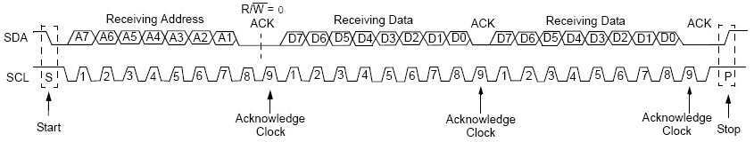

*****************************************************************************
HGST (Hitachi Global Storage Technologies)
SSD: Solid State Drive
SSD: There are no moving parts, no movement, less sounds
SSD: Very low power, the battery life increases some hours
SSD: Colder
SSD: Lighter
Types of SSD: DRAM, NAND: lot number of times that data can be written, expensive, NOR: limited number of times you can write in, but are very fast, special applications like booting
MLC: Multiple layer chip
Read and write in a block

What do you understand by a hard disk and how are they classified?
- Hard drives are usually devices that can be used for storing data and to retrieve it. They are composed of one or more than one rigid disc that rapidly rotates.
- The discs are magnetically coated and use magnetic heads to read and write data on them.
- They are also known as the secondary storage devices used to store large amounts of data.
- They can be classified into the following types: Non-Volatile, Digital, Magnetic or data storage devices.
- Hard drives have been dominant since the use of personal computers as they allow large amounts of data to be stored at low costs and high reliability.

Explain briefly the structure of a hard drive?
- Hard disks in them contain various components such as Platter, Spindle, Actuator, power connector, Jumper block, IDE connector etc.
- In the inside of a hard disk there is the spindle which is used to hold circular magnetic disks also known as platters. They are usually made up of a non-magnetic material, (aluminum alloy).
- These platters are spun at speeds in excess of 4000 RPM, nowadays 7200 RPM based hard disks are common enough.
- The read and write heads work on these spinning platters to read and write data. They are controlled by an actuator arm that prevents any error.

Explain how data is read and written on a hard disk?
- In a hard disk information / data is written on the rotating platters by the read and write heads.
- The heads are not in actual contact with the disk they are actually slightly above the magnetic surface of the platter.
- The heads detects the magnetization of the platter right below them. The actuator arm aids the heads in covering the platter area.
- The surface is divided into micro sized areas known as magnetic domains. Every magnetic domain has a magnetic dipole which has its own field.
- The write heads read/write by magnetizing the area. It generates a strong magnetic field for this purpose.

What are the ways in which errors can be handled by hard disks?
There are various ways in which modern hard disks handle errors.
- Most hard disks use ECC`s error correcting codes mostly the Reed-Solomon error correction techniques.
- The error checking codes usually employ the use of complex algorithms mathematically derived to store extra bits. These bits are used to correct various errors.
- Nowadays most of the drives support LDPC or the low density parity check codes.
- The LDPC allows performance to reach the Shannon limit and also result in the highest storage capacity drives.

Briefly explain what you understand by Formatting in reference to hard disks.
There are two steps involved in formatting magnetic media such as floppy disks and hard disks. The first step involves the creation of the actual structures on the surface of the media that are used to hold the data. This means recording the tracks and marking the start of each sector on each track. This is called low-level formatting, and sometimes is called "true formatting" since it is actually recording the format that will be used to store information on the disk.
The second formatting step is high-level formatting. This is the process of creating the disk's logical structures such as the file allocation table and root directory. The high-level format uses the structures created by the low-level format to prepare the disk to hold files using the chosen file system.
For a hard disk, there is an intermediate task that is performed between the two formatting steps: partitioning. For this reason, combined with the incredible complexity of modern hard disks, they are low-level formatted by the manufacturer, and high-level formatting is done by the DOS FORMAT command (or equivalent). Floppy disks require no intermediate step, and due to their relative simplicity, they are both low-level and high-level formatted at the same time by default when you use the FORMAT command.

What are the various form factors in which the hard disks are available? Give examples
- 8 inch: This was one of the first hard disks to be developed, It`s size was same as that of the 8 inch floppy drives.
- 5.25 inch: Comparatively smaller than 8” this type of drive was first time provided by Segate.
- 3.5 inch: This is the most common size of the drive that is used these days in personal computers.
- 2.5 Inch: This type of hard drives is primarily used inside portable devices such as laptops, music players etc.
- 1.8 Inch: This was a rare size and was primarily intended to be used by audio players and sub notebooks.
- 1 Inch: This type of drives were developed to house the entire disk inside a CF II Slot.

What do you understand by access time? Briefly explain the different types of timings in a hard disk drive.
- The access time is the time taken by the disk to read data on it and it is directly related to the nature of the platter speeds and the moving heads.
- Seek time: This time specified the time taken by the head to reach the track where the required / target data is available.
- Rotational Latency: This latency occurs when the required data by the computer is still not under the head so the assembly will have to move their.
- The access time of the hdd can be improved by giving more speed in the rotation of the platter.

What is the purpose of interleave? Explain.
- Interleave is the process through which gaps are placed between two sectors on the platter of a disk.
- This was done in earlier days when the computers were not quick enough to read continuous streams of data.
- Without interleaving there would be no gaps between the sectors and data would arrive immediately before the reading unit is ready. Due to this to read the same data a complete rotation of the disk would be required again.
- The interleaving ratio was not fixed and can be set by the end user depending on their system specs. Nowadays the ratio of interleaving is 1:1 i.e. no interleaving is used.

Describe the power consumption statistics of the hard disks.
- These days power consumption of electrical devices has become a prime importance as portability and performance greatly depends on devices consumption.
- Power consumption of a hard disk directly affects: Drive age, disk failure rates, temperatures etc.
- Smaller drives consume less energy as compared to large drives. The disks consume maximum energy during starting up, also known as spin up.
- Spin up and spin down is directly controlled by the SCSI controller on such drives.

Briefly mention the different types of disk interfaces used in computers.
There are various interfaces through which hard disks connect to the computer.
- Legacy Bit Serial Interfaces: They are the oldest form of interfaces which used two cables to connect the disk to a controller. One cable was used for data whereas the other is used for control. In addition to the above cables a power cable was also required to provide power to the disk.
- Modern Bit Serial Interfaces: In these types of interfaces the disk is connected to a host bus interface adapter using a single cable. In addition to this cable a power cable is also used to power the drive. Some of the modern bit serial interfaces are as follows: Fibre Channel, Serial ATA and SCSI.
- World Serial interfaces: They are similar to modern bit interfaces; these interfaces make use of a cable for data and control. Some of the common world interfaces are as follows: IDE, EIDE, SCSI etc.

What are the different ways of hard drive failure?
A hard drive may fail due to multiple reasons. Some of the common causes are:
- Head Crash: This is caused when the read/write head comes in contact with the platter. This can cause the area where it has come in contact to lose data.
- Bad Sectors: The platter in a hard drive is split into minute areas known as sectors. Sometime certain sectors might become faulty, this does not affect the entire drive.
- Stiction: Sometimes the head of the disk is not able to take off; it tends to stick to its position. This phenomenon is known as stiction.
- Circuit failure: The hard disk becomes inoperable if any of its circuitry malfunctions.
- Bearing and motor failure: After prolonged usage the hard disks motors or bearing tend to worn out hence not allowing normal disk performance.

What do you understand by Landing zones and their technologies?
- When a hard disk is functioning normally the read write head simply fly`s over the platter without making any contact. These days to prevent the head from touching the platter the head is physically moved (parked) to special areas also known as landing zones to prevent data loss.
- The landing zones are usually areas where no data is stored.
- Another approach is to leave the heads suspended in air so that they never come in contact with the platter surface.
- In legacy devices the heads could not be automatically landed and in order to prevent them from touching the platter the user had to run programs manually to park the heads.

Briefly tell us about the different market segments for Hard Disks.
There are various segments for which the Hard Disks are available:
- Desktops: They are the most common form of hard disks. The Desktop Disks can be used to store data between 60 GB to 4 TB. They generally rotate at RPM`s between 5400 and 1000. The data transfer rates for them is around 0.5 Gbit/s
- Mobile: The hard drives belonging to this segment are smaller as compared to desktops. They have a lower capacity and are usually slower. The standard size for such segments is around 2.5 inches.
- Enterprise: These types of hard disks are usually shared between multiple systems and data is written and read at a very fast pace. They are known to rotate at around 10k to 15k RPM, also these drives have the ability to reach sequential speeds of more than 1.6G bit/s.

What do you understand by SMART?
- SMART means Self-Monitoring, Analysis and Reporting Technology.
- This is a monitoring system for hard disks used to detect and report various factors which can be used to anticipate/predict the risk of a failure for a hard disk.
- The failure of hard disks can be classified into predictable and unpredictable errors.
- Predictable failures are those which are resultant from wear and tear and degradation of storage services. Unpredictable failures on the other hand occur suddenly with no warnings.
- The SMART technology allows the user to monitor the health of the Drive and perform constant maintenance checks to prevent the chances of failures.
- There are multiple number of self-tests that can be performed by SMART such as: Short, Long/Extended, Conveyance and Selective.

What do you understand by Controller and what are its primary functions?
- Controllers can be considered to be an interface between the disk and the host computer.
- These days most of the Controller circuits are placed inside the Southbridge of the motherboard.
- The controller is also used for the following functions: Error code correction, Wear leveling. Bad Block, read scrubbing and disturb.

*****************************************************************************
Scripting-Perl
Every perl program starts off with this as its very first line:
#!/usr/local/bin/perl

Scalar variables
The most basic kind of variable in Perl is the scalar variable. Scalar variables hold both strings and numbers, and are remarkable in that strings and numbers are completely interchangeable. Scalar variables in Perl are always referenced with the leading $.

Getting user input
<SDTIN> (line input operator) can be used to read complete text line from standard input up to the first new line. $a = <STDIN>;

The chomp operator
If a string ends in a new line character, it can get rid of the new line character:
$text = “A line of text\n”;
chomp($text);

Referring to an entire array:
Use the @ sign before the name of the array.

The pop and push operators
The pop operator takes the last element off of an array and returns it. The converse operation is push, which adds an element to the end of an array:
pop @array;
push(@array, 9);

The shift and unshift operators
The unshift operator adds a new element to the beginning of the array, and the shift operator removes the start element of the array:
shift @array;
unshift (@array, 9);

foreach
The foreach loop steps through a list of values, executing one iteration for each value.

Default Input and Pattern Searching Variable
If you don't specify a variable to put each element into, $_ is used instead as it is the default for this operation, and many, many others in Perl. Including the print function:
foreach (@names) {
print "$_";
}
foreach (@names) {
print ;
}
As we haven't supplied any arguments to print, $_ is printed as default. You'll be seeing a lot of $_ in Perl. Actually, that statement is not exactly true. You will be seeing lot of places where $_ is used, but quite often when it is used, it is not actually written. In the above example, you don't actually see $_ but you know it is there.

<SDTIN> in list context
In the list context, <STDIN> returns all of the remaining lines up to the end of the file. Each line is returned as a separate element of the list:
@array = <STDIN>;

If the input is not coming from a file (it comes from keyboard), in linux/unix type ctrl-D and in windows type ctrl-Z to indicate to the system that there is no more input.

Hash in Perl
A hash is a data structure like an array, in that it can hold any number of values and retrieve these values at will. However, instead of indexing the values by number, as we do with arrays, we will look up the values by name, that is the indices called keys aren’t numbers but are arbitrary unique strings.

What is Perl used for?
PERL is a scripting language and normally used to automate task. So to run VLSI tools or test bench stuffs rather than doing things manually you write a script for running the task.
Most of the work in VLSI, expect DESIGN can be redundant. Like simulating the same design, compiling, simulating again and again, we if we make a single change in our design.
So to avoid this, we can use scripting languages to automate this work, just writing what are the steps the tool should do, fetch the file, Compile it, simulate it.

‘my’ command in Perl
‘my’ allows you to create and scope a variable at the same time. For example:

for (1..5) {
my $variable = "hello"
print $variable;
}
print $variable;

that would print "hello" 5 times (e.g. because the loop goes from 1 to 5). However, the print statement outside the loop would not print anything as the variable only exists within the loop - its scope.

Running external programs from Perl with system
In many cases Perl is used as a wrapper around other programs. This means that we run those other programs from our Perl program. For example we might want to capture the output of another command line program and then make some decisions based on that output.
The simplest one is called system. In its most basic form in accepts a string that contains exactly what you would write on the command line in order to invoke the external command.
my $cmd = '/usr/sbin/adduser --home /opt/bfoo --gecos "Foo Bar" bfoo';
system($cmd);

*****************************************************************************
PCI
What is difference between PCI and PCIe?
PCI is a bus, whereas PCI Express is a point-to-point connection, i.e., it connects only two devices; no other device can share this connection. Just to clarify, on a motherboard using standard PCI slots, all PCI devices are connected to the PCI bus and share the same data path, so a bottleneck (i.e., performance decrease because more than one device wants to transmit data at the same time) may occur. On a motherboard with PCI Express slots, each PCI Express slot is connected to the motherboard chipset using a dedicated lane, not sharing this lane (data path) with other PCI Express slots. Also, devices integrated on the motherboard, such as network, SATA, and USB controllers, are usually connected to the motherboard chipset using dedicated PCI Express connections.
PCI and all other kinds of expansion slots use parallel communications, while PCI Express is based on high-speed serial communications.
PCI Express is based on individual lanes, which can be grouped to create higher-bandwidth connections. The “x” that follows the description of a PCI Express connection refers to the number of lanes that connection is using.

*****************************************************************************
Universal Verification Methodology (UVM)

What is UVM?
It is a methodology to write test benches for a design that can be Verilog, VHDL and even Systemc. UVM itself is written in SystemVerilog, so one of the main deliverables in UVM is SystemVerilog Base Class Libraries (BCL) (actual code of UVM). UVM supports constrained random verification which is the idea of using random vectors in simulation. This is helpful to find unexpected bugs. If you plan the test bench and apply the test vectors accordingly you will find the bugs you are looking for. UVM also helps to automate the test process without having to spend long time writing the test benches and verifying the results. UVM has an open source license and can be downloaded from accellera.org, UVM is based on OVM.

One of the key principles of UVM is to develop and leverage reusable UVM-compliant verification components (UVC). A UVC is an encapsulated, ready to use and configurable verification environment intended for an interface protocol, a design sub-module, or even for software verification. Each UVC follows a consistent architecture and contains a complete set of elements for sending stimulus, as well as checking and collecting coverage information for a specific protocol or design.

How does constrained random verification work?
We should always remember 3 Cs: Checkers, Coverage, and Constrains.
Checkers
Does it work?

Random test vectors
00010101010
01000101010
00001010
01010100
Design Under Test

Outputs
Functional Coverage
Are we done?
Recording what goes on during simulation and identifying how thoroughly we verifies the design
Constrains
We need to constrain the random test vectors to increase coverage

How does UVM generate stimulus?
It uses a layered approach called sequences. A sequence generates transactions.

A designer understands the inner workings of his or her block, and is the best person to write assertions about it, but a verification engineer may have a broader view needed to create assertions between blocks.

Full testbench with all layers:

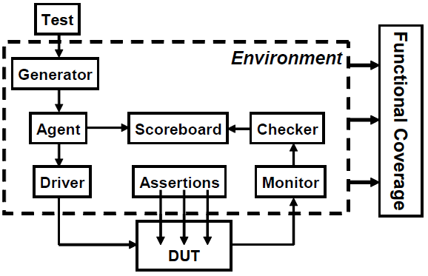

Command layer:
The DUT’s inputs are driven by the driver that runs single commands such as bus read or write. The DUT’s output drives the monitor that takes signal transitions and groups them together into commands. Assertions also cross the command/signal layer, as they look at individual signals but look for changes across an entire command.
The functional layer:
The functional layer feeds the command layer. The agent block receives higher-level transactions such as DMA read or write and breaks them into individual commands. These commands are also sent to the scoreboard that predicts the results of the transaction. The checker compares the commands from the monitor with those in the scoreboard.
The scenario layer:
The functional layer is driven by the generator in the scenario layer. What is a scenario? Remember that your job as a verification engineer is to make sure that this device accomplishes its intended task. An example device is an MP3 player that can concurrently play music from its storage, download new music from a host, and respond to input from the user, such as volume and track controls. Each of these operations is a scenario. Downloading a music file takes several steps, such as control register reads and writes to set up the operation, multiple DMA writes to transfer the song, and then another group of reads and writes. The scenario layer of your testbench orchestrates all these steps with constrained-random values for parameters such as track size and memory location.
The test layer and functional coverage:
The test contains the constraints to create the stimulus. Functional coverage measures the progress of all tests in full filling the requirements in the verification plan. The functional coverage code changes through the project as the various criteria complete. Because it is constantly being modified, it is not part of the environment.

Data types:
The one thing in Verilog that always leaves new users scratching their heads is the difference between a reg and a wire. When driving a port, which should you use? How about when you are connecting blocks? System-Verilog improves the classic reg data type so that it can be driven by continuous assignments, gates and modules, in addition to being a variable. It is given the new name logic so that it does not look like a register declaration. The one limitation is that a logic variable cannot be driven by multiple drivers such as when you are modeling a bidirectional bus. In this case, the variable needs to be a net-type such as wire.
module logic_data_type(input logic rst_h);
parameter CYCLE = 20;
logic q, q_l, d, clk, rst_l;
initial begin
clk <= 0; // Procedural assignment
forever #(CYCLE/2) clk = ~clk;
end
assign rst_l = ~rst_h; // Continuous assignment
not n1(q_l, q); // q_l is driven by gate
my_dff d1(q, d, clk, rst_l); // d is driven by module
endmodule

Declaring and initializing fixed-size array:
int lo_hi[0:15]; //16 ints [0]..[15]
int c_style[16]; //16 integers [0]..[15]

You can initialize an array using an array literal that is an apostrophe and curly braces:
int md[2][3] = ’{’{0,1,2}, ’{3,4,5}};

for and foreach
for (int i=0; i<$size(src); i++)
src[i] = i;
foreach (dst[j])
dst[j] = src[j] * 2;

Dynamic Arrays
A dynamic array is declared with empty word subscripts []. This means that you do not want to give an array size at compile time; instead, you specify it at run-time. The array is initially empty, so you must call the new[] operator to allocate space, passing in the number of entries in the square brackets. If you pass the name of an array to the new[] operator, the values are copied into the new elements.

int dyn[], d2[]; // Empty dynamic arrays
initial begin
dyn = new[5]; // Allocate 5 elements
foreach (dyn[j])
dyn[j] = j; // Initialize the elements
d2 = dyn; // Copy a dynamic array
d2[0] = 5; // Modify the copy
$display(dyn[0],d2[0]); // See both values (0 & 5)
dyn = new[20](dyn); // Expand and copy
dyn = new[100]; // Allocate 100 new integers
// Old values are lost
dyn.delete; // Delete all elements
end

The $size function returns the size of a fixed-size or dynamic array.
When you copy a fixed-size array to a dynamic array, SystemVerilog calls new[] constructor to allocate space, and then copies the values.

Queues
SystemVerilog introduces a new data type, the queue, which provides easy searching and sorting in a structure that is as fast as a fixed-size array but as versatile as a linked list. Like a dynamic array, queues can grow and shrink, but with a queue you can easily add and remove elements anywhere.
int j = 1,
b[$] = {3,4},
q[$] = {0,2,5}; // {0,2,5} Initial queue
initial begin
q.insert(1, j); // {0,1,2,5} Insert 1 before 2
q.insert(3, b); // {0,1,2,3,4,5} Insert whole q.
q.delete(1); // {0,2,3,4,5} Delete elem. #1
// The rest of these are fast
q.push_front(6); // {6,0,2,3,4,5} Insert at front
j = q.pop_back; // {6,0,2,3,4} j = 5
q.push_back(8); // {6,0,2,3,4,8} Insert at back
j = q.pop_front; // {0,2,3,4,8} j = 6
foreach (q[i])
$display(q[i]);
end

Associative Arrays
SystemVerilog offers associative arrays that store entries in a sparse matrix. This means that while you can address a very large address space, SystemVerilog only allocates memory for an element when you write to it. These arrays are declared with wildcard syntax [*].
initial begin
logic [63:0] assoc[*], idx = 1;
// Initialize widely scattered values
repeat (64) begin
assoc[idx] = idx;
idx = idx << 1;
end
// Step through all index values with foreach
foreach (assoc[i])
$display("assoc[%h] = %h", i, assoc[i]);
// Step through all index values with functions
if (assoc.first(idx)) begin // Get first index
do
$display("assoc[%h]=%h", idx, assoc[idx]);
while (assoc.next(idx)); // Get next index
end
// Find and delete the first element
assoc.first(idx);
assoc.delete(idx);
end
The associative array, assoc, with very scattered elements: 1, 2, 4, 8, 16, etc. A simple for loop cannot step through them; you need to use a foreach loop.
Associative arrays can also be addressed with a string index, similar to Perl’s hash arrays. You can use the function exists to check if an element exists, as shown below.
/*
Input file looks like:
42 min_address
1492 max_address
*/
int switch[string], min_address, max_address;
initial begin
int i, r, file;
string s;
file = $fopen("switch.txt", "r");
while (! $feof(file)) begin
r = $fscanf(file, "%d %s", i, s);
switch[s] = i;
end
$fclose(file);
// Get the min address, default is 0
mid_address = switch["min_address"];
// Get the max address, default = 1000
if (switch.exists("max_address"))
max_address = switch["max_address"];
else
max_address = 1000;
end

The min and max functions find the smallest and largest elements in an array. Note that they return a queue, not a scalar as you might expect. The unique method returns a queue of the unique values from the array — duplicate values are not included.
int f[6] = ‘{1,6,2,6,8,6};
int q[$] = ‘{1,3,5,7}, tq[$];
tq = q.min; // {1}
tq = q.max; // {7}
tq = f.unique; // {1,6,2,8}

If you are in a loop, but want to skip over rest of the statements and do the next iteration, use continue. If you want to leave the loop immediately, use break.

Tasks, Functions, and Void Functions
Verilog makes a very clear differentiation between tasks and functions. The most important difference is that a task can consume time while a function cannot. A function cannot have a delay, #100, a blocking statement such as @(posedge clock) or wait(ready), or call a task. Additionally, a Verilog function must return a value, and the value must be used, as in an assignment statement. In SystemVerilog, if you want to call a function and ignore its return value, cast the result to void. This might be done if you are calling the function to use a side effect.
void’(my_func(42));
Some simulators such as VCS allow you to ignore the return value without using the above void syntax.
If you have a SystemVerilog task that does not consume time, you should make it a void function that is a function that does not return a value. Now it can be called from any task or function. For maximum flexibility, any debug routine should be a void function rather than a task so that it can be called from any task or function.

Pass by reference
In this, arguments are passed by reference and are not copied into the task/function area; rather, a reference to the original argument is passed to the task/function. The task/function can then access the argument data via the reference. When the argument is passed by reference, both the caller and the subroutine share the same representation of the argument, so any changes made to the argument either within the caller or the subroutine shall be visible to each other. When the formal argument is declared as a const ref, the subroutine cannot alter the variable.
function reg parity (ref reg [7:0] idata, const ref time tdata);
parity = 0;
for (int i= 0; i < 8; i ++) begin
parity = parity ^ idata[i];
end
// We can modify the data passed through reference
idata ++ ;
// Something that is passed as const ref, can not be modified
// tdata ++ ; This is wrong
endfunction
Tasks and Functions in SystemVerilog are almost the same as Verilog. Passing arguments by reference instead of by value is one of the differences between functions and tasks in Verilog and System Verilog.
Class
A class encapsulates the data together with the routines that manipulate it.
class BusTran;
bit [31:0] addr, crc, data[8];
function void display;
$display("BusTran: %h", addr);
endfunction : display
function void calc_crc;
crc = addr ^ data.xor;
endfunction : calc_crc
endclass : BusTran

You can define a class in SystemVerilog in a program, module, package, or outside of any these. Classes can be used in programs and modules.

OOP terms, definitions, and rough equivalents in Verilog:
Class – a basic building block containing routines and variables.
Object – an instance of a class.
Handle – a pointer to an object. In Verilog, you use the name of an instance when you refer to signals and methods from outside the module. An OOP handle is like the address of the object, but is stored in a pointer that can only refer to one type.
Property – a variable that holds data. In Verilog, this is a signal such as a register or wire.
Method – the procedural code that manipulates variables, contained in tasks and functions.
Prototype – the header of a routine that shows the name, type, and argument list. The body of the routine contains the executable code.
In the following example b is a handle that points to an object of type BusTran. You can simplify this by just calling b a BusTran handle.
BusTran b; // Declare a handle
b = new; // Allocate a BusTran object
When you declare the handle b, it is initialized to the special value null. Next, you call the new function to construct the BusTran object. new allocates space for the BusTran, initializes the variables to their default value (0 for 2-state variables and X for 4-state ones), and returns the address where the object is stored. For every class, SystemVerilog creates a default new to allocate and initialize an object.

Constructor
You can define your own new function so that you can set the values as you prefer.
class BusTran;
logic [31:0] addr, crc, data[8];
function new;
addr = 3;
foreach (data[i])
data[i] = 5;
endfunction
endclass

The difference between new() and new[]
The new[] operator is used to set the size of dynamic arrays.

Object de-allocation
Once your testbench creates and sends thousands of transactions such as transactions into your DUT. Once you know the transaction completed successfully, and you gather statistics, you don’t need to keep it around. You should reclaim the memory; otherwise, a long simulation might run out of memory, or at least run more and more slowly.
BusTran b; // Create a handle
b = new; // Allocate a new BusTran
b = null; // Deallocate the second

Using Objects
You can refer to variables and routines in an object with the “.” notation.
BusTran b; // Declare a handle to a BusTran
b = new; // Construct a BusTran object
b.addr = 32’h42; // Set the value of a variable
b.display(); // Call a routine

Static Variables vs. Global Variables
Every object has its own local variables that are not shared with any other object. If you have two BusTran objects, each has its own addr, and data variables. But sometimes you need a variable that is shared by all objects of a certain type. For example, you might want to keep a running count of the number of transactions that have been created. Without OOP, you would probably create a global variable. Then you would have a global variable that is used by one small piece of code, but is visible to the entire testbench.
In SystemVerilog you can create a static variable inside a class. This variable is shared between all instances of the class, but its scope is limited to the class. In the following example the static variable count holds the number of objects created so far.
class BusTran;
static int count = 0; // Number of objects created
int id; // Unique instance ID
function new;
id = count++; // Set ID, bump count
endfunction
endclass

BusTran b1, b2;
initial begin
b1 = new; // First instance, id=0
b2 = new; // Second instance, id=1
$display("Second id=%d, count=%b", b2.id, b2.count);
end
A static variable is usually initialized in the declaration. You can’t easily initialize it in the class constructor, as this is called for every single new object.

Defining Routines Outside of the Class
A good rule of thumb is you should limit a piece of code to one “page” to keep it understandable. You may be familiar with this rule for routines, but it also applies to classes. If you can see everything in a class on the screen at one time, you can more easily understand it. In SystemVerilog you can break a routine into the prototype (routine name and arguments) inside the class, and the body (the procedural code) that goes after the class.
Here is how you create out-of-block declarations. Copy the first line of the routine, with the name and arguments, and add the extern keyword at the beginning. Now take the entire routine and move it after the class body, and add the class name and two colons (:: the scope operator) before the routine name.
class BusTran;
bit [31:0] addr, crc, data[8];
extern function void display();
endclass
function void BusTran::display();
$display("@%0d: BusTran addr=%h, crc=%h",
addr, crc);
$write("\tdata[0-7]=");
foreach (data[i]) $write(data[i]);
$display();
endfunction

this
this is most commonly used in constructors, where the programmer uses the same name for a class variable and an argument. In the following example the keyword “this” removes the ambiguity to let SystemVerilog know that you are assigning the local variable, oname, to the class variable, oname.
class Scoping;
string oname;
function new(string oname);
this.oname = oname; // class oname = local oname
endfunction
endclass

Copying an object with new
You may want to make a copy of an object to keep a routine from modifying the original, or in a generator to preserve the constraints.
class BusTran;
bit [31:0] addr, crc, data[8];
endclass
BusTran src, dst;
initial begin
src = new; // Create first object
dst = new src; // Make a copy with new
end

Inheritance
The real power of OOP is that it gives you the ability to take an existing class, such as a transaction, and selectively change parts of its behavior by replacing routines, but without having to change the surrounding infrastructure. With some planning, you can create a testbench solid enough to send basic transactions, but able to accommodate any extensions needed by the test. In the following example, the calc_crc function is tagged as virtual so that it can be redefined if needed.
class Transaction;
rand bit [31:0] src, dst, data[8]; // Variables
bit [31:0] crc;
virtual function void calc_crc;
crc = src ^ dst ^ data.xor;
endfunction
virtual function void display;
$display("Tr: src=%h, dst=%h, crc=%h", src,dst,crc);
endfunction
endclass
We can declare a new class, BadTr, as an extension of the current class. Transaction is called the base class, while BadTr is known as the extended class.
class BadTr extends Transaction;
rand bit bad_crc;
virtual function void calc_crc;
super.calc_crc(); // Compute good CRC
if (bad_crc) crc = ~crc; // Corrupt the CRC bits
endfunction
virtual function void display;
$write("BadTr: bad_crc:%b, ");
super.display();
endfunction
endclass : BadTr

The super keyword is used from within a derived class to refer to properties of the parent class. It is necessary to use super when the property of the derived class has been overridden, and cannot be accessed directly. The calc_crc function in the extended class calls calc_crc in the base class using the super prefix.
When you start extending classes, there is one rule about constructors (new function) to keep in mind. If your base class constructor has any arguments, the extend constructor must have a constructor and must call the base’s constructor on its first line.

class Base1;
int var;
function new(int var); // Constructor with an argument
this.var = var;
endfunction
endclass

class Extended extends Base1;
function new(int var);
super.new(var); // Must be first line of new
// Other constructor actions
endfunction
endclass

Data hiding and encapsulation
By default all the methods and members of the class are accessible outside the class from object pointer. What if we don't want some members and some methods to be accessible from outside? For this purpose SystemVerilog provides local reserve word, when added to a class member to method, becomes local to the object and cannot be accessed from outside the object. Even the child class which inherits the parent class cannot access the local members to the parent class.
In case we want the local members to be accessible to a child class, then SystemVerilog provides reserve word protected. A protected class property or method has all of the characteristics of a local member, except that it can be inherited; it is visible to subclasses.
1 program class_data_hiding;
2 class A;
3 integer data;
4 local integer addr;
5 protected integer cmd;
6 static integer credits;
7 function new();
8 begin
9 data = 100;
10 addr = 200;
11 cmd = 1;
12 credits = 10;
13 end
14 endfunction
15 task printA();
16 begin
17 $write ("value of data %0d in A\n", data);
18 $write ("value of addr %0d in A\n", addr);
19 $write ("value of cmd %0d in A\n", cmd);
20 end
21 endtask
22 endclass
23
24 class B extends A;
25 task printB();
26 begin
27 $write ("value of data %0d in B\n", data);
28 // Below line will give compile error
29 //$write ("value of addr %0d in B\n", addr);
30 $write ("value of cmd %0d in B\n", cmd);
31 end
32 endtask
33 endclass
34
35 class C;
36 A a;
37 B b;
38 function new();
39 begin
40 a = new();
41 b = new();
42 b.data = 2;
43 end
44 endfunction
45 task printC();
46 begin
47 $write ("value of data %0d in C\n", a.data);
48 $write ("value of data %0d in C\n", b.data);
49 // Below line will give compile error
50 //$write ("value of addr %0d in C\n", a.addr);
51 //$write ("value of cmd %0d in C\n", a.cmd);
52 //$write ("value of addr %0d in C\n", b.addr);
53 //$write ("value of cmd %0d in C\n", b.cmd);
54 end
55 endtask
56 endclass
57
58 initial begin
59 C c = new();
60 c.a.printA();
61 c.b.printB();
62 c.printC();
63 $write("value of credits is %0d\n",c.a.credits);
64 $write("value of credits is %0d\n",c.b.credits);
65 c.a.credits ++;
66 $write("value of credits is %0d\n",c.a.credits);
67 $write("value of credits is %0d\n",c.b.credits);
68 c.b.credits ++;
69 $write("value of credits is %0d\n",c.a.credits);
70 $write("value of credits is %0d\n",c.b.credits);
71 end
72
73 endprogram

value of data 100 in A
value of addr 200 in A
value of cmd 1 in A
value of data 2 in B
value of cmd 1 in B
value of data 100 in C
value of data 2 in C
value of credits is 10
value of credits is 10
value of credits is 11
value of credits is 11
value of credits is 12
value of credits is 12

The Environment class
The following example shows the environment class that instantiates all the testbench components, and runs these three phases.
// Testbench environment class
class Environment;
Generator gen;
Driver drv;
mailbox gen2drv;
function new;
gen = new(gen2drv);
drv = new(gen2drv);
endfunction
function build;
gen.build;
drv.build;
endfunction
task run;
fork
gen.run;
drv.run;
join_none
endtask
task wrapup;
gen.wrapup;
drv.wrapup;
endtask
endclass

Different types of fork and join
Classic Verilog has two ways of grouping statements — with a begin...end or fork...join. Statements in a begin...end run sequentially, while those in a fork...join execute in parallel. The latter is very limited in that all statements inside the fork...join have to finish before the rest of the block can continue. As a result, it is rare for Verilog testbenches to use this feature. SystemVerilog introduces two new ways to create threads — with the fork...join_none and fork...join_any statements.

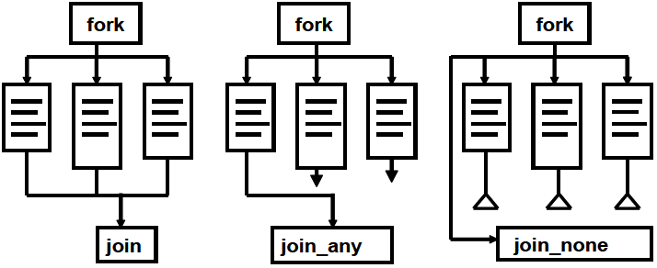

initial begin
$display("@%0d: start fork...join_none example",$time);
#10 $display("@%0d: sequential after #10", $time);
fork
$display("@%0d: parallel start", $time);
#50 $display("@%0d: parallel after #50", $time);
#10 $display("@%0d: parallel after #10", $time);
begin
#30 $display("@%0d: sequential after #20", $time);
#10 $display("@%0d: sequential after #10", $time);
end
join_none
$display("@%0d: after join_none", $time);
#80 $display("@%0d: final after #80", $time);
end

@0: start fork...join_none example
@10: sequential after #10
@10: after join_none
@10: parallel start
@20: parallel after #10
@40: sequential after #30
@50: sequential after #10
@60: parallel after #50
@90: final after #80

initial begin
$display("@%0d: start fork...join_any example",$time);
#10 $display("@%0d: sequential after #10", $time);
fork
$display("@%0d: parallel start", $time);
#50 $display("@%0d: parallel after #50", $time);
#10 $display("@%0d: parallel after #10", $time);
begin
#30 $display("@%0d: sequential after #20", $time);
#10 $display("@%0d: sequential after #10", $time);
end
join_any
$display("@%0d: after join_any", $time);
#80 $display("@%0d: final after #80", $time);
end

@0: start fork...join_any example
@10: sequential after #10
@10: parallel start
@10: after join_none
@20: parallel after #10
@40: sequential after #30
@50: sequential after #10
@60: parallel after #50
@90: final after #80

Connecting the Testbench and Design
There are several steps needed to verify a design: generate stimulus, capture responses, determine correctness, and measure progress. But first, you need the proper testbench, connected to the design. Your testbench wraps around the design, sending in stimulus and capturing the design’s response. The testbench forms the “real world” around the design, mimicking the entire environment. Using a module to hold the testbench often causes timing problems around driving and sampling, so SystemVerilog introduces the program block to separate the testbench, both logically and temporally.

Semaphores
A semaphore allows you to control access to a resource. Imagine that you and your spouse share a car. Obviously, only one person can drive it at a time. You can manage this situation by agreeing that whoever has the key can drive it. When you are done with the car, you will give up the car so that the other person can use it. The key is the semaphore that makes sure only one person has access to the car. In operating system terminology, this is known as “mutually exclusive access,” so a semaphore is known as a mutex and is used to control access to a resource. Semaphores can be used in a testbench when you have a resource, such as a bus, that may have multiple requestors from inside the testbench but, as part of the physical design, can only have one driver. In SystemVerilog, a thread that requests a key when one is not available always blocks. Multiple blocking threads are queued in FIFO order.
Semaphore operations
There are three operations for a semaphore. You create a semaphore with one or more keys using the new method, get one or more keys with get, and return one or more keys with put. If you want to try to get a semaphore, but not block, use the try_get function. It returns 1 if there are enough keys, and 0 if there are insufficient keys.
program automatic test;
semaphore sem; // Create a semaphore
initial begin
sem = new(1); // Allocate with 1 key
fork
sequencer; // Spawn two threads that both
sequencer; // do bus transactions
join
end
task sequencer;
repeat($urandom%10) // Random wait, 0-9 cycles
@bus.cb;
sendTrans; // Execute the transaction
endtask
task sendTrans;
sem.get(1); // Get the key to the bus
@bus.cb; // Drive signals onto bus
bus.cb.addr <= t.addr;
...
sem.put(1); // Put it back when done
endtask
endprogram

Using an interface to simplify connections
The first improvement is to bundle the wires together into an interface block.
interface arb_if(input bit clk);
logic [1:0] grant, request;
logic reset;
endinterface

module top;
bit clk;
always #5 clk = ~clk;
arb_if arbif(clk);
arb a1 (arbif);
test t1(arbif);
endmodule : top

module test (arb_if arbif);
...
initial begin
// reset code left out
@(posedge arbif.clk);
arbif.request <= 2'b01;
$display("@%0d: Drove req=01", $time);
repeat (2) @(posedge arbif.clk);
if (arbif.grant != 2'b01)
$display("@%0d: a1: grant != 2'b01", $time);
$finish;
end
endmodule : test

module arb (arb_if arbif);
...
always @(posedge arbif.clk or posedge arbif.reset)
begin
if (arbif.reset)
arbif.grant <= 2'b00;
else
arbif.grant <= next_grant;
...
end
endmodule

You can see an immediate benefit, even on this small device: the connections become cleaner and less prone to mistakes. If you wanted to put a new signal in an interface, you would just have to add it to the interface definition and the modules that actually used it. You would not have to change any module such as top that just pass the interface through. This language feature greatly reduces the chance for wiring errors.
If you have a legacy design with ports that cannot be changed to use an interface, you can just connect the interface’s signals to the individual ports.
module top;
bit clk;
always #5 clk = ~clk;
arb_if arbif(clk);
arb_port a1 (.grant(arbif.grant), .request(arbif.request),
.reset(arbif.reset), .clk(arbif.clk));
test t1(arbif);
endmodule : top

Grouping signals in an interface using modports
The modport construct in an interface lets you group signals and specify directions. The MONITOR modport allows you to connect a monitor module.
interface arb_if(input bit clk);
logic [1:0] grant, request;
logic reset;
modport TEST (output request, reset, input grant, clk);
modport DUT (input request, reset, clk, output grant);
modport MONITOR (input request, grant, reset, clk);
endinterface

module arb (arb_if.DUT arbif);
...
endmodule

module test (arb_if.TEST arbif);
...
endmodule

module monitor (arb_if.MONITOR arbif);
always @(posedge arbif.request[0]) begin
$display("@%0d: request[0] asserted", $time);
@(posedge arbif.grant[0]);
$display("@%0d: grant[0] asserted", $time);
end

always @(posedge arbif.request[1]) begin
$display("@%0d: request[1] asserted", $time);
@(posedge arbif.grant[1]);
$display("@%0d: grant[1] asserted", $time);
end
endmodule

An interface cannot contain any instances such as modules or other interfaces.

Why are always blocks not allowed in a program?
module in Verilog is used for describing hardware, it can contain, always, initial and assign statements. To have clear separation between testbench and design, SystemVerilog introduces program, which contains full environment for testbench.
In SystemVerilog you can put tasks, functions, classes, and initial blocks in a program, but not always blocks. SystemVerilog programs are closer to a program in C, with one (or more) entry points, than Verilog’s many small blocks of concurrently executing hardware. In a design, an always block might trigger on every positive edge of a clock from the start of simulation. A testbench, on the other hand, goes through initialization, drive and respond to design activity, and then completes. When the last initial block completes, simulation implicitly ends just as if you had executed $finish. If you had an always block, it would never stop.
The clock is more closely tied to the design than the testbench, and so the clock generator should remain in a module.

Bad clock generator in program block
program bad_generator (output bit clk, out_sig);
bit clk=0, out_sig=0;
initial
forever #5 clk <= ~clk ;
initial
forever @(posedge clk)
out_sig <= ~out_sig;
endprogram

The program block is not the place to put a clock generator. The above example can cause race condition.

If you have a design described in a module, a testbench in a program block, and interfaces that connect them together, here is the top-level module that instantiates and connects all the pieces:

module top;
bit clk;
always #5 clk = ~clk;
arb_if arbif(.*);
arb a1 (.*);
test t1(.*);
endmodule : top

It uses a shortcut notation .* (implicit port connection) that automatically connects module instance ports to signals at the current level if they have the same name and data type.

Program – Module Interactions
The program block can read and write all signals in modules, and can call routines in modules, but a module has no visibility into a program. This is because your testbench needs to see and control the design, but the design should not depend on anything in the testbench.
Just like a module, program block has ports. One or more program blocks can be instantiated in a top-level netlist, and connected to the DUT.

Packages
Packages provide ways to have common code to be shared across multiple modules. Packages can not contain any assign statement.
1 //+++++++++++++++++++++++++++++++++++++++++++++++++
2 // Package Declaration
3 //+++++++++++++++++++++++++++++++++++++++++++++++++
4 package definesPkg;
5 //=================================================
6 // TypeDefs declaration
7 //=================================================
8 typedef enum {FALSE, TRUE} bool;
9 typedef struct {
10 bit [7:0] addr;
11 bit [7:0] data;
12 bit wr;
13 } mem_s;
14
15 endpackage

1 //+++++++++++++++++++++++++++++++++++++++++++++++++
2 // Package Declaration
3 //+++++++++++++++++++++++++++++++++++++++++++++++++
4 package msgPkg;
15 endpackage

1 //=================================================
2 // Include all the files
3 //=================================================
4 `include "msgPkg.sv"
5 `include "definesPkg.sv"
6 //=================================================
7 // Import the Packages
8 //=================================================
9 import msgPkg::*;
10 import definesPkg::bool;
11
12 //+++++++++++++++++++++++++++++++++++++++++++++++++
13 // DUT Using the package
14 //+++++++++++++++++++++++++++++++++++++++++++++++++
15 module simple_package();
16
17 bool value = definesPkg::FALSE;
18
19 initial begin
20 msgPkg::initMsgPkg("PACKAGES",0);
21 msgPkg::msg_info("Testing Packages");
22 #10 msgPkg::msg_warn("Testing Packages");
23 #10 msgPkg::msg_error("Testing Packages");
24 msgPkg::msg_info($psprintf("Warning Count %0d, Error Count %0d",
25 msgPkg::getWarnCnt(), msgPkg::getErrCnt()));
26 if (value ! = definesPkg::TRUE)
27 #10 msgPkg::msg_fatal("Value is FALSE");
28 end
29
30 endmodule

Accessing data, functions or types in packages there are two ways.
By class scope resolution operator ::
By import statement: The import statement provides direct visibility of identifiers within packages.

SystemVerilog Assertions
Your testbench procedural code can check the values of design signals and testbench variables and take action if there is a problem. For example, if you have asserted the bus request, you expect that grant will be asserted two cycles later. You could use an if-statement.
bus.cb.request <= 1;
@bus.cb;
if (bus.cb.grant != 2’b01)
$display("Error, grant != 1");
// rest of the test

An assertion is more compact than an if-statement. However, note that the logic is reversed compared to the if-statement above. You want the expression inside the parentheses to be true; otherwise, print an error.
bus.cb.request <= 1;
@bus.cb;
a1: assert (bus.cb.grant == 2’b01);
// rest of the test
If the grant signal is asserted correctly, the test continues. If the signal does not have the expected value, the simulator produces a message similar to the following:
"test.sv", 7: top.t1.a1: started at 55ns failed at 55ns
Offending '(bus.cb.grant == 2’b1)‘

Customizing the assertion actions
A procedural assertion has optional then- and else-clauses. If you want to augment the default message, you can add your own.
a1: assert (bus.cb.grant == 2’b01)
else $error("Grant not asserted");

"test.sv", 76: top.t1.a1: started at 55ns failed at 55ns
Offending '(arbif.cb.grant == 2'b1)'
Error: "test.sv", 76: top.t1.a1: at time 55 ns
Grant not asserted

SystemVerilog has four functions to print messages: $info, $warning, $error, and $fatal. These are allowed only inside an assertion, not in procedural code, though future versions of SystemVerilog may allow this.

a1: assert (bus.cb.grant == 2’b01)
grants_received++; // Another succesful result
else
$error("Grant not asserted");

You can also put assertions in an interface. Now your interface not only transmits signal values but also checks the protocol.

Creating assertions in Verilog
There is no assert statement in Verilog. We can make our own assert using a Verilog task:
task assert;
Input condition;
begin
if (!condition)
$display (“Assertion Error”);
end
endtask

Multicycle assertions
Multi cycle assertions check behaviors that happen over time. For example, say you have a protocol with a request signal (req) and an acknowledge signal (ack). You may require that the ack signal respond to the req signal within two to four clock cycles. This is a multicycle assertion.

Open Verification Library (OVL)
Accellera developed the OVL for multicycle assertions. The OVL is a library of 50 components that you can instantiate in your design to check its behavior. They use a set of assertions to check a behavior completely. The blocks are called checkers because they do more than implementing single assertions. OVL checkers have some advantages over writing assertions ourselves with the assert statement:
- Ten of the OVL assertions can be synthesized. This means they work in the lab and raise a signal if there is an error deep in your chip. This signal can be attached to a logic analyzer or an LED.
- OVL checkers implement a set of assertions that completely check a type of functionality, rather than just one assertion to check one set of signals.
For example there is a lot more to a handshake than checking the time from req to ack, and the OVL_handshake checker looks at all of these:
- The req signal should not transition again before the ack signal responds.
- The ack signal should not assert if there was no req.
- The req signal should not go low before it is acknowledged.

Constrained-random tests (CRT)
A CRT is made of two parts: the test code that uses a stream of random values to create input to the DUT, and a seed to the pseudo-random number generator (PRNG). You can make a CRT behave differently just by using a new seed. This feature allows you to leverage each test so each is the functional equivalent of many directed tests, just by changing seeds. You are able to create more equivalent tests using these techniques than with directed testing.

Randomizing delays
Some designs are sensitive to clock jitter. By sliding the clock edges back and forth by small amounts, you can make sure your design is not overly sensitive to small changes in the clock cycle.

Randomization in SystemVerilog
The random stimulus generation in SystemVerilog is most useful when used with OOP. You first create a class to hold a group of related random variables, and then have the random-solver fill them with random values. You can create constraints to limit the random values to legal values, or to test specific features.
class Packet;
// The random variables
rand bit [31:0] src, dst, data[8];
randc bit [7:0] kind;
// Limit the values for src
constraint c {src > 10;
src < 15;
data < 100;
}
endclass

Packet p;
initial begin
p = new; // Create a packet
assert (p.randomize());
transmit(p);
end

The first three variables use the rand modifier, so that every time you randomize the class, the variables are assigned a value. Think of rolling dice: each roll could be a new value or repeat the current one. The kind variable is randc, which means random cyclic, so that the random solver does not repeat a random value until every possible value has been assigned.
Note that the constraint expression is grouped using curly braces: {}. This is because this code is declarative, not procedural, which uses begin...end. The randomize function returns 0 if a problem is found with the constraints. The procedural assertion is used to check the result.
You cannot make assignments in a constraint block as it only contains expressions. Instead, use the equivalence operator to set a random variable to a value, e.g., len == 42, or to build more complex relationships between one or more random variables, e.g., len == header.addr_mode * 4 + payload.size.
You can create sets of values with the inside operator. SystemVerilog gathers all the values and chooses between the values with equal probability, unless you have other constraints on the variable. As always, you can use variables in the sets:
rand int c; // Random variable
int lo, hi; // Nonrandom variables used as limits
constraint c_range {
c inside {[lo:hi]}; // lo <= c and c <= hi
}

All values in the set are chosen equally, even if they appear multiple times.
constraint c_even_weight {
(c inside {0,1,1,1,1,1}); // 0 or 1, equal probability
}

If you make choice a randc variable, the simulator tries every possible value before repeating. The name function returns a string with the name of an enumerated value.
class Days;
typedef enum {SUN, MON, TUE, WED, THU, FRI, SAT} DAYS_E;
DAYS_E choices[$];
rand DAYS_E choice;
constraint cday {choice inside choices;}
endclass

Days days;
initial begin
days = new;
days.choices = ‘{Days::SUN, Days::SAT};
assert (days.randomize());
$display("Random weekend day %s\n", days.choice.name);
days.choices = ‘{Days::MON, Days::TUE, Days::WED, Days::THU, Days::FRI};
assert (days.randomize());
$display("Random week day %s", days.choice.name);
end

Weighted Distributions
The dist operator allows you to create weighted distributions so that some values are chosen more often than others. A dist operator takes a list of values and weights, separated by the := or the :/ operator. The values and weights can be constants or variables. The values can be a single value or a range such as [lo:hi]. The weights are not percentages and do not have to add up to 100. The := operator specifies that the weight is the same for every specified value in the range, while the :/ operator specifies that the weight is to be equally divided between all the values.
rand int src, dst;
constraint c_dist {
src dist {0:=40, [1:3]:=60};
// src = 0, weight = 40/220
// src = 1, weight = 60/220
// src = 2, weight = 60/220
// src = 3, weight = 60/220
dst dist {0:/40, [1:3]:/60};
// dst = 0, weight = 40/100
// dst = 1, weight = 20/100
// dst = 2, weight = 20/100
// dst = 3, weight = 20/100
}
In above example, src gets the value 0, 1, 2, or 3. The weight of 0 is 40, while 1, 2, and 3 have weights of 60, for a total of 220. The probability of choosing 0 is 40/220, and the probability of choosing 1, 2, or 3 is 60/220 each.
Next, dst gets the value 0, 1, 2, or 3. The weight of 0 is 40, while 1, 2, and 3 share a total weight of 60, for a total of 100. The probability of choosing 0 is 40/100, while the probability of choosing 1, 2, or 3 is only 20/100 each. Once again, the values and weights can be constants or variables.
You can use variable weights to change distributions on the fly or even to eliminate choices by setting the weight to zero.
// Bus operation, byte, word, or longword
class BusOp;
// Operand length
typedef enum {BYTE, WORD, LWRD } length_t;
rand length_t len;
// Random weights for dist constraint
bit [31:0] w_byte=1, w_word=3, w_lwrd=5;
constraint c_len {
len dist {BYTE := w_byte, // Choose a random
WORD := w_word, // length using
LWRD := w_lwrd}; // variable weights
}
endclass

In the above example, the len enumerated variable has three values. The constraint defaults to choosing longword lengths, as w_lwrd has the largest value.

Conditional constraints
Normally, all constraint expressions are active in a block. What if you want to have an expression active only some of the time?

SystemVerilog supports two implication operators, -> and if-else. When you are choosing from a list of expressions, such as an enumerated type, the implication operator, ->, lets you create a case-like block. The parentheses around the expression are not required, but do make the code easier to read.
class BusOp;
...
constraint c_io {
(io_space_mode) -> addr[31] == 1’b1;
}

class BusOp;
...
constraint c_len_rw {
if (op == READ)
len inside {[BYTE:LWRD]};
else
len == LWRD;
}

Unconstrained Randomization
class Unconstrained;
rand bit x; // 0 or 1
rand bit [1:0] y; // 0, 1, 2, or 3
endclass

class Imp1;
rand bit x; // 0 or 1
rand bit [1:0] y; // 0, 1, 2, or 3
constraint c_xy {
(x==0) -> y==0;
}
endclass
Solution x y Probability
A 0 0 1/2
B 0 1 0
C 0 2 0
D 0 3 0
E 1 0 1/8
F 1 1 1/8
G 1 2 1/8
H 1 3 1/8

The implication is bidirectional in that if y were forced to a nonzero value, x would have to be 1.
class Imp2;
rand bit x; // 0 or 1
rand bit [1:0] y; // 0, 1, 2, or 3
constraint c_xy {
y > 0;
(x==0) -> y==0;
}
endclass

In the above example x can never be 0. You can guide the SystemVerilog solver using the “solve...before” constraint:
class SolveBefore;
rand bit x; // 0 or 1
rand bit [1:0] y; // 0, 1, 2, or 3
constraint c_xy {
(x==0) -> y==0;
solve x before y;
}
endclass

The solver chooses values of x (0, 1) with equal probability. When x is 0, y must be 0. When x is 1, y can be 0, 1, 2, or 3 with equal probability.

Multiple Constraints
You can have a separate constraint for each test.
class Packet;
rand int length;
constraint c_short {length inside {[1:32]}; }
constraint c_long {length inside {[1000:1023]}; }
endclass
Packet p;
initial begin
p = new;
// Create a long packet by disabling short constraint
p.c_short.constraint_mode(0);
assert (p.randomize());
transmit(p);
// Create a short packet by disabling all constraints
// then enabling only the short constraint
p.constraint_mode(0);
p.c_short.constraint_mode(1);
assert (p.randomize());
transmit(p);
end

In-line Constraints
As you write more tests, you can end up with many constraints. They can interact with each other in unexpected ways, and the extra code to enable and disable them adds to the test complexity. Additionally, constantly adding and editing constraints to a class could cause problems in a team environment.
Many tests only randomize objects at one place in the code. SystemVerilog allows you to add an extra constraint using randomize() with. This is equivalent to adding an extra constraint to any existing ones in effect.

class Transaction;
rand bit [31:0] addr, data;
constraint c1 {addr inside{[0:100],[1000:2000]};}
endclass
Transaction t = new();
initial begin
int s;
t = new();
// addr is 50-100, 1000-1500, data < 10
assert(t.randomize() with {addr >= 50; addr <= 1500; data < 10;});
driveBus(t);
// force addr to a specific value, data > 10
assert(t.randomize() with {addr == 2000; data > 10;});
driveBus(t);
end

Building a bathtub distribution
For some applications, you want a nonlinear random distribution. For instance, small and large packets are more likely to find a design bug such as buffer overflow than medium-sized packets. So you want a bathtub shaped distribution; high on both ends, and low in the middle. You could build an elaborate dist constraint, but it might require lots of tweaking to get the shape you want. Verilog has several functions for nonlinear distribution such as $dist_exponential but none for a bathtub. However, you can build one by using the exponential function twice.

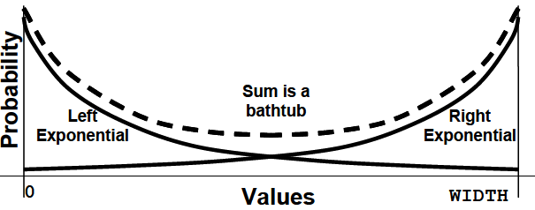

class Bathtub;
int value; // Random variable with bathtub dist
int WIDTH = 50, DEPTH=4, seed=1;
function void pre_randomize();
// Calculate the left curve of the tub
value = $dist_exponential(seed, DEPTH);
if (value > WIDTH) value = WIDTH;
// Randomly put this point on the left or right curve
if ($urandom_range(1))
value = WIDTH - value;
endfunction
endclass

Every time this object is randomized, the variable value gets updated. Across many randomizations, you will see the desired nonlinear distribution.
- $dist_exponential — Exponential decay, as shown in Figure 6-1
- $dist_normal — Bell-shaped distribution
- $dist_poisson — Bell-shaped distribution
- $dist_uniform — Flat distribution
- $random — Flat distribution, returning signed 32-bit random
- $urandom — Flat distribution, returning unsigned 32-bit random
- $urandom_range — Flat distribution over a range

The functions pre_randomize and post_randomize can only call other functions, not tasks that could consume time. After all, you cannot have a delay in the middle of a call to randomize.

Constraints with variables
class bounds;
rand int size;
int max_size = 100;
constraint c_size {
size inside {[1:max_size]};
}
endclass

By default, this class creates random sizes between 1 and 100, but by changing the variable max_size, you can vary the upper limit.

Turn constraints off and on
Simple testbench may use a data class with just a few constraints. What if you want to have two tests with very different flavors of data? You could use the implication operators (-> or if-else) to build a single, elaborate constraint controlled by nonrandom variables.

class Instruction;
typedef enum {NOP, HALT, CLR, NOT} OPCODE_T;
rand OPCODE_T opcode;
bit [1:0] n_operands;
...
constraint c_operands {
if (n_operands == 0)
opcode == NOP || opcode == HALT;
else if (n_operands == 1)
opcode == CLR || opcode == NOT;
...
}
endclass

You can see that having one large constraint can quickly get out of control as you add further expressions for each operand, addressing modes, etc. A more modular approach is to use a separate constraint for each flavor of instruction, and then disable all but the one you need.

class Instruction;
rand OPCODE_T opcode;
…
constraint c_no_operands {
opcode == NOP || opcode == HALT;}
constraint c_one_operand {
opcode == CLR || opcode == NOT;}
endclass
Instruction instr;
initial begin
instr = new;
// Generate an instruction with no operands
instr.constraint_mode(0); // Turn off all constraints
instr.c_no_operands.constraint_mode(1);
assert (instr.randomize());
// Generate an instruction with one operand
instr.constraint_mode(0); // Turn off all constraints
instr.c_one_operand.constraint_mode(1);
assert (instr.randomize());
end

Controlling Multiple Constraint Blocks
A class can contain multiple constraint blocks. Perhaps one constraint would restrict the data length to create small transactions (great for testing congestion), while another would make long transactions.

class Packet;
rand int length;
constraint c_short {length inside {[1:32]}; }
constraint c_long {length inside {[1000:1023]}; }
endclass
Packet p;
initial begin
p = new;
// Create a long packet by disabling short constraint
p.c_short.constraint_mode(0);
assert (p.randomize());
transmit(p);
// Create a short packet by disabling all constraints
// then enabling only the short constraint
p.constraint_mode(0);
p.c_short.constraint_mode(1);
assert (p.randomize());
transmit(p);
end

Functional Coverage
Functional coverage is a measure of which design features have been exercised by the tests. Start with the design specification and create a verification plan with a detailed list of what to test and how. For example, if your design connects to a bus, your tests need to exercise all the possible interactions between the design and bus, including relevant design states, delays, and error modes. The verification plan is a map to show you where to go.

Code coverage
The easiest way to measure verification progress is with code coverage. Here you are measuring how many lines of code have been executed (line coverage), which paths through the code and expressions have been executed (path coverage), which single-bit variables have had the values 0 or 1 (toggle coverage), and which states and transitions in a state machine have been visited (FSM coverage). You don’t have to write any extra HDL code. The tool instruments your design automatically by analyzing the source code and adding hidden code to gather statistics. You then run all your tests, and the code coverage tool creates a database. The end result is a measure of how much your tests exercise the design code. Note that you are primarily concerned with analyzing the design code, not the testbench. Untested design code could conceal a hardware bug, or may be just redundant code. Code coverage measures how thoroughly your tests exercised the “implementation” of the design specification, and not the verification plan. Just because your tests have reached 100% code coverage, your job is not done.
The following module is for a D-flip flop:
module dff(output logic q, q_l, input logic clk, d, reset_l);
always @(posedge clk or negedge reset_l) begin
q <= d;
q_l <= !d;
end
endmodule
The reset logic was accidently left out. A code coverage tool would report that every line had been exercised, yet the model was not implemented correctly.

The design specification details how the device should operate, while the verification plan lists how that functionality is to be stimulated, verified, and measured.

Functional coverage
The design specification details how the device should operate, while the verification plan lists how that functionality is to be stimulated, verified, and measured.
For example, the verification plan for a D-flip flop would mention not only its data storage but also how it resets to a known state. Until your test checks both these design features, you will not have 100% functional coverage

Bug rate
An indirect way to measure coverage is to look at the rate at which fresh bugs are found. You should keep track of how many bugs you found each week, over the life of a project.

Assertion Coverage
Assertions can have local variables and perform simple data checking. If you need to check a more complex protocol, such as determining whether a packet successfully went through a router, procedural code is often better suited for the job.
The most familiar assertions look for errors such as two signals that should be mutually exclusive or a request that was never followed by a grant. These error checks should stop the simulation as soon as they detect a problem.

What if the functional coverage is high but the code coverage is low? Your tests are not exercising the full design, and you need to revise your verification plan and add more functional coverage points to locate untested functionality.
A more difficult situation is high code coverage but low functional coverage. Even though your testbench is giving the design a good workout, you are unable to put it in all the interesting states. First, see if the design implements all the specified functionality. If the functionality is there, but your tests can’t reach it, you might need a formal verification tool that can extract the design’s states and create appropriate stimulus.
The goal is both high code and functional coverage.

Simple Functional Coverage Example
To measure functional coverage, you begin with the verification plan and write an executable version of it for simulation. In your SystemVerilog test bench, sample the values of variables and expressions. These sample locations are known as cover points. Multiple cover points that are sampled at the same time (such as when a transaction completes) are place together in a cover group.
The following design has a transaction that comes in eight flavors. The testbench generates the port variable randomly, and the verification plan requires that every value be tried.
program automatic test(busifc.TB ifc);
class Transaction;
rand bit [31:0] data;
rand bit [2:0] port; // Eight port numbers
endclass
covergroup CovPort;
coverpoint tr.port; // Measure coverage
endgroup
Transaction tr = new;
initial begin
CovPort ck = new; // Instantiate group
repeat (32) begin // Run a few cycles
assert(tr.randomize); // Create a transaction
ifc.cb.port <= tr.port; // and transmit
ifc.cb.data <= tr.data; // onto interface
ck.sample(); // Gather coverage
@ifc.cb; // Wait a cycle
end
end
endprogram
The testbench samples the value of the port field using the CovPort cover group. Eight possible values, 32 random transactions — did your testbench generate them all? Here is part of a coverage report from VCS.
Coverpoint Coverage report
CoverageGroup: CovPort
Coverpoint: tr.port
Summary
Coverage: 87.50
Goal: 100
Number of Expected auto-bins: 8
Number of User Defined Bins: 0
Number of Automatically Generated Bins: 7
Number of User Defined Transitions: 0
Automatically Generated Bins
Bin # hits at least
================================
auto[1] 7 1
auto[2] 7 1
auto[3] 1 1
auto[4] 5 1
auto[5] 4 1
auto[6] 2 1
auto[7] 6 1
================================

As you can see, the testbench generated the values 1, 2, 3, 4, 5, 6, and 7, but never generated a port of 0. The at least column specifies how many hits are needed before a bin is considered covered.

Anatomy of a Cover Group
A cover group is similar to a class — you define it once and then instantiate it one or more times. It contains cover points, options, formal arguments, and an optional trigger. A cover group encompasses one or more data points, all of which are sampled at the same time. You should create very clear cover group names that explicitly indicate what you are measuring and, if possible, reference to the verification plan. The name Parity_Errors_In_Hexaword_Cache_Fills may seem verbose, but when you are trying to read a coverage report that has dozens of cover groups, you will appreciate the extra detail.
A cover group can be defined in a class or at the program or module level. It can sample any visible variable such as program/module variables, signals from an interface, or any signal in the design. A cover group inside a class can sample variables in that class, as well as data values from embedded classes. If the cover group is defined in a class, you do not make a separate name when you instance it; you just use the original cover group name.

The two major parts of functional coverage are the sampled data values and the time when they are sampled. When new values are ready (such as when a transaction has completed), your testbench triggers the cover group. This can be done directly with the sample task, or by using a blocking expression in the covergroup definition. The blocking expression can use a wait or @ to block on signals or events. Use the sample method if you want to explicitly trigger coverage from procedural code, if there is no existing signal or event that tells when to sample, or if there are multiple instances of a cover group that trigger separately. Use the blocking statement in the covergroup declaration if you want to tap into existing events or signals to trigger coverage.

Sampling using a callback
Callbacks
One of the main guidelines of this book is to create a verification environment that you can use for all tests with no changes. The key requirement is that this testbench must provide a “hook” where the test program can inject new code without modifying the original classes. Rather than try to anticipate every possible error, delay, or disturbance in the flow of transactions, the driver just needs to “call back” a routine defined in the top-level test. The beauty of this technique is that the callback routine can be defined differently in every test. As a result, the test can add new functionality to the driver using callbacks without editing the Driver class.
In the following example, the Driver::run task loops forever with a call to a transmit task. Before sending the transaction, run calls the pre-transmit callback. After sending the transaction, it calls the post-callback task.

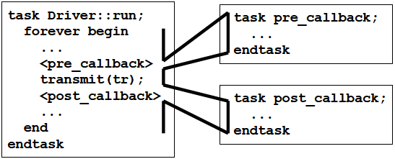

Creating a callback
A callback task is created in the top-level test and called from the driver, the lowest level of the environment. However, the driver does not have to have any knowledge of the test – it just has to use a generic class that the test can extend. The driver uses a queue to hold the callback objects, which simplifies adding new objects.

class Driver_cbs; // Driver callbacks
virtual task pre_tx(Transaction tr, ref bit drop);
// By default, callback does nothing
endtask
virtual task post_tx(Transaction tr);
// By default, callback does nothing
endtask
endclass

class Driver;
Driver_cbs cbs[$];
task run;
bit drop;
Transaction tr;
forever begin
agt2drv.get(tr);
foreach (cbs[i]) cbs.pre_tx(tr, drop);
if (!drop) transmit(tr);
foreach (cbs[i]) cbs.post_tx(tr);
end
endtask
endclass

Using a callback to inject disturbances
A common use for a callback is to inject some disturbance such as causing an error or delay. The following testbench randomly drops packets using a callback object. Callbacks can also be used to send data to the scoreboard or to gather functional coverage values. Note that you can use push_back() or push_front() depending on the order in which you want these to be called. For example, you probably want the scoreboard called after any tasks that may delay, corrupt, or drop a transaction. Only gather coverage after a transaction has been successfully transmitted.
class Driver_cbs_drop extends Driver_cbs;
virtual task pre_tx(Transaction tr, ref bit drop);
// Randomly drop 1 out of every 100 transactions
drop = ($urandom_range(0,99) == 0);
endtask
endclass

program automatic test;
Environment env;
initial begin
env = new;
env.gen_cfg;
env.build;
// Callback injection
begin
Driver_cbs_drop dcd;
dcd = new; // Create scb callback
env.drv.cbs.push_back(dcd); // Put into driver’s Q
end
env.run;
env.wrapup;
end
endprogram

Call back in coverage concept
One of the better ways to integrate functional coverage into your testbench is to use callbacks. This technique allows you to build a flexible testbench without restricting when coverage is collected. You can decide for every point in the verification plan where and when data is sampled. A callback only “fires” when the test registers a callback object. You can create many separate callbacks for each cover group, with little overhead. Callbacks are superior to using a mailbox to connect the testbench to the coverage objects. You might need multiple mailboxes to collect transactions from different points in your testbench. A mailbox requires a transactor to receive transactions, and multiple mailboxes cause you to juggle multiple threads. Instead of an active transactor, use a passive callback. The following two examples define and use the callback
Driver_cs_coverage:
program automatic test;
Environment env;
initial begin
Driver_cbs_coverage dcc;
env = new;
env.gen_cfg;
env.build;
// Create and register the coverage callback
dcc = new;
env.drv.cbs.push_back(dcc); // Put into driver’s Q
env.run;
env.wrapup.
end
endprogram

class Driver_cbs_coverage extends Driver_cbs;
covergroup CovPort;
...
endgroup
virtual task post_tx(Transaction tr);
CovPort.sample(); // Sample coverage values
endtask
endclass

Cover group with an event trigger
In the following example the cover group CovPort is sampled when the testbench triggers the trans_ready event.
event trans_ready;
covergroup CovPort @(trans_ready);
coverpoint ifc.cb.port; // Measure coverage
endgroup

Data Sampling
When you specify a variable or expression in a cover point, SystemVerilog creates a number of “bins” to record how many times each value has been seen. These bins are the basic units of measurement for functional coverage. If you sample a one-bit variable, a maximum of two bins are created. You can imagine that SystemVerilog drops a token in one or the other bin every time the cover group is triggered. At the end of each simulation, a database is created with all bins that have a token in them. You then run an analysis tool that reads all databases and generates a report with the coverage for each part of the design and for the total coverage.

Individual bins and total coverage
To calculate the coverage for a point, you first have to determine the total number of possible values, also known as the domain. There may be one value per bin or multiple values. Coverage is the number of sampled values divided by the number of bins in the domain. A cover point that is a 3-bit variable has the domain 0:7 and is normally divided into eight bins. If, during simulation, values belonging to seven bins are sampled, the report will show 7/8 or 87.5% coverage for this point. All these points are combined to show the coverage for the entire group, and then all the groups are combined to give a coverage percentage for all the simulation databases. This is the status for a single simulation. You need to track coverage over time. Look for trends so you can see where to run more simulations or add new constraints or tests. Now you can better predict when verification of the design will be completed.
SystemVerilog automatically creates bins for cover points. It looks at the domain of the sampled expression to determine the range of possible values. For an expression that is N bits wide, there are 2^N possible values.

Limiting the number of automatic bins created
The cover group option auto_bin_max specifies the maximum number of bins to automatically create, with a default of 64 bins. If the domain of values in the cover point variable or expression is greater than this option, SystemVerilog divides the range into auto_bin_max bins. For example, a 16-bit variable has 65,536 possible values, so each of the 64 bins covers 1024 values.
In reality, you may find this approach impractical, as it is very difficult to find the needle of missing coverage in a haystack of auto-generated bins. Lower this limit to 8 or 16. In the following example, the first bin holds the lower half of the range, 0–3, and the other hold the upper values, 4–7:
covergroup CovPort;
coverpoint tr.port
{ options.auto_bin_max = 2; } // Divide into 2 bins
endgroup

Coverage report:
Bin # hits at least
==================================
auto[0:3] 15 1
auto[4:7] 17 1
==================================

Following example used auto_bin_max as an option for the cover point only. You can also use it as an option for the entire group.

covergroup CovPort;
options.auto_bin_max = 2; // Affects port & data
coverpoint tr.port;
coverpoint tr.data;
endgroup

User-defined bins find a bug
Automatically generated bins are OK for anonymous data values, such as counter values, addresses, or values that are a power of 2. For other values, you should explicitly name the bins to improve accuracy and ease coverage report analysis. SystemVerilog automatically creates bin names for enumerated types, but for other variables you need to give names to the interesting states. The easiest way to specify bins is with the [] syntax.
covergroup CovLen;
len: coverpoint (tr.hdr_len + tr.payload_len + 5’b0)
{bins len[] = {[0:23]}; }
endgroup

(The longest header is 7, and the longest payload is 16)

Bin # hits at least
============================
len_00 13 1
len_01 36 1
len_02 51 1
len_03 60 1
len_04 72 1
len_05 88 1
len_06 127 1
len_07 122 1
len_08 133 1
len_09 138 1
len_0a 115 1
len_0b 128 1
len_0c 125 1
len_0d 111 1
len_0e 115 1
len_0f 134 1
len_10 107 1
len_11 102 1
len_12 70 1
len_13 65 1
len_14 39 1
len_15 30 1
len_16 19 1
len_17 0 1
============================

Naming the cover point bins
Following example samples a 4-bit variable kind that has 16 possible values. The first bin is called zero. The next three values, 1–3, are all grouped into a single bin lo. The upper eight values, 8–15, are kept in separate bins, hi_8, hi_9, hi_a, hi_b, hi_c, hi_d, hi_e, and hi_f. Note how $ in the hi bin expression is used as a shorthand notation for the largest value for the sampled variable. Lastly, misc holds all values that were not previously chosen. Note that the additional information about the coverpoint is grouped
using curly braces: {}.
covergroup CovKind;
coverpoint tr.kind {
bins zero = {0}; // A bin for kind==0
bins lo = {[1:3]}; // 1 bin for values 1:3
bins hi[] = {[8:$]}; // 8 separate bins
bins misc = default; // 1 bin for all the rest
}
endgroup // CoverKind

Bin # hits at least
=============================
hi_8 0 1
hi_9 5 1
hi_a 3 1
hi_b 4 1
hi_c 2 1
hi_d 2 1
hi_e 9 1
hi_f 4 1
lo 16 1
misc 15 1
zero 1 1
=============================

In general, if you are specifying bins, always use the default bin specifier to catch values that you may have forgotten.

Conditional coverage
You can use the iff keyword to add a condition to a cover point. The most common reason for doing so is to turn off coverage during reset so that stray triggers are ignored. The following example gathers only values of port when reset is 0, where reset is active-high.
covergroup CoverPort;
// Don’t gather coverage when reset==1
coverpoint port iff (!bus_if.reset);
endgroup

Alternately, you can use the start and stop functions to control individual instances of cover groups.

initial begin
CovPort ck = new; // Instantiate cover group
// Reset sequence stops collection of coverage data
#1ns bus_if.reset = 1;
ck.stop();
#100ns bus_if.reset = 0; // End of reset
ck.start();
...

Creating bins for enumerated types
For enumerated types, SystemVerilog creates one bin for each possible value.

Transition coverage
You can specify state transitions for a cover point. In this way, you can tell not only what interesting values were seen but also the sequences. For example, you can check if port ever went from 0 to 1, 2, or 3.
covergroup CoverPort;
coverpoint port {
bins t1 = (0 => 1), (0 => 2), (0 => 3);
}
endgroup

You can quickly specify multiple transitions using ranges. The expression (1,2 => 3,4) creates the four transitions (1=>3), (1=>4), (2=>3), and (2=>4). You can specify transitions of any length. Note that you have to sample once for each state in the transition. So (0 => 1 => 2) is different from (0=> 1 => 1 => 2) or (0 => 1 => 1 => 1 => 2). If you need to repeat values, as in the last sequence, you can use the shorthand form:(0 => 1[*3] => 2). To repeat the value 1 for 3, 4, or 5 times, use 1[*3:5].

Ignoring values
With some cover points, you never get all possible values. For instance, a 3-bit variable may be used to store just six values, 0–5. If you use automatic bin creation, you never get beyond 75% coverage. There are two ways to solve this problem. You can explicitly define the bins that you want to cover. Alternatively, you can let SystemVerilog automatically create bins, and then use ignore_bins to tell which values to exclude from functional coverage calculation.
bit [2:0] low_ports_0_5; // Only uses values 0-5
covergroup CoverPort;
coverpoint low_ports_0_5 {
ignore_bins hi = {[6,7]}; // Ignore upper 2 bins
}
endgroup

The original range of low_ports_0_5, a three-bit variable is 0:7. The ignore_bins excludes the last two bins, which reduces the range to 0:5. So total coverage for this group is the number of bins with samples, divided by the total number of bins, which is 5 in this case.

Cross Coverage
A cover point records the observed values of a single variable or expression. You may want to know not only what bus transactions occurred but also what errors happened during those transactions, and their source and destination. For this you need cross coverage that measures what values were seen for two or more cover points at the same time. Note that when you measure cross coverage of a variable with N values, and of another with M values, SystemVerilog needs NxM cross bins to store all the combinations.
Basic cross coverage example
Previous examples have measured coverage of the transaction kind, and port number, but what about the two combined? Did you try every kind of transaction into every port? The cross construct in SystemVerilog records the combined values of two or more cover points in a group. The cross statement takes only cover points or a simple variable name. If you want to use expressions, hierarchical names or variables in an object such as handle.variable, you must first specify the expression in a coverpoint with a label and then use the label in the cross statement.

class Transaction;
rand bit [3:0] kind;
rand bit [2:0] port;
endclass
Transaction tr;
covergroup CovPort;
kind: coverpoint tr.kind; // Create cover point kind
port: coverpoint tr.port // Create cover point port
cross kind, port; // Cross kind and port
endgroup

Cumulative report for Transaction::CovPort
Summary:
Coverage: 95.83
Goal: 100
Coverpoint Coverage Goal Weight
========================================================
kind 100.00 100 1
port 100.00 100 1
========================================================
Cross Coverage Goal Weight
========================================================
Transaction::CovPort 87.50 100 1
Cross Coverage report
CoverageGroup: Transaction::CovPort
Cross: Transaction::CovPort
Summary
Coverage: 87.50
Goal: 100
Coverpoints Crossed: kind port
Number of Expected Cross Bins: 128
Number of User Defined Cross Bins: 0
Number of Automatically Generated Cross Bins: 112
Automatically Generated Cross Bins
kind port # hits at least
==================================================
auto[0] auto[0] 1 1
auto[0] auto[1] 4 1
auto[0] auto[2] 3 1
auto[0] auto[5] 1 1
...

If you want more readable cross coverage bin names, you can label the individual cover point bins, and SystemVerilog will use these names when creating the cross bins.

covergroup CovPortKind;
port: coverpoint tr.port
{bins port[] = {[0:$]};
}
kind: coverpoint tr.kind
{bins zero = {0}; // A bin for kind==0
bins lo = {[1:3]}; // 1 bin for values 1:3
bins hi[] = {[8:$]}; // 8 separate bins
bins misc = default; // 1 bin for all the rest
}
cross kind, port;
endgroup

Excluding cross coverage bins
With cross coverage, you specify the cover point with binsof and the set of values with intersect so that a single ignore_bins construct can sweep out many individual bins.
covergroup CovCovport;
port: coverpoint tr.port
{bins port[] = {[0:$]};
}
kind: coverpoint tr.kind
{
bins zero = {0}; // A bin for kind==0
bins lo = {[1:3]}; // 1 bin for values 1:3
bins hi[] = {[8:$]}; // 8 separate bins
bins misc = default; // 1 bin for all the rest
}
cross kind, port {
ignore_bins hi = binsof(port) intersect {7};
ignore_bins md = binsof(port) intersect {0} &&
binsof(kind) intersect {[9:10]};
ignore_bins lo = binsof(kind.lo);
}
endgroup
The first ignore_bins just excludes bins where port is 7 and any value of kind. Since kind is a 4-bit value, this statement excludes 16 bins. The second ignore_bins is more selective, ignoring bins where port is 0 and kind is 9, 10, or 11, for a total of 3 bins.

Coverage Options
You can specify additional information in the cover group using options. Options can be placed in the cover group so that they apply to all cover points in the group, or they can be put inside a single cover point for finer control. auto_bin_max is an example of coverage options.
Cover group comment
You can add a comment into coverage reports to make them easier to analyze.
covergroup CoverPort;
option.comment = "Section 3.2.14 Port numbers";
coverpoint port;
endgroup

Coverage threshold using at_least
You could set option.at_least to 8 or more to specify that after 8 hits on a bin, you are confident that you have exercised that combination.
If you define option.at_least at the cover group level, it applies to all cover points. If you define it inside a point, it only applies to that single point.

Printing the empty bins
By default, the coverage report shows only the bins with samples. Your job is to verify all that is listed in the verification plan, so you are actually more interested in the bins without samples. Use the option cross_num_print_missing to tell the simulation and report tools to show you all bins, especially the ones with no hits. Set it to a large value, but no larger than you are willing to read.
covergroup CovPort;
kind: coverpoint tr.kind;
port: coverpoint tr.port
cross kind, port;
option.cross_num_print_missing = 1_000;
endgroup

Mailbox
From a hardware point of view, the easiest way to think about a mailbox is that it is just a FIFO, with a source and sink. The source puts data into the mailbox, and the sink gets values from the mailbox. Mailboxes can have a maximum size or can be unlimited. When the source puts a value into a sized mailbox that is full, it blocks until data is removed. Likewise, if a sink tries to remove data from a mailbox that is empty, it blocks until data is put into the mailbox.
A mailbox is an object and thus has to be instantiated by calling the new function. This takes an optional size argument to limit the number of entries in the mailbox. If the size is 0 or not specified, the mailbox is unbounded and can hold an unlimited number of entries. You put data into a mailbox with the put task, and remove it with the get task. A put can block if the mailbox is full and a get blocks if it is empty. The peek task gets a copy of the data in the mailbox but does not remove it. The data can be a single value, such as an integer, or logic of any size. You can put a handle into a mailbox, not an object. By default, a mailbox does not have a type, so you can put any mix of data into it. Don’t do it! Stick to one type per mailbox.
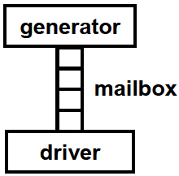
program mailbox_example(bus_if.TB bus, ...);
class Generator;
Transaction tr;
mailbox mbx;
function new(mailbox mbx);
this.mbx = mbx;
endfunction
task run;
repeat (10) begin
tr = new;
assert(tr.randomize);
mbx.put(tr); // Send out transaction
end
endtask
endclass

class Driver;
Transaction tr;
mailbox mbx;
function new(mailbox mbx);
this.mbx = mbx;
endfunction
task run;
repeat (10) begin
mbx.get(tr); // Fetch next transaction
@(posedge busif.cb.ack);
bus.cb.kind <= tr.kind;
...
end
endtask
endclass
mailbox mbx; // Mailbox connecting gen & drv
Generator gen;
Driver drv;
initial begin
mbx = new;
gen = new(mbx);
drv = new(mbx);
fork
gen.run(); // Spawn the generator
drv.run(); // Spawn the driver
join
end
endprogram

Bounded mailboxes
By default, mailboxes are similar to an unlimited FIFO — a producer can put any number of objects into a mailbox before the consumer gets the objects out. However, you may want the two threads to operate in lockstep so that the producer blocks until the consumer is done with the object. You can specify a maximum size for the mailbox when you construct it. The default mailbox size is 0 which creates an unbounded mailbox. Any size greater than 0 creates a “bounded mailbox.” If you attempt to put more objects than this limit and put will block until you get an object, creating more room.
program automatic bounded;
mailbox mbx;
initial begin
mbx = new(1); // Size = 1
fork
// Producer
for (int i=1; i<4; i++) begin
$display("@%0d: Producer: putting %0d", $time, i);
mbx.put(i);
$display("@%0d: Producer: put(%0d) done %0d", $time, i);
end
// Consumer
repeat(3) begin
int j;
#1ns mbx.get(j);
$display("@%0d: Consumer: got %0d", $time, j);
end
join_any
end
endprogram

**************************************************************************
System Verilog

Procedural blocks
SV introduces 3 new procedural blocks intended to model hardware: always_comb, always_ff, and always_latch. Whereas Verilog used a single, general-purpose always block to model different types of hardware structures, each of SV new blocks is intended to model a specific type of hardware, by imposing semantic restrictions to ensure that hardware described by the blocks matches the intended usage of the model.
An always_comb block models combinational logic. The simulator infers the sensitivity list to be all variables from the contained statements.
always_comb begin
tmp = b * b - 4 * a * c;
no_root = (tmp < 0);
end

An always_ff block is meant to infer synchronous logic:
always_ff @(posedge clk)
count <= count + 1;

An always_latch block is meant to infer a level-sensitive latch. Again, the sensitivity list is inferred from the code (is hardly used):
always_latch
if (en) q <= d;

priority if/case statement:
The priorities attribute on an if or case statement indicates that the choices must be evaluated in order, and that one branch must execute. It basically removes the conditions that cannot happen in hardware. It is expected to have at least one case that is true.

priority if (a == b)
…
else if (a == b)
…
else if ..

unique if/case statement
Branches of if statement should be mutually exclusive. In other words in the following example the synthesis tool can assume that only one bit of the state vector can be hot, otherwise we will get a warning during simulation. Therefore the sysnthesize tool can minimize the hardware by implementing in parallel.

always_comb
begin
unique if (sate[0])
…
unique else if(state[1])
…
unique else if(state[2])
…

end

******************************************************************************
Timing analysis, timing closure

Static timing analysis is an important step in analyzing the performance of a design. In the timing analysis setup time, hold time, recovery time, removal time, clock latency, clock skew, clock uncertainty etc. checks are done.

What kinds of timing violations are in a typical timing analysis report?
Setup time violations, Hold time violations, Minimum delay, Maximum delay, Slack, External delay

Explain about setup time and hold time, what will happen if there is setup time and hold time violation, how to overcome this?
Set up time is the amount of time before the clock edge that the input signal needs to be stable to guarantee it is accepted properly on the clock edge.
Hold time is the amount of time after the clock edge that same input signal has to be held before changing it to make sure it is sensed properly at the clock edge.
Whenever there are setup and hold time violations in any flip-flop, it enters a state where its output is unpredictable: this state is known as meta-stable state (quasi stable state); at the end of meta-stable state, the flip-flop settles down to either '1' or '0'. This whole process is known as meta-stability.

What is more crucial setup time or hold time violation?
Hold time violation is more crucial than setup time. Even After the chip is fabricated setup time can be fixed by reducing the clock frequency but not the hold time.

Setup violations occur when the data path is too slow compared to the clock speed.
The designer can fix the setup violations by reducing the delay in the data path. Designer can also reduce the clock speed to fix the setup violation, but it is going to be a poor design technique.
Hold violations occurs when data is too fast when compared to the clock speed.
If hold violations are not fixed before the chip is made, a lot of problems occur unlike setup violation where the clock speed can be reduced. To fix hold violations, designer can add more delay to the data path.

How do we calculate setup time?
The calculation for setup time is the sum of the setup time for the concerned flip flop and the maximum delay from the input logic.
T_{setup} = R_{setup}+ Fpd (MAX)

How do we get the value for the hold time?
The concern here is how soon (minimum time) a primary input can propagate a new value through the input logic while the Flip Flop is attempting to hold on to a stable value. The value for the hold time can be obtained by the following formulae:
T_{HOLD} = R_{HOLD} - Fpd (MIN)
Note that, that the minimum value for hold time is 0. If the calculation produces a negative value, we report a 0 hold time.

If there's a timing violation in the chip, how could you verify it as setup violation or hold time?
If the test engineer slows the clock speed, and the chip pass the test, it's a setup time problem. If the problem did not change, it could be hold time issue.
Given two ASICs, one has setup violation and the other has hold violation. How can they be made to work together without modifying the design?
Slow the clock down on the one with setup violations, and add redundant logic in the path where you have hold violations.

What is clock skew (timing skew)?
In circuit designs, clock skew (sometimes timing skew) is a phenomenon in synchronous circuits in which the clock signal (sent from the clock circuit) arrives at different components at different times.
One problem is caused when the clock travels more slowly than the path from one register to another - allowing data to penetrate two registers in the same clock tick, or maybe destroying the integrity of the latched data. This is called a hold violation because the previous data is not held long enough at the destination flip-flop to be properly clocked through. Another problem is caused if the destination flip-flop receives the clock tick earlier than the source flip-flop - the data signal has that much less time to reach the destination flip-flop before the next clock tick. If it fails to do so, a setup violation occurs, so-called because the new data was not set up and stable before the next clock tick arrived. A hold violation is more serious than a setup violation because it cannot be fixed by increasing the clock period.

How do you optimize skew/insertion delays in CTS (Clock Tree Synthesis)?
Better skew targets and insertion delay values provided while building the clocks.
Choose appropriate tree structure – either based on clock buffers or clock inverters or mix of clock buffers or clock inverters.
For multi clock domain, group the clocks while building the clock tree so that skew is balanced across the clocks. (Inter clock skew analysis).
Usually some kind of clock network which balances the delay paths to all the blocks which are almost at the same wire length away from the master is used: H-clock tree network.

What is slack?
'Slack' is the amount of time you have that is measured from when an event 'actually happens' and when it 'must happen’. The term 'actually happens' can also be taken as being a predicted time for when the event will 'actually happen'.
When something 'must happen' can also be called a 'deadline' so another definition of slack would be the time from when something 'actually happens' (call this Tact) until the deadline (call this Tdead).
Slack = Tdead - Tact.
Negative slack implies that the 'actually happen' time is later than the 'deadline' time...in other words it's too late and a timing violation....you have a timing problem that needs some attention.

What is the significance of negative slack?
Negative slack ==> there is setup violation ==> design can fail

How to ensure that when an ASIC is placed and routed, that every path in the design does not violate setup and hold time specification of the flip flops?
This is where Synopsys’s PrimeTime comes into the ASIC design flow. PrimeTime is a full chip static analysis tool that can fully analyze a multimillion gate ASIC in a short amount of time. The main advantage of PrimeTime is that does not use test vectors to simulate the critical path. This vector-less approach removes the possibility that not all critical paths are identified when writing the delay vectors. With many of the commands the same as Design-Compiler, making the addition of PrimeTime to the ASIC design flow very easy because the designer does not have a steep learning curve. PrimeTime has the ability to analyze a design over various temperatures, voltages, and process variations, will make a designer feel that they have produced a very robust design.

How do we calculate the Maximum Clock rate (MCLK)?
We will have to calculate T_{MIN} first. T_{MIN} here refers to the minimum time period for correct operation of the circuit, so it is calculated using all worst cases (maximum delays).
T_{MIN} = F_{pd} _{(MAX)} + R_{setup} + R_{pd} _{(MAX)}
F_{pd} _{(MAX)}: Maximum delay of input logic
R_{pd} _{(MAX)} : Following the rising clock edge on clock, how long it takes for a valid output to appear on the output of flip flop.
So having found the minimum clock period let us now calculate for the MCLK
M_{CLK} = 1/ T_{MIN} = (F_{pd (MAX)} + R_{SETUP} + R_{pd (MAX)} )^-1
Pd: propagation delay
Hold time is not considered. The hold time of a flop limits the minimum total delay that the combination logic between two flops can have. So hold time has nothing to do with max frequency calculation.

Tell me some of timing constraints you have used?
Before starting a design, you must understand:
• The performance requirements of the system
• The features of the target device
Timing constraints are used to guide the synthesis tools
The OFFSET IN BEFORE constraint:
- Specifies how much setup and hold time is available for synchronous inputs with respect to the rising or falling edge of a clock signal.
- The setup and hold times specified are those that the FPGA "sees" at its input pins - the designer must specify the actual times that will be present on the board.
- For inputs clocked with the rising edge, it is advisable to use the HIGH keyword.
- For inputs clocked with the falling edge, it is advisable to use the LOW keyword.

How do I make sure my synchronous inputs are clocked correctly?
When we talk about synchronous inputs we mean external inputs that are sampled by a clock signal. We must guarantee that the setup and hold times required by the internal registers will be met once all the internal routing delays are taken into account.
Suppose that we have this situation where an input (Data) is sampled by a clock signal...
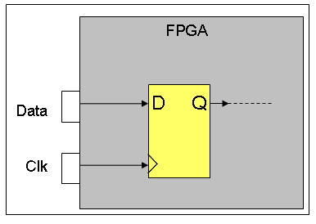
Figure 1: FPGA with External Input Synchronous To Clock
...and we know that the "Data" input has an 8 ns setup time before the "Clk" rising edge and a 7 ns hold time after the rising edge, like this:
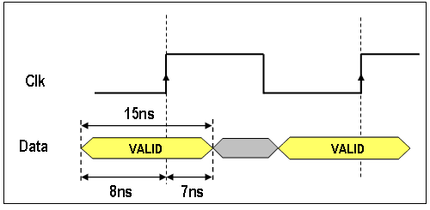
Figure 2: "Data" Setup and Hold Time With Respect To "Clk" Rising Edge
In this case, we must tell the ISE tools that the Data input has a setup time of 8 ns and a hold time of 7 ns with the following syntax:
NET "Data" OFFSET = IN 8ns VALID 15 ns BEFORE "Clk" HIGH;

This specifies that "Data" has a setup time of 8ns before the rising edge of "Clk" and will be valid for a total of 15 ns (8ns setup + 7 ns hold).
How do we know that the setup time is relative to the rising edge of "Clk" and not the falling edge? It's due to the "HIGH" keyword in the OFFSET specification. If we change the keyword to LOW:
NET "Data" OFFSET = IN 8ns VALID 15 ns BEFORE "Clk" LOW;
What we would be specifying is this:
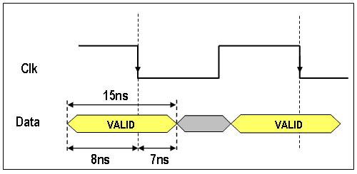
Figure 3: "Data" Setup and Hold Time With Respect To "Clk" Falling Edge
Now that the ISE tools know the relationship between the synchronous input and the clock at the physical pins of the FPGA device, they can route the device to make sure that the setup and hold times are met internally.
The OFFSET OUT AFTER constraint:
- Specifies the maximum delay between when the clock edge arrives at the FPGA pin and when the synchronous output pin becomes valid (usually know as clock-to-out delay).
- For outputs clocked with the rising edge, it is advisable to use the HIGH keyword.
- For outputs clocked with the falling edge, it is advisable to use the LOW keyword.

How Do I make sure my synchronous outputs are fast enough?
What we are concerned with here is how quickly our synchronous outputs become valid after the clock edge which produces them, otherwise known as "clock-to-output" delay.
Suppose that we have a registered output like this:
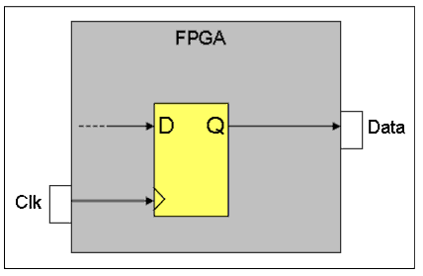
Figure 4: Registered Output
..and we want to have a maximum clock-to-output delay of 8ns, like this...
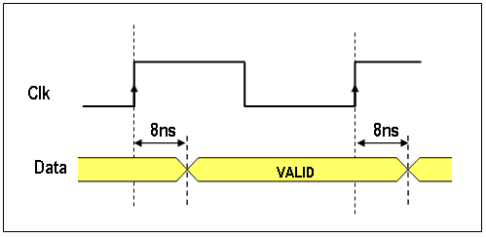
Figure 5: Clock-to-Output Delay
What we need to do is specify an OFFSET OUT constraint:
NET "Data" OFFSET = OUT 8ns AFTER "Clk" HIGH;
The ISE tools will now ensure (if possible) that the delay between when the clock arrives at the FPGA pin to when the "Data" output pin becomes valid will be a maximum of 8 ns.
The PERIOD constraint:
- Controls the maximum delay between any synchronous elements that are in the specified timing group.
- It does not control the delays between external pins (often called pads) and synchronous elements.

How do I specify the clock frequency?
1. The path to be constrained is defined using the "TNM_NET" keyword. This keyword creates a timing group that contains all the synchronous primitives (registers, BRAMs, etc.) that are connected to the specified net and is particularly useful for creating timing groups for clocks and clock enables.
Assume that we want to group together all registers connected to clock "Clk_A":

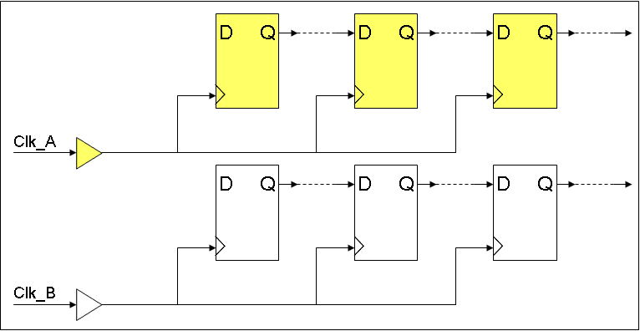
Figure 1: Registers Connected to Clk_A & Clk_B;
The timing group is specified like this:
NET "Clk_A" TNM_NET = "ClkA_Group";

This has the effect of creating a timing group (called "ClkA_Group") that includes only the registers connected to the "Clk_A" net (i.e. those marked in the yellow in figure 1), the registers connected to the "Clk_B" net are excluded from the timing group.
2. Now that we have defined the timing group, we can apply a "PERIOD" timing constraint to it:
TIMESPEC "TS01" = PERIOD "ClkA_Group" 20 ns HIGH 5 ns;

Constraint "TS01" defines the period and duty cycle of "Clk_A", it will have a total period of 20 ns and be high for 5 ns (and hence will be low for 15 ns)
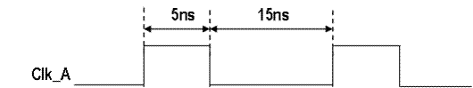
Figure 2: Waveform Defined By Constraint "TS01"
The complete timing constraint specification for the clocks in the circuit shown in figure 1 will look like something like this:
NET "Clk_A" TNM_NET = "ClkA_Group";
TIMESPEC "TS01" = PERIOD "ClkA_Group" 20 ns HIGH 5 ns;
NET "Clk_B" TNM_NET = "ClkB_Group";
TIMESPEC "TS02" = PERIOD "ClkB_Group" 40 ns HIGH 20 ns;
Note: All TIMESPEC names must begin with TS.

The simplest way to set up constraints for Xilinx application is to use a GUI constraints editor. The second way is to manually editing of the UCF file and is more powerful.
Suggest some ways to increase clock frequency?
· Check critical path and optimize it.
· Add more timing constraints (over constrain).
· Pipeline the architecture to the max possible extent keeping in mind latency req's.
. LVT cells
What is the significance of contamination delay in sequential circuit timing?
In digital circuits, the contamination delay is the minimum amount of time needed for the output of an electronic component to match input presented to it (i.e. contamination delay = hold time + device internal I/O propagation time). If there is insufficient delay from the output of one flip-flop to the input of the next, the input may change before the hold time has passed. Because the second flip-flop is still unstable, its data would then be "contaminated." Every path from an input to an output can be characterized with a particular contamination delay.
Well-balanced circuits will have similar speeds for all paths through a combinational stage, so the minimum propagation time is close to the maximum. This corresponding maximum time is the propagation delay. The condition of data being contaminated is called a race.

What are several factors to improve propagation delay of standard cell?
Improve the input transition to the cell under consideration by up sizing the driver.
Reduce the load seen by the cell under consideration, either by placement refinement or buffering.
If allowed increase the drive strength or replace with LVT (low threshold voltage) cell.

What are various ways of timing optimization in synthesis tools?
Logic optimization: buffer sizing, cell sizing, level adjustment, dummy buffering etc.
Less number of logic between Flip Flops speedup the design.
Optimize drive strength of the cell, so it is capable of driving more loads and hence reducing the cell delay.
Better selection of design ware component (select timing optimized design ware components).
Use LVT (Low threshold voltage) and SVT (standard threshold voltage) cells if allowed.

Jitter
Jitter is the undesired deviation from true periodicity of an assumed periodic signal in electronics and telecommunications, often in relation to a reference clock source.

***********************************************************************
Linux

Installing:
sudo apt –get install ProgramName

Extracting a zip/tar file
tar –xzvf FileName.tar.gz

Deleting history in terminal window
history -c

Searching for files:
The following command searches the home directory and all of its subdirectories looking for the file mysong.ogg:
find $HOME –name ‘mysong.ogg’

If you wished to search for all of the ogg files in your home directory, some of which you think might be named 'OGG' rather than 'ogg', you would run:
find $home –iname ‘*.ogg’

