What is JavaScript?
JavaScript is a versatile, dynamically typed programming language that brings life to web pages by making them interactive. It is used for building interactive web applications, supports both client-side and server-side development, and integrates seamlessly with HTML, CSS, and a rich standard library.

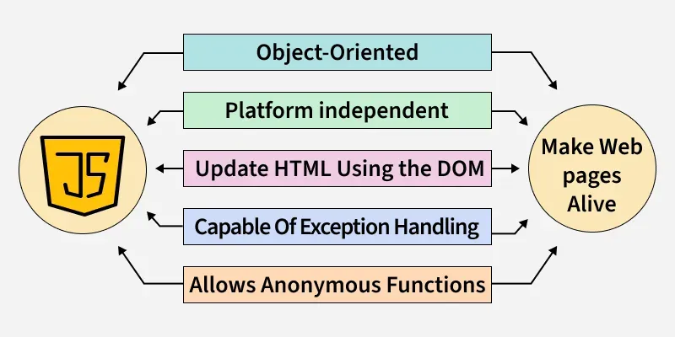

What is the difference between Server-Side Rendering & Client-Side Rendering (CSR Vs. SSR)?

Server-Side Rendering (SSR)
Server-side rendering (SSR) is the process of rendering web pages on the server and sending the fully-rendered HTML to the client. In this approach, the server generates the HTML, including any dynamic data, and sends it to the client as a complete page. The client then displays the page without any further processing.
One example of a popular SSR framework is Next.js.
Advantages:
- Faster initial load times
- Improved SEO optimization
Client-Side Rendering (CSR)
Client-side rendering (CSR) is the process of rendering web pages on the client using JavaScript. In this approach, the server sends the initial HTML file, but the client then uses JavaScript to dynamically update the page as needed. This allows for more interactive and responsive web pages, as the client can update specific parts of the page without needing to reload the entire page.
One example of a popular CSR framework is React. With React, you can write JavaScript code that updates the DOM as needed, providing a more interactive and dynamic web application.

Advantages:
- More dynamic and interactive web applications
- Can provide a smoother and more seamless user experience
- Can reduce the need for additional server requests

What's the difference between Scripting and Programming Languages?

Programming language
Programming languages are set of instructions or code which tells a computer what it needs to do. So basically, we provide a logic or instruction to the computer to perform some tasks to get the desired output from it.
Examples: Java, C, C++, C#.

Scripting Language
It's all about giving the script to perform some certain tasks. Scripting languages are basically the subcategory of programming languages which is used to give guidance to another program or we can say to control another program.
Examples: JavaScript, PHP, Perl, Python.

What is Syntax Error and Runtime Error?
n JavaScript, an error is a problem that prevents the code from running as expected. Errors can occur during development or while the application is running, causing the program to stop executing properly.
Types of Errors in JavaScript
- Syntax Errors: This happens when the code doesn't follow the correct syntax (e.g., missing parentheses, brackets, or commas).
Output:
SyntaxError: missing ) after argument list

- Reference Errors: Occurs when we try to access a variable that hasn’t been declared.
Output:
console.log(x); // ReferenceError: x is not defined

- Type Errors: This happens when a value is not of the expected type (e.g., trying to call a method on undefined).
Output:
let num = 5;
num.toUpperCase(); // TypeError: num.toUpperCase is not a function

- Range Errors: Occurs when a value is out of range, like passing an invalid number to a function.
Output:
RangeError: Invalid array length

What is Exception Handling in JavaScript?
Exception handling in JavaScript refers to the process of dealing with errors (exceptions) that occur during the execution of a program. JavaScript provides some mechanisms to catch, handle, and recover from error instead of letting the error stop the program. The most common approach is using try...catch blocks.

Handling Errors Using try...catch statement
Try Block: You place code that may potentially throw an error here.
Catch Block: This block executes if an error occurs in the try block.
finally Block: The Code inside this block will always run, whether an error occurred or not.

Example:
try {
let res = 10 / 0;
if (!isFinite(res)) {
throw new Error("Cannot divide by zero");
}
console.log(res);
} catch (error) {
console.error("Error occurred:", error.message);
} finally {
console.log("Execution completed");
}
Output:
Error occurred: Cannot divide by zero
Execution completed

