What is Object oriented and event driven programming?

Event Driven Programming
In computer programming, event-driven programming is a programming paradigm in which the flow of the program is determined by events such as user actions (mouse clicks, key presses), sensor outputs, or messages from other programs/threads.

Object Oriented Programming (OOP)
Object Oriented Programming (OOP) is a style of programming that uses classes and objects to model real-world things like data and behaviour. A class is a blueprint that defines the properties and methods an object can have, while an object is a specific instance created from that class.

What are the variables & data types in JavaScript?
Variables
A variable is like a container that holds data that can be reused or updated later in the program. In JavaScript, variables are declared using the keywords var, let, or const.
- var Keyword
- let Keyword
- const Keyword

var keyword:
The var keyword is used to declare a variable. It has a function-scoped or globally-scoped behaviour.
var n = 5;
console.log(n);
var n = 20; // reassigning is allowedconsole.log(n);
output:
5
20

let keyword:
The let keyword is introduced in ES6, has block scope and cannot be re-declared in the same scope.
let n = 10;
n = 20; // Value can be updated
// let n = 15; //cannot redeclare
console.log(n)
output:
20

const keyword:
The const keyword declares variables that cannot be reassigned. It's block-scoped as well.
const n = 100;
// n = 200; This will throw an error
console.log(n)
output:
100

Data Types
Primitive Datatypes:
Primitive datatypes represent single values and are immutable.

- Number: Represents numeric values (integers and decimals).
- String: Represents text enclosed in single or double quotes.
- Boolean: Represents a logical value (true or false).
- Undefined: A variable that has been declared but not assigned a value.
- Null: Represents an intentional absence of any value.
- Symbol: Represents unique and immutable values, often used as object keys.
- BigInt: Represents integers larger than Number.MAX_SAFE_INTEGER.

Non-Primitive Datatypes:
Non-primitive types are objects and can store collections of data or more complex entities.
- Object: Represents key-value pairs.
let obj = {
name: "Amit",
age: 25
};

- Array: Represents an ordered list of values.
let a = ["red", "green", "blue"];

- Function: Represents reusable blocks of code.
function fun() {
console.log("GeeksforGeeks");
}
Function scope & block scope in JavaScript?

Function Scope:
Each JavaScript function have their own scope.
Variables defined inside a function are not accessible (visible) from outside the function.
Variables declared with var, let and const are quite similar when declared inside a function.
function myCarname() {
let car = "volvo";
console.log(car);
}
myCarname();

Local Variables has Function Scope
- They can only be accessed from within the function
- No scripts or functions outside the function can access them
- Variables with the same name can be used outside the function
- Variables with the same name can be used in different functions
- Local variables are created when a function starts
- Local variables are deleted when the function is completed
- Arguments (parameters) work as local variables inside functions

Block Scope:
Before ES6, JavaScript variables could only have Global Scope or Function Scope.
ES6 introduced two important new JavaScript keywords: let and const.
These two keywords provide Block Scope in JavaScript.

{
let x = 2;
}
// x can NOT be used here

What are the JavaScript Arrays?
In JavaScript, an array is an ordered list of values. Each value, known as an element, is assigned a numeric position in the array called its index. The indexing starts at 0, so the first element is at position 0, the second at position 1, and so on.
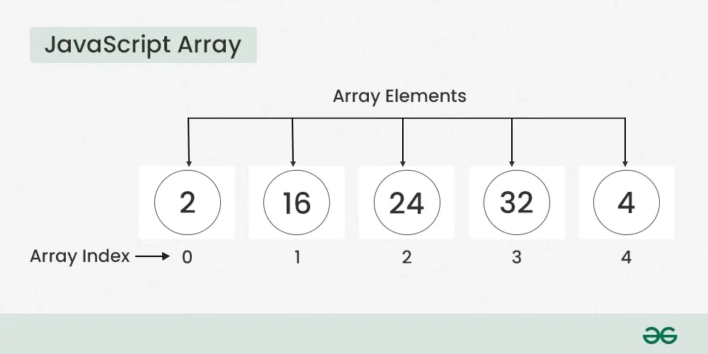

// Creating an Empty Array
let a = [];
console.log(a);

// Creating an Array and Initializing with Values
let b = [10, 20, 30];
console.log(b);
output:
[]
[ 10, 20, 30 ]

What is Hoisting in JavaScript?
JavaScript Hoisting refers to the process whereby the interpreter appears to move the declaration of functions, variables, classes, or imports to the top of their scope, prior to execution of the code.

