What is JavaScript?
JavaScript is a versatile, dynamically typed programming language that brings life to web pages by making them interactive. It is used for building interactive web applications, supports both client-side and server-side development, and integrates seamlessly with HTML, CSS, and a rich standard library.

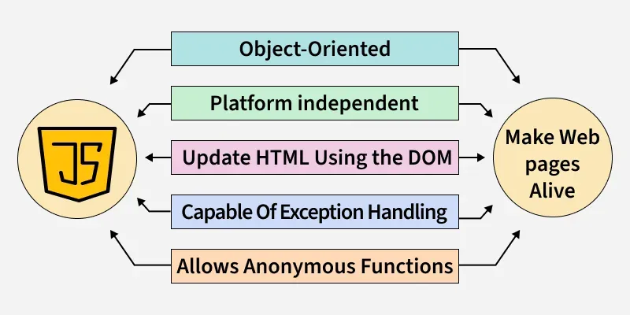

What's the difference between Scripting and Programming Languages?
Programming language
- Programming languages are set of instructions or code which tells a computer what it needs to do. So basically, we provide a logic or instruction to the computer to perform some tasks to get the desired output from it.
- Examples: Java, C, C++, C#.
Scripting Language
- It's all about giving the script to perform some certain tasks. Scripting languages are basically the subcategory of programming languages which is used to give guidance to another program or we can say to control another program.
- Examples: JavaScript, PHP, Perl, Python.

What is Syntax Error and Runtime Error?
n JavaScript, an error is a problem that prevents the code from running as expected. Errors can occur during development or while the application is running, causing the program to stop executing properly.
Types of Errors in JavaScript
- Syntax Errors: This happens when the code doesn't follow the correct syntax (e.g., missing parentheses, brackets, or commas).
Output:
SyntaxError: missing ) after argument list

- Reference Errors: Occurs when we try to access a variable that hasn’t been declared.
Output:
console.log(x); // ReferenceError: x is not defined

- Type Errors: This happens when a value is not of the expected type (e.g., trying to call a method on undefined).
Output:
let num = 5;
num.toUpperCase(); // TypeError: num.toUpperCase is not a function

- Range Errors: Occurs when a value is out of range, like passing an invalid number to a function.
Output:
RangeError: Invalid array length

What is Exception Handling in JavaScript?
Exception handling in JavaScript refers to the process of dealing with errors (exceptions) that occur during the execution of a program. JavaScript provides some mechanisms to catch, handle, and recover from error instead of letting the error stop the program. The most common approach is using try...catch blocks.

Handling Errors Using try...catch statement
Try Block: You place code that may potentially throw an error here.
Catch Block: This block executes if an error occurs in the try block.
finally Block: The Code inside this block will always run, whether an error occurred or not.

Example:
try {
let res = 10 / 0;
if (!isFinite(res)) {
throw new Error("Cannot divide by zero");
}
console.log(res);
} catch (error) {
console.error("Error occurred:", error.message);
} finally {
console.log("Execution completed");
}

Output:
Error occurred: Cannot divide by zero
Execution completed

