What is Constructor?
A constructor is a special type of method used in object-oriented programming languages to initialize objects. The constructor is called automatically every time when an object is created, allowing the object to set initial values for its attributes or perform other setup tasks.

What is Event Loop in JavaScript?
The event loop continuously checks whether the call stack is empty and whether there are pending tasks in the callback queue or microtask queue.

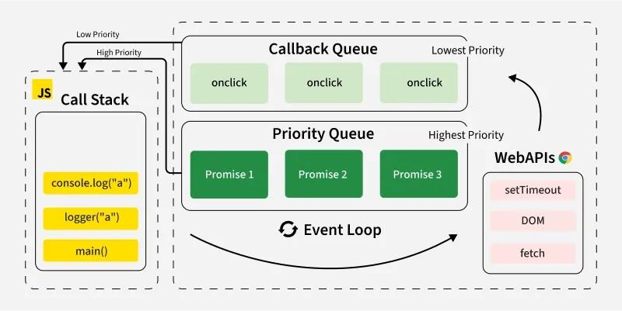

Call Stack: JavaScript has a call stack where function execution is managed in a Last-In, First-Out (LIFO) order.
Web APIs (or Background Tasks): These include setTimeout, setInterval, fetch, DOM events, and other non-blocking operations.
Callback Queue (Task Queue): When an asynchronous operation is completed, its callback is pushed into the task queue.
Microtask Queue: Promises and other microtasks go into the microtask queue, which is processed before the task queue.
Event Loop: It continuously checks the call stack and, if empty, moves tasks from the queue to the stack for execution.

Phases of the Event Loop
The event loop operates in multiple phases.
- Timers Phase: Executes callbacks from setTimeout and setInterval.
- I/O Callbacks Phase: Handles I/O operations like file reading, network requests, etc.
- Prepare Phase: Internal phase used by Node.js.
- Poll Phase: Retrieves new I/O events and executes callbacks.
- Check Phase: Executes callbacks from setImmediate.
- Close Callbacks Phase: Executes close event callbacks, e.g., socket.on('close').
- Microtasks Execution: After each phase, the event loop processes the microtask queue before moving to the next phase.

What is promise?
JavaScript Promises make handling asynchronous operations like API calls, file loading, or time delays easier.
Promise as a placeholder for a value that will be available in the future. It can be in one of three states.
Pending: The task is in the initial state.
Fulfilled: The task was completed successfully, and the result is available.
Rejected: The task failed, and an error is provided.

setTimeout() in JavaScript?
The setTimeout() function is used to add delay or scheduling the execution of a specific function after a certain period. It's a key feature of both browser environments and Node.js, enabling asynchronous behavior in code execution.
JavaScript Promise Chaining?
Promise chaining allows you to execute a series of asynchronous operations in sequence. It is a powerful feature of JavaScript promises that helps you manage multiple operations, making your code more readable and easier to maintain.
- Allows multiple asynchronous operations to run in sequence.
- Reduces callback hell by eliminating deeply nested functions.
- Each then() returns a new promise, allowing further chaining.
- Error handling is easier with a single .catch() for the entire chain.

function task(message, delay) {
return new Promise((resolve) => {
setTimeout(() => {
console.log(message);
resolve();
}, delay);
});
}

// Chaining promises
task('Task 1 completed', 1000)
.then(() => task('Task 2 completed', 2000))
.then(() => task('Task 3 completed', 1000));

