What is NodeJS?
Node.js is a runtime environment that allows JavaScript to run outside the browser for building server-side applications.

What is the difference between Library & Framework?
Library
A library provides a set of helper functions/objects/modules which your application code calls for specific functionality.
Framework
Framework, on the other hand has defined open or unimplemented functions or objects which the user writes to create a custom application.

What are the Modules of NodeJS?
In Node.js Application, a Module can be considered as a block of code that provide a simple or complex functionality that can communicate with external application. Nodejs uses the CommonJS Module standard implementation in its module ecosystem.
Types of Modules: In Nodejs, there is 3 types of modules namely
- Core Modules
- Local Modules
- Third-Party Modules
Core Modules: Node.js comes with dozens of built-in modules. These built-in modules are sometimes referred to as core modules. The module system is built around the require function.
const fs = require('fs'); // Import fs module
fs.writeFile('notes.txt', 'I love to code');
https to make Node.js act as an HTTPS server. // https module
const path = require('path'); // path module
const pathobj = path.parse(__filename);

What is Express?
Express.js is a minimal and flexible Node.js web application framework that simplifies building server-side applications and APIs.
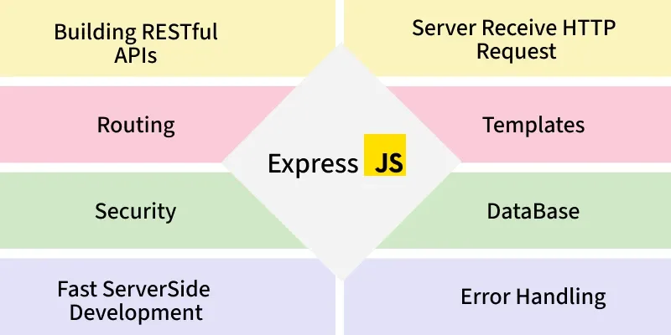
- Middleware-based: Uses middleware functions to handle requests, responses, and add features like authentication, logging, or error handling.
- Routing system: structure—developers can design apps as they want.
- Integration: Works well with databases (MongoDB, MySQL, PostgreSQL) and front-end frameworks.
- Scalable: Suitable for small apps to large-scale enterprise APIs.

What are the Routing structure of ExpressJs?
Basic routing in Express.js is the process of defining URL endpoints (routes) and specifying how the server should respond to client requests at those endpoints.
- app.get() - Handle GET requests
- app.post() - Handle POST requests
- app.put() - Handle PUT requests
- app.patch() – Update particular fields
- app.delete() - Handle DELETE requests

