# Project Title

## Introduction

This project is a web-based application that helps you track your daily tasks

## Problem Statement

Many students struggle with keeping their day or even a week organized due to the lack of

easily accessible and intuitive tools. This web-app solves this problem with having a clean

interface and easy action of adding tasks, setting due dates and giving them priority.

## Objectives

-Development of easily accessible tool;

-Allowing users to add/delete tasks, set due dates, assign priorities;

-Design an appealing and intuitive interface.

## Technology Stack

* Frontend: ReactJS, NodeJS,CSS
* Backend: Firebase Firestore database.

## Installation Instructions

NOTE FOR TEACHER: Reason for the one massive commit as initial commit is that I first used different code redactor and then switched to Visual Studio and after that committed, sorry in advance!

Step-by-step guide to set up the project locally.

# 1. Clone the repository

git clone <https://github.com/telRes24/DailyTaskPlanner_20P.git>

# 2. Navigate into the project directory

cd DailyTaskPlanner_20P

# 3. Install dependencies

npm install

# 4. Start the application

npm start

## Usage Guide

.

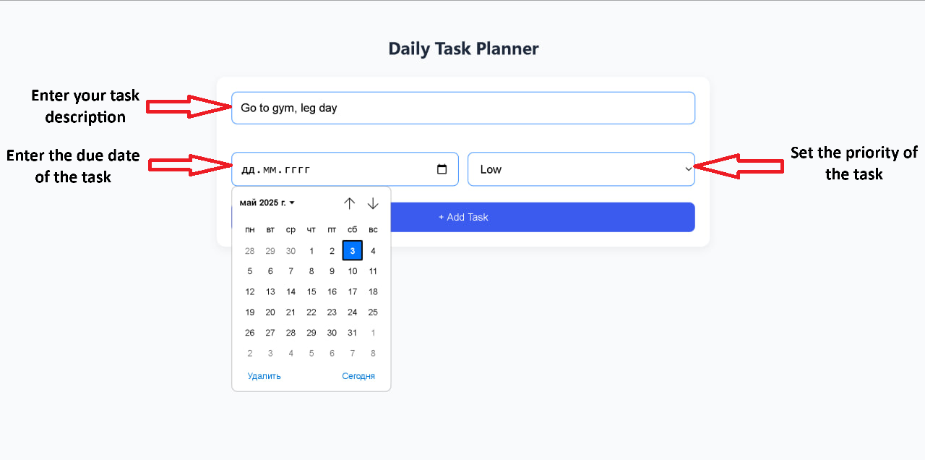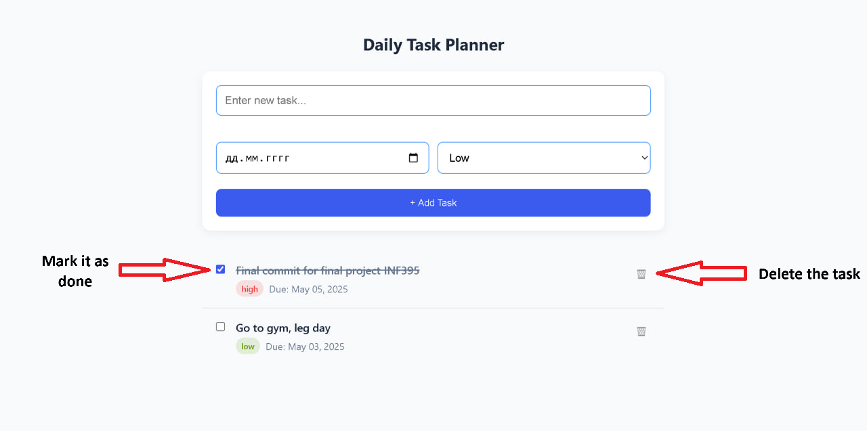

## Known Issues / Limitations

Mac OS not supported.

Android / IOS not supported.

No Error messages (For exception handling).

## References

Official documentation: [Firebase docs](https://firebase.google.com/docs?hl=ru)

YouTube tutorials: [Git & GitHub for dummies](https://www.youtube.com/playlist?list=PLuY6eeDuleIMtvOvJBAbakwcIdEt7IAXT), [Firebase + React for beginners](https://www.youtube.com/watch?v=2hR-uWjBAgw&t=13s)

# Team Members

* Serikkazy Daulet, 220103243, 20-P