Research on Improvement of Receiving-Detecting Circuit for Digital Radiographic Systems with Advanced Spatial Resolution

V.D. Ryzhikov¹, O.D. Opolonin¹, O.K. Lysetska¹, S.M. Galkin¹, Y.F. Voronkin¹ and V.L. Perevertaylo²

¹Institute for Scintillation Materials of STC “Institute for Single Crystals”, NAS of Ukraine, Kharkov, Ukraine
²Research Institute for Micro Instrument, Kiev, Ukraine

Abstract

Development and studies of characteristics are reported for X-ray radiation detectors of “scintillator-photodiode” type showing improved spatial resolution with photosensitive area step of 1.6, 0.8, 0.4 and 0.2 mm and number of channels 16, 32, 128 and 256, respectively. The receiving-detecting channel has been adjusted and tested, appropriate software has been developed, and shadow X-ray images of tested objects were obtained. Evaluations were made of spatial resolution, resolution over thickness and detecting ability of the digital radiographic sysyem based on the detector array. Recommendations are formulated on application of such devices for non-destructive testing and technical diagnostics. Further studies on obtaining two-energy images show possibilities of substantial broadening of the application fields of the digital radiographic system, allowing determination of the effective atomic number Zeff for component substances of the tested objects. A possibility is shown of substance discrimination by their effective atomic number even for “light” elements with Zeff from 6 to 13. Clear distinction could be observed between such substances as water (Н2О) with Zeff≈7.43 and glycerol (СН2ОНСНОНСН2ОН) with Zeff≈ 6.87.

1. Introduction

The worldwide trend of transition from film radiography to digital radiography requires creation of advanced digital radiography systems (DRS) [1-4]. Materials of the 9th European Conference on non-destructive testing show that the main direction of DRS development is improvement of spatial resolution (SR) [4].
This work was aimed at looking for new possibilities of improvement of SR, resolution over thickness and detection ability of DRS based on X-ray radiation detectors of “scintillator-photodiode” (S-PD) type.
Preliminary studies indicated two main technological problems hindering creation of S-PD detectors with improved SR [5]. One of them is preparation of scintillator arrays (assemblies) with small aperture of each scintillation element. The other is compact arrangement of pre-amplifiers (PA).
We have proposed technical solutions for production and improvement of PD and scintillation arrays with number of channels from 32 to 256 on each PD, as well as detector design as a whole.

2.DESIGN DEVELOPMENT OF A DETECTOR WITH IMPROVED SR

The X-ray radiation detector of S-PD type comprises two main elements – a multi-channel PD and a scintillator array (assembly).
Previously used design of 16- and 32-channel PD imposes limitations on the directions of PD irradiation (Fig.1,2). These detectors can be used correctly only if irradiation is normal to the plane of photosensitive elements.
In collaboration with Research Institute for Micro Instrument, Kyiv, Ukraine we have developed a new design of the 32-channel PD (Fig.3). Its advantages are: feature allows easy attachment of detectors with minimum gap between them, which is important for preserving the channel step in 0.8 mm arrays and reaching the identity of characteristics of detector couples (high-energy and low-energy detectors, HED and LED).
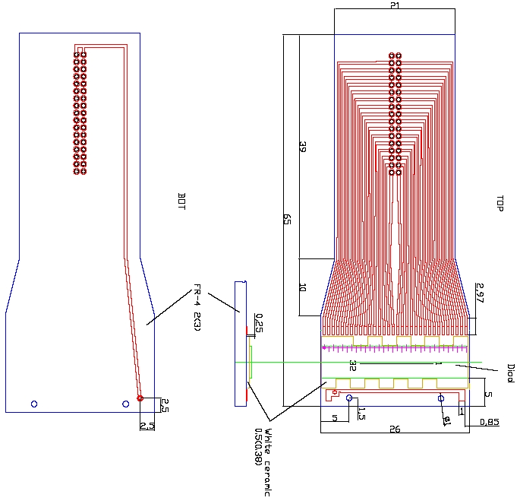
Fig.3 Design of 32-channel photodiode.

Also, the PD design ensures sufficiently large distance between the detector and the PA board, which protects the element base from effects of direct and scattered ionizing radiation. Protection of the elements of electronics is especially important when, e.g., high-energy X-ray sources (XRS) with anode voltage up to 450 keV are used.
32-channel scintillator assemblies made from plates had dimensions 25.4х4х0.6 mm, showed good uniformity of scintillation characteristics and could be precisely placed on photosensitive elements of multi-channel PD.

3. PREPARATION OF MODEL DETECTORS AND STUDIES OF THEIR CHARACTERISTICS

According to the developed design documentation and technological regulations, model samples of 32-channel X-ray radiation detectors were made (fig.4,5).
Requirements to parameters of the 32-channel detector were formulated at the level of foreign analogs:
1. Detector output window area 0.6х0.6mm²
2. Detector step 0.8 mm
3. Number of elements 32
4. Static detector current without irradiation
(Т=20° С, U_{bias} = 10 mV) < 20 pA
5. Maximum breakdown voltage, not less than 5 V
6. Detector sensitivity in the current mode for X-ray radiation
(W- anode, U_{a}= 100 kV)
for scintillators СsI(Tl) and ZnSe(Te) > 50 nA× min×R⁻¹×cm⁻²
for scintillator CdWO₄ > 20 nA× min×R⁻¹×cm⁻²
7. Sensitivity scatter of module detectors < ±20 %
8 . Detector signal decay after 10 ms:
СsI(Tl) to 2% level
ZnSe(Te) to 0,2% level
CdWO₄ to 0,1% level
9. Detector capacitance (Т=20° С, U_{bias} = 100mV) < 50pF
10.Topology of the detector module should allow sequential attachment of modules into a line preserving the detector step at the module junction.

4. MODEL SAMPLE OF DRS ON THE BASIS OF RECEIVING-DETECTING CIRCUIT WITH AN ARRAY OF 32-CHANNEL DETECTORS

A model sample was assembled of DRS based on receiving-detecting circuit (RDC) with an array of 32-channel detectors. External appearance of the model DRS sample is shown in Fig.6.
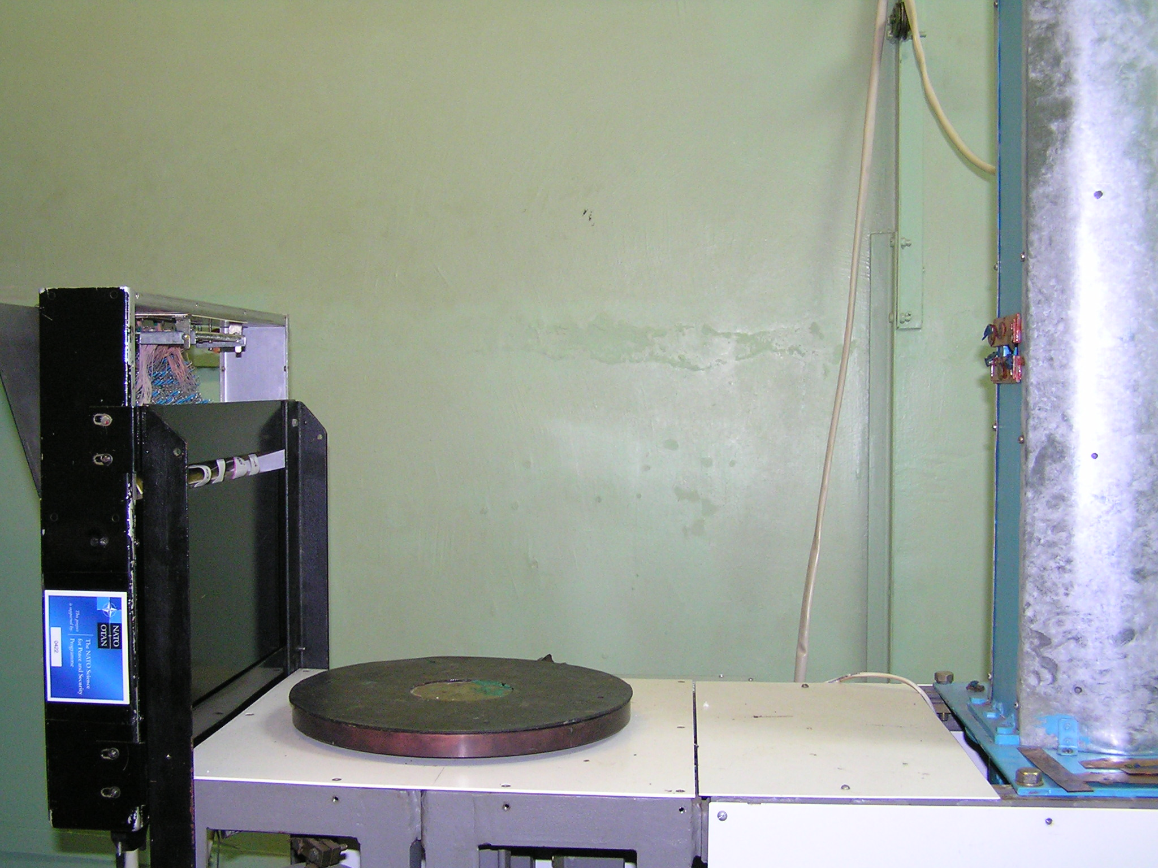
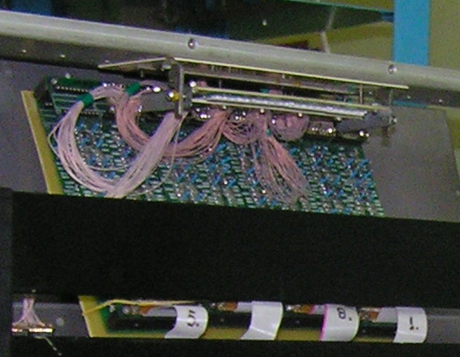
Scanning mechanism сканування
Array of 32-channel detectors
RAPAN 140/140 X-ray source

Fig.6. Model sample of DRS based on RDC with array of 32-channel detectors.

Main characteristics of the DRS model sample:
X-ray source RAPAN 140/140:
Anode voltage 60 ÷140 kV with step 10 kV
Anode current 0.5; 0.75; 1 mA
Mechanism for movement of the inspected object:
Vertical displacement – 0 ÷297mm with step 0.033 ÷4.2 mm
Mass of the inspected object, not more than 10kg
Receiving-detecting circuit:
Sampling time of the detector array – 10 ms
ADC digit capacity – 14
Number of channels – 256
Connection to PC – USB, LPT, Com

TESTING OF DETECTOR ARRAY AS PART OF MODEL RDC, date and Results
Using detectors with scintillation elements of different thickness, spatial resolution of DRS was determined using several test objects, namely, EN 462 (calibrated pairs of wires) and a brass gauze with step 1.23 mm and wire diameter 0.38 mm (fig.7).

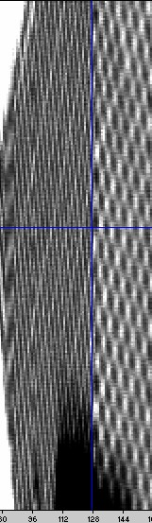

Inspected object – brass gauze with step 1.23 mm and wire diameter 0.38 mm. Magnification: ≈2

16-channel detectors
(step 1.6 mm)
32-channel detectors
(step 0.8 mm)

Fig.7. Comparison of shadow X-ray images of a brass gauze obtained using 16-channel detectors and 32-channel detectors of old design.

The images of a brass gauze obtained using 16- and 32-channel detectors of old design is shown in Fig.7.
First, we compared shadow images obtained using 32-channel detectors of old design and detectors under the present development.
Using an array of detectors of new design, we obtained a shadow X-ray image of the gauze under the same conditions (anode voltage 140 kV, magnification ≈2) – see Fig.7. Comparison of these images is a clear evidence of higher spatial resolution with detectors of new design. Tests of detector arrays with different thickness of scintillation elements as part of model DRS, with obtaining images of tested objects (calibrated wire pairs), have shown that, depending upon thickness of the scintillation assembly, the spatial resolution is 1÷1.25 line pairs/mm, and detecting ability is better than 0.1 mm steel wire (Fig.8).
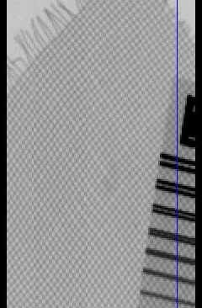
Fig.7. Shadow X-ray image of a brass gauze obtained using 32-channel detectors of a new design.

Also for quantitative determination of the spatial resolution, we used an EN 462 test object (calibrated wire pairs), the sizes are given in Table 1.

Table 1. Dimensions of wire pairs of a standard metrological sample of testing object EN 462

Pair | 1D | 2D | 3D | 4D | 5D | 6D | 7D | 8D | 9D | 10D | 11D | 12D | 13D
Diameter, mm | 1.60 | 1.26 | 1.00 | 0.80 | 0.64 | 0.50 | 0.40 | 0.32 | 0.26 | 0.20 | 0.16 | 0.13 | 0.10

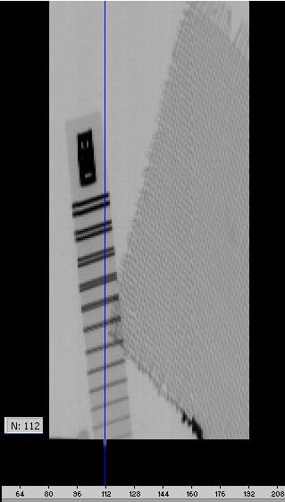
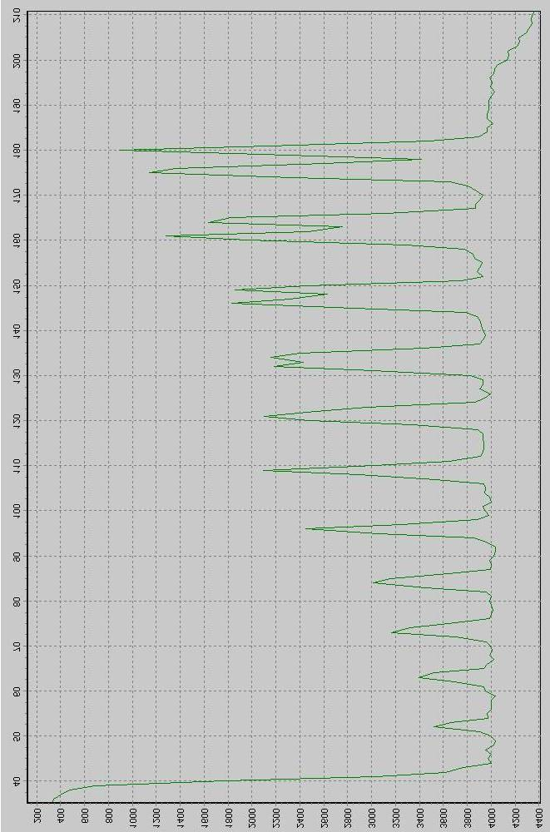
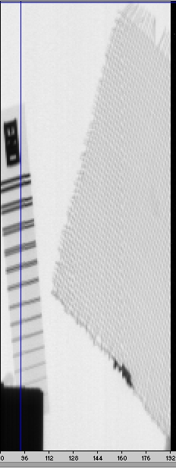
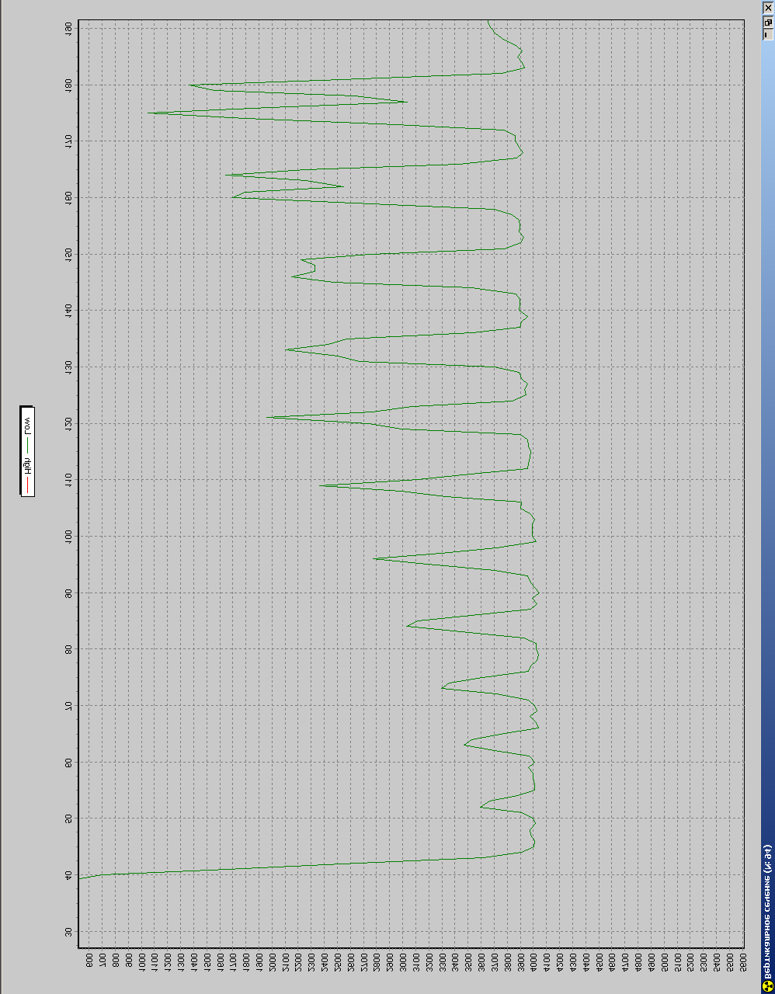
Thickness of scintillation element
0.4 mm
Thickness of scintillation element 1 mm

Fig.8. Shadow X-ray image of the test object obtained using detectors with different thickness of scintillation elements.

For our studies, we used test objects allowing determination of the DRS prototype detection ability and density resolution (contrast sensitivity). They included: welded steel plates of 6 mm thickness; a set of probe rods of 0.05÷0.30 mm thickness; a set of iron wires from 0.25 mm to 1 mm (Fig.9).

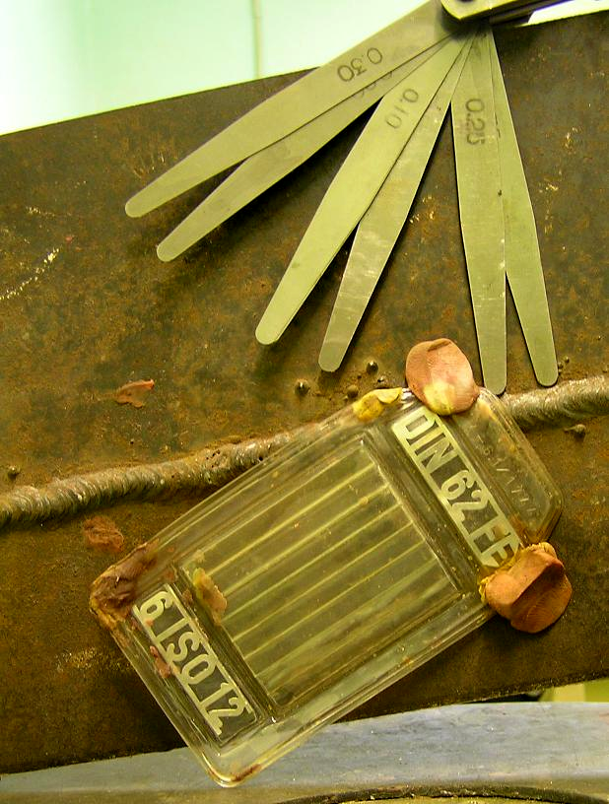
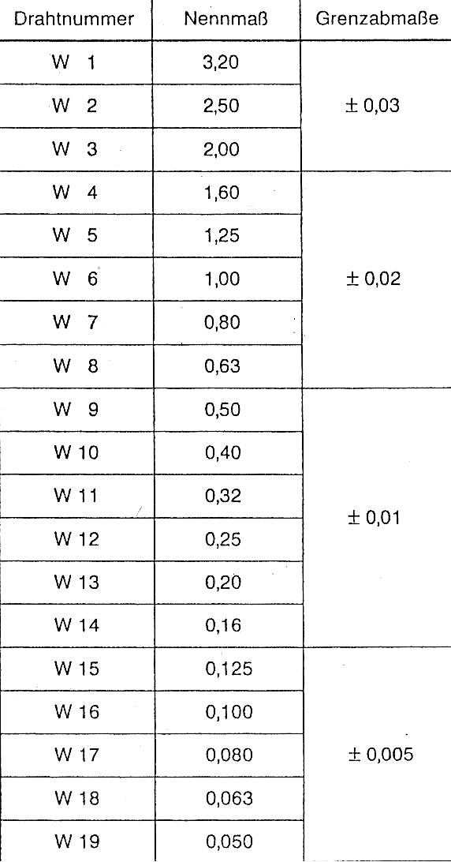
Fig.9. Test objects: welded steel plates, set of probe rods, set of iron wires (see table)

Shadow X-ray images of the test objects allowed evaluation of the density resolution – not worse than 0.9%, and detection ability – iron wire Ø 0.5 mm behind 6 mm steel. One can see good contrast on the image fragment where the 0.1 mm thick plate is crossed with the 0.05 mm plate behind 6 mm steel(Fig.10) .
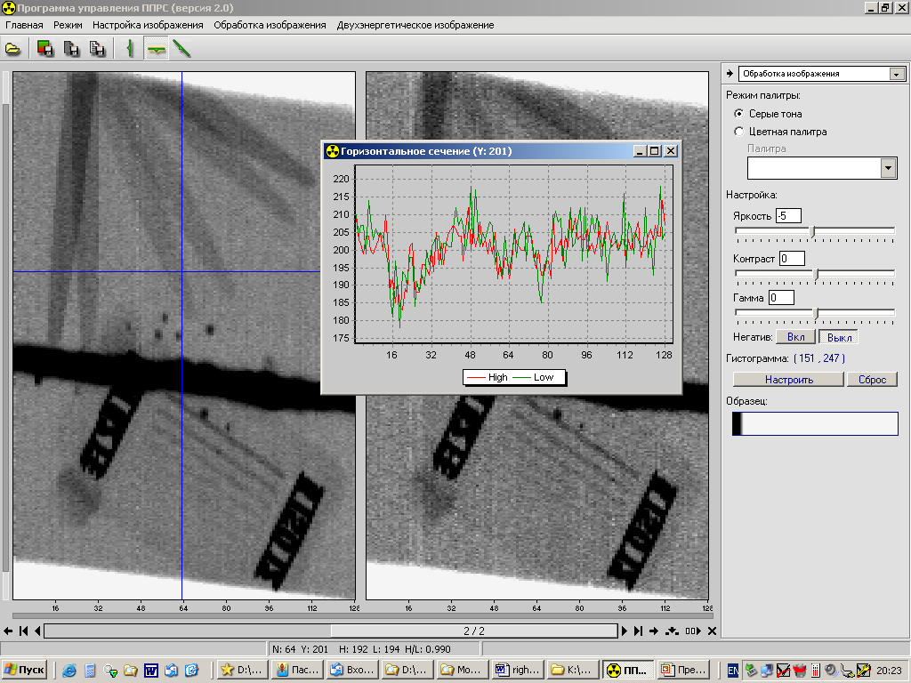
Fig.10. Shadow X-ray image of test objects and the horizontal section plot.
These measurement results show the possibility of using DRS as thickness meter, or for detection of corrosion processes leading to a decrease in the inspected object (IO) thickness by less than 1%.
The presented X-ray images were obtained using 16-channel detectors of “scintillator-photodiode” type. The detector step in the array is 1.6 mm.

For two-energy digital radiography, we carried out an experiment on determination of the best possible discrimination between substances by their effective atomic number.
As inspected objects, we chose two substances with close effective atomic number values– water (Н₂О), Z_{eff}≈7.43, and glycerol (СН₂ОНСНОНСН₂ОН), Z_{eff}≈ 6.87. To study the HED/LED ratio as function of the object thickness (characterized by HED+LED), we used small-sized polyethylene packages as containers for liquids (fig11). The use of such containers allowed obtaining X-ray images.
To obtain the highest level of discrimination by Z_{eff} , we obtained two shadow X-ray images of the tested objects. Large separation of the energies allowed reliable distinction between water and glycerol by their effective atomic numbers (fig 11).

It can be concluded that X-ray detectors reported in this work can be successfully used for creation of fast DRS with improved SR. Their applications include welded joints, pipelines, fabricated metals and metalworks, as well as various objects with components made of materials with different effective atomic number.

REFERENCES

[1] Ryzhikov, V.D., Opolonin O.D., Serhiy M. Galkin “Development of Receiving-Detecting Circuit for Digital Radiographic Systems with Improved Spatial Resolution”, Proc. SPIE 7450, 0J1-0J6 (2009).
[2] Ryzhikov, V.D., Opolonin, O.D., Kozin, D.N., “X-ray radiation detectors of "scintillator-photoreceiving device" type for digital industrial radiography with improved spatial resolution,” Nuclear Instruments and Methods in Physics Research (A 505), 192-199 (2003).
[3] Ryzhikov, V., Kozin, D.,Grynyov, B., “Scintillator-photodiod detectors for scanning introscopy with high special resolution”, Nuclear Instruments and Methods in Physics Research (A 505), 181-184 (2003).
[4] Naydenov, S.V., Ryzhikov, V.D., Smith, C.F., “Multi-energy ZnSe-based radiography against terrorism: theory and experiments,” Proc. SPIE 6319, A1-A8 (2006).
[5] Seminozhenko, V.P., Ryzhikov, V. D., Opolonin, A.D., “ZnSe(Te)-Based Crystals and Detectors for Nondestructive Testing and Cargo Inspection,” Proc. SPIE 6319, B-1-B-8 (2006).
[6] Bavendiek, K., Ewert, U., Zscherpel, U., Meade, “New Digital Radiography Procedure Exceeds Film Sensitivity Considerably in Aerospace Applications” Proc.9-th Europian Conference on NDT, 44-48 (2006).
[7] Grinyov, B.V., Ryzhikov, V.D., SeminozhenkoV.P., [Scintillation detectors and radiation monitoring systems on their base], Naukova Dumka, Kyiv, 447 (2007).
[8] Ryzhikov, V., Grynyov, B., Opolonin, A., “Scintillation materials and detectors on their base for non-destructive two-energy testing”, Radiation Measurements (42), 915– 920 (2007)
[9] Scherbakov, V.I., Grezdov, G.I.., [Electronic circuits on operational amplifiers], Tekhnika, Kyiv, 280(1983).
[10] Naydenov, S.V., Ryzhikov, V.D., Smith,C.F., “Radiographic spectroscopy of composition of materials: a multi-energy approach” Proc. IEEE Nuclear Science Symposium, 119-125 (2004).
[11]Naydenov, S.V., Ryzhikov, V.D., “Determining Chemical Compositions by Method of Multi-Energy Radiography”, Technical Physics Letters 28(5), 357-360 (2002).
[12]Grinyov, B., Ryzhikov, V. and Lecoq, P., “Dual-energy radiography of bone tissues using ZnSe-based scintielectronic detectors,” Nuclear Instruments and Methods in Physics Research, (A 571), 399–403 (2007)
[13]http://www.mxftech.com/
[14]Naydenov, S.V., Ryzhikov, V.D. and Seminozhenko,V.P., “Multi-energy approach in non-destructive testing of functional materials,” Reports of NANU (11), 95-100(2002).

