IDP/IDM Integration with T-CaaS - Requirements

Introduction
This document outlines the requirements for integrating an Identity Provider (IDP) and Identity Manager (IDM) with T-CaaS Kubernetes. The integration will facilitate the management of groups, group owners, and group members within the IDM environment. The IDM should abstract the aforementioned actions into an API which can be consumed by T-CaaS Kubernetes. The IDP should serve as the authentication endpoint and token provider for T-CaaS Kubernetes. The document also describes the concept of a Tenant viewed from the point of T-CaaS, how the Tenant roles are scoped, and the naming convention of groups.

IDM API Endpoints
To ensure tenant-wide (global), environment-wide (prod/ref/test) and cluster-wide (unique) groups used for secure access to T-CaaS Kubernetes API, the following IDM APIs will be provided for the lifecycle management of groups, group owners, and group members.

Group Lifecycle
The following endpoints are responsible for managing the lifecycle of groups.
Method | Endpoint | Path
GET | $REMOTE_API | /group/$name
POST | $REMOTE_API | /group
DEL | $REMOTE_API | /group

Group Owner Lifecycle
The following endpoints are responsible for managing the lifecycle of group owners.
Method | Endpoint | Path
GET | $REMOTE_API | /group/$name/owner
POST | $REMOTE_API | /group/$name/owner
DEL | $REMOTE_API | /group/$name/owner

Group Member Lifecycle
The following endpoints are responsible for managing the lifecycle of group members.
Method | Endpoint | Path
GET | $REMOTE_API | /group/$name/member
POST | $REMOTE_API | /group/$name/member
DEL | $REMOTE_API | /group/$name/member

Object Definitions

Group Object
The group object is responsible for representing a group within the system. The object must minimally have the following fields:
- 1. Name (string)
- 2. Type (string)
- 3. Parent (string)
The group object should support nesting and subgrouping.

Owner Object
The owner object represents the owner of a group. The object must minimally have one of the following fields:
- 1. Username (string)
- OR
- 2. Email (string)

Member Object
The member object represents a member of a group. The object must minimally have one of the following fields:
- 1. Username (string)
- OR
- 2. Email (string)

Scoping & Naming Conventions
A Tenant is a T-CaaS Kubernetes cluster consumer. The tenancy is scoped around a product or a group of related applications that share a common team. Each tenant is always assigned 6 unique roles which are correctly scoped to reflect permission segregation in a T-CaaS Kubernetes cluster. Please refer to the table below:
Scoped Role | Description
Cluster Poweruser | Can execute all verbs on cluster scoped resources, except on restricted API groups and restricted API resources
Cluster Collaborator | Can execute a subset of verbs on cluster scoped resources, except on restricted API groups and restricted API resources
Cluster Reader | Can read all cluster scoped resources
Namespaced Poweruser | Can execute all verbs on namespace scoped resources, except on restricted API groups and restricted API resources
Namespaced Collaborator | Can execute a subset of verbs on namespace scoped resources, except on restricted API groups and restricted API resources
Namespaced Reader | Can read all namespace scoped resources (except kube-system secrets)

These 6 roles are implemented tenant-wide (global), environment-wide (prod/ref/test) and cluster-wide (unique). The tenant-wide (global) groups will exist as long as a tenant has atleast 1 living cluster. The environment-wide (prod/ref/test) groups will exist as long as a tenant has atleast 1 living cluster per environment. The cluster-wide (unique) groups will exist only for the life duration of that specific cluster.
Tenant-wide | Environment-wide | Cluster-wide
$tenantName-$permissionScope-$role | $tenantName-$environment-$permissionScope-$role | $clusterName-$tenantName-$siteLocation-$environment-$permissionScope-$role
sddata-cluster-admin | sddata-prod-cluster-admin | 5gmvnr-sddata-bonn-prod-cluster-admin

As shown in the table, the number of groups grows in multiples of 6 for each new cluster added to the tenant. To avoid administrative overhead for lifecycle management of groups, group owners and group members – an API is warranted.

IDP Endpoint
The endpoint should serve as an OpenID Connect (OIDC) provider which will authenticate users based on their credentials (API token or username/password) and issue an Identity Token or an Access Token which will be used to consume Kubernetes API services. In the context of T-CaaS Kubernetes the initiating client is kubectl, specifically the kubelogin plugin. Please refer to the diagram below for the full flow of authentication:
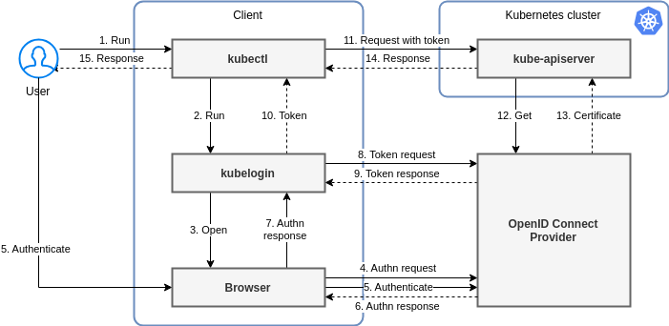

Additional Requirements
The owner and member objects must be able to belong to multiple groups simultaneously.

TDI Connect requirements
Owner or owners of an existing group must be able to manage the users of the group from the TDI Connect UI allowing the following:
- Add / Remove owners to a group
- Add / Remove users to a group
Reference from TDI IDP:
Groups menu:
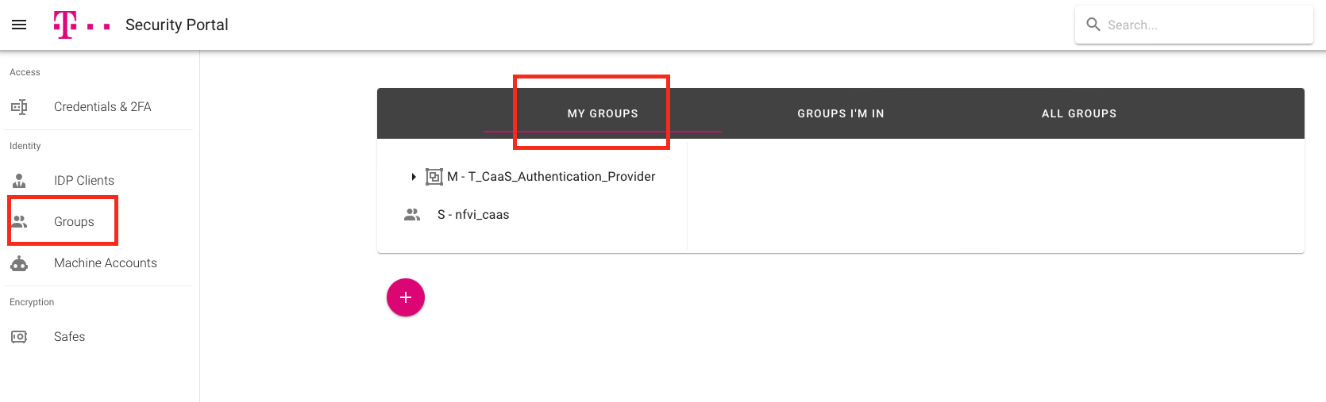
Options to add Owners and Members to a group
