Lab 2
I tried decision tree and K nearest neighbor algorithm on the data set to classify the area target. Some preprocessing and feature engineering process are done beforehand:
- label encoding month and day column
- take the log of area column
- cutting the logged area values into 6 bins for classification

It could be observed that there’s an obvious class bias and some minority classes exist:
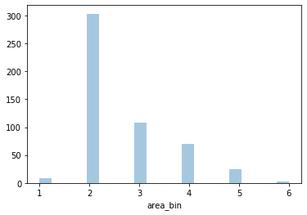
So I did some oversampling using SMOTE mechanism, which tends to add more sample points on the line between two minority class points. There are 1810 samples after oversampling.
Based on that, I applied decision tree and KNN on both original and oversampled dataset. Besides, I also self-implemented 2 functions to calculate sensitivity and specificity matrix for multi-label classification

1. Decision Tree
I start with a simple decision tree on the original dataset (without oversampling), with gini criterion and max_depth to be 3. It reached an accuracy of .61.
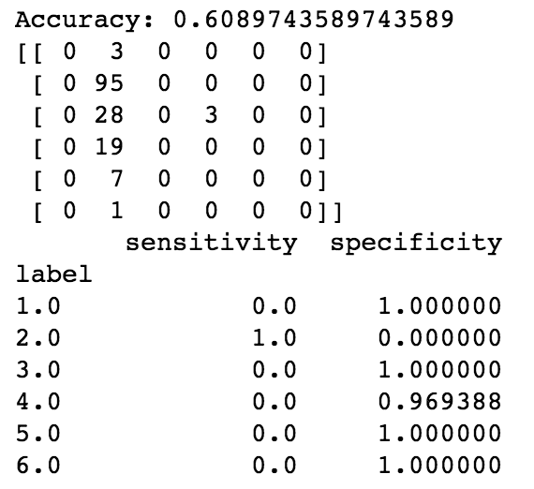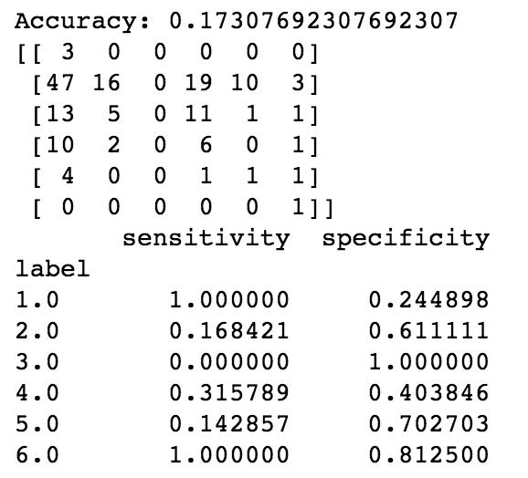
original oversampled
Oberving from the confusion matrix, it seems like most classes other than 2 are misclassified, with sensitivities of 0. Also, it is a surprise that the accuracy on oversampled dataset was so low. Thus I procceed with parameter tuning.
I started with an important parameter: max_depth which controls the depth of the tree. Accuracy apparently improves with more depths:
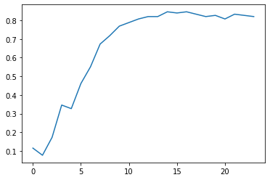

The performance peaks at around 14, and slightly fluctuate afterwards. So setting max_depth to be 14 would be a good way to avoid overfitting.
In order to try tuning more parameters more efficiently, I self-implemented a grid search that outputs the best model and accuracy based on the given parameter space.
The grid search outputs that, the best parameters on the oversampled dataset would be:
- criterion: gini
- splitter: best
- max_depth: None, which means no limit on the max depth
- max_features: 5
- min_samples_split: 2
- min_samples_leaf: 1
The best accuracy outputted was .797, very close to the one that we got from simply tuning max_depth. Thus we could see that, max_depth played a decisive role here for classification accuracy.
Going further, I’m more and more curious how boosting and bagging would help on this dataset. I tried random forest with grid search but the performance didn’t improve much, but when doing boosting, there were some good news.
A Gradient Boosting classifier with 800 trees, deviance loss and 7 max_features would achieve an accuracy of around .906, which is a big improvement on one single tree.

