Part1:
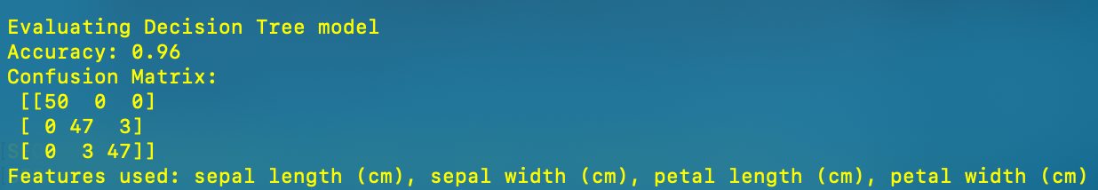

Part2:
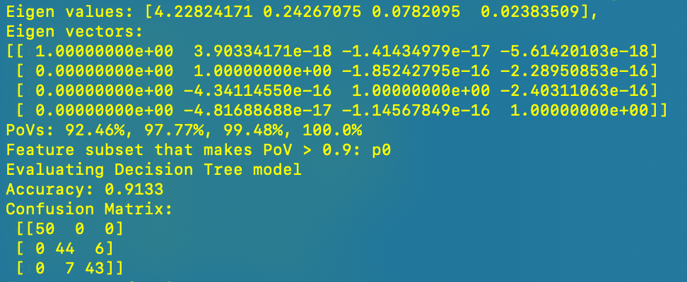

Part3:
The process of algorithm running for each iterataion:
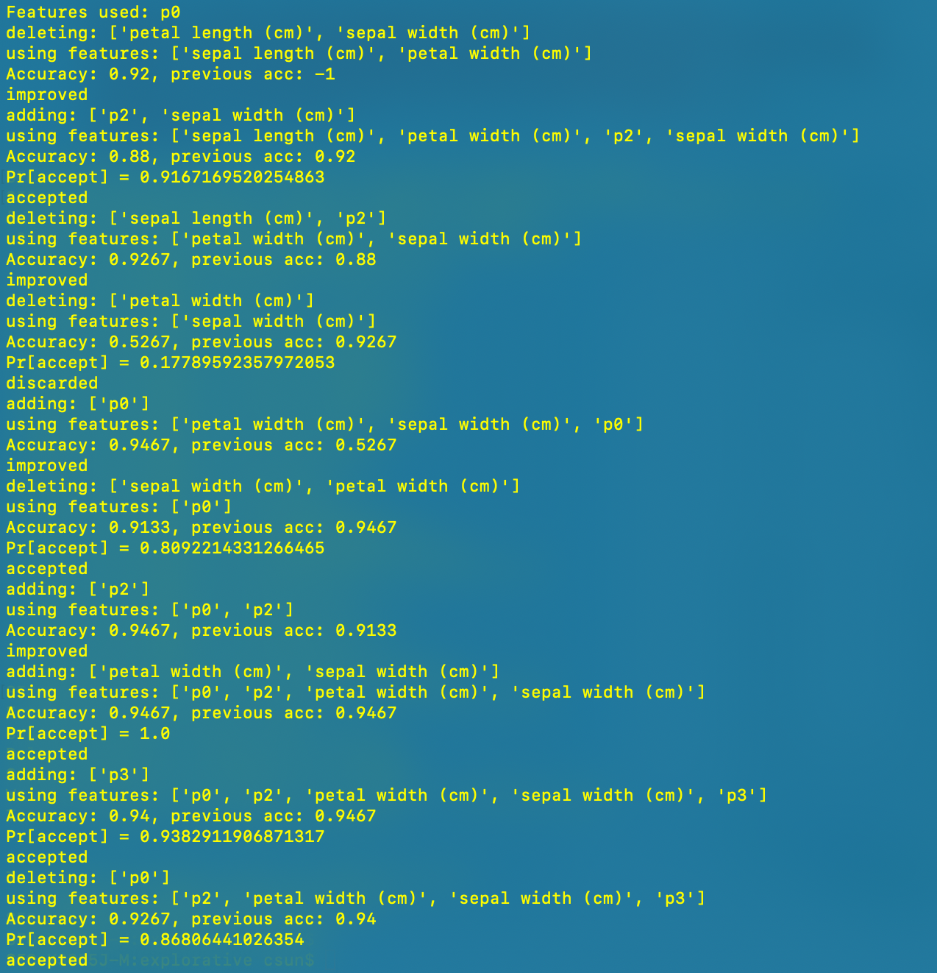
Since it’s too long, a dataframe is generated which contains all the information required:
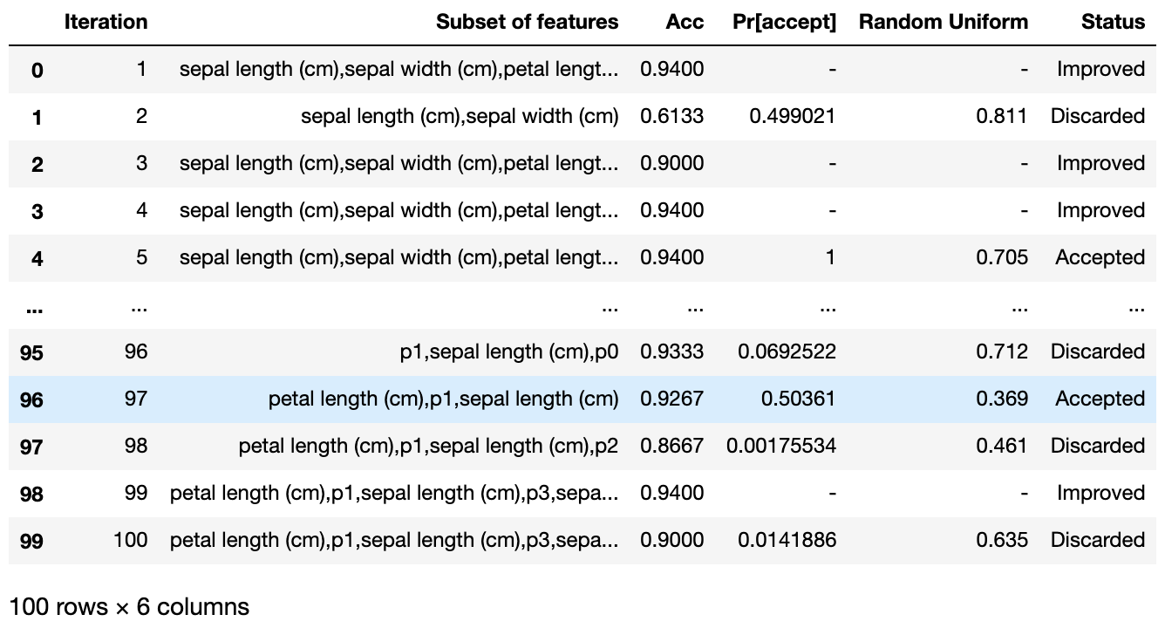

And the final evaluation using best found features:
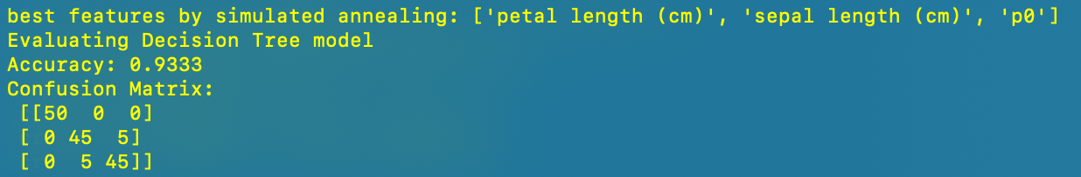

Part4:
