a. Based on accuracy which model is the best one?
Looking from accuracy, linear regression and Linear Discriminant Analysis model outperform all the others, with an accuracy of 0.9667.

b. For each of the 6 other models, explain why you think it does not perform as well as the best one.

- For Naïve Bayesian(accuracy 0.96), from confusion matrix it performs bit worse in virginica class. An important reason for the inaccuracy would be that GaussianNB assumes an independent relationship between any two features, and also it assumes a Gaussian distribution for numeric features while here that's not always the case.
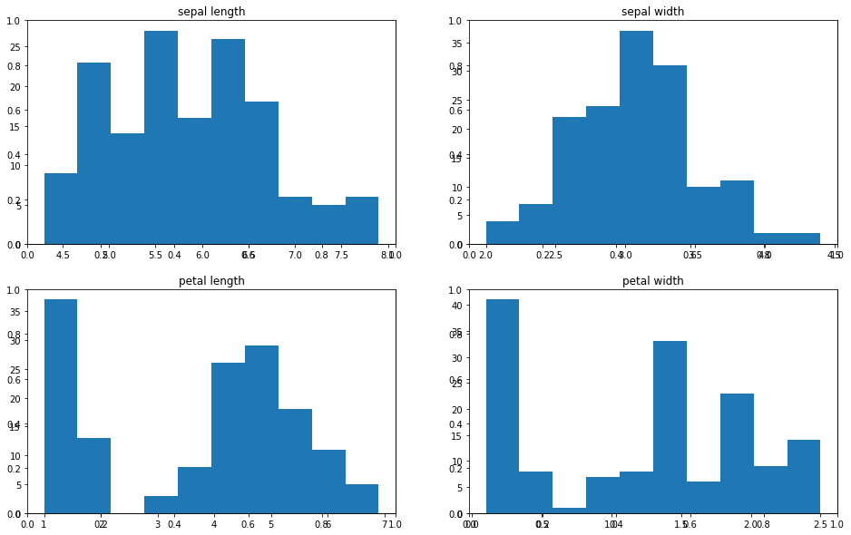

- For Polynomial of degree 2 & 3, it assumes and tries to fit a polynomial relation among all the features, and this is deviating from the behavior of the dataset a bit. Petal length looks like to be in a linear correlation with petal width, while the other features don’t seem to show a salient correlation that is depictable by polynomial relations. Thus the polynomial of both degree 2 and 3 both returned a rather low accuracy.
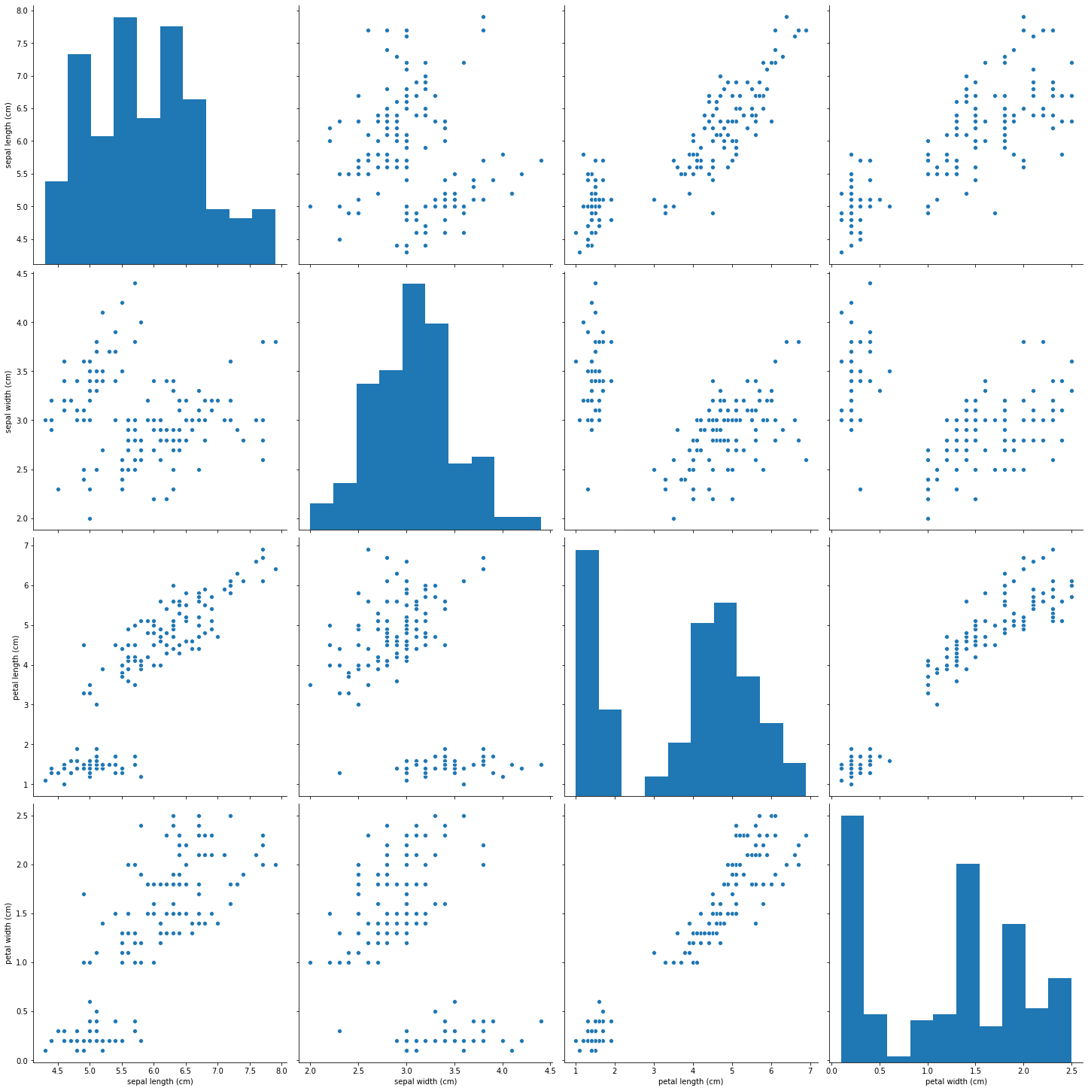

- For KNN classifier, it’s quite close to the best accuracy. KNeighbor models work quite well in low dimension scenarios. When squashed into 2-d space using PCA(over 97% variance explainable), the 3 classes are quite distinguishable(shown below). I think this would partially explain why KNN classifier performs almost as well as our best ones.
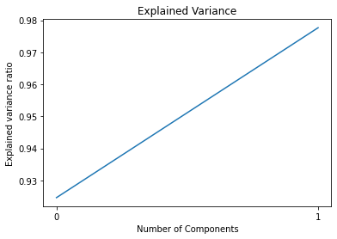
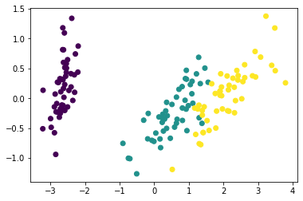

- For the QDA model, it’s also as close as our best ones. The only diff appears to be one more type II error in versicolor. Looking from the 2-d scatter plot after conducting PCA(above), the border between versicolor and virginica appears non-linear and difficult to fit & distinguish. QDA unfortunately misclassifies one more sample than LDA in our case here.

