Lab3

1. Base model.
The base model was trained on the MNIST dataset with an architecture of 32, 32, 10, with SGD optimizer, ReLU activation for hidden layers and softmax for output layer, and categorical_crossentropy for loss function. The model has the form of:
_________________________________________________________________
Layer (type) Output Shape Param #
=================================================================
dense_12 (Dense) (None, 32) 25120
_________________________________________________________________
dense_13 (Dense) (None, 32) 1056
_________________________________________________________________
output (Dense) (None, 10) 330
=================================================================
Total params: 26,506
Trainable params: 26,506
Non-trainable params: 0

After 20 epochs of training, it achieved an accuracy of .9613 on validation set using 73s.
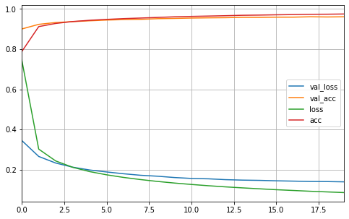

2.

