Visualizing US border-crossing behavior since 1996

(1) What the data are.
The dataset for the project is the US border crossing data, which contains all the incidents of crossing the border into the US, provided by the Bureau of Transportation Statistics, Govt. of the US. This dataset tells about the incoming counts into the US.

(2) The source of the data
The data comes from the Bureau of Transportation Statistics, Govt. of the US.

(3) What variables are included in the data, and what type of variables they are.
The dataset contains the below variables, with their types attached.
 | Variable | Explanation | type | example
1 | Port Name | Name of the port | string | Van Buren
2 | State | Name of the state | string | Maine
3 | Port Code | Code of the port | integer | 108
4 | Border | Type of border(US-Mexico/US-Canada) | category | US-Mexico Border
5 | Date | Date for the border crossing incident | date | 03/01/2019 12:00:00 AM
6 | Measure | Measure of border crossing | category | Trucks
7 | Value | Number of border crossing incidents | integer | 81217
8 | Location | longitude and latitude of the port | fields | POINT (-67.94271 47.16207)

(4) A breakdown of missing values in the data
The dataset does not contain missing values.
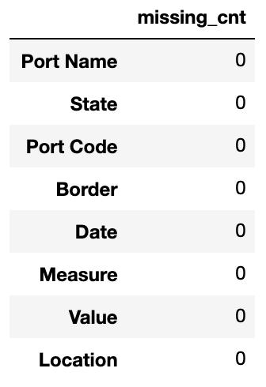

(5) Proposed title.
The proposed title for the project would be: Visualizing US border-crossing behavior since 1996.

