Pre-processing and exploratory data analysis
1. Data preprocessing
Some data preprocessing steps are done before initial data analysis for data cleaning and exploration purposes.
1) Generating new features
Try to generate several new features here for broader exploration possibilities. Since there is a datetime feature in the data, two more features are generated: day of the week and a bool column indicating if it’s a weekday, to further explore the relation between border-crossing behavior and weekend/weekdays

2) Joining more data
The original dataset is purely focused on border-crossing stats such as port information and crossing measurement. In order to excavate extra info, two datasets are joined: the GDP stats of each state, and the average temperature of each state, to explore the relation between border-crossing behavior and economical/thermal state.
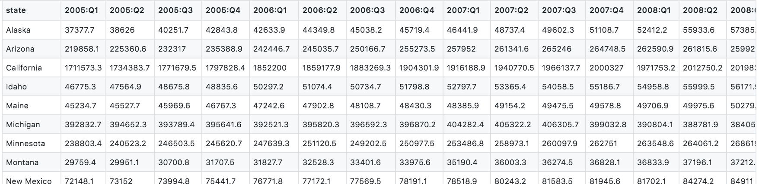
GDP by state dataset

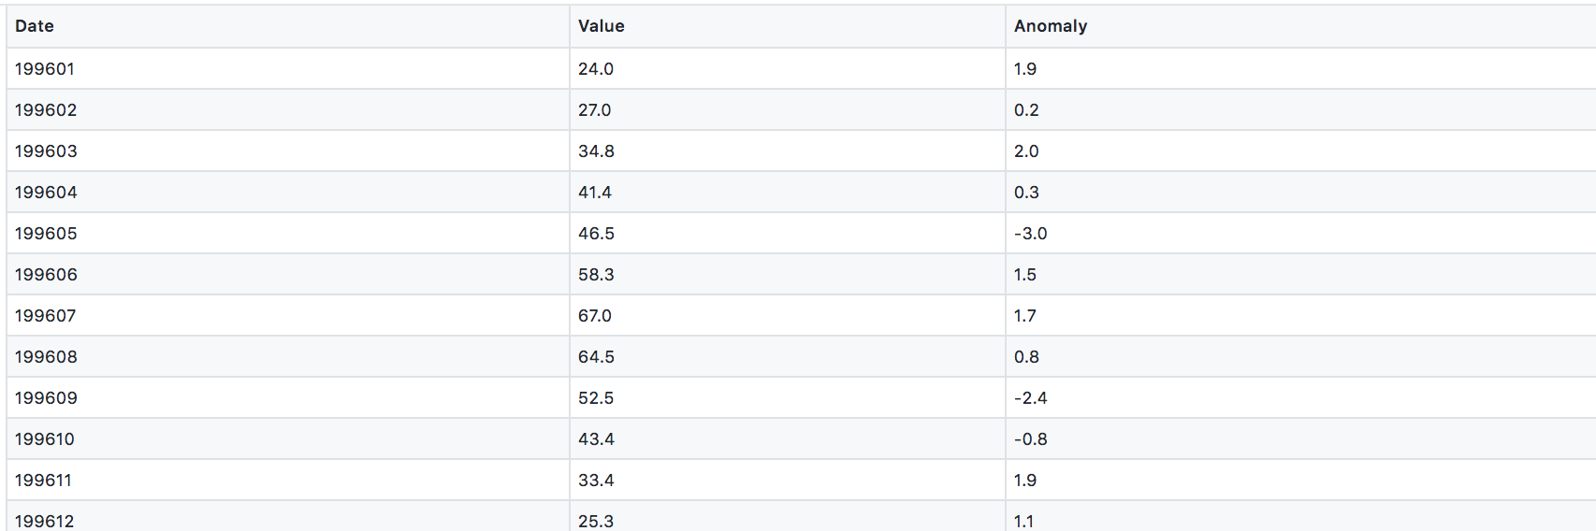
Average temperature by state dataset

3) Standardization
For numeric features such as geographical coordinate of ports, border crossing value, etc., they are standardized to facilitate further modeling process
4) One-hot encoding
For categorical features such as state, measurement and border type(US-Canada or US-Mexico), etc., they are one-hot encoded to multiple columns so that they can be further fed into models that only accept numerical inputs.

2. Exploratory data analysis
Some exploratory data analysis are done for initial data pattern exploration, as well as for data wrangling before feeding it into further data science models.
1) explorative visualization
Below is the line chats showing the overall border-crossing quantities going over time, as well as month breakdowns.

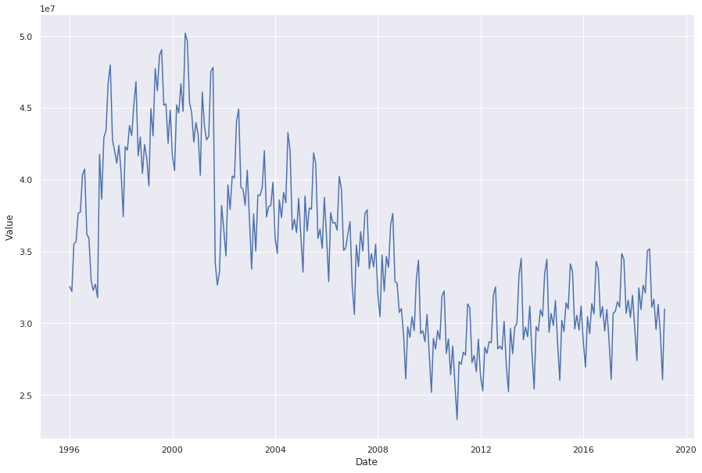 | 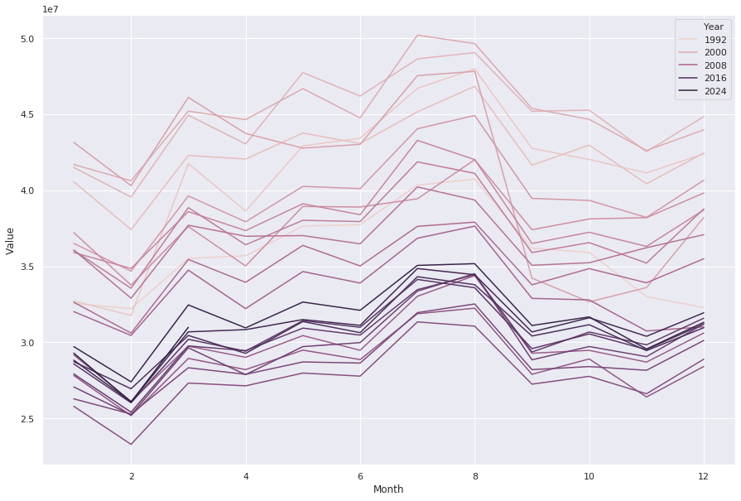
And the aggregated quantities by measure (e.g. by truck/train/vehicle, etc.)
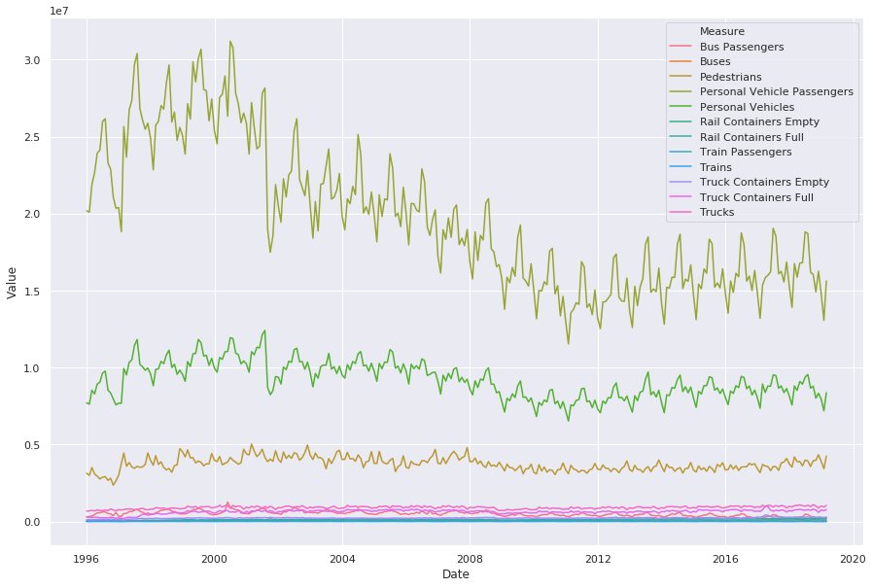
A strong seasonal trend could be observed in the above plots, which indicates that border-crossing behaviors are somewhat related with seasonality and temperature.
2) Anomaly detection
Tried several machine learning algorithms here to detect anomalies, such as isolation forest and one-class SVM. The below visualization shows the quarterly outlier distribution detected by isolation forest.
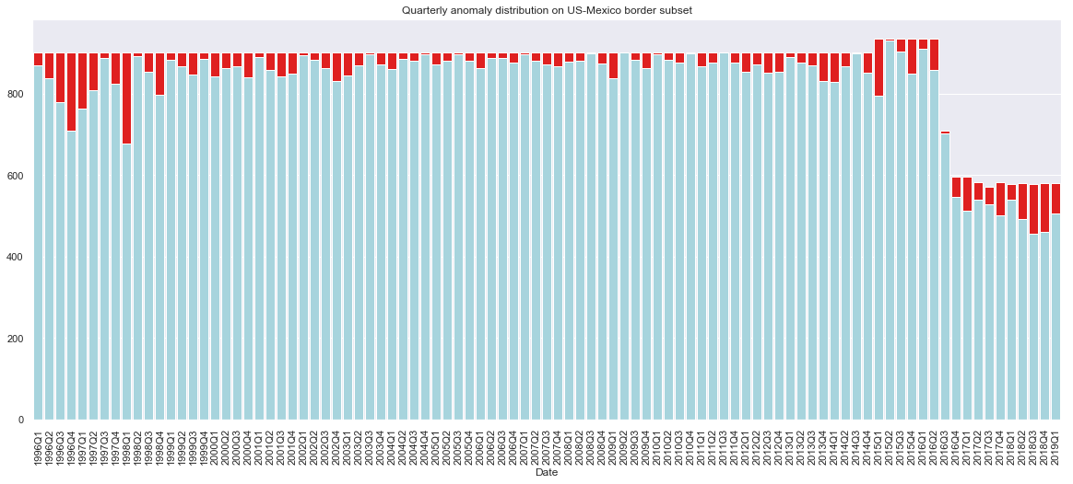

And below illustrates the outlier distribution by month overall, detected by isolation forest.
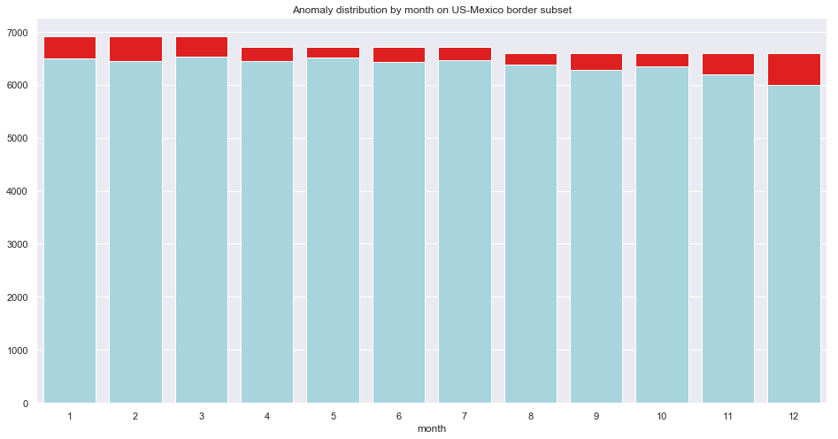

It could be observed that outliers are more prone to happen before 1998 Q3 and after 2017 Q4. Looking by month, there seems to be more outliers in December, January and February.
Taking a closer look at a specific port (Lukeville) with a specific measure (Trucks). One-class SVM detects the outlier pattern as below.
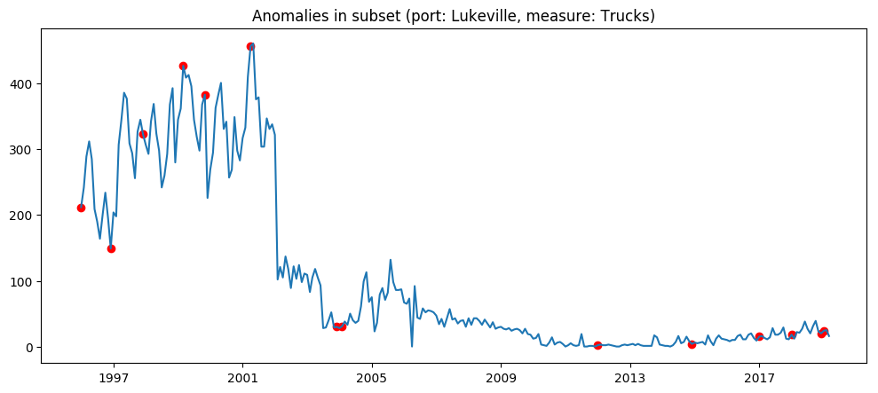
Outliers detected are mainly distributed on data peaks and troughs, and evenly distributed across all years in the dataset.

