Semester Project Report
Visualizing US border-crossing behavior since 1996
(1) Dataset
The dataset for the project is the US border crossing data, which contains all the incidents of crossing the border into the US, provided by the Bureau of Transportation Statistics, Govt. of the US. This dataset tells about the incoming border crossing counts into the US.
Below is a preview of the raw data:
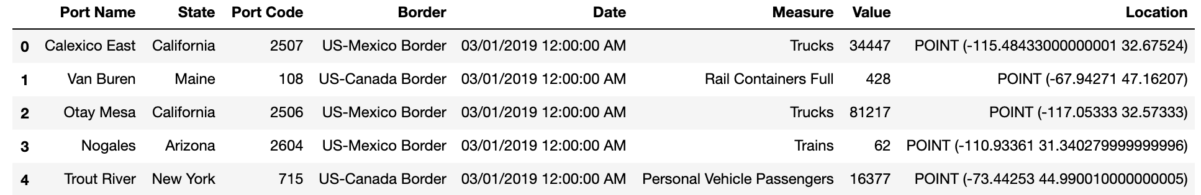

And below is a detailed description of the data schema:
 | Variable | Explanation | type | example
1 | Port Name | Name of the port | string | Van Buren
2 | State | Name of the state | string | Maine
3 | Port Code | Code of the port | integer | 108
4 | Border | Type of border(US-Mexico/US-Canada) | category | US-Mexico Border
5 | Date | Date for the border crossing incident | date | 03/01/2019 12:00:00 AM
6 | Measure | Measure of border crossing | category | Trucks
7 | Value | Number of border crossing incidents | integer | 81217
8 | Location | longitude and latitude of the port | fields | POINT (-67.94271 47.16207)

(2) Data preprocessing
Some data preprocessing are conducted before further analysis and virtualization. Two features are generated:
- Day of the week (numeric)
- Is week day (bool)
And more data was joined to further explore and visualize some potential reasons that might affect border-crossing behavior, shown as below.
- GDP stats of each state
- Average temperature of each state per month
Besides, standardization and one-hot encoding were also applied on the dataset, respectively on numeric and categorical features.

(3) Visualizations
Here’re the detailed visualizations on the dataset.
First, below is the charts describing the trend of cross-border count going with time, with breakdown in year, port and measure (approach).
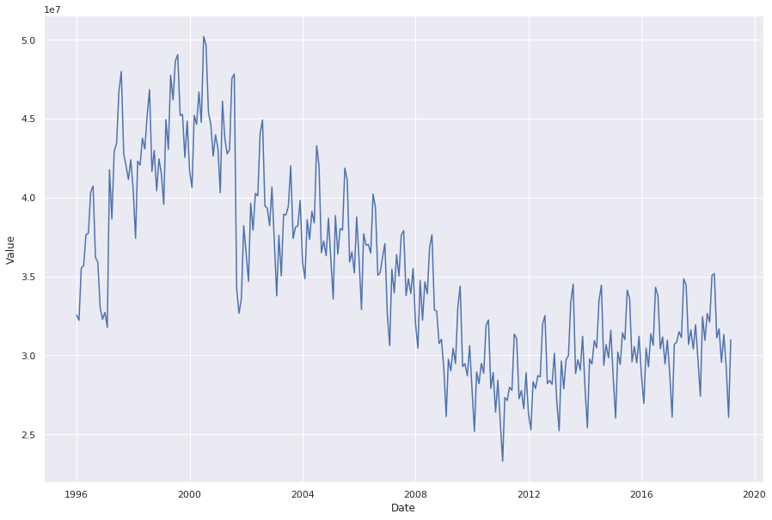 | 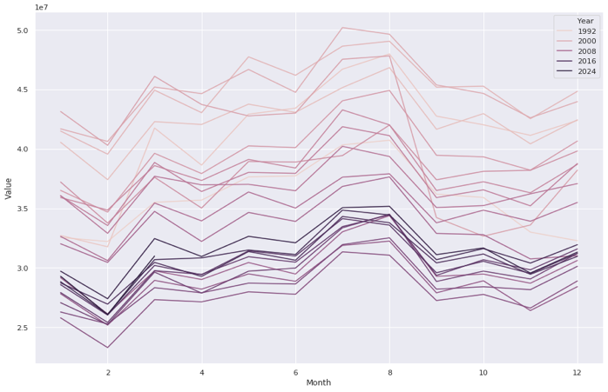
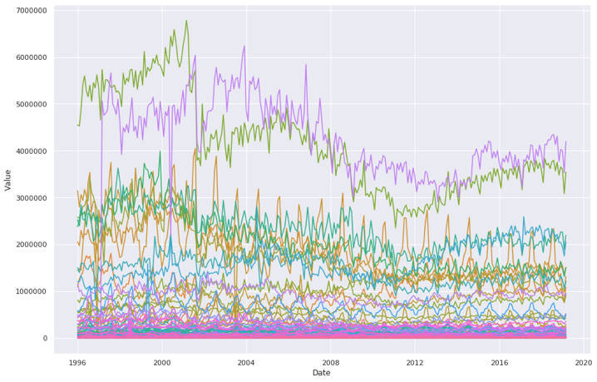 | 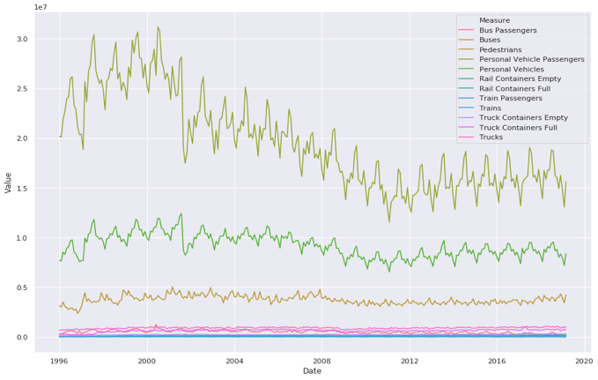
To better compare the crossing counts under different approaches, each measure is plotted and combined into a complete plot.
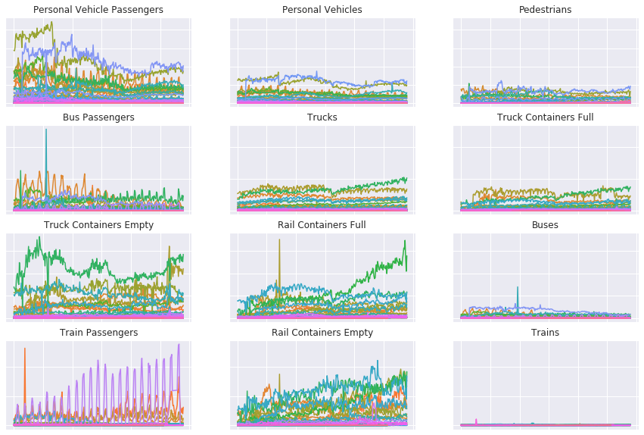
Then, anomaly detection was used to find the outliers in the data, and visualizations were further applied to illustrate the anomaly detection process.

