1) Run the example on the Indian diabetes dataset. Plot the decision tree for the gini measure with a max depth of 3.
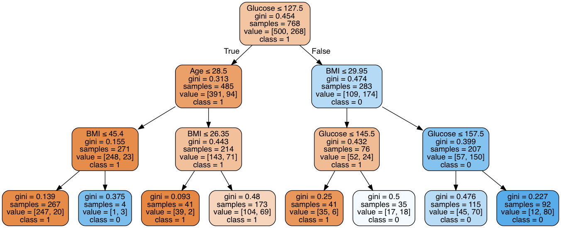

2) Now apply the online example to data from class. Use the insurance fraud dataset we discussed in class. Split the data into a 10% train and 90% test set using random_state = 1. Create a decision tree with a max depth of 3 using a gini measure. Print the accuracy on the test set and the tree. Is this a good approach? Why or why not?
Accuracy: 0.644
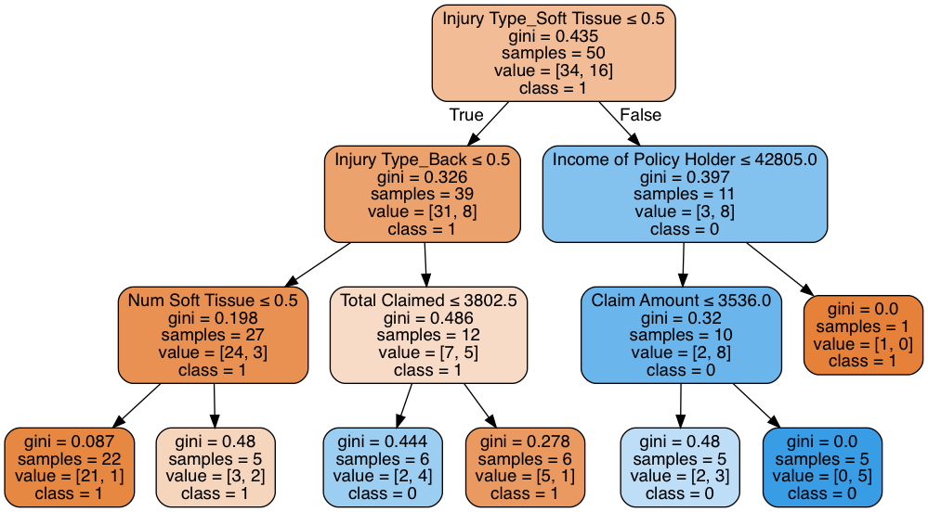

This is not an approach good enough. The 10% - 90% train test split makes it difficult for the model to learn patterns from the limited training set.

3) Create a decision tree on the same data with max depth of 3 and an entropy measure. Does the accuracy change? Does the tree change? Discuss which measure you think is better.
Accuracy: 0.644
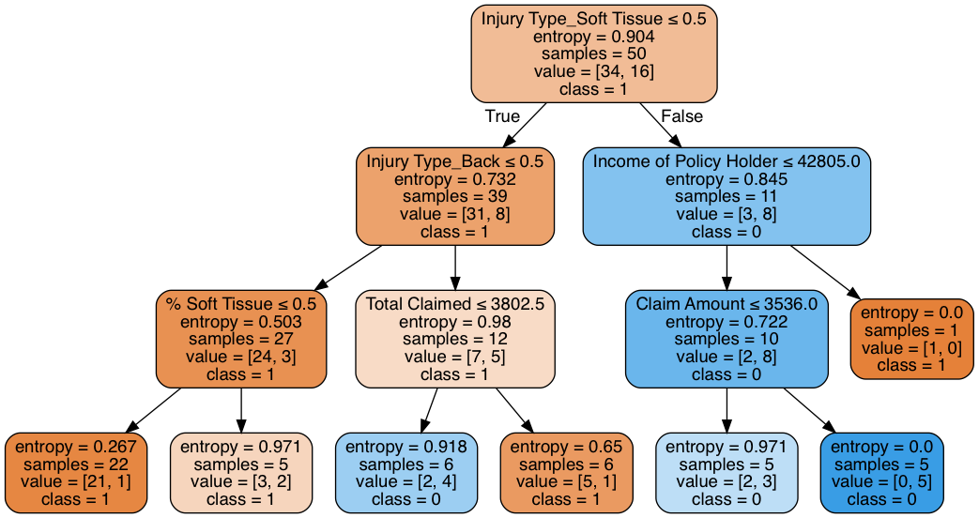
The accuracy doesn’t change, but the tree does change a little bit. The left subtree under condition Injury Type_Black <= 0.5 changes from feature “Num Soft Tissue” to “% Soft Tissue”. For this case, the two trees share a same splitting performance so I don’t tend to have any preference.
4) Now split the data into 70% train and 30% test using random_state = 1. Redo 2 and 3. Have the trees and accuracy changed? Are the trees more or less similar now? Discuss which split you think is better and why.
Accuracy of gini criterion: 0.727
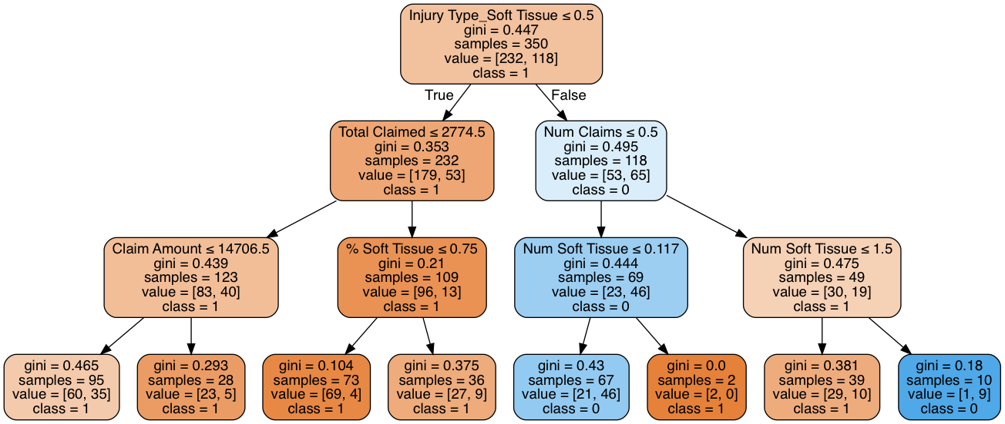

Accuracy of entropy criterion: 0.7
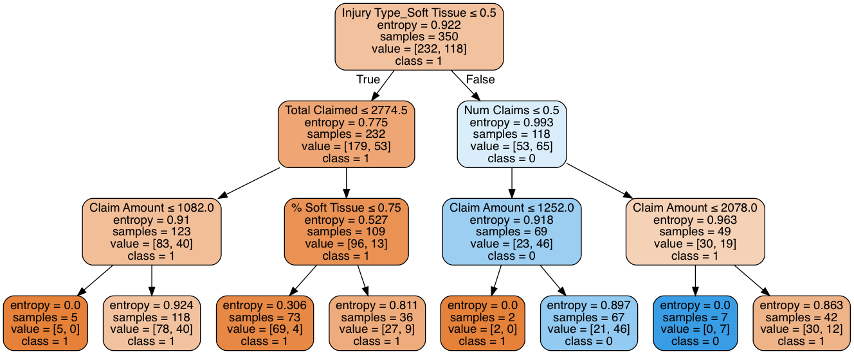

Both accuracy and trees change now. Gini outperformed entropy by .006. The trees are less similar now, and the difference is mainly on the splitting features and values on the second layer. Obviously the 70-30 split is better since more training data are fed into the model to learn the pattern.
5) Evaluate how the accuracy changes with the depth of the tree with the 70-30 data. Look at the accuracy for a max depth of 1, 2, 3, ... 10, 15, 20. Do you see underfitting? Do you see overfitting?
Below is the chart of accuracy changing with max_depth.
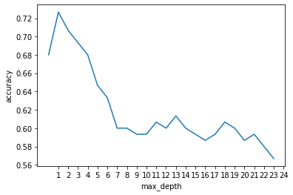

It could be observed that the performance peaks at max_depth of 2(.72), then gradually drops to .60 and oscillates up and down, displaying an overfitting that tends to split at deeper layers without improving accuracy. Although it “overfits”, I don’t think the model ever fits the data well with .72 accuracy, it could be further tuned to improve underfitting.
6) What variable provides the most information gain in the insurance fraud data (for the 70-30 split)?
In my case, it is the “Injury Type_Soft Tissue” after one-hot encoding the Injury Type column.
7) Decision trees are a “white box” method. What do you observe about the insurance fraud data using decision trees?
Decision trees apply a greedy methodology on every layer about choosing features. So we could directly observe which feature contributes most to the current subset. The two criteria – gini and entropy tend to choose the same splits for the top 2 layers, and differ slightly on the third layer and beyond.
Also, a single decision tree would easily overfit by enabling deeper splits. So it’s a good idea to detect the point of overfitting thru test set performance, and use some bagging approaches such as random forest to further improve the performance.
8) We talked about ‘clamping’ in class. Should we have done clamping on the data before using a decision tree?

